**Request-Reply Communication Paradigm**

Web app using Request-Reply

Student: Radu Dorin

Grupa: 30643

# 1.Cerinte

## Functionar requirements

* Logging as User/Administrator
* Viewing flights in a table/list

**User – side:**

* Logging as a user into aplication
* Viewing the flights
* Viewing the arrival time according to the arrival city’s timezone

**Administrator - side:**

* CRUD on flights

## Tehnologii pentru implementare

* HTML
* Java Servlets
* Hibernate ORM

## Cerinte nonfunctionale

* Session security in order to limit user acces.
* Make sure that that user can’t acces pages without logging in.

# 2. Diagrams

**Database Diagra**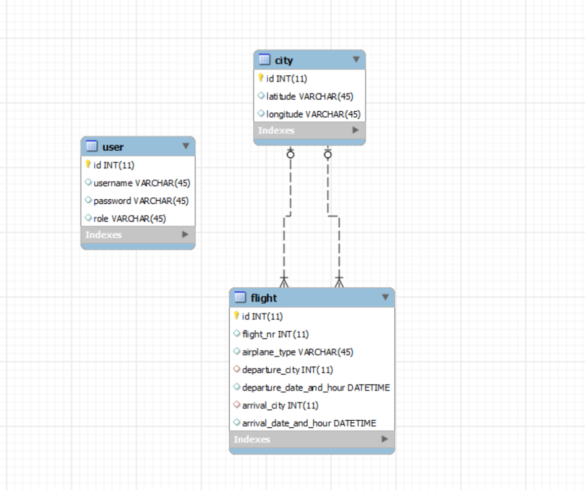

**Architectural Diagram**

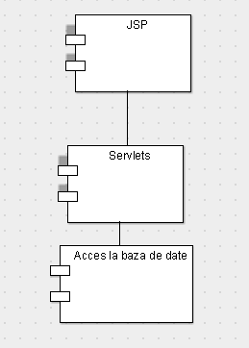

**Deployment diagram**

