DISTRIBUTED SYSTEMS

Remote Procedure Call (RPC)

Student: Radu Dorin

Grupa: 30643

1. **Requirements**

Design, implement and test a client-server distributed system that uses RPC to compute taxes and selling prices for cars.

Functional requirements:

* Users introduce the information of their cars using a simple form (Web or Desktop):
  + int year – fabrication year
  + int engineCapacity – engine size
  + double price- purchasing price
* The application uses RPC to send the car information to the distributed object from the server that computes the following information depending on the client request:
  + Tax for a car

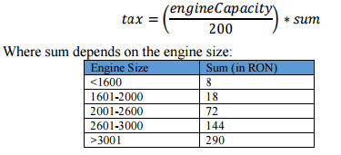

* + Selling price for a car 𝑝𝑟𝑖𝑐𝑒𝑠𝑒𝑙𝑙𝑖𝑛𝑔 = 𝑝𝑟𝑖𝑐𝑒𝑝𝑢𝑟𝑐 ℎ𝑎𝑠𝑖𝑛𝑔 − 𝑝𝑟𝑖𝑐𝑒𝑝𝑢𝑟𝑐 ℎ𝑎𝑠𝑖𝑛𝑔 7 ∗ (2015 − 𝑦𝑒𝑎𝑟)
* The result of the invoked operation, tax, respectively selling price, is displayed on the client GUI

Implementation technologies:

* Use the following technologies: JAVA RMI or .NET Remoting
* without logging in.

# 2. Diagrams

**Architectural Diagram**

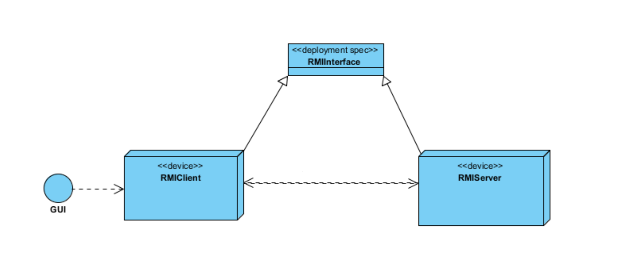

**Deployment diagram**

