QHO543 — Object Oriented Design and Development

AE2: Cinema Ticket Booking System — GUI Application

Individual Assessment Report

Student: Radu Bostan
Student ID: 10435443

Table of Contents
1. Introduction 3
2. Adapting the Group Project Code 3
2.1 Dissolving CinemaSystem 3
2.2 Model Classes Preserved 3
2.3 Discount Logic Unchanged 4
3. New Code Written for AE2 4
3.1 DatabaseManager 4
3.2 Service Layer 4
3.3 GUI and Admin Authentication 4
4. Separation of Concerns 5
5. Design Patterns 5
6. Testing Strategy 6
7. Application Screenshots 7
7.1 Film Search 7
7.2 Screening Display 10
7.3 Seat Selection 11
7.4 Ticket Purchase 13
7.5 Administrator Login 16
7.6 View Film and Screening Information 18
7.7 Film and Pricing Management 19
7.8 Special Offer Management 22
7.9 Automatic Offer Application — Morning First 24
8. Conclusion 26

1. Introduction
This report covers the development of the AE2 Cinema Ticket Booking System, a Kotlin desktop application that extends the AE1 group project into a database-backed, graphical system. The aim throughout was to change as little of the original code as necessary. The AE1 domain model and discount logic transfer into AE2 largely intact; what changed is how data is stored, how business operations are invoked, and how the user interacts with the system.

2. Adapting the Group Project Code

2.1 Dissolving CinemaSystem
The most consequential decision in AE2 was what to do with the AE1 CinemaSystem class. It acted as a god-class: it held three MutableLists for films, users, and offers, seeded them through seedUsers(), seedOffers(), and seedFilms(), and provided every user operation from searchFilms() to login() and modifyTicketPricing(). This made adding a database difficult because every method was entangled with every other.

The solution was to dissolve CinemaSystem entirely. Data access moved to DatabaseManager in cinema.booking.data, with a six-table SQLite schema (users, films, screenings, seats, offers, bookings). Business operations split across BookingService (customer journey) and AdminService (admin operations) in cinema.booking.service. The seed data was preserved faithfully — Inception, Titanic, Batman, and Frozen with their original prices, the Admin123 credential, and both special offers enabled by default. AE2 starts from the same state as AE1, just stored in SQLite rather than in memory.

2.2 Model Classes Preserved
Film, Screening, Seat, and Booking changed very little. Each gained a Long id primary key — needed because the system can no longer use list indices — but kept their original field names and types. Screening still carries a direct Film reference, which BookingService populates when loading from the database. Booking gained two Boolean flags, morningDiscountApplied and groupDiscountApplied, set by BookingService after DiscountService runs. printTicket() is preserved verbatim from AE1 and now reads those flags to display which discounts were applied. The User, Admin, and Customer hierarchy is unchanged: Admin.getRole() still returns "Administrator", Customer.getRole() still returns "Customer".

2.3 Discount Logic Unchanged
DiscountService keeps its AE1 arithmetic intact. Is MorningDiscountApplicable() uses the same java.time check (before noon on a non-weekend day). Calculate GroupDiscount() still computes the first two tickets at the effective price and the remainder at effectivePrice × 0.70. The one addition is calculateTotal (film, screening, seatCount), which returns a DiscountResult data class instead of a bare Double, carrying the final price plus the two Boolean flags. Requirement (i) is satisfied by the same ordering as AE1: morning is applied first to derive the effective price, then the group calculation uses that reduced value.

3. New Code Written for AE2

3.1 DatabaseManager
DatabaseManager is the most significant piece of new code. It creates the SQLite schema on first launch and runs seedData() to populate it with the AE1 seed values. Every SQL statement in the application lives here — no service class or composable function imports java.sql.* or writes a query string. The constructor accepts a database URL with a default of "jdbc:sqlite:cinema.db", which allows the JUnit test suite to pass "jdbc:sqlite:memory:" for fully isolated in-memory testing.

3.2 Service Layer
Three service classes replace the operations that lived in CinemaSystem. BookingService handles the customer journey: searching films, loading screenings, calculating prices, and completing purchases. AdminService covers admin operations: login(), getAllFilmsWithScreenings(), addFilmWithScreening(), and updateFilmPrice(). The price update multiplies the entered base price by an entered factor, implementing requirement g's price-factor feature.

3.3 GUI and Admin Authentication
The Compose Multiplatform GUI uses Material 3 throughout. The application opens on a WelcomeScreen with Login as Administrator and Login as Customer buttons. Administrators are routed to a credential-checked AdminLoginScreen that validates against the SQLite users table before the admin dashboard becomes accessible — satisfying requirement e. The admin dashboard is then divided into three tabs covering requirements f (Films and Screenings view), g (Pricing management), and h (Special Offers). Customers use a single scrollable CustomerBookingScreen where each section appears progressively as selections are made.

4. Separation of Concerns
AE2 applies the Single Responsibility Principle across four layers, each with one clearly defined role:

- Model layer (cinema.booking.model): pure Kotlin classes with no dependencies on databases, services, or composables.
- Data layer (cinema.booking.data): DatabaseManager alone — the only class that imports java.sql.*. Services call named methods; they never construct queries.
- Service layer (cinema.booking.service): BookingService, AdminService, DiscountService, OfferManager. All business rules live here, with no Compose imports.
- UI layer (cinema.booking.ui.screens): composable functions only. These import service and model classes but never DatabaseManager.

The proof that this separation is real rather than just described is the test suite: 47 JUnit tests across all nine requirements run by instantiating BookingService and DiscountService directly against an in-memory database, with no composable function involved. Business logic can be exercised, verified, and debugged entirely independently of the GUI.

5. Design Patterns
Repository Pattern. DatabaseManager provides a named API for each entity (getAllFilms, bookSeats, setOfferEnabled) so that callers never think about SQL. When a method was missing, there was exactly one file to change.

Service Layer Pattern. BookingService, AdminService, DiscountService, and OfferManager form an explicit service layer. In AE1 all of these responsibilities lived in CinemaSystem; separating them gave each class a clearly bounded scope.

Sealed Result Type. BookingResult is a sealed class with Success and Failure subclasses, returned by purchaseTickets(). Error paths are typed values that the compiler forces the caller to handle, rather than exceptions thrown into composable functions.

Template Method (preserved from AE1). SpecialOffer defines applyDiscount() using discountPercentage; MorningDiscount and GroupBookingDiscount inherit it and supply their percentages (0.25 and 0.30). The discount logic is identical; only the value varies — exactly what Template Method exists for.

Observer via Compose State. The admin dashboard holds offer toggle states in mutableStateOf Boolean variables. Compose recomposes only the parts of the screen that depend on those variables, keeping the UI in sync with the database without manual notification code.

6. Testing Strategy
The JUnit 5 test suite contains 47 tests organised into nine nested inner classes, one per requirement (a through i). Every test method carries a comment naming the AE1 behaviour it mirrors and identifying whether it is a success or error case. All tests use DatabaseManager("jdbc:sqlite:memory:"), creating a fresh in-memory database for every run with no order dependencies between tests.

The discount tests are arithmetically verifiable rather than only checking Boolean flags. The combined morning-and-group test for Batman uses three seats on the 09:30 Thursday screening: morning first gives effective price 9.50 × 0.75 = £7.125; group total is (2 × 7.125) + (1 × 7.125 × 0.70) = £19.24. The test asserts this exact figure, so reversing the discount order would fail with a concrete number mismatch. Error cases are tested alongside every success case.

7. Application Screenshots

7.1 Film Search

SCREENSHOT 1: Welcome Screen — Login buttons visible

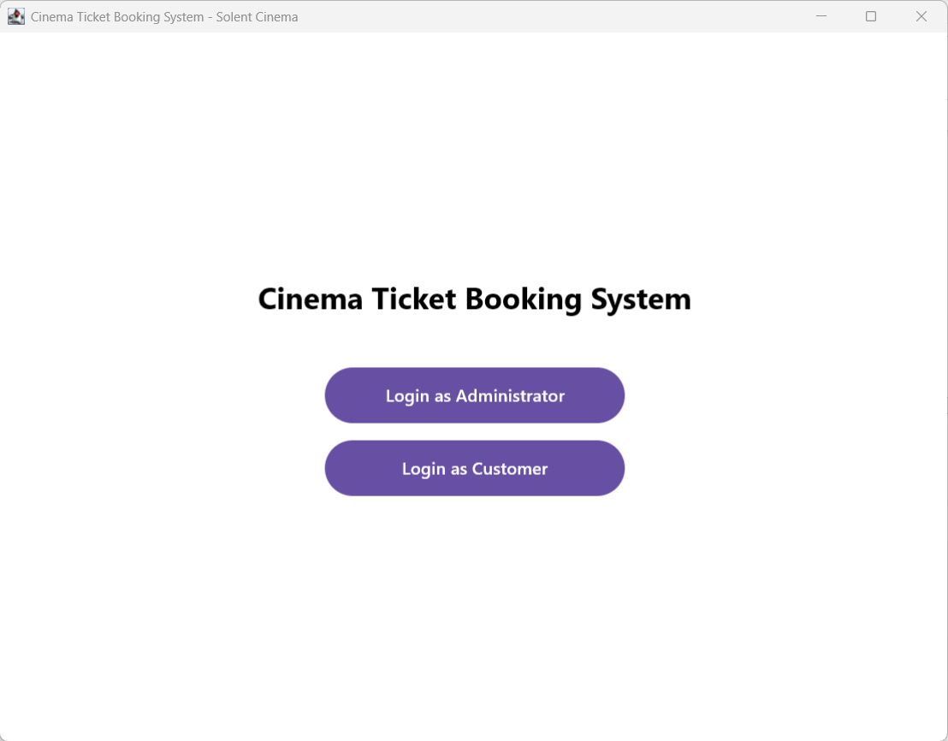

SCREENSHOT 2: Film Search — all four films listed

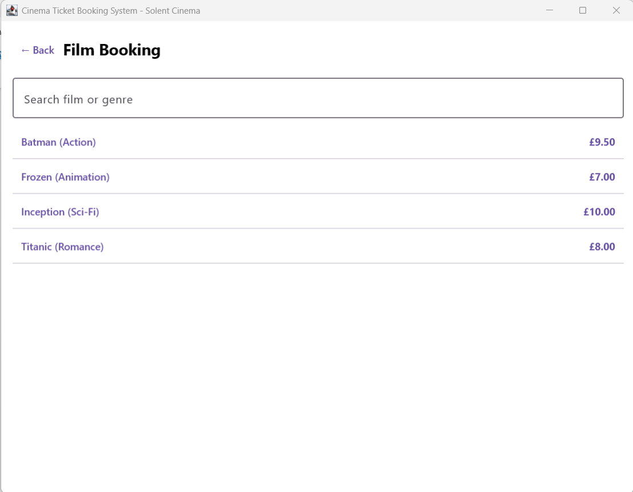

SCREENSHOT 3: Film Search — filtered by genre

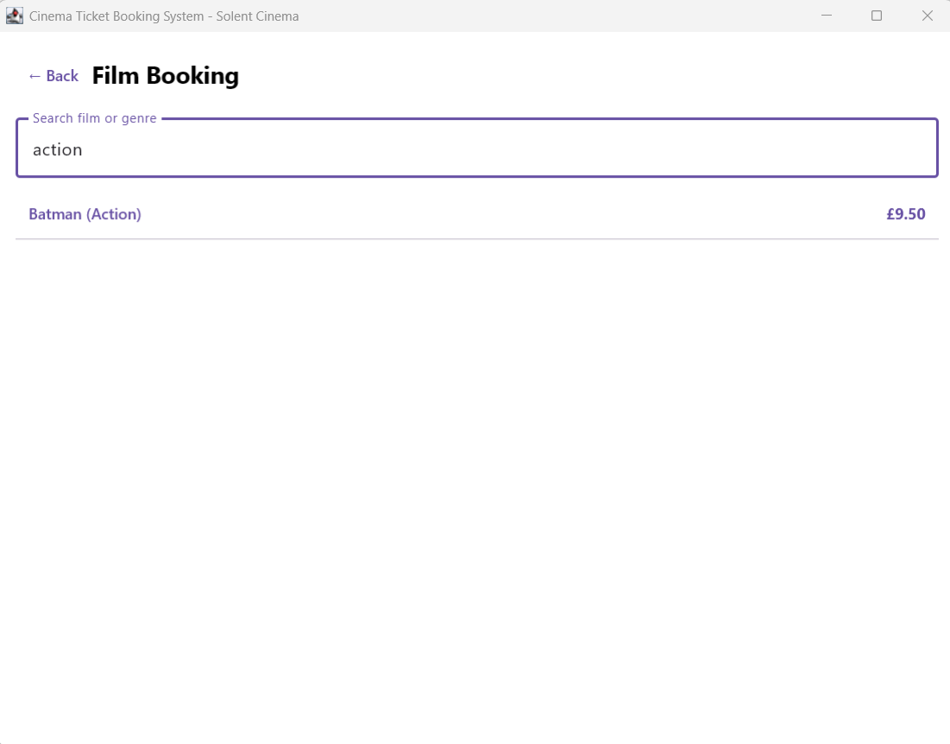

7.2 Screening Display

SCREENSHOT 4: Screening Display — three Inception screenings

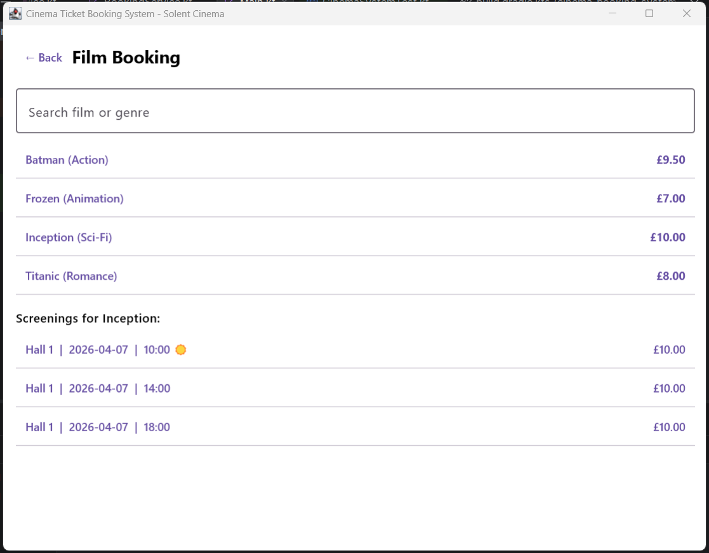

7.3 Seat Selection

SCREENSHOT 5: Seat Grid — all 10 seats available

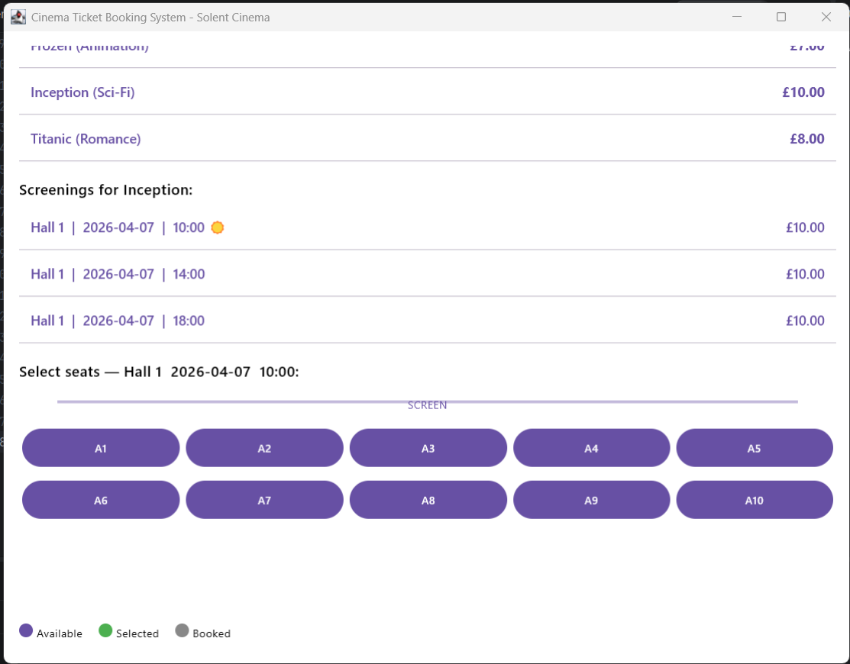

SCREENSHOT 6: Seat Grid — three seats selected

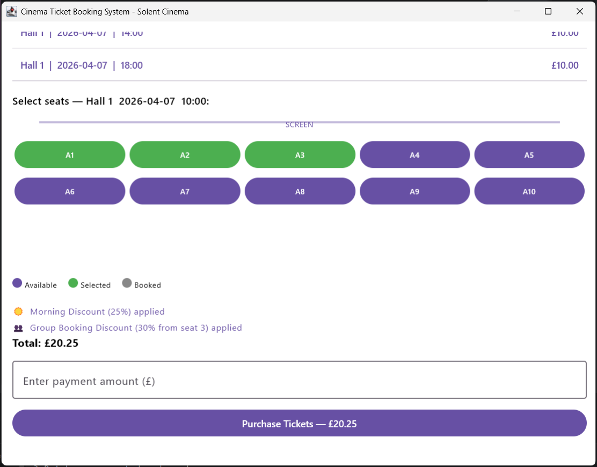

7.4 Ticket Purchase

SCREENSHOT 7: Payment area — both discounts applied

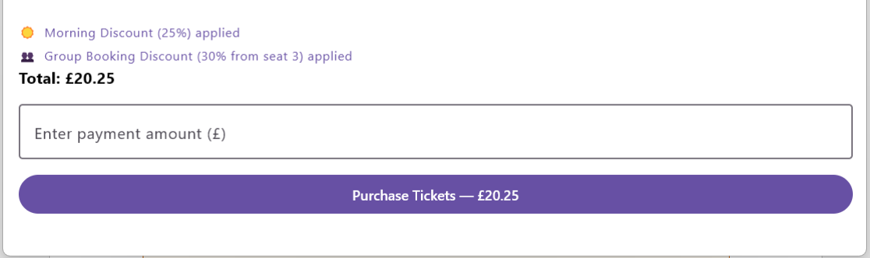

SCREENSHOT 8: Payment — insufficient funds error

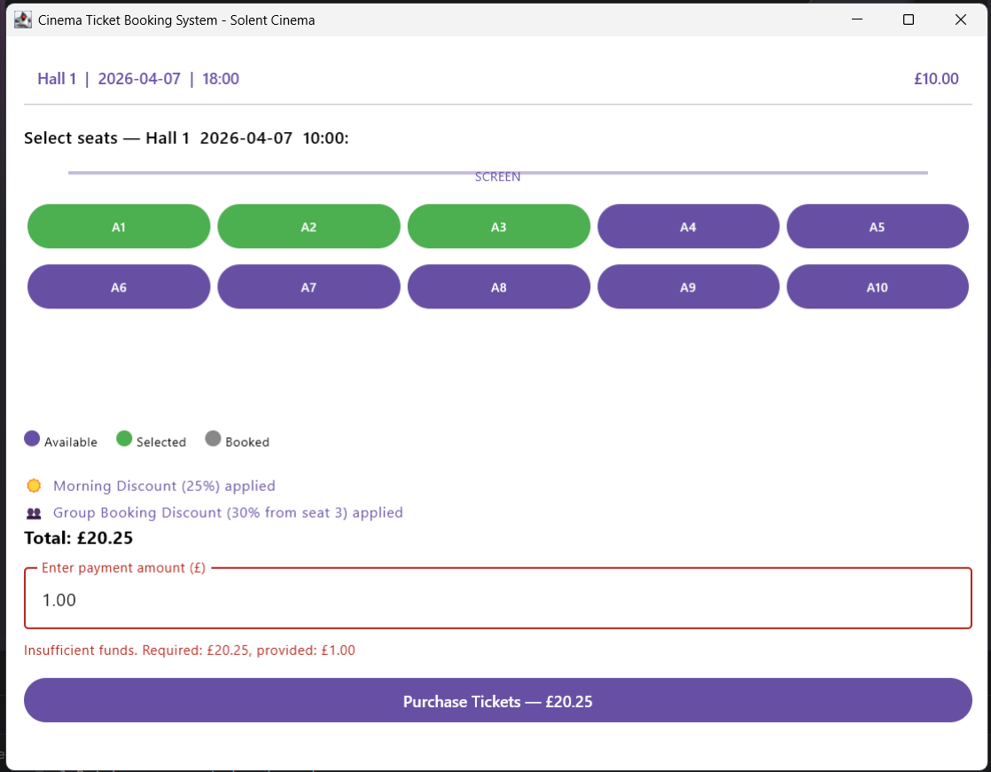

SCREENSHOT 9: Ticket Receipt — AE1 printTicket() format

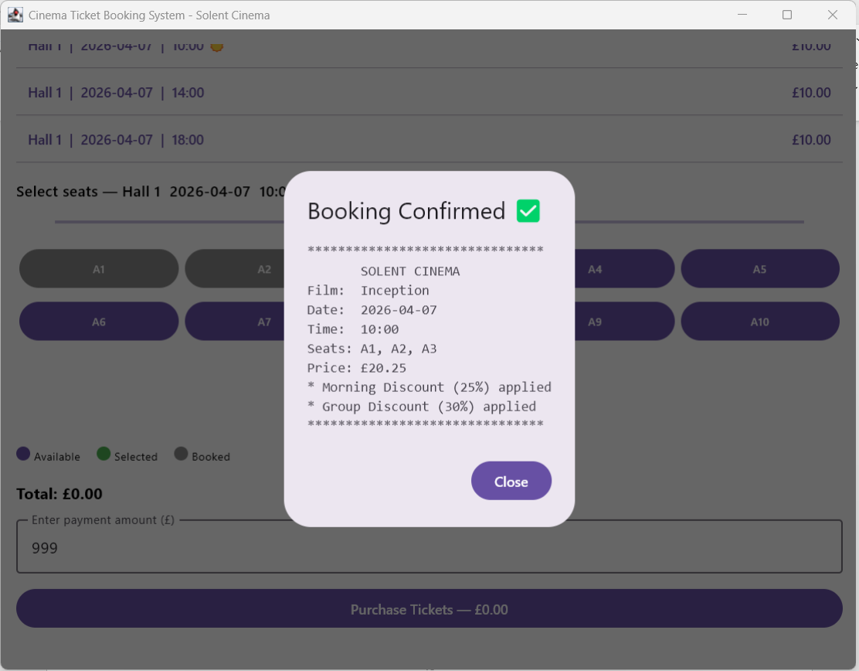

SCREENSHOT 10: Seat Grid — booked seats grey after purchase

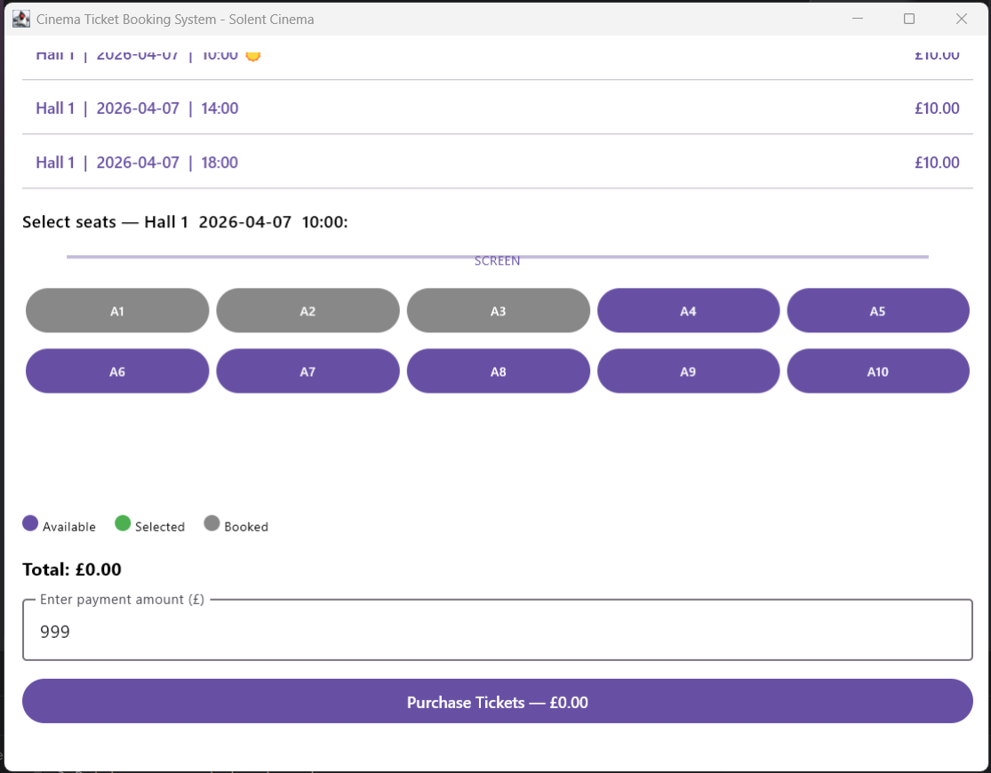

7.5 Administrator Login

SCREENSHOT 11: Admin Login — credentials entered

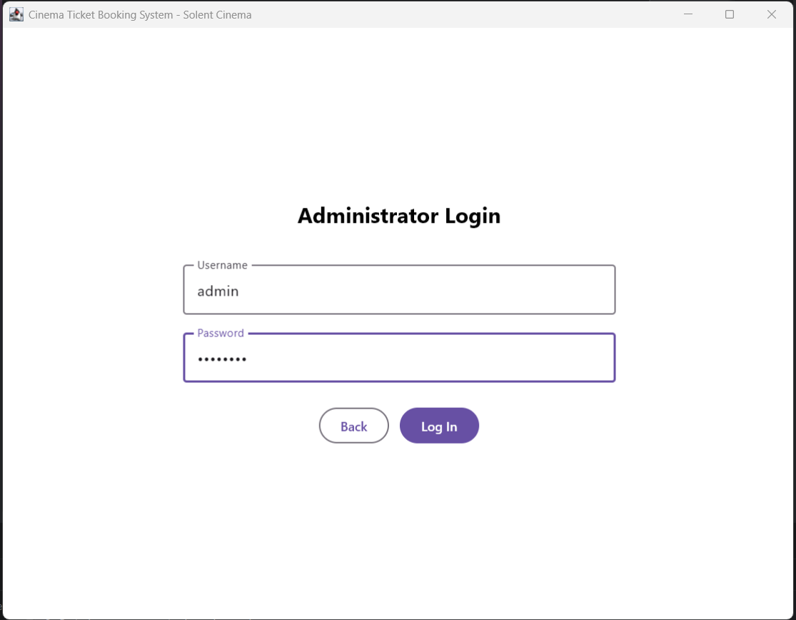

SCREENSHOT 12: Admin Login — wrong password rejected

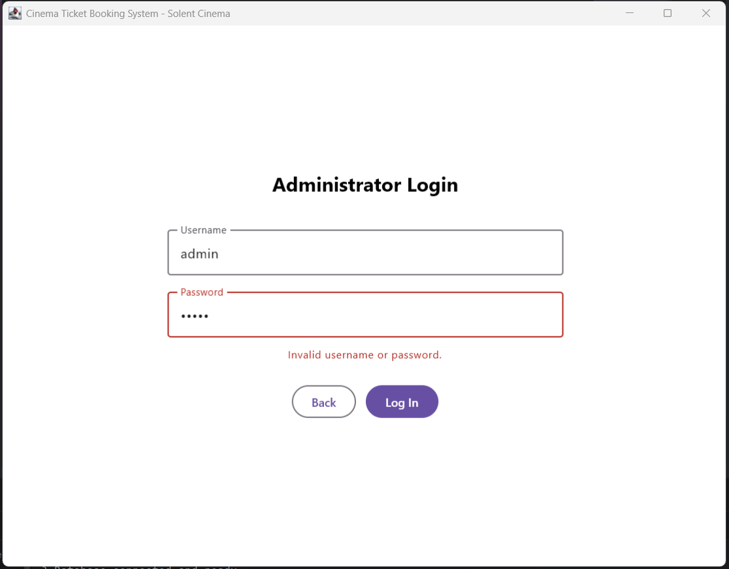

7.6 View Film and Screening Information

SCREENSHOT 13: Admin Dashboard — Films and Screenings tab

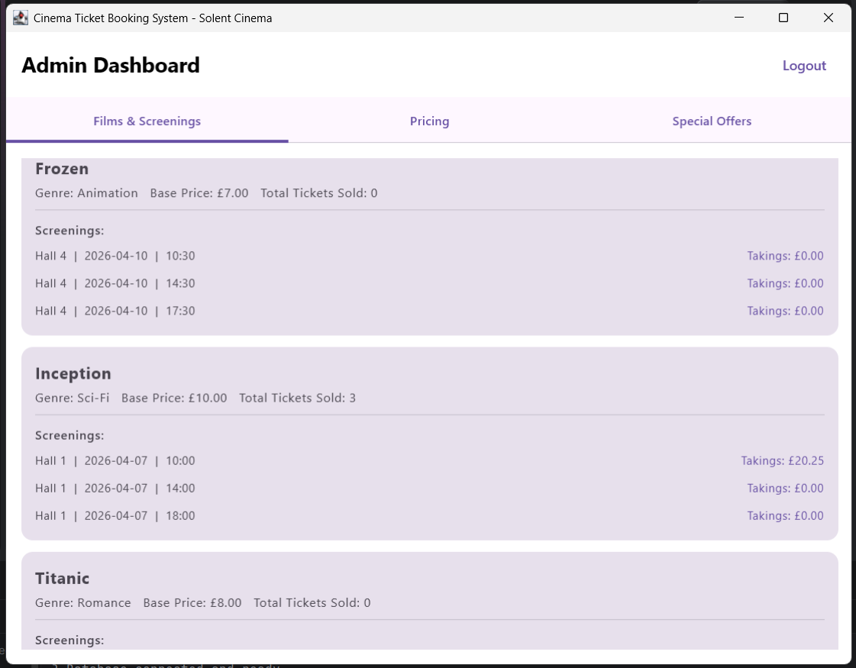

7.7 Film and Pricing Management

SCREENSHOT 14: Admin Pricing — price updated with factor

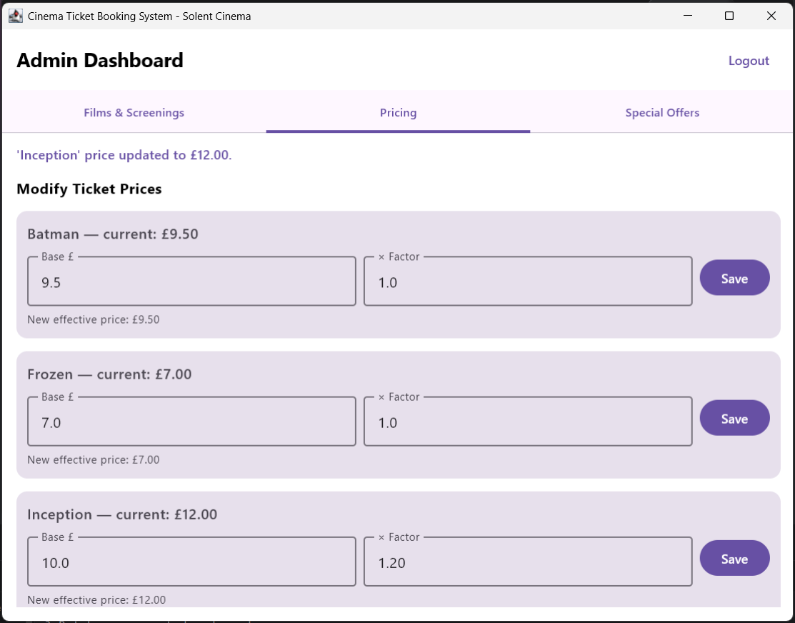

SCREENSHOT 15: Admin Pricing — new film added

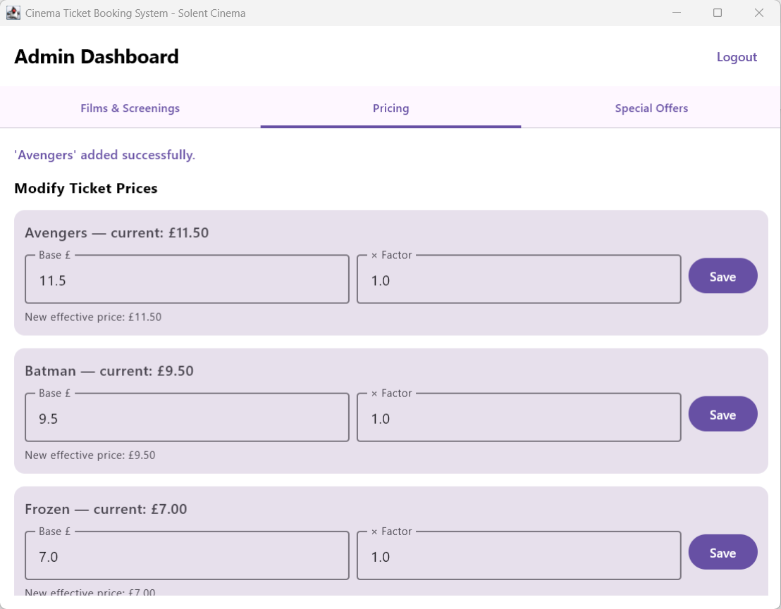

SCREENSHOT 16: Avengers persists after logout

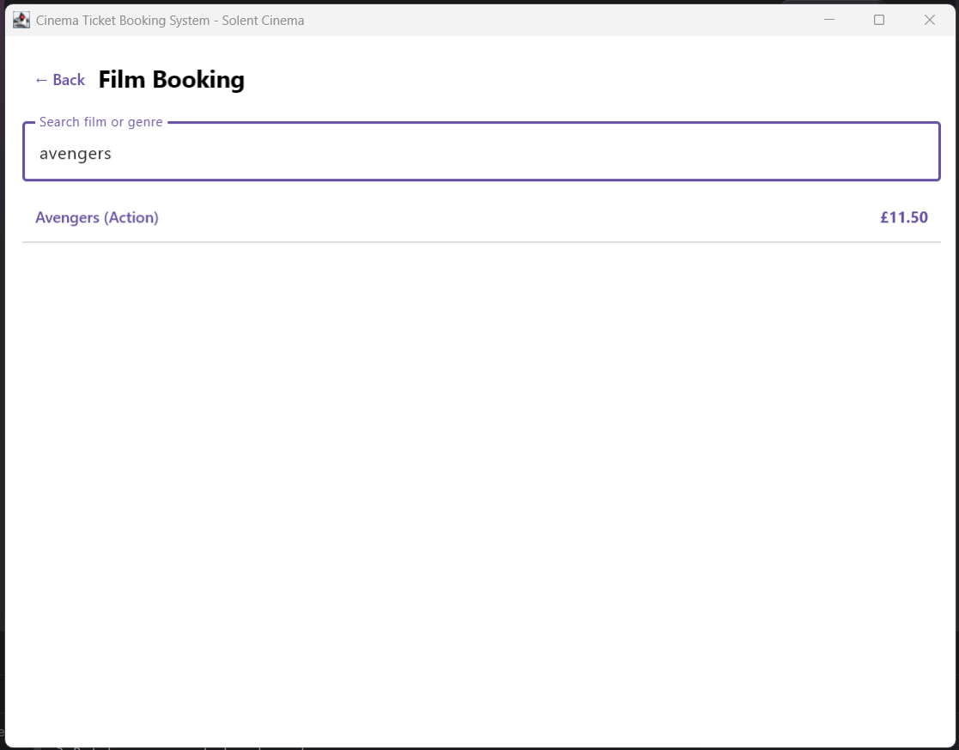

7.8 Special Offer Management

SCREENSHOT 17: Special Offers — both enabled by default

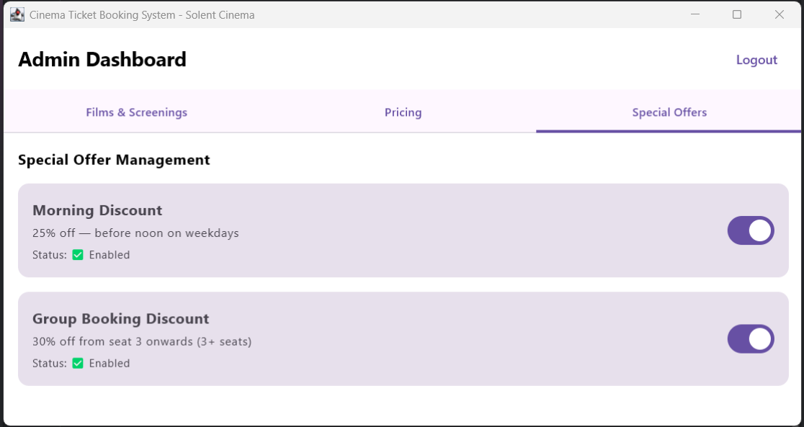

SCREENSHOT 18: Special Offers — Morning Discount disabled

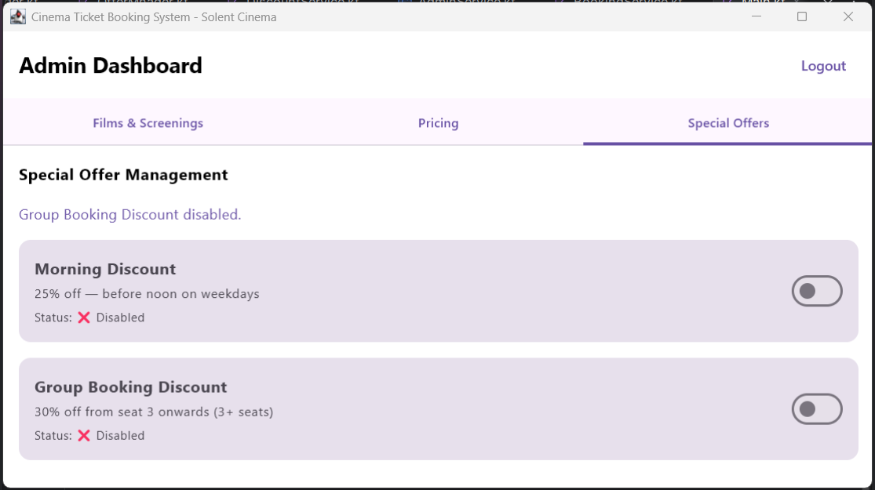

SCREENSHOT 19: Payment — no discount when offer disabled

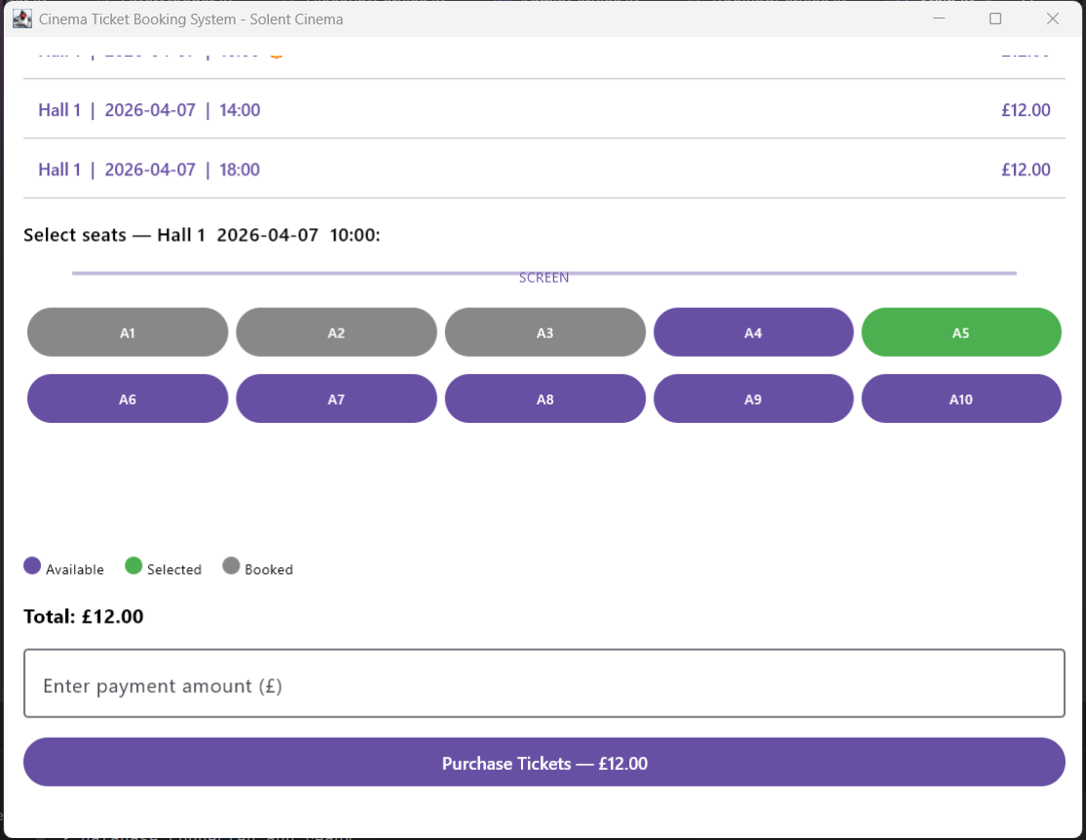

7.9 Automatic Offer Application — Morning First
For Batman at £9.50 with 3 seats on a Thursday morning: effective price = 9.50 × 0.75 = £7.125; total = (2 × 7.125) + (7.125 × 0.70) = £19.24. JUnit test i-05 verifies this exact figure.

SCREENSHOT 20: Payment — both discounts, total = £19.24

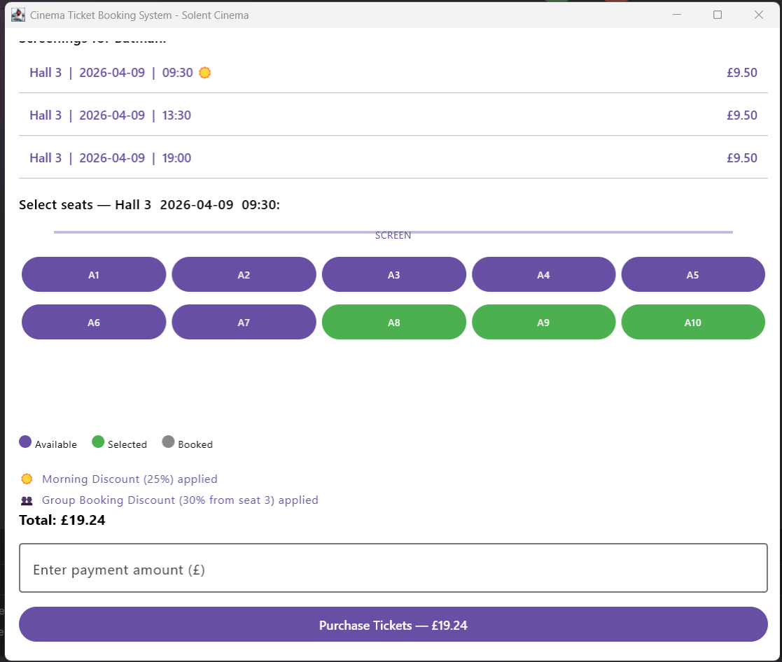

SCREENSHOT 21: JUnit Test Results — all 47 tests green

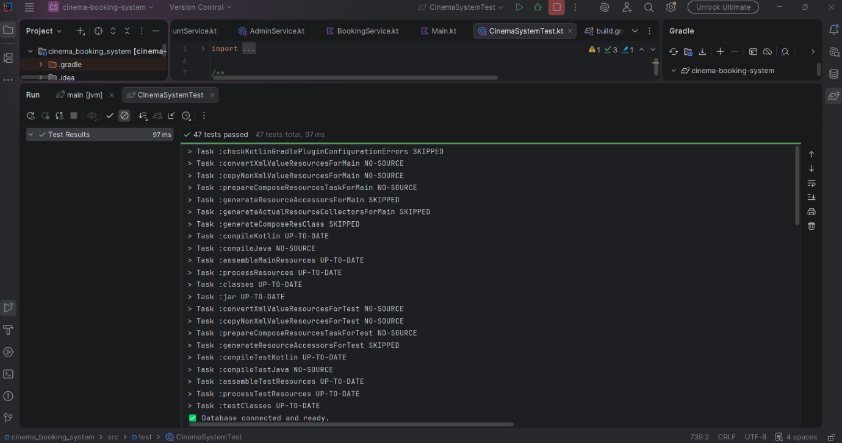

8. Conclusion

Extending the group project turned out to be as much a design exercise as a coding one. The domain model and discount rules were already correct and did not need changing. What the system needed was a proper structural home for each of its concerns: DatabaseManager for data access, dedicated service classes for business logic, and a Compose Multiplatform GUI for presentation. The values that the group project established — 25% morning discount before noon on weekdays, 30% group discount applied from the third seat, morning applied first when both are eligible, and the same ticket receipt format — all carry through unchanged. AE2 adds the persistence, the login system, the administrative interface, and 47 automated tests that verify every requirement against a real SQLite database.

