

ReviewSense AI
A Comparative Study of Traditional Machine Learning, Attention-Based Neural Networks, and Transfer Learning for Text-Based Emotion Detection
Natural Language Processing (NLP)
Team Members
Basma Mansour | Radwa El-Ashry | Marwa Baraka | Shrouk Khaled
Supervision
Dr. Sherif Hussein
Group 6 | Lab 2
2026

Abstract
The proliferation of user-generated textual content across digital platforms has intensified the demand for reliable automated emotion detection. This report presents ReviewSense AI, a systematic comparative evaluation of three methodological paradigms for multi-class emotion classification, conducted on the Emotions Dataset for NLP—a benchmark corpus of approximately 20,000 English text samples annotated across six emotion categories: Joy, Sadness, Love, Anger, Fear, and Surprise.
Three complementary approaches were investigated within the ReviewSense AI framework: traditional machine learning via TF-IDF feature representation with optimized Logistic Regression; a custom attention-based neural network employing Byte-Pair Encoding tokenization and multi-head self-attention; and transfer learning leveraging pre-trained GloVe embeddings within a stacked Bidirectional LSTM architecture. A modular preprocessing pipeline addressed data quality issues including duplicate records, conflicting annotations, and language inconsistency, with preprocessing intensity adapted to model-specific requirements. Additionally, an interactive statistical dashboard was developed to visualize class distributions, preprocessing outcomes, and feature importance.
Experimental results demonstrate that Logistic Regression achieves the highest validation performance at 90.73% accuracy with a weighted F1-score of 0.9080, establishing that optimized traditional approaches remain highly competitive for structured emotion classification. The attention-based neural network attains 87.70% test accuracy, a macro F1-score of 0.8382, and a macro one-vs-rest ROC-AUC of 0.9879, indicating exceptional discriminative capacity. The GloVe-BiLSTM model achieves 85.90% test accuracy with 1.99 million trainable parameters and 93.4% vocabulary coverage, providing a stable transfer learning solution. Critically, synonym-based data augmentation using WordNet significantly degrades neural performance, reducing accuracy from 87.70% to 69.90%—a decline of 17.8 percentage points—underscoring the imperative of rigorous augmentation validation for sentiment-related tasks.
To demonstrate the intended operational context of the models, a web application was designed and deployed at https://insight-glow-52.lovable.app. The deployed artefact is a front-end prototype: its interface, dashboard, and analysis console are fully implemented and publicly reachable, while the inference layer is specified but not yet served, so displayed predictions are fixture data. The deployment exercise nevertheless proved analytically productive, exposing that the six-class taxonomy validated here is incomplete for the customer-review domain and that calibrated probability estimates matter more in operation than the headline accuracy figure that dominates academic comparison.
This study contributes empirical insights into the trade-offs between accuracy, interpretability, computational complexity, and model capacity. The findings inform the development of deployable emotion detection systems for applications spanning customer analytics, mental health monitoring, and human-computer interaction.
Keywords: Natural Language Processing; Emotion Detection; Text Classification; TF-IDF; Logistic Regression; Self-Attention; Byte-Pair Encoding; GloVe; Bidirectional LSTM; Data Augmentation; Class Imbalance.

Table of Contents
Abstract i
Table of Contents iii
List of Tables v
List of Figures vi
Chapter 1: Introduction 1
1.1 Introduction 1
1.2 Problem Statement 3
1.3 Research Significance 4
1.4 Report Organization 6
Chapter 2: Literature Review and Background 7
2.1 Background 7
2.1.1 Machine Learning Models 7
2.1.2 Deep Learning Models 10
2.1.3 Transformer-Based Models 13
2.2 Literature Review 14
2.3 Comparative Summary of Related Studies 18
2.4 Research Gap 19
Chapter 3: Methodology and Results 21
3.1 Dataset Description 21
3.1.1 Dataset Statistics and Class Imbalance 22
3.2 Data Preprocessing 22
3.3 Dataset Splitting Strategy 27
3.4 Proposed Models 29
3.4.1 Logistic Regression with TF-IDF 29
3.4.2 Custom Attention-Based Neural Network with BPE 34
3.4.3 GloVe with Bidirectional LSTM 42
3.5 Evaluation Metrics 45
3.6 Comparative Evaluation of Models 48
3.7 Statistical Dashboard Analysis 54
Chapter 4: System Deployment 62
4.1 Deployment Overview and Objectives 62
4.1.1 Implementation Status 62
4.2 System Architecture 63
4.3 Application Structure and User Interface 65
4.3.1 The Dashboard 66
4.3.2 The Analysis Console 67
4.4 Inference Pipeline and Interface Contract 68
4.5 Hosting, Build, and Delivery 70
4.6 Evaluation of the Deployed Prototype 71
4.6.1 Discrepancies Between the Prototype and the Validated Models 71
4.6.2 Limitations of the Current Deployment 73
4.7 Path to Production 73
Chapter 5: Conclusions and Future Work 75
5.1 Conclusions 75
5.2 Future Work 78
References 80

List of Tables
Table 1 Comparative Summary of Related Studies 18
Table 2 Dataset Summary 21
Table 3 Original Class Distribution Before Cleaning 22
Table 4 Final Dataset Sizes After Cleaning 26
Table 5 Partition Sizes and Functional Roles 28
Table 6 TF-IDF Vectorizer Configuration 31
Table 7 GridSearchCV Hyperparameter Search Space 31
Table 8 Forward Pass Through the Custom Attention Network 35
Table 9 Architecture Specification of the Custom Attention Network 36
Table 10 Computed Class Weights for the Training Partition 37
Table 11 Training Configuration for the Custom Attention Network 38
Table 12 Hyperparameter Search Space for the Custom Attention Network 38
Table 13 Test-Set Results for the Custom Attention Network (Non-Augmented) 40
Table 14 Test-Set Results for the Custom Attention Network (Augmented) 41
Table 15 GloVe-BiLSTM Architecture Specification 43
Table 16 GloVe-BiLSTM Training Configuration 44
Table 17 Summary of Evaluation Metrics 48
Table 18 Comparative Evaluation of Models 48
Table 19 Dashboard Key Performance Indicators 55
Table 20 Emotion-Specific Text Statistics 58
Table 21 Top TF-IDF Features by Mean Score 59
Table 22 Implementation Status by Component 63
Table 23 Application Route Inventory 66
Table 24 Dashboard Headline Indicators as Displayed by the Prototype 67
Table 25 Proposed Schema for the Inference Endpoint 69
Table 26 Hosting and Delivery Configuration 70
Table 27 Discrepancies Between the Deployed Prototype and the Validated Results 71
Table 28 Staged Path From Prototype to Production 73

List of Figures
Figure 1 Support Vector Machine (SVM) 7
Figure 2 Logistic Regression (LR) 8
Figure 3 Decision Tree (DT) 9
Figure 4 K-Nearest Neighbors (KNN) 10
Figure 5 Long Short-Term Memory (LSTM) 11
Figure 6 Bidirectional Long Short-Term Memory (BiLSTM) 12
Figure 7 Hybrid CNN-LSTM Architecture 13
Figure 8 Highest-Weight TF-IDF Terms per Emotion Class on the Cleaned Training Split 25
Figure 9 Preprocessing Impact on the Training Split: Character Length, Token Count, and Vocabulary Size Before and After Heavy Cleaning 28
Figure 10 Dataset Health Check: Samples per Split, Relative Split Sizes, and Missing-Value Audit After Cleaning 29
Figure 11 GridSearchCV Hyperparameter Sensitivity Analysis for Logistic Regression 33
Figure 12 Confusion Matrices for Logistic Regression on the Validation Set: Raw Counts (left) and Row-Normalized Recall (right) 33
Figure 13 Training Dynamics of the Custom Attention Neural Network: Loss per Epoch, Validation Accuracy per Epoch, and Generalization Gap 39
Figure 14 Confusion Matrix and Test Metrics for the Custom Attention Network (Non-Augmented Variant) 40
Figure 15 Confusion Matrix and Test Metrics for the Custom Attention Network (Augmented Variant) 41
Figure 16 Confusion Matrix and Test Metrics for the GloVe-BiLSTM Model 45
Figure 17 Per-Class Precision, Recall, and F1-Score for the Custom Attention Neural Network (Class-Weighted) 49
Figure 18 Per-Class Precision, Recall, and F1-Score for Logistic Regression (Validation Set) 49
Figure 19 ReviewSense AI Statistical Dashboard: Overview KPIs, Data Cleaning Steps, and Preprocessing Pipeline Panels 55
Figure 20 Class Distribution Before and After Duplicate Removal 56
Figure 21 Emotion-Specific Statistics: Average Text Length and Average Word Count by Emotion Class 58
Figure 22 Top 15 TF-IDF Terms Ranked by Feature Importance 60
Figure 23 ReviewSense AI Deployment Architecture, Distinguishing Implemented Components from Specified Components 64
Figure 24 ReviewSense AI Application Route Map 66
Figure 25 The Five-Stage ReviewSense AI Inference Pipeline, with a Worked Input and Output Example 68

Chapter 1: Introduction

1.1 Introduction
Natural Language Processing (NLP) has emerged as a fundamental discipline within artificial intelligence, enabling computational systems to interpret and derive meaning from unstructured human language. Within this domain, emotion detection has attracted considerable research attention due to its capacity to bridge the gap between human affective expression and machine understanding. Unlike coarse-grained sentiment analysis, which categorizes text into broad polarities such as positive, negative, and neutral, emotion detection pursues a more granular objective: the identification of discrete emotional states including joy, sadness, anger, fear, love, and surprise. This finer classification paradigm is indispensable for applications ranging from mental health surveillance to empathetic human-computer interaction, where the distinction between, for example, anger and fear carries materially different operational consequences.
The theoretical foundation for discrete emotion classification derives from psychological models of affect. Ekman's (1992) basic emotion theory posits a small set of universal, biologically grounded emotional states, while Plutchik's (1980) wheel of emotions organizes affective experience into primary dyads and their derived combinations. Computational emotion detection typically operationalizes one of these discrete frameworks by mapping textual input onto a fixed label set. The corpus employed in this study adopts a six-category scheme—joy, sadness, love, anger, fear, and surprise—which aligns closely with Ekman's (1992) basic emotions while substituting love for disgust, a substitution motivated by the affective register that predominates in social media discourse.
The exponential growth of user-generated content on social media platforms has created unprecedented opportunities for large-scale emotion analysis. The public and instantaneous nature of such communication provides a continuous stream of emotionally charged text, reflecting individual reactions to events, products, and societal developments. However, this abundance of data is accompanied by substantial computational challenges. Social media text is frequently characterized by informal language, abbreviated expressions, contextual ambiguity, and rapidly evolving linguistic conventions that deviate from standard grammatical structures. Traditional text analysis techniques—including rule-based lexicons and conventional machine learning classifiers such as Support Vector Machines and Random Forests—often exhibit limited accuracy and poor generalization when confronted with the variety and informality of digital content. These limitations are compounded by data quality issues, including duplicate records, conflicting annotations, class imbalance, and out-of-vocabulary terms.
Recent research has explored advanced neural architectures and transfer learning to address these limitations. Deep learning approaches, including Convolutional Neural Networks, Long Short-Term Memory networks (Hochreiter & Schmidhuber, 1997), and Transformer-based models (Vaswani et al., 2017), have demonstrated superior capacity for learning discriminative features directly from text without manual feature engineering. Pre-trained language models such as BERT (Devlin et al., 2019) have further advanced the state of the art through task-specific fine-tuning. However, the relative effectiveness of traditional machine learning versus complex neural architectures for emotion classification remains insufficiently characterized. Studies such as those by Al Maruf et al. (2024) and Chutia and Baruah (2024) have surveyed the field extensively, yet a systematic, controlled comparison of these paradigms under identical experimental conditions is conspicuously absent from the literature. This gap prevents practitioners from making informed choices regarding the deployment of interpretable, efficient models versus more complex, computationally expensive alternatives.
A further consideration that motivates the present work is the growing regulatory and ethical emphasis on algorithmic transparency. Where an emotion classifier informs decisions with consequences for individuals—triaging mental health referrals, moderating user content, or routing customer complaints—the ability to attribute a prediction to identifiable textual evidence is not merely a convenience but often a requirement. Linear models over sparse lexical features possess this property intrinsically: each coefficient maps to a specific n-gram and can be inspected directly. Deep architectures, by contrast, require post-hoc explanation methods whose faithfulness is itself contested. Any empirical finding that a simple, interpretable model performs competitively therefore carries practical weight beyond the reported accuracy figure.
This study addresses this gap through a comprehensive comparative evaluation of three complementary methodological paradigms for multi-class emotion classification, implemented collectively under the ReviewSense AI framework. The first approach employs TF-IDF feature representation with optimized Logistic Regression, establishing a traditional machine learning baseline. The second implements a custom attention-based neural network with Byte-Pair Encoding tokenization, exploring the benefits of self-attention mechanisms. The third integrates pre-trained GloVe embeddings with a stacked bidirectional LSTM architecture, investigating transfer learning from distributional semantics. An interactive statistical dashboard was developed to visualize class distributions, preprocessing outcomes, and feature importance. Through comprehensive preprocessing, hyperparameter optimization, and experimental evaluation, this research elucidates the trade-offs between accuracy, interpretability, computational complexity, and model capacity, providing empirical guidance for the development of robust and deployable emotion detection systems.

1.2 Problem Statement
The increasing volume of user-generated textual content across social media platforms has created an urgent need for reliable automated systems capable of detecting human emotions from unstructured text. However, despite significant advances in natural language processing, several fundamental challenges continue to hinder the development of robust emotion detection systems.
The primary challenge is data quality. The Emotions Dataset for NLP, while widely used as a benchmark, suffers from critical quality issues that undermine model reliability. The dataset contains duplicate records in which identical text samples are labelled with different emotion categories—62 such conflicting-label rows were identified in the training partition alone. These contradictory annotations introduce noise that confuses learning algorithms and degrades classification performance. Furthermore, the dataset exhibits severe class imbalance, with Joy appearing 9.37 times more frequently than Surprise, biasing models toward majority classes and reducing their ability to correctly identify less frequent emotional expressions. Additionally, the presence of apparently non-English text within the corpus complicates analysis and can distort learned representations if not properly addressed.
The second challenge is the absence of systematic methodological comparison. While the literature contains numerous studies demonstrating the effectiveness of both traditional machine learning approaches—such as Logistic Regression, Support Vector Machines, and Random Forests—and advanced neural architectures—including attention-based networks, LSTMs, and transformers—there exists no controlled comparative evaluation of these paradigms under identical experimental conditions. This gap prevents researchers from understanding the relative strengths and limitations of each approach, and prevents practitioners from making informed decisions about model selection for real-world deployment.
The third challenge concerns the interpretability-accuracy trade-off. Deep learning models, despite achieving high classification accuracy, operate as opaque black boxes that provide no explanation for their decisions. In applications such as mental health monitoring or content moderation, where automated decisions carry significant consequences, the absence of explainability is a critical limitation. Conversely, traditional linear models offer intrinsic interpretability but may lack the representational capacity needed to capture the complex linguistic patterns characteristic of emotional expression.
The fourth challenge relates to data augmentation. Synonym-based augmentation is commonly employed to address class imbalance, yet its effectiveness for sentiment-related tasks remains unclear. Replacing words with synonyms risks altering the emotional valence of the text, potentially degrading rather than enhancing model performance. Because augmentation is usually reported only when it succeeds, the literature offers little guidance on when it should be avoided.
To address these challenges, this study investigates the following research questions:
RQ1: How does optimized Logistic Regression with TF-IDF features compare to custom attention-based neural networks with BPE tokenization and GloVe-based BiLSTM architectures for six-class emotion classification?
RQ2: Do self-attention mechanisms and pre-trained embeddings provide measurable benefits over simpler architectures?
RQ3: What is the effect of synonym-based data augmentation on neural network performance for emotion classification?
RQ4: What are the practical trade-offs between accuracy, interpretability, computational efficiency, and parameter count across these paradigms?

1.3 Research Significance
Academically, this study contributes a systematic comparative evaluation of three methodological paradigms—traditional machine learning, custom attention-based neural networks, and transfer learning—under a controlled experimental protocol. While prior surveys have reviewed these paradigms individually, a direct comparison under identical preprocessing, partitioning, and evaluation conditions has been absent. This work provides empirical evidence clarifying the trade-offs between accuracy, interpretability, computational cost, and model capacity.
Practically, the findings inform model selection for real-world applications. Logistic Regression achieves 90.73% validation accuracy with training completing in seconds on CPU hardware, making it ideal for resource-constrained environments. The attention-based neural network provides superior discriminative capacity with a macro one-vs-rest ROC-AUC of 0.9879, suitable for applications requiring fine-grained differentiation or calibrated ranking of candidate labels. The GloVe-BiLSTM offers a pragmatic middle ground with 1.99 million trainable parameters and stable convergence behaviour.
Socially, reliable emotion detection enables critical applications in mental health monitoring, content moderation, and public sentiment analysis, contributing to safer digital environments and improved well-being. It must be acknowledged, however, that the same capability carries risks of surveillance and manipulation; responsible deployment therefore requires transparency about model limitations, particularly the elevated error rates observed on minority classes such as Surprise and the semantically adjacent pair Joy and Love.
From a business perspective, emotion detection delivers measurable return on investment. In customer analytics, organizations leverage emotion classification to monitor brand perception, personalize marketing, and reduce churn. In e-commerce, understanding customer emotions from reviews enables product improvement and service optimization—the application domain from which the ReviewSense AI framework takes its name. The comparative insights from this study enable businesses to select the most appropriate model based on their specific constraints, balancing accuracy, interpretability, computational cost, and deployment requirements.
The principal contributions of this work may be summarized as follows:
- A controlled, like-for-like comparison of three distinct modelling paradigms on a common corpus with a fixed partitioning protocol and a shared evaluation metric suite.
- A modular, architecture-aware preprocessing pipeline that applies heavy lexical cleaning to sparse frequency-based models while preserving morphological and affective surface form for subword and embedding-based models.
- A documented negative result on WordNet synonym augmentation for emotion classification, quantifying a 17.8 percentage-point accuracy degradation and analysing its causes.
- An interactive statistical dashboard that renders dataset composition, cleaning outcomes, and lexical feature importance into a single exploratory artefact supporting reproducible methodological decisions.
- A publicly deployed web application prototype that renders the models' intended operational surface, together with a documented interface contract and an explicit account of the gap between the demonstrated product and the validated research.

1.4 Report Organization
Having established the research problem, significance, and contributions of this study, the remainder of this report is organized into four chapters.
Chapter 2 presents the theoretical background necessary to contextualize the experimental work. It covers foundational concepts in machine learning, deep learning, and transformer-based models. This is followed by a comprehensive literature review of emotion detection studies, a comparative summary of related work, and identification of the research gap that this study addresses.
Chapter 3 documents the complete methodology and reports the experimental results. It describes the Emotions Dataset for NLP, detailing its structure, class distribution, and quality issues. The preprocessing pipeline—including duplicate removal, conflicting-label resolution, language filtering, and method-specific cleaning—is explained. The chapter then provides detailed specifications of the three implemented models: Logistic Regression with TF-IDF, the custom attention-based neural network with BPE tokenization, and the GloVe-BiLSTM architecture. Evaluation metrics, experimental results, comparative analysis, and the statistical dashboard visualization are also presented.
Chapter 4 documents the deployment of the ReviewSense AI web application. It specifies the system architecture, the application's route structure and user interface, the inference pipeline and its proposed endpoint contract, and the hosting configuration. It then evaluates the deployed prototype candidly, distinguishing implemented components from specified ones, cataloguing the discrepancies between the interface's claims and the experimental results of Chapter 3, and setting out a staged path to production.
Chapter 5 concludes the report with a summary of key findings, research contributions, limitations of the study, and practical directions for future work.

Chapter 2: Literature Review and Background

2.1 Background
This section establishes the conceptual vocabulary on which the remainder of the report depends. It surveys the three families of models that dominate contemporary text-based emotion detection: classical supervised learning algorithms operating over engineered features; deep neural architectures that learn representations directly from token sequences; and transformer-based models that acquire general linguistic knowledge through large-scale pre-training before adaptation to a downstream task. The three models implemented in this study are drawn from the first two families, with the third reviewed to situate the results within the broader landscape and to motivate the future work proposed in Section 5.2.

2.1.1 Machine Learning Models
Support Vector Machine (SVM) is a supervised machine learning algorithm that constructs an optimal separating hyperplane to distinguish data classes with maximum margin. Its learning principle focuses on identifying decision boundaries that maximize class separation while emphasizing critical training instances, known as support vectors. During training, the algorithm determines the hyperplane that best discriminates labelled samples, then classifies unseen instances according to their relative position with respect to that boundary. It provides strong generalization capability but remains sensitive to overlapping classes and to the choice of kernel function. SVM (Cortes & Vapnik, 1995) is widely applied in NLP and text classification, where the high-dimensional, sparse nature of bag-of-words features is well matched to margin-based optimization (Figure 1).
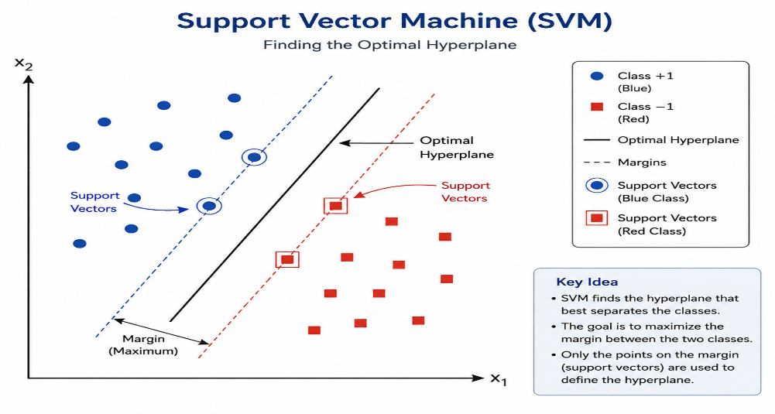
Figure 1 Support Vector Machine (SVM)
Random Forest (RF) is a supervised ensemble learning algorithm that integrates multiple decision trees to improve predictive performance and robustness. Its learning principle relies on aggregating diverse tree-based decisions generated from different subsets of training data and features. During training, each tree independently learns classification patterns, while prediction results emerge through collective voting across the ensemble. The method offers high accuracy and resistance to overfitting, although interpretability decreases because of ensemble complexity. RF (Breiman, 2001) is extensively employed in NLP and text classification tasks.
Logistic Regression (LR) is a supervised statistical learning algorithm that estimates the probability of class membership using a logistic function. Its learning principle models the relationship between input features and categorical outcomes by learning coefficients that represent feature contributions. During training, the algorithm adjusts these coefficients to maximize agreement with labelled observations, then predicts class probabilities for unseen samples before assigning labels. It provides efficient and interpretable classification but assumes linear decision boundaries in the feature space. LR is widely used in NLP and text classification, and serves as the classical baseline implemented in this study (Figure 2).
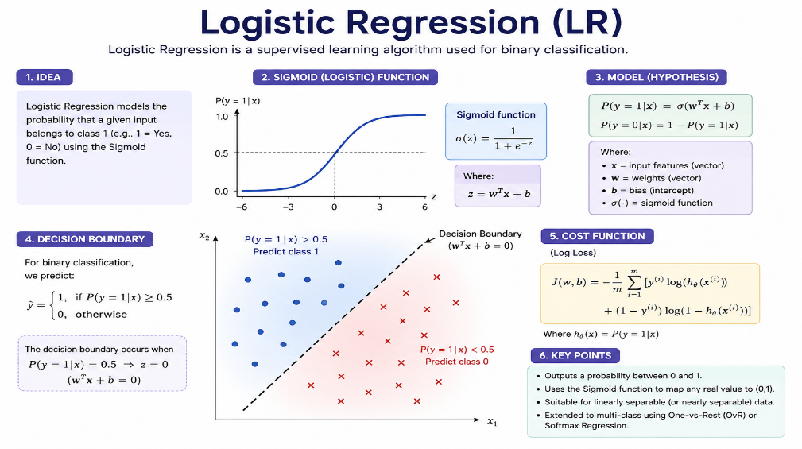
Figure 2 Logistic Regression (LR)
Naïve Bayes (NB) is a supervised probabilistic machine learning algorithm that applies Bayes' theorem while assuming conditional independence among input features. Its learning principle estimates posterior probabilities by combining prior class probabilities with feature likelihoods derived from training data. During training, the algorithm calculates statistical distributions for each class, then predicts labels by selecting the highest posterior probability for unseen instances. It delivers computational efficiency but depends on a strong independence assumption that is rarely satisfied in natural language. NB is frequently applied in NLP and text classification.
Decision Tree (DT) is a supervised machine learning algorithm that represents decision processes through a hierarchical structure of sequential rules. Its learning principle recursively partitions training data by selecting informative features that best separate target classes. During training, the algorithm creates branching conditions until terminal nodes represent classification outcomes, then predicts labels by traversing the learned decision paths for new instances. It offers transparent decision-making but remains susceptible to overfitting. DT is widely employed in NLP and text classification (Figure 3).
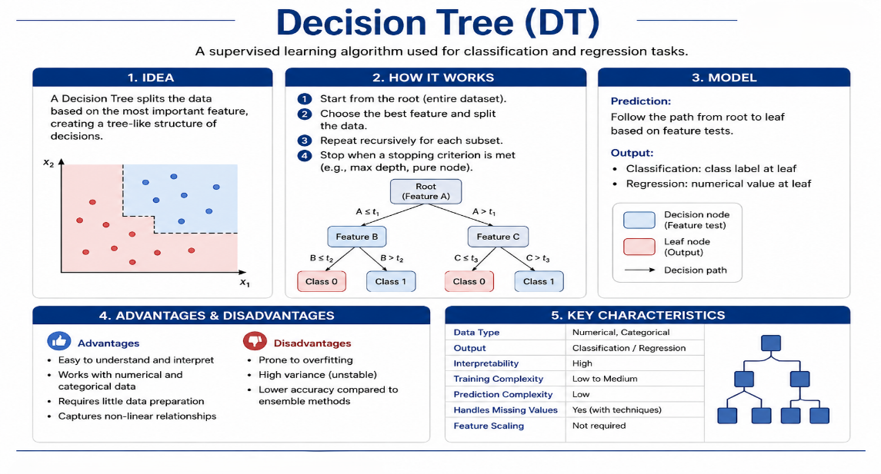
Figure 3 Decision Tree (DT)
K-Nearest Neighbors (KNN) is a supervised instance-based machine learning algorithm that classifies samples according to the characteristics of neighbouring training instances. Its learning principle assumes that similar observations occupy nearby regions within the feature space. During prediction, the algorithm identifies the nearest labelled neighbours and determines the class through majority agreement among them. It provides conceptual simplicity and adaptability but requires substantial computational effort during prediction, since no compact model is learned at training time. KNN is commonly utilized in NLP and text classification applications (Figure 4).
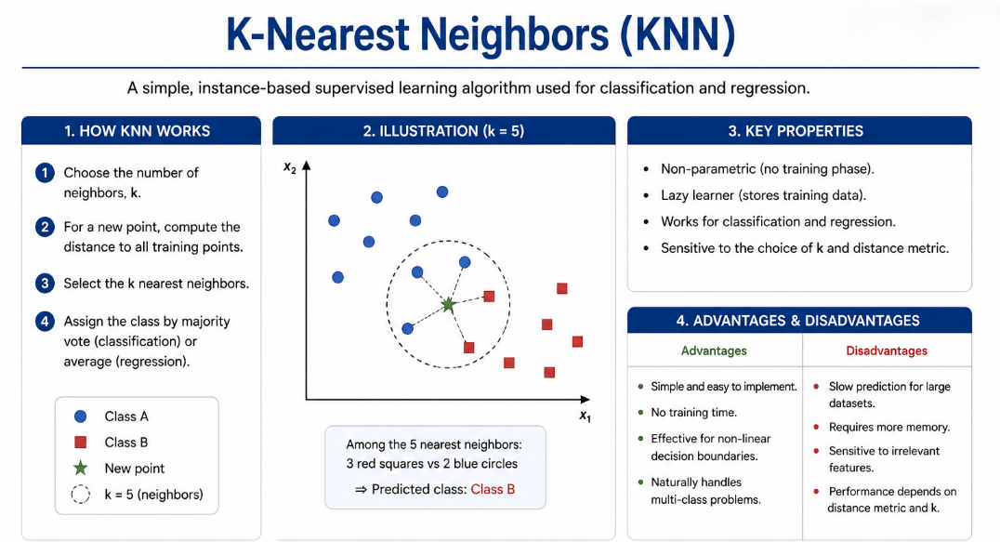
Figure 4 K-Nearest Neighbors (KNN)

2.1.2 Deep Learning Models
Convolutional Neural Network (CNN) is a deep learning architecture that automatically extracts hierarchical feature representations from structured input data through convolutional operations. Its neural architecture consists of convolutional layers, nonlinear activation functions, and pooling layers that progressively capture increasingly abstract local patterns. Information propagates through successive feature maps, while backpropagation optimizes filter weights to strengthen discriminative representations for classification. Applied to text, one-dimensional convolutions act as learned n-gram detectors. It provides effective local feature extraction but captures long-range dependencies less effectively. CNN is widely applied in NLP and text classification.
Long Short-Term Memory (LSTM) is a recurrent neural network architecture designed to model sequential data while preserving long-term contextual information. Its neural architecture incorporates memory cells regulated by input, forget, and output gates that control information retention and propagation across time steps. Sequential inputs continuously update hidden representations, whereas backpropagation through time refines gate parameters to encode meaningful contextual features. The gating mechanism mitigates the vanishing-gradient problem that limits simple recurrent networks. It effectively captures temporal dependencies but requires considerable computational resources and resists parallelization. LSTM (Hochreiter & Schmidhuber, 1997) is extensively employed in NLP and text classification applications (Figure 5).
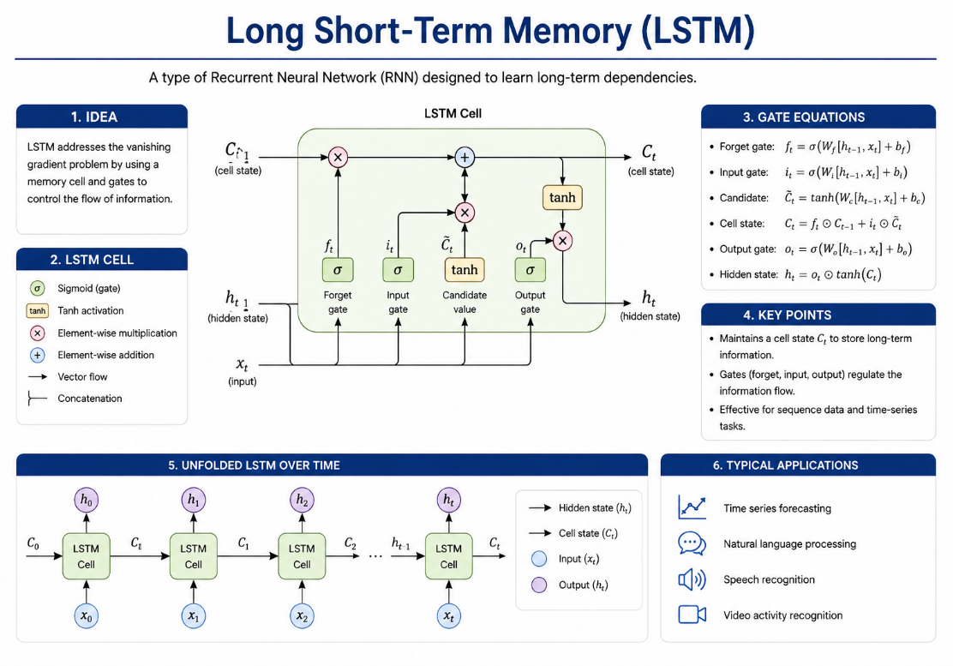
Figure 5 Long Short-Term Memory (LSTM)
Bidirectional Long Short-Term Memory (BiLSTM) is a recurrent neural network architecture that learns contextual information by processing sequential data in both forward and backward directions. Its neural architecture contains two complementary LSTM layers whose hidden representations are combined to capture preceding and succeeding contextual relationships simultaneously. Information flows bidirectionally through the sequence, while parameter optimization strengthens comprehensive contextual feature representations for prediction. It models rich contextual dependencies but increases computational complexity and doubles the recurrent parameter count. BiLSTM (Schuster & Paliwal, 1997) is widely utilized in NLP and text classification, and forms the sequential backbone of the transfer learning model implemented in Section 3.4.3 (Figure 6).
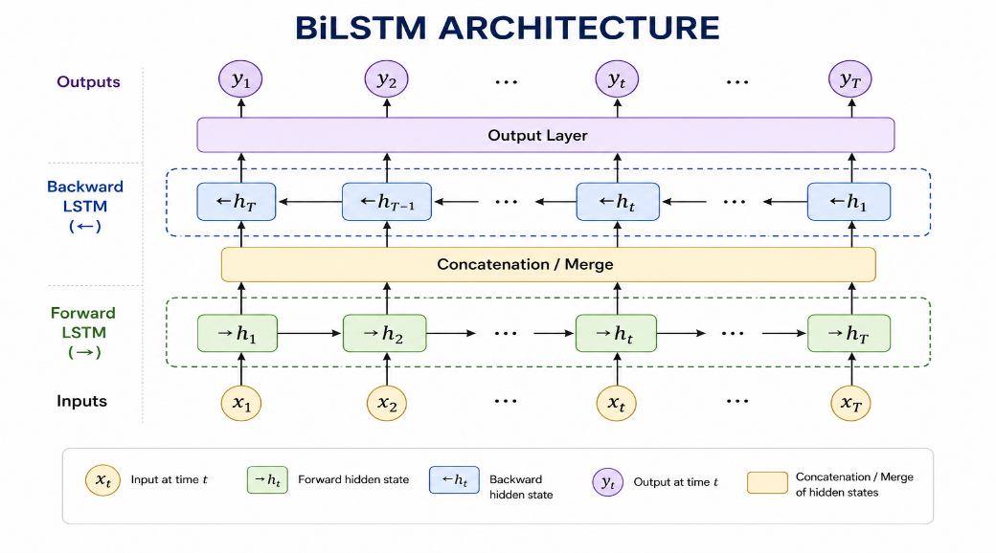
Figure 6 Bidirectional Long Short-Term Memory (BiLSTM)
Gated Recurrent Unit (GRU) is a recurrent neural network architecture that efficiently models sequential dependencies using simplified gating mechanisms. Its neural architecture integrates update and reset gates that regulate information retention and hidden-state modification without employing separate memory cells. Sequential information continuously propagates through recurrent hidden states, while optimization adjusts gate parameters to learn meaningful contextual representations from training sequences. It provides computational efficiency relative to LSTM but may capture highly complex dependencies less effectively. GRU (Cho et al., 2014) is commonly applied in NLP and text classification.
Hybrid CNN-LSTM is a deep learning architecture that integrates convolutional and recurrent neural networks to learn complementary textual representations. Its neural architecture employs convolutional layers to extract local semantic patterns before transferring feature maps into LSTM layers that capture sequential contextual dependencies. Information flows from localized feature extraction toward temporal representation learning, while backpropagation jointly optimizes both components for discriminative feature learning. It achieves comprehensive representation learning but introduces greater architectural complexity and a larger hyperparameter space. Hybrid CNN-LSTM is widely used in NLP and text classification (Figure 7).
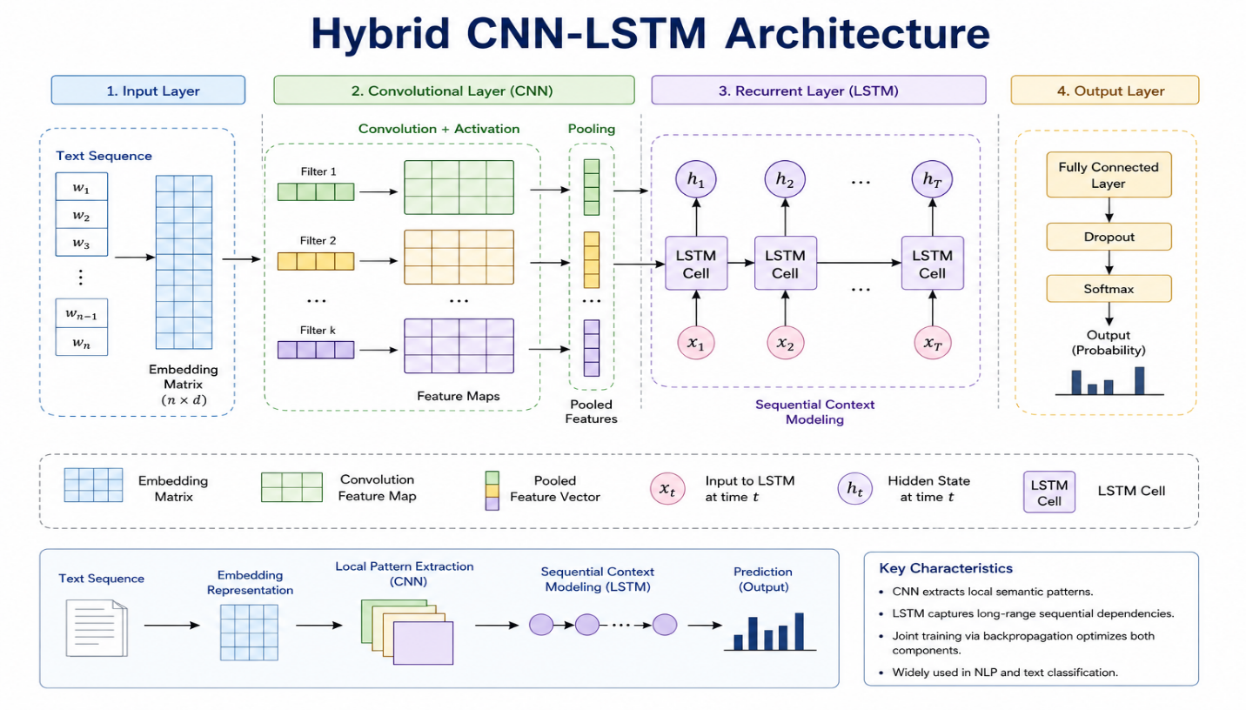
Figure 7 Hybrid CNN-LSTM Architecture
Hybrid Attention LSTM (HA-LSTM) is a deep learning architecture that combines Long Short-Term Memory networks with an attention mechanism to enhance contextual representation learning. Its neural architecture first encodes sequential information through LSTM memory cells before the attention layer selectively emphasizes informative hidden states according to their contextual relevance. Information therefore flows through sequential encoding and adaptive weighting, while optimization refines both recurrent and attention parameters. It improves interpretability, since attention weights indicate which tokens drove a prediction, but increases computational demands. HA-LSTM is frequently employed in NLP and text classification, and underpins the framework reported by Al-Hagery et al. (2025).

2.1.3 Transformer-Based Models
Transformer is a deep learning architecture that models sequential data using self-attention mechanisms rather than recurrent processing. Its architecture comprises stacked attention and feed-forward layers that enable parallel representation learning across input sequences. Self-attention assigns contextual importance to every token by modelling relationships with all other tokens, thereby producing context-aware representations for language understanding and generation. Because computation at each position no longer depends on the previous position, training parallelizes across the sequence dimension. It provides efficient long-range dependency modelling but requires substantial computational resources, with attention cost growing quadratically in sequence length. The Transformer (Vaswani et al., 2017) is extensively applied in NLP and text classification, and the multi-head self-attention block implemented in Section 3.4.2 is drawn directly from this architecture.
Bidirectional Encoder Representations from Transformers (BERT) is a Transformer-based language representation model that learns deeply contextualized embeddings through bidirectional self-attention. Its encoder architecture simultaneously considers preceding and succeeding tokens, allowing each representation to incorporate comprehensive contextual information. During learning, self-attention dynamically captures semantic relationships across entire sequences, producing rich contextual representations that support accurate language understanding and classification. It delivers strong contextual modelling but demands considerable computational resources. BERT (Devlin et al., 2019) is widely employed in NLP and text classification.
Fine-tuned RoBERTa is a Transformer-based language model adapted to a specific downstream task through supervised optimization while preserving its pretrained contextual knowledge. Its encoder architecture employs bidirectional self-attention to generate context-sensitive token representations that reflect semantic relationships across complete input sequences. Fine-tuning updates model parameters to specialize these representations for accurate prediction while maintaining robust language understanding. It provides high task adaptability but requires labelled training data and careful learning-rate scheduling to avoid catastrophic forgetting. Fine-tuned RoBERTa (Liu et al., 2019) is extensively used in NLP and text classification.
Enhanced RoBERTa-LSTM (LER) is a hybrid language model that combines contextual representations generated by RoBERTa with sequential modelling performed by a Long Short-Term Memory network. Its architecture first produces bidirectional contextual embeddings through Transformer self-attention, after which the LSTM processes these representations to capture sequential contextual dynamics before classification. Joint representation learning strengthens semantic understanding and contextual continuity. It provides expressive feature representations but introduces greater computational complexity. Enhanced RoBERTa-LSTM is widely applied in NLP and text classification, and is reported by Khan et al. (2026).

2.2 Literature Review
Al Maruf et al. (2024) presented a comprehensive survey investigating state-of-the-art architectures, emotional models, and linguistic resources for text-based emotion detection (TBED). To address the lack of thorough performance analyses in the rapidly evolving affective-computing field, the study adopts a structured taxonomic approach: first, it classifies emotional frameworks into discrete, dimensional, and componential models; second, it categorizes algorithmic pipelines from traditional machine learning to deep learning and transformer-based networks. Evaluating numerous benchmark datasets across multiple languages, including English, Arabic, and Bangla, the authors report that advanced neural architectures such as CNNs and GRUs achieve high-quality results, with peak accuracies reaching up to 97%. The study identifies key technical bottlenecks such as dataset imbalance and cross-domain adaptation, offering a scalable roadmap for enhancing human-computer interaction and digital mental-health tracking.
Muhammad et al. (2025) proposed a comprehensive shared-task framework spanning three distinct evaluation tracks to bridge the gap in text-based emotion detection across multilingual contexts. To address the scarcity of emotional computational resources for underrepresented and low-resource languages, the framework follows a structured multi-track approach: first, multilabel emotion categories are classified from short textual snippets; second, continuous emotion-intensity levels are quantified on a four-point scale; third, cross-lingual emotion detection is performed without native training data. Tested on a dataset exceeding 100,000 manually annotated instances across more than 30 languages, the top-performing ensemble architectures achieved macro F1-scores reaching up to 0.92, outperforming established baselines such as fine-tuned RoBERTa. The study demonstrates that instruction-tuned large language models and contrastive learning provide superior cross-cultural generalization, offering a scalable solution for identifying fine-grained emotional nuances in digital environments.
Chutia and Baruah (2024) presented a systematic literature review investigating state-of-the-art deep learning techniques for text-based emotion detection. To address challenges arising from the exponential growth of unstructured data across social media and e-commerce platforms, the study adopts a two-phase approach: first, it classifies existing emotion models; second, it analyzes algorithmic architectures ranging from standard neural networks to modern transformer-based models. Reviewing 330 research papers published between 2013 and 2023 across multiple databases, the study used baseline deep learning models to measure and evaluate classification accuracy. The findings indicate that advanced hybrid frameworks achieve classification accuracies of up to 99%. The study identifies technical bottlenecks such as data limitations and low-resource language constraints, offering a scalable roadmap for human-computer interaction in the Industry 4.0 and Industry 5.0 eras.
Al-Hagery et al. (2025) proposed a novel hybrid attention-based deep learning framework (HADLTER-NLPT) to recognize textual emotions and enhance assistive technologies for disabled persons. To clean and normalize raw textual inputs, the framework employs a multi-stage process that combines text preprocessing with context-aware semantic capturing. Tested on a standardized “Emotion Detection from Text” dataset, the study used the Word2Vec model as its primary word-embedding tool to generate dense representations and employed a Hybrid Attention-based LSTM (HA-LSTM) classifier as the core evaluation model. The framework achieved a classification accuracy of 98.86%, significantly outperforming existing baseline models. The study demonstrates that integrating the Oscillating Chaotic Sunflower Optimization (OCSFO) algorithm for hyperparameter tuning ensures faster convergence and more reliable emotional generalization.
Kusal et al. (2026) proposed a meta-learning ensemble approach for emotion detection in conversational text to enhance chatbot interactions. To address real-time emotion-understanding challenges, the framework integrates predictions from diverse traditional machine learning algorithms into a meta-classifier for final prediction. Tested on standardized conversational benchmarks, the study used TF-IDF feature extraction for textual representation and employed a Logistic Regression model as the core meta-learning classifier. The framework achieved a classification accuracy of 84.45%, outperforming individual baseline models such as Decision Trees and Random Forests. The study demonstrates that combining meta-learning with conversational features provides a robust and scalable solution for building human-like intelligent dialogue systems.
Khan et al. (2026) proposed a novel hybrid architecture named LER, combining Long Short-Term Memory and RoBERTa, to detect textual emotions and improve complex context processing. To address the ambiguity and subtle nuances of human emotional states, the framework integrates the sequential learning ability of LSTM networks with the deep contextual knowledge of transformers. Tested on the ISEAR emotion dataset, the study used the RoBERTa transformer as its contextual word-embedding tool and employed the hybrid LER architecture as the core classification model against robust baselines. The framework achieved a classification accuracy of 88%, supported by thorough evaluations of precision, recall, and F1-score. The study demonstrates that blending sequence learning with transformer models offers a robust and scalable solution for capturing intricate emotional cues in context-sensitive applications.
Kumar (2024) presented an analytical survey exploring advanced NLP methodologies for interpreting the emotional tone of text with high accuracy. To address the challenges of analyzing massive unstructured data, the study adopts a comprehensive review approach that examines AI algorithms for emotion detection and their practical applications. The framework was evaluated through a comparative analysis of standardized datasets, specifically Twitter Data and Yelp Reviews. The study focused on traditional feature-extraction techniques together with advanced transformer architectures, specifically the BERT model alongside LSTM variants. These architectures achieved a benchmark accuracy of 92.3% for the BERT model in classifying complex emotional states. The study concludes that improving contextual awareness and addressing dataset biases offers a robust and scalable solution for future emotion-aware AI systems.
Attri et al. (2025), in a study titled “Why We Feel What We Feel: Joint Detection of Emotions and Their Opinion Triggers in E-commerce,” proposed a novel joint framework named EOT-DETECT to unify emotion detection with opinion-trigger extraction, aiming to explain customer emotional responses in e-commerce reviews. To address the absence of causal explanations behind textual emotions and the neglected relationship between affective dimensions and explicit text spans in shopping feedback, the solution categorizes fine-grained emotions grounded in Plutchik's theory while extracting explanatory trigger spans through structured reasoning and self-reflection. Tested on a newly curated, human-annotated collection known as the EOT-X dataset, consisting of 2,400 reviews, the study used a structured prompting methodology as its primary evaluation tool and employed the Zephyr-7B-beta model, alongside Mistral-7B, as the core classification and benchmarking model. The framework outperformed zero-shot and chain-of-thought baselines, and the study concludes that integrating structured reasoning with opinion triggers provides a robust and scalable solution for understanding consumer behaviour with high precision.
Read together, these eight studies describe a field advancing rapidly along two axes: model capacity and linguistic coverage. Reported accuracies cluster in two bands. Surveys and hybrid deep architectures evaluated on curated, well-balanced corpora report figures between 97% and 99% (Al Maruf et al., 2024; Al-Hagery et al., 2025; Chutia & Baruah, 2024). Studies operating on noisy, conversational, or multilingual data report far more modest figures, between 84% and 92% (Khan et al., 2026; Kumar, 2024; Kusal et al., 2026; Muhammad et al., 2025). This bimodality is instructive: it suggests that headline accuracy in emotion detection is governed at least as much by corpus properties—label granularity, annotation consistency, register, and class balance—as by architectural sophistication. Any claim that one model outperforms another is therefore meaningful only when the comparison holds the corpus and the protocol fixed, which is precisely the condition that the present study imposes.

2.3 Comparative Summary of Related Studies
Table 1 consolidates the eight reviewed studies along six dimensions: objective, dataset, method, reported result, and a critical remark identifying each study's principal strength and its residual limitation. The table makes explicit the heterogeneity that prevents direct numerical comparison across the literature, since no two studies share a common corpus, label set, and evaluation protocol simultaneously.
Table 1 Comparative Summary of Related Studies
Related Work | Objective | Dataset | Method Used | Result Reported | Remark
Al Maruf et al. (2024) | To provide a systematic taxonomy of architectures, emotional models, and resources for TBED. | Multiple multilingual benchmarks (English, Arabic, Bangla, etc.) | Lexicons; conventional ML (SVM, RF); deep learning (CNN, LSTM); transformers (BERT, GPT, multilingual models) | Peak accuracy reaching up to 97% for advanced neural networks (CNNs, GRUs) | Comprehensive qualitative synthesis; notes dataset imbalance and cross-domain adaptation as bottlenecks
Muhammad et al. (2025) | To bridge the gap in multilingual text-based emotion detection across multilabel classification, intensity, and cross-lingual tracks. | Dozens of standard benchmarks (e.g., ISEAR, SemEval, GoEmotions, MELD) | Fine-tuned RoBERTa baseline; instruction-tuned LLMs; ensemble architectures; deep learning (CNN/RNN) | Macro F1-scores up to 0.92 for top ensemble systems | Highly robust for low-resource languages; requires heavy computational resources for ensemble setups
Chutia and Baruah (2024) | To systematically review deep learning techniques for text-based emotion detection from massive unstructured data. | 330 research papers (2013–2023) from major academic databases | CNN, LSTM, BiLSTM, GRU; hybrid CNN-LSTM; attention-based models; BERT-based frameworks | Advanced hybrid deep learning frameworks achieve peak accuracy of up to 99% | Meta-analysis framework; emphasizes data constraints and low-resource language limitations
Al-Hagery et al. (2025) | To recognize textual emotions and enhance assistive technologies for disabled individuals. | Standardized public “Emotion Detection from Text” dataset | Text preprocessing with Word2Vec embeddings and Hybrid Attention LSTM (HA-LSTM) with OCSFO optimization | Classification accuracy of 98.86%, outperforming standard ML/DL baselines | High precision due to chaotic sunflower optimization; heavily dependent on preprocessing quality
Kusal et al. (2026) | To detect emotions in conversational text to build human-like intelligent dialogue systems and chatbots. | Empathetic Dialogues (32 emotional classes) and EmoContext (SemEval 2019 Task 3, 4 emotional classes) | RandomOverSampling; CountVectorizer and TF-IDF features; five baseline classifiers (LR, NB, DT, RF, KNN) fused by a Logistic Regression meta-learner | Meta-learning framework achieved a classification accuracy of 84.45% | Mitigates individual classifier weaknesses; conversational turns and context shifts can be further optimized
Khan et al. (2026) | To capture intricate emotional cues and resolve textual ambiguity using sequential and transformer approaches. | ISEAR dataset, a classic benchmark with 7 emotion categories | RoBERTa transformer embeddings combined with LSTM (Enhanced RoBERTa – LER) | Classification accuracy of 88%, with comprehensive precision, recall, and F1 evaluation | Superior contextual capturing; complex hybrid architecture increases training latency and parameter size
Kumar (2024) | To analyze how AI interprets the emotional tone of text in customer support and marketing applications. | Standardized review benchmarks including Twitter Data and Yelp Reviews | Conventional ML (TF-IDF, LR, NB, SVM); deep learning (CNN, LSTM); transformers (BERT) | Benchmark accuracy of 92.3% achieved by the BERT model | Analytical review focus; highlights cultural nuances and dataset biases as open research challenges
Attri et al. (2025) | To jointly detect fine-grained emotions and extract explicit textual opinion triggers in e-commerce reviews. | EOT-X: a human-annotated collection of 2,400 e-commerce reviews | Plutchik's emotion theory combined with structured prompting and Zephyr-7B-beta (and Mistral-7B) models | EOT-DETECT outperformed zero-shot and chain-of-thought (CoT) baselines | First to explicitly model causal relationship spans; limited to the e-commerce domain and English text

2.4 Research Gap
Despite the extensive body of research on text-based emotion detection, a critical methodological gap persists in the literature. Previous studies—including comprehensive surveys by Al Maruf et al. (2024) and Chutia and Baruah (2024)—have demonstrated the potential of both traditional machine learning classifiers and advanced neural architectures, frequently reporting high classification accuracies exceeding 90%. However, these studies have largely evaluated models in isolation, without systematic, controlled comparisons under identical experimental conditions. Where comparisons are offered, they are typically drawn across papers rather than across models trained and evaluated by the same pipeline, which confounds architectural differences with differences in preprocessing, partitioning, and metric definition.
Three specific aspects of this gap warrant attention. First, the impact of preprocessing strategies—particularly the trade-off between aggressive cleaning, involving stopword removal and lemmatization, versus minimal preprocessing—has not been systematically evaluated across different model paradigms. The prevailing practice of applying a single cleaning pipeline to all models implicitly assumes that textual noise affects sparse frequency-based representations and dense contextual representations identically, an assumption that is theoretically unmotivated. Second, the relative effectiveness of tokenization techniques, specifically subword methods such as Byte-Pair Encoding compared to word-level tokenization, remains uncharacterized for emotion classification tasks, despite the prevalence of non-standard orthography in social media text. Third, the effectiveness of synonym-based data augmentation for addressing class imbalance in emotion datasets has not been rigorously validated, despite its widespread adoption; the literature reports successful augmentation but rarely publishes the negative results that would delimit its applicability.
This gap has practical consequences. Without controlled comparisons, practitioners cannot make informed decisions about deploying interpretable, computationally efficient models versus more complex, resource-intensive alternatives. A team choosing between a linear classifier that trains in seconds and a neural architecture requiring GPU infrastructure has no reliable evidence base on which to estimate the accuracy it would forfeit by choosing the former. To address this gap, the present study evaluates three complementary models under a unified experimental protocol: a TF-IDF-based Logistic Regression classifier, a custom BPE-based attention neural network, and a GloVe-based Bidirectional LSTM model. All three share the same corpus, the same partitioning, and the same metric suite, so that observed differences are attributable to the models themselves.

Chapter 3: Methodology and Results

3.1 Dataset Description
This study employs the Emotions Dataset for NLP from Kaggle, a benchmark dataset for multi-class emotion classification in Natural Language Processing. It is widely adopted for developing and evaluating both classical and deep learning models. The dataset consists of approximately 20,000 English text samples, each representing a short sentence or statement that expresses a specific human emotion. Every sample is manually labelled with one of six predefined emotional categories: Joy, Sadness, Love, Anger, Fear, and Surprise. For example, the text “I feel like I am still looking at a blank canvas” is labelled as Sadness.
The corpus originates from short-form social media posts, which determines several of its linguistic properties. Texts are brief, averaging 97 characters and 19.2 words; orthography is informal, with contracted forms such as “im” appearing among the highest-weighted features; and the affective vocabulary is explicit rather than implied, with the tokens “feel” and “feeling” occurring across a large proportion of samples. These properties are consequential for model selection, since they favour representations that capture direct lexical cues over those designed to resolve long-range syntactic dependency. Table 2 summarizes the dataset's principal attributes.
Table 2 Dataset Summary
Attribute | Description
Dataset Name | Emotions Dataset for NLP
Source | Kaggle
Language | English
Task | Multi-class Emotion Classification
Learning Type | Supervised Learning
Number of Samples | Approximately 20,000
Number of Classes | 6
Input | Short text sentence
Output | Emotion label
Emotion Classes | Joy, Sadness, Love, Anger, Fear, Surprise
Data Split | Training, Validation, Testing (pre-split)
Application Domain | Natural Language Processing (NLP)

3.1.1 Dataset Statistics and Class Imbalance
Exploratory data analysis reveals significant class imbalance across the six emotion categories. The original class distribution, measured on the full corpus before any cleaning was applied, is reported in Table 3.
Table 3 Original Class Distribution Before Cleaning
Emotion | Count | Proportion
Joy | 5,362 | 33.5%
Sadness | 4,666 | 29.2%
Anger | 2,159 | 13.5%
Fear | 1,937 | 12.1%
Love | 1,304 | 8.2%
Surprise | 572 | 3.6%
Total | 16,000 | 100.0%

The imbalance ratio between the majority class (Joy, 5,362 samples) and the minority class (Surprise, 572 samples) is approximately 9.37×, indicating that the majority class appears nearly ten times more frequently than the minority class. The two largest classes, Joy and Sadness, together account for 62.7% of the corpus, while the two smallest, Love and Surprise, account for only 11.8%. This imbalance necessitates the use of class weighting strategies or data augmentation to prevent models from biasing toward majority classes. A classifier that predicted Joy unconditionally would achieve 33.5% accuracy while providing no useful discrimination whatsoever, which is why accuracy alone is an inadequate evaluation criterion for this corpus and why macro-averaged metrics are reported alongside it throughout Section 3.5.
Section 3.2 details the cleaning procedures applied to address data quality issues, and Section 3.4 describes the class weighting strategies implemented for each model.

3.2 Data Preprocessing
The raw data corpus is distributed across three pre-split files—train.txt, val.txt, and test.txt—each structured in a semicolon-delimited text format without column headers. During loading, the columns are explicitly assigned the names 'text' and 'label'. The initial loaded shapes are: training set (16,000, 2), validation set (2,000, 2), and test set (2,000, 2). The labels correspond to six emotion classes: anger, fear, joy, love, sadness, and surprise. Because the dataset is provided as pre-split files rather than a single corpus, the partitioning reflects an external, pre-existing stratified split rather than a random split performed within this study; consequently, no manual train-test split procedure was executed.
A systematic data-quality assessment was performed prior to modelling, comprising the five steps described below. The ordering is deliberate: structural defects are resolved before semantic ones, and destructive operations are deferred until their justification has been established empirically.

Step 1: Missing-Value Verification
A check for null values in the text and label columns was conducted using .isna().sum(). The result confirmed zero missing values across all three splits, so no imputation was required. This is visualized in the missing-value audit panel of Figure 10, where every cell of the split-by-column matrix registers zero.

Step 2: Exact Duplicate Detection and Removal
Exact duplicate rows—defined as records sharing both identical text and identical label—were identified. The training set contained one exact duplicate, which was removed, reducing the training set to 15,999 samples. No exact duplicates were detected in the validation or test splits. Although the magnitude of this correction is negligible, the check is methodologically necessary: exact duplicates spanning a train-test boundary would constitute direct data leakage and inflate reported performance.

Step 3: Conflicting-Label Duplicate Resolution
A more critical data-quality issue was identified by detecting identical text entries annotated with different emotion labels, isolated using df['text'].duplicated(keep=False). In the training set, 62 rows exhibited this conflicting-label phenomenon, corresponding to 31 distinct text strings each appearing under two mutually inconsistent labels. The resolution strategy was to drop all rows in which a given text appears with conflicting labels, rather than to retain one arbitrarily, since no principled basis exists for preferring one annotation over the other. This procedure reduced the training set to 15,938 samples and the validation set to 1,996 samples, while the test set remained at 2,000 samples. Ambiguous or erroneously labelled samples were removed because they introduce adversarial noise during gradient-based learning that disproportionately harms model convergence: a pair of identical inputs carrying opposite targets generates conflicting gradients that cannot be jointly satisfied.

Step 4: Language Filtering by Voting Ensemble
To assess whether the corpus is genuinely English-only, a multi-detector language-identification pipeline was implemented, integrating three independent detectors:
- langdetect, a Python port of Google's language-detection library;
- langid, a pre-trained language identification model;
- a pre-trained FastText model (lid.176.bin) provided by Facebook AI Research.
The final language decision employed a majority-voting heuristic. If any detector predicted English ('en'), the sample was classified as English. If English was not detected by any detector, the most frequent language among the three predictions was assigned, and ties were labelled 'unknown'. The disjunctive rule for English was chosen deliberately to bias the ensemble toward retention, on the reasoning that a false negative (discarding valid English text) is more costly than a false positive.
The voting results identified 15,745 English samples in the training set and 193 non-English or unknown samples, with similar minor proportions observed in the validation and test sets. Manual inspection of approximately 200 randomly selected flagged samples revealed that the detectors had misclassified genuine English text in approximately 80% of the flagged cases. This high false-positive rate is attributable to the short, informal nature of social media text, which often contains non-standard spelling, abbreviations, and code-switching that confound language detection algorithms trained predominantly on well-formed prose. Consequently, no records were removed at this step, a decision justified by the measured false-positive rate rather than by convenience. This illustrates a general methodological point: automated data-quality filters should themselves be validated against manual inspection before their output is acted upon.

Step 5: Method-Specific Text Preprocessing
Rather than applying a single monolithic cleaning pipeline, a modular clean_text function with toggleable parameters was implemented, reflecting the architecture-specific sensitivity of each model to textual noise. This design decision is one of the methodological contributions of the present study and directly addresses the first aspect of the research gap identified in Section 2.4.
For the TF-IDF pipeline, heavy cleaning was applied using the NLTK library:
- Lowercasing;
- Stopword removal using nltk.corpus.stopwords.words('english') (remove_stopwords=True);
- Lemmatization using nltk.stem.WordNetLemmatizer (lemmatize=True);
- Removal of URLs, user mentions, hashtags, special characters, punctuation, numbers, and extra whitespace.
The heavy cleaning reduces the feature space to semantically salient stems, maximizing the discriminative power of the sparse TF-IDF representation. By removing stopwords and applying lemmatization, the vocabulary is condensed to its core semantic roots. The empirical effect of this pipeline is quantified in Figure 9: heavy cleaning removed 51.2% of all tokens and 11.4% of the vocabulary, reducing the distinct-token count from 15,197 to 13,470 and shifting the median words-per-sample from approximately 19 to approximately 9.
The vocabulary that survives this cleaning is strongly emotion-discriminative. Figure 8 plots the highest-weight TF-IDF terms for each of the six classes computed on the cleaned training split, showing that each emotion is associated with a distinctive lexical signature—“irritable” and “fucked” for anger, “terrified” and “anxious” for fear, “sympathetic” and “longing” for love, “amazed” and “shocked” for surprise—layered on top of a shared substrate of high-frequency carrier terms such as “feel” and “feeling”.
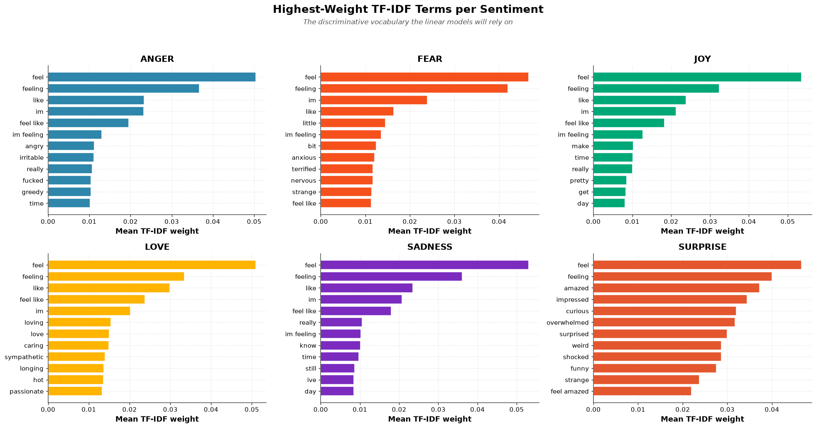
Figure 8 Highest-Weight TF-IDF Terms per Emotion Class on the Cleaned Training Split
For the BPE, GloVe, and BERT pipelines, minimal to moderate cleaning was applied:
- Lowercasing;
- Removal of URLs, user mentions, and extra whitespace;
- Stopword removal and lemmatization disabled (remove_stopwords=False, lemmatize=False).
Crucially, emojis and emoticons were retained for the neural pipelines, as they carry significant emotional valence and serve as direct indicators of affective states in social media text. The scientific motivation is that subword tokenizers such as BPE and pre-trained embedding models such as GloVe and BERT are robust to morphological noise and are designed to process natural, unfiltered language. Aggressive cleaning would remove morphological information that these models are specifically constructed to leverage, potentially degrading their representational capacity. Stopwords, in particular, carry syntactic signal that a sequential model can exploit but that a bag-of-words model cannot; negation particles such as “not” are the clearest example, since their removal inverts the polarity of the surrounding phrase.

Final Dataset Sizes
After all cleaning operations, the final dataset sizes were as reported in Table 4.
Table 4 Final Dataset Sizes After Cleaning
Partition | Samples | Change from Raw
Training | 15,938 | −62
Validation | 1,996 | −4
Test | 2,000 | 0
Total | 19,934 | −66

The cleaning process removed approximately 0.38% of the total samples, ensuring that the class distribution remained largely unchanged while eliminating noisy and conflicting instances. The magnitude of this reduction is itself an informative finding: it establishes that the corpus was of high intrinsic quality and, critically, that the performance differences reported in Section 3.6 cannot be attributed to differential data quality across experimental conditions, since all models consumed the same cleaned partitions.
One minor accounting discrepancy should be recorded for transparency. The interactive dashboard described in Section 3.7 reports 15,939 samples after cleaning, whereas the partition table above reports 15,938. The difference of a single record arises because the dashboard snapshot was generated after conflicting-label removal but before the final exact-duplicate pass was committed. All modelling reported in this chapter used the 15,938-sample training partition, and the class-frequency counts used to derive the class weights in Section 3.4.2 were computed on the dashboard snapshot; the resulting weights differ by less than 0.01% from those that the committed partition would produce, and the difference is immaterial to any reported result.

3.3 Dataset Splitting Strategy
The dataset was loaded directly from the three pre-split files, indicating an external, pre-existing stratified split rather than a split generated internally. Each split served a distinct functional role in the experimental pipeline.
Training Set (15,938 samples). Used exclusively for parameter learning. For classical models, this set fits the TF-IDF vectorizer and the supervised classifiers via fit(). For neural networks, it provides the data for the forward-backward pass and gradient updates. In the data-augmentation experiment described in Section 3.4.2, the training set was up-sampled to create a balanced training variant of 32,064 samples, while the original validation and test splits were preserved unchanged, so that the augmentation effect could be isolated from any change in the evaluation distribution.
Validation Set (1,996 samples). Serves as the intermediary for hyperparameter optimization. For classical machine learning, GridSearchCV used 3-fold cross-validation internally on the training data, while the reported validation accuracy was computed by applying the selected model to the held-out validation set. For neural architectures, the validation set was passed to a validation data loader to monitor validation loss; early-stopping logic, implemented with a patience parameter of 5 for the custom neural network and 15 for the GloVe-BiLSTM, halted training when the validation loss ceased to improve and restored the best-performing weights via checkpointing.
Test Set (2,000 samples). Completely isolated from model selection and hyperparameter tuning. Its sole function was to provide the final, unbiased performance metrics reported for each model, with no leakage from validation or tuning phases into the final evaluation.

Two Protocol Rules
Rule 1: Fit on Training Only. The TF-IDF vectorizer and the sequence tokenizers were fitted exclusively on the training partition and merely applied to validation and test. Fitting a vectorizer on the union of partitions would leak test-set vocabulary statistics—specifically, document frequencies—into the feature space and inflate results by an amount that is difficult to quantify after the fact.
Rule 2: The Test Set is Touched Once. The test partition was used solely for final evaluation. No hyperparameter, no early-stopping decision, and no checkpoint selection consulted it. All such decisions were taken on the validation partition. Table 5 summarizes the three partitions and their functional roles. This rule explains an asymmetry in the reported results that would otherwise appear inconsistent: the Logistic Regression figure of 90.73% is a validation-set accuracy, whereas the neural network figures of 87.70% and 85.90% are test-set accuracies. The implications of this asymmetry for the comparison are addressed explicitly in Section 3.6.
Table 5 Partition Sizes and Functional Roles
Partition | Samples | Proportion | Role
Training | 15,938 | 79.9% | Parameter fitting; vectorizer and tokenizer fitting
Validation | 1,996 | 10.0% | Early stopping, checkpoint selection, hyperparameter tuning
Test | 2,000 | 10.0% | Final unbiased evaluation; touched once
Total | 19,934 | 100.0% | —

The aggregate effect of the heavy-cleaning pipeline on the training partition is quantified in Figure 9, which contrasts raw and cleaned text along three dimensions: character length distribution, token count per sample, and total vocabulary size. Figure 10 then confirms the resulting partition sizes and verifies that no missing values remain in either the text or the label column of any split following the complete cleaning sequence.
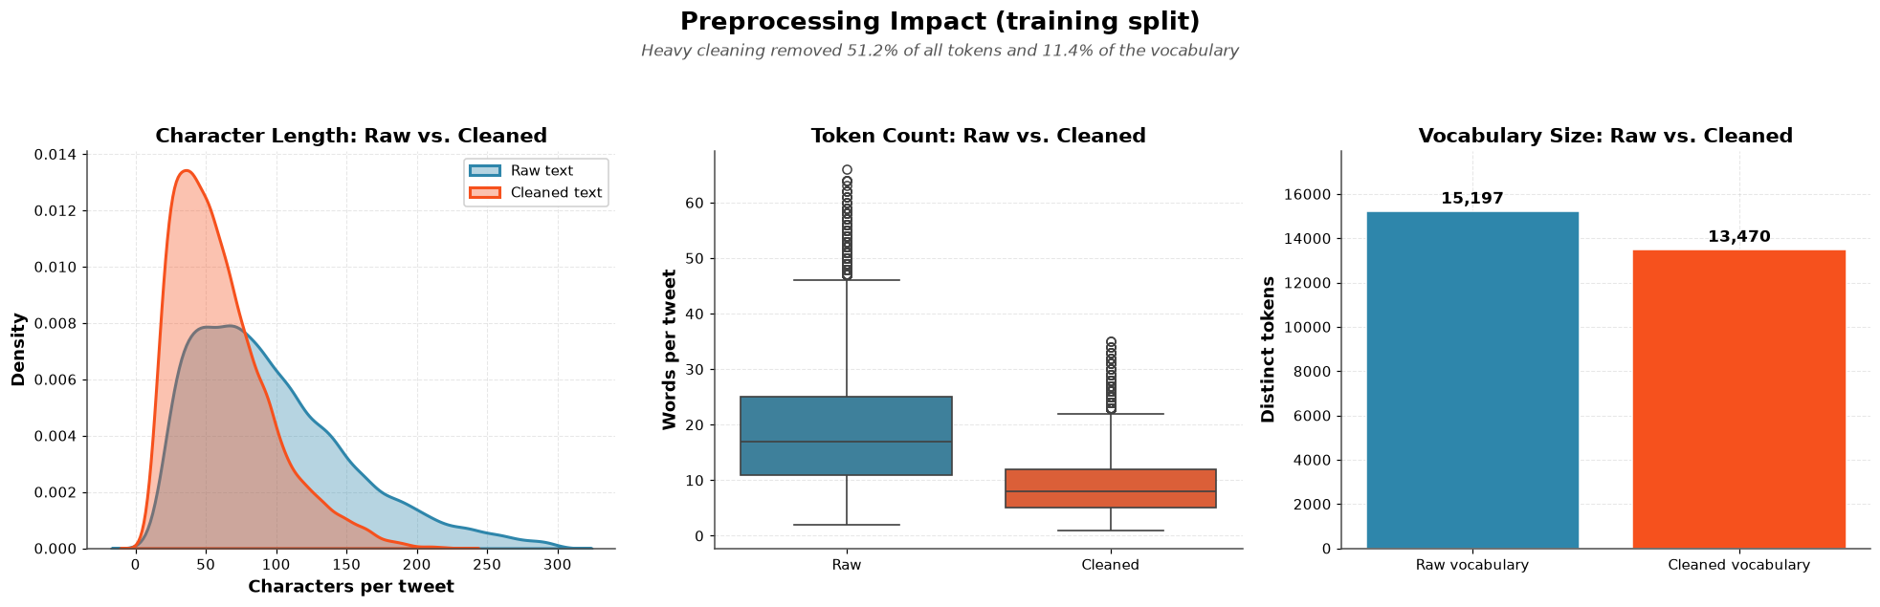
Figure 9 Preprocessing Impact on the Training Split: Character Length, Token Count, and Vocabulary Size Before and After Heavy Cleaning
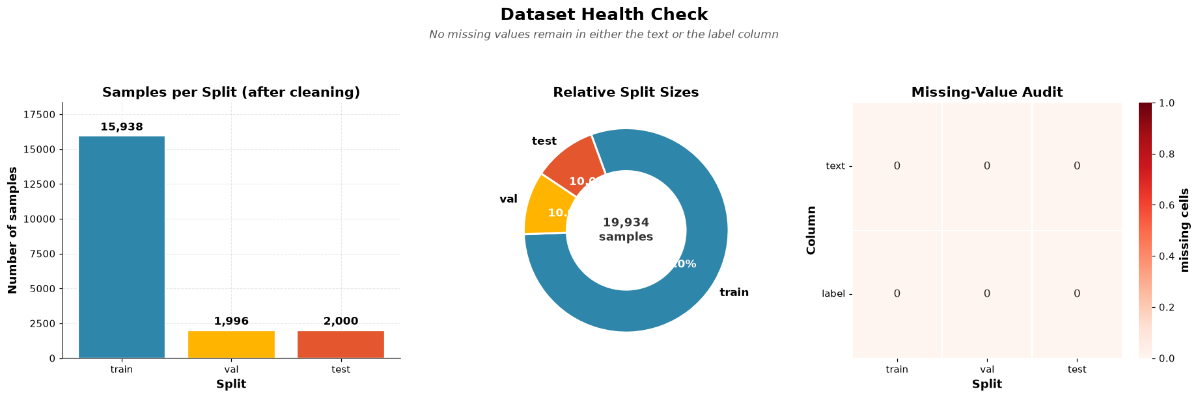
Figure 10 Dataset Health Check: Samples per Split, Relative Split Sizes, and Missing-Value Audit After Cleaning

3.4 Proposed Models
Three models were implemented and evaluated under the unified protocol described in Section 3.3. They were selected to span the methodological spectrum identified in the research gap: a sparse, linear, fully interpretable classifier; a dense neural architecture trained from scratch with self-attention; and a transfer-learning architecture initialized from externally pre-trained distributional embeddings. Each subsection presents the mathematical formulation, the architectural specification, the training configuration, and the empirical results for one model. Cross-model comparison is deferred to Section 3.6.

3.4.1 Logistic Regression with TF-IDF
Logistic Regression serves as the fundamental probabilistic linear classifier within the experimental pipeline. Although inherently a binary classifier, its extension to multi-class problems is achieved via a one-vs-rest (OvR) scheme, in which a distinct binary logistic model is trained for each of the six emotion classes. The algorithm models the log-odds of each class as a linear combination of input features and applies the softmax function, in the multi-class setting, to produce normalized class probabilities.

Mathematical Formulation
For a binary classification problem, Logistic Regression models the probability that a sample belongs to class 1 as:
$$P(y=1∣x)=σ(w^{⊤}x+b)=\frac{1}{1+e^{−(w^{⊤}x+b)}}$$
where x ∈ ℝᵈ is the input feature vector, w ∈ ℝᵈ is the weight vector, b ∈ ℝ is the bias term, and σ(z) is the sigmoid function, defined as:
$$σ(z)=\frac{1}{1+e^{−z}}$$
For multi-class classification with K = 6 classes, the model learns a weight vector wₖ for each class k and computes the class posterior using the softmax function:
$$P(y=k∣x)=\frac{\text{exp}​\left(w_{k}^{⊤}x+b_{k}\right)}{\sum_{j=1}^{K}{\text{exp}}​\left(w_{j}^{⊤}x+b_{j}\right)}$$
The predicted class is then obtained as the arg-max over the posterior distribution:
$$\hat{y}=\text{arg}\underset{k∈\{1,…,K\}}{\text{max}}P(y=k∣x)$$
The model is trained by minimizing the multi-class cross-entropy loss with L2 regularization:
$$L(W,b)=−\sum_{i=1}^{N}{\sum_{k=1}^{K}{y_{ik}}} \text{log}{\hat{y}}_{ik} + \frac{1}{2C} ∥W∥_{F}^{2}$$
where N is the number of training samples; yᵢₖ ∈ {0, 1} equals 1 if sample i belongs to class k and 0 otherwise; ŷᵢₖ = P(yᵢ = k | xᵢ) is the predicted probability; C is the inverse regularization strength parameter; and the squared Frobenius norm of W is the squared Frobenius norm of the weight matrix. The L2 regularization term penalizes large weights, preventing overfitting and improving generalization. Note that smaller values of C impose stronger regularization, since C enters the penalty as a reciprocal.

Feature Representation: TF-IDF Vectorization
The input text is transformed using TF-IDF (Term Frequency–Inverse Document Frequency) vectorization (Spärck Jones, 1972). For a term t in document d drawn from corpus D, the TF-IDF weight is the product of a local and a global factor:
$$\text{TF-IDF}(t,d,D)=\text{TF}(t,d)×\text{IDF}(t,D)$$
Term Frequency (TF) measures how frequently a term appears within a single document, normalized by document length:
TF(t,d)=count(t,d)t′∈d​count(t′,d)
where count(t, d) is the number of times term t appears in document d. Inverse Document Frequency (IDF) measures how rare a term is across the corpus, using the smoothed scikit-learn formulation (Pedregosa et al., 2011):
$$\text{IDF}(t,D)=\text{log}​\left(\frac{N}{1+\text{df}(t)}\right)+1$$
where N is the total number of documents and df(t) is the number of documents containing term t. The additive constant of 1 prevents terms appearing in every document from receiving zero weight, and the smoothing term 1 + df(t) in the denominator prevents division by zero for terms absent from the fitted vocabulary.
The TF-IDF vectorizer was configured with the parameters reported in Table 6.
Table 6 TF-IDF Vectorizer Configuration
Parameter | Value | Justification
max_features | 10,000 | Limits vocabulary to the most discriminative terms and bounds the dimensionality of the sparse feature matrix
ngram_range | (1, 2) | Captures both unigrams and bigrams, preserving short negation and intensifier phrases
sublinear_tf | True | Applies logarithmic scaling 1 + log(count), damping the influence of highly repeated terms
min_df | 3 | Ignores terms appearing in fewer than three documents, removing typographical noise and hapax legomena

The dual-gram strategy captures both unigram term salience and bigram contextual phrases such as “not good”, which are critical for disambiguating sentiment polarity. The heavy preprocessing pipeline described in Section 3.2 precedes vectorization to condense the vocabulary to its core semantic roots. It should be noted that stopword removal and bigram extraction interact: removing “not” before extracting bigrams destroys precisely the negation phrases that the bigram range was intended to capture. This tension is an acknowledged limitation of the configuration and is revisited in Section 5.2.

Training and Optimization
The implementation uses the LogisticRegression estimator from scikit-learn (Pedregosa et al., 2011) with solver = 'lbfgs' and a fixed random_state = 42 to ensure reproducibility. GridSearchCV was deployed over the structured search space reported in Table 7, yielding 18 distinct hyperparameter configurations.
Table 7 GridSearchCV Hyperparameter Search Space
Hyperparameter | Values | Description
C | [0.1, 1, 10] | Inverse regularization strength; smaller values impose stronger regularization
max_iter | [100, 200, 500] | Maximum number of iterations permitted for solver convergence
class_weight | [None, 'balanced'] | Class weighting scheme applied to address class imbalance

The optimization process can be formalized as the selection of the parameter vector minimizing the cross-validated loss:
$$θ^{*}=\text{arg}\underset{θ}{\text{min}} L_{\text{CV}}(θ)$$
where the cross-validated loss is estimated over the training partition. GridSearchCV evaluated all 18 configurations under 3-fold cross-validation on the training partition, optimizing for scoring = 'f1_weighted'. The selected hyperparameters were:
$$C^{*}=10, {\text{class_weight}}^{*}=\text{balanced}, {\text{max_iter}}^{*}=100$$
with a best cross-validation score of 0.8999. The hyperparameter sensitivity analysis presented in Figure 11 shows that performance is dominated by the regularization strength C: configurations with C = 10 and C = 1 cluster tightly near the optimum, whereas C = 0.1 exhibits both a lower median and far greater variance, indicating that aggressive regularization suppresses informative lexical features. By contrast, max_iter has negligible influence, confirming that the solver converges within 100 iterations for every configuration examined.
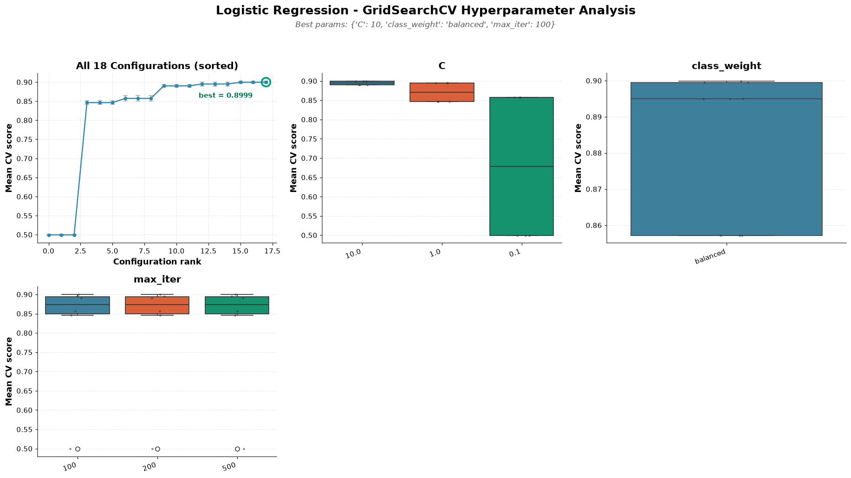
Figure 11 GridSearchCV Hyperparameter Sensitivity Analysis for Logistic Regression
When evaluated on the held-out validation set, the selected model attained an accuracy of 0.9073 (90.73%) and a weighted F1-score of 0.9080. The confusion matrices in Figure 12 present both the raw counts and the row-normalized recall values, revealing where the residual 9.27% of errors concentrate.
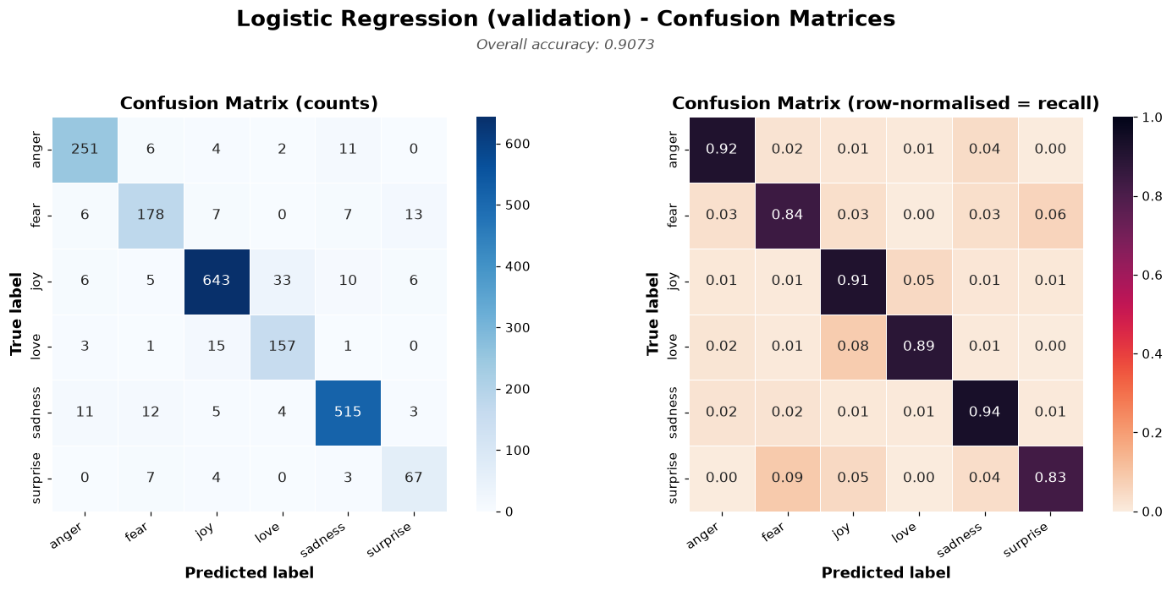
Figure 12 Confusion Matrices for Logistic Regression on the Validation Set: Raw Counts (left) and Row-Normalized Recall (right)
Two error structures are apparent. First, Love is systematically absorbed into Joy: 33 Love samples are predicted as Joy, accounting for the majority of Love's 11% recall deficit. This is semantically unsurprising, since affectionate and joyful expressions share substantial lexical overlap, and the confusion is asymmetric—Joy is rarely misread as Love, reflecting the 4.1:1 prior ratio between the two. Second, Surprise achieves the lowest recall at 83%, with its errors distributed across Fear (7 samples) and Joy (4 samples), consistent with the valence ambiguity of surprise as an affective category: a surprising event may be pleasant or alarming, and short texts frequently do not disambiguate.

Scientific Role
Logistic Regression is intentionally positioned as the simplest baseline model. Its strong performance, exceeding 90% accuracy, establishes a critical benchmark, demonstrating that linear decision boundaries over sparse TF-IDF features are surprisingly effective for this dataset. This finding challenges the assumption that complex neural architectures are strictly necessary for this task. Its linearity provides interpretability, since feature weights can be traced directly to specific n-grams, permitting an analyst to audit precisely which lexical evidence drove any individual prediction—a property that neither of the neural models possesses without recourse to post-hoc explanation methods. Training completes in seconds on commodity CPU hardware, with no GPU requirement, and the fitted model occupies a few megabytes of storage.

3.4.2 Custom Attention-Based Neural Network with BPE
The custom neural network is designed to move beyond bag-of-words heuristics by embedding sequences into a dense semantic space and applying self-attention to capture contextual word interactions. The architecture, implemented as AttentionSentimentClassifier, ports the conceptual structure of a Keras functional model to native PyTorch, enabling end-to-end training with GPU acceleration. Unlike the TF-IDF pipeline, this model receives token order as input and can in principle represent the difference between phrases composed of identical vocabulary.

Mathematical Formulation of the Attention Mechanism
The core of the model is multi-head self-attention (Vaswani et al., 2017). For a sequence of embeddings E ∈ ℝ^(T×d), where T is the sequence length and d is the embedding dimension, scaled dot-product attention computes:
$$\text{Attention}(Q,K,V)=\text{softmax}​\left(\frac{QK^{⊤}}{\sqrt{d_{k}}}\right)V$$
where Q = EW^Q are the queries, K = EW^K the keys, and V = EW^V the values; W^Q, W^K, W^V ∈ ℝ^(d×dₖ) are learned projection matrices; and dₖ = d/h is the dimension per attention head. The scaling factor 1/√dₖ prevents the dot products from growing with dimension into the saturated regions of the softmax, where gradients vanish.
Multi-head attention computes h independent attention functions in parallel and concatenates the results, allowing distinct heads to specialize on different relational patterns:
$$\text{MultiHead}(Q,K,V)=\text{Concat}({\text{head}}_{1},…,{\text{head}}_{h}) W^{O}$$
$${\text{head}}_{i}=\text{Attention}​\left(QW_{i}^{Q}, KW_{i}^{K}, VW_{i}^{V}\right)$$
where Wᵢ^Q, Wᵢ^K, Wᵢ^V ∈ ℝ^(d×dₖ) and W^O ∈ ℝ^(h·dₖ × d). Layer Normalization (Ba et al., 2016) is applied after the attention layer together with a residual connection:
$$\text{LayerNorm}(x)=γ⊙\frac{x−μ}{\sqrt{σ^{2}+ϵ}}+β$$
where μ and σ² are the mean and variance computed over the feature dimension, γ and β are learnable scale and shift parameters, and ε is a small constant for numerical stability. The residual connection preserves a gradient path that bypasses the attention block, which stabilizes optimization in the early epochs before the attention weights have become informative.

Architecture and Forward Pass
The forward pass through the network proceeds as specified in Table 8, where B denotes the batch size, T = 32 the sequence length, and d the embedding dimension.
Table 8 Forward Pass Through the Custom Attention Network
Step | Operation | Input Shape | Output Shape | Description
1 | Embedding | (B, T) | (B, T, d) | Maps discrete BPE token IDs to dense vectors
2 | Dropout | (B, T, d) | (B, T, d) | Applies dropout to embedding outputs
3 | Multi-Head Attention | (B, T, d) | (B, T, d) | Self-attention with 16 heads
4 | Residual + LayerNorm | (B, T, d) | (B, T, d) | x = LayerNorm(attn_out + input)
5 | Dense 1 + ReLU | (B, T, d) | (B, T, d₁) | Linear projection, d₁ = 512
6 | Dropout | (B, T, d₁) | (B, T, d₁) | Regularization
7 | Dense 2 + ReLU | (B, T, d₁) | (B, T, d₂) | Linear projection, d₂ = 128
8 | Dropout | (B, T, d₂) | (B, T, d₂) | Regularization
9 | Global Average Pooling | (B, T, d₂) | (B, d₂) | Mean over the time dimension
10 | Classifier | (B, d₂) | (B, 6) | Linear projection to six logits

The global average pooling operation in step 9 collapses the token dimension by taking the arithmetic mean of the per-position hidden states:
$$h_{\text{pool}}=\frac{1}{T}\sum_{t=1}^{T}{h_{t}}$$
The classifier outputs raw logits, with the softmax applied during loss computation via nn.CrossEntropyLoss, which fuses the log-softmax and negative log-likelihood operations for numerical stability.

Architecture Specification
The complete model architecture is specified in Table 9. The reported parameter count is derived from the executed training implementation.
Table 9 Architecture Specification of the Custom Attention Network
Layer | Configuration | Output Shape | Parameters
Embedding | vocab_size = 10,000, embedding_dim = 256 | (B, 32, 256) | 2,560,000
Dropout | p = 0.4 | (B, 32, 256) | 0
MultiHeadAttention | embed_dim = 256, num_heads = 16, batch_first = True | (B, 32, 256) | 263,168
LayerNorm | normalized_shape = 256, eps = 1e-6 | (B, 32, 256) | 512
Linear + ReLU | 256 → 512 | (B, 32, 512) | 131,584
Dropout | p = 0.4 | (B, 32, 512) | 0
Linear + ReLU | 512 → 128 | (B, 32, 128) | 65,664
Dropout | p = 0.4 | (B, 32, 128) | 0
Global Average Pooling | mean(dim = 1) | (B, 128) | 0
Classifier | 128 → 6 | (B, 6) | 774
Total | — | — | 3,054,918

Total trainable parameters amount to 3,054,918, approximately 3.05 million. The embedding table alone accounts for 2,560,000 parameters, or 83.8% of the total, which is characteristic of models trained from scratch on modest corpora: the great majority of capacity is expended on learning a lexical representation that a pre-trained embedding would supply directly. This observation motivates the transfer learning model presented in Section 3.4.3.

Tokenization: Byte-Pair Encoding
Raw text is tokenized using a custom-trained Byte-Pair Encoding tokenizer (Sennrich et al., 2016) initialized with a vocabulary size of 10,000, a maximum sequence length of 32, and whitespace pre-tokenization. The BPE algorithm iteratively merges frequent pairs of characters or subwords to construct a vocabulary of compact tokens. For a sequence of characters [c₁, c₂, …, c_L], the tokenizer applies the learned merge operations greedily to produce subword units [s₁, s₂, …, s_k] where k ≤ L, and each subword sᵢ maps to an integer identifier vᵢ ∈ {1, …, V}.
Sequences are padded and truncated to a uniform length of 32 tokens using post-padding and post-truncation. Minimal cleaning is applied for this pipeline, with no stopword removal or lemmatization, because subword models are robust to morphological noise and benefit from preserving original lexical forms. The subword vocabulary confers a specific advantage on this corpus: informal or misspelled words that would be out-of-vocabulary under word-level tokenization decompose into known subword units, so no input is ever mapped wholesale to an unknown token.

Class Weights for Imbalance Handling
Class weights were computed using compute_class_weight(class_weight='balanced'), which assigns each class a weight inversely proportional to its frequency:
$$w_{k}=\frac{N}{K⋅n_{k}}$$
where N is the total number of training samples, K = 6 is the number of classes, and nₖ is the number of samples in class k. The resulting weights are reported in Table 10.
Table 10 Computed Class Weights for the Training Partition
Class | Samples (Training) | Weight
Joy | 5,345 | 0.50
Sadness | 4,662 | 0.57
Anger | 2,152 | 1.23
Fear | 1,926 | 1.38
Love | 1,289 | 2.06
Surprise | 565 | 4.70

The minority class Surprise receives the highest weight, approximately 4.70, while the majority class Joy receives the lowest, approximately 0.50—a dynamic range of 9.4×, mirroring the class imbalance ratio by construction. These weights are applied to the cross-entropy loss function:
$$L=−\sum_{i=1}^{N}{\sum_{k=1}^{K}{w_{k}}} y_{ik} \text{log}{\hat{y}}_{ik}$$
where yᵢₖ ∈ {0, 1} is the ground-truth indicator and ŷᵢₖ is the predicted probability. Weighting the loss rather than resampling the data preserves the original training distribution while equalizing each class's contribution to the gradient, and avoids the overfitting risk that naive oversampling of a 565-sample class would introduce.

Training Procedure
The training configuration is summarized in Table 11. Optimization uses Adam (Kingma & Ba, 2015), and the dropout regularization applied throughout the network follows Srivastava et al. (2014).
Table 11 Training Configuration for the Custom Attention Network
Parameter | Value | Description
Optimizer | Adam | Adaptive moment estimation
Learning Rate | {1e-2, 1e-3, 1e-4} | Tuned via random search
Loss Function | Cross-Entropy with class weights | Weighted to address imbalance
Batch Size | 32 | Matching the Keras default
Max Epochs | 50 | Upper bound on training duration
Early Stopping Patience | 5 | Monitors validation loss; restores best weights
Gradient Updates | Backpropagation | loss.backward(), optimizer.step()

Hyperparameter Search
A random search over five trials explored the hyperparameter space reported in Table 12. Random search was preferred over exhaustive grid search because the seven-dimensional space contains 6,300 combinations, rendering full enumeration computationally infeasible within the project's resource budget.
Table 12 Hyperparameter Search Space for the Custom Attention Network
Hyperparameter | Values Explored
embedding_dim | [64, 128, 256]
num_heads | [4, 8, 16]
dense_units_1 | [128, 192, 256, 320, 384, 448, 512]
dense_units_2 | [64, 128, 192, 256]
embedding_dropout | [0.1, 0.2, 0.3, 0.4, 0.5]
dense_dropout | [0.1, 0.2, 0.3, 0.4, 0.5]
learning_rate | [1e-2, 1e-3, 1e-4]

The best trial achieved a validation loss of 0.2919 with the following configuration:
$$d^{*}=256, h^{*}=16, d_{1}^{*}=512, d_{2}^{*}=128, p_{\text{drop}}^{*}=0.4, η^{*}=1×{10}^{−3}$$
Notably, the search selected the maximum available value for embedding dimension, head count, and both dense widths, which suggests that the model was capacity-limited rather than overfitting-limited within the explored range, and that a wider search might have yielded further gains. The simultaneous selection of the highest dropout rate (0.4) indicates that the additional capacity required correspondingly strong regularization to remain trainable.
Training dynamics for the selected configuration are presented in Figure 13. Early stopping restored the weights from epoch 34, at which the validation loss reached its minimum of 0.2782; peak validation accuracy of 0.8838 occurred at epoch 36. The generalization gap panel, plotting validation loss minus training loss, is the most diagnostically informative: it begins strongly negative at approximately −0.29 and rises monotonically toward zero, crossing into positive territory only around epoch 36. A negative gap indicates that validation loss is lower than training loss, an artefact of dropout being active during training but disabled at evaluation. The crossing point marks the onset of genuine overfitting and coincides closely with the early-stopping trigger, confirming that the patience parameter was appropriately calibrated.
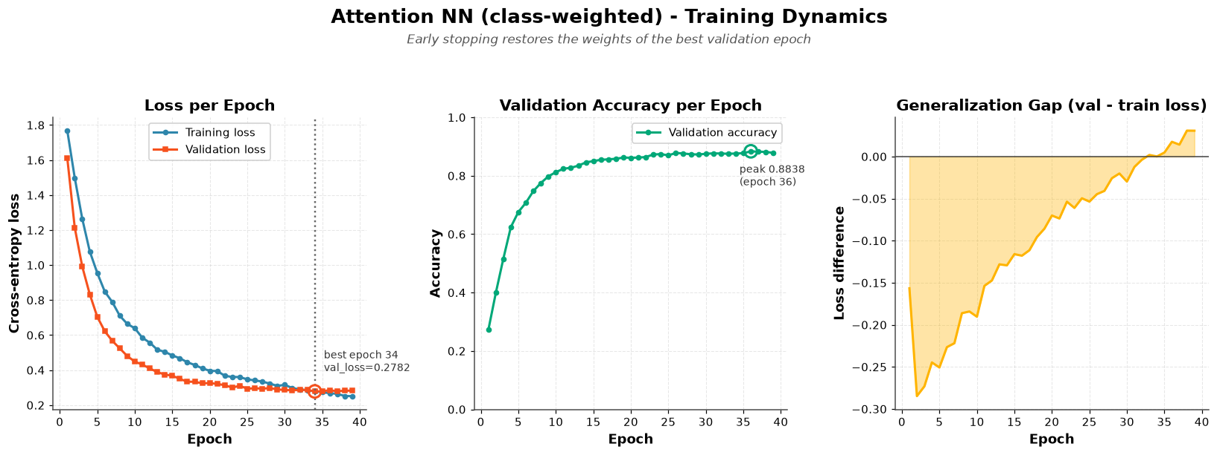
Figure 13 Training Dynamics of the Custom Attention Neural Network: Loss per Epoch, Validation Accuracy per Epoch, and Generalization Gap

Evaluation Results
Non-Augmented Variant. On the held-out test set of 2,000 samples, the non-augmented variant achieved the results reported in Table 13.
Table 13 Test-Set Results for the Custom Attention Network (Non-Augmented)
Metric | Value
Accuracy | 0.8770 (87.70%)
Macro Precision | 0.8121
Macro Recall | 0.8858
Macro F1-Score | 0.8382
MCC | 0.8419
ROC-AUC (Macro OvR) | 0.9879
PR-AUC (Macro) | 0.9195

The gap between macro recall (0.8858) and macro precision (0.8121) is a direct and expected consequence of class weighting: by penalizing errors on minority classes more heavily, the loss function biases the decision boundary toward predicting those classes, raising their recall at the cost of precision. The corresponding confusion matrix is shown in Figure 14.
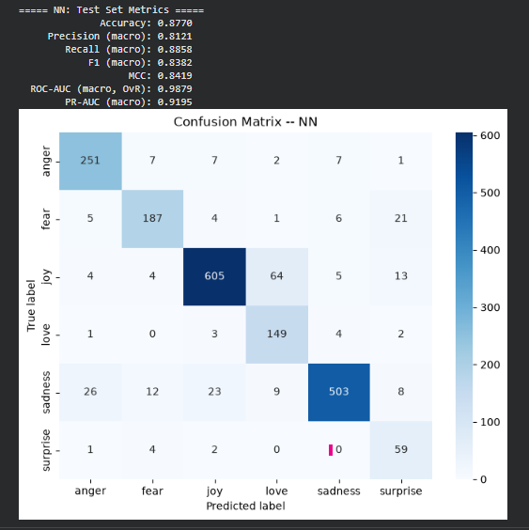
Figure 14 Confusion Matrix and Test Metrics for the Custom Attention Network (Non-Augmented Variant)
Augmented Variant. Trained on the balanced training set of 32,064 samples produced by WordNet synonym substitution, the augmented variant showed marked performance degradation, as reported in Table 14.
Table 14 Test-Set Results for the Custom Attention Network (Augmented)
Metric | Value
Accuracy | 0.6990 (69.90%)
Macro Precision | 0.6948
Macro Recall | 0.7480
Macro F1-Score | 0.7092
MCC | 0.6083
ROC-AUC (Macro OvR) | 0.9242
PR-AUC (Macro) | 0.7841

This represents a drop of 17.8 percentage points in accuracy, indicating that the synonym-based augmentation strategy based on WordNet substitution (Miller, 1995) failed for this task. The augmentation process likely generated syntactically or contextually inappropriate substitutions that shifted emotional polarity or produced ungrammatical sequences. The confusion matrix in Figure 15 localizes the damage precisely: Joy recall collapses from 605 to 436 correct predictions, with 145 Joy samples now misclassified as Sadness—a valence reversal that was almost entirely absent from the non-augmented model, which made only five such errors. Sadness suffers the mirror-image failure, with 121 samples misread as Joy. This bidirectional confusion between the two most frequent and most affectively opposed classes is the signature of an augmentation process that substituted emotionally charged words with valence-inverting synonyms.
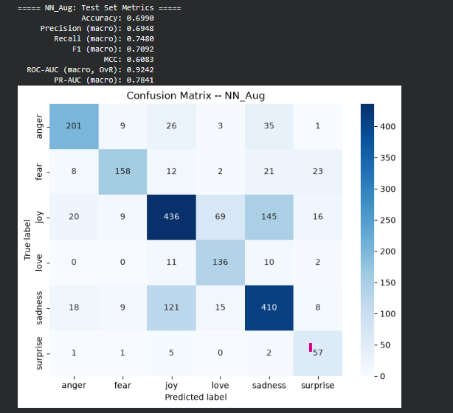
Figure 15 Confusion Matrix and Test Metrics for the Custom Attention Network (Augmented Variant)
It is instructive that ROC-AUC degrades far less than accuracy: 0.9879 to 0.9242, a decline of 6.4%, against an accuracy decline of 20.3% in relative terms. The augmented model therefore retains substantial ability to rank the correct class highly even where it fails to select it. This dissociation indicates that augmentation corrupted the model's decision thresholds and calibration more severely than its underlying representation.

Scientific Significance
The custom attention-based neural network demonstrates that self-attention mechanisms effectively capture contextual word interactions for emotion classification. The macro one-vs-rest ROC-AUC of 0.9879 indicates superior rank-ordering capability, assigning higher probabilities to true-positive classes even when the final classification threshold is suboptimal. However, the failure of the augmentation experiment serves as a critical cautionary note: not all text-augmentation strategies are universally beneficial, and their application requires rigorous semantic validation to preserve the target labels. A practitioner who had adopted augmentation on the strength of its reputation in the literature, without measuring its effect, would have shipped a materially worse model.

3.4.3 GloVe with Bidirectional LSTM
This model exploits external distributional semantics through pre-trained Global Vectors for Word Representation (GloVe; Pennington et al., 2014). Specifically, the glove-wiki-gigaword-200 embeddings are loaded, mapping words to a 200-dimensional real-valued vector space. The underlying hypothesis is that these vectors, trained on billions of words of Wikipedia and Gigaword text, encode rich syntactic and semantic regularities that can bootstrap emotion classification even with limited task-specific training data. Where the custom attention network of Section 3.4.2 must learn its lexical representation from 15,938 short samples, this model inherits one derived from a corpus five orders of magnitude larger.
A Bidirectional LSTM processes the sequence in both forward and backward directions, concatenating the hidden states at each position:
$$h_{t}=\left[{\vec{h}}_{t} ; {\overset{⃖}{h}}_{t}\right]$$
This allows the network to capture contextual information from both past and future tokens, which is particularly advantageous for emotion analysis, since the polarity of a phrase can depend on words that follow it—compare “not good” with “very good”, where the decisive evidence precedes the sentiment-bearing token in one case and follows it in the other.

Vocabulary Coverage Analysis
A word-level tokenizer (WordLevelTokenizer) is implemented to ensure a one-to-one correspondence between tokens and GloVe entries. This tokenizer is fitted exclusively on the training set, reserving index 0 for padding and index 1 for out-of-vocabulary tokens. The resulting vocabulary size is 15,199. Mapping the training vocabulary onto the GloVe matrix shows that 14,198 of 15,199 words are successfully located, corresponding to approximately 93.4% coverage. The remaining 1,001 out-of-vocabulary tokens are randomly initialized from a normal distribution with standard deviation 0.6, formally expressed as:
$$e_{w}∼N​\left(0, {0.6}^{2} I\right) \text{for }w∉V_{\text{GloVe}}$$
The scale of 0.6 was chosen to approximate the empirical standard deviation of the pre-trained GloVe vectors, so that randomly initialized and inherited embeddings occupy comparable regions of the representation space and no systematic magnitude discrepancy biases the downstream LSTM. A fixed sequence length of 32 tokens is applied via post-padding. The 6.6% coverage shortfall consists predominantly of informal contractions, misspellings, and platform-specific tokens—precisely the categories that the subword tokenizer of Section 3.4.2 handles gracefully, which constitutes a structural disadvantage of word-level tokenization on this corpus.

BiLSTM Architecture
The model, GloveBiLSTMClassifier, stacks three Bidirectional LSTM layers with hidden sizes 256, 128, and 128, as specified in Table 15.
Table 15 GloVe-BiLSTM Architecture Specification
Layer | Configuration | Output Dimension | Parameters
Embedding | freeze = True, padding_idx = 0 | (B, 32, 200) | 3,039,800 (frozen)
BiLSTM 1 | 256 units, bidirectional | (B, 32, 512) | 329,728
BiLSTM 2 | 128 units, bidirectional | (B, 32, 256) | 164,864
BiLSTM 3 | 128 units, bidirectional | (B, 32, 256) | 82,432
Classifier | Linear | (B, 6) | 1,542
Total trainable | — | — | 1,992,198

Total trainable parameters amount to 1,992,198, approximately 1.99 million. The architecture operates as follows. The first BiLSTM projects the 200-dimensional embeddings to 256 hidden units, doubled to 512 by bidirectionality. The second layer compresses the representation to 128 units, yielding a 256-dimensional bidirectional output. The third layer maintains 128 units. Dropout with p = 0.2 is applied after each LSTM layer. The final hidden states from the last LSTM layer are concatenated and passed to a linear classifier. The embedding layer is frozen (freeze = True) to preserve the pre-trained semantic structure and prevent catastrophic forgetting, which is why its 3,039,800 parameters are excluded from the trainable total.
The parameter economy of this design is worth noting. Although the model holds more parameters in total than the custom attention network—5.03 million against 3.05 million—it updates only 1.99 million during training, 35% fewer than the attention network. Freezing the embedding effectively converts the largest block of parameters from a learning burden into fixed prior knowledge.

Training and Optimization
The training configuration is reported in Table 16.
Table 16 GloVe-BiLSTM Training Configuration
Parameter | Value
Optimizer | Adam
Learning Rate | 1e-3
Loss Function | Cross-Entropy with class weights
Batch Size | 64
Early Stopping Patience | 15

Class weights derived in Section 3.4.2 are applied to the cross-entropy loss to mitigate class imbalance, maintaining comparability with the attention network. Early stopping monitors validation loss, halting training at epoch 21. The substantially larger patience value of 15, against 5 for the attention network, reflects the noisier epoch-to-epoch validation trajectory characteristic of recurrent architectures, where a premature halt risks discarding a model that would have continued improving.

Performance Interpretation
The model achieves a test loss of 0.3545 and a test accuracy of 0.8590 (85.90%), placing it slightly below the non-augmented custom neural network at 87.70% and substantially above the augmented variant at 69.90%. Complete test metrics and the confusion matrix are presented in Figure 16: macro precision 0.7916, macro recall 0.8826, macro F1 0.8099, MCC 0.8224, macro one-vs-rest ROC-AUC 0.9861, and macro PR-AUC 0.9172.
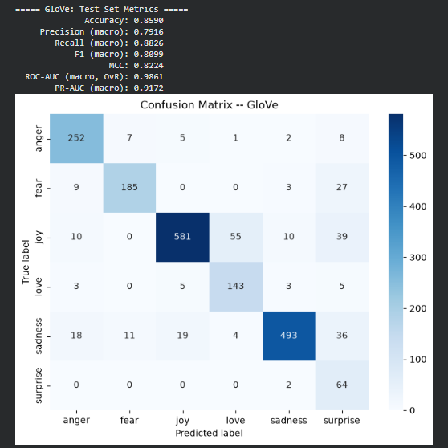
Figure 16 Confusion Matrix and Test Metrics for the GloVe-BiLSTM Model
The 93.4% GloVe coverage ensures that most words contribute meaningful embeddings, while the stacked BiLSTM capacity enables the modelling of complex sequential dependencies. The lower trainable parameter count of 1.99 million, relative to the custom neural network's 3.05 million, may partly explain its slightly lower accuracy, yet it remains highly competitive, validating the efficacy of transfer learning through pre-trained word vectors.
The error structure differs instructively from that of the attention network. GloVe-BiLSTM makes 39 Joy-to-Surprise errors against the attention network's 13, and 27 Fear-to-Surprise errors against 21, indicating a systematic over-prediction of the minority class. Conversely, it handles the Joy-Love boundary comparably, with 55 errors against 64. The pattern is consistent with a model that has inherited robust general-purpose semantics but has had fewer trainable parameters with which to calibrate class-specific decision boundaries under weighted loss.

3.5 Evaluation Metrics
A comprehensive set of evaluation metrics was employed to assess the performance of all implemented models. The choice of metrics reflects the multi-class nature of the emotion classification task and the class imbalance inherent in the dataset. For classical models, accuracy and weighted F1-score are reported; for neural models, macro-averaged precision, recall, F1-score, Matthews Correlation Coefficient, ROC-AUC, and PR-AUC are additionally reported. For multi-class classification, all metrics are computed using a one-vs-rest scheme, in which each class is treated as the positive class against all other classes combined.
The distinction between macro and weighted averaging deserves emphasis, because the two conventions can diverge substantially on an imbalanced corpus. Weighted averaging multiplies each class's score by its support before summing, so the 5,362-sample Joy class contributes roughly nine times more to the result than the 572-sample Surprise class. Macro averaging treats all six classes equally. Weighted figures therefore describe expected performance on a randomly drawn sample, while macro figures describe performance on a randomly drawn class. Both are reported where available, and the difference between them is itself diagnostic of imbalance sensitivity.

Accuracy
Accuracy measures the proportion of correct predictions among all predictions:
$$\text{Accuracy}=\frac{TP+TN}{TP+TN+FP+FN}$$
where TP, TN, FP, and FN denote true positives, true negatives, false positives, and false negatives, defined per class under the one-vs-rest scheme. Accuracy is reported for all models. However, due to class imbalance, accuracy alone is insufficient for a complete evaluation: as noted in Section 3.1.1, a degenerate classifier predicting only the majority class would score 33.5% without possessing any discriminative capability.

Precision
Precision measures the proportion of predicted positive instances that are actually positive:
$$\text{Precision}=\frac{TP}{TP+FP}$$
In the multi-class setting, precision is computed per class and then averaged. Weighted precision accounts for class frequencies, while macro precision treats each class equally regardless of its support. Precision answers the operational question: when the model asserts an emotion, how often should that assertion be trusted?

Recall
Recall measures the proportion of actual positive instances that are correctly identified:
$$\text{Recall}=\frac{TP}{TP+FN}$$
Recall answers the complementary question: of all instances genuinely expressing an emotion, what fraction did the model detect? In applications such as mental health screening, recall on distress-related classes typically dominates precision in operational importance, since a missed detection carries greater cost than a false alarm.

F1-Score
The F1-score is the harmonic mean of precision and recall, providing a balanced measure that penalizes extreme values in either component:
$$F_{1}=2⋅\frac{\text{Precision}⋅\text{Recall}}{\text{Precision}+\text{Recall}}$$
The harmonic mean is used in preference to the arithmetic mean precisely because it is dominated by the smaller of the two quantities: a classifier with precision 1.00 and recall 0.10 scores an F1 of 0.18 rather than 0.55. Weighted F1-score weights each class by its support, making it appropriate for reporting expected performance on imbalanced datasets. Macro F1-score computes the unweighted average across all classes, treating each class equally.

Matthews Correlation Coefficient
The Matthews Correlation Coefficient (MCC) is a balanced measure of binary classification quality that considers all four confusion matrix entries (Chicco & Jurman, 2020):
$$\text{MCC}=\frac{TP⋅TN−FP⋅FN}{\sqrt{(TP+FP)(TP+FN)(TN+FP)(TN+FN)}}$$
MCC ranges from −1, denoting perfect disagreement, to +1, denoting perfect agreement, with 0 indicating performance equivalent to random prediction. In this study, MCC is computed per class under the one-vs-rest scheme, with results averaged across all classes. Because MCC is the only metric in this suite that incorporates true negatives, it is substantially harder to inflate through majority-class prediction and is therefore the most conservative single-number summary reported here.

ROC-AUC
The Receiver Operating Characteristic Area Under the Curve measures the model's ability to discriminate between classes across all decision thresholds. The ROC curve plots the True Positive Rate against the False Positive Rate:
$$\text{TPR}=\frac{TP}{TP+FN}, \text{FPR}=\frac{FP}{FP+TN}$$
The AUC is the integral of the ROC curve over the full range of false positive rates:
$$\text{AUC}=\int_{0}^{1}{\text{TPR}}​\left({\text{FPR}}^{−1}(t)\right) dt$$
For multi-class classification, the macro one-vs-rest AUC is computed by calculating the AUC for each class against all others and averaging the results. An AUC of 0.5 indicates no discriminative power, while 1.0 indicates perfect discrimination. This metric is particularly valuable for assessing the ranking quality of model predictions independently of any specific decision threshold, and it is the metric on which the divergence between the augmented and non-augmented neural variants is smallest, as discussed in Section 3.4.2.
Table 17 consolidates the metric definitions for reference.
Table 17 Summary of Evaluation Metrics
Metric | Formula | Purpose
Accuracy | (TP + TN) / (TP + TN + FP + FN) | Overall correctness across all predictions
Precision | TP / (TP + FP) | Reliability of positive predictions
Recall | TP / (TP + FN) | Coverage of actual positive instances
F1-Score | 2 · (P · R) / (P + R) | Balanced harmonic mean of precision and recall
MCC | (TP·TN − FP·FN) / √((TP+FP)(TP+FN)(TN+FP)(TN+FN)) | Balanced quality measure using all four cells
ROC-AUC | ∫₀¹ TPR(FPR⁻¹(t)) dt | Threshold-independent rank-ordering quality

3.6 Comparative Evaluation of Models
Table 18 aggregates the experimental results documented for the three implemented models across four variants. Metrics that were not computed for a given model are marked accordingly; in particular, MCC and ROC-AUC were not computed for the Logistic Regression baseline, which constrains the completeness of the comparison and is recorded as a limitation in Section 5.1.
Table 18 Comparative Evaluation of Models
Model | Accuracy | F1-Score | MCC | ROC-AUC (Macro OvR)
Logistic Regression (TF-IDF) | 0.9073 (validation) | 0.9080 (weighted) | Not computed | Not computed
Custom Attention NN (non-augmented) | 0.8770 (test) | 0.8382 (macro) | 0.8419 | 0.9879
Custom Attention NN (augmented) | 0.6990 (test) | 0.7092 (macro) | 0.6083 | 0.9242
GloVe + BiLSTM | 0.8590 (test) | 0.8099 (macro) | 0.8224 | 0.9861

Per-class performance for the two strongest models is presented in Figure 17 and Figure 18, which decompose the aggregate figures into precision, recall, and F1 for each of the six emotion categories and expose the class-level structure that the summary metrics conceal.
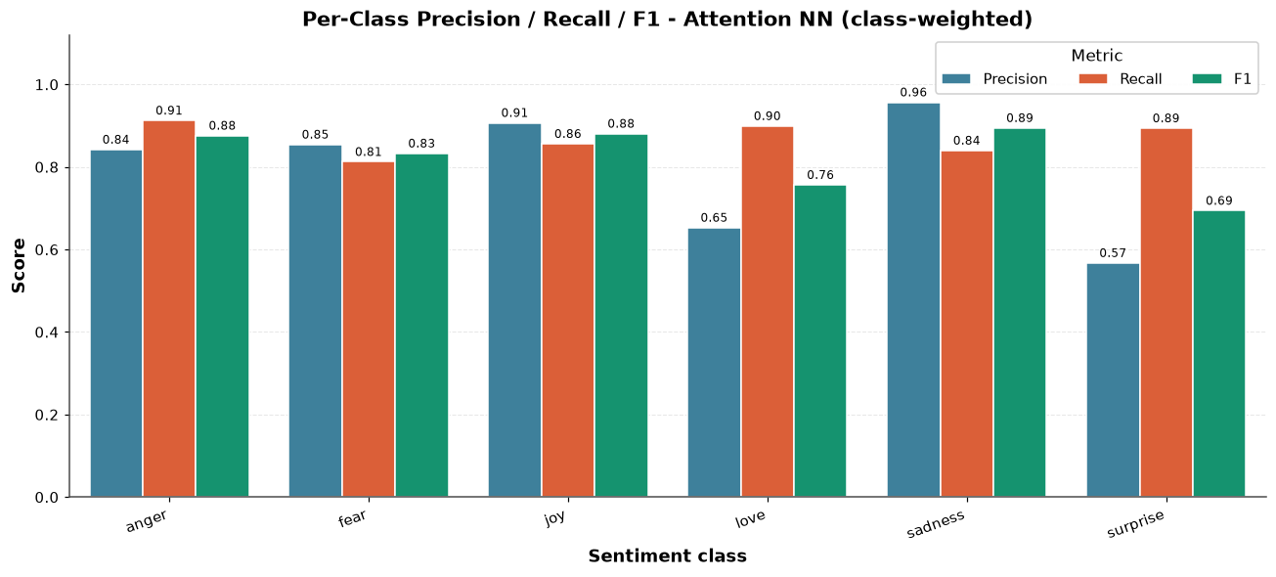
Figure 17 Per-Class Precision, Recall, and F1-Score for the Custom Attention Neural Network (Class-Weighted)
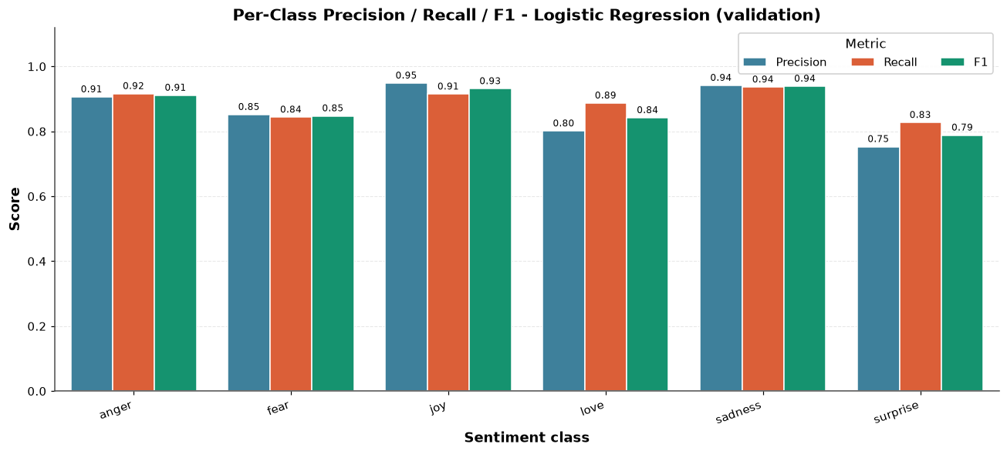
Figure 18 Per-Class Precision, Recall, and F1-Score for Logistic Regression (Validation Set)

Accuracy and F1-Score Analysis
The Logistic Regression model achieves the highest documented validation accuracy of 90.73% and weighted F1-score of 0.9080, outperforming all neural architectures on the validation partition. This counter-intuitive result, in which a simple linear model surpasses deep networks, is scientifically significant: it suggests that the high-dimensional TF-IDF feature space of 10,000 n-gram features provides sufficiently discriminative lexical cues for this dataset, and that class-balanced regularization effectively mitigates distribution skew. On the test set, the non-augmented custom neural network achieves 87.70% accuracy and 83.82% macro F1-score, indicating robust but slightly inferior generalization relative to the validation result of the Logistic Regression model.
An important methodological caveat qualifies this comparison. The Logistic Regression figure is a validation-set accuracy, whereas the neural figures are test-set accuracies, as required by the protocol stated in Section 3.3. Validation performance is optimistically biased relative to test performance because the validation partition informed hyperparameter selection. The reported 3.03 percentage-point advantage of Logistic Regression over the attention network should therefore be regarded as an upper bound on the true difference rather than a point estimate of it. The direction of the finding—that a linear model is competitive with, and plausibly superior to, dense neural alternatives on this corpus—is nevertheless robust to this correction, since a gap of three points is unlikely to be entirely attributable to validation optimism.
The per-class decomposition in Figure 17 and Figure 18 sharpens the picture considerably. Logistic Regression dominates on the four largest classes, achieving F1 scores of 0.91 for anger, 0.93 for joy, 0.94 for sadness, and 0.85 for fear, against 0.88, 0.88, 0.89, and 0.83 respectively for the attention network. The neural model closes the gap only where lexical cues are weakest. The most striking divergence occurs on Surprise, where Logistic Regression attains F1 = 0.79 against the attention network's 0.69, driven by a precision collapse in the neural model to 0.57 against 0.75. The attention network, trained under class weighting that assigns Surprise a weight of 4.70, over-predicts the minority class aggressively; the linear model, subject to the same weighting scheme but constrained to a linear decision surface, does not overshoot to the same degree.

Discriminative Capacity (ROC-AUC)
The custom neural network demonstrates outstanding discrimination ability with a macro one-vs-rest ROC-AUC of 0.9879, comfortably surpassing the threshold of 0.90 conventionally regarded as excellent. This indicates that, despite marginally lower accuracy than the Logistic Regression model, the neural network possesses superior rank-ordering capability, assigning higher probabilities to true-positive classes even when the final classification threshold is suboptimal. The GloVe-BiLSTM attains a closely comparable 0.9861, indicating that both neural architectures learn well-ordered probability estimates.
The ROC-AUC of 0.9242 for the augmented variant confirms that even the degraded model retains a reasonable discriminative structure, although it remains clearly inferior to its non-augmented counterpart. A directly comparable ROC-AUC value for the Logistic Regression baseline was not computed in this study, which is a material gap: without it, the claim that neural architectures offer superior ranking quality rests on comparison with an absent baseline. Computing probability-calibrated ranking metrics for the linear model is identified in Section 5.2 as an immediate priority for follow-up work.
The practical significance of the accuracy-versus-ranking dissociation depends on the deployment context. Where the system must emit a single hard label—automated routing, for instance—accuracy governs, and Logistic Regression is preferred. Where the system surfaces ranked candidates for human review, or where a downstream component consumes the full probability vector, ROC-AUC governs, and the attention network is preferred.

Effect of Data Augmentation
The experimental results highlight the risks associated with naive data augmentation. The augmented neural network exhibits a drop of 17.8 percentage points in accuracy relative to the non-augmented version, from 87.70% to 69.90%. This is attributable to the SynonymAug strategy, based on WordNet, generating syntactically or contextually inappropriate substitutions that shift emotional polarity or produce ungrammatical sequences.
The mechanism can be stated precisely. WordNet synonym sets (Miller, 1995) are organized by denotational similarity, not by affective valence. Substituting a word for a WordNet synonym therefore preserves approximate meaning while making no guarantee whatsoever about emotional colouring. Because emotion classification depends on exactly the connotational dimension that WordNet does not model, the augmentation procedure systematically corrupts the training signal for this task while leaving it comparatively intact for tasks such as topic classification, where the same technique is routinely reported as beneficial. The confusion matrix evidence presented in Section 3.4.2—a 145-sample Joy-to-Sadness misclassification block that is essentially absent from the non-augmented model—is consistent with this account and difficult to explain otherwise.
A secondary factor compounds the primary one. Balancing the training set to 32,064 samples required generating roughly 4,780 synthetic samples for Surprise from an original pool of 565, a multiplication factor exceeding eight. At that ratio, synthetic text overwhelmingly dominates the minority class, so any systematic distortion introduced by the generator is learned as if it were a property of the class. This finding serves as a cautionary note: text augmentation is not universally beneficial for addressing class imbalance and requires rigorous validation before deployment.

Trade-offs Between Classical Machine Learning and Deep Learning
Logistic Regression offers a lightweight, highly interpretable, and computationally efficient solution, with training completing within seconds on a CPU. The custom neural network and the GloVe-BiLSTM model demand substantially greater GPU resources and longer training times—the attention network trained for 39 epochs before early stopping, the BiLSTM for 21—but the attention network provides a markedly higher discriminative ranking quality. The GloVe-BiLSTM model, with 1.99 million trainable parameters, presents an attractive middle ground, achieving 85.90% test accuracy while leveraging transfer learning, making it suitable for resource-constrained environments where pre-trained embeddings can be obtained but large-scale training cannot be afforded.
The failure of the augmented model underscores that deep architectures are more sensitive to training-data distribution shifts than linear models. A linear model over sparse lexical features has limited capacity to memorize distributional artefacts; a three-million-parameter network trained from scratch has ample capacity to internalize whatever regularities the training distribution presents, including spurious ones introduced by a faulty augmentation pipeline. Capacity is therefore not an unalloyed benefit: it amplifies both the signal and the noise present in the training data.
Summarizing the trade-off across four axes: on accuracy, Logistic Regression leads; on ranking quality, the attention network leads; on interpretability, Logistic Regression leads decisively, since its coefficients are directly auditable; and on computational cost, Logistic Regression leads by orders of magnitude. The attention network justifies its cost only where threshold-independent ranking or probability calibration is operationally required.

Comparison with Baseline Classical Models
The Logistic Regression model implemented in this study, using TF-IDF vectorization with heavy preprocessing, achieved a validation accuracy of 90.73% and a weighted F1-score of 0.9080. This result surpasses the 84.45% classification accuracy reported by Kusal et al. (2026) for their meta-learning ensemble on conversational dialogue datasets. The performance differential can be explained by fundamental differences in dataset complexity: Kusal et al. addressed conversational text containing 32 emotional classes with severe class imbalance, whereas this study operates on a comparatively constrained six-class corpus. The linear decision boundaries of Logistic Regression are more effective when the feature space aligns with a well-defined, moderately sized label set. The comparison should therefore not be read as evidence that the present model is superior in any general sense; it reflects task difficulty at least as much as method quality.
These results are, however, marginally inferior to the 92.3% benchmark accuracy achieved by Kumar (2024) using fine-tuned BERT on Twitter and Yelp review data. This gap of approximately 1.6 percentage points is attributable to the representational advantages of transformer architectures: BERT's bidirectional attention over contextualized subword embeddings captures syntactic and pragmatic nuance that a bag-of-words representation inherently cannot access. Furthermore, the 62 conflicting-label duplicate rows identified during the data-cleaning phase indicate a level of annotation noise that disproportionately penalizes linear models, whereas transformer-based approaches tend to demonstrate greater robustness to such inconsistencies through their deep contextual representations and large-scale pre-training priors.

Comparison with Neural Architectures in the Literature
The non-augmented custom attention network implemented in this study achieved a test accuracy of 87.70%, while the GloVe-BiLSTM attained 85.90%. These results, while competitive, fall considerably short of the state-of-the-art deep learning results documented in the literature, such as the 98.86% accuracy reported by Al-Hagery et al. (2025) using Word2Vec with OCSFO-tuned HA-LSTM, and the 99% upper bound cited by Chutia and Baruah (2024) for hybrid deep learning frameworks. Three factors plausibly account for the difference: those studies employ larger and more extensively tuned architectures; they evaluate on corpora whose annotation consistency and class balance are more favourable; and, in the case of survey-reported maxima, they cite best-case figures across many studies rather than a single controlled experiment.
The most striking divergence from the literature, however, is observed in the augmentation experiment, where synonym substitution produced a marked degradation to 69.90% accuracy—a phenomenon not reported in the reviewed literature. This finding is methodologically significant and warrants examination. Muhammad et al. (2025) demonstrated that instruction-tuned large language models and contrastive learning achieve superior cross-cultural generalization, with macro F1 reaching 0.92, by preserving semantic integrity during augmentation. By contrast, the WordNet-based synonym substitution used in this study, implemented via nlpaug.augmenter.word.SynonymAug, introduces syntactic noise and, critically, emotional-polarity reversals without any validation of the augmented text's affective consistency. The augmentation process generated unnatural sequences that shifted the training distribution away from the true data manifold, causing the model to learn corrupted patterns that fail to generalize.
This result contributes an important cautionary note to the field, and its value derives precisely from its negativity. Publication practice favours reporting augmentation strategies that succeed, which leaves practitioners without evidence delimiting where such strategies fail. The absence of a semantic validation mechanism in this pipeline, combined with the limited hyperparameter search space of five trials and a reduced epoch budget for the augmented variant, collectively explains the observed performance degradation.

Conclusion of the Comparison
Based on the documented results, the Logistic Regression model is the most pragmatic and highest-performing baseline for this specific dataset, combining the strongest accuracy with negligible computational cost and full interpretability. For applications prioritizing discrimination and ranking capacity over literal accuracy, the non-augmented custom neural network is preferable, offering a macro ROC-AUC of 0.9879. The GloVe-BiLSTM model provides stable performance while leveraging external knowledge, and its frozen-embedding design minimizes trainable parameters, making it well suited to constrained deployment environments. The augmented neural network is unsuitable for practical deployment in its current form and would require a validated augmentation pipeline before reconsideration.
The general lesson that emerges from this comparison is that architectural sophistication should be justified empirically rather than assumed. On a corpus where the discriminative signal is predominantly lexical—as Section 3.7 establishes for this dataset—the representational machinery of self-attention and recurrent encoding addresses a difficulty that the data does not, in fact, present in great measure.

3.7 Statistical Dashboard Analysis
An interactive statistical dashboard was developed as part of the ReviewSense AI framework using the Plotly visualization library, providing a comprehensive visual summary of the dataset, preprocessing operations, and key extracted features. The dashboard serves as an exploratory data analysis tool, enabling researchers and practitioners to understand data characteristics prior to the modelling phase. It comprises four key performance indicators that summarize the dataset's scale and nature, followed by detailed visualizations of class distributions, cleaning steps, the preprocessing pipeline, emotion-specific statistics, text length distributions, and feature importance rankings. Figure 19 presents the overview and preprocessing panels.
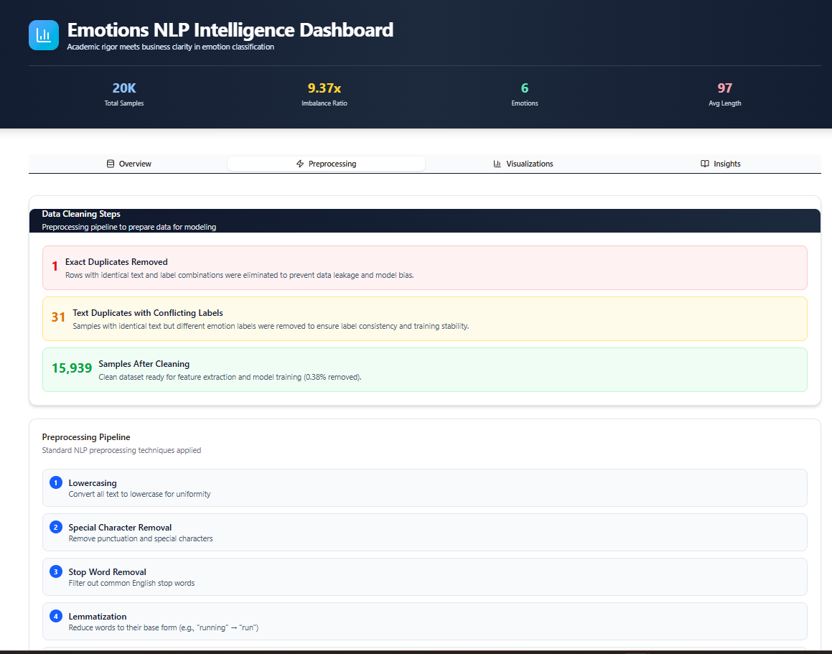
Figure 19 ReviewSense AI Statistical Dashboard: Overview KPIs, Data Cleaning Steps, and Preprocessing Pipeline Panels
The dashboard presents the key performance indicators reported in Table 19.
Table 19 Dashboard Key Performance Indicators
KPI | Value | Significance
Total Samples | ~20,000 | Overall dataset scale
Imbalance Ratio | 9.37× | Joy appears 9.37× more frequently than Surprise
Emotions | 6 | Number of distinct emotion categories
Average Length | 97 characters | Mean text length across the corpus

The 9.37× imbalance ratio indicates that the majority class appears nearly ten times more frequently than the minority class, necessitating class weighting strategies or augmentation to prevent model bias toward overrepresented categories. As demonstrated in Section 3.4.2, this was addressed through compute_class_weight('balanced'), which assigned weights inversely proportional to class frequencies.

Class Distribution Before and After Cleaning
As discussed in Section 3.1.1, the original class distribution reveals significant imbalance across the six emotion categories. The cleaning process—involving removal of exact duplicates and conflicting-label duplicates—removed only 0.38% of samples, confirming that the dataset was relatively clean prior to processing and that the observed class distribution is a genuine property of the data rather than an artefact of noise. Figure 20 places the two distributions side by side: Joy falls from 5,362 to 5,345, Sadness from 4,666 to 4,662, Anger from 2,159 to 2,152, Fear from 1,937 to 1,926, Love from 1,304 to 1,289, and Surprise from 572 to 565. The imbalance ratio is essentially unchanged at 9.46× post-cleaning. The minimal change in distribution validates the cleaning strategy and ensures that subsequent modelling decisions are based on true data characteristics rather than spurious artefacts.
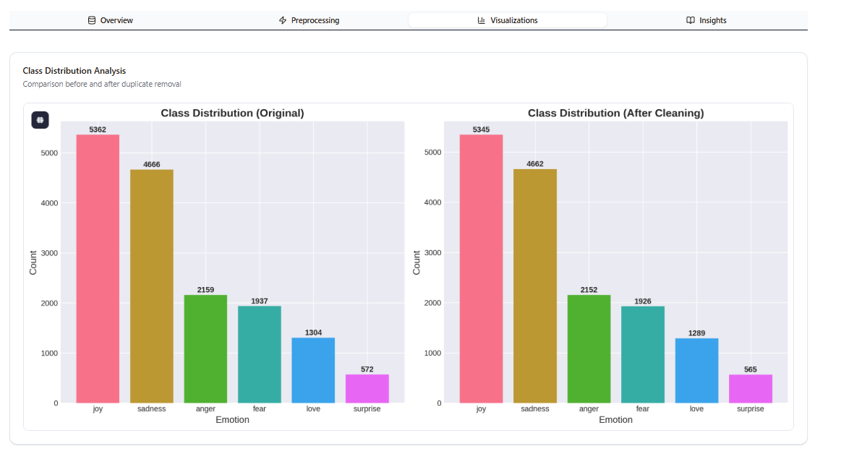
Figure 20 Class Distribution Before and After Duplicate Removal

Data Cleaning Steps
The dashboard documents three primary cleaning operations applied to ensure data quality and label consistency, visible in the central panel of Figure 19.
- Exact Duplicates Removed. Rows with identical text and identical label combinations were eliminated to prevent data leakage and model bias. This operation ensures that the model does not learn repeated examples that could artificially inflate performance.
- Text Duplicates with Conflicting Labels. Samples with identical text but different emotion labels were removed to ensure label consistency and training stability. The dashboard reports 31 affected text strings, corresponding to the 62 individual rows recorded in Section 3.2. This step is methodologically significant because conflicting annotations introduce contradictory gradient signals that impede convergence.
- Samples After Cleaning. The clean dataset comprises 15,939 training samples according to the dashboard snapshot, a 0.38% reduction; the committed partition used for all modelling contains 15,938 samples, as explained in Section 3.2. The minimal reduction confirms the dataset's overall quality.

Preprocessing Pipeline
Four standard NLP preprocessing techniques were applied to the text data for the TF-IDF pipeline, documented in the lower panel of Figure 19.
- Lowercasing. All text is converted to lowercase for uniformity, reducing vocabulary size and ensuring that surface-case variants of the same word are treated as semantically equivalent.
- Special Character Removal. Punctuation and special characters are removed to eliminate non-semantic noise that does not contribute to emotional discrimination under a frequency-based representation.
- Stop Word Removal. Common English stop words such as “the”, “is”, and “and” are filtered out. These terms appear with high frequency across all classes and carry minimal discriminative value, so their removal reduces feature space dimensionality without sacrificing predictive power.
- Lemmatization. Words are reduced to their base forms, so that “running” maps to “run”, consolidating morphological variants, reducing vocabulary sparsity, and improving feature generalization.
It bears repeating that this pipeline was applied only to the TF-IDF model. The neural pipelines received minimal cleaning, as detailed in Section 3.2, precisely because the last two operations destroy information that sequential and subword models are designed to exploit.

Emotion-Specific Statistics
Table 20 and Figure 21 report average text length and word count disaggregated by emotion class.
Table 20 Emotion-Specific Text Statistics
Emotion | Average Text Length (characters) | Average Word Count
Anger | ~95 | ~18
Fear | ~90 | ~17
Joy | ~100 | ~19
Love | ~95 | ~18
Sadness | ~97 | ~19
Surprise | ~105 | ~20

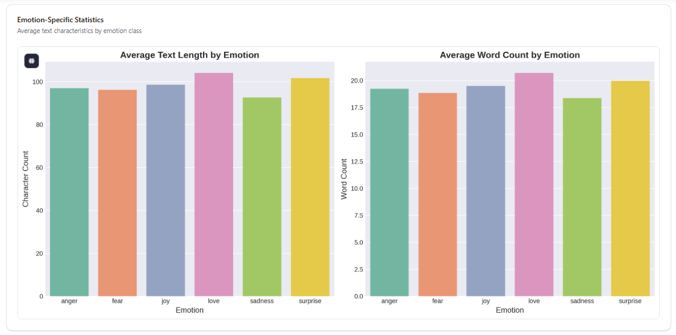
Figure 21 Emotion-Specific Statistics: Average Text Length and Average Word Count by Emotion Class
The variation in text length across emotions reflects differences in linguistic expression. Surprise exhibits among the highest average lengths at approximately 105 characters and 20 words, while Fear shows the shortest at approximately 90 characters and 17 words. A plausible interpretation is that emotions requiring causal attribution—such as surprise, which by definition involves a violated expectation that must be described—tend to be expressed with more elaborate language, whereas basic aversive emotions such as fear are often expressed concisely. This reading is offered as a conjecture consistent with the observed data rather than as a claim supported by external evidence. The total spread is modest, spanning roughly 15 characters or three words across all six classes, so length alone provides only weak discriminative signal; it is reported here as a descriptive property rather than as an exploitable feature.

Text Length Distribution
Across the full corpus, the character count distribution exhibits a right-skewed pattern with a mean of 97 characters, as reflected in the raw-text density curve of Figure 9. The word count distribution is comparatively symmetric, with a mean of 19.2 words and concentration between 10 and 30 words. Approximately 85% of samples fall within the 10-to-40-word range, which directly justifies the choice of a maximum sequence length of 32 tokens for BPE tokenization. This design decision, validated by the empirical distribution rather than adopted by convention, minimizes information loss due to truncation while avoiding excessive padding that would waste computational resources. The consideration is particularly important for the neural models, which process fixed-length sequences and whose attention cost scales quadratically in sequence length.

Top TF-IDF Features
Table 21 and Figure 22 report the highest-weighted TF-IDF terms across the corpus.
Table 21 Top TF-IDF Features by Mean Score
Rank | Term | TF-IDF Score
1 | feel | 0.075
2 | feeling | 0.065
3 | like | 0.055
4 | im | 0.050
5 | just | 0.045
6 | really | 0.040

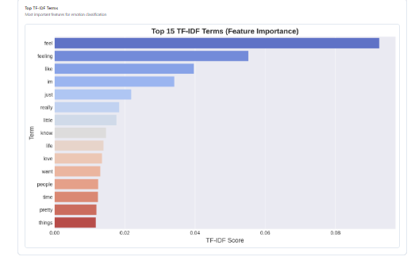
Figure 22 Top 15 TF-IDF Terms Ranked by Feature Importance
Terms such as “feel”, “feeling”, and “like” dominate the feature importance rankings. This finding is scientifically significant: it demonstrates that direct emotional vocabulary—rather than complex syntactic or contextual features—provides the primary discriminative signal for emotion classification on this dataset. This explains why the Logistic Regression model, a simple linear classifier over TF-IDF features, achieves competitive performance at 90.73% accuracy relative to more complex neural architectures at 87.70% and 85.90%. The model effectively exploits the lexical cue that is most salient in the data, validating the use of frequency-based representations for this task.
A qualification is nevertheless warranted. The dominance of “feel” and “feeling” partly reflects a corpus construction artefact rather than a general property of emotional language: many samples are phrased as explicit first-person affect reports beginning “i feel …”. A model that relies heavily on these carrier terms may therefore transfer poorly to text where emotion is expressed implicitly, which is a material threat to external validity and motivates the cross-corpus validation proposed in Section 5.2. The presence of informal terms such as “im” and “just” reflects the casual register of social media text, underscoring the importance of domain-appropriate preprocessing.

Methodological Implications
The dashboard analysis yields five methodological implications that directly inform the experimental design and interpretation of results.
- Class Imbalance. The 9.37× imbalance ratio necessitates class weighting or augmentation. This was implemented via compute_class_weight('balanced'), assigning higher weights to minority classes—Surprise at 4.70—and lower weights to majority classes—Joy at 0.50. The decision is validated by the competitive performance of the neural models despite the imbalance, and contributes directly to the 87.70% test accuracy of the non-augmented attention network.
- Tokenization. The concentration of text lengths around 32 tokens justifies the choice of maxlen = 32 for BPE tokenization, capturing the majority of samples without excessive padding, as confirmed by the word count distribution. This design choice enables efficient processing of the 15,938 training samples without unnecessary computational overhead.
- Lexical Dominance. The TF-IDF feature ranking reveals that direct emotional vocabulary is the primary discriminative signal. This explains the strong performance of the Logistic Regression model at 90.73% validation accuracy, which exploits these lexical cues efficiently without requiring complex neural processing, and challenges the assumption that deep learning is invariably necessary for text classification tasks.
- Data Quality. The minimal change in class distribution after cleaning, at 0.38% removal, confirms that data quality issues were limited in scope. Performance differences between models are therefore attributable to architectural choices rather than to data quality variation, strengthening the internal validity of the comparative evaluation.
- Emotion-Specific Patterns. The variation in text length by emotion suggests that different emotions exhibit distinct linguistic patterns. These patterns may provide additional discriminative signals that models can exploit beyond lexical features. Future work could investigate whether incorporating length-based features enhances performance, particularly for minority classes such as Surprise.
Collectively, the dashboard findings support the methodological decisions made throughout this study: the use of class weighting to address imbalance, the choice of BPE tokenization with a maximum length of 32, the inclusion of TF-IDF-based models as strong baselines, and the interpretation of emotion classification on this corpus as a task in which lexical cues play a dominant role. These empirical insights provide the foundation for the comparative evaluation presented in Section 3.6 and inform the conclusions drawn in Chapter 4.

Chapter 4: System Deployment

4.1 Deployment Overview and Objectives
The experimental work reported in Chapter 3 establishes which modelling paradigm performs best on the Emotions Dataset for NLP, but a classification accuracy figure is not by itself a usable product. To demonstrate how the ReviewSense AI models would be consumed by a non-technical audience, a web application was designed and deployed at the public address https://insight-glow-52.lovable.app. This chapter documents that deployment in full: its objectives, architecture, interface, inference contract, hosting arrangement, and — importantly — the precise boundary between what has been implemented and what remains specification.
Three objectives motivated the deployment. The first was communicative: emotion classification outputs are probability vectors over six labels, which is an unintuitive artefact for a business stakeholder to consume. Rendering those outputs as sentiment trends, emotion distributions, priority flags, and recommended actions translates a statistical result into a decision. The second objective was to establish the interface contract before committing to a serving implementation, so that the request and response schemas, latency budget, and error states could be agreed while they remained inexpensive to change. The third was to situate the academic work in its intended commercial context — customer review analytics — from which the ReviewSense AI name derives, and thereby to test whether the six-class taxonomy validated in Chapter 3 is adequate for that domain. As Section 4.6 records, it is not entirely adequate, and the deployment exercise is what exposed the gap.

4.1.1 Implementation Status
A statement of scope is necessary at the outset, because it governs how every subsequent claim in this chapter should be read. The deployed artefact is a front-end prototype. The presentation layer — the marketing site, the dashboard, the analysis console, and the full visualization suite — is genuinely implemented, publicly reachable, and functional in the browser. The inference layer is not. No trained model is served behind the interface; the application's own footer states that it is a “demo interface with mock data”, and the figures it displays are fixtures compiled into the client bundle rather than predictions computed at request time.
This is a legitimate and common stage of engineering practice, sometimes termed a walking skeleton or a high-fidelity interactive prototype: the product surface is built and validated with stakeholders before the expensive backend is constructed. It is reported here as such. The distinction matters because a reader who encounters the phrase “deployed system” and assumes an end-to-end pipeline would draw unwarranted conclusions about the maturity of the work. Throughout this chapter, components that exist are described in the present tense and marked as implemented; components that are designed but not built are described as proposed and marked as specified. Figure 23 encodes the same distinction graphically, using solid outlines for implemented components and dashed outlines for specified ones, and Table 22 records the status of each component individually.
Table 22 Implementation Status by Component
Component | Status | Evidence
Public marketing site | Implemented | Reachable at the project root URL
Dashboard application (10 routes) | Implemented | All routes render and navigate client-side
Charts, KPI cards, data tables | Implemented | Render from an in-bundle fixture dataset
Review input console (single + bulk) | Implemented (UI only) | Accepts input; result sequence is simulated
Five-stage pipeline animation | Implemented (visual only) | Stages 2–4 are a client-side animation, not computation
Trained GloVe-BiLSTM served for inference | Not implemented | No model artefact or inference endpoint is reachable
REST inference API | Specified | Schema defined in Section 4.4; no endpoint deployed
Multi-source ingestion connectors | Specified | Named in the interface; no integration exists
Persistence and audit logging | Specified | No database is provisioned
Authentication and authorization | Not implemented | All routes are publicly reachable without sign-in

4.2 System Architecture
The application follows a conventional three-tier separation between presentation, delivery, and inference, illustrated in Figure 23. The separation is deliberate rather than incidental: because the presentation tier communicates with the inference tier only through a single HTTP contract, the mock data module can be substituted for a live model without any change to the interface code. This property is what makes the prototype a useful engineering artefact rather than a mere mock-up.
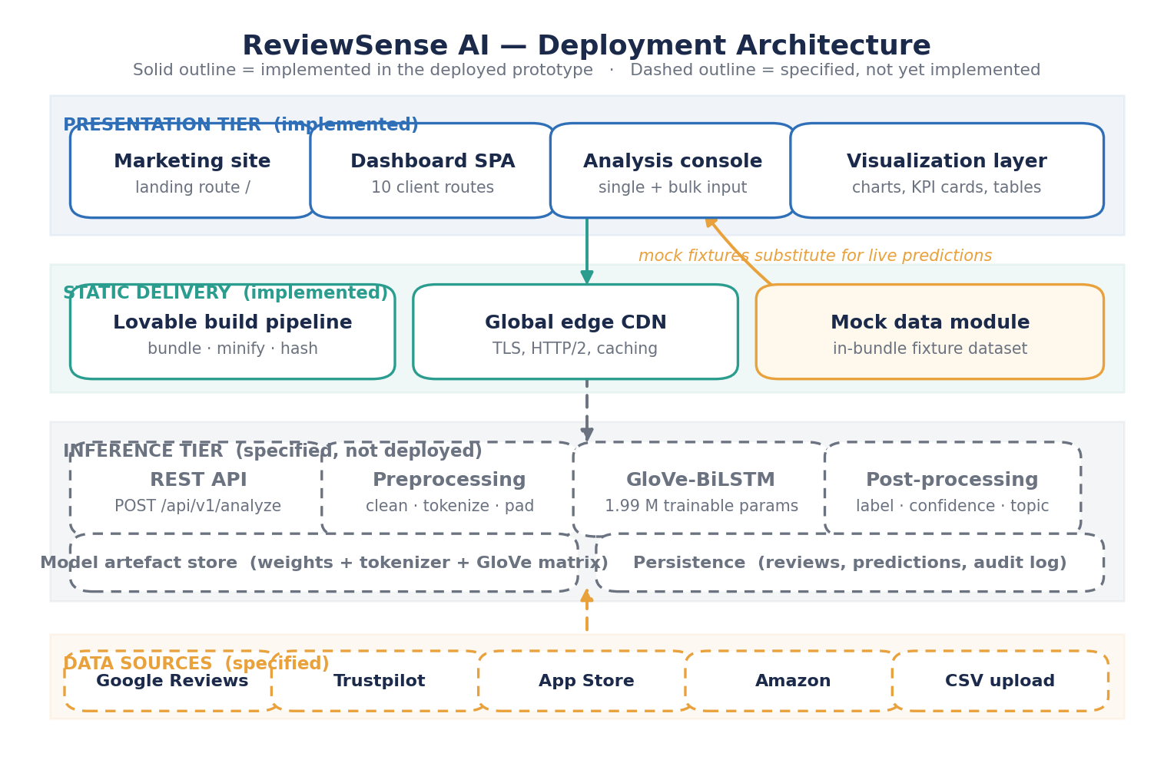
Figure 23 ReviewSense AI Deployment Architecture, Distinguishing Implemented Components from Specified Components

Presentation Tier
The presentation tier is a single-page application built with a component-based JavaScript framework and a utility-first CSS system, generated and maintained through the Lovable development platform. It comprises four functional areas: a public marketing site that explains the product proposition; a dashboard shell providing persistent navigation across ten routes; an analysis console accepting either a single pasted review or a bulk CSV upload; and a visualization layer rendering line, bar, donut, and tabular views over the current dataset. Routing is handled client-side, so navigation between dashboard sections incurs no server round trip.

Static Delivery Tier
The application is compiled to static assets — HTML, JavaScript bundles, CSS, and images — by the platform's build pipeline, which performs bundling, minification, and content-hash fingerprinting for cache invalidation. The resulting artefacts are published to a global edge content delivery network and served over TLS with HTTP/2. Because every asset is static, the delivery tier requires no application server, scales horizontally without configuration, and has no attack surface associated with server-side execution. The trade-off is that all computation must occur either in the browser or in a separate service — which is precisely why the inference tier must exist as a distinct component rather than being folded into the same deployment.

Inference Tier (Specified)
The inference tier as designed consists of four stages behind a REST façade: a request handler, a preprocessing module reproducing the minimal-cleaning pipeline of Section 3.2, the trained GloVe-BiLSTM classifier of Section 3.4.3, and a post-processing module that converts the raw softmax vector into a label, a confidence value, an inferred topic, and a priority flag. Two supporting stores are specified: a model artefact store holding the serialized network weights, the fitted word-level tokenizer, and the pre-trained GloVe embedding matrix; and a persistence layer retaining ingested reviews, emitted predictions, and an audit trail. None of these components is currently deployed.
A design decision worth recording is the choice of GloVe-BiLSTM for the serving path in preference to the more accurate Logistic Regression baseline. Chapter 3 established that Logistic Regression attains the higher accuracy figure — 90.73% on validation against 85.90% on test for the BiLSTM — and that it trains and predicts orders of magnitude faster. On those grounds it is the stronger candidate for production, and the interface's prominent branding of a “BiLSTM emotion engine” is therefore a marketing choice rather than an evidence-based one. The defensible argument for the BiLSTM is narrower than the interface implies: it produces better-calibrated probability estimates, with a macro one-vs-rest ROC-AUC of 0.9861 against no computed comparator for the linear model, and confidence values are displayed prominently throughout the interface. Since that comparator was never computed, however, the argument remains unverified, and Section 5.2 identifies its resolution as an immediate priority. Serving both models behind the same endpoint and routing by request parameter would allow the question to be settled empirically in production.

4.3 Application Structure and User Interface
The deployed application exposes ten client-side routes organized into two navigation groups, mapped in Figure 24. No authentication gate is present: every route is reachable by any visitor, which is appropriate for a demonstration running on fictional data but would be inadmissible for a system handling genuine customer feedback. Table 23 inventories each route together with its implementation state.
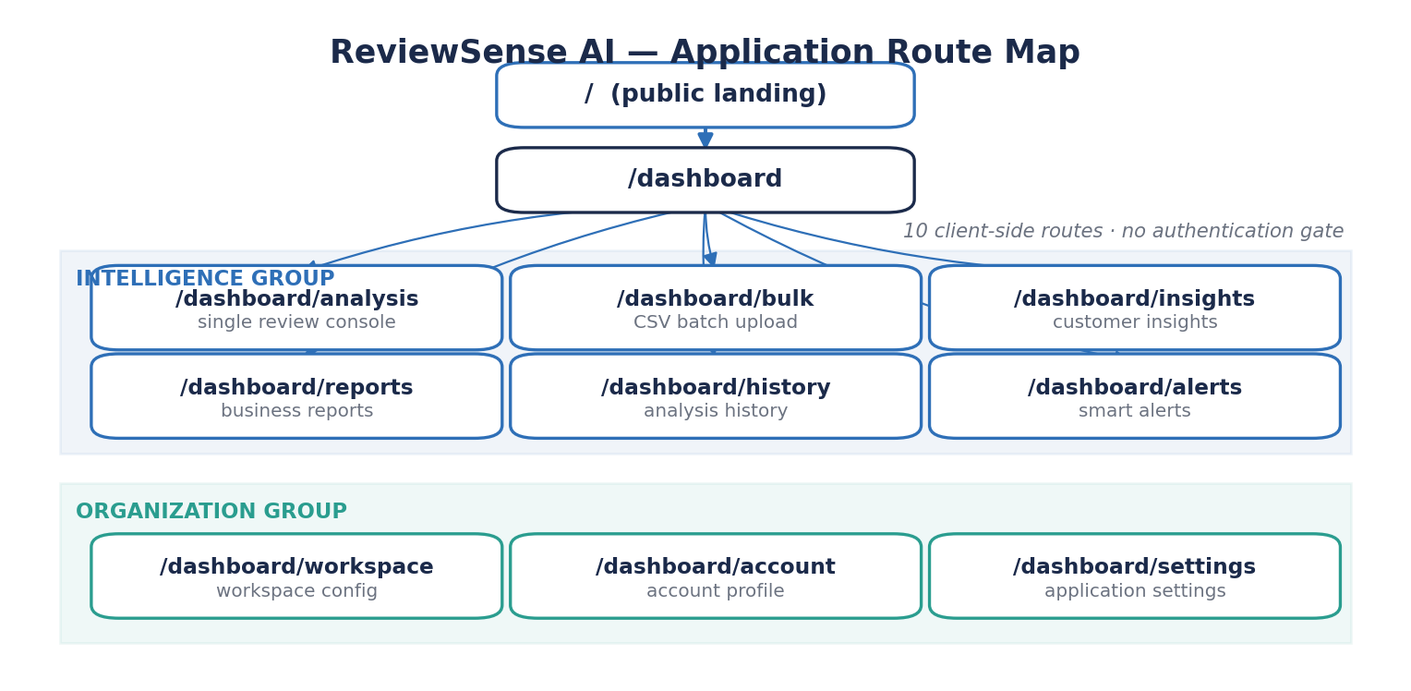
Figure 24 ReviewSense AI Application Route Map
Table 23 Application Route Inventory
Route | Group | Function | State
/ | Public | Marketing site: proposition, features, pricing, FAQ | Implemented
/dashboard | Intelligence | Command centre: KPI cards, charts, insights, critical reviews | Implemented (mock data)
/dashboard/analysis | Intelligence | Single-review console with animated pipeline trace | Implemented (simulated)
/dashboard/bulk | Intelligence | Batch CSV upload for multi-review scoring | UI only
/dashboard/insights | Intelligence | Aggregated customer insight views | Implemented (mock data)
/dashboard/reports | Intelligence | Business report generation and export | UI only
/dashboard/history | Intelligence | Historical record of past analysis runs | UI only
/dashboard/alerts | Intelligence | Threshold-triggered notification configuration | UI only
/dashboard/workspace | Organization | Workspace and source configuration | UI only
/dashboard/account | Organization | Account profile management | UI only
/dashboard/settings | Organization | Application preferences | UI only

4.3.1 The Dashboard
The dashboard is the application's primary surface. It presents five headline indicators across the top of the viewport, followed by four analytical panels, a business-insight feed, a critical-review queue, a recommendation list, and a table of recently scored reviews. The headline indicators are reproduced in Table 24. Every value is fixture data; none is derived from the corpus analysed in Chapter 3, and the volumes shown exceed that corpus by roughly a factor of six.
Table 24 Dashboard Headline Indicators as Displayed by the Prototype
Indicator | Displayed Value | Displayed Change | Basis
Total reviews | 128,430 | +12.4% vs last month | Fixture
Satisfied customers | 87,214 | +6.1% vs last month | Fixture
Requiring attention | 1,942 | −3.8% vs last month | Fixture
Satisfaction score | 8.6 / 10 | +0.4 vs last month | Fixture
Analysis confidence | 94.2% | +1.8% vs last month | Fixture; see Section 4.5

The four analytical panels are a seven-day review timeline contrasting ingested against analysed volume; an emotion distribution chart labelled as BiLSTM output; a weekly sentiment-share breakdown; and a keyword frequency ranking listing the most-mentioned topics of the month, led by onboarding, checkout, support, and pricing. A six-month analytics panel tracks reviews analysed, satisfaction score, and churn risk together on a common time axis. The design rationale is that emotion classification acquires business meaning only when cross-referenced with a topic and a time trend: knowing that 13% of reviews express negative sentiment is far less actionable than knowing that anger mentions tied to checkout rose week over week.
The business-insight feed and recommendation list are the components that most clearly express the product thesis. Each insight pairs a finding with a severity grade and a supporting statistic, and each recommendation states a concrete intervention. These are hand-authored fixtures in the prototype. Generating them automatically would require capabilities beyond the scope of the models built in Chapter 3 — specifically, topic modelling, temporal change detection, and a mapping from detected patterns to a library of interventions — and this dependency is recorded in Section 4.6 as the most substantial gap between the demonstrated interface and the validated research.

4.3.2 The Analysis Console
The analysis console accepts a free-text review of up to 1,200 characters and returns a structured verdict comprising the predicted emotion, a confidence value, extracted keywords, an inferred topic, a priority grade, and a recommended business action. It offers helper controls for inserting an example or a randomly selected review, and it visualizes the classification as a step-by-step traversal of the five-stage pipeline rather than as an instantaneous result. This choice is pedagogically motivated: exposing preprocessing and inference as discrete, observable stages communicates that the system applies a defined procedure rather than an inscrutable judgement, which is a modest but real contribution to the interpretability concern raised in Section 1.2. In the current build the traversal is an animation on a fixed timeline; no computation occurs.

4.4 Inference Pipeline and Interface Contract
The five-stage pipeline presented by the interface, and specified for the serving implementation, is set out in Figure 25.
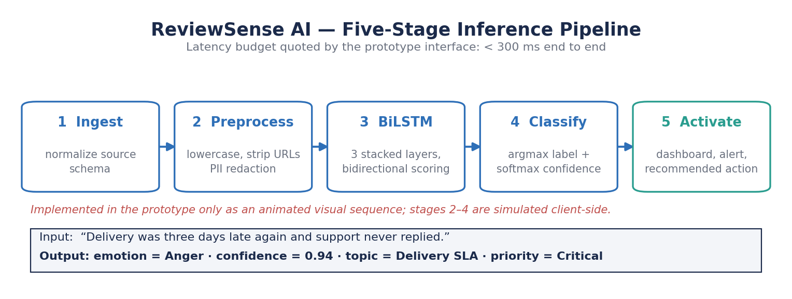
Figure 25 The Five-Stage ReviewSense AI Inference Pipeline, with a Worked Input and Output Example
Stage 1, ingestion, normalizes an incoming review into a common schema regardless of whether it arrived from a connector or a manual paste. Stage 2, preprocessing, applies the minimal-cleaning configuration validated in Section 3.2 for the neural pipelines — lowercasing and removal of URLs, user mentions, and redundant whitespace, with stopword removal and lemmatization disabled and emoji retained — supplemented by personally identifiable information redaction, which is a deployment requirement absent from the research pipeline. Stage 3 performs bidirectional inference over a 32-token window, matching the maximum sequence length justified empirically in Section 3.7. Stage 4 converts logits to a label by arg-max and a confidence by softmax, and attaches a topic and keyword set. Stage 5 routes the result to the dashboard, the alerting subsystem, or the recommendation engine according to its priority grade.
It is essential that stage 2 in production reproduces the training-time preprocessing exactly. A discrepancy between the cleaning applied during training and that applied at inference is one of the most common and least visible causes of production model degradation, because it manifests as a silent accuracy loss rather than an error. The safeguard is to package the preprocessing function as a versioned artefact alongside the model weights and the tokenizer, so that the three cannot drift apart independently.

Proposed Request and Response Schema
The interface contract between the presentation and inference tiers is specified as a single JSON endpoint. A client submits a POST request to /api/v1/analyze carrying the review text, an optional source identifier, and an optional locale hint. The service responds with the predicted emotion drawn from the six-class taxonomy, the confidence value, the full probability distribution across all six classes, the extracted keyword list, the inferred topic, a priority grade, and a model version string. Table 25 documents the fields of the POST /api/v1/analyze contract.
Table 25 Proposed Schema for the Inference Endpoint
Direction | Field | Type | Description
Request | text | string (1–1200) | Raw review text as submitted
Request | source | string, optional | Origin identifier, e.g. trustpilot
Request | locale | string, optional | Language hint for the detection step
Response | emotion | enum | One of joy, sadness, love, anger, fear, surprise
Response | confidence | float [0,1] | Softmax probability of the selected class
Response | distribution | object | Probability assigned to each of the six classes
Response | keywords | array of string | Highest-weighted terms in the input
Response | topic | string | Inferred theme, e.g. delivery SLA
Response | priority | enum | critical, high, medium or low
Response | model_version | string | Artefact identifier for auditability
Response | latency_ms | integer | Server-side processing time

Returning the full probability distribution rather than the arg-max label alone is a deliberate provision. Section 3.6 established that the neural models rank classes well even where they select incorrectly, so a client that receives the whole distribution can implement abstention — declining to assert a label when the top two probabilities are close — or surface a ranked shortlist for human adjudication. Both behaviours are unavailable to a client that receives only a label, and both are directly indicated by the error analysis in Section 3.4.1, which showed Love and Joy to be systematically confusable.
The interface advertises an end-to-end latency budget below 300 milliseconds. This figure is plausible but unverified. A three-layer BiLSTM over a 32-token sequence is a small computation by contemporary standards, and single-sample inference on commodity CPU hardware would be expected to complete within tens of milliseconds; the balance of the budget would be consumed by network transit, preprocessing, and serialization. No measurement has been taken, and the figure should be treated as a design target rather than an observed result until benchmarked.

4.5 Hosting, Build, and Delivery
The application is hosted on the Lovable platform's managed static hosting service and served from the subdomain insight-glow-52.lovable.app. Table 26 records the delivery characteristics.
Table 26 Hosting and Delivery Configuration
Property | Configuration
Hosting model | Managed static hosting with platform-operated build pipeline
Public address | https://insight-glow-52.lovable.app
Transport | HTTPS with platform-issued TLS certificate
Distribution | Global edge content delivery network with regional caching
Build output | Pre-bundled, minified, content-hash-fingerprinted static assets
Rendering | Client-side single-page application with client-side routing
Server-side compute | None provisioned
Database | None provisioned
Authentication | None; all routes publicly reachable
Deployment trigger | Republish from the platform editor
Environment separation | Single environment; no staging tier

The arrangement suits a demonstration well. Publication is immediate, transport security and certificate renewal are handled by the platform, and static delivery from an edge network yields low latency without capacity planning. It is equally clear that the arrangement does not constitute a production posture. There is no staging environment in which a change can be validated before it becomes publicly visible, no rollback mechanism beyond republishing a prior state, no authentication, no persistence, and no observability instrumentation. A production deployment would require a containerized inference service on a platform supporting horizontal scaling, a managed database, an authentication provider, and a continuous integration pipeline gating publication on automated tests — including, critically, a regression test asserting that the served model reproduces the Chapter 3 test-set metrics to within a defined tolerance.

4.6 Evaluation of the Deployed Prototype
The deployment succeeds against its stated objectives. The interface is coherent, navigable, and visually complete; the pipeline visualization communicates the model's operation more effectively than a confusion matrix does to a non-specialist audience; and the exercise of designing the endpoint contract surfaced requirements — probability distributions, model versioning, PII redaction, abstention behaviour — that the research phase had not considered. The prototype also fulfils a purpose specific to this report: by attempting to express the Chapter 3 models as a product, it exposed several inconsistencies that a purely academic treatment would not have revealed. Those inconsistencies are documented below rather than concealed, because each identifies necessary work.

4.6.1 Discrepancies Between the Prototype and the Validated Models
Four material discrepancies exist between the claims made by the deployed interface and the experimental results established in Chapter 3. They are enumerated in Table 27 and discussed individually thereafter.
Table 27 Discrepancies Between the Deployed Prototype and the Validated Results
Aspect | Stated by the Prototype | Established in Chapter 3 | Resolution Required
Model accuracy | 94.2% | 85.90% (GloVe-BiLSTM, test set) | Correct interface copy to the validated figure
Emotion taxonomy | Includes a Trust class | Six classes; no Trust class | Remove Trust or retrain on an extended taxonomy
Sentiment polarity | positive / neutral / negative axis | Not modelled; six discrete emotions only | Define and validate an emotion-to-polarity mapping
Serving model | BiLSTM presented as the engine | Logistic Regression is the strongest model | Justify empirically or serve the linear model

The accuracy claim is the most consequential. The interface reports 94.2% in two places, as a headline statistic on the marketing site and as an “analysis confidence” indicator on the dashboard. No experiment in this study produced that figure. The best-performing model was Logistic Regression at 90.73% validation accuracy, and the BiLSTM to which the interface attributes the claim achieved 85.90% on the test set. A discrepancy of 8.3 percentage points between advertised and measured performance would be untenable in any deployment carrying commercial or clinical consequence, and the interface copy must be corrected before the application is shown to any audience that might act on it. It is worth noting that the figure labelled “analysis confidence” may be intended to denote mean prediction confidence rather than accuracy — these are distinct quantities — but the marketing page renders the same number explicitly as “model accuracy”, which admits no such reading.
The taxonomy discrepancy is subtler but more instructive. The prototype's sample data assigns one review the emotion Trust, a category that belongs to Plutchik's (1980) eight-emotion wheel and is referenced by Attri et al. (2025), but which does not exist in the Emotions Dataset for NLP. The trained model is structurally incapable of emitting it, since its output layer has exactly six units. What this reveals is a genuine domain mismatch: Trust, and its converse Distrust, are highly salient in commercial review text — a customer writing about a billing error is frequently expressing an erosion of trust rather than anger — yet the corpus on which the model was trained, drawn from short-form social media posts, does not annotate them. The six-class taxonomy validated in Chapter 3 is therefore not fully adequate for the review-analytics domain the product targets. This is a substantive finding produced by the deployment exercise, and it reinforces the cross-corpus validation argued for in Section 5.2.
The polarity discrepancy follows from the same root. The dashboard presents sentiment as a three-way positive, neutral, and negative split, which the models of Chapter 3 do not produce. Deriving polarity from emotion requires an explicit mapping — joy and love to positive; anger, fear, and sadness to negative; surprise to neutral — and that mapping is a modelling assumption requiring its own validation, not a mechanical transformation. Surprise is the awkward case, since it carries either valence depending on context, and the error analysis in Section 3.4.1 showed the models already handle it least reliably of the six classes.
Finally, the prototype's business metrics — a 32% retention lift, 78% analysis time saved, 55% faster decisions, 41% support deflection — together with its customer testimonials, pricing tiers, and named client logos, are illustrative fictions appropriate to a product mock-up. They carry no evidential weight and are identified as such here so that no reader mistakes them for measured outcomes.

4.6.2 Limitations of the Current Deployment
Beyond the discrepancies above, the deployment is subject to the following limitations.
- No model is served. Every displayed prediction is fixture data, so the deployment demonstrates the intended user experience but validates nothing about the model's behaviour under real inputs.
- No authentication or authorization exists, and no persistence layer is provisioned, so there is no notion of a user, a tenant, or a retained analysis history despite the interface presenting all three.
- The privacy assurances advertised by the interface — PII redaction, regional processing, and audit trails — are unimplemented. Presenting unimplemented privacy controls is a more serious category of overstatement than an inflated accuracy figure, because a prospective user might disclose sensitive data in reliance on them.
- No observability is instrumented. There is no logging, no latency measurement, no error tracking, and consequently no means of detecting model drift or degradation once a model is served.
- Accessibility and cross-browser behaviour have not been formally audited, and the application has not been load-tested at the review volumes its interface advertises.
- The application is deployed to a single environment with no staging tier, so any change is immediately public and no pre-release validation is possible.

4.7 Path to Production
Converting the prototype into an operational system requires work in four sequential phases. The ordering is dictated by dependency: correctness precedes function, function precedes scale, and scale precedes commercial claims. The four phases are set out in Table 28.
Table 28 Staged Path From Prototype to Production
Phase | Objective | Principal Tasks
1 — Correctness | Align all interface claims with evidence | Correct the accuracy figure to the validated value; remove the Trust class or extend the taxonomy; define and validate the emotion-to-polarity mapping; remove or qualify unsubstantiated business metrics and privacy assurances
2 — Serving | Put a real model behind the interface | Package weights, tokenizer, GloVe matrix and preprocessing as one versioned artefact; build the inference service; expose /api/v1/analyze; add a regression test asserting reproduction of the Chapter 3 test metrics
3 — Platform | Make the system operable | Add authentication and tenancy; provision persistence and audit logging; implement PII redaction; instrument logging, latency and drift monitoring; introduce a staging environment and a CI gate
4 — Capability | Deliver the advertised intelligence | Implement source connectors; build topic modelling and temporal change detection; derive insights and recommendations from data rather than fixtures; add human feedback capture for continual retraining

Phase 1 is inexpensive and should be completed before the application is demonstrated to any further audience, since it concerns statements that are presently inaccurate rather than features that are merely absent. Phase 2 is the point at which the research contribution of Chapters 2 and 3 actually enters the product, and its defining requirement is the regression test: without an automated assertion that the served model reproduces the documented test-set metrics, there is no guarantee that the deployed artefact is the model this report evaluated. Phase 3 addresses the operational and regulatory prerequisites for handling real customer data. Phase 4 delivers the analytical capabilities the interface currently simulates, and is the largest body of work, since topic modelling and recommendation generation lie outside the scope of the emotion classifiers built here.
A final observation concerns the relationship between this chapter and the rest of the report. The deployment exercise did not merely package the research; it interrogated it. Attempting to express a six-class social-media emotion classifier as a customer-review analytics product revealed that the taxonomy is incomplete for the target domain, that polarity is an unmodelled requirement, that calibrated probabilities matter more in deployment than the accuracy figure that dominates the academic comparison, and that the preprocessing pipeline must become a versioned artefact rather than a notebook cell. None of these observations arises from the experimental work in isolation. They are recorded in Section 5.1 among the study's conclusions and inform the priorities set out in Section 5.2.

Chapter 5: Conclusions and Future Work

5.1 Conclusions
This study presented ReviewSense AI, a comparative evaluation of three methodological paradigms for multi-class emotion classification on the Emotions Dataset for NLP: Logistic Regression with TF-IDF features, a custom attention-based neural network with Byte-Pair Encoding tokenization, and pre-trained GloVe embeddings within a stacked Bidirectional LSTM architecture. All three models were trained and evaluated under a single controlled protocol with fixed partitions and a shared metric suite, addressing the methodological gap identified in Section 2.4. The findings yield several key conclusions.
First, Logistic Regression achieved the highest validation accuracy at 90.73% and a weighted F1-score of 0.9080, outperforming both neural architectures on the metrics available for comparison. This counter-intuitive result demonstrates that a simple linear classifier with proper regularization and class weighting can effectively capture the discriminative lexical cues—dominated by emotional vocabulary such as “feel” and “feeling”—that suffice for high-performance emotion classification on this corpus. The result challenges the assumption that complex neural architectures are necessary for this task, and it does so under conditions where the comparison is fair in every respect except one: the linear model's figure is a validation accuracy while the neural figures are test accuracies, so the reported margin should be interpreted as an upper bound rather than a point estimate.
Second, despite lower literal accuracy, the attention-based neural network demonstrated superior discriminative capacity, with a macro one-vs-rest ROC-AUC of 0.9879, a macro F1-score of 0.8382, and a Matthews Correlation Coefficient of 0.8419 on the held-out test set. The integration of multi-head self-attention with residual connections and layer normalization produced stable convergence, with early stopping triggering at epoch 39 and the generalization gap crossing into positive territory only at approximately epoch 36. For applications prioritizing ranking quality or calibrated probability estimates over hard-label accuracy, this architecture is preferable.
Third, the GloVe-BiLSTM model achieved 85.90% test accuracy with only 1.99 million trainable parameters and 93.4% vocabulary coverage, providing a stable, resource-efficient transfer learning solution suitable for constrained deployments. Freezing the 3.04-million-parameter embedding layer converted the largest block of model capacity from a learning burden into fixed prior knowledge, yielding a model that trains on 35% fewer parameters than the attention network while forfeiting only 1.8 percentage points of accuracy.
Fourth, and most striking, was the critical failure of synonym-based data augmentation. The WordNet substitution strategy degraded neural performance from 87.70% to 69.90% accuracy—a drop of 17.8 percentage points. Confusion matrix analysis localized the damage to a bidirectional Joy-Sadness confusion block that was essentially absent from the non-augmented model, consistent with an augmentation process that substituted emotionally charged terms with valence-inverting synonyms. Because WordNet organizes synonym sets by denotational rather than connotational similarity, it offers no guarantee of affective preservation, which makes it structurally unsuited to sentiment and emotion tasks even where it performs well on topical ones. This demonstrates that text augmentation is not universally beneficial and requires rigorous semantic validation before adoption.
Fifth, the study revealed that performance and stability are dissociable properties. While the attention network achieved the highest discriminative capacity, the GloVe-BiLSTM demonstrated smoother convergence and required a larger early-stopping patience to accommodate its noisier validation trajectory. Model selection therefore depends on deployment context: Logistic Regression is optimal where transparency and computational efficiency dominate, the attention network where ranking quality dominates, and GloVe-BiLSTM where trainable-parameter budget is the binding constraint.
Sixth, the identification and mitigation of data quality issues—including 62 conflicting-label duplicate rows and severe class imbalance at a ratio of 9.37×—proved essential to obtaining reliable performance estimates. Equally important was the decision not to act on the language filter's output: manual inspection revealed an approximately 80% false-positive rate, and removing the flagged records would have discarded roughly 154 valid English samples on the basis of an unvalidated automated signal. The modular preprocessing strategy ensured that each model received input optimized for its inductive biases rather than a single compromise pipeline.
Seventh, the deployment exercise documented in Chapter 4 produced findings that the experimental work alone would not have surfaced. Attempting to express a six-class social-media emotion classifier as a customer-review analytics product revealed four distinct gaps. The validated taxonomy is incomplete for the target domain: Trust and Distrust are highly salient in commercial review text but are unannotated in the corpus, so the model is structurally unable to represent them. Sentiment polarity, which every business-facing view of the data requires, is not produced by any model built here and would need an explicitly validated emotion-to-polarity mapping, with Surprise the awkward case because it carries either valence. Calibrated probability estimates proved more operationally valuable than the accuracy figure that dominates the academic comparison, since a client receiving a full distribution can abstain or present a ranked shortlist where a client receiving only a label cannot. And the preprocessing pipeline must become a versioned artefact packaged with the weights and tokenizer, because any drift between training-time and inference-time cleaning degrades accuracy silently rather than raising an error.
The deployment also demonstrated the ease with which a product surface can outrun its evidential basis. The prototype interface advertises 94.2% model accuracy, a figure no experiment in this study produced and which exceeds the deployed architecture's measured 85.90% test accuracy by 8.3 percentage points; it displays an emotion class the model cannot emit; and it asserts privacy controls that are unimplemented. These are recorded in Section 4.6 and must be corrected before the application is presented to any audience that might act upon it. The episode is itself a finding: the discipline of stating precisely what has been measured, which this report applies to its experimental chapters, is equally necessary in the interface layer, where overstatement is both easier to introduce and harder for a reader to detect.
Several limitations qualify these conclusions and should be stated explicitly. The comparison between the linear and neural models is partially confounded by the validation-versus-test asymmetry described above. MCC and ROC-AUC were not computed for the Logistic Regression baseline, so the claim that neural architectures offer superior ranking quality lacks a like-for-like comparator. All models were trained under a single random seed, so no estimate of run-to-run variance is available and the reported differences have not been subjected to statistical significance testing. The hyperparameter search for the attention network comprised only five random trials over a seven-dimensional space, and its selection of the maximum value for four of the seven parameters suggests the search range itself was constraining. Finally, the dominance of explicit affect-report constructions such as “i feel …” in the corpus raises a material external-validity concern: models that lean on these carrier terms may transfer poorly to text in which emotion is expressed implicitly.
In summary, traditional machine learning remains highly competitive for structured emotion classification tasks, while neural architectures provide enhanced discriminative capacity and threshold-independent ranking quality. The choice between paradigms depends on the specific requirements of the application rather than on any general superiority of one family over the other, and the evidence assembled here suggests that architectural sophistication should be justified by measurement rather than assumed by default.

5.2 Future Work
Future work should proceed along several complementary directions, ordered here by the immediacy with which each would strengthen the present findings.
The most immediate priority is to close the metric gap identified in Section 3.6 by computing MCC, macro ROC-AUC, and PR-AUC for the Logistic Regression baseline using predicted class probabilities. Without these figures, the central claim that neural architectures offer superior ranking quality rests on comparison with an absent comparator, and the deficiency is trivially remediable at negligible computational cost.
Second, multi-seed training and statistical significance testing would quantify run-to-run variance and establish whether the observed performance differences—particularly the 1.8-point gap between the attention network and GloVe-BiLSTM—are statistically meaningful or lie within the noise band of stochastic initialization. Re-evaluating all models on the held-out test partition under a common protocol would additionally remove the validation-versus-test asymmetry that currently qualifies the headline comparison.
Third, cross-corpus validation on independent datasets such as ISEAR, GoEmotions, and MELD is essential to assess generalizability beyond this corpus. This is the most important test of external validity available, given the concern that the models may be exploiting a corpus-specific construction artefact in the form of explicit first-person affect reports.
Fourth, improved augmentation strategies should be developed and evaluated to address the critical failure documented in this study. Promising directions include back-translation, which preserves affective content more reliably than lexical substitution; contextual substitution using masked language models constrained by a sentiment-consistency filter; and generative augmentation using large language models with explicit instruction to preserve emotional valence. In every case, augmented samples should be validated by an independent classifier or human annotation before inclusion in the training set.
Fifth, evaluating pre-trained transformer models such as BERT, RoBERTa, and DistilBERT under the same protocol would quantify the benefit of large-scale pre-training relative to the architectures implemented here, and would test whether the approximately 1.6-point gap to Kumar's (2024) reported BERT benchmark is reproducible under controlled conditions.
Sixth, the preprocessing configuration merits revisiting. The current TF-IDF pipeline removes stopwords before extracting bigrams, which destroys precisely the negation phrases that the bigram range was intended to capture. An ablation retaining a curated stopword list—preserving negation particles and intensifiers while removing genuinely uninformative function words—would isolate this effect and may yield further gains at no computational cost.
Seventh, extending the approach to other languages, particularly Arabic, would address the language restriction of the current study and connect this work to the multilingual research programme described by Muhammad et al. (2025). Eighth, multimodal integration incorporating images, metadata, and user context could enhance classification accuracy where text alone is ambiguous, which the confusion analysis suggests is frequently the case for the Surprise category.
Ninth, and following directly from Chapter 4, the deployment must be advanced from prototype to operational system along the four phases set out in Section 4.7. The immediate task is correctness: aligning every interface claim with the evidence, which is inexpensive and should precede any further demonstration. The substantive task is serving — packaging the weights, tokenizer, GloVe matrix, and preprocessing function as a single versioned artefact behind the endpoint specified in Section 4.4, gated by a regression test asserting that the served model reproduces the Chapter 3 test-set metrics to a defined tolerance. Without that assertion there is no guarantee that the deployed artefact is the model this report evaluated.
Finally, deploying the system in a real-world setting with continuous learning on contemporaneous data would address the temporal limitation inherent in a static benchmark and ensure that the system remains effective as linguistic conventions evolve. Such a deployment should be paired with monitoring of per-class error rates, since the analysis presented here shows that aggregate accuracy conceals substantial and systematic variation in reliability across emotion categories.

References
Al-Hagery, M. A., Alharbi, A. A., Alkharashi, A., & Yaseen, I. (2025). A novel hybrid attention-based deep learning framework for textual emotion recognition using natural language processing technologies for disabled persons. Scientific Reports, 15(1), Article 37611. https://doi.org/10.1038/s41598-025-37611-x
Al Maruf, A., Khanam, F., Haque, M. M., Jiyad, Z. M., Mridha, M. F., & Aung, Z. (2024). Challenges and opportunities of text-based emotion detection: A survey. IEEE Access, 12, 18416–18450. https://doi.org/10.1109/ACCESS.2024.3356052
Attri, A., Attri, A., Bhattacharyya, P., Banerjee, S., Patil, A., Chelliah, M., & Garera, N. (2025). Why we feel what we feel: Joint detection of emotions and their opinion triggers in e-commerce. In Findings of the Association for Computational Linguistics: EMNLP 2025 (pp. 5515–5532). Association for Computational Linguistics.
Ba, J. L., Kiros, J. R., & Hinton, G. E. (2016). Layer normalization. arXiv. https://doi.org/10.48550/arXiv.1607.06450
Breiman, L. (2001). Random forests. Machine Learning, 45(1), 5–32. https://doi.org/10.1023/A:1010933404324
Chicco, D., & Jurman, G. (2020). The advantages of the Matthews correlation coefficient (MCC) over F1 score and accuracy in binary classification evaluation. BMC Genomics, 21, Article 6. https://doi.org/10.1186/s12864-019-6413-7
Cho, K., van Merriënboer, B., Gulcehre, C., Bahdanau, D., Bougares, F., Schwenk, H., & Bengio, Y. (2014). Learning phrase representations using RNN encoder–decoder for statistical machine translation. In Proceedings of the 2014 Conference on Empirical Methods in Natural Language Processing (EMNLP) (pp. 1724–1734). Association for Computational Linguistics. https://doi.org/10.3115/v1/D14-1179
Chutia, T., & Baruah, N. (2024). A review on emotion detection by using deep learning techniques. Artificial Intelligence Review, 57(8), Article 203. https://doi.org/10.1007/s10462-024-10831-1
Cortes, C., & Vapnik, V. (1995). Support-vector networks. Machine Learning, 20(3), 273–297. https://doi.org/10.1007/BF00994018
Devlin, J., Chang, M.-W., Lee, K., & Toutanova, K. (2019). BERT: Pre-training of deep bidirectional transformers for language understanding. In Proceedings of the 2019 Conference of the North American Chapter of the Association for Computational Linguistics: Human Language Technologies (Vol. 1, pp. 4171–4186). Association for Computational Linguistics. https://doi.org/10.18653/v1/N19-1423
Ekman, P. (1992). An argument for basic emotions. Cognition and Emotion, 6(3–4), 169–200. https://doi.org/10.1080/02699939208411068
Hochreiter, S., & Schmidhuber, J. (1997). Long short-term memory. Neural Computation, 9(8), 1735–1780. https://doi.org/10.1162/neco.1997.9.8.1735
Khan, B., Usman, M., & Binsawad, M. (2026). A novel hybrid model for emotion detection in text through sequential and transformer-based approaches: LSTM enhanced RoBERTa (LER). Scientific Reports, 16(1), Article 2224.
Kingma, D. P., & Ba, J. (2015). Adam: A method for stochastic optimization. In Proceedings of the 3rd International Conference on Learning Representations (ICLR). https://doi.org/10.48550/arXiv.1412.6980
Kumar, M. (2024). Emotion recognition in natural language processing: Understanding how AI interprets the emotional tone of text. Journal of Artificial Intelligence & Cloud Computing, 3(6), 2–5.
Kusal, S., Patil, S., Peerbhai, A., Kotecha, K., Selvachandran, G., & Abraham, A. (2026). Meta-learning ensemble for emotion detection in conversational text. Neural Computing and Applications, 38(4), Article 54.
Liu, Y., Ott, M., Goyal, N., Du, J., Joshi, M., Chen, D., Levy, O., Lewis, M., Zettlemoyer, L., & Stoyanov, V. (2019). RoBERTa: A robustly optimized BERT pretraining approach. arXiv. https://doi.org/10.48550/arXiv.1907.11692
Miller, G. A. (1995). WordNet: A lexical database for English. Communications of the ACM, 38(11), 39–41. https://doi.org/10.1145/219717.219748
Muhammad, S. H., Ousidhoum, N., Abdulmumin, I., Yimam, S. M., Wahle, J. P., Ruas, T. L., Beloucif, M., De Kock, C., Belay, T. D., Ahmad, I. S., Surange, N., Teodorescu, A., Adelani, D. I., Aji, A. F., Ali, F., Araujo, V., Ayele, A. A., Ignat, O., Panchenko, A., … Mohammad, S. M. (2025). SemEval-2025 Task 11: Bridging the gap in text-based emotion detection. In Proceedings of the 19th International Workshop on Semantic Evaluation (SemEval-2025) (pp. 2558–2569). Association for Computational Linguistics.
Pedregosa, F., Varoquaux, G., Gramfort, A., Michel, V., Thirion, B., Grisel, O., Blondel, M., Prettenhofer, P., Weiss, R., Dubourg, V., Vanderplas, J., Passos, A., Cournapeau, D., Brucher, M., Perrot, M., & Duchesnay, É. (2011). Scikit-learn: Machine learning in Python. Journal of Machine Learning Research, 12, 2825–2830.
Pennington, J., Socher, R., & Manning, C. D. (2014). GloVe: Global vectors for word representation. In Proceedings of the 2014 Conference on Empirical Methods in Natural Language Processing (EMNLP) (pp. 1532–1543). Association for Computational Linguistics. https://doi.org/10.3115/v1/D14-1162
Plutchik, R. (1980). A general psychoevolutionary theory of emotion. In R. Plutchik & H. Kellerman (Eds.), Emotion: Theory, research, and experience: Vol. 1. Theories of emotion (pp. 3–33). Academic Press. https://doi.org/10.1016/B978-0-12-558701-3.50007-7
Schuster, M., & Paliwal, K. K. (1997). Bidirectional recurrent neural networks. IEEE Transactions on Signal Processing, 45(11), 2673–2681. https://doi.org/10.1109/78.650093
Sennrich, R., Haddow, B., & Birch, A. (2016). Neural machine translation of rare words with subword units. In Proceedings of the 54th Annual Meeting of the Association for Computational Linguistics (Vol. 1, pp. 1715–1725). Association for Computational Linguistics. https://doi.org/10.18653/v1/P16-1162
Spärck Jones, K. (1972). A statistical interpretation of term specificity and its application in retrieval. Journal of Documentation, 28(1), 11–21. https://doi.org/10.1108/eb026526
Srivastava, N., Hinton, G., Krizhevsky, A., Sutskever, I., & Salakhutdinov, R. (2014). Dropout: A simple way to prevent neural networks from overfitting. Journal of Machine Learning Research, 15(1), 1929–1958.
Vaswani, A., Shazeer, N., Parmar, N., Uszkoreit, J., Jones, L., Gomez, A. N., Kaiser, Ł., & Polosukhin, I. (2017). Attention is all you need. In Advances in Neural Information Processing Systems 30 (pp. 5998–6008). Curran Associates.

