# **C3-S8 –PRACTICE**

## EX1

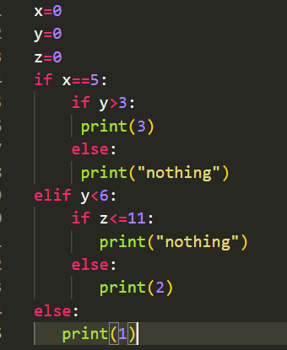Convert this tree to python

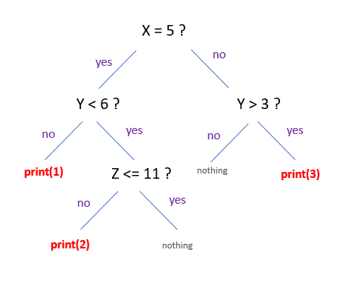

## EX2

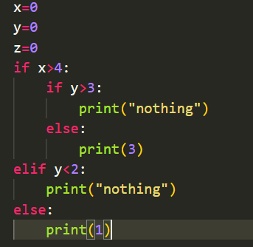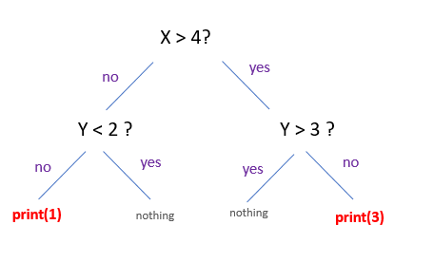Converts this tree to python

## EX3

* Create variable name “**nbRepeat**” and set the values to 5
* Print « Hello World » following variable**« nbRepeate »** times

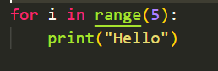**It should print this:**

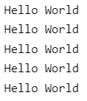

## EX4

Create variable name “**number**” set the value to 20

As long as when the number still greater than 5

* Print “**number**”
* Increment number of -2

**It should print this:**

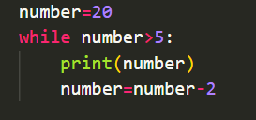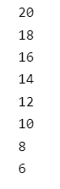

## EX5

* Create 2 variables
* name = “Tola”
* age = 21

You shall write the value of those 2 variables with some text, as show on the result

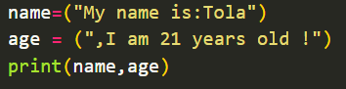It should print this:

**My name is : Tola, I am : 21 years old !**

## EX6

Get the number **entered from keyboard** and store it into a variable **userMessage**

* If the **userMessage** is lower than 0, display “Negative Number!”
* Else display “Positive Number”

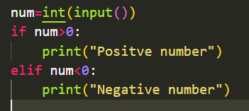**Example:**

If user enters -1:

**Negative Number!**

If user enters 5:

**Positive Number!**

## EX7

Example: To see "Dog" number must be in the range: **] –infinity, 25[**

|  |
| --- |
| if number < 25 :  print(« Dog »)  elif number <= 30 :  print(«Cat»)  else :  print(«Cow ») |

Q1: What must be the range of number to see "Cat"?

]-infinity, 30[

Q2: What must be the range of number to see "Cow"?

[ 30, +infinity [

## EX8

What will be print if value equal to 10?

|  |
| --- |
| if value >= 5 :  print(« Apple »)  elif value <= 10 :  print(«Banana») |

Answer:

Apple

## EX9

What will be print if value equal to 10?

|  |
| --- |
| if value >10 :  print(« Red »)  if value <= 10 :  print(«Blue») |

Answer:

Blue

## EX10

- Enter a string **text** in the console

- **n** is the length of **text**

- Print **n** times of the character "X”

Case 1:

>test

>X X X X

Case 2:

>tryagain

>X X X X X X X X

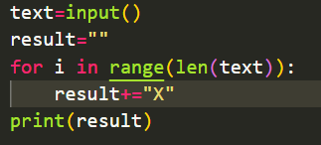

## EX11

-Enter a number **n** in the console

-Print a reversed triangle of “X”

Exemple:

>5

>X

>X X

>X X X

>X X X X

>X X X X X

>2

>X

>X X

## 

## EX12

-Enter a number **n** in the console

-Print a reversed using numbers (see example)

Example:

>5

>12345

>1234

>123

>12

>1

>2

>12

>1

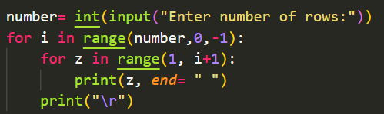

## EX13

- Enter a string **word** in the console

- Print “X” on the console (see example)

Exemple:

>hello

>XXXXX

>testing

>XXXXXXX



## EX14

- Enter a string **word** in the console

- Enter the number **n** in the console

- If **word** equal to “good” and the number between 7 and 15, it’s will be print “It’s good”

- If **word** equal to “bad” and the number lower than 7 or greater than 15, it’s will be print “It’s bad”

Exemple:

>good

>10

>It’s good

>bad

>6

>It’s bad

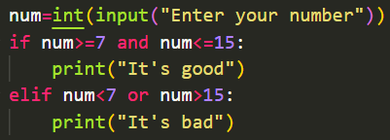

## EX15

- Enter a number **n** in the console

- Print a reversed using numbers (see example)

Example:

>5

>1

>2 3

>4 5 6

>7 8 9 10

>11 12 13 14 15

Example :

>3

>1

>2 3

>4 5 6