

INTEGRATED
CORRECTIONAL INMATE
MANAGEMENT SYSTEM

ITEC81- Event Driven Programming
ITEC48- Advanced Database System
ITEC54- System Integration & Architecture 1

PREPARED BY:
De Roxas, Raeziel Anne
Jasmin, Razel Ryle
Caasi, Jharille Joy
Salazar, Abby
ITEC54 Final Project Documentation: Integrated
Correctional Inmate Management System
(ICIM)

Goal
The goal of the Integrated Correctional Inmate Management (ICIM) System is to provide a secure, centralized, and efficient digital platform that streamlines the monitoring, recording, and management of inmate information, visitor activities, and daily incident logs within a correctional facility.

Problem to solve
Traditional correctional facility record-keeping often relies on manual logs, scattered files, and outdated processes that lead to:
● Delays in retrieving inmate information
● Risk of misplaced or inaccurate records
● Inefficient monitoring of incidents and visitor activities
● Lack of real-time data for decision-making
● Security risks due to multiple access points or low authentication controls
These issues reduce operational efficiency and increase the likelihood of administrative errors.
The ICIM system addresses these problems by creating a single-admin, secure, digital platform where all correctional data is stored, updated, and accessed in real-time.

Objectives

1. Centralize Data Management
-To consolidate inmate profiles, visitor logs, and incidents into one unified system for easier access and management.

2. Improve Security Through Single-Admin Control
-To implement a secure login system with one authorized administrator to ensure controlled access to all sensitive data.

3. Streamline Daily Correctional Operations
-To automate processes such as logging incidents, updating inmate information, monitoring visitors, and managing personnel schedules.

4. Enhance Accuracy and Reduce Administrative Errors
-To ensure data consistency through validation, referential integrity, and automated data handling.

5. Provide Efficient Reporting
-To generate real-time dashboards and summarized reports that assist in operational decision-making.

6. Improve Traceability and Accountability
-To maintain audit logs (coming soon) for key administrative actions such as login events and record modifications.

7. Support Future Integration
To design a system that can be expanded for future modules (e.g., CCTV integration, RFID tracking, or biometric logging).


I. System Development Life Cycle (SDLC) &
Architecture Report

A. SDLC Phases and Application
1. Requirements/Analysis: Functional and Non-Functional Requirements
Requirement Type | Description | How Satisfied by the System
Functional: Admin  Authentication | Must have a single-admin login system for maximum security and access control. | ITEC81 (Front-End):  Runs the Login Event Handler that validates credentials.  ITEC48 (Database):  Has a secured  table (e.g., user_tb ) to store and verify the single admin credential.
Functional: Data  Management | Must store and monitor prisoners profiles, incident(daily news) reports, and visitor logs. | ITEC81 (Front-End): Provides UI Forms for CRUD (Create, Read, Update, Delete)  operations.  ITEC48 (Database):  Contains tables such as Prisoner’s Profiles and Records, Visitor Logs, Daily Activities, and Incident (Daily News) Logs.
Functional: Reporting | Must generate dashboards and summaries for efficient  decision-making. | ITEC81 (Front-End): Displays a dashboard with buttons to interact for adding and viewing reports.  ITEC48 (Database): Provides stored procedures for quick data summarization and report generation.
Non-Functional: Security | The system must provide  controlled access and  maximum data protection. | ITEC48 (Database): Uses  database security features  (e.g., user permissions  and encryption (coming soon)) to protect sensitive data.  ITEC81 (Front-End): Enforces single admin authentication.
Non-Functional: Data  Accuracy | Ensure that prisoners records are accurate and up-to-date. | ITEC81 (Front-End):  Uses input validation in data entry forms.  ITEC48 (Database):  Uses referential integrity (Foreign Keys) to prevent data inconsistencies.

- Design

System Architecture (e.g., Client-Server Model)

Model: Two-Tier Client–Server Architecture
Client Tier (ITEC81 – Front-End):
VB.NET event-driven application for login, prisoner management, visitor logs, and incident entry.
Data Tier (ITEC48 – Database Server):
Stores all tables (Prisoner_Profiles, Visitor_Logs, Incident_Logs).
Receives SQL commands from the client via connection string.

Data Design (Main Tables and Relationships - ITEC48)
● Prisoner’s Profiles: Stores prisoner’s profile, case details, and cell number. Primary Key: prisonerID.
● Incident_Logs: Records daily activity and incident reports. Foreign Key: prisonerID
(linking to the incident that occurred).
● Visitor_Logs: Logs visitors and their relationship to Prisoner. Foreign Key: prisonerID.
● Relationship: The prisonerID serves as a Foreign Key in many transaction tables (e.g., Visitor_Logs), ensuring referential integrity.
Application Design (UI and Event-Handling Structure - ITEC81)
● Main UI Components: Single Admin Login Screen, Main Dashboard (for system
overview), Prisoner Management Module, Visitor Management Module, and Reports and Records.
● Event-Handling Structure:
○ Login_Click Event: Triggers a SELECT query to verify the single admin credential.
○ Add_Prisonner_Click Event: Triggers an INSERT statement into the prisoners table.
○ NewVisitor_Click Event: Triggers an INSERT statement into the visitor table.
○ displayPrisoners_Click Event: Triggers a complex SELECT query or Stored Procedure to generate a data summary.
○ DailyNews_Click Event: Triggers an INSERT statement into the Prison’s Daily News.


- Implementation and Testing

# | Test Case Title | Event-Driven  Action(ITEC81) | Database  Transaction  (ITEC48) | Expected Result
1 | Single Admin  Login Test | Admin enters  correctcredentials  and clicks "Login". | SELECT query  successfully  verifiescredentials in user_tb  table. | Admin is  redirected to the Main Dashboard  and an Audit Log (coming soon) is activated.
2 | Add New Prisoner  Record | Admin fills out the  Inmate Profile  Form and clicks  "Save". | INSERTstatement  executed in  prisoners table. | The new prisonerID is successfully  recorded; Record Count on the  Dashboard  increases by one.
3 | Log Daily News | Admin clicks "Daily News" button. | INSERTstatement  executed in  Incident_Logs  table, including the Foreign Key  InmateID. | The incident is recorded and appears in the Incident Log History.
5 | Generate Daily  Report | Admin selects date and description and it will automatically display. | Complex SELECT  query on  Daily News and  prisoners. | The system  displays a  summary report for  the selected  period.
Formal Testing Plan: These Test Cases examine the core functionality of single-admin access and data logging, linking the ITEC81 Front-End to the ITEC48 Database



- System Integration Focus

Connecting the Event-Driven Front-End (ITEC81) to the ITEC48 Database

● Connection Method: The ITEC81 Event-Driven Front-End connects to the ITEC48
Database (Local Server) using a Connection String. The Connection String
contains critical information such as the Server Address, Database Name, and Security Credentials (essential for a secure system like ICPIM). Typically, this uses ODBC ora database-specific connector (e.g., ADO.NET).

● Event Handler Mechanism:
1. When an Event occurs (e.g., Admin clicks 'Add Prisoner' button), the Event Handlercoded in ITEC81 calls the data access layer.
2. This layer executes an SQL Command (e.g., INSERT INTO prisoners(table)...)
based on the admin's input.
3. The SQL Command is sent to the ITEC48 Database via the Connection String.
4. ITEC48 ensures the transaction is executed (e.g., the new prisoner record is saved),
and any result (e.g., successful insertion) is returned to ITEC81.
5. This mechanism is used for all single-admin actions (read, write, update,display) to ensure
the user interface is synchronous with the database status.

II. Use Case Diagram and Detailed Narratives

A. Use Case Diagram (UML)
Primary Actors:

1. System Administrator (Single Admin): The sole authorized user who can access and manage all data.
2. External System: The conceptual external system (e.g., CCTV/RFID Integration) that may provide data in the future.
Primary Use Cases:
● Secure Login (Single Admin)
● Manage Prisoner’s Profiles
● Log Incident & Activity
● Monitor Visitor Logs
● Generate System Reports

B. Detailed Narratives (Narrative & Project Integration)
Use Case 1: Secure Login (Single Admin)
Element | Description
Use Case: | Secure Login (Single Admin)
Actor: | System Administrator
Objective: | To verify the Admin's identity and grant  controlled access to the system.
Pre-conditions: | Admin is on the Login Screen.
Post-conditions: | Admin is authenticated and on the Main  Dashboard. The Audit Log is updated.
Main Flow (ITEC81 & ITEC48 Connection): | 1. User Action (ITEC81): Enters Username and Password and clicks "Login".  2. ITEC81 Event Handler: Constructs an SQL SELECT  statement to verify credentials against the user_tb table.  3. ITEC48 Database: Receives the query and returns a result.  4. ITEC81 UI: If valid, redirects to the Dashboard. If invalid, displays an error message.
Alternative Flow (Include): | <<Include>> Log Audit Trail: If the login is valid, the system immediately records the login time and AdminID in the Audit_Logs table.

Use Case 2: Log Incident & Activity
Element | Description
Use Case: | Log Incident & Activity
Actor: | System Administrator
Objective: | To record violations, daily activities, and special events.
Pre-conditions: | The Admin is logged in and authenticated.
Post-conditions: | A new record is added to the Daily_News  table.
Main Flow (ITEC81 & ITEC48 Connection): | 1. User Action (ITEC81): Admin selects the Daily News and inputs incident details and other events in the Prison’s Daily news. Clicks "Submit ".  2. ITEC81 Event Handler: Constructs an SQL INSERT statement, sending the News Details and prisonerID (as Foreign Key).  3. ITEC48 Database: Executes the INSERT transaction in the Daily_News table.  4. ITEC81 UI: Displays an "Successfully Saved" message
Alternative Flow: | If the prisonerID does not exist in the  prisoners table, the INSERT transaction  fails due to Referential Integrity(ITEC48). The system displays an "Error: Prisoner ID Not Found" message.

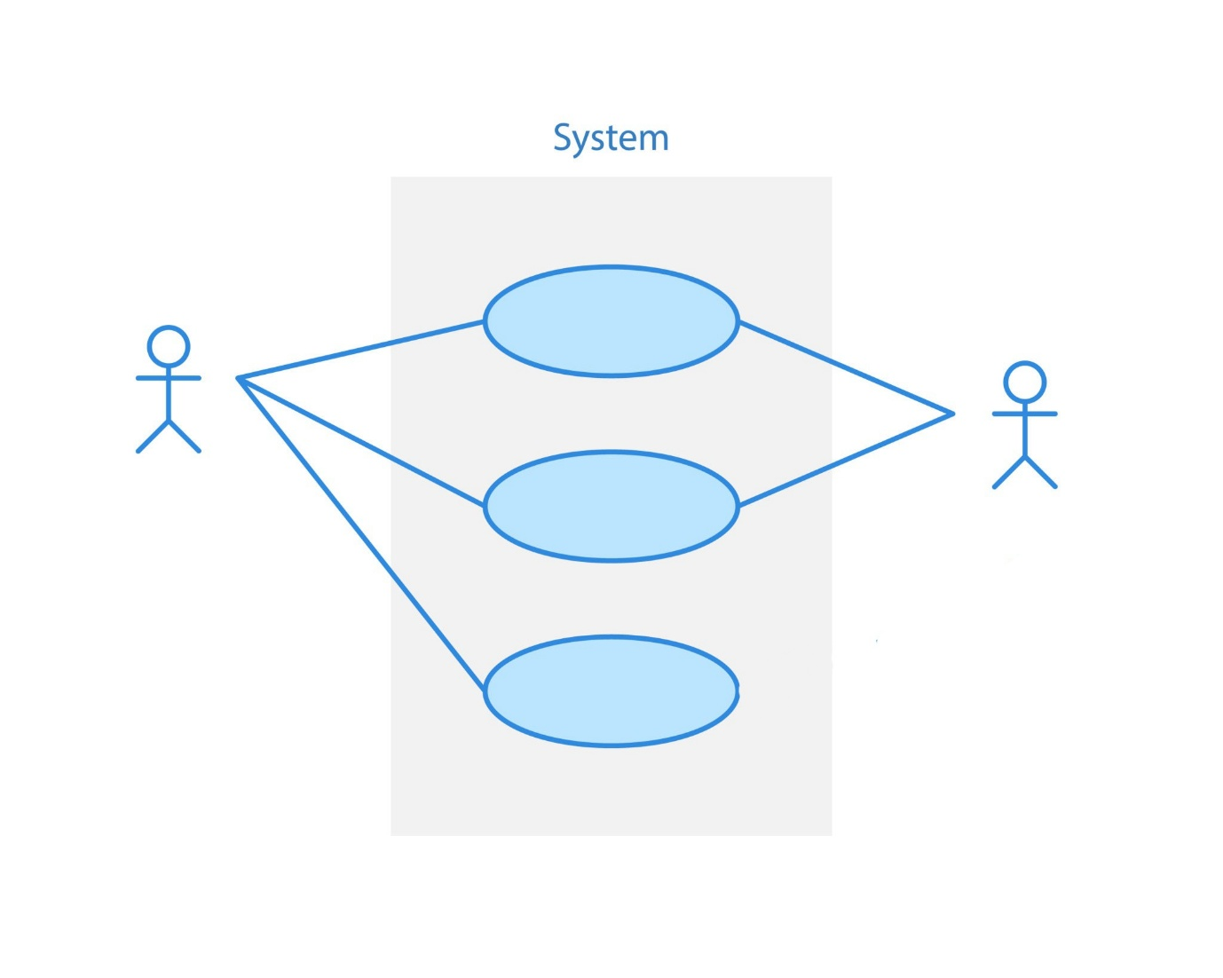

FLOW OF THE SYSTEM
LOGIN
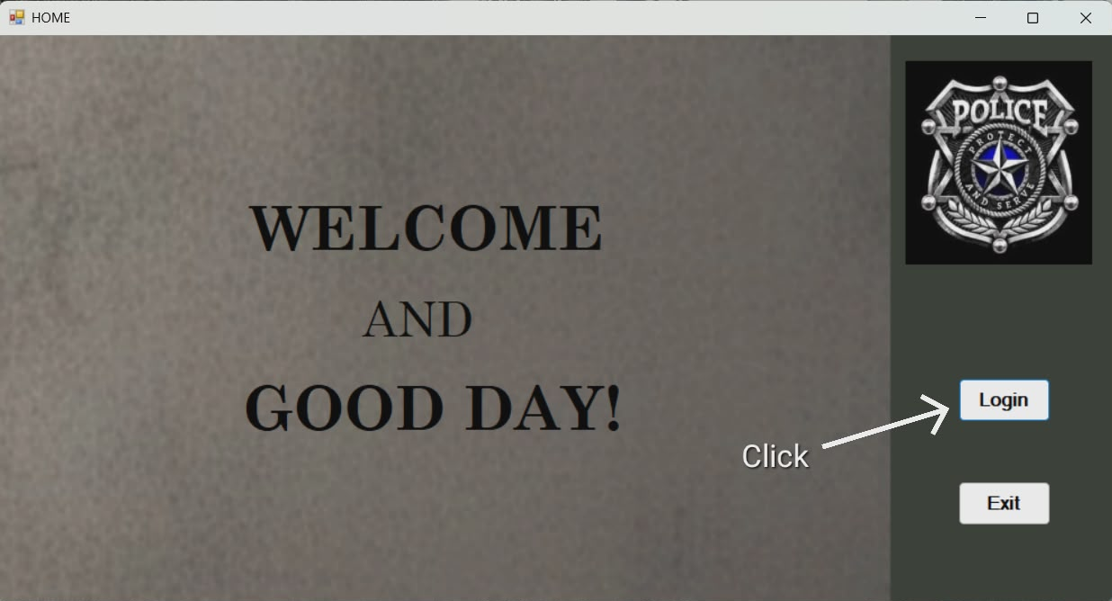

SIGN IN
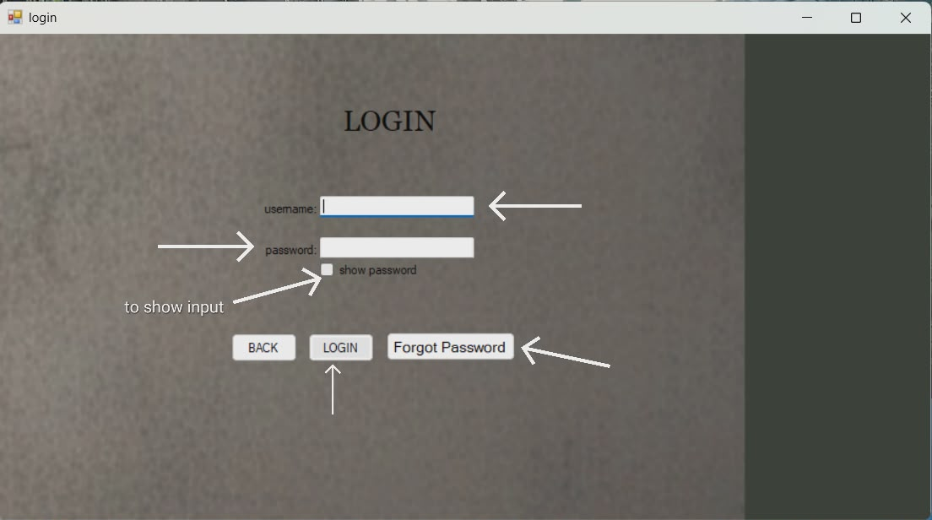

RESET PASSWORD FORM
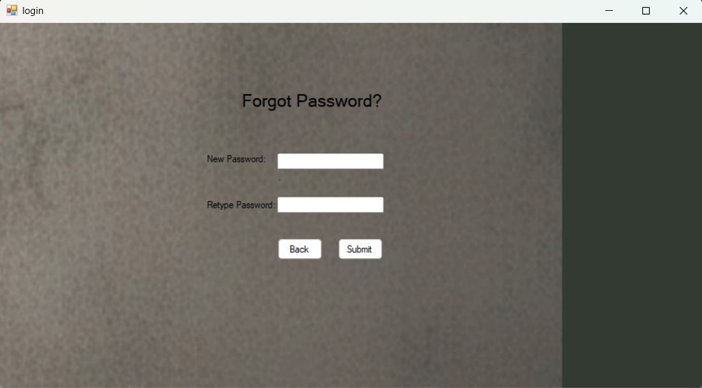

MAIN PAGE
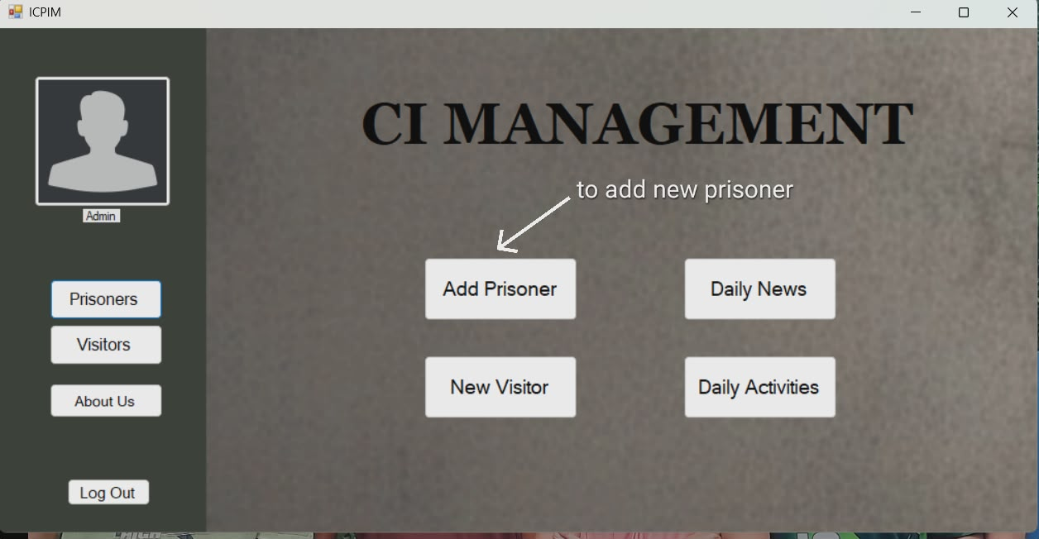

ADD PRISONER FORM
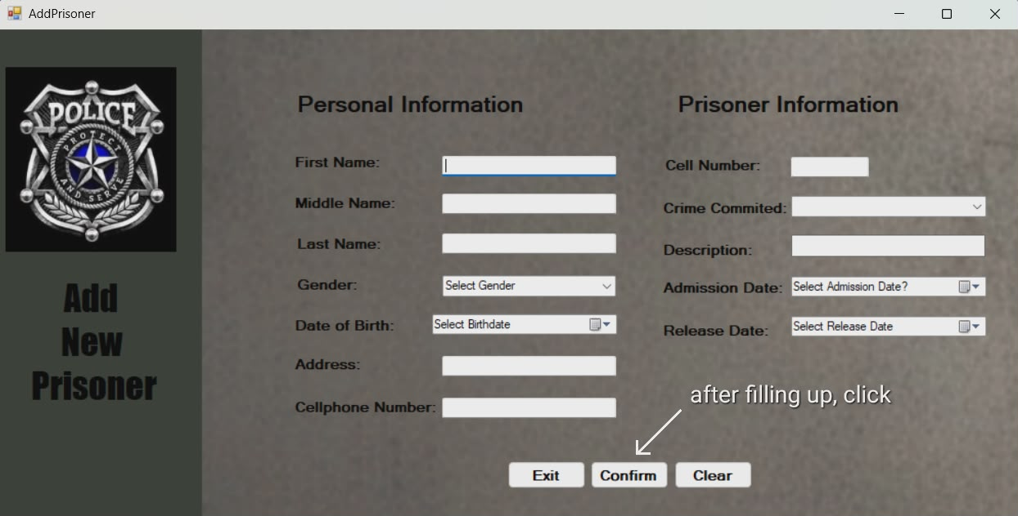

CONFIRMATION OF THE FORM SUBMITTED
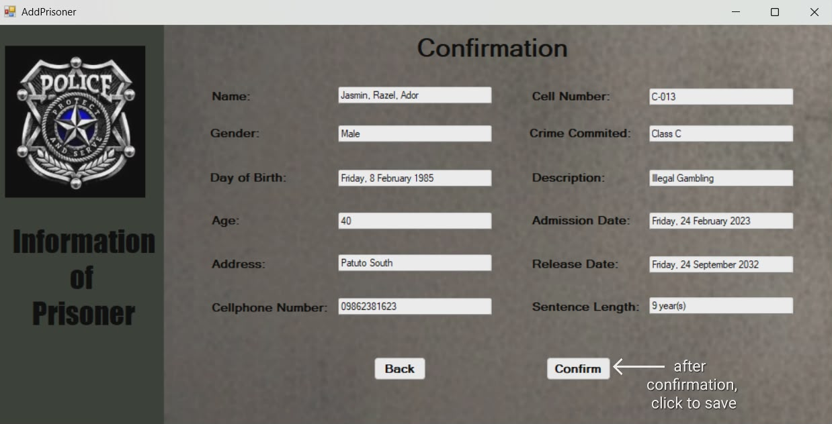

MAIN PAGE TO NEW VISITOR
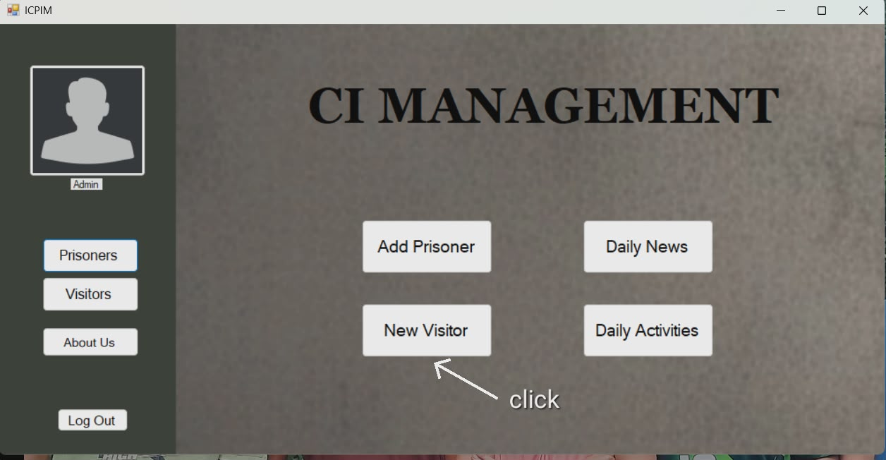

NEW VISITOR FORM
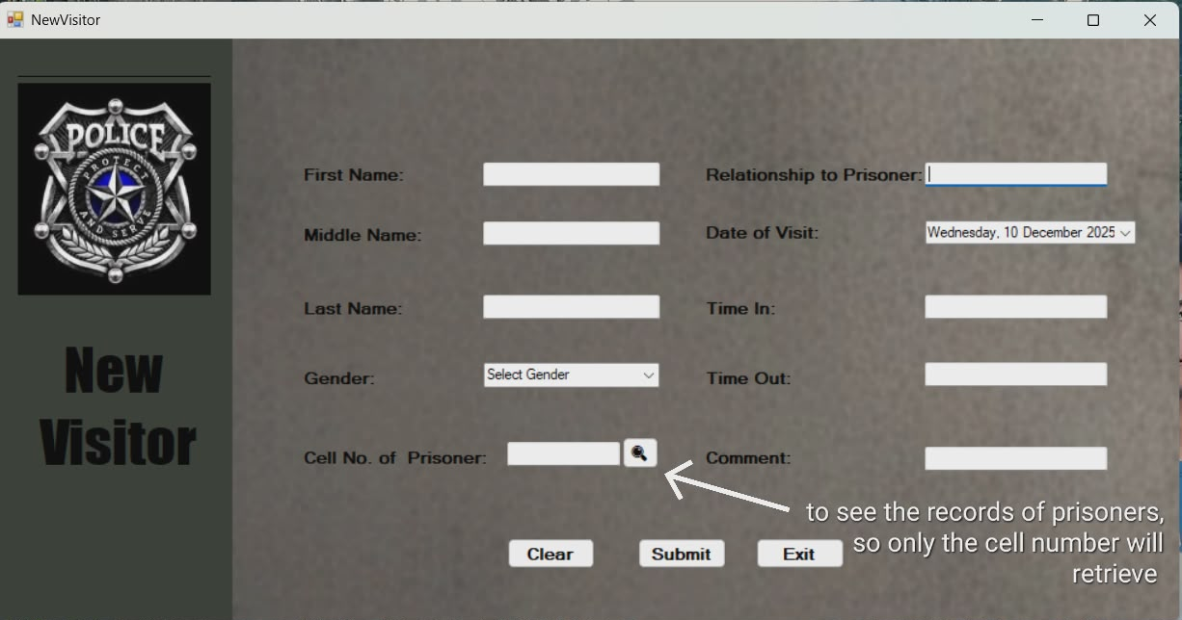

RECORDS OF PRISONERS
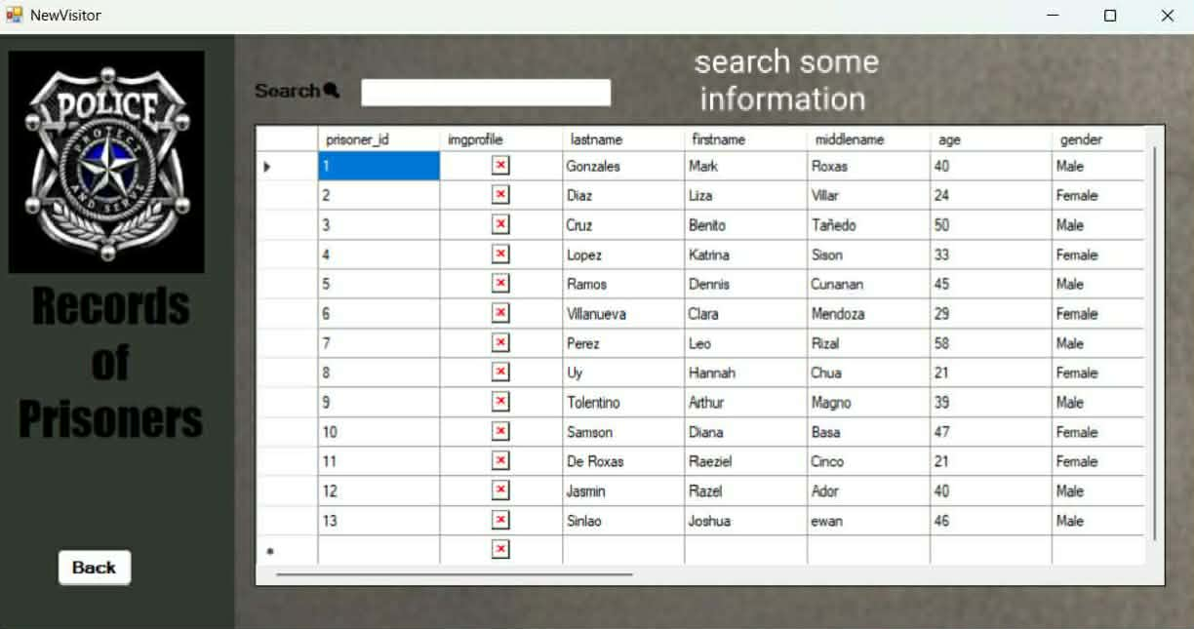

MAIN PAGE TO DAILY NEWS
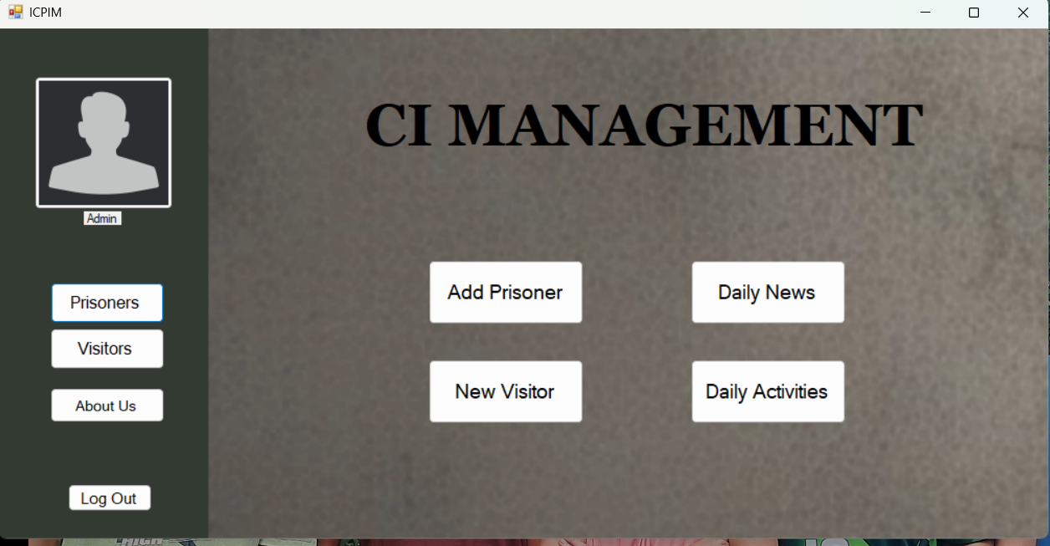

DAILY NEWS FORM
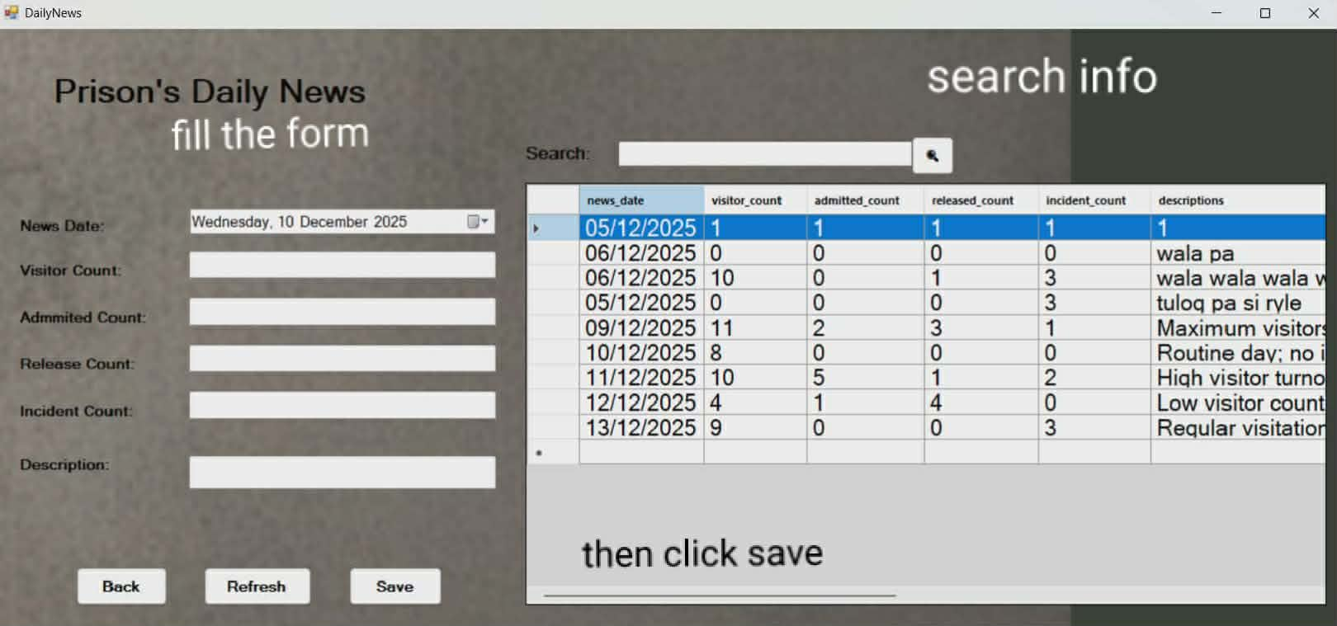

MAIN PAGE TO DAILY ACTIVITIES

PRISONERS DAILY ACTIVITIED
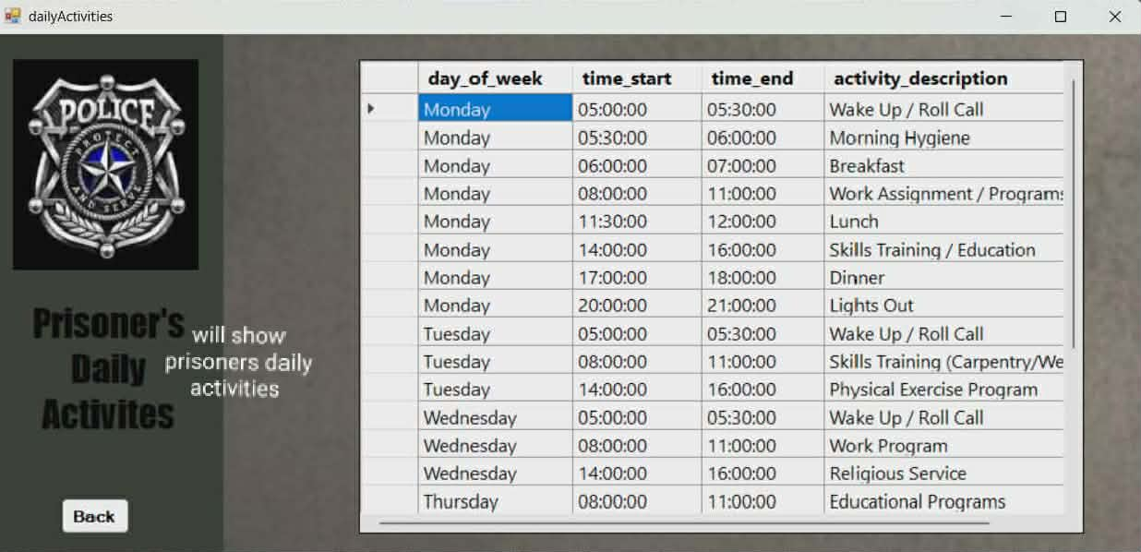

MAIN PAGE TO VISITORS(records of visitors)

HISTORY OF VISITORS
