**Methods**

In this paper, we aim to estimate the burden of childhood asthma due to NO2 exposure using state specific asthma incidence rates and compare the change in estimates from those produced by Alotaibi et al. (2019) using a flat national (country) asthma incidence rate, as is typically done (add Haneen’s European assessment, Susan Annenberg’s paper, Haneen’s Bradford two papers, and California and 10 European cities assessment).

*Study area and time points*

*Census data*

We included populated census blocks of the contiguous United States (U.S.) for the year 2010, as obtained from the National Historical Geographic Information System (NHGIS) website (Manson et al., 2018; US Census Bureau, 2010). Each block included information on the total population of children <18 years, and whether the census block was designated as an urban or a rural block. Census-designated urban areas are defined using multiple criteria including total population thresholds, density, land use, and distance, with census blocks forming the basic geographical units of urban areas. Further urban areas are classified into two subtypes based on population thresholds including: urban clusters with a population threshold of ≥2,500 and <50,000, or urbanized areas with a population threshold of ≥50,000 people. Median household income was available only for census block groups, which is a level higher than census blocks (US Census Bureau, 2017) . We divided median household income into five categorizes consistent with two previous relevant publications: <$20,000, $20,000 to <$35,000, $35,000 to <$50,000, $50,000 to <$75,000 and ≥$75,000 (Alotaibi et al., 2019; Clark et al., 2017). There were 2,686 (0.04%) census blocks with missing median income data in 2010 which were assigned as “Not defined” in the analysis of median household income. Table 1 summarizes the geographical and demographic data across all census blocks included in this analysis.



*NO2 exposure assessment*

Annual average NO2 concentrations for each populated census block were available at the centroid location for the year 2010. Concentrations were derived from a land use regression model utilizing Environmental Protection Agency (EPA), satellite data and several GIS covariates. A detailed description of the model can be found at Bechle et al. (2015). NO2 concentrations were converted from ppb to ug/m3through multiplying by 1.88 (WHO, 2005).

*Concentration-response function*

We used a concentration-response function (CRF) of 1.05 (95% CI = 1.02-1.07) per 4ug/m3 of NO2. The CRF was obtained from a meta-analysis of 20 studies examining the association between exposure to traffic-related air pollution (TRAP) and risk of developing asthma among children (Khreis et al., 2017). These CRF represent data from the most up-to-date and widest analysis on traffic-related air pollution and the onset of childhood asthma, and have been used in several published peer-reviewed burden of disease assessments .

*Asthma incidence and prevalence rates*

An incidence rate is defined as the number of new cases of a disease within a specified time period among an at-risk population. To estimate the childhood asthma incidence rate, we extracted the number of new childhood asthma cases and at-risk children for the years 2006 through 2010 using the Asthma Call Back Survey (ACBS) and Behavioral Risk Factor Surveillance System (BRFSS) (CDC, 2009, 2011), and following the methods described by Winer et al. (2012). In brief, participants in the BRFSS were asked “Has a doctor, nurse, or other health professional ever said that the [name of child] has asthma?” to determine their asthma status. If the answer is “yes”, the respondent is designated as “Ever asthma” and requested to participate in the ACBS follow up survey. If the answer is “no”, the respondent is designated as “Never asthma”. To determine the incident asthma status, the ACBS survey further asks: “How old was the [name of child] when a doctor or other health professional first said [he/she] had asthma? How long ago was that?”. If the answer to the latter part of this question was “within the past 12 months”, the respondent is designated as an “Incident asthma”. “At-risk children” are the sum of “Incident asthma” cases and children with “Never asthma” status (Figure 1).

*Data analysis* *method*

We obtained the BRFSS and ACBS child data sets for the years 2006-2010 from the CDC website <https://www.cdc.gov/brfss/>. All analysis was conducted using R statistical software (R Core Team, 2018). States and territories not within the contiguous U.S. were excluded from the analysis, namely Alaska, Hawaii and Puerto Rico.

Samples from the ACBS and BRFSS were assigned weights to adjust for actual response of each respondent, variation in probability of selection, nonresponse, or disproportionate population subgroup selection relative to the state’s population distribution. Each respondent is assigned a weight. This weight represents the number of children within each state, with similar characteristics to the respondent, but who have not been surveyed. Children not surveyed are then assigned the same response as the respondent, for all questions. The sum of the BRFSS weights represents the total population of children within the state, while the sum of the ACBS weights represent the total children with ever asthma within the state (Garbe et al., 2011; Korn et al., 2011).

We extracted the following variables from the BRFSS and ACBS surveys; the state, asthma status, incident asthma status, and children sample weights (Figure S1). Each respondent was assigned their weight and the following was estimated for each state and year separately:

Equation 1

Equation 2

Equation 3

The state-specific average asthma incident rate was then estimated by taking the sum of “Incident asthma” divided by the sum of “At-risk children” across all available years. The national average asthma incident rate was estimated by aggregating all the previous estimates across the states and years. during the whole period (2006-2010) national.

*Burden of disease estimate*

To estimate the burden of disease, we used a standard assessment methods described by Mueller et al. (2017) with the following steps:

We estimated the at-risk children for each state by subtracting the total number of prevalent cases from the total number of children within the state. We then estimated the number of asthma cases for each state by multiplying the state-specific childhood asthma incidence rate with at-risk children for each census block.

Equation 4

Equation 5

We then calculated the relative risk (RRdiff) for asthma due to exposure difference between estimated exposure levels (NO2 concentration at the census block level) and no exposure (zero NO2 concentration).

Equation 6

Where RR is the CRF and RRunit is the exposure unit for the CRF as extracted from Khreis et al. (2017). The population attributable fraction (PAF) is then estimated.

Equation 7

The attributable number of asthma incident cases (AC) was estimated by multiplying the PAF with the number of incident asthma cases at each census block. The AC is then summed up to get the total AC.

**Results**

*NO2 concentrations and trends*

The mean (min-max) NO2 concentrations were 13.3 (1.5-58.3) ug/m3. By living location, the mean NO2 concentrations was highest at urbanized areas (18.4 ug/m3), while mean NO2 concentration was highest among median income group of ≥$75,000 (16.5 ug/m3) (Table 2 and Figures S2-S4). South Dakota had the lowest **mean** NO2 concentration (5.2 ug/m3), while the District of Columbia had the highest (26.3 ug/m3) (Table S1 and Figure S5). Figure S6-S7 demonstrates NO2 concentrations across living location and median household income for each state.



*ACBS and BRFSS results*

Overall, there were 32 states with available childhood asthma incidence rates (Table 9-12). The total childhood samples collected for the period (2006-2008) are shown in Table 9 Table 11. Table 12 also shows the year’s available incidence rate data for each state. BRFSS weighted estimates representing the total childhood population of available states and ACBS weighted estimates representing total children with ever asthma of available states are shown in Table 10 Table 12

The average national incidence rate for the years 2006-2010 was 12.1 per 1,000. The state of Montana had the lowest average childhood asthma incidence rate (IR = 4.3 per 1,000), while District of Columbia had the highest average childhood asthma incidence rate (IR = 17.7 per 1,000). States that did not have an incidence rate (add number of states) available were assigned the national incidence rate of 12.1 per 1,000.

*Asthma incident cases*

Using state-specific asthma incidence rates the estimated number of childhood asthma incident cases were 754,893 in 2010 (Table 4). By living location, 19% lived in a rural area, while 9% and 72% lived in an urban cluster and urbanized area, respectively. The largest percentage of childhood asthma cases (28%) lived in an income block group of $50,000 to <$75,000, while the lowest percentage (4%) lived in the lowest income block group of <$20,000. The state with the lowest number of estimated childhood asthma incident cases was Montana with 900 cases, while the state with the largest number was Texas with 99,100 cases (Table 5).

*Attributable number of cases and fraction*

On average, we estimated a total of 132,829 childhood asthma cases attributable to NO2 exposure which accounted for 17.6% of all childhood asthma cases (Table 4). By living location, urbanized areas had the largest number of attributable cases totaling 109,581 cases and highest percentage of all asthma cases of 20.3%. Rural areas had total of 13,951 cases and accounting for the least percentage of all asthma cases with 9.8%, while urban clusters had only 9,296 cases representing 13% of all asthma cases (Figure 9). By income, $50,000 to <$75,000 had the largest number of cases attributable to NO2, 37,559 cases accounting for 16.8% of all asthma cases. However, the income group with the largest percentage of asthma cases was the lowest income group <$20,000, accounting for 20.8% of all asthma cases (Figure 10). The mean value of attributable fraction increased by income group in rural areas, decreased by income group in urban clusters and presented as a U shape in urbanized areas (Figure 11&12).

The state with the lowest number of estimated AC was Montana with 70 cases, while the state with the largest AC was California with 19,200 cases. The state with the lowest AF was South Dakota (7.6%), while the state with the highest AF was District of Columbia (26.9) (Table 5and Figure 6).

Figures 14&15 present the distribution of AF by living location and median income group for each state. The majority of states follow a distribution similar to the national level with a few exceptions (e.g. see Arizona, Montana, Rhode Island & Wyoming).

*Comparison with the main paper*

*Comparing total asthma cases*

Using state-specific asthma incidence rates, the overall number of cases reduced by an average of 40,041 (5%) cases compared to estimates in the main paper that used a flat national asthma incidence rate (Table 6). By living location, the largest reduction was among urban clusters with a decrease of 4,204 (5.6%) cases followed by urbanized areas which reduced by 29,926 (5.2%) cases. By income group, the largest decrease in the number of cases was among the highest income groups by 13,123 (6.8%) cases, while the least decrease was among the lowest income group by 168 (0.6%) cases.

*Comparing attributable cases*

The total attributable cases reduced by 9,103 (6.4%) cases when compared to the main paper (Table 6). By living location, urbanized areas had the largest reduction of 8,040 (6.8%) cases while rural areas had the least reduction by 514 (3.6%) cases attributable to NO2 exposure. By income group, the highest income group also had the largest decrease in attributable cases by 2.994 (8.5%) and the lowest income group had the least decrease by 58 (1%) cases.

*Comparing attributable fractions*

The overall attributable fraction reduced 1.4% with urbanized areas having the largest reduction by 1.7% in terms of living location. In terms of income group, the largest reduction was 1.8% for both $50,000 to <$75,000 and ≥$75,000 (Table 7).

*Comparing state estimates*

Table 8 summarizes the changes in total asthma incident cases and AC by state after applying state specific asthma incidence rates. In brief, the state of Montana had the largest percent reduction in total childhood asthma incident cases and AC of 64.1% while the state of Texas had the largest percent increase of 33.8%. The state of California had the largest decrease in numbers of total childhood asthma incident cases of 24,442 cases while the state of Texas had the largest increase in numbers by 25,019 cases. The state of California had the largest decrease in AC by 6,190 cases while the state of Texas had the largest increase by 3,615 cases.

**Discussion (bullet points)**

* Using state specific asthma incidence rates did not change the results much (within the range of the sensitivity analysis from the main paper)
* The state specific total number of asthma cases and attributable cases changed when applying state specific incidence rates (Table 8)
* The state-specific attributable fractions did not change. The reason is that the incident rate is applied uniformly across the state (spatially), thus the total asthma cases and total attributable cases will change with equal proportion when applying the new asthma incidence rate but not the AF. The AF is a function of CRF and exposure estimate regardless of the IR. Had we applied an incidence rate based on other factors like age, gender, race, income group, then the attributable fraction across the state would differ since the change won’t in incidence rate won’t be uniform within the state.
* The percentage of all asthma cases has a J shaped distribution when examining income groups. The lowest income group had the highest % then drops and rises again with the highest income group.
* Explore why the U shaped distribution is shown among AF for income groups.

***Tables***

Table 1: Census data description, year 2010

|  |  |  |
| --- | --- | --- |
| **Geographic characteristics** | **Total populated census blocks** | 6,182,882 |
| **Total census-designated urban areas** | 3,590,278 |
| **Demographic characteristics** | **Total population** | 306,675,006 |
| **Total population of children (birth – 18)** | 73,690,271 (24%) |
| **Mean (range) number of children in census blocks** | 12 (0-2214) |
| **Population of children by living location** | **Rural** | 13,763,183 (19%) |
| **Urban clusters (≥2,500 and <50,000 people)** | 6,994,464 (9%) |
| **Urbanized area (≥50,000 people)** | 52,932,624 (72%) |
| **Population of children by median household income** | **<$20,000** | 2,614,804 (4%) |
| **$20,000 to <$35,000** | 12,770,843 (17%) |
| **$35,000 to <$50,000** | 18,573,954 (25%) |
| **$50,000 to <$75,000** | 21,953,876 (30%) |
| **≥$75,000** | 17,763,239 (24%) |

Table 2: NO2 concentration by strata

|  |  |  |  |  |  |  |  |
| --- | --- | --- | --- | --- | --- | --- | --- |
|  |  | **Mean** | **Min** | **25%** | **Median** | **75%** | **Max** |
| **Total** |  | 13.2 | 1.5 | 7.9 | 11.4 | 16.6 | 58.3 |
| **By living location** | **Rural** | 8.0 | 1.5 | 6.0 | 7.8 | 9.8 | 37.7 |
| **Urban cluster** | 12.0 | 1.6 | 9.6 | 11.9 | 14.2 | 35.6 |
| **Urbanized area** | 18.4 | 2.6 | 13.0 | 17.0 | 22.1 | 58.3 |
| **By median household income** | **<$20,000** | 16.1 | 2.0 | 10.4 | 14.9 | 20.1 | 56.8 |
| **$20,000 to <$35,000** | 13.2 | 1.6 | 8.1 | 11.7 | 16.7 | 58.3 |
| **$35,000 to <$50,000** | 11.8 | 1.5 | 7.0 | 10.0 | 14.5 | 58.0 |
| **$50,000 to <$75,000** | 12.8 | 1.6 | 7.6 | 10.8 | 15.7 | 55.7 |
| **≥$75,000** | 16.5 | 2.1 | 10.9 | 14.9 | 20.6 | 55.5 |

Table 3: Childhood asthma survey summary

|  |  |  |  |  |  |
| --- | --- | --- | --- | --- | --- |
|  | **2006** | **2007** | **2008** | **2009** | **2010** |
| **BRFSS sample (weighted)** | 55,094 (50,674,742) | 59,487 (43,661,381) | 61,862 (53,327,550) | 59,821 (47,747,373) | 57,200 (39,975,264) |
| **Ever asthma sample (weighted)** | 7,168 (6,493,224) | 7,971 (5,763,409) | 8,255 (7,218,400) | 8,126 (6,279,938) | 7,483 (5,158,455) |
| **ACBS Sample (weighted)** | 2017 () | 3924 () | 3924 () | 4095 () | 2196 () |
| **Incident case sample (weighted)** | 154 (404,276) | 173 (312,917) | 169 (385,818) | 153 (297,546) | 160 (319,743) |
| **At-risk sample (weighted)** | 48,080 (30,825,589) | 51,689 (36,050,557) | 53,776 (26,491,259) | 51,848 (25,942,087) | 49,877 (22,900,850) |
| **Incidence rate** | 13.1 | 8.7 | 14.6 | 11.5 | 14.0 |
| **Prevalence rate** | 12.8 | 13.2 | 13.5 | 13.2 | 12.9 |
| **Number of states included** |  |  |  |  |  |



Table 5: Comparing results of the burden of disease using state-specific estimates with original estimates (Cases and attributable cases)

|  |  |  |  |  |  |  |  |  |  |  |  |  |  |
| --- | --- | --- | --- | --- | --- | --- | --- | --- | --- | --- | --- | --- | --- |
|  |  | **Main results** | | | **Original results** | | | **Difference** | | | **Percentage difference** | | |
|  |  | **Incident cases** | **AC** | **AF** | **Incident cases** | **AC** | **AF** | **Incident cases** | **AC** | **AF** | **Incident cases** | **AC** | **AF** |
|  | **Total** | 754,893 | 132,829 | 17.6% | 794,934 | 141,931 | 17.9% | -40,041 | -9,103 | -0.3% | -5.0% | -6.4% | -1.4% |
| **By living location (% of Total)** | **Rural** | 142,559 (19%) | 13,951 (11%) | 9.8% | 148,470 (19%) | 14,466 (10%) | 9.7% | -5,911 | -514 | 0.0% | -4.0% | -3.6% | 0.4% |
| **Urban cluster** | 71,249 (9%) | 9,296 (7%) | 13.0% | 75,453 (9%) | 9,844 (7%) | 13.0% | -4,204 | -549 | 0.0% | -5.6% | -5.6% | 0.0% |
| **Urbanized area** | 541,085 (72%) | 109,581 (82%) | 20.3% | 571,011 (72%) | 117,621 (83%) | 20.6% | -29,926 | -8,040 | -0.3% | -5.2% | -6.8% | -1.7% |
| **By median household income (% of Total)** | **<$20,000** | 28,039 (4%) | 5,834 (4%) | 20.8% | 28,207 (4%) | 5,892 (4%) | 20.9% | -168 | -58 | -0.1% | -0.6% | -1.0% | -0.4% |
| **$20,000 to <$35,000** | 134,208 (18%) | 24,906 (19%) | 18.6% | 137,765 (17%) | 25,794 (18%) | 18.7% | -3,558 | -889 | -0.2% | -2.6% | -3.4% | -0.9% |
| **$35,000 to <$50,000** | 190,481 (25%) | 32,369 (24%) | 17.0% | 200,367 (25%) | 34,549 (24%) | 17.2% | -9,885 | -2,180 | -0.2% | -4.9% | -6.3% | -1.4% |
| **$50,000 to <$75,000** | 223,522 (30%) | 37,559 (28%) | 16.8% | 236,827 (30%) | 40,540 (29%) | 17.1% | -13,305 | -2,981 | -0.3% | -5.6% | -7.4% | -1.8% |
| **≥$75,000** | 178,497 (24%) | 32,133 (24%) | 18.0% | 191,621 (24%) | 35,128 (25%) | 18.3% | -13,123 | -2,994 | -0.3% | -6.8% | -8.5% | -1.8% |































Figure 1: Childhood asthma incidence rate flow chart.

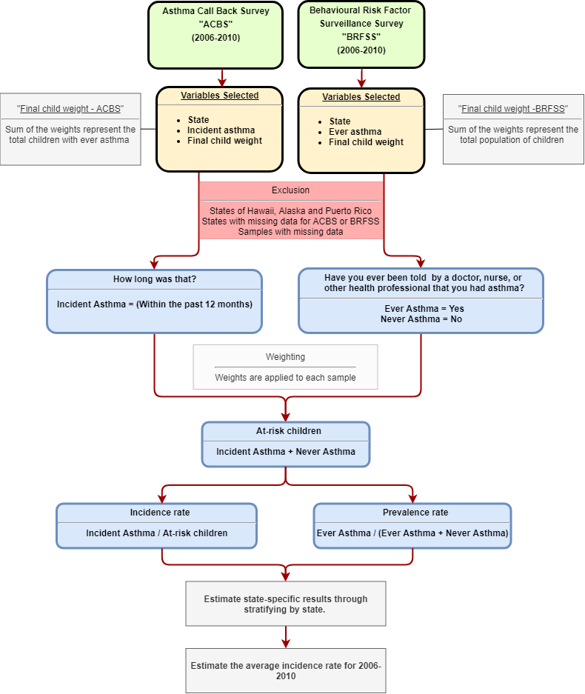

Figure 2: Attributable fraction by median income grp stratified into living location

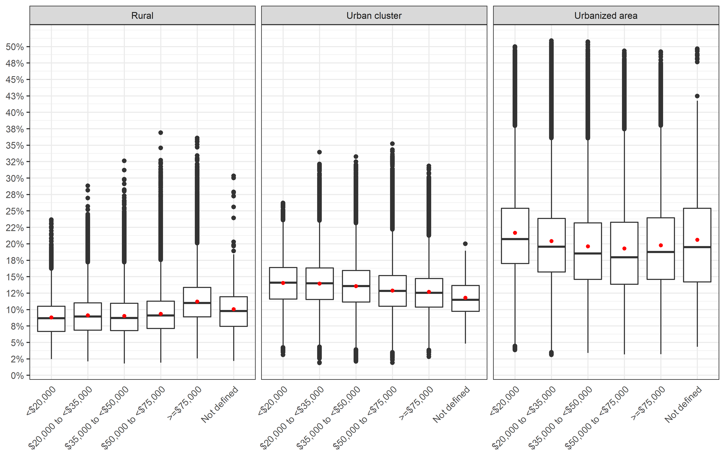

Figure 3: Attributable fraction by state

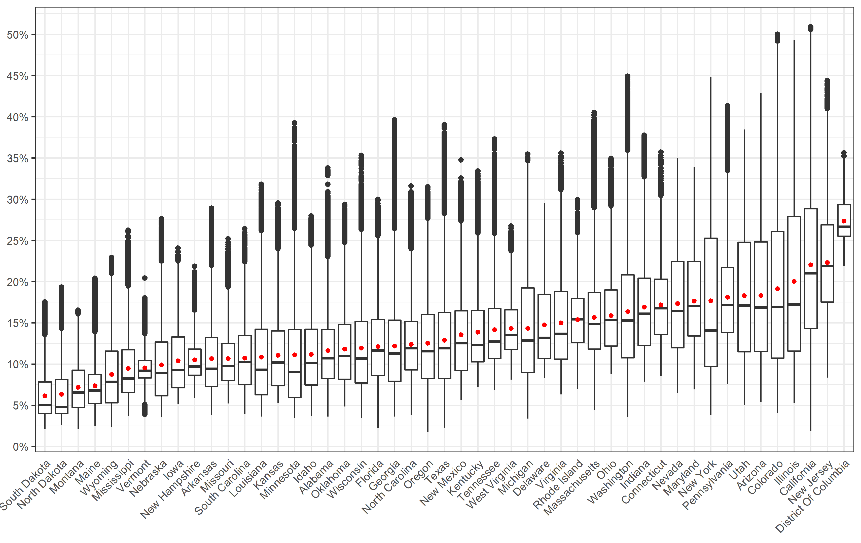

Figure 4: Attributable fraction by state and living location

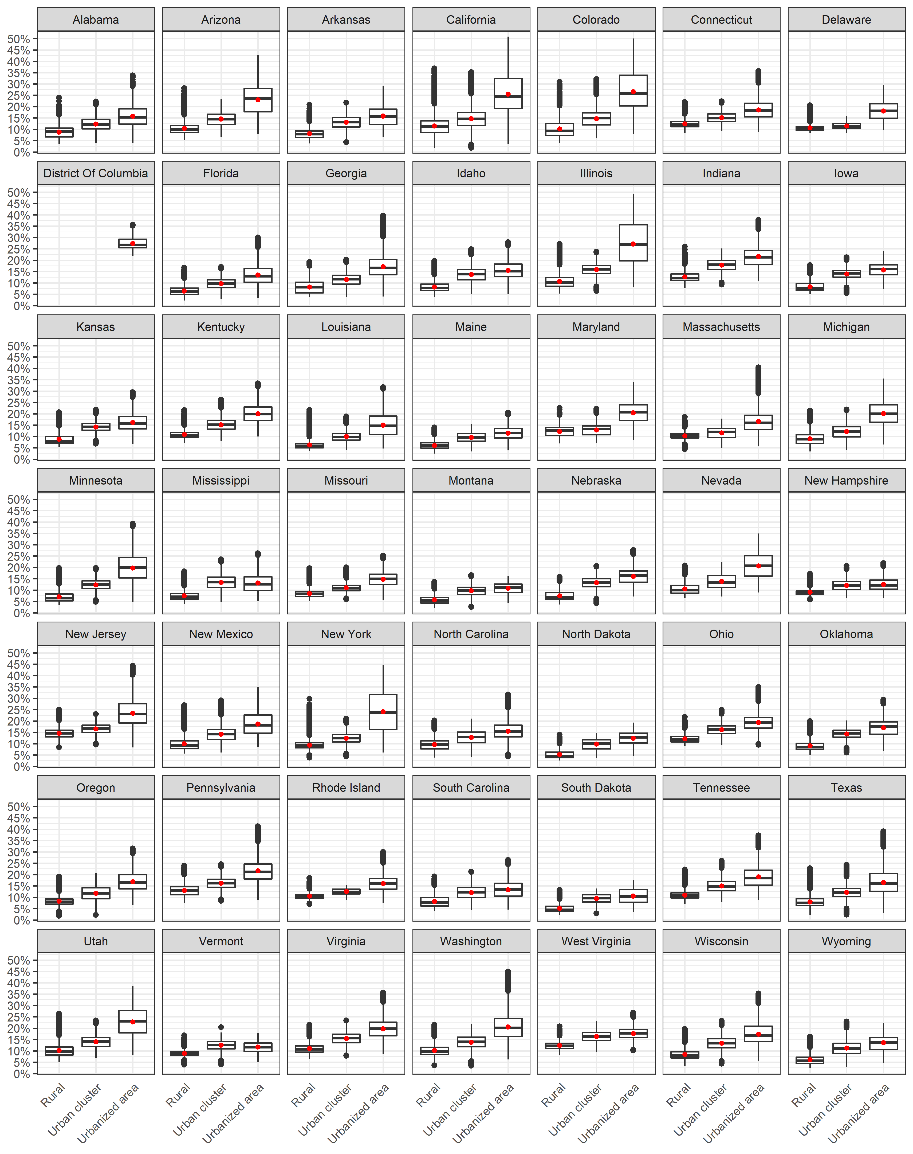

Figure 5: Attributable fraction by state and median income group

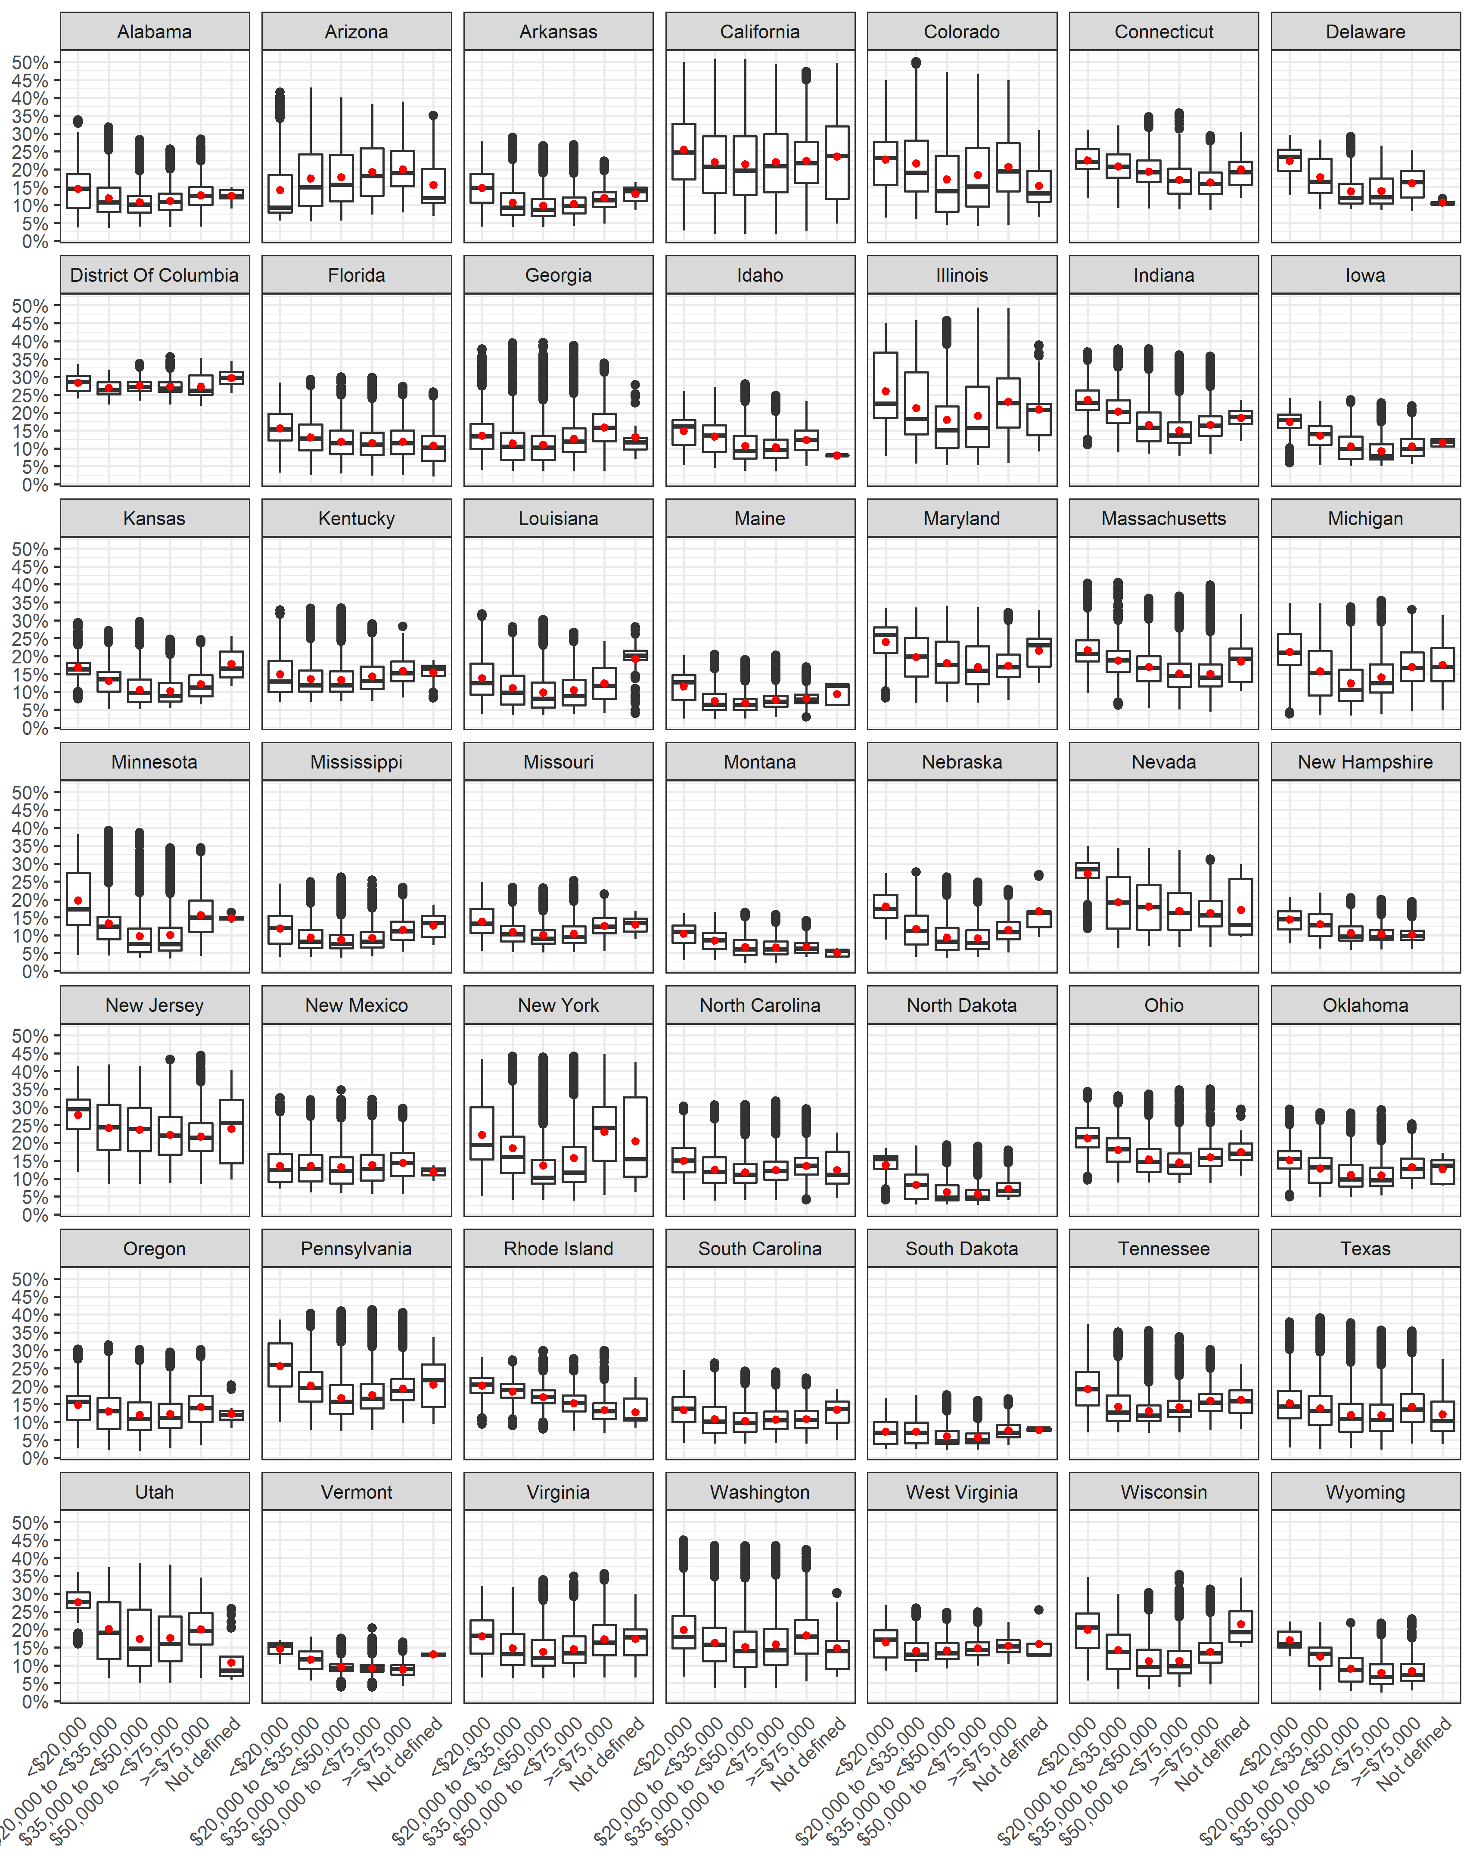

Alotaibi, R., Bechle, M., Marshall, J. D., Ramani, T., Zietsman, J., Nieuwenhuijsen, M. J., & Khreis, H. (2019). Traffic related air pollution and the burden of childhood asthma in the contiguous United States in 2000 and 2010. *Environment international*.

Bechle, M. J., Millet, D. B., & Marshall, J. D. (2015). National spatiotemporal exposure surface for NO2: monthly scaling of a satellite-derived land-use regression, 2000–2010. *Environmental science & technology, 49*(20), 12297-12305.

CDC. (2009). Centers for Disease Control and Prevention. Behavioral Risk Factor Surveillance System Survey Data. Atlanta, Georgia: U.S. Department of Health and Human Services, Centers for Disease Control and Prevention, 2019.

CDC. (2011). *Centers for Disease Control and Prevention. 2006-2008 ACBS Summary Data Qulaity Report. 2011*. Retrieved from <https://www.cdc.gov/brfss/acbs/2008> \_ documentation.htm

Clark, L. P., Millet, D. B., & Marshall, J. D. (2017). Changes in transportation-related air pollution exposures by race-ethnicity and socioeconomic status: Outdoor nitrogen dioxide in the United States in 2000 and 2010. *Environmental health perspectives, 125*(9), 1--10. doi:10.1289/EHP959

Garbe, P., Balluz, L. S., & Chief, B. (2011). Behavioral Risk Factor Surveillance System Asthma Call-Back Survey History And Analysis Guidance.

Khreis, H., Kelly, C., Tate, J., Parslow, R., Lucas, K., & Nieuwenhuijsen, M. (2017). Exposure to traffic-related air pollution and risk of development of childhood asthma: a systematic review and meta-analysis. *Environment international, 100*, 1-31.

Korn, E. L., & Graubard, B. I. (2011). *Analysis of health surveys* (Vol. 323): John Wiley & Sons.

Manson, S., Schroeder, J., Van Riper, D., & Ruggles, S. (2018). *IPUMS National Historical Geographic Information System: Version 13.0 [Database]. Minneapolis: University of Minnesota.*

Mueller, N., Rojas-Rueda, D., Basagaña, X., Cirach, M., Cole-Hunter, T., Dadvand, P., Donaire-Gonzalez, D., Foraster, M., Gascon, M., & Martinez, D. (2017). Urban and transport planning related exposures and mortality: a health impact assessment for cities. *Environmental health perspectives, 125*(1), 89.

R Core Team. (2018). R: A Language and Environment for Statistical Computing: R Foundation for Statistical Computing. Retrieved from <https://www.R-project.org/>

US Census Bureau. (2010). American factfinder: US Census Bureau Washington, DC.

US Census Bureau. (2017). Census.gov. Retrieved from <https://www.census.gov/>

WHO. (2005). *Air Quality Guidlines Global Update 2005*. Retrieved from [www.euro.who.int](C:\\Users\\R-Alotaibi\\Documents\\R Projects\\TTI-AsthmaIR\\Results\\Manuscript\\www.euro.who.int)

Winer, R. A., Qin, X., Harrington, T., Moorman, J., & Zahran, H. (2012). Asthma incidence among children and adults: findings from the Behavioral Risk Factor Surveillance system asthma call-back survey—United States, 2006–2008. *Journal of Asthma, 49*(1), 16-22.

**Supplementary Material**

Table S1: NO2 concentration by state 2

Table S2: Childhood asthma survey summary by state (Total of 2006-2010) 4

Table S3: State results and comparison 6

Table S4: Comparing results by state 7

Figure S1: NO2 concentration (ug/m3) by living location 10

Figure S2: NO2 concentration (ug/m3) by median income group 10

Figure S3: NO2 concentration (ug/m3) by living location stratified into median income group 11

Figure S4: NO2 concentration (ug/m3) by median income group stratified into living location 11

Figure S5: NO2 concentration (ug/m3) by state 12

Figure S6: NO2 concentration (ug/m3) by state and median income group 13

Figure S7: NO2 concentration (ug/m3) by state and living location 14

Figure S8: Attributable Fraction by living location 15

Figure S9: Attributable Fraction by median income group 15

Figure S10: Attributable Fraction by living location stratified into median income group 16

Table S1: NO2 concentration by state

|  |  |  |  |  |  |  |
| --- | --- | --- | --- | --- | --- | --- |
| **State** | **Mean** | **Min** | **25%** | **Median** | **75%** | **Max** |
| Alabama | 10.3 | 3.0 | 7.1 | 9.3 | 12.5 | 33.8 |
| Arizona | 17.0 | 4.6 | 10.1 | 15.1 | 23.4 | 45.9 |
| Arkansas | 9.3 | 3.2 | 6.2 | 8.1 | 11.6 | 28.0 |
| California | 21.1 | 1.6 | 12.7 | 19.3 | 27.9 | 58.3 |
| Colorado | 18.1 | 3.4 | 9.3 | 15.2 | 24.8 | 56.9 |
| Connecticut | 15.6 | 7.3 | 11.9 | 15.0 | 18.6 | 36.2 |
| Delaware | 13.2 | 7.1 | 9.3 | 11.6 | 16.7 | 28.7 |
| District Of Columbia | 26.3 | 20.2 | 24.2 | 25.4 | 28.5 | 36.1 |
| Florida | 10.7 | 1.8 | 7.4 | 10.2 | 13.7 | 29.2 |
| Georgia | 10.8 | 3.0 | 6.8 | 9.8 | 13.6 | 41.4 |
| Idaho | 9.8 | 3.1 | 6.4 | 8.8 | 12.6 | 26.9 |
| Illinois | 19.0 | 4.4 | 10.1 | 15.5 | 26.9 | 55.7 |
| Indiana | 15.4 | 6.7 | 10.7 | 14.4 | 18.7 | 38.9 |
| Iowa | 9.1 | 4.3 | 6.1 | 8.0 | 11.7 | 22.6 |
| Kansas | 9.7 | 4.5 | 6.3 | 8.8 | 12.4 | 28.7 |
| Kentucky | 12.4 | 6.1 | 8.9 | 10.8 | 14.8 | 33.3 |
| Louisiana | 9.6 | 3.0 | 5.3 | 8.0 | 12.6 | 31.4 |
| Maine | 6.3 | 2.0 | 4.4 | 5.8 | 7.5 | 18.7 |
| Maryland | 16.1 | 5.9 | 11.8 | 15.3 | 20.8 | 34.0 |
| Massachusetts | 14.1 | 3.7 | 10.3 | 13.2 | 17.0 | 42.5 |
| Michigan | 12.9 | 2.8 | 7.7 | 11.3 | 17.5 | 35.9 |
| Minnesota | 9.9 | 2.9 | 5.0 | 7.8 | 12.5 | 40.8 |
| Mississippi | 8.3 | 3.1 | 5.6 | 7.0 | 10.2 | 24.9 |
| Missouri | 9.3 | 4.4 | 6.8 | 8.4 | 11.0 | 23.8 |
| Montana | 6.2 | 1.7 | 4.0 | 5.5 | 8.0 | 14.8 |
| Nebraska | 8.6 | 3.0 | 5.2 | 7.7 | 11.1 | 26.5 |
| Nevada | 15.9 | 5.5 | 10.5 | 14.7 | 20.8 | 35.2 |
| New Hampshire | 9.1 | 5.0 | 7.4 | 8.4 | 10.3 | 20.2 |
| New Jersey | 21.0 | 7.1 | 15.8 | 20.2 | 25.7 | 48.1 |
| New Mexico | 12.1 | 4.7 | 7.9 | 11.0 | 14.8 | 35.0 |
| New York | 16.6 | 3.2 | 8.3 | 12.4 | 23.9 | 48.7 |
| North Carolina | 11.0 | 3.2 | 8.0 | 10.4 | 13.5 | 31.1 |
| North Dakota | 5.4 | 2.1 | 3.3 | 4.0 | 6.9 | 17.6 |
| Ohio | 14.3 | 7.5 | 10.7 | 13.6 | 17.3 | 35.2 |
| Oklahoma | 10.4 | 4.1 | 7.0 | 9.5 | 13.1 | 28.5 |
| Oregon | 11.1 | 1.5 | 7.0 | 10.1 | 14.3 | 31.0 |
| Pennsylvania | 16.6 | 6.4 | 12.2 | 15.5 | 20.1 | 43.7 |
| Rhode Island | 13.8 | 5.9 | 11.1 | 13.7 | 16.2 | 29.2 |
| South Carolina | 9.4 | 3.3 | 6.4 | 8.9 | 11.9 | 25.1 |
| South Dakota | 5.2 | 1.8 | 3.3 | 4.2 | 6.7 | 15.8 |
| Tennessee | 12.7 | 5.9 | 9.2 | 11.2 | 15.0 | 38.3 |
| Texas | 11.5 | 1.9 | 7.0 | 10.4 | 14.5 | 40.6 |
| Utah | 17.0 | 4.3 | 10.0 | 15.4 | 23.4 | 39.8 |
| Vermont | 8.3 | 3.3 | 7.1 | 7.9 | 9.1 | 18.7 |
| Virginia | 13.5 | 5.3 | 9.2 | 12.0 | 17.1 | 36.1 |
| Washington | 14.9 | 2.9 | 9.3 | 13.6 | 19.1 | 48.9 |
| West Virginia | 12.7 | 6.9 | 10.3 | 11.9 | 14.9 | 25.5 |
| Wisconsin | 10.6 | 2.8 | 6.6 | 9.3 | 13.5 | 35.7 |
| Wyoming | 7.6 | 2.0 | 4.5 | 6.7 | 10.1 | 21.4 |

Table S2: Childhood asthma survey summary by state (Total of 2006-2010)

|  |  |  |  |  |  |  |  |  |
| --- | --- | --- | --- | --- | --- | --- | --- | --- |
| **State** | **ACBS Sample** | **BRFSS sample** | **Ever asthma** | **Incident case** | **At-risk** | **Incidence rate** | **Prevalence rate** | **Years available** |
| Arizona | 103 | 5,535 | 699 | 10 | 4,846 | 15.2 | 13.1 |  |
| California | 172 | 11,801 | 1,543 | 13 | 10,271 | 9.3 | 12.2 |  |
| Connecticut | 549 | 7,112 | 1,132 | 47 | 6,027 | 12 | 16 |  |
| D.C. | 69 | 4,101 | 685 | 6 | 3,422 | 17.7 | 19.9 |  |
| Georgia | 545 | 9,433 | 1,455 | 26 | 8,004 | 9.1 | 15.1 |  |
| Illinois | 122 | 6,187 | 778 | 6 | 5,415 | 6.7 | 12.4 |  |
| Indiana | 500 | 9,824 | 1,361 | 41 | 8,504 | 15.2 | 12.8 |  |
| Iowa | 245 | 8,084 | 724 | 19 | 7,379 | 6.3 | 8.4 |  |
| Kansas | 827 | 14,699 | 1,839 | 50 | 12,910 | 9 | 11.6 |  |
| Louisiana | 88 | 8,829 | 1,214 | 4 | 7,619 | 5.8 | 13 |  |
| Maine | 376 | 4,523 | 644 | 23 | 3,902 | 9.2 | 13.2 |  |
| Maryland | 624 | 13,093 | 1,897 | 44 | 11,240 | 11.2 | 14.8 |  |
| Michigan | 680 | 10,762 | 1,524 | 43 | 9,281 | 12 | 13.6 |  |
| Mississippi | 208 | 10,816 | 1,527 | 14 | 9,303 | 14 | 14.2 |  |
| Missouri | 262 | 5,646 | 814 | 20 | 4,852 | 12.9 | 13.9 |  |
| Montana | 286 | 8,609 | 909 | 17 | 7,717 | 4.3 | 9.7 |  |
| Nebraska | 717 | 17,883 | 1,644 | 53 | 16,292 | 9.1 | 9.3 |  |
| New Hampshire | 232 | 5,285 | 664 | 19 | 4,640 | 12 | 12.1 |  |
| New Jersey | 458 | 15,410 | 2,230 | 32 | 13,212 | 9.8 | 14.3 |  |
| New Mexico | 287 | 5,554 | 765 | 17 | 4,806 | 6.7 | 12 |  |
| New York | 404 | 7,083 | 1,079 | 28 | 6,032 | 14.7 | 15.8 |  |
| Ohio | 351 | 7,989 | 1,138 | 32 | 6,883 | 15.1 | 12.3 |  |
| Oklahoma | 299 | 8,611 | 1,291 | 21 | 7,341 | 10.8 | 14 |  |
| Oregon | 165 | 4,793 | 579 | 13 | 4,227 | 11.1 | 11.1 |  |
| Pennsylvania | 209 | 14,760 | 2,090 | 12 | 12,682 | 13.2 | 13.9 |  |
| Rhode Island | 169 | 7,127 | 1,209 | 11 | 5,929 | 14.3 | 16.1 |  |
| Texas | 780 | 16,749 | 2,293 | 55 | 14,511 | 16.6 | 13.1 |  |
| Utah | 573 | 14,417 | 1,617 | 45 | 12,845 | 10.4 | 10.2 |  |
| Vermont | 597 | 8,784 | 1,220 | 40 | 7,604 | 11.5 | 13.8 |  |
| Washington | 594 | 9,706 | 1,165 | 33 | 8,574 | 6.8 | 10.8 |  |
| West Virginia | 85 | 5,089 | 663 | 5 | 4,431 | 11.8 | 12.7 |  |
| Wisconsin | 140 | 5,170 | 611 | 10 | 4,569 | 12.3 | 10.6 |  |

Table S3: State results and comparison

|  |  |  |  |  |  |  |  |  |  |
| --- | --- | --- | --- | --- | --- | --- | --- | --- | --- |
|  | Main results | | | | Comparison | | Difference | | |
| **State** | **Total children** | **Incident cases** | **AC** | **AF** | **Origin cases** | **Origin AC** | **Incident cases** | **AC** | **%** |
| **Alabama** | 1,132,459 | 11,700 | 1,380 | 11.8% | 12,216 | 1,439 | -494 | -58 (-4.0%) | -4.0% |
| **Arizona** | 1,629,014 | 21,500 | 4,620 | 21.5% | 17,573 | 3,772 | 3,965 | 851 (22.6%) | 22.6% |
| **Arkansas** | 711,475 | 7,500 | 860 | 11.6% | 7,675 | 887 | -199 | -23 (-2.6%) | -2.6% |
| **California** | 9,295,040 | 75,800 | 19,200 | 25.3% | 100,270 | 25,395 | -24,442 | -6,190 (-24.4%) | -24.4% |
| **Colorado** | 1,225,609 | 12,900 | 3,010 | 23.4% | 13,221 | 3,089 | -342 | -80 (-2.6%) | -2.6% |
| **Connecticut** | 817,015 | 8,300 | 1,500 | 18.2% | 8,814 | 1,601 | -549 | -100 (-6.2%) | -6.2% |
| **Delaware** | 205,765 | 2,000 | 330 | 16.0% | 2,220 | 355 | -184 | -29 (-8.3%) | -8.3% |
| **District Of Columbia** | 100,815 | 1,400 | 390 | 26.9% | 1,088 | 293 | 346 | 93 (31.8%) | 31.8% |
| **Florida** | 4,002,091 | 42,100 | 5,360 | 12.7% | 43,173 | 5,502 | -1,118 | -142 (-2.6%) | -2.6% |
| **Georgia** | 2,491,552 | 19,200 | 2,770 | 14.5% | 26,878 | 3,887 | -7,713 | -1,115 (-28.7%) | -28.7% |
| **Idaho** | 429,072 | 4,700 | 590 | 12.6% | 4,629 | 581 | 96 | 12 (2.1%) | 2.1% |
| **Illinois** | 3,129,179 | 18,300 | 4,510 | 24.7% | 33,756 | 8,333 | -15,492 | -3,824 (-45.9%) | -45.9% |
| **Indiana** | 1,608,298 | 21,300 | 3,850 | 18.1% | 17,350 | 3,143 | 3,913 | 709 (22.6%) | 22.6% |
| **Iowa** | 727,993 | 4,200 | 520 | 12.4% | 7,853 | 971 | -3,660 | -453 (-46.6%) | -46.6% |
| **Kansas** | 726,939 | 5,800 | 790 | 13.6% | 7,842 | 1,067 | -2,061 | -281 (-26.3%) | -26.3% |
| **Kentucky** | 1,023,371 | 10,700 | 1,590 | 14.9% | 11,040 | 1,649 | -389 | -58 (-3.5%) | -3.5% |
| **Louisiana** | 1,118,015 | 5,600 | 650 | 11.6% | 12,061 | 1,401 | -6,445 | -749 (-53.4%) | -53.4% |
| **Maine** | 274,533 | 2,200 | 170 | 7.9% | 2,962 | 234 | -766 | -60 (-25.9%) | -25.9% |
| **Maryland** | 1,352,964 | 12,800 | 2,450 | 19.1% | 14,595 | 2,787 | -1,746 | -333 (-12.0%) | -12.0% |
| **Massachusetts** | 1,418,923 | 14,900 | 2,470 | 16.6% | 15,307 | 2,539 | -396 | -66 (-2.6%) | -2.6% |
| **Michigan** | 2,344,068 | 24,400 | 4,060 | 16.7% | 25,287 | 4,211 | -931 | -155 (-3.7%) | -3.7% |
| **Minnesota** | 1,284,063 | 14,100 | 2,120 | 15.1% | 13,852 | 2,093 | 210 | 32 (1.5%) | 1.5% |
| **Mississippi** | 755,555 | 9,100 | 930 | 10.2% | 8,151 | 832 | 951 | 97 (11.7%) | 11.7% |
| **Missouri** | 1,425,436 | 15,800 | 1,900 | 12.0% | 15,377 | 1,845 | 445 | 53 (2.9%) | 2.9% |
| **Montana** | 223,563 | 900 | 70 | 8.0% | 2,412 | 192 | -1,546 | -123 (-64.1%) | -64.1% |
| **Nebraska** | 459,221 | 3,800 | 490 | 13.1% | 4,954 | 648 | -1,179 | -154 (-23.8%) | -23.8% |
| **Nevada** | 665,008 | 7,200 | 1,430 | 19.9% | 7,174 | 1,431 | -4 | -1 (-0.1%) | -0.1% |
| **New Hampshire** | 287,234 | 3,000 | 330 | 10.9% | 3,099 | 338 | -82 | -9 (-2.6%) | -2.6% |
| **New Jersey** | 2,065,214 | 17,300 | 4,160 | 24.0% | 22,278 | 5,357 | -4,997 | -1,202 (-22.4%) | -22.4% |
| **New Mexico** | 518,672 | 3,000 | 470 | 15.4% | 5,595 | 864 | -2,548 | -394 (-45.5%) | -45.5% |
| **New York** | 4,324,929 | 53,600 | 13,500 | 25.2% | 46,655 | 11,754 | 6,945 | 1,750 (14.9%) | 14.9% |
| **North Carolina** | 2,281,635 | 24,000 | 3,100 | 12.9% | 24,613 | 3,182 | -637 | -82 (-2.6%) | -2.6% |
| **North Dakota** | 149,871 | 1,700 | 140 | 8.6% | 1,617 | 139 | 36 | 3 (2.2%) | 2.2% |
| **Ohio** | 2,730,751 | 36,100 | 6,160 | 17.1% | 29,458 | 5,036 | 6,602 | 1,129 (22.4%) | 22.4% |
| **Oklahoma** | 929,666 | 8,600 | 1,150 | 13.4% | 10,029 | 1,342 | -1,410 | -189 (-14.1%) | -14.1% |
| **Oregon** | 866,453 | 8,500 | 1,180 | 13.9% | 9,347 | 1,295 | -829 | -115 (-8.9%) | -8.9% |
| **Pennsylvania** | 2,792,155 | 31,600 | 6,310 | 20.0% | 30,120 | 6,011 | 1,499 | 299 (5.0%) | 5.0% |
| **Rhode Island** | 223,956 | 2,700 | 420 | 15.7% | 2,416 | 380 | 263 | 41 (10.9%) | 10.9% |
| **South Carolina** | 1,080,474 | 11,400 | 1,250 | 11.0% | 11,656 | 1,287 | -302 | -33 (-2.6%) | -2.6% |
| **South Dakota** | 202,797 | 2,100 | 160 | 7.6% | 2,188 | 165 | -57 | -4 (-2.6%) | -2.6% |
| **Tennessee** | 1,496,001 | 15,700 | 2,440 | 15.5% | 16,138 | 2,503 | -418 | -65 (-2.6%) | -2.6% |
| **Texas** | 6,865,824 | 99,100 | 14,320 | 14.4% | 74,065 | 10,701 | 25,019 | 3,615 (33.8%) | 33.8% |
| **Utah** | 871,027 | 8,100 | 1,670 | 20.5% | 9,396 | 1,929 | -1,254 | -258 (-13.3%) | -13.3% |
| **Vermont** | 129,233 | 1,300 | 130 | 9.8% | 1,394 | 136 | -110 | -11 (-7.9%) | -7.9% |
| **Virginia** | 1,853,677 | 19,400 | 3,320 | 17.2% | 19,997 | 3,430 | -622 | -107 (-3.1%) | -3.1% |
| **Washington** | 1,581,354 | 9,600 | 1,700 | 17.8% | 17,059 | 3,039 | -7,500 | -1,336 (-44.0%) | -44.0% |
| **West Virginia** | 387,418 | 4,000 | 580 | 14.4% | 4,179 | 603 | -176 | -25 (-4.2%) | -4.2% |
| **Wisconsin** | 1,339,492 | 14,700 | 2,150 | 14.7% | 14,450 | 2,118 | 244 | 36 (1.7%) | 1.7% |
| **Wyoming** | 135,402 | 1,500 | 140 | 9.7% | 1,461 | 141 | 22 | 2 (1.5%) | 1.5% |

Table S4: Comparing results by state

|  |  |  |  |  |  |  |  |  |
| --- | --- | --- | --- | --- | --- | --- | --- | --- |
| **State** | **State cases** | **Origin cases** | **Diff** | **% Diff** | **State AC** | **Origin AC** | **Diff** | **% Diff** |
| Montana | 866 | 2,412 | -1,546 | -64.1% | 69 | 192 | -123 | -64.1% |
| Louisiana | 5,616 | 12,061 | -6,445 | -53.4% | 653 | 1,401 | -749 | -53.4% |
| Iowa | 4,193 | 7,853 | -3,660 | -46.6% | 519 | 971 | -453 | -46.6% |
| Illinois | 18,264 | 33,756 | -15,492 | -45.9% | 4,509 | 8,333 | -3,824 | -45.9% |
| New Mexico | 3,047 | 5,595 | -2,548 | -45.5% | 471 | 864 | -394 | -45.5% |
| Washington | 9,559 | 17,059 | -7,500 | -44.0% | 1,703 | 3,039 | -1,336 | -44.0% |
| Georgia | 19,165 | 26,878 | -7,713 | -28.7% | 2,772 | 3,887 | -1,115 | -28.7% |
| Kansas | 5,781 | 7,842 | -2,061 | -26.3% | 787 | 1,067 | -281 | -26.3% |
| Maine | 2,196 | 2,962 | -766 | -25.9% | 173 | 234 | -60 | -25.9% |
| California | 75,829 | 100,270 | -24,442 | -24.4% | 19,205 | 25,395 | -6,190 | -24.4% |
| Nebraska | 3,775 | 4,954 | -1,179 | -23.8% | 494 | 648 | -154 | -23.8% |
| New Jersey | 17,281 | 22,278 | -4,997 | -22.4% | 4,155 | 5,357 | -1,202 | -22.4% |
| Oklahoma | 8,619 | 10,029 | -1,410 | -14.1% | 1,154 | 1,342 | -189 | -14.1% |
| Utah | 8,142 | 9,396 | -1,254 | -13.3% | 1,672 | 1,929 | -258 | -13.3% |
| Maryland | 12,849 | 14,595 | -1,746 | -12.0% | 2,454 | 2,787 | -333 | -12.0% |
| Oregon | 8,517 | 9,347 | -829 | -8.9% | 1,180 | 1,295 | -115 | -8.9% |
| Delaware | 2,036 | 2,220 | -184 | -8.3% | 326 | 355 | -29 | -8.3% |
| Vermont | 1,285 | 1,394 | -110 | -7.9% | 126 | 136 | -11 | -7.9% |
| Connecticut | 8,265 | 8,814 | -549 | -6.2% | 1,502 | 1,601 | -100 | -6.2% |
| West Virginia | 4,003 | 4,179 | -176 | -4.2% | 578 | 603 | -25 | -4.2% |
| Alabama | 11,722 | 12,216 | -494 | -4.0% | 1,381 | 1,439 | -58 | -4.0% |
| Michigan | 24,356 | 25,287 | -931 | -3.7% | 4,056 | 4,211 | -155 | -3.7% |
| Kentucky | 10,650 | 11,040 | -389 | -3.5% | 1,591 | 1,649 | -58 | -3.5% |
| Virginia | 19,375 | 19,997 | -622 | -3.1% | 3,323 | 3,430 | -107 | -3.1% |
| New Hampshire | 3,017 | 3,099 | -82 | -2.6% | 329 | 338 | -9 | -2.6% |
| Arkansas | 7,476 | 7,675 | -199 | -2.6% | 864 | 887 | -23 | -2.6% |
| Massachusetts | 14,910 | 15,307 | -396 | -2.6% | 2,473 | 2,539 | -66 | -2.6% |
| South Carolina | 11,354 | 11,656 | -302 | -2.6% | 1,254 | 1,287 | -33 | -2.6% |
| Tennessee | 15,720 | 16,138 | -418 | -2.6% | 2,438 | 2,503 | -65 | -2.6% |
| South Dakota | 2,131 | 2,188 | -57 | -2.6% | 161 | 165 | -4 | -2.6% |
| Colorado | 12,879 | 13,221 | -342 | -2.6% | 3,009 | 3,089 | -80 | -2.6% |
| North Carolina | 23,976 | 24,613 | -637 | -2.6% | 3,099 | 3,182 | -82 | -2.6% |
| Florida | 42,055 | 43,173 | -1,118 | -2.6% | 5,360 | 5,502 | -142 | -2.6% |
| Nevada | 7,170 | 7,174 | -4 | -0.1% | 1,430 | 1,431 | -1 | -0.1% |
| Wyoming | 1,482 | 1,461 | 22 | 1.5% | 144 | 141 | 2 | 1.5% |
| Minnesota | 14,061 | 13,852 | 210 | 1.5% | 2,124 | 2,093 | 32 | 1.5% |
| Wisconsin | 14,694 | 14,450 | 244 | 1.7% | 2,154 | 2,118 | 36 | 1.7% |
| Idaho | 4,724 | 4,629 | 96 | 2.1% | 593 | 581 | 12 | 2.1% |
| North Dakota | 1,652 | 1,617 | 36 | 2.2% | 142 | 139 | 3 | 2.2% |
| Missouri | 15,821 | 15,377 | 445 | 2.9% | 1,898 | 1,845 | 53 | 2.9% |
| Pennsylvania | 31,619 | 30,120 | 1,499 | 5.0% | 6,310 | 6,011 | 299 | 5.0% |
| Rhode Island | 2,679 | 2,416 | 263 | 10.9% | 422 | 380 | 41 | 10.9% |
| Mississippi | 9,101 | 8,151 | 951 | 11.7% | 929 | 832 | 97 | 11.7% |
| New York | 53,600 | 46,655 | 6,945 | 14.9% | 13,504 | 11,754 | 1,750 | 14.9% |
| Ohio | 36,060 | 29,458 | 6,602 | 22.4% | 6,165 | 5,036 | 1,129 | 22.4% |
| Indiana | 21,263 | 17,350 | 3,913 | 22.6% | 3,852 | 3,143 | 709 | 22.6% |
| Arizona | 21,538 | 17,573 | 3,965 | 22.6% | 4,623 | 3,772 | 851 | 22.6% |
| D.C. | 1,433 | 1,088 | 346 | 31.8% | 386 | 293 | 93 | 31.8% |
| Texas | 99,084 | 74,065 | 25,019 | 33.8% | 14,316 | 10,701 | 3,615 | 33.8% |

Figure S1: NO2 concentration (ug/m3) by living location

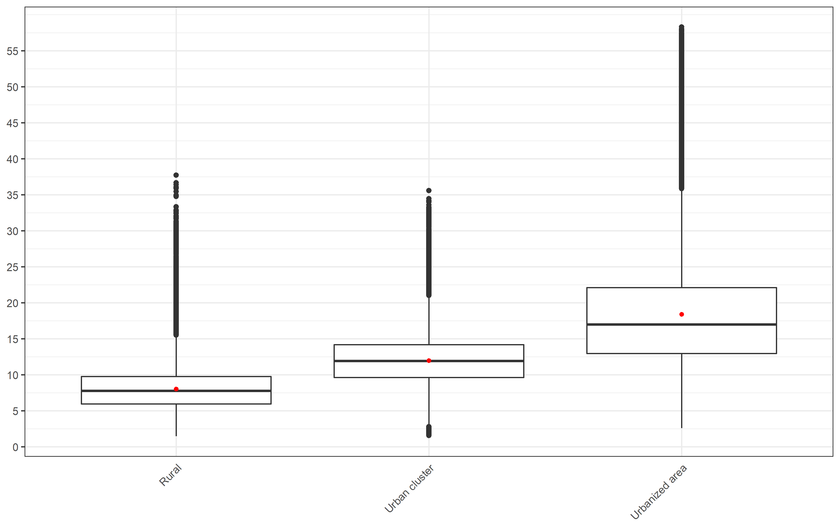

Figure S2: NO2 concentration (ug/m3) by median income group

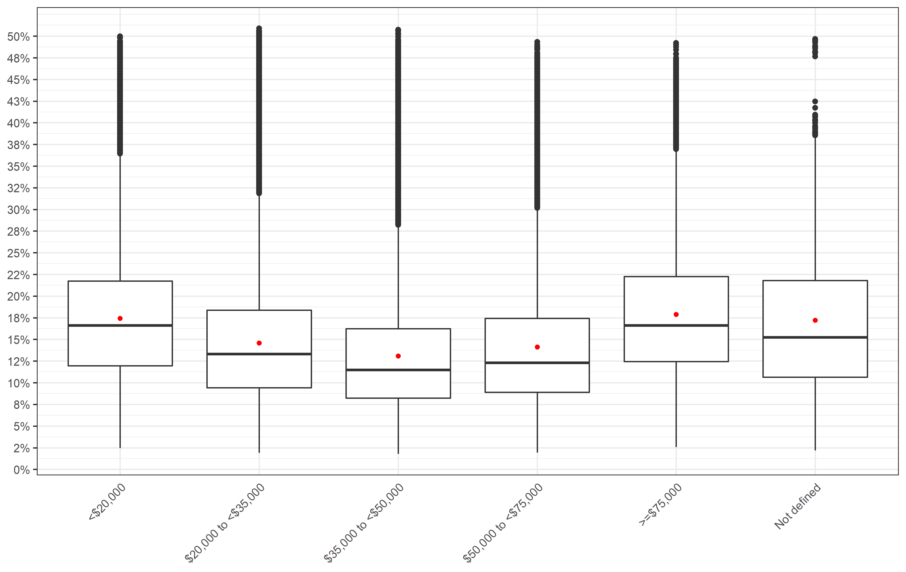

Figure S3: NO2 concentration (ug/m3) by living location stratified into median income group

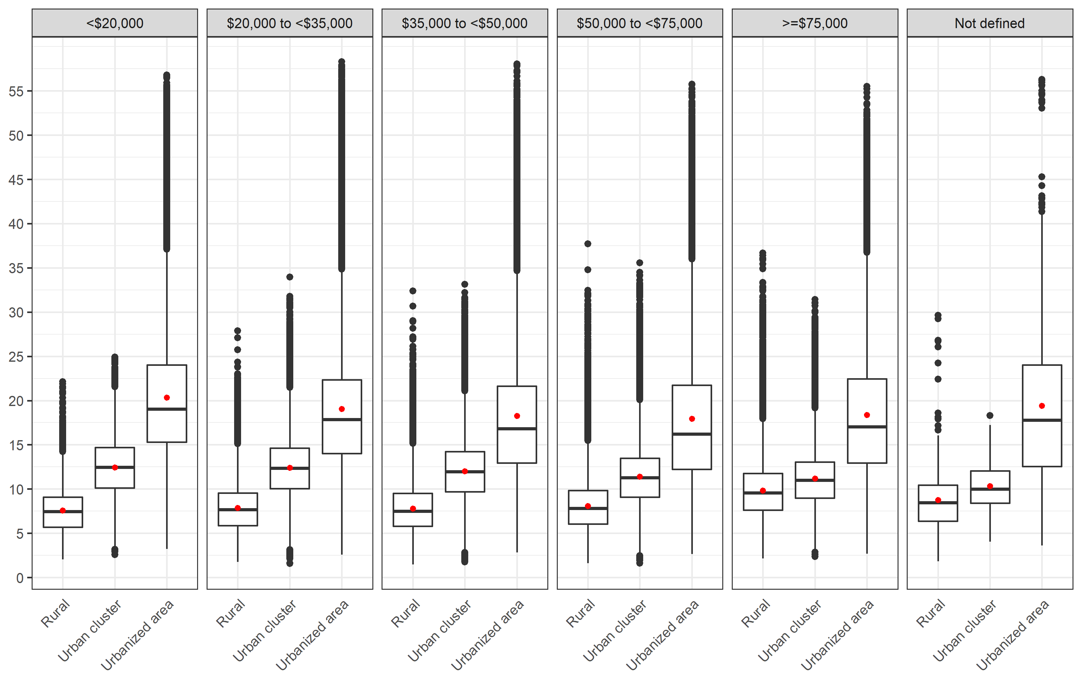

Figure S4: NO2 concentration (ug/m3) by median income group stratified into living location

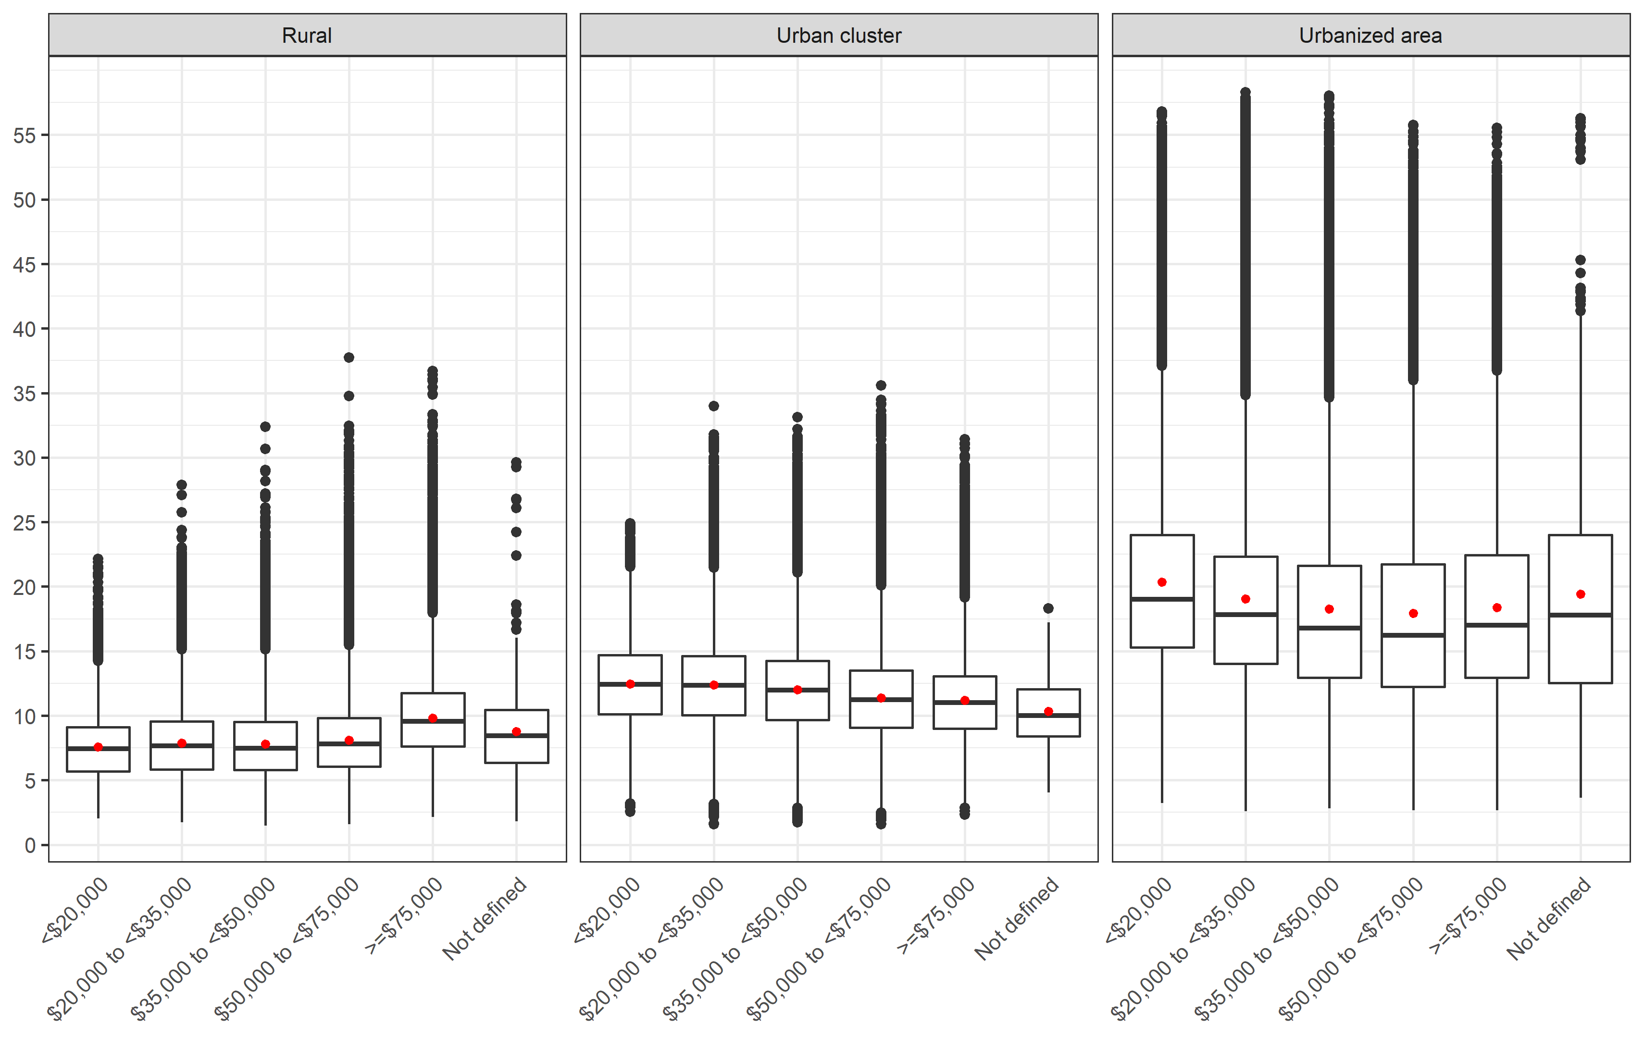

Figure S5: NO2 concentration (ug/m3) by state

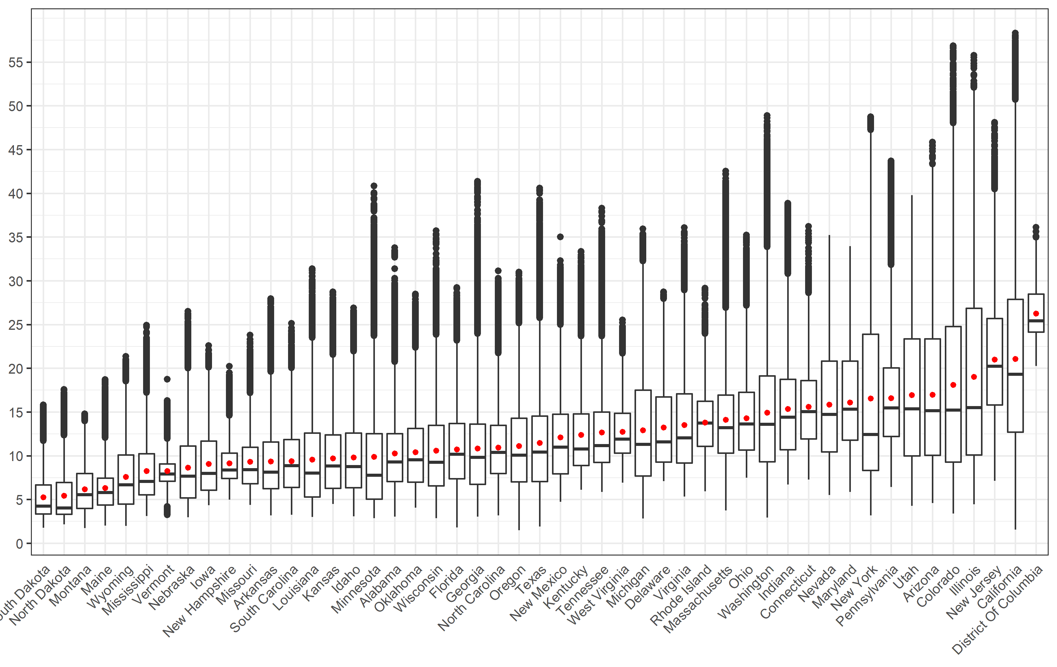

Figure S6: NO2 concentration (ug/m3) by state and median income group

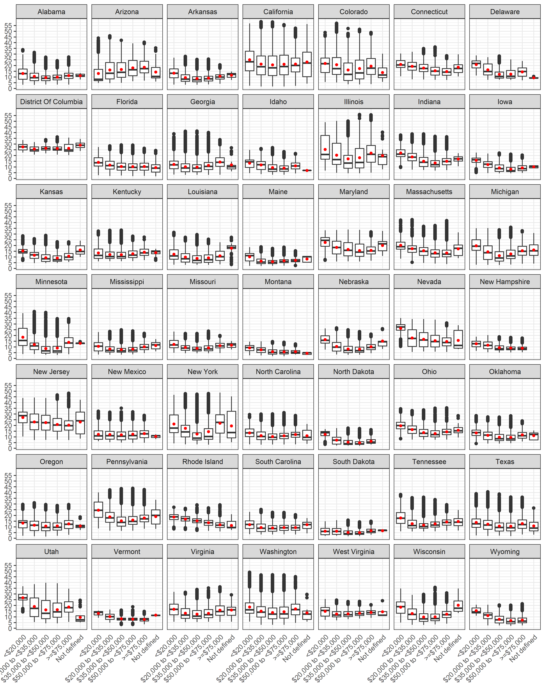

Figure S7: NO2 concentration (ug/m3) by state and living location

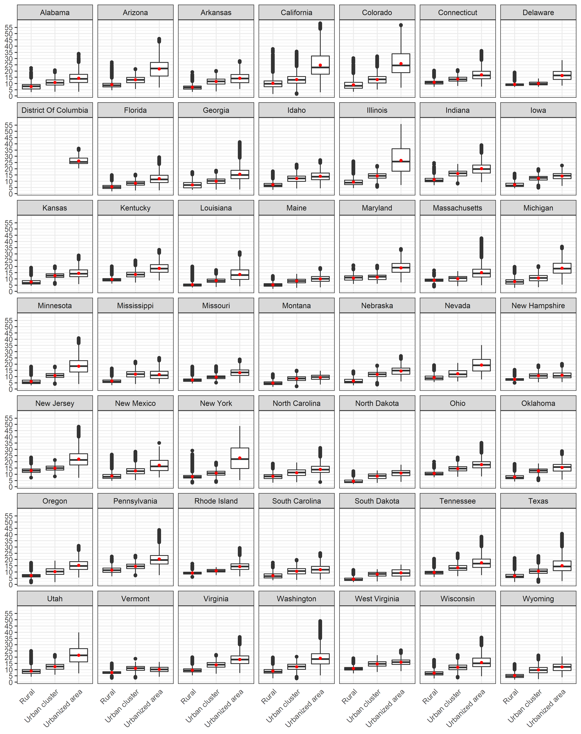

Figure S8: Attributable Fraction by living location

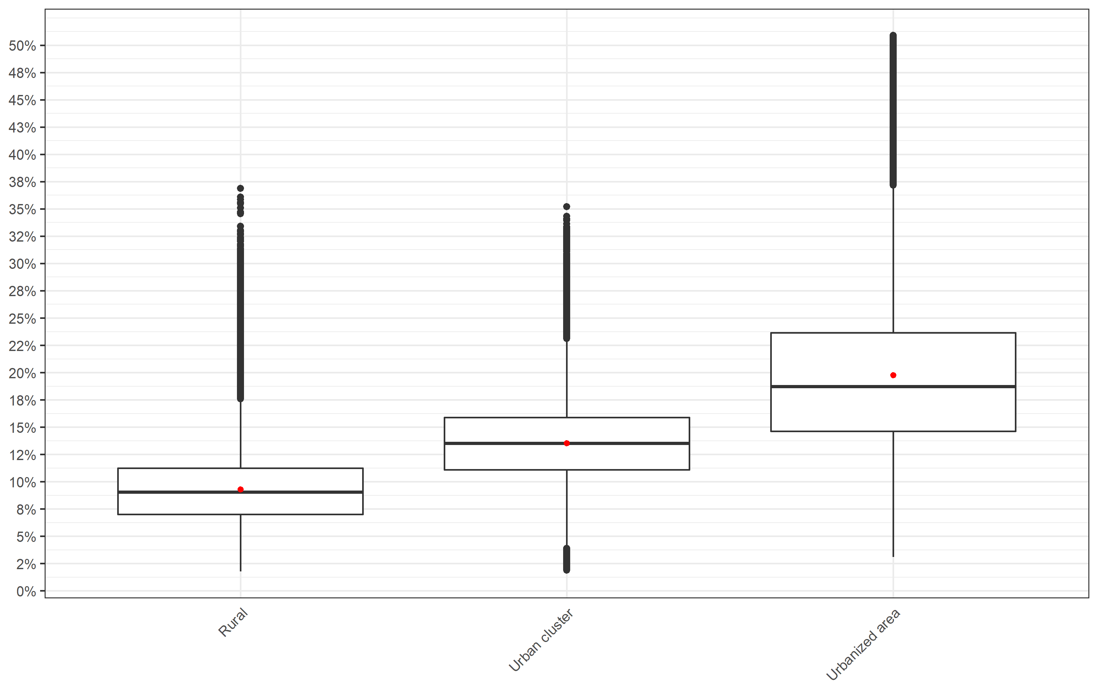

Figure S9: Attributable Fraction by median income group



Figure S10: Attributable Fraction by living location stratified into median income group

