## The Impact of Baseline Incidence Rates on Burden of Disease Assessment of Air Pollution and Onset Childhood Asthma: Analysis of Data from the Contiguous United States

**Haneen Khreis1, 2, 3, 4 *, Raed Alotaibi1,5,6, Jennifer Horney7 and Rob McConnell8**

1 Center for Advancing Research in Transportation, Emissions, Energy, and Health (CARTEEH), Texas A&M Transportation Institute (TTI), Texas, USA

2 ISGlobal, Centre for Research in Environmental Epidemiology (CREAL), Barcelona, Spain

3 Universitat Pompeu Fabra (UPF), Barcelona, Spain

4 CIBER Epidemiologia y Salud Publica (CIBERESP), Madrid, Spain

5 Department of Family and Community Medicine, Imam Abdulrahman Bin Faisal University, Saudi Arabia

6 Texas A&M Health Science Center School of Public Health, Texas, USA

7 Program in Epidemiology, University of Delaware

8 Department of Preventive Medicine, University of Southern California Keck School of Medicine, Los Angeles, California, USA

**\* Corresponding author at the Center for Advancing Research in Transportation Emissions, Energy, and Health (CARTEEH), Texas A&M Transportation Institute (TTI), 1111 RELLIS Parkway, Room 3412, Bryan, Texas 77807, USA.**

**Acknowledgments:**

We would like to thank Matthew Bechle and Professor Julian Marshall at the University of Washington for providing the 2010 Nitrogen Dioxide (NO2) exposure estimates.

**Competing financial interests:**

The authors declare they have no competing interests.

**Funding**

This research was made possible by funding from the Texas A&M Transportation Institute's (TTI) Center for Advancing Research in Transportation Emissions, Energy, and Health (CARTEEH), a U.S. Department of Transportation's University Transportation Center with the grant number (69A3551747128).

**Disclaimer**

The contents of this report reflect the views of the authors, who are responsible for the facts and the accuracy of the information presented herein. This document is disseminated in the interest of information exchange. The report is funded, partially or entirely, by a grant from the U.S. Department of Transportation's University Transportation Centers Program. However, the U.S. Government assumes no liability for the contents or use thereof.

**Abbreviations**

**AC:** Attributable number of cases

**ACBS:** Asthma Call Back Survey

**AF:** Attributable fraction of cases

**BRFSS:** Behavioral Risk Factor Surveillance System

**CDC:** Center for Disease Control and Prevention

**CRF**: Concentration-Response Function

**D.C.:** District of Columbia

**EPA:** United States Environmental Protection Agency

**IR:** Incidence rate

**LUR:** Land-use regression

**NHGIS:** National Historical Geographic Information System

**PAF:** Population attributable fraction

**ppb**: Parts per billion

**PR:** Prevalence rate

**TRAP:** Traffic-related air pollution

**U.S.:** United States

**Abstract**

**Background**

Burden of disease (BoD) assessments typically rely on national-level incidence rates for the health outcomes of interest. The impact of using a constant national-level incidence rate, versus a more granular spatially varying rate, remains unknown and understudied in the literature. At the same time, there has been an increasing number of publications estimating BoD of childhood asthma attributable to air pollution, as emerging evidence demonstrates that traffic-related air pollution (TRAP) leads to onset of the disease. In this paper, we estimated the burden of incident childhood asthma cases attributable to Nitrogen Dioxide (NO2), a good marker of TRAP, in the contiguous U.S. We used both a national-level and newly generated state-specific asthma incidence rates and compared results from the two approaches.

**Methods**

We estimated the number and percentage of incident childhood asthma cases attributable to NO2 using standard BoD assessment methods. We combined children (<18 years) counts and 2010 NO2 exposures at populated census blocks with a constant national-level and newly generated state-specific incidence rates. We estimated incidence rates using raw data from 2006-2010 Behavioral Risk Factor Surveillance System (BRFSS) and the nested Asthma Call Back (ACS) surveys collected by the Center for Disease Control and Prevention (CDC). We sourced concentration response functions (CRF) from the latest meta-analysis on TRAP and risk of onset childhood asthma. NO2 concentrations were obtained from a previously validated land-use regression (LUR) model. We stratified estimated BoD by urban versus rural status and by median household income, exploring trends across 48 states and the District of Columbia (D.C.).

**Results**

The mean (min-max) NO2 concentration(s) was 13.2 (1.5-58.3) ug/m3 and was highest in census-designated urbanized areas. We were able to estimate childhood asthma incidence rates in 32 states which ranged from 4.3 (Montana) to 17.7 (D.C.) per 1,000 at-risk children. The 17 states that did not have data to estimate an incidence rate were assigned the national aggregate asthma incidence rate of 11.6 per 1,000 at-risk children. Using the state-specific incidence rates resulted in a 7.2% relative reduction of 10,192 attributable number of cases, compared with estimates using a single incidence rate for all states based on the national average. This amounted to a 1.7% relative reduction in the attributable fraction at the U.S. level. The relative change in the attributable number of cases across the states was more prominent and ranged from -64.1% (Montana) to +33.8% (Texas). California had the largest absolute decrease, with 6,190 fewer attributable cases, while Texas had the largest increase, with 3,615 additional cases. Stratifying our analyses by socioeconomic status and urban versus rural status produced new trends compared to what we observed in past analyses where we employed a national-level incidence rate.

**Conclusion**

Using a constant U.S. versus state-specific asthma incidence rates resulted in a small change in the NO2 attributable BoD at the national level but had a more prominent impact on BoD estimates at the state level. This is the first study to analyze and document the impact of using a constant versus a spatially varying asthma incidence rate in the context of air pollution and asthma BoD assessment.

**Introduction**

Burden of disease (BoD) assessment is a powerful and relatively practical method to estimate the number/percentage of premature mortality and morbidity cases which may be attributable to environmental exposures. Such estimates can indicate how many cases of deaths and/or disease may be prevented by eliminating or reducing the exposure of interest. In the context of air pollution exposure, BoD assessments have become increasingly popular and predominantly used to assess the burden of mortality attributable to air pollution at the global, national, regional and local scales (Cohen et al., 2017, Cohen et al., 2005, Ostro and Organization, 2004, Lelieveld et al., 2015, Bhalla et al., 2014, Tainio, 2015, Mueller et al., 2017). The prior focus on mortality may reflect the availability of well-established epidemiological data that associate air pollution with premature death. It could also reflect the level of advancement in BoD, which is a relatively new practice still concerned with the most extreme outcome (death). Yet, to truly map, grasp and communicate the public health impact of air pollution, extending BoD beyond mortality is required, especially to chronic diseases. Chronic diseases are important as they have significant impacts on quality of life of individuals and families, affect productivity at work and school, can result in death and imply significant health care costs which may be preventable. Further, given the ubiquity of air pollution, especially in urban areas, the relatively modest-sized risk estimates from epidemiology translate into a large, yet modifiable, BoD.

One chronic disease that recently received attention in the context of air pollution is the onset of childhood asthma. Asthma is the most common chronic illness of childhood (Gasana et al., 2012, National Survey of Children's Health, 2012). In the U.S. alone, 6 million children had ongoing asthma in 2016 (Zahran et al., 2018). It is the third leading cause of hospitalization in children aged 15 and under and the leading cause of school absenteeism due to a chronic disease (American Lung Association, 2019, Hsu et al., 2016). The U.S. Center for Disease Control and Prevention (CDC) estimates the number of missed school days in a single year, 2008, at 10.4 million for children with asthma (CDC, 2010). The economic burden of asthma in the U.S., including costs incurred by absenteeism and mortality, was $81.9 billion in 2013 (Nurmagambetov et al., 2018).

Emerging epidemiological evidence suggests that exposure to air pollution, primarily when traffic-related, is associated with the onset of children’s asthma (Khreis et al., 2017), a conclusion supported by other recent studies (Rancière et al., 2016, Rice et al., 2018, Lee et al., 2018, Pennington et al., 2018). However, a limited number of studies have investigated the burden of incident childhood asthma attributable to traffic-related air pollution (TRAP) or its markers. Previous BoD studies investigating this topic (Achakulwisut et al., 2019, Khreis et al., 2018c, Khreis et al., 2018b, Anenberg et al., 2018, Alotaibi et al., 2019, Khreis et al., 2019) have identified several data gaps that may impact final BoD estimates and potentially result in uncertainty and error to these estimates. The accuracy of the BoD estimate is dependent on the accuracy of input data, namely: 1) the air pollution exposure levels and distribution, 2) the concentration-response functions, and 3) the baseline asthma incidence rates. Some studies investigated the impacts of different input datasets on final BoD estimates and found that different exposure assessment methods (dispersion versus land-use regression modeling) can result in up to a 3% absolute difference in the percentage of total annual asthma cases attributable to TRAP (Khreis et al., 2018a). Alotaibi et al. (2019) explored the impact of uncertainty in concentration-response functions (CRF) on final BoD estimates and found that using the most conservative epidemiologic estimate of the CRF (based on the lower 95% CI) can reduce the estimated absolute percentage of annual attributable asthma cases by up to 22%, when compared to the central estimate. On the other hand, using the most extreme epidemiologic estimate of the CRF (based on the upper 95% CI) can increase the estimated percentage of annual attributable asthma cases by up to 14%, when compared to the central estimate. Finally, one study (Khreis et al., 2018a) and follow-up work by the same group (2019) showed that using a national versus a local baseline asthma incidence rate can result in up to a 10% difference in the number of estimated attributable asthma cases. However, this analysis was limited to one medium-sized city in England (Bradford).

The impact of baseline asthma incidence rates on BoD estimates has not been thoroughly studied. Childhood asthma can be challenging to diagnose and ascertain, and national-level incidence rates are likely to vary at the subnational, in particular among urban and rural populations. Previous literature relied on national-level asthma incidence rates, which is in line with practice by prominent institutions and studies such as the Global Burden of Disease analyses (Soriano et al., 2015). In this paper, we explore the impact of using state-specific varying asthma incidence rates on the final burden of childhood asthma due to NO2 in the U.S. We compare the change in the BoD estimates to those produced by Alotaibi et al. (2019) who used a national-level asthma incidence rate, as typically practiced (Achakulwisut et al., 2019, Khreis et al., 2018c, Perez et al., 2009, Perez et al., 2013, Khreis et al., 2018b, Anenberg et al., 2018). We conduct this comparison at the national level but also state by state. Using these more granular state-specific asthma incidence rates, we also explore trends in BoD estimates by socioeconomic status and urban versus rural status to compare with trends observed in past analysis (Alotaibi et al., 2019). We selected NO2 as the exposure of interest, as the CRF is well supported and it has been the most commonly used pollutant in previous epidemiological and BoD assessments of incident asthma (Khreis et al., 2017). Thus, establishing how the pollution-attributable BoD estimates vary depending on baseline childhood asthma incidence rate distinguishes this from previous BoD studies.

**Methods**

*Study area and time point*

We analyzed data for the 48 contiguous U.S. States and the District of Columbia (D.C.) for 2010 at the census block level: the smallest census geographical unit available. Population counts, urban or rural living status and annual NO2 concentrations were all available at the census block level. However, median household income, a key covariate, was only available at the census block group level, which is one level higher than the census block (US Census Bureau, 2010). Childhood asthma incidence rates were estimated at the state level. NO2 concentrations were not available for states or territories outside the contiguous U.S. (Alaska, Hawaii and Puerto Rico), and hence these were excluded from our analysis.

*Census data*

We included populated census blocks of the contiguous U.S. for the year 2010, as obtained from the National Historical Geographic Information System (NHGIS) website (Manson et al., 2018, US Census Bureau, 2010). Each block included information on the total population of children <18 years old, and whether the census block was designated as an urban or a rural block. Census-designated urban areas were defined by the census bureau using multiple criteria including total population thresholds, density, nonresidential urban land use (e.g. paved areas and airports), and distance to other urban developed areas (US Census Bureau, 2016). Further, census-designated urban areas are classified into two subtypes; urban clusters (≥2,500 to <50,000 people) or urbanized areas (≥50,000 people). The median household income in the past 12 months using 2010 inflation adjusted dollars was divided into five categories consistent with two previous relevant publications: <$20,000, $20,000 to <$35,000, $35,000 to <$50,000, $50,000 to <$75,000 and ≥$75,000 (Clark et al., 2017, Alotaibi et al., 2019). Census blocks were assigned the same median household income of the census block group they resided within. There were 2,686 (0.04%) census blocks with missing median household income data in 2010. These census blocks were assigned a “Not defined” status in the analysis of median household income. Table 1 summarizes the geographical and demographic data across all census blocks included in this analysis.

*Table 1: Census data description, year 2010*

|  |  |  |
| --- | --- | --- |
| **Geographic characteristics** | **Total populated census blocks** | 6,182,882 |
| **Total census-designated urban areas** | 3,590,278 (58%) |
| **Demographic characteristics** | **Total population** | 306,675,006 |
| **Total population of children (birth – 18)** | 73,690,271 (24%) |
| **Mean (range) number of children in census blocks** | 12 (0-2214) |
| **Population of children by living location** | **Rural** | 13,763,183 (19%) |
| **Urban clusters (≥2,500 and <50,000 people)** | 6,994,464 (9%) |
| **Urbanized area (≥50,000 people)** | 52,932,624 (72%) |
| **Population of children by median household income** | **<$20,000** | 2,614,804 (4%) |
| **$20,000 to <$35,000** | 12,770,843 (17%) |
| **$35,000 to <$50,000** | 18,573,954 (25%) |
| **$50,000 to <$75,000** | 21,953,876 (30%) |
| **≥$75,000** | 17,763,239 (24%) |

*NO2 exposure assessment*

Annual average NO2 concentrations for each populated census block were available at the centroid location for the year 2010. Concentrations were derived from a land-use regression model (LUR) developed by Bechle et al. (2015) that incorporates spatial and temporal air pollutant data. The spatial data is derived from the U.S. Environmental Protection Agency (EPA) air quality monitoring data, satellite data and several GIS covariates including impervious surfaces, elevation, major, minor and residential roads, and distance to coast. The temporal data of the LUR model is incorporated by scaling the spatial data with the average monthly monitor readings for 11 consecutive years. The model achieves a relatively high predictive power as demonstrated using hold-out cross validation when compared to similar NO2 LUR models (Vienneau et al., 2013, Beelen et al., 2009, Hystad et al., 2011, Novotny et al., 2011) with an R2 reaching 82%. The LUR model has been used in multiple studies including Clark et al. (2017) and Alotaibi et al. (2019). A detailed description of the model can be found at Bechle et al. (2015). NO2 concentrations were converted from ppb to ug/m3through multiplying by 1.88 (WHO, 2005). Exposure data was matched with census blocks using a unique identifier for each census block as provided in the NHGIS dataset.

*Concentration-response functions*

We used an incident asthma CRF of 1.05 (95% CI = 1.02-1.07) per 4 ug/m3 of NO2. The CRF was obtained from a meta-analysis of 20 studies examining the association between exposure to NO2 and the risk of developing asthma among children from birth to 18 years of age (Khreis et al., 2017). This CRF represents data from the most recent meta-analysis of TRAP and onset of childhood asthma and has been used in several published peer-reviewed BoD assessments (Khreis et al., 2018c, Khreis et al., 2018b, Achakulwisut et al., 2019, Alotaibi et al., 2019, Khreis et al., 2019).

*Asthma incidence and prevalence rates*

An incidence rate (IR) is defined as the number of new cases of a disease within a specified time period among an at-risk population (Mausner and Kramer, 1985). To estimate the childhood asthma IR aggregated for the years 2006 through 2010 among U.S. states, we obtained the Behavioral Risk Factor Surveillance System (BRFSS) and Asthma Call Back Survey (ACBS) child data sets (CDC, 2011, CDC, 2009), which can be found at the CDC website <https://www.cdc.gov/brfss/>. We followed methods described by Winer et al. (2012) to estimate the asthma incidence rates and present our step by step approach in Figure 1. The BRFSS and ACBS define childhood as birth to 18 years of age, which is in line with the meta-analysis from where we sourced the CRF (Khreis et al., 2017). The following variables were extracted from the surveys:

* State
* Asthma status question (from the BRFSS),
* Incident status question (from the ACBS), and
* Children sample weights from both surveys.

All analysis was conducted using the open-access statistical software: R (R Core Team, 2018).

*Figure 1: Childhood asthma incidence rate estimation flow chart*

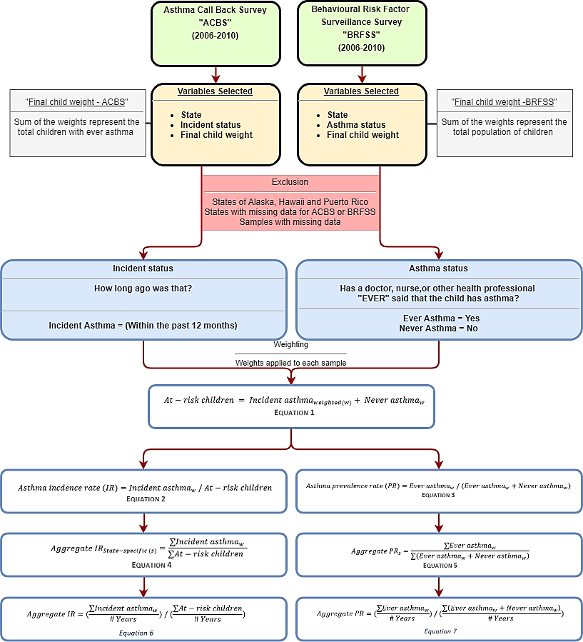

To determine the “asthma status” of children, respondents to the BRFSS were asked “Has a doctor, nurse, or other health professional EVER said that the child has asthma?”, If the answer was “Yes”, the respondent was designated as “Ever asthma”. If the answer was “No”, the respondent was designated as “Never asthma”. Respondents with children designated as “Ever asthma” were requested to participate in the ACBS follow up. To determine the “incident status” of children, respondents to the ACBS were asked: “How old was the [name of child] when a doctor or other health professional first said [he/she] had asthma? How long ago was that?” If the answer to the latter part of this question was “within the past 12 months”, the respondent was designated as an “Incident asthma”, while other responses were not relevant to the analysis described next.

Each respondent (sample) from the BRFSS and ACBS was assigned a weight to adjust for the disproportionate population sample selection as compared to the state’s overall population distribution, the variation in probability of selection, the actual response of each respondent, or nonresponse (Garbe et al., 2011, Korn and Graubard, 2011). To simplify this, the weight of each sample represents the number of children within each state, with similar characteristics (age, sex and race) to the sample. Weights were used to convert samples to population estimates of children. For example, if respondent (X) had a weight of 150, her/his response to survey questions represented answers of 150 children within their state, with similar age, sex and race characteristics. The sum of childhood weights for the BRFSS represents the total population of children within each state, while the sum of weights for the ACBS represents the total population of children with “Ever asthma” within each state.

“At-risk children” were then estimated by taking the weighted sum of respondents designated as “Incident asthma” and “Never asthma”, as shown in Equation 1.

*Equation 1*

The asthma incidence rate (IR) was the weighted “Incident asthma” divided by “At-risk children”, as shown in Equation 2.

*Equation 2*

The asthma prevalence rate (PR) was the weighted “Ever asthma” divided by the sum of weighted “Ever asthma” and weighted “Never asthma”, as shown in Equation 3.

*Equation 3*

To estimate the state-specific aggregate asthma IR and PR, we summed numerators and denominators across available years (2006-2010) for each state separately, as shown in Equation 4 and 5.

*Equation 4*

*Equation 5*

For states with no available data to allow estimating state-specific incidence rates (n = 17) and/or state-specific prevalence rates (n = 8), we assigned them the overall aggregate IR (11.6 per 1,000 at-risk children) and aggregate PR (13.1 per 100 children), which represented all the available data across all states. In order to aggregate across all the states, we re-weighted the data to adjust for the number of available years in each state. For example, the state of Arizona had two years of available data (2006 and 2007). To aggregate the IR for Arizona across all available years, we summed the weighted “Incident asthma” across all the years and divided it by two (the number of years with available data for the state of Arizona). We then divided the results by the sum of “At-risk children” across all the two years, again divided by two, as shown in Equation 6.

*Equation 6*

The aggregate asthma PR across all available years was estimated as shown in Equation 7.

*Equation 7*

*Burden of disease estimation*

To estimate the BoD of incident childhood asthma attributable to NO2 exposure, we followed standard methods described in Alotaibi et al. (2019) with the following steps:

The total number of at-risk children residing in a census block was estimated for each state. This was done by subtracting the total number of children within the census block multiplied by the state-specific aggregate PR (from Equation 5 or 7) from the total number of children within the same census block, as shown in Equation 8.

*Equation 8*

We then estimated the number of childhood asthma incident cases within each census block by multiplying the state-specific aggregate asthma IR (from Equation 4 or 6) by the at-risk children in each census block (from Equation 8), as shown in Equation 9.

*Equation 9*

We then calculated the relative risk (RRdiff) for asthma onset due to the exposure difference between the estimated exposure levels from the LUR model (NO2 concentration at the centroid of each census block) and no exposure (zero concentration for NO2) at each census block, as shown in Equation 10.

*Equation 10*

Where RR is the CRF and RRunit is the exposure unit (4 ug/m3) for the CRF as extracted from Khreis et al. (2017). The population attributable fraction (PAF) was then also estimated at each census block, as shown in Equation 11.

*Equation 11*

The attributable number of asthma incident cases (AC) was estimated by multiplying the PAF with the total number of asthma incident cases at each census block (from Equation 9), as shown in Equation 12.

*Equation 12*

The attributable number of asthma incident cases for each census block was then summed across the state to obtain state total AC estimates, and the entire country to obtain the national AC estimates, as shown in Equation 13.

*Equation 13*

**Results**

*NO2 concentrations and trends*

The mean (min-max) NO2 concentrations were 13.2 (1.5-58.3) ug/m3 (Table 2) with the highest mean NO2 concentrations in urbanized areas (18.4 ug/m3) (for visual representation, see Figure S1) and among the highest median household income group of ≥$75,000 (16.5 ug/m3), followed by the lowest median household income group of <$20,000 (16.1 ug/m3) (for visual representation, see Figure S2). When stratifying NO2 concentrations by median household income groups for urban and rural areas, rural areas had an increasing average concentration as income increased, while urban clusters has a decreasing average concentration as income increased, showing a U-shaped trend (Figure S3 and Figure S4). South Dakota had the lowest mean NO2 concentration (5.2 ug/m3), while D.C. had the highest (26.3 ug/m3) (Table S1 and Figure S5). Figure S6 and Figure S7 demonstrate NO2 concentrations across median household income and urban/rural location, separately for each state.

*Table 2: NO2 concentrations (ug/m3) by strata*

|  |  |  |  |  |  |  |  |
| --- | --- | --- | --- | --- | --- | --- | --- |
|  |  | **Mean** | **Min** | **25%** | **Median** | **75%** | **Max** |
| **Total** |  | 13.2 | 1.5 | 7.9 | 11.4 | 16.6 | 58.3 |
| **By living location** | **Rural** | 8.0 | 1.5 | 6.0 | 7.8 | 9.8 | 37.7 |
| **Urban cluster** | 12.0 | 1.6 | 9.6 | 11.9 | 14.2 | 35.6 |
| **Urbanized area** | 18.4 | 2.6 | 13.0 | 17.0 | 22.1 | 58.3 |
| **By median household income** | **<$20,000** | 16.1 | 2.0 | 10.4 | 14.9 | 20.1 | 56.8 |
| **$20,000 to <$35,000** | 13.2 | 1.6 | 8.1 | 11.7 | 16.7 | 58.3 |
| **$35,000 to <$50,000** | 11.8 | 1.5 | 7.0 | 10.0 | 14.5 | 58.0 |
| **$50,000 to <$75,000** | 12.8 | 1.6 | 7.6 | 10.8 | 15.7 | 55.7 |
| **≥$75,000** | 16.5 | 2.1 | 10.9 | 14.9 | 20.6 | 55.5 |

*ACBS and BRFSS results*

Overall, there were 32 states where we were able to extract childhood asthma incidence rates and 41 states with childhood asthma prevalence rates (Table S2-S4). The total childhood samples included for the period 2006-2010 were 293,464 samples from the BRFSS and 16,156 samples from the ACBS (Table 3). The BRFSS samples ranged between 55,094 samples (2006) and 61,862 (2008). The ACBS samples ranged between 2,017 samples (2006) and 4,095 (2009). The weighted estimates represent the childhood population counts of available states from the BRFSS and the ACBS for the years when the survey was conducted.

Across all available states, the overall aggregate asthma incidence rate for the years 2006-2010 was 11.6 per 1,000 at-risk children (Table 3). The state of Montana had the lowest aggregate childhood asthma incidence rate (IR = 4.3 per 1,000 at-risk children), while D.C. had the highest aggregate childhood asthma incidence rate (IR = 17.7 per 1,000 at-risk children) (Table S2). States that did not have an incidence rate available (n = 19 states) were assigned the overall aggregate asthma incidence rate of 11.6 per 1,000 at-risk children (Table S2-S4).

The overall aggregate asthma prevalence rate for the years 2006-2010 was 13.1 per 100 children (Table 3). The state of Iowa had the lowest aggregate childhood asthma prevalence rate (PR = 8.4 per 100 children), while D.C. had the highest aggregate childhood asthma prevalence rate (PR = 19.9 per 100 children) (Table S2). States that did not have a prevalence rate available (n = 8 states) were assigned the overall aggregate asthma prevalence rate of 13.1 per 100 children.

*Table 3: Childhood asthma survey summaries*

|  |  |  |  |  |  |  |
| --- | --- | --- | --- | --- | --- | --- |
|  | **2006** | **2007** | **2008** | **2009** | **2010** | **Total** |
| **BRFSS sample (weighted)** | 55,094 (50,674,742) | 59,487 (43,661,381) | 61,862 (53,327,550) | 59,821 (47,747,373) | 57,200 (39,975,264) | 293,464 |
| **Ever asthma sample (weighted)** | 7,168 (6,493,224) | 7,971 (5,763,409) | 8,255 (7,218,400) | 8,126 (6,279,938) | 7,483 (5,158,455) | 39,003 |
| **ACBS Sample (weighted)** | 2,017 (4,580,870) | 2,797 (5,459,638) | 3,924 (4,343,245) | 4,095 (4,154,076) | 2,196 (3,116,669) | 16,156 |
| **Incident case sample (weighted)** | 154 (404,276) | 173 (312,917) | 169 (385,818) | 153 (297,546) | 160 (319,743) | 809 |
| **At-risk sample (weighted)** | 48,080 (30,825,589) | 51,689 (36,050,557) | 53,776 (26,491,259) | 51,848 (25,942,087) | 49,877 (22,900,850) | 255,270 |
| **Incidence rate** | 13.1 | 8.7 | 14.6 | 11.5 | 14.0 | 11.6* |
| **Prevalence rate** | 12.8 | 13.2 | 13.5 | 13.2 | 12.9 | 13.1** |
| **Number of states included** | 18 | 26 | 20 | 17 | 17 | 32*** |

*\*Aggregate asthma incidence rate per 1,000 at-risk children*

*\*\*Aggregate asthma prevalence rate per 100 children*

*\*\*Total number of states included in the aggregate asthma incidence rate estimation*

*Asthma incident cases*

Using state-specific asthma incidence rates, the estimated number of incident cases of childhood asthma in 2010 were 747,437 (Table 4). The state with the lowest number of estimated incident cases of childhood asthma was Montana with 866 cases, while the state with the largest number was Texas with 99,084 cases (Table S5).

*Attributable number of cases and fraction*

We estimated a total of 131,739 childhood asthma incident cases attributable to NO2 exposure, accounting for 17.6% of all childhood asthma incident cases (Table 4). By living location, urbanized areas had the largest number of attributable cases totaling 108,745 cases and the highest percentage of all asthma incident cases at 20.3%. Rural areas had a total of 13,788 cases and accounted for the lowest percentage of all asthma cases at 9.8%, while urban clusters had 9,206 cases representing 13.1% of all asthma incident cases (Table 4). By median household income, census blocks with incomes of $50,000 to <$75,000 had the largest number of cases attributable to NO2: 37,253 cases accounting for 16.8% of all asthma incident cases. However, the income group with the largest proportion of asthma cases attributable to NO2 was the lowest income group <$20,000, accounting for 20.8% of all asthma incident cases (Table 4).

The distribution of attributable fractions at the census block level shows that the mean value was higher in urbanized areas compared to rural areas (Figure S8) and followed a U shape distribution by income group (Figure S9). When examining the distribution of attributable fraction across income groups stratified by living location, we observed that the mean value increased by increasing income group in rural areas, decreased by increasing income group in urban clusters and presented as a U shape in urbanized areas (Figure 2).

The state with the lowest number of estimated attributable cases was Montana with 69 cases, while the state with the largest number of estimated attributable cases was California with 19,205 cases (Table S5). The state with the lowest attributable fraction was South Dakota (7.5%), while the state with the highest attributable fraction was D.C. (26.9%) (Table S5). When examining the distribution of attributable fractions across all census blocks, we observed that the state with the lowest average value was South Dakota while the state with the largest average value was District of Columbia (Figure 3).

*T**able 4: Comparing the results of the burden of disease using state-specific estimates vs original estimates*

|  |  |  |  |  |  |  |  |  |  |  |  |  |  |
| --- | --- | --- | --- | --- | --- | --- | --- | --- | --- | --- | --- | --- | --- |
|  |  | **Results using constant national-level IR****[1]** | | | **Results using state-specific IR** | | | **Difference** | | | **Difference (%)** | | |
|  |  | **Incident cases** | **AC****[2]** | **AF****[3]** | **Incident cases** | **AC** | **AF** | **Incident cases** | **AC** | **AF** | **Incident cases** | **AC** | **AF** |
|  | **Total** | 794,934 | 141,931 | 17.9% | 747,437 | 131,739 | 17.6% | -47,497 | -10,192 | -0.3% | -6.0% | -7.2% | -1.7% |
| **By living location (% of Total)** | **Rural** | 148,470 (19%) | 14,466 (10%) | 9.7% | 140,799 (19%) | 13,788 (10%) | 9.8% | -7,671 | -678 | 0.1% | -5.2% | -4.7% | 1.0% |
| **Urban cluster** | 75,453 (9%) | 9,844 (7%) | 13.0% | 70,524 (9%) | 9,206 (7%) | 13.1% | -4,929 | -638 | 0.1% | -6.5% | -6.5% | 0.8% |
| **Urbanized area** | 571,011 (72%) | 117,621 (83%) | 20.6% | 536,113 (72%) | 108,745 (83%) | 20.3% | -34,898 | -8,876 | -0.3% | -6.1% | -7.5% | -1.5% |
| **By median household income (% of Total)** | **<$20,000** | 28,207 (4%) | 5,892 (4%) | 20.9% | 27,770 (4%) | 5,786 (4%) | 20.8% | -437 | -106 | -0.1% | -1.5% | -1.8% | -0.5% |
| **$20,000 to <$35,000** | 137,765 (17%) | 25,794 (18%) | 18.7% | 132,843 (18%) | 24,699 (19%) | 18.6% | -4,922 | -1,095 | -0.1% | -3.6% | -4.2% | -0.5% |
| **$35,000 to <$50,000** | 200,367 (25%) | 34,549 (24%) | 17.2% | 188,466 (25%) | 32,088 (24%) | 17.0% | -11,901 | -2,461 | -0.2% | -5.9% | -7.1% | -1.2% |
| **$50,000 to <$75,000** | 236,827 (30%) | 40,540 (29%) | 17.1% | 221,334 (30%) | 37,253 (28%) | 16.8% | -15,493 | -3,287 | -0.3% | -6.5% | -8.1% | -1.8% |
| **≥$75,000** | 191,621 (24%) | 35,128 (25%) | 18.3% | 176,880 (24%) | 31,885 (24%) | 18.0% | -14,741 | -3,243 | -0.3% | -7.7% | -9.2% | -1.6% |

*Figure 2: Distribution of attributable fractions by median household income group stratified by living location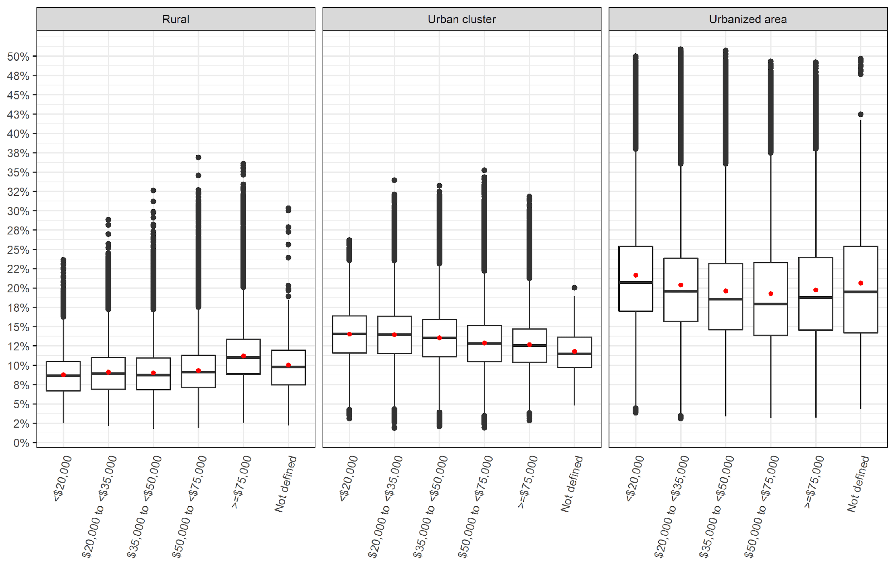*

*\*Red dot represents the mean value while the midline represents the median value of attributable fractions across all the census blocks*

*Figure 3: Distribution of attributable fractions by state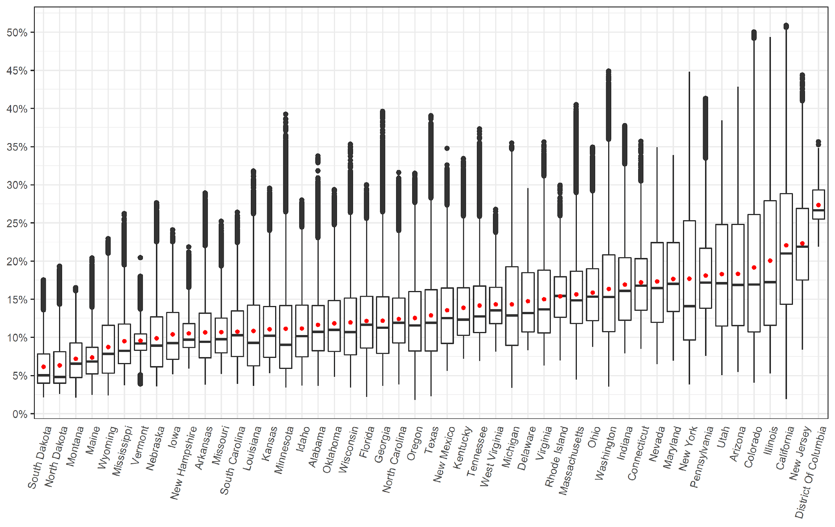*

Figures 4 and 5 present the distribution of attributable fractions across all census blocks by living location and median household income group for each state. The majority of states broadly follow a distribution similar to the national level as shown in Figure S8 and Figure S9, with a few exceptions (By living location see; Delaware, Maryland, Mississippi, Vermont. By median household income see; Arizona, Connecticut, D.C., Florida, Maine, Massachusetts, Montana, Nevada, New Hampshire, New Jersey, New Mexico, Vermont, West Virginia, Rhode Island and Wyoming).

*Figure 4: Distribution of attributable fraction by state and living location*

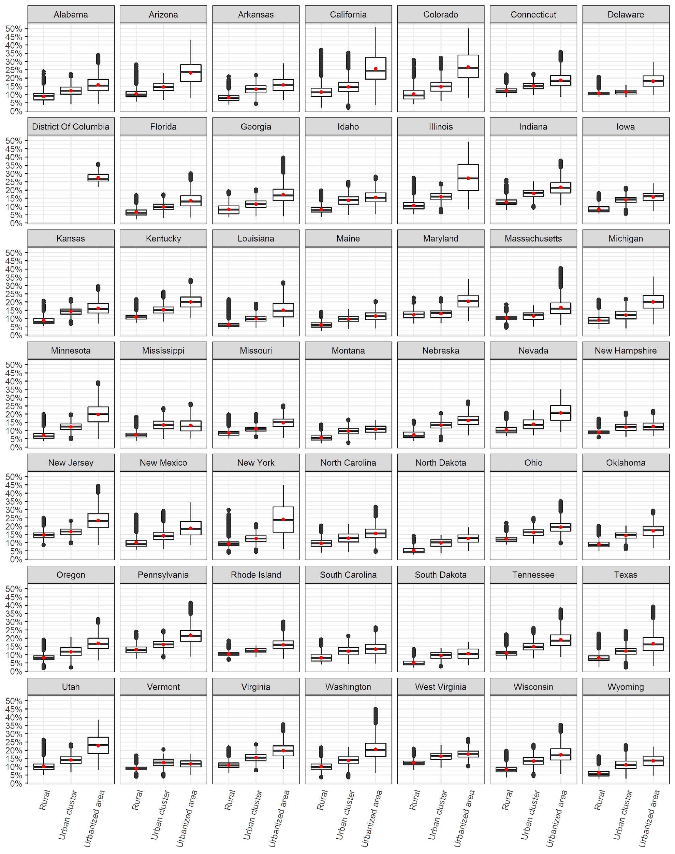

*Figure 5: Distribution of attributable fraction by state and median household income group*

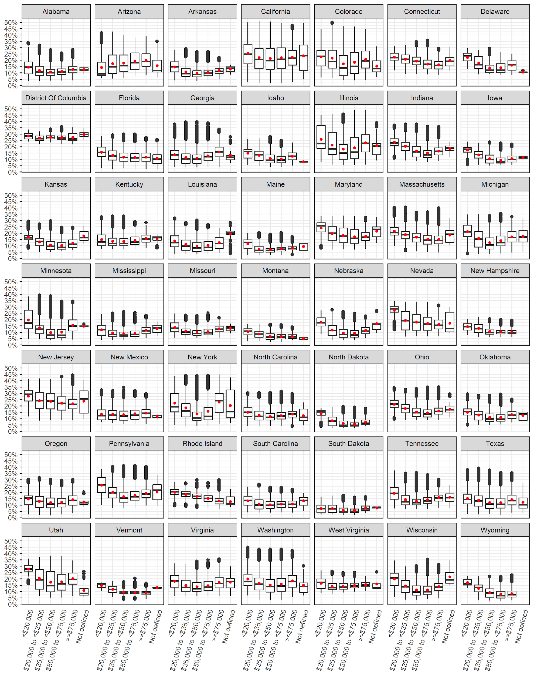

*Comparing* ***total asthma incident cases*** *using state-specific versus a constant national-level incidence rate*

Using state-specific asthma incidence rates, the total number of total incident asthma cases was reduced by 47,497 (6% relative change) compared to estimates using a national-level asthma incidence rate of 12.5 per 1,000 at-risk children assigned to all states (Table 4) (Alotaibi et al., 2019). By living location, the largest relative change was among urban clusters, with a decrease of 4,929 (6.5%) cases, followed by urbanized areas with a reduction of 34,898 (6.1%) cases. By income group, the largest relative change in the number of total incident cases was among the highest income groups with a decrease of 14,741 (7.7%) cases, while the smallest relative change was among the lowest income group, with a decrease of 437 (1.5%) cases (Table 4). California had the largest decrease in the number of total childhood asthma incident cases (24,441 cases), while Texas had the largest increase in numbers of total childhood asthma incident cases (25,019 cases) (Table S5). Montana had the largest relative reduction in total childhood asthma incident cases (64.1%). Texas had the largest relative increase (33.8%) (Table S5).

*Comparing* ***attributable asthma incident cases due to NO2****using state-specific versus a constant national-level incidence rate*

The number of cases attributable to NO2 was reduced by 10,192 (7.2% relative change) when compared to estimates using a national-level asthma incidence rate (Table 4). By living location, urbanized areas had the largest relative change with a decrease of 8,876 (7.5%) cases, while rural areas had the least relative change with a decrease of 678 (4.7%) cases attributable to NO2 exposure. By income group, the highest income group had the largest relative change with a decrease in attributable cases by 3,243 (9.2%) while the lowest income group had the least relative change with a decrease of 106 (1.8%) cases. California had the largest decrease in cases attributable to NO2 (6,190 cases), while Texas had the largest increase (3,615 cases) (Table S5).

*Comparing* ***attributable asthma incident fractions due to NO2****using state-specific versus a constant national-level incidence rate*

The overall attributable fraction was absolutely reduced by 0.3% (a 1.7% relative reduction) (Table 4). In terms of living location, urbanized areas had the largest relative reduction by 1.5%, while rural areas had the largest relative increase by 1%. In terms of income group, the largest relative reduction was 1.8% for the $50,000 to <$75,000 income strata (Table 4). The attributable fraction across states did not differ when using state-specific asthma incidence rates. The small differences observed across some states in Table S5 are due to rounding errors.

**Discussion**

*Summary and key findings*

Using validated NO2 exposure models and U.S. Census data for the year 2010, we investigated the impact baseline childhood asthma incidence rates have on NO2 BoD estimates across 48 U.S. states and D.C. We documented differences in BoD estimates when using state-specific versus a constant national-level asthma incidence rate for the first time. Previous literature relied on national-level asthma incidence rates for BoD assessments and the impact of this simplification was unknown. Using the state-specific asthma incidence rates, we also explored trends in BoD estimates stratifying our analyses by socioeconomic status and urban versus rural status to compare trends we observed in past analysis using only a national-level incidence rate (Alotaibi et al., 2019).

At the national level, the difference in the estimated BoD using state-specific versus a national-level asthma incidence rate was relatively small. Using the state-specific incidence rates resulted in a 7.2% relative reduction of 10,192 attributable number of cases, which amounted to a 1.7% relative reduction in the attributable fraction. While a 1.7% relative reduction in the attributable fraction is relatively small and needs to be weighed against the effort required to produce state-specific incidence rates, its implications might be more significant depending on whether/how BoD estimates are used in policy making, including regulatory cost-benefit analysis or EPA risk assessments. For example, according to Perry et al. (2019), the average annual costs of asthma per child in the U.S. ranged from $3,076 to $13,612. In simplistic terms, using the state-specific versus the national-level incidence rate could result in an overall reduction ranging from $31,350,592 to $138,733,504 in estimated burden costs, per year, at the national level. More importantly, however, is the larger variation across the states which is important for state policy priority setting. Using the state-specific incidence rates, which we expected to more accurately capture between-state variation, resulted in a relative change in the attributable number of cases ranging from -64.1% (Montana) to 33.8% (Texas). California had the largest absolute decrease in the number of attributable cases by 6,190 cases while Texas had the largest increase by 3,615 cases, followed by New York (1,750).

Further, stratifying our analyses by socioeconomic status and urban versus rural living produced new trends compared to what we observed in past analysis which employed a national-level incidence rate (Alotaibi et al., 2019). For example, most of the relative change in the attributable number of cases (-7.5%) occurred in urbanized areas and among the highest median household income group of ≥$75,000 (-9.2%). The distribution of the attributable fractions across all census blocks by living location and median household income group showed that the majority of states broadly followed the U-shaped distribution observed at the national level; where the lowest and the highest median household income groups had the highest burden, corresponding to highest exposures in those strata. There were many exceptions, however, including Arizona, Connecticut, D.C., Florida, Maine, Massachusetts, Montana, Nevada, New Hampshire, New Jersey, New Mexico, Vermont, West Virginia, Rhode Island and Wyoming. On the other hand, there were states where this U-shaped distribution was more prominent including Illinois and New York, and to a lesser extent: Pennsylvania and Texas. This may reflect a trend of lowest income populations to live in most polluted census blocks due to financial constraints on housing in less polluted areas, a finding that is well established in the environmental justice literature (Hajat et al., 2015). On the other hand, it is possible, although less intuitive, that the highest income populations live in highly polluted census blocks as they prefer to live near the amenities of busy downtowns and central business districts, where TRAP is higher. If this was the case, this trend does not apply to all states and may even differ by rural, urban cluster and urbanized area status (Figure S4, S6 and S7). Previous work suggested that metropolitan areas, in particular, exhibit considerable heterogeneity when it comes to socioeconomic status and exposure to air pollution. For example, in cities like New York, wealthy neighborhoods have been associated with higher concentrations of pollution (Hajat et al., 2013). These trends warrant further investigation using more refined air pollution and asthma incidence estimates at an even more granular spatial scale.

*Comparison with previous studies*

All previous BoD studies on air pollution and new onset asthma (Achakulwisut et al., 2019, Khreis et al., 2018c, Khreis et al., 2018b, Alotaibi et al., 2019, Anenberg et al., 2018, Khreis et al., 2019) have identified the use of a constant national-level baseline asthma incidence rate as a data gap which might impact the final BoD estimates. Our results suggested that at the national level, this impact was small, but that at the state level, the impact was large ranging from a relative change in the attributable number of cases between -64.1% to +33.8%. These results are not directly comparable to previous studies as only a national-level incidence rate was used in the past. Overall, our BoD estimates attributable to NO2 (attributable fraction = 17.6%) were very similar to previous reports of 18% in Alotaibi et al. (2019); 19% in high-income North America (Achakulwisut et al., 2019), 23% in 18 European countries (Khreis et al., 2019) and 18-24% in Bradford, England (Khreis et al., 2018a).

*Strengths and limitations*

This study is the first study that investigates impact of using a national-level compared to state-specific baseline incidence rates on BoD assessment of air pollution and onset asthma. Our analysis included information on NO2 concentrations across the contiguous U.S. and over 73 million children aged birth-18 years old. Our exposure assessment, CRF selection and BoD procedure was standardized with previous analysis (Alotaibi et al., 2019), with the only difference being use of state-specific asthma incidence rates in the present study. We used the best available data from CDC, for the longest period possible, aligned with our exposure assessment year (2010), to generate state-specific childhood asthma incidence rates. These state-specific childhood asthma incidence rates have not been readily available until now where we used raw data from CDC surveys to estimate them. We used meta-analysis derived CRF of continuous NO2 exposures from the widest and most recent analysis of TRAP and onset childhood asthma (Khreis et al., 2017). A meta-analysis derived CRF can overcome statistical uncertainty associated with a single study’s CRF and would better account for heterogeneity among different populations. We also specifically investigated trends in the BoD across different socioeconomic strata, separately by each state, and showed that these trends are far from uniform, differing across different states and urban versus rural locations.

Despite its strengths, this study has some noteworthy limitations. We selected NO2 as the exposure of interest, as it has been the most commonly used pollutant in previous BoD analyses and as a larger body of studies support its use as an appropriate CRF. It can be argued, however, that NO2 is not the putative agent, and that it serves as a surrogate pollutant for the mixture of fresh traffic exhaust and regional NO2. Indeed, there is stronger toxicological evidence that links particulate matter with onset asthma (American Thoracic Society, under review). However, this issue is less relevant in our current analysis as the aim of this study was to establish impact of using different baseline asthma incidence rates only. Possible interactions between pollutants was not considered as there is very limited epidemiological data to support this analysis Furthermore, most studies included in the meta-analysis underlying our calculations adjusted for major confounders (e.g. socioeconomic status, smoking, parental atopy) (Khreis et al., 2017). However, there were no specific CRFs based on these variables (e.g. a CRF for low versus high median household income), and as such we could not account for this in our analysis. However, we stratified our BoD results by living location and median household income to visualize corresponding differences in BoD, without using different CRFs and incidence rates across these strata, which is a novel contribution. Another caveat with this approach is that we did not have median household income at the census block level, which was the geographical level at which we assigned exposure and population data. Instead, census blocks were assigned the same median household income of the census block *group* they resided within. This was our best available option, but it could have resulted in misclassification and therefore distorted some of the trends we observed in the stratified socioeconomic status analyses.

There were also limitations to the datasets we used to estimate the state-specific asthma incidence rates. The total childhood samples included for the period 2006-2010 were 293,464 samples from the BRFSS and 16,156 samples from the ACBS (Table 3). These samples were, however, weighted to represents number of children within each state, with similar characteristics (age, sex and race) to the sample. In other words, weights were used to convert samples to population estimates of children. A larger sample size in these surveys would have better represented the U.S. childhood population of <73 million which we included in our analysis. Finally, we relied on state-specific pediatric asthma incidence rates in our analysis, but sub-state variations most likely exist, including between urban and rural populations, and amongst different races, sexes, ages and socioeconomic classes. Unfortunately, this information is still not readily available, hindering our ability to estimate sub-population-specific asthma incidence rates, within each state.

**Conclusions**

Using a constant U.S. versus state-specific asthma incidence rates resulted in a small change in the NO2 attributable BoD at the national level. However, the change in BoD estimates at the state level was more prominent. For example, the relative change in the attributable number of childhood asthma cases using the state-specific asthma incidence rates ranged from -64.1% (Montana) to +33.8% (Texas), compared with estimates using a single incidence rate for all states based on the national average. The reduction in the NO2 attributable fraction of asthma at the U.S. level was relatively small and needs to be weighed against the effort required to produce state-specific incidence rates. However, the implications of using finer level incidence rates might be significant depending on whether and how BoD estimates are used in regulatory cost-benefit analysis or EPA risk assessments for policy making. This is specifically relevant if these regulatory assessments were conducted at the state level. Otherwise, our findings support using national-level asthma incidence rates to estimate asthma burden due to air pollution, when incidence rates are not available at a finer resolution. This is the first study to analyze and document the impact of using a constant versus a spatially varying asthma incidence rate in the context of air pollution and asthma BoD assessment.

**References**

ACHAKULWISUT, P., BRAUER, M., HYSTAD, P. & ANENBERG, S. C. 2019. Global, national, and urban burdens of paediatric asthma incidence attributable to ambient NO2 pollution: estimates from global datasets. *The Lancet Planetary Health,* 3**,** e166-e178.

ALOTAIBI, R., BECHLE, M., MARSHALL, J. D., RAMANI, T., ZIETSMAN, J., NIEUWENHUIJSEN, M. J. & KHREIS, H. 2019. Traffic related air pollution and the burden of childhood asthma in the contiguous United States in 2000 and 2010. *Environment International*.

AMERICAN LUNG ASSOCIATION, E. A. S. U. 2019. *Lung Health & Diseases: Asthma and Children Fact Sheet* [Online]. Available: <https://www.lung.org/lung-health-and-diseases/lung-disease-lookup/asthma/learn-about-asthma/asthma-children-facts-sheet.html> [Accessed].

AMERICAN THORACIC SOCIETY, A.T.S., Report on the American Thoracic Society Workshop on Outdoor Air Pollution and New-Onset Airway Disease. Under Review.

ANENBERG, S. C., HENZE, D. K., TINNEY, V., KINNEY, P. L., RAICH, W., FANN, N., MALLEY, C. S., ROMAN, H., LAMSAL, L. & DUNCAN, B. 2018. Estimates of the Global Burden of Ambient PM 2.5, Ozone, and NO 2 on Asthma Incidence and Emergency Room Visits. *Environmental health perspectives,* 126**,** 107004.

BECHLE, M. J., MILLET, D. B. & MARSHALL, J. D. 2015. National Spatiotemporal Exposure Surface for NO2: Monthly Scaling of a Satellite-Derived Land-Use Regression, 2000–2010. *Environmental science & technology,* 49**,** 12297-12305.

BEELEN, R., HOEK, G., PEBESMA, E., VIENNEAU, D., DE HOOGH, K. & BRIGGS, D. J. 2009. Mapping of background air pollution at a fine spatial scale across the European Union. *Science of the Total Environment,* 407**,** 1852-1867.

BHALLA, K., SHOTTEN, M., COHEN, A., BRAUER, M., SHAHRAZ, S., BURNETT, R., LEACH-KEMON, K., FREEDMAN, G. & MURRAY, C. 2014. *Transport for health: the global burden of disease from motorized road transport*.

CDC 2009. Centers for Disease Control and Prevention. Behavioral Risk Factor Surveillance System Survey Data. Atlanta, Georgia: U.S. Department of Health and Human Services, Centers for Disease Control and Prevention, 2019.

CDC 2010. Asthma Severity among Children with Current Asthma.

CDC 2011. Centers for Disease Control and Prevention. 2006-2008 ACBS Summary Data Qulaity Report. 2011.

CLARK, L. P., MILLET, D. B. & MARSHALL, J. D. 2017. Changes in transportation-related air pollution exposures by race-ethnicity and socioeconomic status: Outdoor nitrogen dioxide in the United States in 2000 and 2010. *Environmental Health Perspectives,* 125**,** 1--10.

COHEN, A. J., BRAUER, M., BURNETT, R., ANDERSON, H. R., FROSTAD, J., ESTEP, K., BALAKRISHNAN, K., BRUNEKREEF, B., DANDONA, L. & DANDONA, R. 2017. Estimates and 25-year trends of the global burden of disease attributable to ambient air pollution: an analysis of data from the Global Burden of Diseases Study 2015. *The Lancet,* 389**,** 1907-1918.

COHEN, A. J., ROSS ANDERSON, H., OSTRO, B., PANDEY, K. D., KRZYZANOWSKI, M., KÜNZLI, N., GUTSCHMIDT, K., POPE, A., ROMIEU, I. & SAMET, J. M. 2005. The global burden of disease due to outdoor air pollution. *Journal of Toxicology and Environmental Health, Part A,* 68**,** 1301-1307.

GARBE, P., BALLUZ, L. S. & CHIEF, B. 2011. Behavioral Risk Factor Surveillance System Asthma Call-Back Survey History And Analysis Guidance.

GASANA, J., DILLIKAR, D., MENDY, A., FORNO, E. & RAMOS VIEIRA, E. 2012. Motor vehicle air pollution and asthma in children: a meta-analysis. *Environmental Research,* 117**,** 36-45.

HAJAT, A., DIEZ-ROUX, A. V., ADAR, S. D., AUCHINCLOSS, A. H., LOVASI, G. S., O’NEILL, M. S., SHEPPARD, L. & KAUFMAN, J. D. 2013. Air pollution and individual and neighborhood socioeconomic status: evidence from the Multi-Ethnic Study of Atherosclerosis (MESA). *Environmental health perspectives,* 121**,** 1325-1333.

HAJAT, A., HSIA, C. AND O’NEILL, M.S. 2015. Socioeconomic disparities and air pollution exposure: a global review. Current environmental health reports, 2(4), pp.440-450.

HSU, J., QIN, X., BEAVERS, S. F. & MIRABELLI, M. C. 2016. Asthma-related school absenteeism, morbidity, and modifiable factors. *American journal of preventive medicine,* 51**,** 23-32.

HYSTAD, P., SETTON, E., CERVANTES, A., POPLAWSKI, K., DESCHENES, S., BRAUER, M., VAN DONKELAAR, A., LAMSAL, L., MARTIN, R. & JERRETT, M. 2011. Creating national air pollution models for population exposure assessment in Canada. *Environmental health perspectives,* 119**,** 1123-1129.

KHREIS, H., DE HOOGH, K. & NIEUWENHUIJSEN, M. 2018a. Full-Chain Health Impact Assessment of Traffic-Related Air Pollution and Childhood Asthma. *Environment International,* Available online 27 March 2018.

KHREIS, H., DE HOOGH, K. & NIEUWENHUIJSEN, M. J. 2018b. Full-chain health impact assessment of traffic-related air pollution and childhood asthma. *Environment international,* 114**,** 365-375.

KHREIS, H., KELLY, C., TATE, J., PARSLOW, R., LUCAS, K. & NIEUWENHUIJSEN, M. 2017. Exposure to traffic-related air pollution and risk of development of childhood asthma: a systematic review and meta-analysis. *Environment international,* 100**,** 1-31.

KHREIS, H., RAMANI, T., DE HOOGH, K., MUELLER, N., ROJAS-RUEDA, D., ZIETSMAN, J. & NIEUWENHUIJSEN, M. 2019. Traffic-Related Air Pollution and the Local Chronic Burden of Childhood Asthma in Bradford, UK. *International Journal of Transportation Science and Technology,* 8**,** 116-128.

KHREIS, H., RAMANI, T., DE HOOGH, K., MUELLER, N., ROJAS-RUEDA, D., ZIETSMAN, J. & NIEUWENHUIJSEN, M. J. 2018c. Traffic-Related Air Pollution and the Local Burden of Childhood Asthma in Bradford, UK. *International Journal of Transportation Science and Technology*.

KHREIS, H. C., MARTA; MUELLER, NATALIE; KEES DE HOOGH; HOEK, GERARD; NIEUWENHUIJSEN, MARK J; ROJAS-RUEDA, DAVID 2019. Outdoor Air Pollution and the Burden of Childhood Asthma across Europe. DOI: 10.1183/13993003.02194-2018, *European Respiratory Journal*.

KORN, E. L. & GRAUBARD, B. I. 2011. *Analysis of health surveys*, John Wiley & Sons.

LEE, J.-Y., LEEM, J.-H., KIM, H.-C., LAMICHHANE, D. K., HWANG, S.-S., KIM, J.-H., PARK, M.-S., JUNG, D.-Y., KO, J.-K. & KWON, H.-J. 2018. Effects of traffic-related air pollution on susceptibility to infantile bronchiolitis and childhood asthma: a cohort study in Korea. *Journal of Asthma,* 55**,** 223-230.

LELIEVELD, J., EVANS, J. S., FNAIS, M., GIANNADAKI, D. & POZZER, A. 2015. The contribution of outdoor air pollution sources to premature mortality on a global scale. *Nature,* 525**,** 367.

MANSON, S., SCHROEDER, J., VAN RIPER, D. & RUGGLES, S. 2018. IPUMS National Historical Geographic Information System: Version 13.0 [Database]. Minneapolis: University of Minnesota.

MAUSNER, J. & KRAMER, S. 1985. Epidemiology: An Introductory Text. Phila-delphia. *PA: Saunders*.

MUELLER, N., ROJAS-RUEDA, D., BASAGAÑA, X., CIRACH, M., COLE-HUNTER, T., DADVAND, P., DONAIRE-GONZALEZ, D., FORASTER, M., GASCON, M. & MARTINEZ, D. 2017. Urban and transport planning related exposures and mortality: a health impact assessment for cities. *Environmental Health Perspectives,* 125**,** 89-96.

NATIONAL SURVEY OF CHILDREN'S HEALTH, N. 2012. Data query from the Child and Adolescent Health Measurement Initiative. Data Resource Center for Child and Adolescent Health website.

NOVOTNY, E. V., BECHLE, M. J., MILLET, D. B. & MARSHALL, J. D. 2011. National satellite-based land-use regression: NO2 in the United States. *Environmental science & technology,* 45**,** 4407-4414.

NURMAGAMBETOV, T., KUWAHARA, R. & GARBE, P. 2018. The economic burden of asthma in the United States, 2008–2013. *Annals of the American Thoracic Society,* 15**,** 348-356.

OSTRO, B. & ORGANIZATION, W. H. 2004. Outdoor air pollution: assessing the environmental burden of disease at national and local levels.

PENNINGTON, A. F., STRICKLAND, M. J., KLEIN, M., ZHAI, X., BATES, J. T., DREWS-BOTSCH, C., HANSEN, C., RUSSELL, A. G., TOLBERT, P. E. & DARROW, L. A. 2018. Exposure to mobile source air pollution in early-life and childhood asthma incidence: the Kaiser Air Pollution and Pediatric Asthma Study. *Epidemiology,* 29**,** 22-30.

PEREZ, L., DECLERCQ, C., IÑIGUEZ, C., AGUILERA, I., BADALONI, C., BALLESTER, F., BOULAND, C., CHANEL, O., CIRARDA, F. B. & FORASTIERE, F. 2013. Chronic burden of near-roadway traffic pollution in 10 European cities (APHEKOM network). *European Respiratory Journal***,** erj00311-2012.

PEREZ, L., KÜNZLI, N., AVOL, E., HRICKO, A. M., LURMANN, F., NICHOLAS, E., GILLILAND, F., PETERS, J. & MCCONNELL, R. 2009. Global goods movement and the local burden of childhood asthma in southern California. *American Journal of Public Health,* 99**,** S622-S628.

PERRY, R., BRAILEANU, G., PALMER, T. & STEVENS, P. 2019. The economic burden of pediatric asthma in the United States: Literature review of current evidence. *PharmacoEconomics,* 37**,** 155-167.

R CORE TEAM 2018. R: A Language and Environment for Statistical Computing. R Foundation for Statistical Computing.

RANCIÈRE, F., BOUGAS, N., VIOLA, M. & MOMAS, I. 2016. Early exposure to traffic-related air pollution, respiratory symptoms at 4 years of age, and potential effect modification by parental allergy, stressful family events, and sex: a prospective follow-up study of the PARIS birth cohort. *Environmental health perspectives,* 125**,** 737-745.

RICE, M. B., RIFAS-SHIMAN, S. L., LITONJUA, A. A., GILLMAN, M. W., LIEBMAN, N., KLOOG, I., LUTTMANN-GIBSON, H., COULL, B. A., SCHWARTZ, J. & KOUTRAKIS, P. 2018. Lifetime air pollution exposure and asthma in a pediatric birth cohort. *Journal of Allergy and Clinical Immunology,* 141**,** 1932-1934. e7.

SORIANO, J.B., ABAJOBIR, A.A., ABATE, K.H., ABERA, S.F., AGRAWAL, A., AHMED, M.B., AICHOUR, A.N., AICHOUR, I., AICHOUR, M.T.E., ALAM, K. AND ALAM, N., 2017. Global, regional, and national deaths, prevalence, disability-adjusted life years, and years lived with disability for chronic obstructive pulmonary disease and asthma, 1990–2015: a systematic analysis for the Global Burden of Disease Study 2015. The Lancet Respiratory Medicine, 5(9), pp.691-706.

TAINIO, M. 2015. Burden of disease caused by local transport in Warsaw, Poland. *Journal of transport & health,* 2**,** 423-433.

US CENSUS BUREAU 2010. American factfinder. US Census Bureau Washington, DC.

US CENSUS BUREAU. 2016. *Defining rural at the U.S. census bureau* [Online]. Available: <https://www.census.gov/library/publications/2016/acs/acsgeo-1.html> [Accessed].

VIENNEAU, D., DE HOOGH, K., BECHLE, M. J., BEELEN, R., VAN DONKELAAR, A., MARTIN, R. V., MILLET, D. B., HOEK, G. & MARSHALL, J. D. 2013. Western European land use regression incorporating satellite-and ground-based measurements of NO2 and PM10. *Environmental science & technology,* 47**,** 13555-13564.

WHO 2005. Air Quality Guidlines Global Update 2005.

WINER, R. A., QIN, X., HARRINGTON, T., MOORMAN, J. & ZAHRAN, H. 2012. Asthma incidence among children and adults: findings from the Behavioral Risk Factor Surveillance system asthma call-back survey—United States, 2006–2008. *Journal of Asthma,* 49**,** 16-22.

ZAHRAN, H. S., BAILEY, C. M., DAMON, S. A., GARBE, P. L. & BREYSSE, P. N. 2018. Vital signs: asthma in children—United States, 2001–2016. *Morbidity and Mortality Weekly Report,* 67**,** 149.

**Supplementary Material**

**Tables**

Table S1: NO2 concentration (ug/m3) by state 32

Table S2: Available childhood asthma incidence rates by state and year 33

Table S3: Childhood asthma survey summary by state (2006-2010) 34

Table S4: Aggregated childhood asthma weighted survey summary (2006-2010) 35

Table S5: State-specific results and comparison 36

**Figures**

Figure S1: Distribution NO2 concentrations (ug/m3) by living location 38

Figure S2: Distribution NO2 concentrations (ug/m3) by median household income group 39

Figure S3: Distribution NO2 concentrations (ug/m3) by living location stratified by median household income group 39

Figure S4: Distribution NO2 concentrations (ug/m3) by median household income group stratified by living location 40

Figure S5: Distribution NO2 concentrations (ug/m3) by state 40

Figure S6: Distribution NO2 concentrations (ug/m3) by state and median household income group 41

Figure S7: Distribution NO2 concentrations (ug/m3) by state and living location 42

Figure S8: Distribution of attributable fractions by living location 43

Figure S9: Distribution of attributable fractions by median household income group 43

Figure S10: Distribution of attributable fractions by median household income group stratified by living location 44

*Table S1: NO2 concentration (ug/m3) by state*

|  |  |  |  |  |  |  |
| --- | --- | --- | --- | --- | --- | --- |
| **State** | **Mean** | **Min** | **25%** | **Median** | **75%** | **Max** |
| Alabama | 10.3 | 3.0 | 7.1 | 9.3 | 12.5 | 33.8 |
| Arizona | 17.0 | 4.6 | 10.1 | 15.1 | 23.4 | 45.9 |
| Arkansas | 9.3 | 3.2 | 6.2 | 8.1 | 11.6 | 28.0 |
| California | 21.1 | 1.6 | 12.7 | 19.3 | 27.9 | 58.3 |
| Colorado | 18.1 | 3.4 | 9.3 | 15.2 | 24.8 | 56.9 |
| Connecticut | 15.6 | 7.3 | 11.9 | 15.0 | 18.6 | 36.2 |
| Delaware | 13.2 | 7.1 | 9.3 | 11.6 | 16.7 | 28.7 |
| D.C. | 26.3 | 20.2 | 24.2 | 25.4 | 28.5 | 36.1 |
| Florida | 10.7 | 1.8 | 7.4 | 10.2 | 13.7 | 29.2 |
| Georgia | 10.8 | 3.0 | 6.8 | 9.8 | 13.6 | 41.4 |
| Idaho | 9.8 | 3.1 | 6.4 | 8.8 | 12.6 | 26.9 |
| Illinois | 19.0 | 4.4 | 10.1 | 15.5 | 26.9 | 55.7 |
| Indiana | 15.4 | 6.7 | 10.7 | 14.4 | 18.7 | 38.9 |
| Iowa | 9.1 | 4.3 | 6.1 | 8.0 | 11.7 | 22.6 |
| Kansas | 9.7 | 4.5 | 6.3 | 8.8 | 12.4 | 28.7 |
| Kentucky | 12.4 | 6.1 | 8.9 | 10.8 | 14.8 | 33.3 |
| Louisiana | 9.6 | 3.0 | 5.3 | 8.0 | 12.6 | 31.4 |
| Maine | 6.3 | 2.0 | 4.4 | 5.8 | 7.5 | 18.7 |
| Maryland | 16.1 | 5.9 | 11.8 | 15.3 | 20.8 | 34.0 |
| Massachusetts | 14.1 | 3.7 | 10.3 | 13.2 | 17.0 | 42.5 |
| Michigan | 12.9 | 2.8 | 7.7 | 11.3 | 17.5 | 35.9 |
| Minnesota | 9.9 | 2.9 | 5.0 | 7.8 | 12.5 | 40.8 |
| Mississippi | 8.3 | 3.1 | 5.6 | 7.0 | 10.2 | 24.9 |
| Missouri | 9.3 | 4.4 | 6.8 | 8.4 | 11.0 | 23.8 |
| Montana | 6.2 | 1.7 | 4.0 | 5.5 | 8.0 | 14.8 |
| Nebraska | 8.6 | 3.0 | 5.2 | 7.7 | 11.1 | 26.5 |
| Nevada | 15.9 | 5.5 | 10.5 | 14.7 | 20.8 | 35.2 |
| New Hampshire | 9.1 | 5.0 | 7.4 | 8.4 | 10.3 | 20.2 |
| New Jersey | 21.0 | 7.1 | 15.8 | 20.2 | 25.7 | 48.1 |
| New Mexico | 12.1 | 4.7 | 7.9 | 11.0 | 14.8 | 35.0 |
| New York | 16.6 | 3.2 | 8.3 | 12.4 | 23.9 | 48.7 |
| North Carolina | 11.0 | 3.2 | 8.0 | 10.4 | 13.5 | 31.1 |
| North Dakota | 5.4 | 2.1 | 3.3 | 4.0 | 6.9 | 17.6 |
| Ohio | 14.3 | 7.5 | 10.7 | 13.6 | 17.3 | 35.2 |
| Oklahoma | 10.4 | 4.1 | 7.0 | 9.5 | 13.1 | 28.5 |
| Oregon | 11.1 | 1.5 | 7.0 | 10.1 | 14.3 | 31.0 |
| Pennsylvania | 16.6 | 6.4 | 12.2 | 15.5 | 20.1 | 43.7 |
| Rhode Island | 13.8 | 5.9 | 11.1 | 13.7 | 16.2 | 29.2 |
| South Carolina | 9.4 | 3.3 | 6.4 | 8.9 | 11.9 | 25.1 |
| South Dakota | 5.2 | 1.8 | 3.3 | 4.2 | 6.7 | 15.8 |
| Tennessee | 12.7 | 5.9 | 9.2 | 11.2 | 15.0 | 38.3 |
| Texas | 11.5 | 1.9 | 7.0 | 10.4 | 14.5 | 40.6 |
| Utah | 17.0 | 4.3 | 10.0 | 15.4 | 23.4 | 39.8 |
| Vermont | 8.3 | 3.3 | 7.1 | 7.9 | 9.1 | 18.7 |
| Virginia | 13.5 | 5.3 | 9.2 | 12.0 | 17.1 | 36.1 |
| Washington | 14.9 | 2.9 | 9.3 | 13.6 | 19.1 | 48.9 |
| West Virginia | 12.7 | 6.9 | 10.3 | 11.9 | 14.9 | 25.5 |
| Wisconsin | 10.6 | 2.8 | 6.6 | 9.3 | 13.5 | 35.7 |
| Wyoming | 7.6 | 2.0 | 4.5 | 6.7 | 10.1 | 21.4 |

*Table S2: Available childhood asthma incidence rates by state and year*

|  |  |  |  |  |  |  |  |
| --- | --- | --- | --- | --- | --- | --- | --- |
| **State** | **2006\*** | **2007\*** | **2008\*** | **2009\*** | **2010\*** | **Aggregate IR**  **IR\*** | **Aggregate PR\*\*** |
| Alabama |  |  |  |  |  | 11.6 | 14.4 |
| Arizona | 23.7 | 6.8 |  |  |  | 15.2 | 13.1 |
| Arkansas |  |  |  |  |  | 11.6 | 13.1 |
| California | 12.1 | 6.5 |  |  |  | 9.3 | 12.2 |
| Colorado |  |  |  |  |  | 11.6 | 13.1 |
| Connecticut |  | 9.9 | 14.1 | 10.8 | 13.5 | 12 | 16 |
| Delaware |  |  |  |  |  | 11.6 | 18.2 |
| District of Columbia | 5.3 | 28.8 |  |  |  | 17.7 | 19.9 |
| Florida |  |  |  |  |  | 11.6 | 13.1 |
| Georgia | 6.4 | 5.8 | 9.1 | 16.6 | 6.9 | 9.1 | 15.1 |
| Idaho |  |  |  |  |  | 11.6 | 9 |
| Illinois |  | 4.2 |  | 9.2 |  | 6.7 | 12.4 |
| Indiana | 25.4 | 9.3 | 13.4 | 9.9 | 17.6 | 15.2 | 12.8 |
| Iowa | 5 | 4 | 9.9 |  |  | 6.3 | 8.4 |
| Kansas | 7.8 | 9.9 | 9.9 | 8.3 | 9 | 9 | 11.6 |
| Kentucky |  |  |  |  |  | 11.6 | 14 |
| Louisiana |  |  |  | 5.8 |  | 5.8 | 13 |
| Maine | 13 | 8.7 | 5.8 |  |  | 9.2 | 13.2 |
| Maryland | 16.2 | 8.6 | 11 | 17.3 | 2.3 | 11.2 | 14.8 |
| Massachusetts |  |  |  |  |  | 11.6 | 13.1 |
| Michigan | 5.3 | 7.7 | 5.2 | 13.4 | 29.3 | 12 | 13.6 |
| Minnesota |  |  |  |  |  | 11.6 | 9.5 |
| Mississippi |  | 10.8 |  |  | 17.2 | 14 | 14.2 |
| Missouri | 21.2 | 10.3 | 7.2 |  |  | 12.9 | 13.9 |
| Montana | 2.8 | 2 |  | 3.7 | 8.5 | 4.3 | 9.7 |
| Nebraska | 11.9 | 8.3 | 8.9 | 3.3 | 12.9 | 9.1 | 9.3 |
| Nevada |  |  |  |  |  | 11.6 | 10.9 |
| New Hampshire | 11.5 | 13.8 | 10.4 |  |  | 12 | 12.1 |
| New Jersey |  |  | 6.3 | 12.5 | 10.5 | 9.8 | 14.3 |
| New Mexico |  | 3.2 | 9.5 |  | 7.2 | 6.7 | 12 |
| New York | 12.9 | 6.1 | 28.4 | 11.2 |  | 14.7 | 15.8 |
| North Carolina |  |  |  |  |  | 11.6 | 13.1 |
| North Dakota |  |  |  |  |  | 11.6 | 8.9 |
| Ohio |  | 13.1 | 17 |  |  | 15.1 | 12.3 |
| Oklahoma |  | 9.2 | 10.1 |  | 12.9 | 10.8 | 14 |
| Oregon |  | 11.1 |  |  |  | 11.1 | 11.1 |
| Pennsylvania |  | 21.8 |  |  | 4.3 | 13.2 | 13.9 |
| Rhode Island |  |  | 15.3 | 13.2 |  | 14.3 | 16.1 |
| South Carolina |  |  |  |  |  | 11.6 | 13.1 |
| South Dakota |  |  |  |  |  | 11.6 | 13.1 |
| Tennessee |  |  |  |  |  | 11.6 | 13.1 |
| Texas | 14.4 |  | 18.2 | 12.5 | 21 | 16.6 | 13.1 |
| Utah |  | 15.4 | 11.9 | 5.6 | 9.3 | 10.4 | 10.2 |
| Vermont | 13.5 | 4.4 | 8.5 | 21.2 | 10.4 | 11.5 | 13.8 |
| Virginia |  |  |  |  |  | 11.6 | 13.6 |
| Washington |  |  |  | 7.9 | 5.6 | 6.8 | 10.8 |
| West Virginia |  | 11.8 |  |  |  | 11.8 | 12.7 |
| Wisconsin | 12.3 |  |  |  |  | 12.3 | 10.6 |
| Wyoming |  |  |  |  |  | 11.6 | 9.5 |

*\*Incidence rate per 1,000 at-risk children*

*\*\* Prevalence rate per 100 children*

*[Note: The grey highlight indicates states/years with no available data]*

*Table S3: Childhood asthma survey summary by state (2006-2010)*

|  |  |  |  |  |
| --- | --- | --- | --- | --- |
| **State** | **Total ACBS sample** | **Total BRFSS sample** | **Total ever asthma** | **Total incident cases** |
| Arizona | 103 | 5,535 | 699 | 10 |
| California | 172 | 11,801 | 1,543 | 13 |
| Connecticut | 549 | 7,112 | 1,132 | 47 |
| D.C. | 69 | 4,101 | 685 | 6 |
| Georgia | 545 | 9,433 | 1,455 | 26 |
| Illinois | 122 | 6,187 | 778 | 6 |
| Indiana | 500 | 9,824 | 1,361 | 41 |
| Iowa | 245 | 8,084 | 724 | 19 |
| Kansas | 827 | 14,699 | 1,839 | 50 |
| Louisiana | 88 | 8,829 | 1,214 | 4 |
| Maine | 376 | 4,523 | 644 | 23 |
| Maryland | 624 | 13,093 | 1,897 | 44 |
| Michigan | 680 | 10,762 | 1,524 | 43 |
| Mississippi | 208 | 10,816 | 1,527 | 14 |
| Missouri | 262 | 5,646 | 814 | 20 |
| Montana | 286 | 8,609 | 909 | 17 |
| Nebraska | 717 | 17,883 | 1,644 | 53 |
| New Hampshire | 232 | 5,285 | 664 | 19 |
| New Jersey | 458 | 15,410 | 2,230 | 32 |
| New Mexico | 287 | 5,554 | 765 | 17 |
| New York | 404 | 7,083 | 1,079 | 28 |
| Ohio | 351 | 7,989 | 1,138 | 32 |
| Oklahoma | 299 | 8,611 | 1,291 | 21 |
| Oregon | 165 | 4,793 | 579 | 13 |
| Pennsylvania | 209 | 14,760 | 2,090 | 12 |
| Rhode Island | 169 | 7,127 | 1,209 | 11 |
| Texas | 780 | 16,749 | 2,293 | 55 |
| Utah | 573 | 14,417 | 1,617 | 45 |
| Vermont | 597 | 8,784 | 1,220 | 40 |
| Washington | 594 | 9,706 | 1,165 | 33 |
| West Virginia | 85 | 5,089 | 663 | 5 |
| Wisconsin | 140 | 5,170 | 611 | 10 |

\**Incidence rate* per 1,000 at-risk children

\**Prevalence rate per 100 children*

*Table S4: Aggregated childhood asthma weighted survey summary (2006-2010)*

|  |  |  |  |
| --- | --- | --- | --- |
| **State** | **Aggregated weighted**  **incident cases** | **Aggregated at-risk**  **children** | **Years of available**  **data** |
| Arizona | 42,622 | 2,802,422 | 2 |
| California | 156,599 | 16,850,453 | 2 |
| Connecticut | 32,939 | 2,734,478 | 4 |
| D.C. | 3,184 | 179,493 | 2 |
| Georgia | 94,786 | 10,458,074 | 5 |
| Illinois | 37,799 | 5,673,571 | 2 |
| Indiana | 105,219 | 6,936,762 | 5 |
| Iowa | 11,510 | 1,829,734 | 3 |
| Kansas | 27,509 | 3,059,760 | 5 |
| Louisiana | 5,379 | 931,966 | 1 |
| Maine | 6,662 | 722,763 | 3 |
| Maryland | 64,871 | 5,816,584 | 5 |
| Michigan | 126,102 | 10,491,065 | 5 |
| Mississippi | 18,264 | 1,300,917 | 2 |
| Missouri | 46,410 | 3,600,272 | 3 |
| Montana | 3,296 | 768,012 | 4 |
| Nebraska | 18,262 | 2,014,605 | 5 |
| New Hampshire | 9,423 | 788,302 | 3 |
| New Jersey | 51,472 | 5,274,310 | 3 |
| New Mexico | 8,857 | 1,327,496 | 3 |
| New York | 221,226 | 15,027,481 | 4 |
| Ohio | 71,568 | 4,755,245 | 2 |
| Oklahoma | 24,628 | 2,285,659 | 3 |
| Oregon | 8,328 | 752,768 | 1 |
| Pennsylvania | 62,292 | 4,733,925 | 2 |
| Rhode Island | 5,476 | 384,117 | 2 |
| Texas | 381,999 | 22,992,023 | 4 |
| Utah | 30,221 | 2,902,955 | 4 |
| Vermont | 6,498 | 563,280 | 5 |
| Washington | 18,647 | 2,752,373 | 2 |
| West Virginia | 3,847 | 325,031 | 1 |
| Wisconsin | 14,404 | 1,174,447 | 1 |

*Table S5: State-specific results and comparison*

|  |  |  |  |  |  |  |  |  |  |  |  |  |
| --- | --- | --- | --- | --- | --- | --- | --- | --- | --- | --- | --- | --- |
|  | **Results using constant national-level IR1** | | | **Results using state-specific IR** | | | **Difference** | | | **Difference (%)** | | |
| **State** | **Incident cases** | **AC2** | **AF3** | **Incident cases** | **AC** | **AF** | **Incident cases** | **AC** | **AF** | **Incident cases** | **AC** | **AF** |
| **Alabama** | 12,216 | 1,439 | 11.8% | 11,288 | 1,330 | 11.8% | -928 | -109 | 0.0% | -7.6% | -7.6% | 0.0% |
| **Arizona** | 17,573 | 3,772 | 21.5% | 21,538 | 4,623 | 21.5% | 3,965 | 851 | 0.0% | 22.6% | 22.6% | 0.0% |
| **Arkansas** | 7,675 | 887 | 11.6% | 7,204 | 832 | 11.5% | -471 | -55 | 0.0% | -6.1% | -6.2% | -0.1% |
| **California** | 100,270 | 25,395 | 25.3% | 75,829 | 19,205 | 25.3% | -24,441 | -6,190 | 0.0% | -24.4% | -24.4% | 0.0% |
| **Colorado** | 13,221 | 3,089 | 23.4% | 12,410 | 2,900 | 23.4% | -811 | -189 | 0.0% | -6.1% | -6.1% | 0.0% |
| **Connecticut** | 8,814 | 1,601 | 18.2% | 8,265 | 1,502 | 18.2% | -549 | -99 | 0.0% | -6.2% | -6.2% | 0.0% |
| **Delaware** | 2,220 | 355 | 16.0% | 1,960 | 313 | 16.0% | -260 | -42 | 0.0% | -11.7% | -11.8% | -0.1% |
| **D.C.** | 1,088 | 293 | 26.9% | 1,433 | 386 | 26.9% | 345 | 93 | 0.0% | 31.7% | 31.7% | 0.0% |
| **Florida** | 43,173 | 5,502 | 12.7% | 40,522 | 5,164 | 12.7% | -2,651 | -338 | 0.0% | -6.1% | -6.1% | 0.0% |
| **Georgia** | 26,878 | 3,887 | 14.5% | 19,165 | 2,772 | 14.5% | -7,713 | -1,115 | 0.0% | -28.7% | -28.7% | 0.0% |
| **Idaho** | 4,629 | 581 | 12.6% | 4,549 | 571 | 12.6% | -80 | -10 | 0.0% | -1.7% | -1.7% | 0.0% |
| **Illinois** | 33,756 | 8,333 | 24.7% | 18,264 | 4,509 | 24.7% | -15,492 | -3,824 | 0.0% | -45.9% | -45.9% | 0.0% |
| **Indiana** | 17,350 | 3,143 | 18.1% | 21,263 | 3,852 | 18.1% | 3,913 | 709 | 0.0% | 22.6% | 22.6% | 0.0% |
| **Iowa** | 7,853 | 971 | 12.4% | 4,193 | 519 | 12.4% | -3,660 | -452 | 0.0% | -46.6% | -46.5% | 0.1% |
| **Kansas** | 7,842 | 1,067 | 13.6% | 5,781 | 787 | 13.6% | -2,061 | -280 | 0.0% | -26.3% | -26.2% | 0.1% |
| **Kentucky** | 11,040 | 1,649 | 14.9% | 10,256 | 1,532 | 14.9% | -784 | -117 | 0.0% | -7.1% | -7.1% | 0.0% |
| **Louisiana** | 12,061 | 1,401 | 11.6% | 5,616 | 653 | 11.6% | -6,445 | -748 | 0.0% | -53.4% | -53.4% | 0.1% |
| **Maine** | 2,962 | 234 | 7.9% | 2,196 | 173 | 7.9% | -766 | -61 | 0.0% | -25.9% | -26.1% | -0.3% |
| **Maryland** | 14,595 | 2,787 | 19.1% | 12,849 | 2,454 | 19.1% | -1,746 | -333 | 0.0% | -12.0% | -11.9% | 0.0% |
| **Massachusetts** | 15,307 | 2,539 | 16.6% | 14,367 | 2,383 | 16.6% | -940 | -156 | 0.0% | -6.1% | -6.1% | 0.0% |
| **Michigan** | 25,287 | 4,211 | 16.7% | 24,356 | 4,056 | 16.7% | -931 | -155 | 0.0% | -3.7% | -3.7% | 0.0% |
| **Minnesota** | 13,852 | 2,093 | 15.1% | 13,540 | 2,046 | 15.1% | -312 | -47 | 0.0% | -2.3% | -2.2% | 0.0% |
| **Mississippi** | 8,151 | 832 | 10.2% | 9,101 | 929 | 10.2% | 950 | 97 | 0.0% | 11.7% | 11.7% | 0.0% |
| **Missouri** | 15,377 | 1,845 | 12.0% | 15,821 | 1,898 | 12.0% | 444 | 53 | 0.0% | 2.9% | 2.9% | 0.0% |
| **Montana** | 2,412 | 192 | 8.0% | 866 | 69 | 8.0% | -1,546 | -123 | 0.0% | -64.1% | -64.1% | 0.1% |
| **Nebraska** | 4,954 | 648 | 13.1% | 3,775 | 494 | 13.1% | -1,179 | -154 | 0.0% | -23.8% | -23.8% | 0.0% |
| **Nevada** | 7,174 | 1,431 | 19.9% | 6,904 | 1,377 | 19.9% | -270 | -54 | 0.0% | -3.8% | -3.8% | 0.0% |
| **New Hampshire** | 3,099 | 338 | 10.9% | 3,017 | 329 | 10.9% | -82 | -9 | 0.0% | -2.6% | -2.7% | 0.0% |
| **New Jersey** | 22,278 | 5,357 | 24.0% | 17,281 | 4,155 | 24.0% | -4,997 | -1,202 | 0.0% | -22.4% | -22.4% | 0.0% |
| **New Mexico** | 5,595 | 864 | 15.4% | 3,047 | 471 | 15.5% | -2,548 | -393 | 0.0% | -45.5% | -45.5% | 0.1% |
| **New York** | 46,655 | 11,754 | 25.2% | 53,600 | 13,504 | 25.2% | 6,945 | 1,750 | 0.0% | 14.9% | 14.9% | 0.0% |
| **North Carolina** | 24,613 | 3,182 | 12.9% | 23,102 | 2,986 | 12.9% | -1,511 | -196 | 0.0% | -6.1% | -6.2% | 0.0% |
| **North Dakota** | 1,617 | 139 | 8.6% | 1,591 | 137 | 8.6% | -26 | -2 | 0.0% | -1.6% | -1.4% | 0.2% |
| **Ohio** | 29,458 | 5,036 | 17.1% | 36,060 | 6,165 | 17.1% | 6,602 | 1,129 | 0.0% | 22.4% | 22.4% | 0.0% |
| **Oklahoma** | 10,029 | 1,342 | 13.4% | 8,619 | 1,154 | 13.4% | -1,410 | -188 | 0.0% | -14.1% | -14.0% | 0.1% |
| **Oregon** | 9,347 | 1,295 | 13.9% | 8,517 | 1,180 | 13.9% | -830 | -115 | 0.0% | -8.9% | -8.9% | 0.0% |
| **Pennsylvania** | 30,120 | 6,011 | 20.0% | 31,619 | 6,310 | 20.0% | 1,499 | 299 | 0.0% | 5.0% | 5.0% | 0.0% |
| **Rhode Island** | 2,416 | 380 | 15.7% | 2,679 | 422 | 15.8% | 263 | 42 | 0.0% | 10.9% | 11.1% | 0.2% |
| **South Carolina** | 11,656 | 1,287 | 11.0% | 10,940 | 1,208 | 11.0% | -716 | -79 | 0.0% | -6.1% | -6.1% | 0.0% |
| **South Dakota** | 2,188 | 165 | 7.5% | 2,053 | 155 | 7.5% | -135 | -10 | 0.0% | -6.2% | -6.1% | 0.1% |
| **Tennessee** | 16,138 | 2,503 | 15.5% | 15,147 | 2,349 | 15.5% | -991 | -154 | 0.0% | -6.1% | -6.2% | 0.0% |
| **Texas** | 74,065 | 10,701 | 14.4% | 99,084 | 14,316 | 14.4% | 25,019 | 3,615 | 0.0% | 33.8% | 33.8% | 0.0% |
| **Utah** | 9,396 | 1,929 | 20.5% | 8,142 | 1,672 | 20.5% | -1,254 | -257 | 0.0% | -13.3% | -13.3% | 0.0% |
| **Vermont** | 1,394 | 136 | 9.8% | 1,285 | 126 | 9.8% | -109 | -10 | 0.0% | -7.8% | -7.4% | 0.5% |
| **Virginia** | 19,997 | 3,430 | 17.2% | 18,657 | 3,200 | 17.2% | -1,340 | -230 | 0.0% | -6.7% | -6.7% | 0.0% |
| **Washington** | 17,059 | 3,039 | 17.8% | 9,559 | 1,703 | 17.8% | -7,500 | -1,336 | 0.0% | -44.0% | -44.0% | 0.0% |
| **West Virginia** | 4,179 | 603 | 14.4% | 4,003 | 578 | 14.4% | -176 | -25 | 0.0% | -4.2% | -4.1% | 0.1% |
| **Wisconsin** | 14,450 | 2,118 | 14.7% | 14,694 | 2,154 | 14.7% | 244 | 36 | 0.0% | 1.7% | 1.7% | 0.0% |
| **Wyoming** | 1,461 | 141 | 9.7% | 1,427 | 138 | 9.7% | -34 | -3 | 0.0% | -2.3% | -2.1% | 0.2% |

*Figure S1: Distribution of NO2 concentrations (ug/m3) by living location*

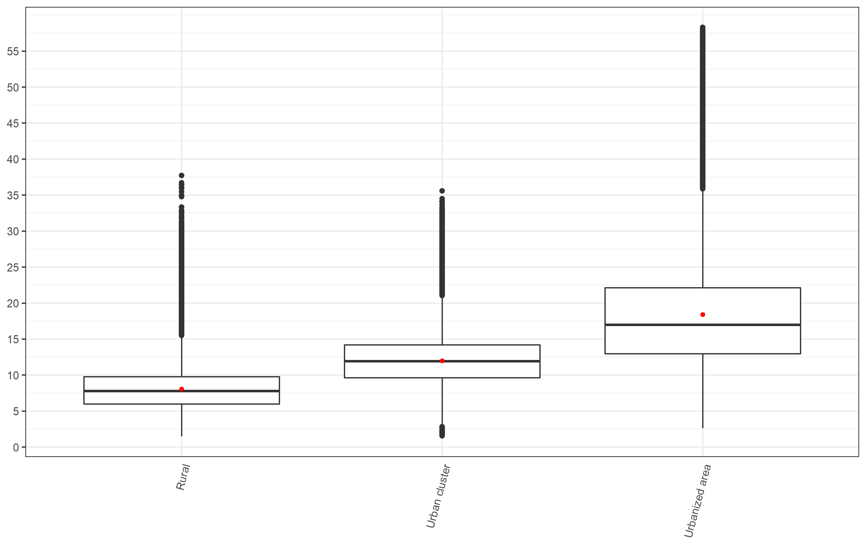

*\*Red dot represents the mean value while the midline represents the median value across all census blocks*

*Figure S2: Distribution of NO2 concentrations (ug/m3) by median household income group*

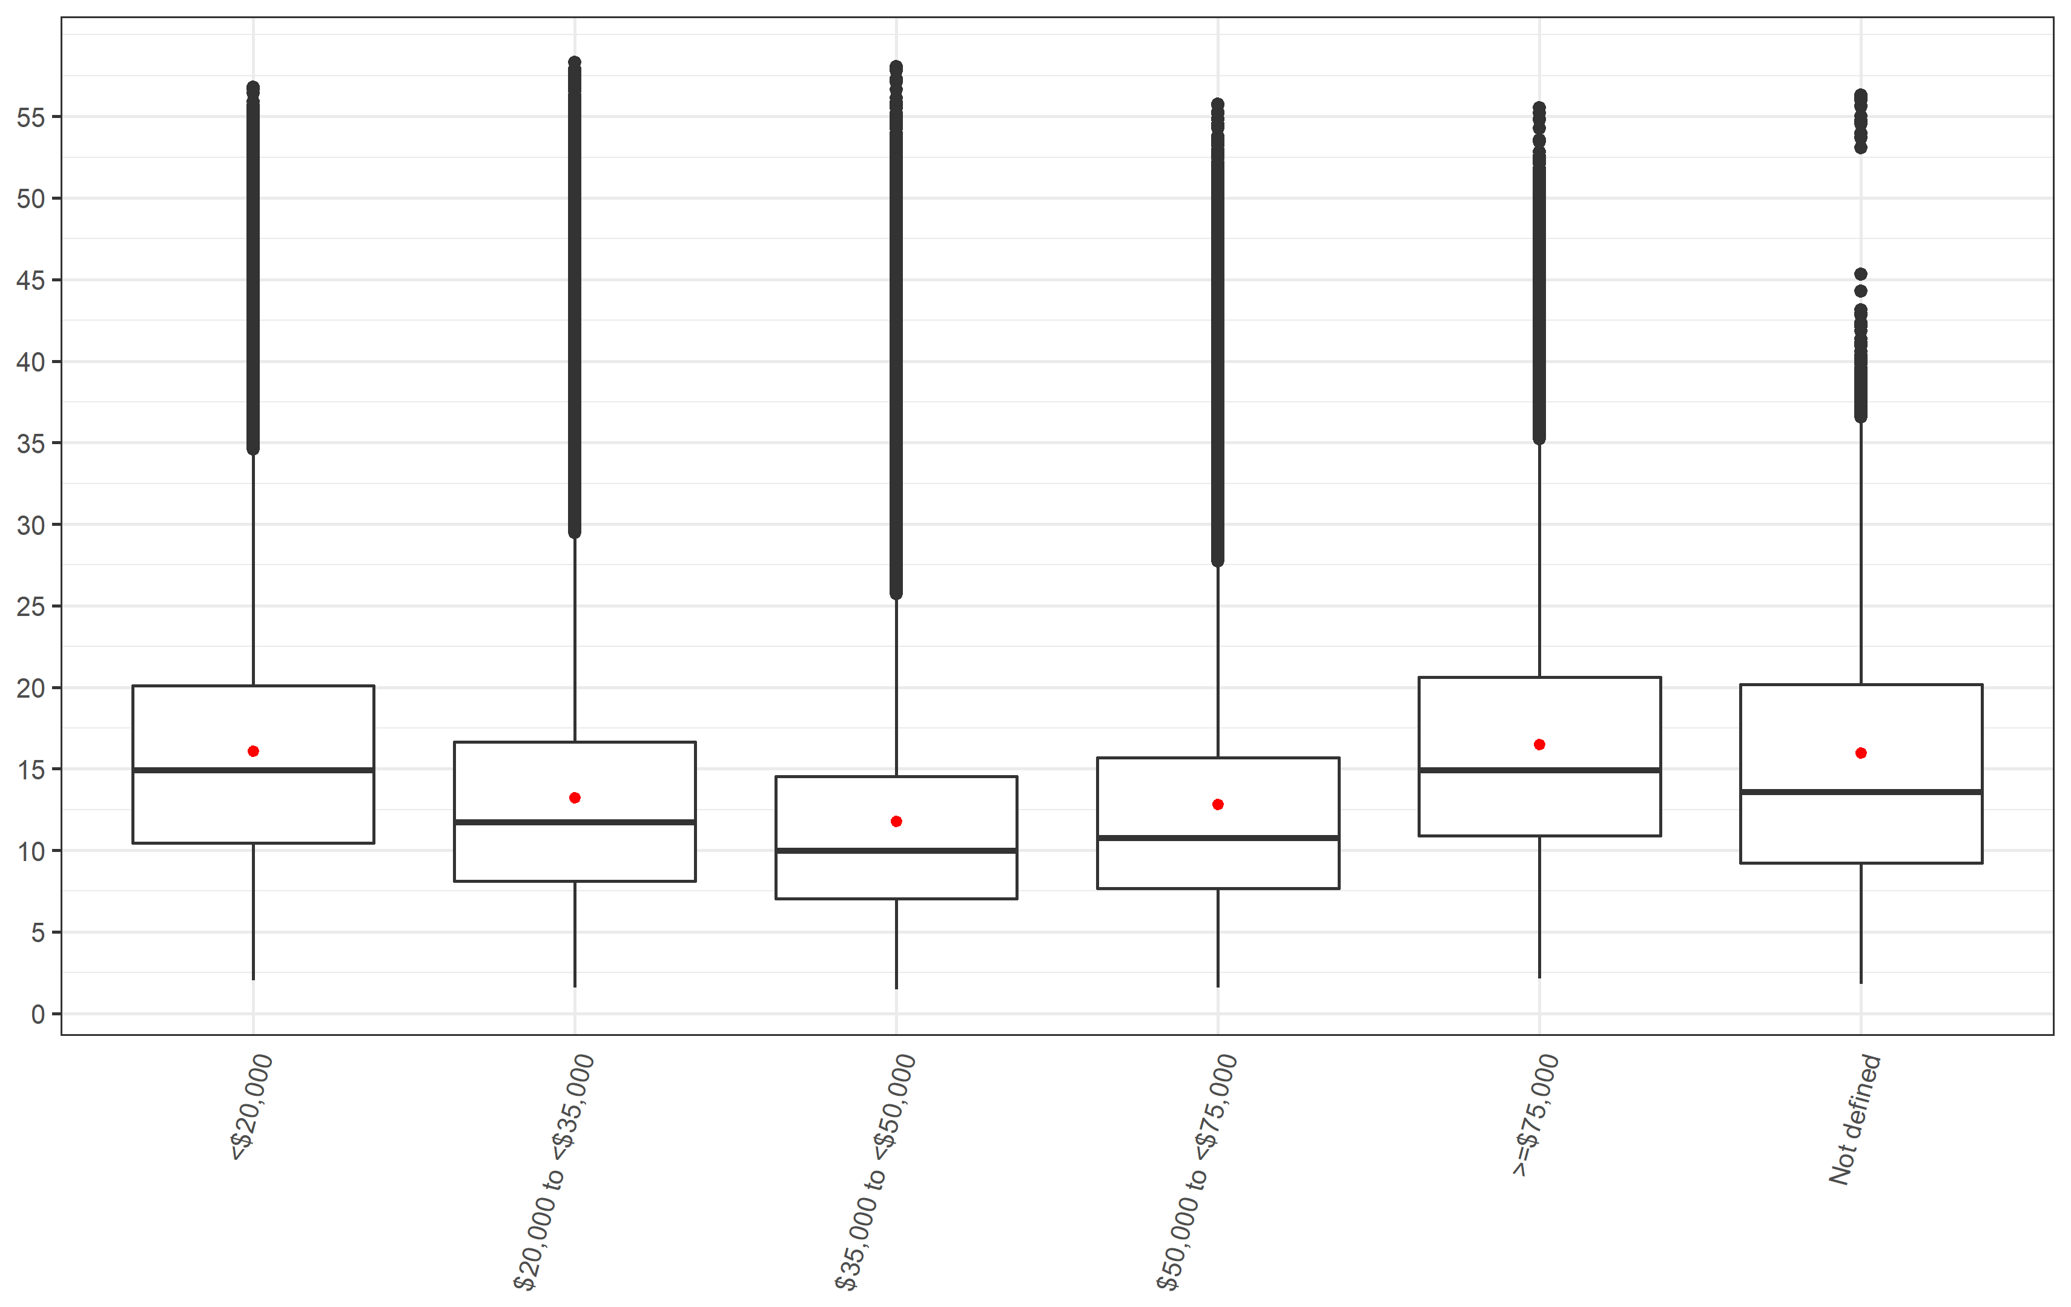

*Figure S3: Distribution of NO2 concentrations (ug/m3) by living location stratified by median household income group*

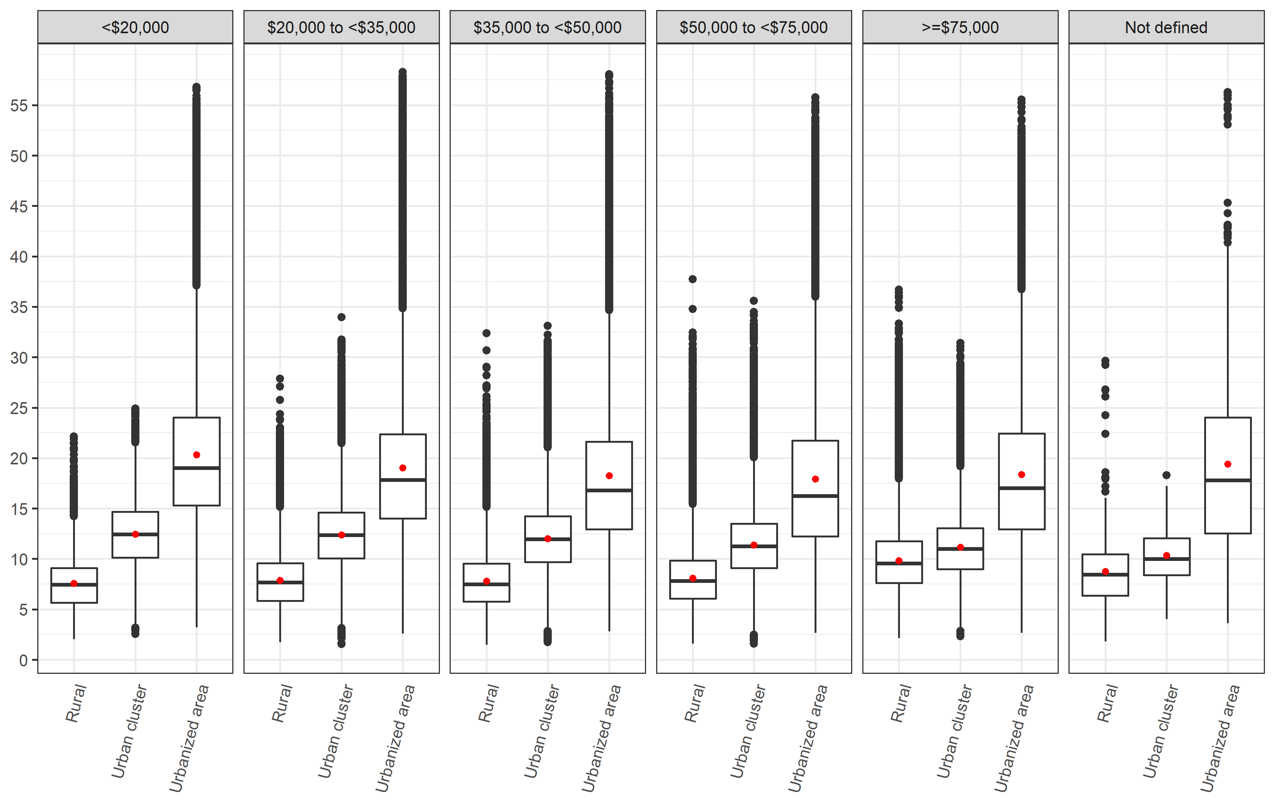

*Figure S4: Distribution of NO2 concentrations (ug/m3) by median household income group stratified by living location*

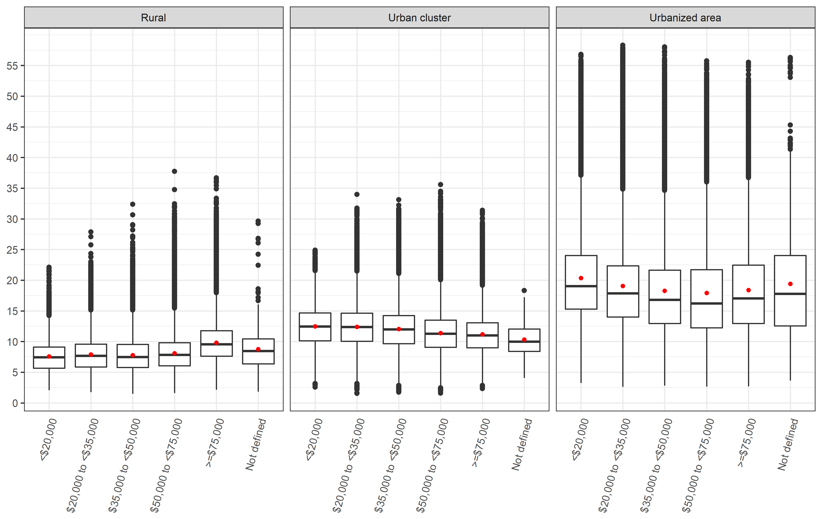

*Figure S5: Distribution of NO2 concentrations (ug/m3) by state*

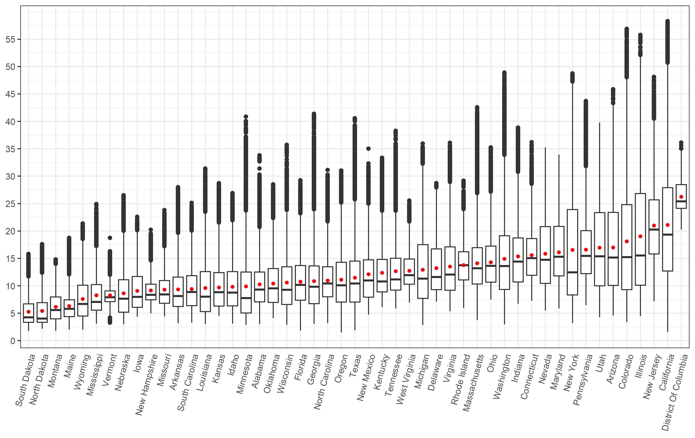

*Figure S6: Distribution of NO2 concentrations (ug/m3) by state and median household income group*

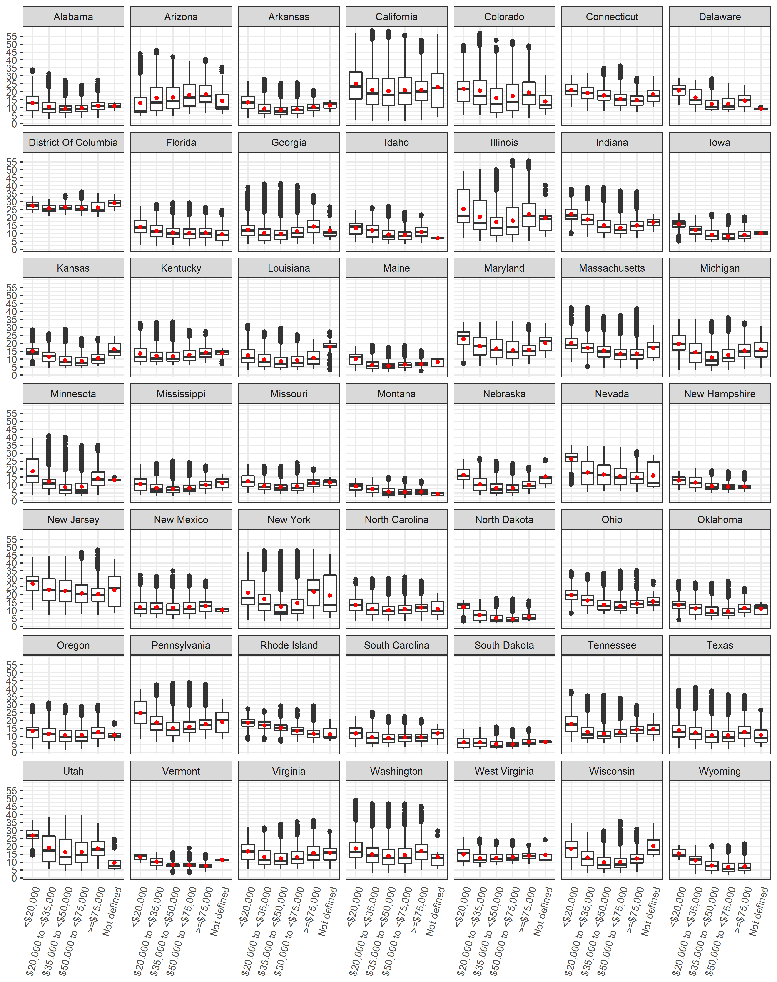

*Figure S7: Distribution of NO2 concentrations (ug/m3) by state and living location*

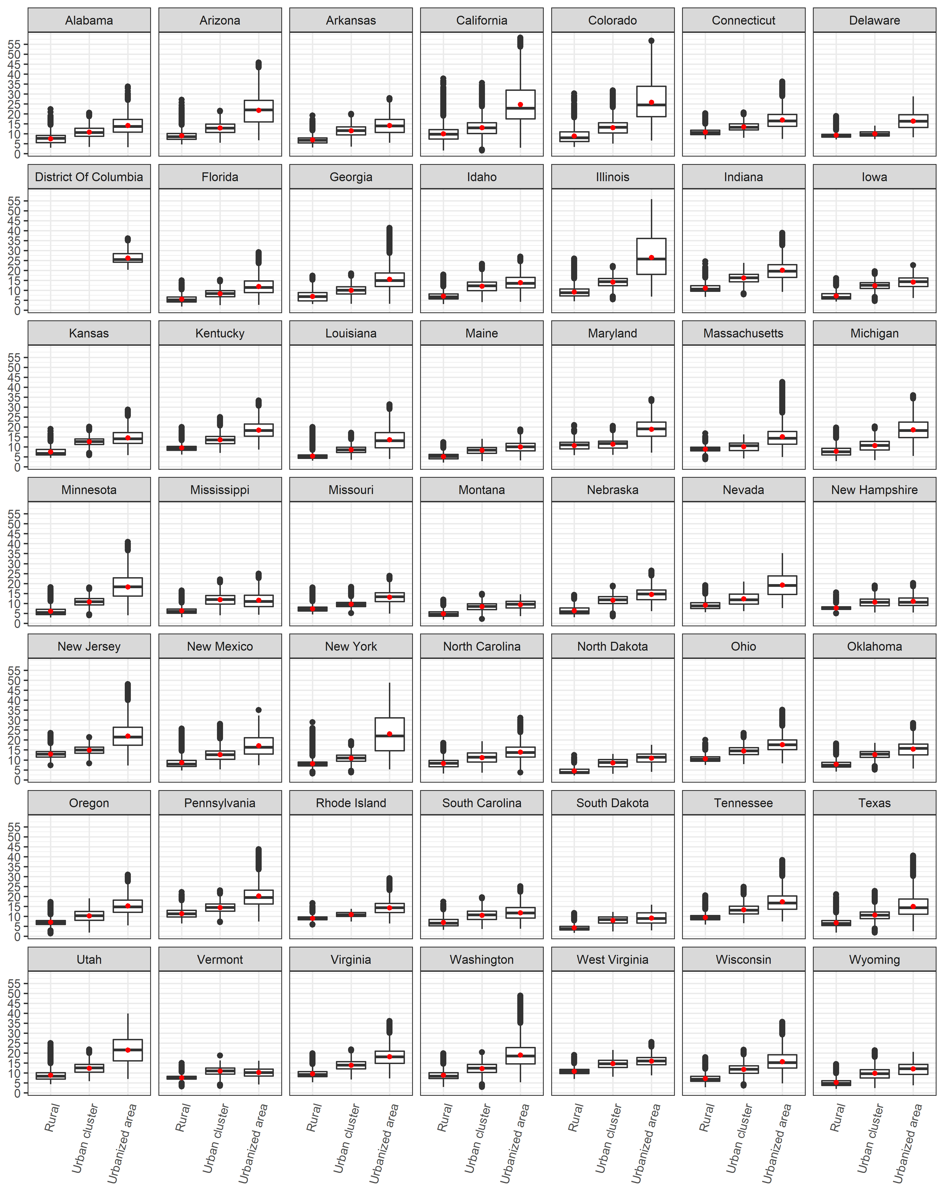

*Figure S8: Distribution of attributable fractions by living location*

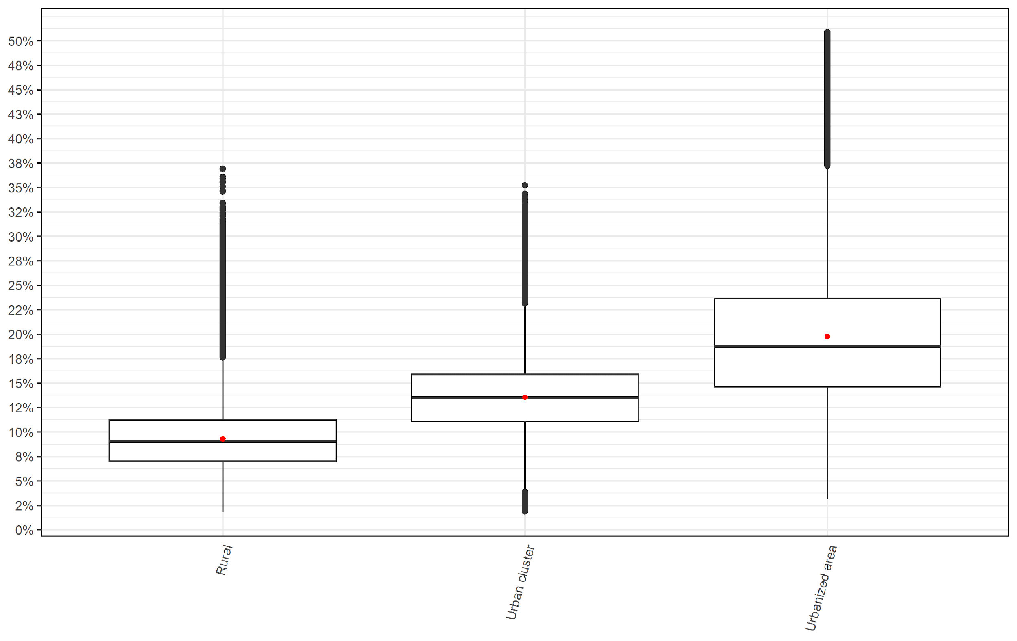

*Figure S9: Distribution of attributable fractions by median household income group*

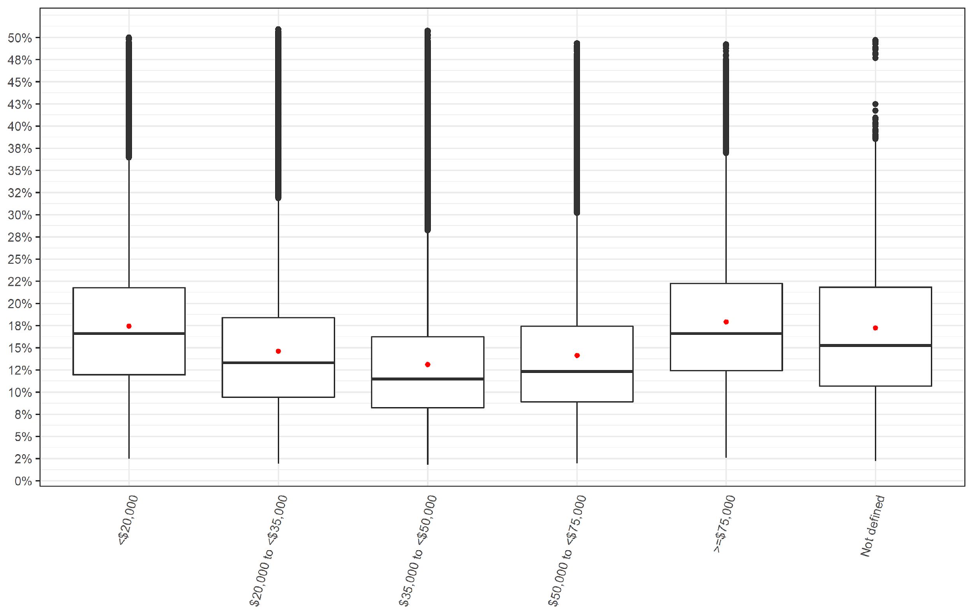

*Figure S10: Distribution of attributable fractions by median household income group stratified by living location*



1. IR: Incidence Rate
2. AC: Attributable number of cases
3. AF: Attributable fraction of cases