## The Impact of Baseline Incidence Rates on Burden of Disease Assessment of Air Pollution and Onset Childhood Asthma: Analysis of Data from the Contiguous United States

**Haneen Khreis1, 2, 3, 4 *, Raed Alotaibi1,5,6, Jennifer Horney7 and Rob McConnell8**

1 Center for Advancing Research in Transportation, Emissions, Energy, and Health (CARTEEH), Texas A&M Transportation Institute (TTI), Texas, USA

2 ISGlobal, Centre for Research in Environmental Epidemiology (CREAL), Barcelona, Spain

3 Universitat Pompeu Fabra (UPF), Barcelona, Spain

4 CIBER Epidemiologia y Salud Publica (CIBERESP), Madrid, Spain

5 Department of Family and Community Medicine, Imam Abdulrahman Bin Faisal University, Saudi Arabia

6 Texas A&M Health Science Center School of Public Health, Texas, USA

7 University of Delaware

8 Department of Preventive Medicine, University of Southern California Keck School of Medicine, Los Angeles, California, USA

**\* Corresponding author at the Center for Advancing Research in Transportation Emissions, Energy, and Health (CARTEEH), Texas A&M Transportation Institute (TTI), 1111 RELLIS Parkway, Room 3412, Bryan, Texas 77807, USA.**

**Acknowledgments:**

We would like to thank Matthew Bechle and Professor Julian Marshall at the University of Washington for providing the 2010 Nitrogen Dioxide (NO2) exposure estimates.

**Competing financial interests:**

The authors declare they have no competing interests.

**Funding**

This research was made possible by funding from the Texas A&M Transportation Institute's (TTI) Center for Advancing Research in Transportation Emissions, Energy, and Health (CARTEEH), a U.S. Department of Transportation's University Transportation Center with the grant number (69A3551747128).

**Disclaimer**

The contents of this report reflect the views of the authors, who are responsible for the facts and the accuracy of the information presented herein. This document is disseminated in the interest of information exchange. The report is funded, partially or entirely, by a grant from the U.S. Department of Transportation's University Transportation Centers Program. However, the U.S. Government assumes no liability for the contents or use thereof.

**Abbreviations**

**AC:** Attributable number of cases

**ACBS:** Asthma Call Back Survey

**AF:** Attributable fraction of cases

**BRFSS:** Behavioral Risk Factor Surveillance System

**CDC:** Center for Disease Control and Prevention

**CRF**: Concentration-Response Function

**D.C.:** District of Columbia

**EPA:** United States Environmental Protection Agency

**U.S.:** United States

**LUR:** Land-use regression

**NHGIS:** National Historical Geographic Information System

**PAF:** Population attributable fraction

**IR:** Incidence rate

**PR:** Prevalence rate

**ppb**: Parts per billion

**TRAP:** Traffic-related air pollution

**Abstract**

**Background**

Burden of disease (BoD) assessments typically rely on national-level incidence rates of the health outcomes of interest. The impact of using a flat national-level incidence rate, versus a more granular spatially varying rate, remains unknown and understudied in the literature. At the same time, there has been a growth in publications estimating burden of onset childhood asthma attributable to air pollution exposures, as emerging evidence demonstrates that traffic-related air pollution (TRAP) leads to the onset of the disease. In this paper, we estimated the number of incident asthma cases among children attributable to Nitrogen Dioxide (NO2), a good marker of TRAP, in the contiguous U.S. We used a flat national-level and newly generated state-specific asthma incidence rates and compared results from the two approaches.

**Methods**

We estimated the number of incident childhood asthma cases and percentage that might be attributable to NO2 using standard BoD assessment methods. We combined children (<18 years) counts and 2010 NO2 exposures at populated U.S. census blocks with a flat national-level and newly generated state-specific asthma incidence rates. We calculated incidence rates using raw data from 2006-2010 Behavioral Risk Factor Surveillance System (BRFSS) and the nested Asthma Call Back (ACS) surveys, collected by the Center for Disease Control and Prevention (CDC). We sourced concentration response functions (CRF) from the latest meta-analysis on TRAP and risk of onset childhood asthma. NO2 concentrations were obtained from a previously validated land-use regression (LUR) model. We stariftied our BoD estimates by urban or rural status and by median household income and explored trends across 48 states and the District of Columbia (D.C.).

**Results**

The mean (min-max) NO2 concentration(s) was 13.2 (1.5-58.3) ug/m3 and was highest in census-designated urbanized areas. We were able to estimate childhood asthma incidence rates in 32 states which ranged from 4.3 (Montana) to 17.7 (D.C.) per 1,000 at-risk children. The 17 states that did not have data to calculate an incidence rate were assigned the national aggregate asthma incidence rate of 11.6 per 1,000 at-risk children. Using the state-specific incidence rates resulted in a 7.2% reduction (absolute number=10,192) in number of incident asthma cases attributable to NO2, which amounted to a 1.7% reduction in the attributable fraction at the U.S. level. The change in the attributable number of cases across the states was more prominent and ranged from -50% (Iowa, Louisiana, Montana) to +33.6% (Texas). The state of California had the largest absolute decrease in the number of attributable cases by 6,200 cases while the state of Texas had the largest increase by 3,600 cases, followed by New York (1,700). Stratifying our analyses by socioeconomic status and urban versus rural status produced new trends compared to what we observed in past analysis which employed a national-level incidence rate.

**Conclusion**

Using state-specific versus a flat national-level asthma incidence rate resulted in a small change in the attributable BoD at the U.S. level, but had a more prominent impact on the BoD estimates at the state level. This is the first study to analyse and document the impact of using a flat versus a spatially varying asthma incidence rate in the context of air pollution BoD assessment.

**Introduction**

Burden of disease (BoD) assessment is a powerful and relatively practical method to estimate the number/percentage of premature mortality and morbidity cases which may be attributable to environmental exposures. Such estimates can indicate how many cases of premature deaths and/or disease may be prevented by eliminating or reducing the exposure of interest. In the context of air pollution exposure, BoD methods have become increasingly popular and have been predominantly used to assess the burden of premature mortality attributable to air pollution at the global, national, regional and local scales (Cohen et al., 2017, Cohen et al., 2005, Ostro and Organization, 2004, Lelieveld et al., 2015, Bhalla et al., 2014, Tainio, 2015, Mueller et al., 2017). The previous focus on premature mortality may reflect the availability of well-established epidemiological data which associate air pollution with premature death. It could also reflect the level of advancement in BoD, which is a relatively new practice still concerned with the most extreme outcome (death). Yet, to truly map, grasp and communicate to the true public health impact of air pollution exposures, extending BoD beyond premature mortality is required, especially to chronic disease. Chronic diseases are important as they have significant impacts on the quality of life of individuals and families, affect productivity at work and school, can result in death and imply significant health care costs which may be preventable. Further, given the ubiquity of air pollution exposure, especially in urban areas, the relatively modest-sized risk estimates from epidemiology translate into a large, yet modifiable, BoD.

One chronic disease which recently received more attention in the context of air pollution is the onset of childhood asthma. Asthma is a burdensome disease which is often cited as the most chronic illness of childhood (Gasana et al., 2012, National Survey of Children's Health, 2012). It is the third leading cause of hospitalization in children aged 15 and under and the leading cause of school absenteeism due to a chronic disease (American Lung Association, 2019, Hsu et al., 2016). In the United States (U.S.) alone, 6 million children had ongoing asthma in 2016 (Zahran et al., 2018). The economic burden of asthma in the U.S., including costs incurred by absenteeism and mortality, was $81.9 billion in 2013 (Nurmagambetov et al., 2018). The Center for Disease Control and Prevention (CDC) estimated that the number of missed school days in a single year, 2008, had reached 10.4 million for children with asthma (CDC, 2010).

There is emerging evidence that the exposure to air pollution, primarily when traffic-related, is associated with the onset of children’s asthma (Khreis et al., 2017), and more recent studies reconfirm these associations (Rancière et al., 2016, Rice et al., 2018, Lee et al., 2018, Pennington et al., 2018). A limited number of studies investigated the burden of incident childhood asthma which may be attributable to traffic-related air pollution (TRAP). All previous BoD studies investigating this topic (Achakulwisut et al., 2019, Khreis et al., 2018c, Khreis et al., 2018b, Alotaibi et al., 2019, Anenberg et al., 2018) agreeably highlighted several data gaps which might impact final BoD estimates and potentially result in uncertainty and error. Previous studies stressed that the accuracy of the BoD estimate is dependent on the accuracy of input data, namely: 1) the air pollution exposure levels and distribution, 2) the concentration-response functions, and 3) the baseline asthma incidence rates. Some of the studies cited above investigated the impacts of different input datasets on final BoD estimates and found that different exposure assessment methods (e.g. dispersion versus land-use regression modeling) can result in up to 3% difference in BoD estimates (Khreis et al., 2018a). Alotaibi et al. (2019) explored the impact of uncertainty in concentration-response functions (CRF) on final BoD estimates and found that using the most conservative end of the CRF (the lower 95% CI) can reduce the estimated burden by up to 19% when compared to the central estimate. On the other hand, using the most extreme end of the CRF (the upper 95% CI) can increase the estimated burden by up to 14% when compared to the central estimate. Finally, one English study (Khreis et al., 2018a) and their follow-up work in Khreis et al. (2019) showed that using a national versus a local baseline asthma incidence rate can result in up to 11% difference in BoD estimates, but this analysis was limited to one medium-sized city North of England.

The impact that the asthma baseline incidence rates have on BoD estimates has not been studied thoroughly yet. Childhood asthma is indeed a very challenging disease to diagnose and ascertain, and national-level incidence rates are likely to vary substantially, and also between urban and rural populations. Previous literature relied on national-level asthma incidence rates, which is also in line with practice by prominent institutions and studies such as the Global Burden of Disease analyses. In this paper, we aimed to explore the potential impact of using state-specific varying asthma incidence rates on the final burden of childhood asthma due to NO2 and compare the change in BoD estimates to those produced by Alotaibi et al. (2019) who used a national-level asthma incidence rate, as typically practiced (Achakulwisut et al., 2019, Khreis et al., 2018c, Perez et al., 2009, Perez et al., 2013, Khreis et al., 2018b, Anenberg et al., 2018). Using this more granular state-specific asthma incidence rates, we also explored trends in the BoD estimates by socioeconomic status and urban versus rural status to confirm (or otherwise) previous trends we observed in past analysis. We selected NO2 as the exposure of interest, as more studies underline this pollutant’s CRF and as it has been the most commonly used pollutant in previous epidemiological and BoD assessments (Khreis et al., 2017). Further, the selection of the pollutant in this instance is less relevant as our aim was to establish the difference in BoD estimates from previous analyses, *only* by altering the baseline childhood asthma incidence rate.

**Methods**

*Study area and time point*

We analyzed data for the 48 states within the contiguous U.S. and the District of Columbia (D.C.) for the year 2010 at the census block level: the smallest geographical unit available. Population counts, urban or rural living location status and annual NO2 concentrations were all available at the census block level. However, median household income was only available at the census block group level, which is one level higher than the census block (US Census Bureau, 2010). Childhood asthma incidence rates were calculated at the state level. NO2 concentrations were not available for states outside the contiguous U.S. (Alaska, Hawaii and Puerto Rico), and hence these states were excluded from the analysis.

*Census data*

We included populated census blocks of the contiguous U.S. for the year 2010, as obtained from the National Historical Geographic Information System (NHGIS) website (Manson et al., 2018, US Census Bureau, 2010). Each block included information on the total population of children <18 years old, and whether the census block was designated as an urban or a rural block. Census-designated urban areas were defined by the census bureau using multiple criteria including total population thresholds, density, nonresidential urban land use (e.g. paved areas and airports), and distance to other urban developed areas (US Census Bureau, 2016). Census blocks are the basic geographical units of urban areas. Further, census-designated urban areas are classified into two subtypes; urban clusters or urbanized areas. Urban clusters have a population threshold of ≥2,500 and <50,000, while urbanized areas have a population threshold of ≥50,000 people. The median household income in the past 12 months using 2010 inflation adjusted dollars was divided into five categories consistent with two previous relevant publications (Clark et al., 2017, Alotaibi et al., 2019): <$20,000, $20,000 to <$35,000, $35,000 to <$50,000, $50,000 to <$75,000 and ≥$75,000. Census blocks were assigned the same median household income of the census block group they resided within.

There were 2,686 (0.04%) census blocks with missing median household income data in 2010. These census blocks were assigned a “Not defined” status in the analysis of median household income. Table 1 summarizes the geographical and demographic data across all census blocks included in this analysis.

*Table 1: Census data description, year 2010*

|  |  |  |
| --- | --- | --- |
| **Geographic characteristics** | **Total populated census blocks** | 6,182,882 |
| **Total census-designated urban areas** | 3,590,278 (58%) |
| **Demographic characteristics** | **Total population** | 306,675,006 |
| **Total population of children (birth – 18)** | 73,690,271 (24%) |
| **Mean (range) number of children in census blocks** | 12 (0-2214) |
| **Population of children by living location** | **Rural** | 13,763,183 (19%) |
| **Urban clusters (≥2,500 and <50,000 people)** | 6,994,464 (9%) |
| **Urbanized area (≥50,000 people)** | 52,932,624 (72%) |
| **Population of children by median household income** | **<$20,000** | 2,614,804 (4%) |
| **$20,000 to <$35,000** | 12,770,843 (17%) |
| **$35,000 to <$50,000** | 18,573,954 (25%) |
| **$50,000 to <$75,000** | 21,953,876 (30%) |
| **≥$75,000** | 17,763,239 (24%) |

*NO2 exposure assessment*

Annual average NO2 concentrations for each populated census block were available at the centroid location for the year 2010. Concentrations were derived from a land-use regression model (LUR) developed by Bechle et al. (2015). The model incorporates spatial and temporal air pollutant data. The spatial data is derived from the U.S. Environmental Protection Agency (EPA) air quality monitoring data, satellite data and several GIS covariates including impervious surfaces, elevation, major, minor and residential roads, and distance to coast. The temporal data of the LUR model is incorporated by scaling the spatial data with the average monthly monitor readings for 11 consecutive years. The model achieves a relatively high predictive power as demonstrated using hold-out cross validation when compared to similar NO2 LUR models (Vienneau et al., 2013, Beelen et al., 2009, Hystad et al., 2011, Novotny et al., 2011) with an R2 reaching 82%. The LUR model has been used in multiple studies including Clark et al. (2017) and Alotaibi et al. (2019). A detailed description of the model can be found at Bechle et al. (2015). NO2 concentrations were converted from ppb to ug/m3through multiplying by 1.88 (WHO, 2005). Exposure data was matched with census blocks using a unique identifier for each census block as provided in the NHGIS dataset.

*Concentration-response functions*

We used an incident asthma CRF of 1.05 (95% CI = 1.02-1.07) per 4 ug/m3 of NO2. The CRF was obtained from a meta-analysis of 20 studies examining the association between exposure to TRAP and the risk of developing asthma among children from birth to 18 years of age (Khreis et al., 2017). These CRF represent data from the most up-to-date and widest analysis on TRAP and the onset of childhood asthma, and has been used in several published peer-reviewed BoD assessments (Khreis et al., 2018c, Khreis et al., 2018b, Achakulwisut et al., 2019, Alotaibi et al., 2019, Khreis, In press).

*Asthma incidence and prevalence rates*

An incidence rate (IR) is defined as the number of new cases of a disease within a specified time period among an at-risk population (Mausner and Kramer, 1985). To estimate the childhood asthma IR aggregated for the years 2006 through 2010 among U.S. states, we obtained the Behavioral Risk Factor Surveillance System (BRFSS) and Asthma Call Back Survey (ACBS) child data sets (CDC, 2011, CDC, 2009), which can be found at the CDC website <https://www.cdc.gov/brfss/>. We followed methods described by Winer et al. (2012) to estimate the asthma incidence rates, and present our steps in Figure 1. The ACBS and BRFSS define children as birth to 18 years of age people, which is in line with the meta-analysis from where we sourced the CRF (Khreis et al., 2017). The following variables were extracted from the surveys: the state, asthma status question (from the BRFSS), incident status question (from the ACBS), and children sample weights from both surveys. All analysis was conducted using R statistical software (R Core Team, 2018).

*Figure 1: Childhood asthma incidence rate estimation flow chart*

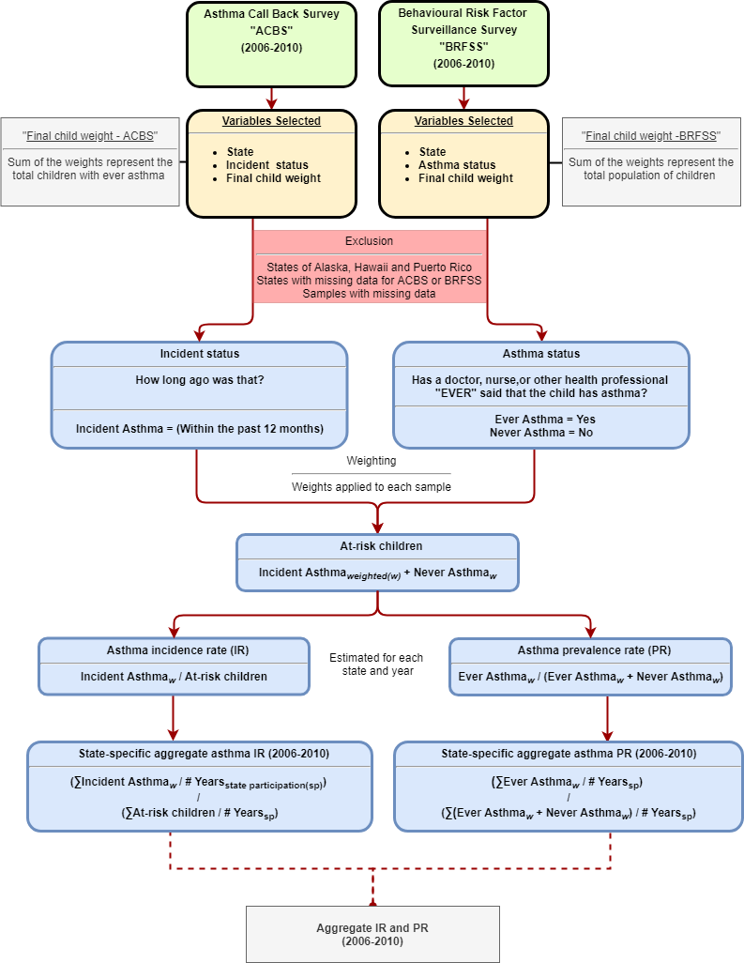

To determine the “Asthma status” of children, respondents to the BRFSS were asked “Has a doctor, nurse, or other health professional EVER said that the child has asthma?”, If the answer was “Yes”, the respondent was designated as “Ever asthma”. If the answer was “No”, the respondent was designated as “Never asthma”. Respondents with children designated as “Ever asthma” were requested to participate in the ACBS follow up. To determine the “Incident status” of children, respondents to the ACBS were asked: “How old was the [name of child] when a doctor or other health professional first said [he/she] had asthma? How long ago was that?” If the answer to the latter part of this question was “within the past 12 months”, the respondent was designated as an “Incident asthma”, while other responses were not relevant to the analysis described next.

Each respondent (sample) from the BRFSS and ACBS was assigned a weight to adjust for the disproportionate population sample selection as compared to the state’s overall population distribution, the variation in probability of selection, the actual response of each respondent, or nonresponse (Garbe et al., 2011, Korn and Graubard, 2011). To simplify this, the weight of each sample represents the number of children within each state, with similar characteristics (age, sex and race) to the sample. Weights were used to convert samples to population estimates of children. For example, if respondent (X) had a weight of 150, her/his response to survey questions represented answers of 150 children within their state, with similar age, sex and race characteristics. The sum of childhood weights for the BRFSS represent the total population of children within each state, while the sum of weights for the ACBS represent the total population of children with “Ever asthma” within each state.

“At-risk children” were then estimated by taking the weighted sum of respondents designated as “Incident asthma” and “Never asthma”, as shown in Equation 1.

*Equation 1*

The asthma incidence rate (IR) was the weighted “Incident asthma” divided by “At-risk children”, as shown in Equation 2.

*Equation 2*

The asthma prevalence rate (PR) was the weighted “Ever asthma” divided by the sum of weighted “Ever asthma” and weighted “Never asthma”, as shown in Equation 3.

*Equation 3*

To estimate the aggregate asthma IR across all available years for each state, we re-weighted the samples to adjust for the number of available years of data. For example, the state of Arizona had two years of available data (2006 and 2007). To estimate the aggregate IR in Arizona across all available years, we summed the weighted “Incident asthma” across all the years and divided it by two (since there were only two years of available data for the state of Arizona). We then divided the results by the sum of “At-risk children” across all the two years, again divided by two, as shown in Equation 4.

*Equation 4*

The aggregate asthma PR across all available years for each state was estimated as shown in Equation 5.

*Equation 5*

To estimate the overall national-level aggregate asthma IR and PR, we simply took the sum of the numerators and denominators across all states after re-weighting. States that did not participate and/or states that did not have available data in the ACBS during the period 2006 through 2010 (n = 17 states) were assigned the aggregate asthma IR (11.6 per 1,000 at-risk children) and PR (13.1 per 100 children).

*Burden of disease estimation*

To estimate the BoD of incident childhood asthma attributable to NO2 exposure, we followed standard methods described in Alotaibi et al. (2019) with the following steps:

The total number of at-risk children residing in a census block was estimated for each state. This was done by subtracting the total number of children within the census block multiplied by the state-specific aggregate PR (from Equation 5) from the total number of children within the same census block, as shown in Equation 6.

*Equation 6*

We then estimated the number of childhood asthma incident cases within each census block by multiplying the state-specific aggregate asthma IR (from Equation 4) by the at-risk children in each census block (from Equation 6), as shown in Equation 7.

*Equation 7*

We then calculated the relative risk (RRdiff) for asthma onset due to the exposure difference between the estimated exposure levels from the LUR model (NO2 concentration at the centroid of each census block) and no exposure (zero concentration for NO2) at each census block, as shown in Equation 8.

*Equation 8*

Where RR is the CRF and RRunit is the exposure unit (4 ug/m3) for the CRF as extracted from Khreis et al. (2017). The population attributable fraction (PAF) was also estimated at each census block using Equation 9:

*Equation 9*

The attributable number of asthma incident cases (AC) was estimated by multiplying the PAF with the total number of asthma incident cases at each census block (from Equation 7), as shown in Equation 10.

*Equation 10*

The attributable number of asthma incident cases for each census block was then summed across the state to obtain state total AC estimates, and the entire country to obtain the national AC estimates, as shown in Equation 11.

*Equation 11*

**Results**

*NO2 concentrations and trends*

The mean (min-max) NO2 concentrations were 13.2 (1.5-58.3) ug/m3 (Table 2). By living location, the mean NO2 concentration was highest in urbanized areas (18.4 ug/m3) (Figure S1), while the mean NO2 concentration was highest among the highest median household income group of ≥$75,000 (16.5 ug/m3) followed by the lowest median household income group of <$20,000 (16.1 ug/m3) (Figure S2). When stratifying NO2 concentrations by median household income groups, but separately for each living location, rural areas had an increasing average concentration as income increased, urban clusters has a decreasing average concentration as income increased, and urbanized areas showed a U-shaped trend (Figure S3 and Figure S4). South Dakota had the lowest mean NO2 concentration (5.2 ug/m3), while D.C. had the highest (26.3 ug/m3) (Table S1 and Figure S5). Figure S6 and Figure S7 demonstrate NO2 concentrations across median household income and living location, separately for each state.

*Table 2: NO2 concentrations (ug/m3) by strata*

|  |  |  |  |  |  |  |  |
| --- | --- | --- | --- | --- | --- | --- | --- |
|  |  | **Mean** | **Min** | **25%** | **Median** | **75%** | **Max** |
| **Total** |  | 13.2 | 1.5 | 7.9 | 11.4 | 16.6 | 58.3 |
| **By living location** | **Rural** | 8.0 | 1.5 | 6.0 | 7.8 | 9.8 | 37.7 |
| **Urban cluster** | 12.0 | 1.6 | 9.6 | 11.9 | 14.2 | 35.6 |
| **Urbanized area** | 18.4 | 2.6 | 13.0 | 17.0 | 22.1 | 58.3 |
| **By median household income** | **<$20,000** | 16.1 | 2.0 | 10.4 | 14.9 | 20.1 | 56.8 |
| **$20,000 to <$35,000** | 13.2 | 1.6 | 8.1 | 11.7 | 16.7 | 58.3 |
| **$35,000 to <$50,000** | 11.8 | 1.5 | 7.0 | 10.0 | 14.5 | 58.0 |
| **$50,000 to <$75,000** | 12.8 | 1.6 | 7.6 | 10.8 | 15.7 | 55.7 |
| **≥$75,000** | 16.5 | 2.1 | 10.9 | 14.9 | 20.6 | 55.5 |

*ACBS and BRFSS results*

Overall, there were 32 states where we were able to extract childhood asthma incidence rates and 41 states for childhood asthma prevalence rates (Table S2-S4). The total childhood samples included for the period 2006-2010 were 293,464 samples from the BRFSS and 16,156 samples from the ACBS (Table 3). The BRFSS samples ranged between 55,094 samples (2006) and 61,862 (2008). The ACBS samples ranged between 2,017 samples (2006) and 4,095 (2009). The weighted estimates represent the childhood population counts of available states from the BRFSS and the ACBS, for the years when the survey was conducted.

Across all available states, the overall aggregate asthma incidence rate for the years 2006-2010 was 11.6 per 1,000 at-risk children (Table 3). The state of Montana had the lowest aggregate childhood asthma incidence rate (IR = 4.3 per 1,000 at-risk children), while D.C. had the highest aggregate childhood asthma incidence rate (IR = 17.7 per 1,000 at-risk children) (Table S2). States that did not have an incidence rate available (n = 17 states) were assigned the overall aggregate asthma incidence rate of 11.6 per 1,000 at-risk children (Table S2-S4).

The overall aggregate asthma prevalence rate for the years 2006-2010 was 13.1 per 100 children (Table 3). The state of Iowa had the lowest aggregate childhood asthma prevalence rate (PR = 8.4 per 100 children), while D.C. had the highest aggregate childhood asthma prevalence rate (PR = 19.9 per 100 children) (Table S2). States that did not have a prevalence rate available (n = 8 states) were assigned the overall aggregate asthma prevalence rate of 13.1 per 100 children.

*Table 3: Childhood asthma survey summaries*

|  |  |  |  |  |  |  |
| --- | --- | --- | --- | --- | --- | --- |
|  | **2006** | **2007** | **2008** | **2009** | **2010** | **Total** |
| **BRFSS sample (weighted)** | 55,094 (50,674,742) | 59,487 (43,661,381) | 61,862 (53,327,550) | 59,821 (47,747,373) | 57,200 (39,975,264) | 293,464 |
| **Ever asthma sample (weighted)** | 7,168 (6,493,224) | 7,971 (5,763,409) | 8,255 (7,218,400) | 8,126 (6,279,938) | 7,483 (5,158,455) | 39,003 |
| **ACBS Sample (weighted)** | 2,017 (4,580,870) | 2,797 (5,459,638) | 3,924 (4,343,245) | 4,095 (4,154,076) | 2,196 (3,116,669) | 16,156 |
| **Incident case sample (weighted)** | 154 (404,276) | 173 (312,917) | 169 (385,818) | 153 (297,546) | 160 (319,743) | 809 |
| **At-risk sample (weighted)** | 48,080 (30,825,589) | 51,689 (36,050,557) | 53,776 (26,491,259) | 51,848 (25,942,087) | 49,877 (22,900,850) | 255,270 |
| **Incidence rate** | 13.1 | 8.7 | 14.6 | 11.5 | 14.0 | 11.6* |
| **Prevalence rate** | 12.8 | 13.2 | 13.5 | 13.2 | 12.9 | 13.1** |
| **Number of states included** | 18 | 26 | 20 | 17 | 17 | 32*** |

*\*Aggregate asthma incidence rate per 1,000 at-risk children*

*\*\*Aggregate asthma prevalence rate per 100 children*

*\*\*Total number of states included in the aggregate asthma incidence rate estimation*

*Asthma incident cases*

Using state-specific asthma incidence rates, the estimated number of childhood asthma incident cases were 747,437 in 2010 (Table 4). By living location, 19% lived in a rural area, while 9% and 72% lived in an urban cluster and urbanized area, respectively. The largest percentage of childhood asthma cases (30%) lived in an income block group of $50,000 to <$75,000, while the lowest percentage (4%) lived in the lowest income block group of <$20,000. The state with the lowest number of estimated childhood asthma incident cases was Montana with 900 cases, while the state with the largest number was Texas with 99,100 cases (Table S5).

*Attributable number of cases and fraction*

We estimated a total of 131,739 childhood asthma incident cases attributable to NO2 exposure which accounted for 17.6% of all childhood asthma incident cases (Table 4). By living location, urbanized areas had the largest number of attributable cases totaling 108,745 cases and the highest percentage of all asthma incident cases at 20.3%. Rural areas had total of 13,788 cases and accounted for the least percentage of all asthma cases at 9.8%, while urban clusters had only 9,206 cases representing 13.1% of all asthma incident cases (Table 4 and Figure S8). By income, $50,000 to <$75,000 had the largest number of cases attributable to NO2; 37,253 cases accounting for 16.8% of all asthma incident cases. However, the income group with the largest percentage of asthma cases attributable to NO2 exposure was the lowest income group <$20,000, accounting for 20.8% of all asthma incident cases (Table 4 and Figure S9). The mean value of the attributable fraction increased by income group in rural areas, decreased by income group in urban clusters and presented as a U shape in urbanized areas (Figure 2 and Figure S10).

The state with the lowest number of estimated attributable cases was Montana with 100 cases, while the state with the largest number of estimated attributable cases was California with 19,200 cases (Figure 3 and Table S4 ). The state with the lowest attributable fraction was North Dakota (6.3%), while the state with the highest attributable fraction was D.C. (28.6%) {WHICH FIGURE SHOWS THIS INFORMATION}.

*Table 4: Comparing the results of the burden of disease using state-specific estimates vs original estimates*

|  |  |  |  |  |  |  |  |  |  |  |  |  |  |
| --- | --- | --- | --- | --- | --- | --- | --- | --- | --- | --- | --- | --- | --- |
|  |  | **Results using flat national-level IR** | | | **Results using state-specific IR** | | | **Difference** | | | **Difference (%)** | | |
|  |  | **Incident cases** | **AC** | **AF** | **Incident cases** | **AC** | **AF** | **Incident cases** | **AC** | **AF** | **Incident cases** | **AC** | **AF** |
|  | **Total** | 794,934 | 141,931 | 17.9% | 747,437 | 131,739 | 17.6% | -47,497 | -10,192 | -0.3% | -6.0% | -7.2% | -1.7% |
| **By living location (% of Total)** | **Rural** | 148,470 (19%) | 14,466 (10%) | 9.7% | 140,799 (19%) | 13,788 (10%) | 9.8% | -7,671 | -678 | 0.1% | -5.2% | -4.7% | 1.0% |
| **Urban cluster** | 75,453 (9%) | 9,844 (7%) | 13.0% | 70,524 (9%) | 9,206 (7%) | 13.1% | -4,929 | -638 | 0.1% | -6.5% | -6.5% | 0.8% |
| **Urbanized area** | 571,011 (72%) | 117,621 (83%) | 20.6% | 536,113 (72%) | 108,745 (83%) | 20.3% | -34,898 | -8,876 | -0.3% | -6.1% | -7.5% | -1.5% |
| **By median household income (% of Total)** | **<$20,000** | 28,207 (4%) | 5,892 (4%) | 20.9% | 27,770 (4%) | 5,786 (4%) | 20.8% | -437 | -106 | -0.1% | -1.5% | -1.8% | -0.5% |
| **$20,000 to <$35,000** | 137,765 (17%) | 25,794 (18%) | 18.7% | 132,843 (18%) | 24,699 (19%) | 18.6% | -4,922 | -1,095 | -0.1% | -3.6% | -4.2% | -0.5% |
| **$35,000 to <$50,000** | 200,367 (25%) | 34,549 (24%) | 17.2% | 188,466 (25%) | 32,088 (24%) | 17.0% | -11,901 | -2,461 | -0.2% | -5.9% | -7.1% | -1.2% |
| **$50,000 to <$75,000** | 236,827 (30%) | 40,540 (29%) | 17.1% | 221,334 (30%) | 37,253 (28%) | 16.8% | -15,493 | -3,287 | -0.3% | -6.5% | -8.1% | -1.8% |
| **≥$75,000** | 191,621 (24%) | 35,128 (25%) | 18.3% | 176,880 (24%) | 31,885 (24%) | 18.0% | -14,741 | -3,243 | -0.3% | -7.7% | -9.2% | -1.6% |

*Figure 2: Attributable fraction by median household income group stratified into living location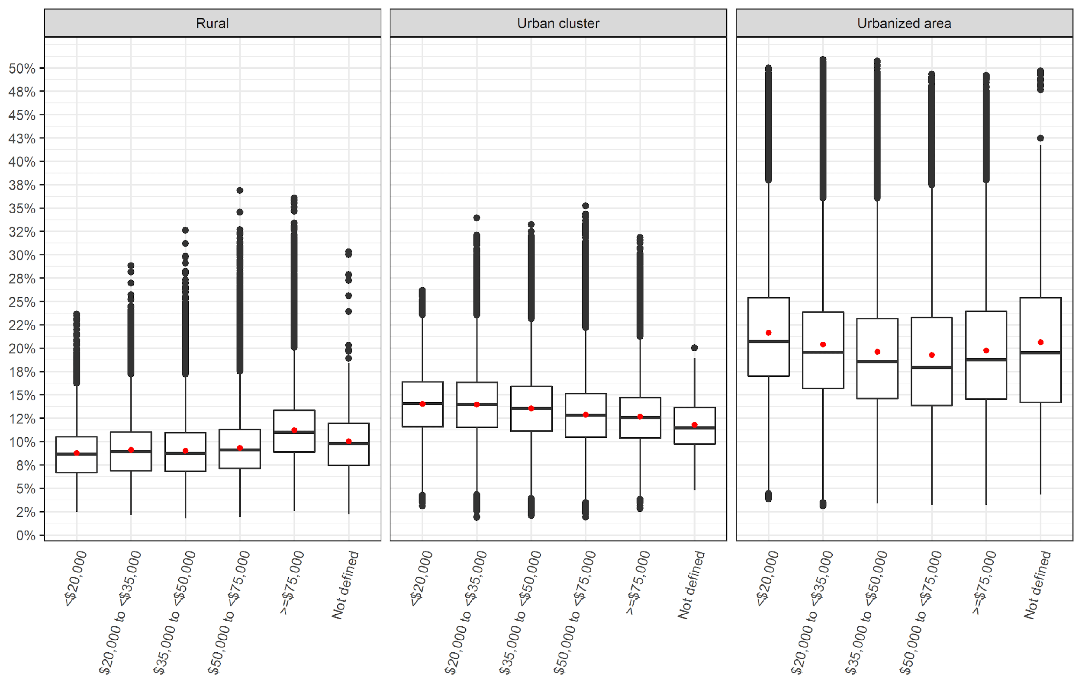*

*\*Red dot represents the mean value while the midline represents the median value*

*Figure 3: Attributable fraction by state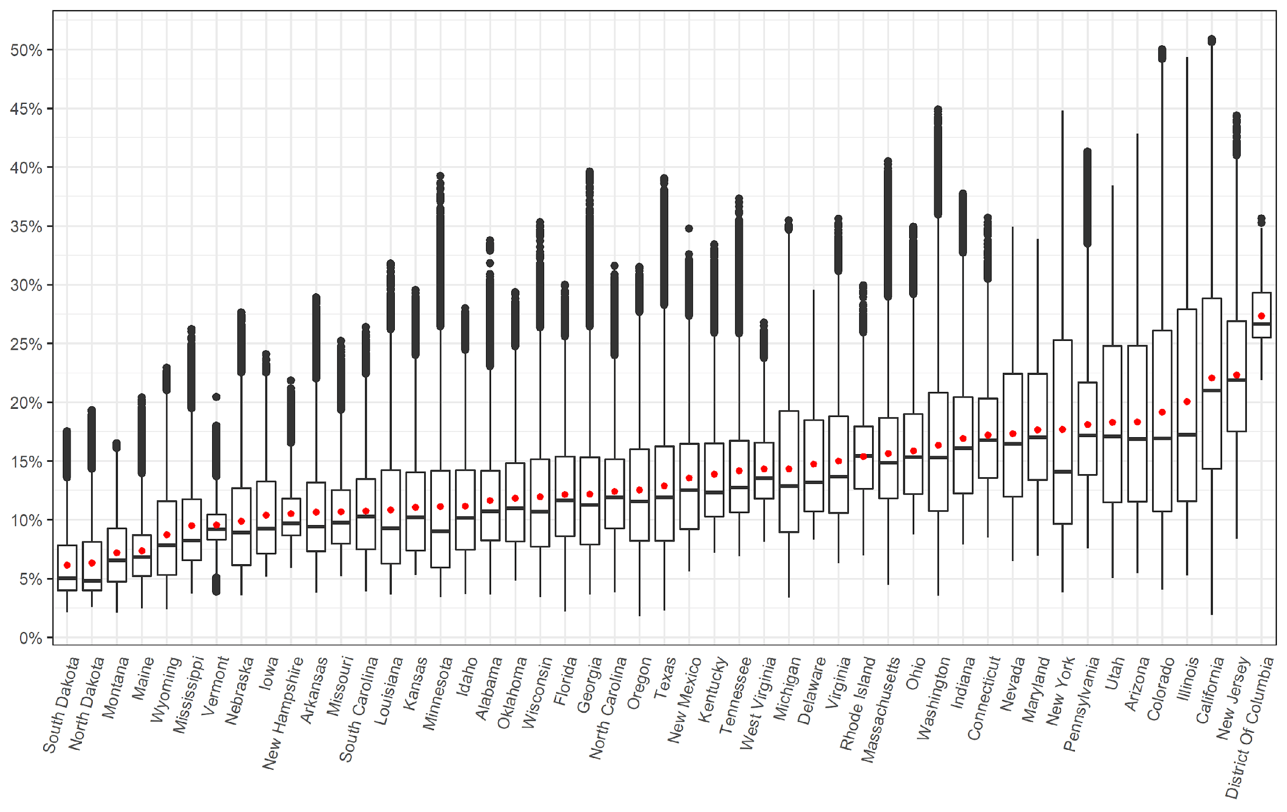*

Figure 4 and Figure 5 present the distribution of attributable fraction by living location and median household income group for each state. The majority of states broadly follow a distribution similar to the national level as shown in Figure S8 and Figure S9, with a few exceptions (By living location see; Delaware, Maryland, Mississippi, Vermont. By median household income see; Arizona, Connecticut, D.C., Florida, Maine, Massachusetts, Montana, Nevada, New Hampshire, New Jersey, New Mexico, Vermont, West Virginia, Rhode Island and Wyoming).

*Figure 4: Attributable fraction by state and living location*

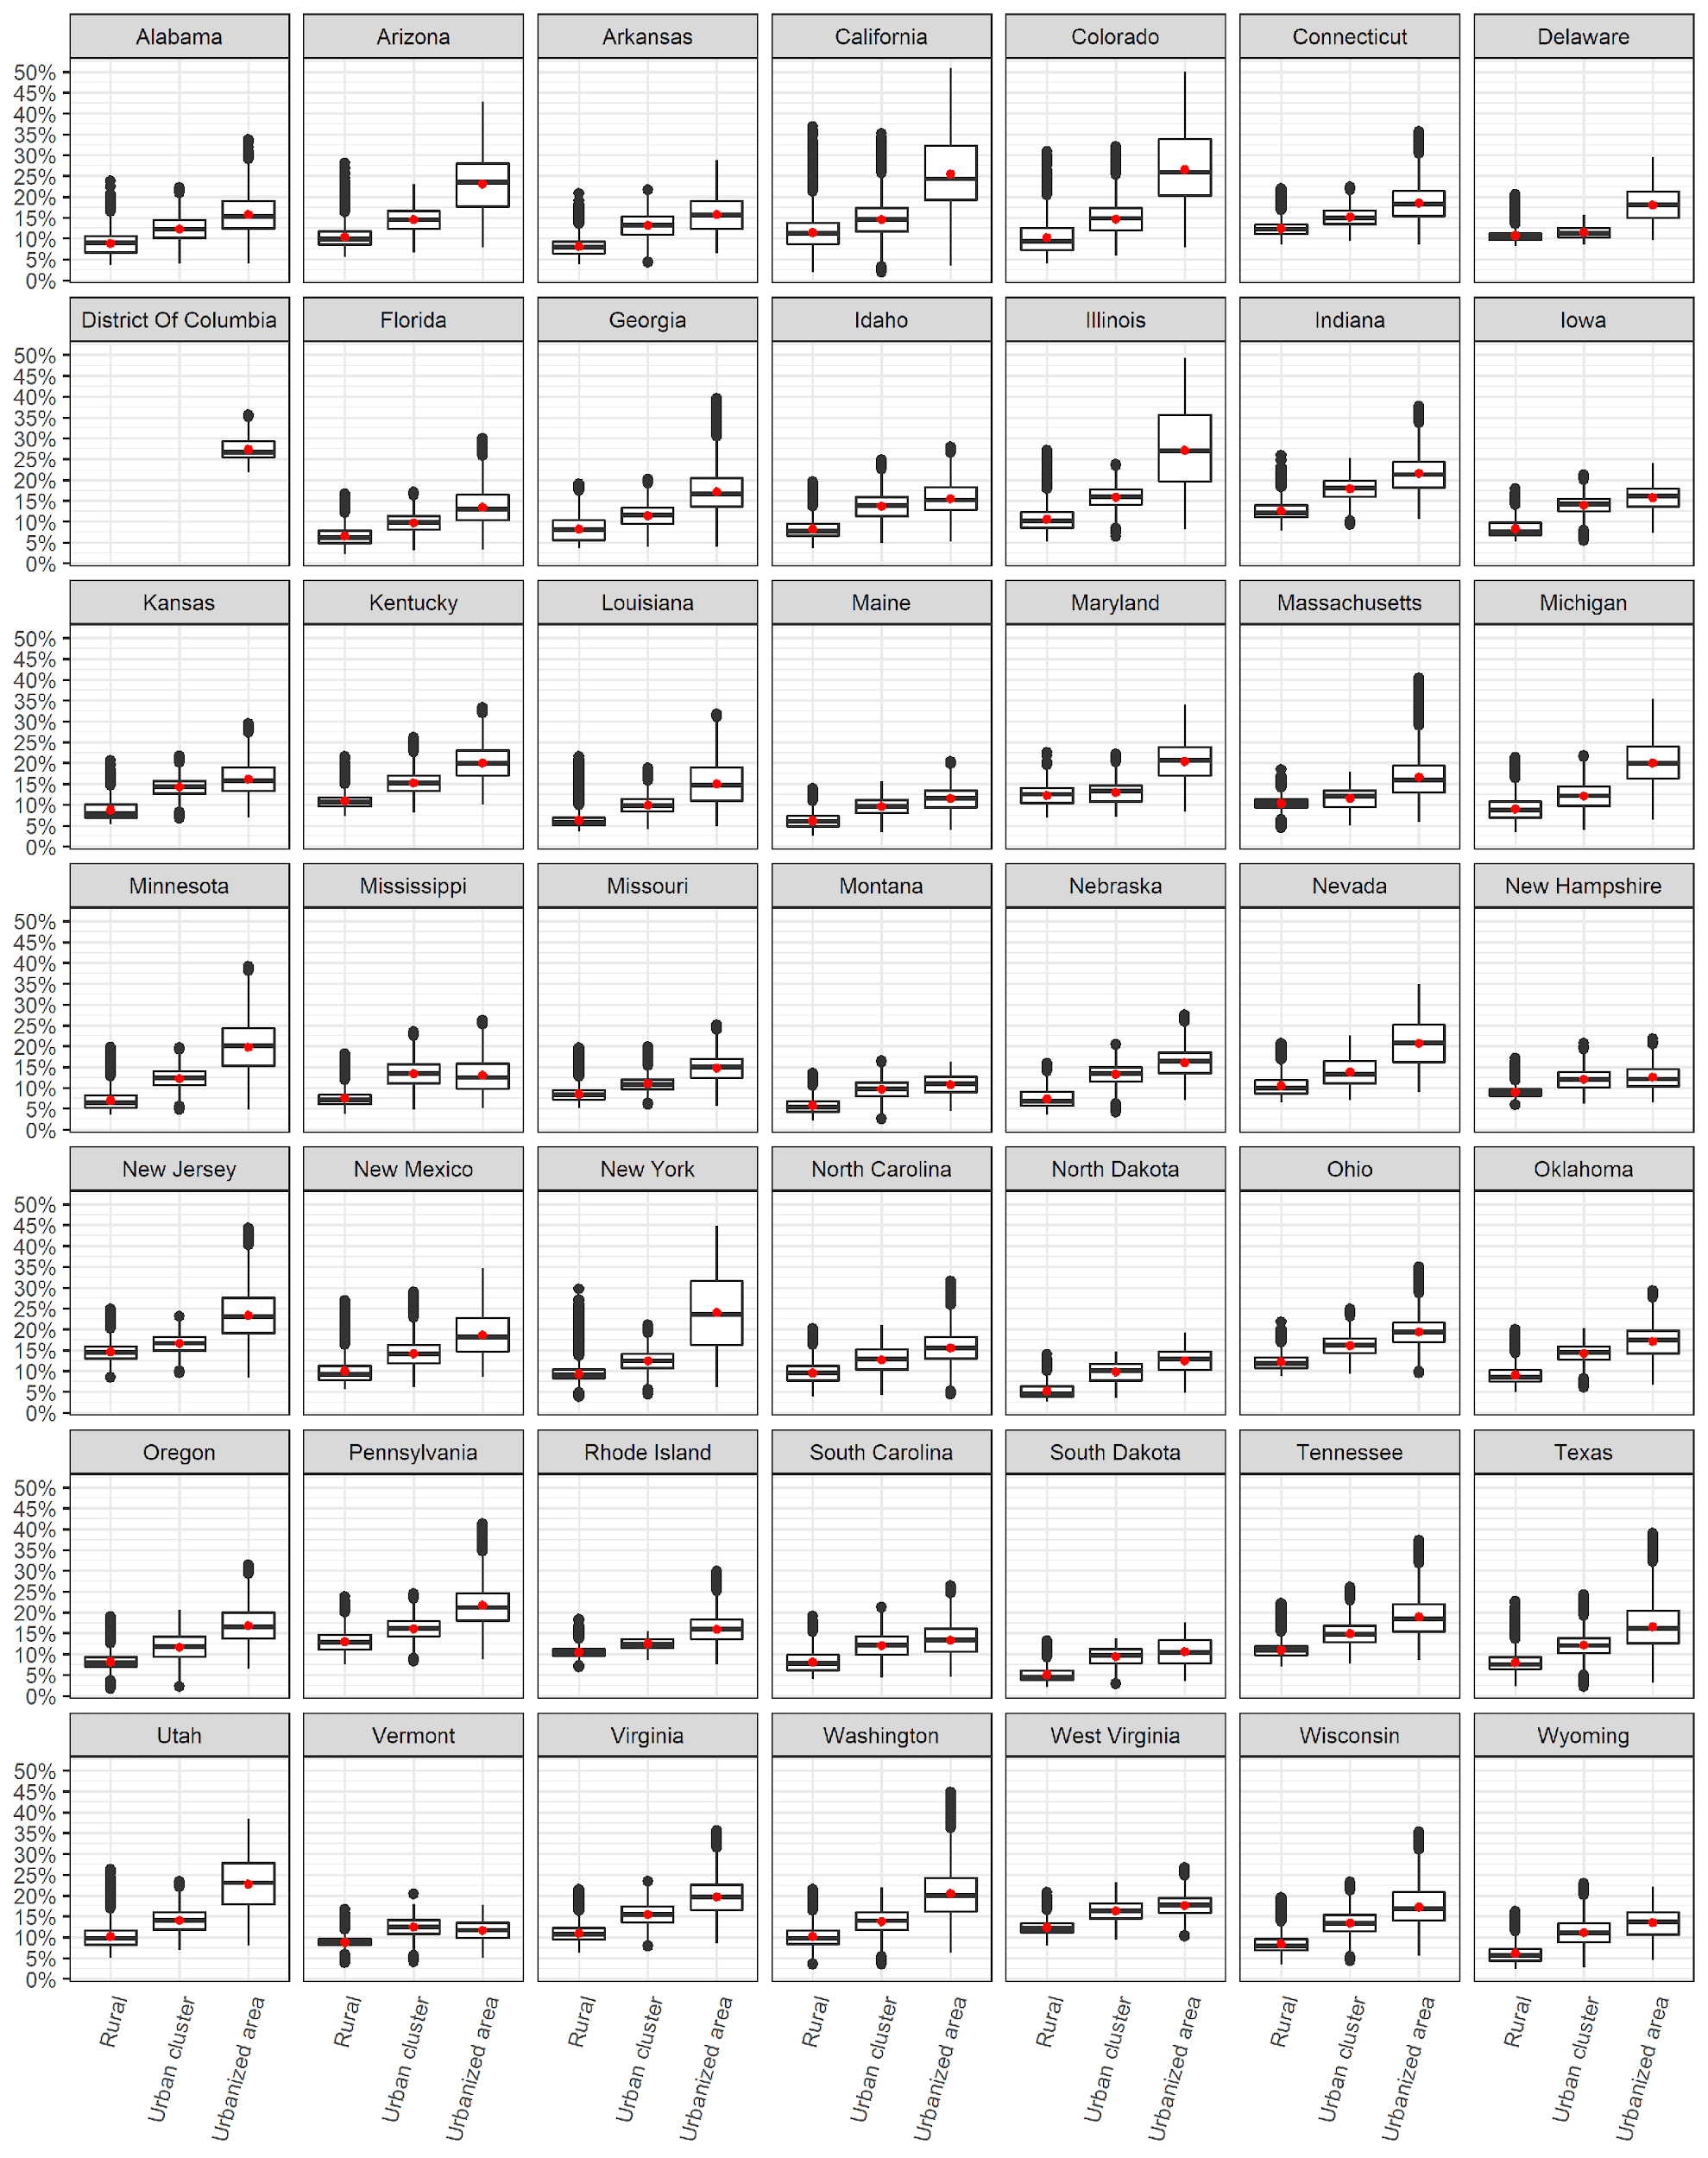

*Figure 5: Attributable fraction by state and median household income group*

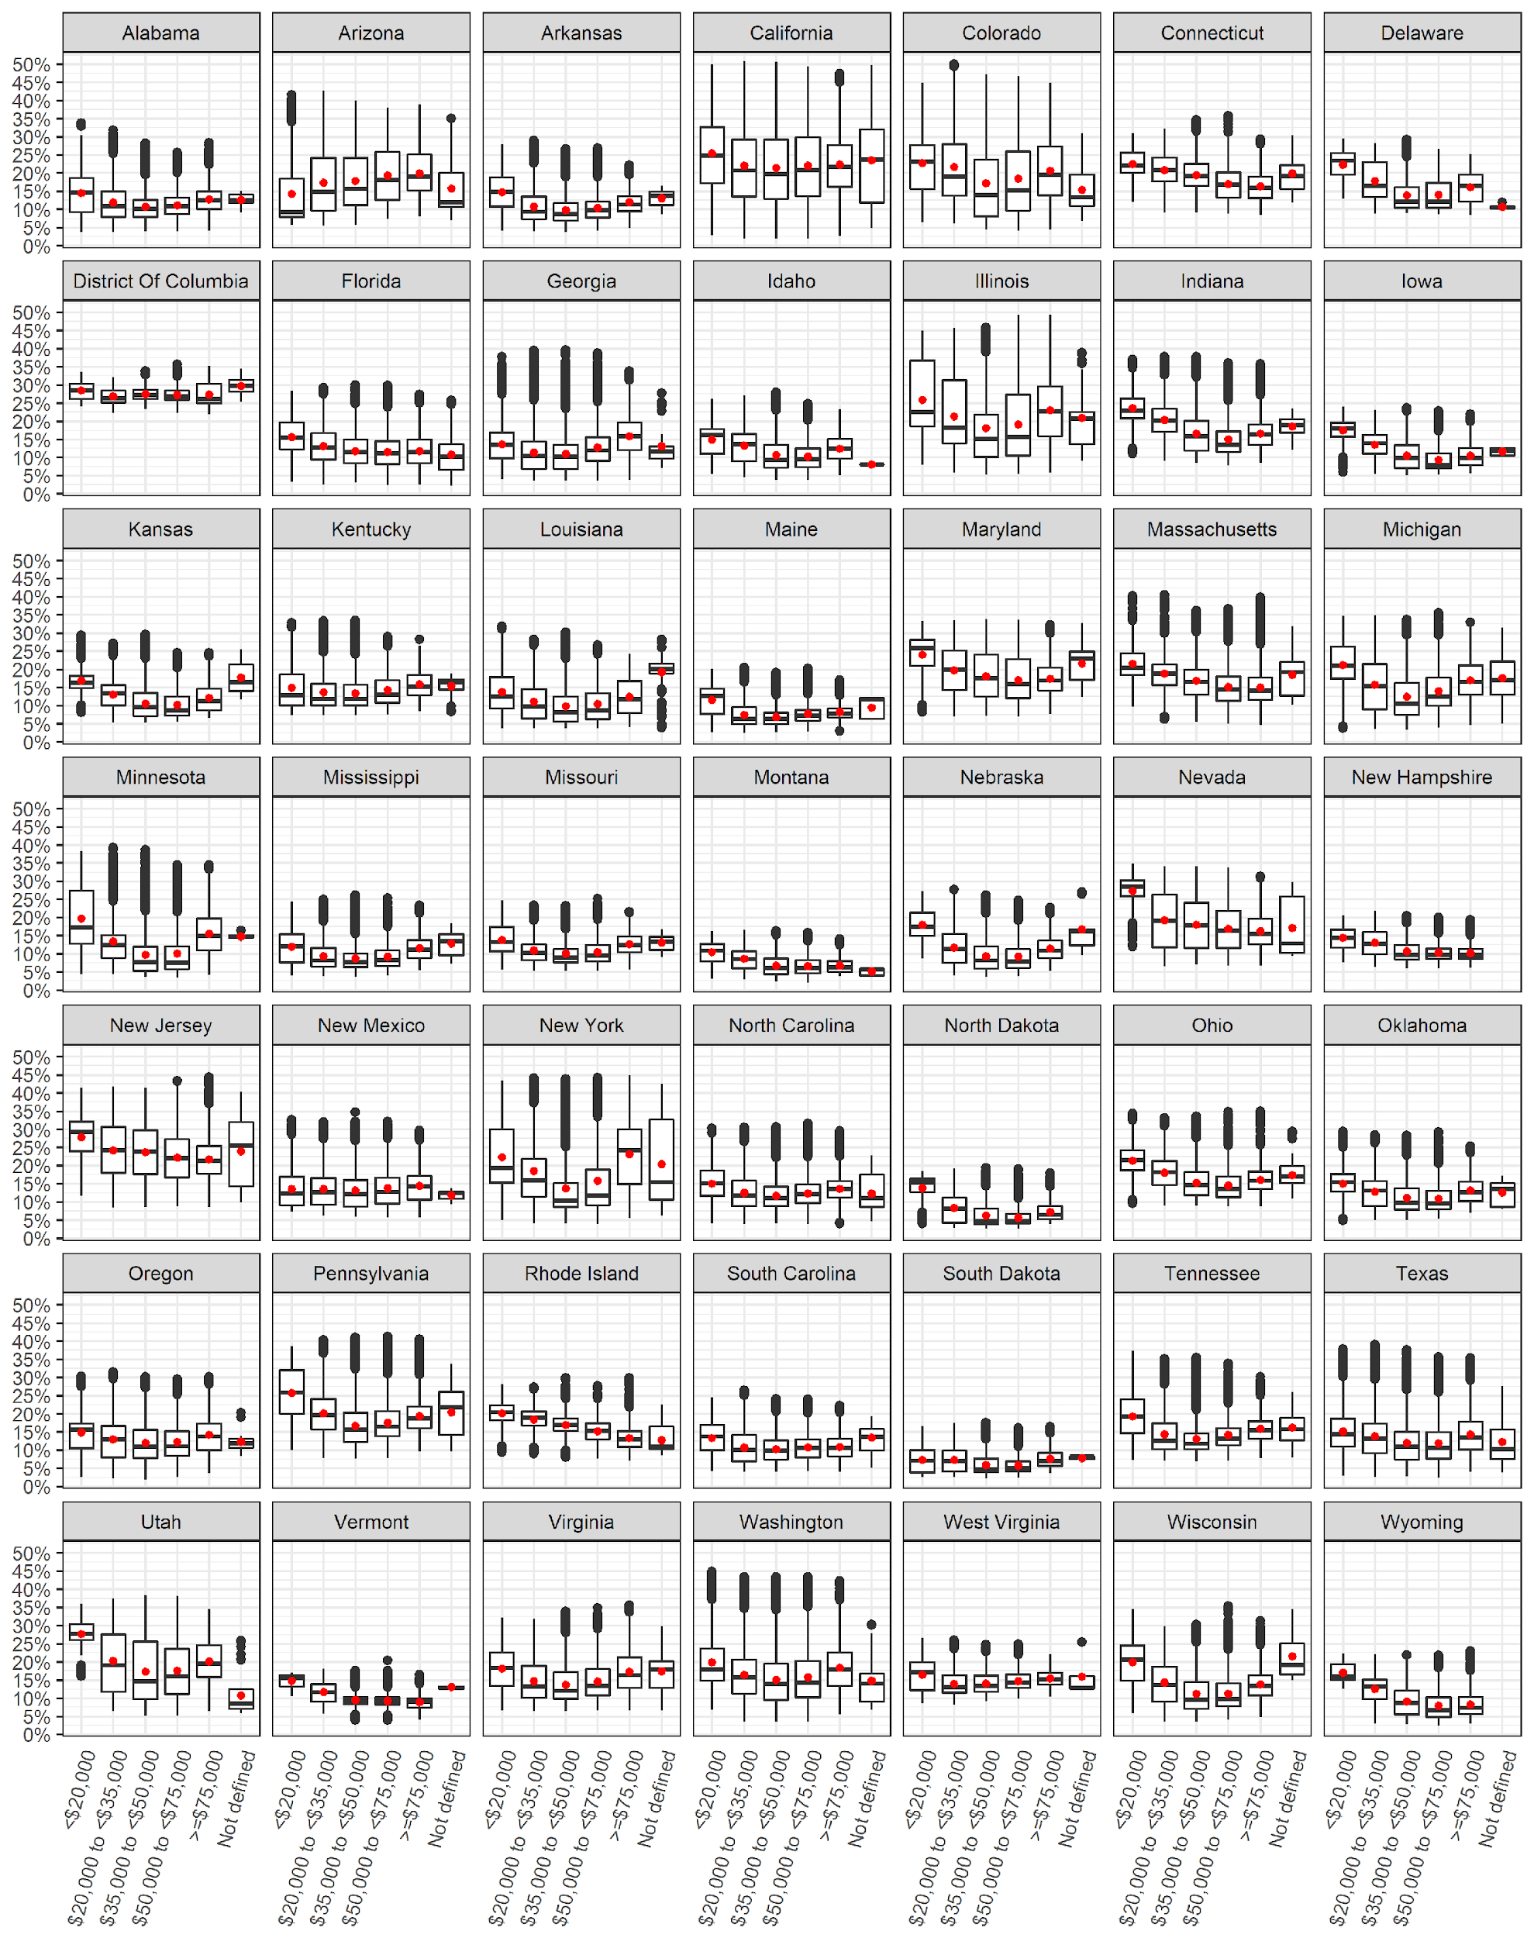

*Comparing total asthma incident cases using state-specific versus a flat national-level incidence rate*

Using state-specific asthma incidence rates, the overall number of incident asthma cases was reduced by 47,497 (6%) cases compared to estimates presented in the original paper which used a flat national-level asthma incidence rate of 12.5 per 1,000 at-risk children (Table 4) (Alotaibi et al., 2019). By living location, the largest relative change was among urban clusters with a decrease of 4,929 (6.5%) cases followed by urbanized areas which reduced by 34,898 (6.1%) cases. By income group, the largest relative change in the number of cases was among the highest income groups with a decrease of 14,741 (7.7%) cases, while the least relative change was among the lowest income group with a decrease of 437 (1.5%) cases (Table 4). The state of California had the largest decrease in numbers of total childhood asthma incident cases by 24,500 cases while the state of Texas had the largest increase in numbers of total childhood asthma incident cases by 25,000 cases (Table S5). The state of Montana had the largest relative reduction in total childhood asthma incident cases by 62.5% while the state of Texas had the largest relative increase by 33.7% (Table S5).

*Comparing attributable asthma incident cases due to NO2 using state-specific versus a flat national-level incidence rate*

The total attributable cases reduced by 10,192 (7.2%) cases when compared to the original paper which used a flat national-level asthma incidence rate (Table 4). By living location, urbanized areas had the largest relative change with a decrease of 8,876 (7.5%) cases, while rural areas had the least relative change with a decrease of 678 (4.7%) cases attributable to NO2 exposure. By income group, the highest income group had the largest relative change with a decrease in attributable cases by 3,243 (9.2%) while the lowest income group had the least relative change with a decrease of 106 (1.8%) cases. The state of California had the largest decrease in attributable cases by 6,200 cases while the state of Texas had the largest increase by 3,600 cases (Table S5).

*Comparing attributable asthma incident fractions due to NO2 using state-specific versus a flat national-level incidence rate*

The overall attributable fraction reduced by 0.3% (a 1.7% reduction). In terms of living location, urbanized areas had the largest relative reduction by 1.5%, while rural areas had a relative increase by 1%. In terms of income group, the largest relative reduction was 1.8% for the $50,000 to <$75,000 income strata (Table 4). The attributable fraction across states did not differ when using state-specific asthma incidence rates, the difference observed in (*Table S5*) is due to rounding.

**Discussion**

*Summary and key findings*

In this study, we investigated the impact that baseline childhood asthma incidence rates have on BoD estimates; an issue that has not been studied in depth. We used validated NO2 exposure data and census data from the year 2010 and across 48 U.S. states and D.C. to test and document the differences in BoD estimates when using state-specific versus a flat national-level asthma incidence rate, for the first time. We utilized data from 2006-2010 surveys from the CDC to estimate the number of at-risk children, state-specific incidence and prevalence rates, and applied these estimates to population data at the census block level, in the most comprehensive exercise to date. Previous literature relied on national-level asthma incidence rates for BoD assessments and the impact of this simplification was unknown. Using the state-specific asthma incidence rates, we also explored trends in BoD estimates stratifying our analyses by socioeconomic status and urban versus rural status to confirm (or otherwise) trends we observed in past analysis which employed a flat national-level incidence rate (Alotaibi et al., 2019).

Our results showed that at the national level, the difference in the estimated BoD using state-specific versus a national-level incidence rate was relatively small. Using the state-specific incidence rates resulted in a 7.2% reduction of 10,192 attributable number of cases, which amounted to a 1.7% reduction in the attributable fraction. While a 1.7% reduction in the attributable fraction is relatively small and need to be carefully weighed against the effort required to produce state-specific estimates, its implications might be more significant depending on if/how BoD estimates are used in policy making. For example, according to Perry et al. (2019), the average annual costs of asthma per child in the U.S. ranged from $3,076 to $13,612. In simplistic terms, using the state-specific versus the national-level incidence rate could result in a reduction ranging from $31,350,592 to $138,733,504 in estimated burden costs, per year. This is significant. More interestingly, however, is the variation across the states which we expect to be more accurately captured when using the state-specific incidence rates. Using the state-specific incidence rates resulted in a change in the attributable number of cases ranging from -50% (Iowa, Louisiana, Montana) to 33.6% (Texas). The state of California had the largest absolute decrease in the number of attributable cases by 6,200 cases while the state of Texas had the largest increase by 3,600 cases, followed by New York (1,700).

Further, stratifying our analyses by socioeconomic status and urban versus rural status produced new trends than what we observed in past analysis which employed a flat national-level incidence rate (Alotaibi et al., 2019). For example, most of the change in the attributable number of cases (-7.5%) occurred in urbanized areas. Likewise, most of the change in the attributable number of cases occurred in the highest median household income group of ≥$75,000 (-9.2%). The distribution of the attributable fraction by living location and median household income group was investigated separately for each state, rather than the national aggregation which we followed in previous analysis (Alotaibi et al., 2019). The majority of states broadly followed the U-shaped distribution observed at the national level; where the lowest and the highest median household income groups had the highest burden. There with many exceptions, however, including Arizona, Connecticut, D.C., Florida, Maine, Massachusetts, Montana, Nevada, New Hampshire, New Jersey, New Mexico, Vermont, West Virginia, Rhode Island and Wyoming. On the other hand, there were states where this U-shaped distribution was more prominent including Illinois and New York. This distribution might somewhat reflect a trend of the lowest income populations living in the most polluted census blocks due to financial restrain, a trend that is well established in the environmental justice literature. On the other hand, it is possible, although counter-intuitive, that the highest income populations live in highly polluted census blocks close to busy downtowns and central districts. If this was the case, it is clear that this trend does not apply to all states and may even differ by rural, urban cluster and urbanized area status (Figure S4). Previous work suggested that metropolitan areas in particular exhibit considerable heterogeneity when it comes to socioeconomic status and exposure to air pollution; where in places like New York, for example, wealthy neighborhoods were associated with higher concentrations of pollution (Hajat et al., 2013). These trends warrant further investigation, ideally using more refined air pollution and asthma incidence estimates at an even more granular spatial scale.

*Comparison with previous studies*

All previous BoD studies investigating this topic (Achakulwisut et al., 2019, Khreis et al., 2018c, Khreis et al., 2018b, Alotaibi et al., 2019, Anenberg et al., 2018) agreeably highlighted several data gaps which might impact the final BoD estimates and potentially introduce uncertainty and error. In fact, these gaps are applicable to BoD studies of air pollution and any health outcome. Previous studies stressed that the accuracy of the BoD estimate is dependent on the accuracy of input data, namely: 1) the air pollution exposure levels and distribution, 2) the concentration-response functions, and 3) the baseline asthma incidence rates. Some of the studies cited above investigated the impacts of different input datasets on final BoD estimates and found that different exposure assessment methods (e.g. dispersion versus land use regression modeling) can result in up to 3% difference in BoD estimates (Khreis et al., 2018a). Alotaibi et al. (2019) explored the impact of uncertainty in concentration-response functions (CRF) on final BoD estimates and found that using the most conservative end of the CRF (the lower 95% CI) can reduce the estimated burden by up to 19% when compared to the central estimate. On the other hand, using the most extreme end of the CRF (the upper 95% CI) can increase the estimated burden by up to 14% when compared to the central estimate. Finally, one English study (Khreis et al., 2018a) and their follow-up work in Khreis et al. (2019) showed that using a national versus a local baseline asthma incidence rate can result in up to 11% difference in BoD estimates, but this analysis was limited to one medium-sized city North of England.

The impact that the asthma baseline incidence rates have on BoD estimates has not been studied thoroughly yet. Childhood asthma is indeed a very challenging disease to diagnose and ascertain, and national-level incidence rates might vary substantially at smaller spatial resolutions, and also between urban and rural populations. Previous literature relied on national-level asthma incidence rates, which is also in line with practice by prominent institutions and studies such as the Global Burden of Disease analyses. In this paper, we aimed to explore the potential impact of using state-specific varying asthma incidence rates on the final burden of childhood asthma due to NO2 and compare the change in BoD estimates to those produced by Alotaibi et al. (2019) who used a national-level asthma incidence rate, as is typically practiced (Achakulwisut et al., 2019, Khreis et al., 2018c, Perez et al., 2009, Perez et al., 2013, Khreis et al., 2018b, Anenberg et al., 2018). Using this more granular state-specific asthma incidence rates, we also explored trends in the BoD estimates by socioeconomic status and urban versus rural status to confirm (or otherwise) previous trends we observed in past analysis. We selected NO2 as the exposure of interest, as more studies underline this pollutant’s CRF and as it has been the most commonly used pollutant in previous similar analyses. Further, the selection of the pollutant in this instance is less relevant as our aim was to establish the difference in BoD estimates from previous analyses, only by altering the baseline childhood asthma incidence rate.

*Strengths and limitations*

We selected NO2 as the exposure of interest, as more studies underline this pollutant’s CRF and as it has been the most commonly used pollutant in previous similar analyses. Further, the selection of the pollutant in this instance is less relevant as our aim was to establish the difference in BoD estimates from previous analyses, only by altering the baseline childhood asthma incidence rate.

* The results in this paper re-affirm our finding in the main paper, more specifically the sensitivity analysis. In our main paper we argued that changing or testing ranges of asthma IR in the analysis did not alter the end results compared to a change in the CRF function (Check the sensitivity matrix).
* We can derive from this finding, that using national level incidence rates to estimate asthma burden due to TRAP is acceptable even if asthma incidence rates is not available at a finer level.
* The state-specific attributable fractions did not change. The reason is that the incident rate is applied uniformly across the state (spatially), thus the total asthma cases and total attributable cases will change with equal proportion when applying the new asthma incidence rate. The attributable fraction is a function of CRF and exposure estimate regardless of the IR. Had we applied an incidence rate based on other factors like age, gender, race, income group, then the attributable fraction across the state would differ since the change in incidence rate won’t be uniform within the state.
* Third, we relied on national paediatric asthma incidence rates in our analysis, but subnational variations most likely exist, especially between urban and rural populations

**Conclusions**

**References**

ACHAKULWISUT, P., BRAUER, M., HYSTAD, P. & ANENBERG, S. C. 2019. Global, national, and urban burdens of paediatric asthma incidence attributable to ambient NO2 pollution: estimates from global datasets. *The Lancet Planetary Health,* 3**,** e166-e178.

ALOTAIBI, R., BECHLE, M., MARSHALL, J. D., RAMANI, T., ZIETSMAN, J., NIEUWENHUIJSEN, M. J. & KHREIS, H. 2019. Traffic related air pollution and the burden of childhood asthma in the contiguous United States in 2000 and 2010. *Environment International*.

AMERICAN LUNG ASSOCIATION, E. A. S. U. 2019. *Lung Health & Diseases: Asthma and Children Fact Sheet* [Online]. Available: <https://www.lung.org/lung-health-and-diseases/lung-disease-lookup/asthma/learn-about-asthma/asthma-children-facts-sheet.html> [Accessed].

ANENBERG, S. C., HENZE, D. K., TINNEY, V., KINNEY, P. L., RAICH, W., FANN, N., MALLEY, C. S., ROMAN, H., LAMSAL, L. & DUNCAN, B. 2018. Estimates of the Global Burden of Ambient PM 2.5, Ozone, and NO 2 on Asthma Incidence and Emergency Room Visits. *Environmental health perspectives,* 126**,** 107004.

BECHLE, M. J., MILLET, D. B. & MARSHALL, J. D. 2015. National Spatiotemporal Exposure Surface for NO2: Monthly Scaling of a Satellite-Derived Land-Use Regression, 2000–2010. *Environmental science & technology,* 49**,** 12297-12305.

BEELEN, R., HOEK, G., PEBESMA, E., VIENNEAU, D., DE HOOGH, K. & BRIGGS, D. J. 2009. Mapping of background air pollution at a fine spatial scale across the European Union. *Science of the Total Environment,* 407**,** 1852-1867.

BHALLA, K., SHOTTEN, M., COHEN, A., BRAUER, M., SHAHRAZ, S., BURNETT, R., LEACH-KEMON, K., FREEDMAN, G. & MURRAY, C. 2014. *Transport for health: the global burden of disease from motorized road transport*.

CDC 2009. Centers for Disease Control and Prevention. Behavioral Risk Factor Surveillance System Survey Data. Atlanta, Georgia: U.S. Department of Health and Human Services, Centers for Disease Control and Prevention, 2019.

CDC 2010. Asthma Severity among Children with Current Asthma.

CDC 2011. Centers for Disease Control and Prevention. 2006-2008 ACBS Summary Data Qulaity Report. 2011.

CLARK, L. P., MILLET, D. B. & MARSHALL, J. D. 2017. Changes in transportation-related air pollution exposures by race-ethnicity and socioeconomic status: Outdoor nitrogen dioxide in the United States in 2000 and 2010. *Environmental Health Perspectives,* 125**,** 1--10.

COHEN, A. J., BRAUER, M., BURNETT, R., ANDERSON, H. R., FROSTAD, J., ESTEP, K., BALAKRISHNAN, K., BRUNEKREEF, B., DANDONA, L. & DANDONA, R. 2017. Estimates and 25-year trends of the global burden of disease attributable to ambient air pollution: an analysis of data from the Global Burden of Diseases Study 2015. *The Lancet,* 389**,** 1907-1918.

COHEN, A. J., ROSS ANDERSON, H., OSTRO, B., PANDEY, K. D., KRZYZANOWSKI, M., KÜNZLI, N., GUTSCHMIDT, K., POPE, A., ROMIEU, I. & SAMET, J. M. 2005. The global burden of disease due to outdoor air pollution. *Journal of Toxicology and Environmental Health, Part A,* 68**,** 1301-1307.

GARBE, P., BALLUZ, L. S. & CHIEF, B. 2011. Behavioral Risk Factor Surveillance System Asthma Call-Back Survey History And Analysis Guidance.

GASANA, J., DILLIKAR, D., MENDY, A., FORNO, E. & RAMOS VIEIRA, E. 2012. Motor vehicle air pollution and asthma in children: a meta-analysis. *Environmental Research,* 117**,** 36-45.

HAJAT, A., DIEZ-ROUX, A. V., ADAR, S. D., AUCHINCLOSS, A. H., LOVASI, G. S., O’NEILL, M. S., SHEPPARD, L. & KAUFMAN, J. D. 2013. Air pollution and individual and neighborhood socioeconomic status: evidence from the Multi-Ethnic Study of Atherosclerosis (MESA). *Environmental health perspectives,* 121**,** 1325-1333.

HSU, J., QIN, X., BEAVERS, S. F. & MIRABELLI, M. C. 2016. Asthma-related school absenteeism, morbidity, and modifiable factors. *American journal of preventive medicine,* 51**,** 23-32.

HYSTAD, P., SETTON, E., CERVANTES, A., POPLAWSKI, K., DESCHENES, S., BRAUER, M., VAN DONKELAAR, A., LAMSAL, L., MARTIN, R. & JERRETT, M. 2011. Creating national air pollution models for population exposure assessment in Canada. *Environmental health perspectives,* 119**,** 1123-1129.

KHREIS, H., DE HOOGH, K. & NIEUWENHUIJSEN, M. 2018a. Full-Chain Health Impact Assessment of Traffic-Related Air Pollution and Childhood Asthma. *Environment International,* Available online 27 March 2018.

KHREIS, H., DE HOOGH, K. & NIEUWENHUIJSEN, M. J. 2018b. Full-chain health impact assessment of traffic-related air pollution and childhood asthma. *Environment international,* 114**,** 365-375.

KHREIS, H., KELLY, C., TATE, J., PARSLOW, R., LUCAS, K. & NIEUWENHUIJSEN, M. 2017. Exposure to traffic-related air pollution and risk of development of childhood asthma: a systematic review and meta-analysis. *Environment international,* 100**,** 1-31.

KHREIS, H., RAMANI, T., DE HOOGH, K., MUELLER, N., ROJAS-RUEDA, D., ZIETSMAN, J. & NIEUWENHUIJSEN, M. 2019. Traffic-Related Air Pollution and the Local Chronic Burden of Childhood Asthma in Bradford, UK. *International Journal of Transportation Science and Technology,* 8**,** 116-128.

KHREIS, H., RAMANI, T., DE HOOGH, K., MUELLER, N., ROJAS-RUEDA, D., ZIETSMAN, J. & NIEUWENHUIJSEN, M. J. 2018c. Traffic-Related Air Pollution and the Local Burden of Childhood Asthma in Bradford, UK. *International Journal of Transportation Science and Technology*.

KHREIS, H. C., MARTA; MUELLER, NATALIE; KEES DE HOOGH; HOEK, GERARD; NIEUWENHUIJSEN, MARK J; ROJAS-RUEDA, DAVID; In press. Outdoor Air Pollution and the Burden of Childhood Asthma across Europe. *European Respiratory Journal*.

KORN, E. L. & GRAUBARD, B. I. 2011. *Analysis of health surveys*, John Wiley & Sons.

LEE, J.-Y., LEEM, J.-H., KIM, H.-C., LAMICHHANE, D. K., HWANG, S.-S., KIM, J.-H., PARK, M.-S., JUNG, D.-Y., KO, J.-K. & KWON, H.-J. 2018. Effects of traffic-related air pollution on susceptibility to infantile bronchiolitis and childhood asthma: a cohort study in Korea. *Journal of Asthma,* 55**,** 223-230.

LELIEVELD, J., EVANS, J. S., FNAIS, M., GIANNADAKI, D. & POZZER, A. 2015. The contribution of outdoor air pollution sources to premature mortality on a global scale. *Nature,* 525**,** 367.

MANSON, S., SCHROEDER, J., VAN RIPER, D. & RUGGLES, S. 2018. IPUMS National Historical Geographic Information System: Version 13.0 [Database]. Minneapolis: University of Minnesota.

MAUSNER, J. & KRAMER, S. 1985. Epidemiology: An Introductory Text. Phila-delphia. *PA: Saunders*.

MUELLER, N., ROJAS-RUEDA, D., BASAGAÑA, X., CIRACH, M., COLE-HUNTER, T., DADVAND, P., DONAIRE-GONZALEZ, D., FORASTER, M., GASCON, M. & MARTINEZ, D. 2017. Urban and transport planning related exposures and mortality: a health impact assessment for cities. *Environmental Health Perspectives,* 125**,** 89-96.

NATIONAL SURVEY OF CHILDREN'S HEALTH, N. 2012. Data query from the Child and Adolescent Health Measurement Initiative. Data Resource Center for Child and Adolescent Health website.

NOVOTNY, E. V., BECHLE, M. J., MILLET, D. B. & MARSHALL, J. D. 2011. National satellite-based land-use regression: NO2 in the United States. *Environmental science & technology,* 45**,** 4407-4414.

NURMAGAMBETOV, T., KUWAHARA, R. & GARBE, P. 2018. The economic burden of asthma in the United States, 2008–2013. *Annals of the American Thoracic Society,* 15**,** 348-356.

OSTRO, B. & ORGANIZATION, W. H. 2004. Outdoor air pollution: assessing the environmental burden of disease at national and local levels.

PENNINGTON, A. F., STRICKLAND, M. J., KLEIN, M., ZHAI, X., BATES, J. T., DREWS-BOTSCH, C., HANSEN, C., RUSSELL, A. G., TOLBERT, P. E. & DARROW, L. A. 2018. Exposure to mobile source air pollution in early-life and childhood asthma incidence: the Kaiser Air Pollution and Pediatric Asthma Study. *Epidemiology,* 29**,** 22-30.

PEREZ, L., DECLERCQ, C., IÑIGUEZ, C., AGUILERA, I., BADALONI, C., BALLESTER, F., BOULAND, C., CHANEL, O., CIRARDA, F. B. & FORASTIERE, F. 2013. Chronic burden of near-roadway traffic pollution in 10 European cities (APHEKOM network). *European Respiratory Journal***,** erj00311-2012.

PEREZ, L., KÜNZLI, N., AVOL, E., HRICKO, A. M., LURMANN, F., NICHOLAS, E., GILLILAND, F., PETERS, J. & MCCONNELL, R. 2009. Global goods movement and the local burden of childhood asthma in southern California. *American Journal of Public Health,* 99**,** S622-S628.

PERRY, R., BRAILEANU, G., PALMER, T. & STEVENS, P. 2019. The economic burden of pediatric asthma in the United States: Literature review of current evidence. *PharmacoEconomics,* 37**,** 155-167.

R CORE TEAM 2018. R: A Language and Environment for Statistical Computing. R Foundation for Statistical Computing.

RANCIÈRE, F., BOUGAS, N., VIOLA, M. & MOMAS, I. 2016. Early exposure to traffic-related air pollution, respiratory symptoms at 4 years of age, and potential effect modification by parental allergy, stressful family events, and sex: a prospective follow-up study of the PARIS birth cohort. *Environmental health perspectives,* 125**,** 737-745.

RICE, M. B., RIFAS-SHIMAN, S. L., LITONJUA, A. A., GILLMAN, M. W., LIEBMAN, N., KLOOG, I., LUTTMANN-GIBSON, H., COULL, B. A., SCHWARTZ, J. & KOUTRAKIS, P. 2018. Lifetime air pollution exposure and asthma in a pediatric birth cohort. *Journal of Allergy and Clinical Immunology,* 141**,** 1932-1934. e7.

TAINIO, M. 2015. Burden of disease caused by local transport in Warsaw, Poland. *Journal of transport & health,* 2**,** 423-433.

US CENSUS BUREAU 2010. American factfinder. US Census Bureau Washington, DC.

US CENSUS BUREAU. 2016. *Defining rural at the U.S. census bureau* [Online]. Available: <https://www.census.gov/library/publications/2016/acs/acsgeo-1.html> [Accessed].

VIENNEAU, D., DE HOOGH, K., BECHLE, M. J., BEELEN, R., VAN DONKELAAR, A., MARTIN, R. V., MILLET, D. B., HOEK, G. & MARSHALL, J. D. 2013. Western European land use regression incorporating satellite-and ground-based measurements of NO2 and PM10. *Environmental science & technology,* 47**,** 13555-13564.

WHO 2005. Air Quality Guidlines Global Update 2005.

WINER, R. A., QIN, X., HARRINGTON, T., MOORMAN, J. & ZAHRAN, H. 2012. Asthma incidence among children and adults: findings from the Behavioral Risk Factor Surveillance system asthma call-back survey—United States, 2006–2008. *Journal of Asthma,* 49**,** 16-22.

ZAHRAN, H. S., BAILEY, C. M., DAMON, S. A., GARBE, P. L. & BREYSSE, P. N. 2018. Vital signs: asthma in children—United States, 2001–2016. *Morbidity and Mortality Weekly Report,* 67**,** 149.

**Supplementary Material**

*Table S1: NO2 concentration (ug/m3) by state* 32

*Table S2: Available childhood asthma incidence rates by state and year* 33

*Table S3: Childhood asthma survey summary by state (Total of 2006-2010)* 34

Table S4: Aggregated childhood asthma weighted survey summary (2006-2010) 35

*Table S5: State-specific results and comparison* 36

Figure S1: NO2 concentration (ug/m3) by living location 38

Figure S2: NO2 concentration (ug/m3) by median household income group 39

Figure S3: NO2 concentration (ug/m3) by living location stratified into median household income group 39

Figure S4: NO2 concentration (ug/m3) by median household income group stratified into living location 40

Figure S5: NO2 concentration (ug/m3) by state 40

Figure S6: NO2 concentration (ug/m3) by state and median household income group 41

Figure S7: NO2 concentration (ug/m3) by state and living location 42

Figure S8: Attributable Fraction by living location 43

Figure S9: Attributable Fraction by median household income group 43

Figure S10: Attributable Fraction by median household income group stratified into living location 44

*Table S1: NO2 concentration (ug/m3) by state*

|  |  |  |  |  |  |  |
| --- | --- | --- | --- | --- | --- | --- |
| **State** | **Mean** | **Min** | **25%** | **Median** | **75%** | **Max** |
| Alabama | 10.3 | 3.0 | 7.1 | 9.3 | 12.5 | 33.8 |
| Arizona | 17.0 | 4.6 | 10.1 | 15.1 | 23.4 | 45.9 |
| Arkansas | 9.3 | 3.2 | 6.2 | 8.1 | 11.6 | 28.0 |
| California | 21.1 | 1.6 | 12.7 | 19.3 | 27.9 | 58.3 |
| Colorado | 18.1 | 3.4 | 9.3 | 15.2 | 24.8 | 56.9 |
| Connecticut | 15.6 | 7.3 | 11.9 | 15.0 | 18.6 | 36.2 |
| Delaware | 13.2 | 7.1 | 9.3 | 11.6 | 16.7 | 28.7 |
| D.C. | 26.3 | 20.2 | 24.2 | 25.4 | 28.5 | 36.1 |
| Florida | 10.7 | 1.8 | 7.4 | 10.2 | 13.7 | 29.2 |
| Georgia | 10.8 | 3.0 | 6.8 | 9.8 | 13.6 | 41.4 |
| Idaho | 9.8 | 3.1 | 6.4 | 8.8 | 12.6 | 26.9 |
| Illinois | 19.0 | 4.4 | 10.1 | 15.5 | 26.9 | 55.7 |
| Indiana | 15.4 | 6.7 | 10.7 | 14.4 | 18.7 | 38.9 |
| Iowa | 9.1 | 4.3 | 6.1 | 8.0 | 11.7 | 22.6 |
| Kansas | 9.7 | 4.5 | 6.3 | 8.8 | 12.4 | 28.7 |
| Kentucky | 12.4 | 6.1 | 8.9 | 10.8 | 14.8 | 33.3 |
| Louisiana | 9.6 | 3.0 | 5.3 | 8.0 | 12.6 | 31.4 |
| Maine | 6.3 | 2.0 | 4.4 | 5.8 | 7.5 | 18.7 |
| Maryland | 16.1 | 5.9 | 11.8 | 15.3 | 20.8 | 34.0 |
| Massachusetts | 14.1 | 3.7 | 10.3 | 13.2 | 17.0 | 42.5 |
| Michigan | 12.9 | 2.8 | 7.7 | 11.3 | 17.5 | 35.9 |
| Minnesota | 9.9 | 2.9 | 5.0 | 7.8 | 12.5 | 40.8 |
| Mississippi | 8.3 | 3.1 | 5.6 | 7.0 | 10.2 | 24.9 |
| Missouri | 9.3 | 4.4 | 6.8 | 8.4 | 11.0 | 23.8 |
| Montana | 6.2 | 1.7 | 4.0 | 5.5 | 8.0 | 14.8 |
| Nebraska | 8.6 | 3.0 | 5.2 | 7.7 | 11.1 | 26.5 |
| Nevada | 15.9 | 5.5 | 10.5 | 14.7 | 20.8 | 35.2 |
| New Hampshire | 9.1 | 5.0 | 7.4 | 8.4 | 10.3 | 20.2 |
| New Jersey | 21.0 | 7.1 | 15.8 | 20.2 | 25.7 | 48.1 |
| New Mexico | 12.1 | 4.7 | 7.9 | 11.0 | 14.8 | 35.0 |
| New York | 16.6 | 3.2 | 8.3 | 12.4 | 23.9 | 48.7 |
| North Carolina | 11.0 | 3.2 | 8.0 | 10.4 | 13.5 | 31.1 |
| North Dakota | 5.4 | 2.1 | 3.3 | 4.0 | 6.9 | 17.6 |
| Ohio | 14.3 | 7.5 | 10.7 | 13.6 | 17.3 | 35.2 |
| Oklahoma | 10.4 | 4.1 | 7.0 | 9.5 | 13.1 | 28.5 |
| Oregon | 11.1 | 1.5 | 7.0 | 10.1 | 14.3 | 31.0 |
| Pennsylvania | 16.6 | 6.4 | 12.2 | 15.5 | 20.1 | 43.7 |
| Rhode Island | 13.8 | 5.9 | 11.1 | 13.7 | 16.2 | 29.2 |
| South Carolina | 9.4 | 3.3 | 6.4 | 8.9 | 11.9 | 25.1 |
| South Dakota | 5.2 | 1.8 | 3.3 | 4.2 | 6.7 | 15.8 |
| Tennessee | 12.7 | 5.9 | 9.2 | 11.2 | 15.0 | 38.3 |
| Texas | 11.5 | 1.9 | 7.0 | 10.4 | 14.5 | 40.6 |
| Utah | 17.0 | 4.3 | 10.0 | 15.4 | 23.4 | 39.8 |
| Vermont | 8.3 | 3.3 | 7.1 | 7.9 | 9.1 | 18.7 |
| Virginia | 13.5 | 5.3 | 9.2 | 12.0 | 17.1 | 36.1 |
| Washington | 14.9 | 2.9 | 9.3 | 13.6 | 19.1 | 48.9 |
| West Virginia | 12.7 | 6.9 | 10.3 | 11.9 | 14.9 | 25.5 |
| Wisconsin | 10.6 | 2.8 | 6.6 | 9.3 | 13.5 | 35.7 |
| Wyoming | 7.6 | 2.0 | 4.5 | 6.7 | 10.1 | 21.4 |

*Table S2: Available childhood asthma incidence rates by state and year*

|  |  |  |  |  |  |  |  |
| --- | --- | --- | --- | --- | --- | --- | --- |
| **State** | **2006\*** | **2007\*** | **2008\*** | **2009\*** | **2010\*** | **Aggregate IR\*** | **Aggregate PR\*\*** |
| Alabama |  |  |  |  |  | 11.6 | 14.4 |
| Arizona | 23.7 | 6.8 |  |  |  | 15.2 | 13.1 |
| Arkansas |  |  |  |  |  | 11.6 | 13.1 |
| California | 12.1 | 6.5 |  |  |  | 9.3 | 12.2 |
| Colorado |  |  |  |  |  | 11.6 | 13.1 |
| Connecticut |  | 9.9 | 14.1 | 10.8 | 13.5 | 12 | 16 |
| Delaware |  |  |  |  |  | 11.6 | 18.2 |
| D.C. | 5.3 | 28.8 |  |  |  | 17.7 | 19.9 |
| Florida |  |  |  |  |  | 11.6 | 13.1 |
| Georgia | 6.4 | 5.8 | 9.1 | 16.6 | 6.9 | 9.1 | 15.1 |
| Idaho |  |  |  |  |  | 11.6 | 9 |
| Illinois |  | 4.2 |  | 9.2 |  | 6.7 | 12.4 |
| Indiana | 25.4 | 9.3 | 13.4 | 9.9 | 17.6 | 15.2 | 12.8 |
| Iowa | 5 | 4 | 9.9 |  |  | 6.3 | 8.4 |
| Kansas | 7.8 | 9.9 | 9.9 | 8.3 | 9 | 9 | 11.6 |
| Kentucky |  |  |  |  |  | 11.6 | 14 |
| Louisiana |  |  |  | 5.8 |  | 5.8 | 13 |
| Maine | 13 | 8.7 | 5.8 |  |  | 9.2 | 13.2 |
| Maryland | 16.2 | 8.6 | 11 | 17.3 | 2.3 | 11.2 | 14.8 |
| Massachusetts |  |  |  |  |  | 11.6 | 13.1 |
| Michigan | 5.3 | 7.7 | 5.2 | 13.4 | 29.3 | 12 | 13.6 |
| Minnesota |  |  |  |  |  | 11.6 | 9.5 |
| Mississippi |  | 10.8 |  |  | 17.2 | 14 | 14.2 |
| Missouri | 21.2 | 10.3 | 7.2 |  |  | 12.9 | 13.9 |
| Montana | 2.8 | 2 |  | 3.7 | 8.5 | 4.3 | 9.7 |
| Nebraska | 11.9 | 8.3 | 8.9 | 3.3 | 12.9 | 9.1 | 9.3 |
| Nevada |  |  |  |  |  | 11.6 | 10.9 |
| New Hampshire | 11.5 | 13.8 | 10.4 |  |  | 12 | 12.1 |
| New Jersey |  |  | 6.3 | 12.5 | 10.5 | 9.8 | 14.3 |
| New Mexico |  | 3.2 | 9.5 |  | 7.2 | 6.7 | 12 |
| New York | 12.9 | 6.1 | 28.4 | 11.2 |  | 14.7 | 15.8 |
| North Carolina |  |  |  |  |  | 11.6 | 13.1 |
| North Dakota |  |  |  |  |  | 11.6 | 8.9 |
| Ohio |  | 13.1 | 17 |  |  | 15.1 | 12.3 |
| Oklahoma |  | 9.2 | 10.1 |  | 12.9 | 10.8 | 14 |
| Oregon |  | 11.1 |  |  |  | 11.1 | 11.1 |
| Pennsylvania |  | 21.8 |  |  | 4.3 | 13.2 | 13.9 |
| Rhode Island |  |  | 15.3 | 13.2 |  | 14.3 | 16.1 |
| South Carolina |  |  |  |  |  | 11.6 | 13.1 |
| South Dakota |  |  |  |  |  | 11.6 | 13.1 |
| Tennessee |  |  |  |  |  | 11.6 | 13.1 |
| Texas | 14.4 |  | 18.2 | 12.5 | 21 | 16.6 | 13.1 |
| Utah |  | 15.4 | 11.9 | 5.6 | 9.3 | 10.4 | 10.2 |
| Vermont | 13.5 | 4.4 | 8.5 | 21.2 | 10.4 | 11.5 | 13.8 |
| Virginia |  |  |  |  |  | 11.6 | 13.6 |
| Washington |  |  |  | 7.9 | 5.6 | 6.8 | 10.8 |
| West Virginia |  | 11.8 |  |  |  | 11.8 | 12.7 |
| Wisconsin | 12.3 |  |  |  |  | 12.3 | 10.6 |
| Wyoming |  |  |  |  |  | 11.6 | 9.5 |

*\*Incidence rate per 1,000 at-risk children*

*\*\* Prevalence rate per 100 children*

*[Note: The grey highlight indicates states/years with no available data]*

*Table S3: Childhood asthma survey summary by state (Total of 2006-2010)*

|  |  |  |  |  |
| --- | --- | --- | --- | --- |
| **State** | **Total ACBS sample** | **Total BRFSS sample** | **Total ever asthma** | **Total incident cases** |
| Arizona | 103 | 5,535 | 699 | 10 |
| California | 172 | 11,801 | 1,543 | 13 |
| Connecticut | 549 | 7,112 | 1,132 | 47 |
| D.C. | 69 | 4,101 | 685 | 6 |
| Georgia | 545 | 9,433 | 1,455 | 26 |
| Illinois | 122 | 6,187 | 778 | 6 |
| Indiana | 500 | 9,824 | 1,361 | 41 |
| Iowa | 245 | 8,084 | 724 | 19 |
| Kansas | 827 | 14,699 | 1,839 | 50 |
| Louisiana | 88 | 8,829 | 1,214 | 4 |
| Maine | 376 | 4,523 | 644 | 23 |
| Maryland | 624 | 13,093 | 1,897 | 44 |
| Michigan | 680 | 10,762 | 1,524 | 43 |
| Mississippi | 208 | 10,816 | 1,527 | 14 |
| Missouri | 262 | 5,646 | 814 | 20 |
| Montana | 286 | 8,609 | 909 | 17 |
| Nebraska | 717 | 17,883 | 1,644 | 53 |
| New Hampshire | 232 | 5,285 | 664 | 19 |
| New Jersey | 458 | 15,410 | 2,230 | 32 |
| New Mexico | 287 | 5,554 | 765 | 17 |
| New York | 404 | 7,083 | 1,079 | 28 |
| Ohio | 351 | 7,989 | 1,138 | 32 |
| Oklahoma | 299 | 8,611 | 1,291 | 21 |
| Oregon | 165 | 4,793 | 579 | 13 |
| Pennsylvania | 209 | 14,760 | 2,090 | 12 |
| Rhode Island | 169 | 7,127 | 1,209 | 11 |
| Texas | 780 | 16,749 | 2,293 | 55 |
| Utah | 573 | 14,417 | 1,617 | 45 |
| Vermont | 597 | 8,784 | 1,220 | 40 |
| Washington | 594 | 9,706 | 1,165 | 33 |
| West Virginia | 85 | 5,089 | 663 | 5 |
| Wisconsin | 140 | 5,170 | 611 | 10 |

\**Incidence rate* per 1,000 at-risk children

\**Prevalence rate per 100 children*

*Table S4: Aggregated childhood asthma weighted survey summary (2006-2010)*

|  |  |  |  |
| --- | --- | --- | --- |
| **State** | **Aggregated weighted**  **incident cases** | **Aggregated at-risk**  **children** | **Years of available**  **data** |
| Arizona | 42,622 | 2,802,422 | 2 |
| California | 156,599 | 16,850,453 | 2 |
| Connecticut | 32,939 | 2,734,478 | 4 |
| D.C. | 3,184 | 179,493 | 2 |
| Georgia | 94,786 | 10,458,074 | 5 |
| Illinois | 37,799 | 5,673,571 | 2 |
| Indiana | 105,219 | 6,936,762 | 5 |
| Iowa | 11,510 | 1,829,734 | 3 |
| Kansas | 27,509 | 3,059,760 | 5 |
| Louisiana | 5,379 | 931,966 | 1 |
| Maine | 6,662 | 722,763 | 3 |
| Maryland | 64,871 | 5,816,584 | 5 |
| Michigan | 126,102 | 10,491,065 | 5 |
| Mississippi | 18,264 | 1,300,917 | 2 |
| Missouri | 46,410 | 3,600,272 | 3 |
| Montana | 3,296 | 768,012 | 4 |
| Nebraska | 18,262 | 2,014,605 | 5 |
| New Hampshire | 9,423 | 788,302 | 3 |
| New Jersey | 51,472 | 5,274,310 | 3 |
| New Mexico | 8,857 | 1,327,496 | 3 |
| New York | 221,226 | 15,027,481 | 4 |
| Ohio | 71,568 | 4,755,245 | 2 |
| Oklahoma | 24,628 | 2,285,659 | 3 |
| Oregon | 8,328 | 752,768 | 1 |
| Pennsylvania | 62,292 | 4,733,925 | 2 |
| Rhode Island | 5,476 | 384,117 | 2 |
| Texas | 381,999 | 22,992,023 | 4 |
| Utah | 30,221 | 2,902,955 | 4 |
| Vermont | 6,498 | 563,280 | 5 |
| Washington | 18,647 | 2,752,373 | 2 |
| West Virginia | 3,847 | 325,031 | 1 |
| Wisconsin | 14,404 | 1,174,447 | 1 |

*Table S5: State-specific results and comparison*

|  |  |  |  |  |  |  |  |  |  |  |  |  |
| --- | --- | --- | --- | --- | --- | --- | --- | --- | --- | --- | --- | --- |
|  | **Results using flat national-level IR** | | | **Results using state-specific IR** | | | **Difference** | | | **Difference (%)** | | |
| **State** | **Incident cases** | **AC** | **AF** | **Incident cases** | **AC** | **AF** | **Incident cases** | **AC** | **AF** | **Incident cases** | **AC** | **AF** |
| **Alabama** | 12,200 | 1,400 | 11.5% | 11,300 | 1,300 | 11.5% | -900 | -100 | 0.0% | -7.4% | -7.1% | 0.3% |
| **Arizona** | 17,600 | 3,800 | 21.6% | 21,500 | 4,600 | 21.4% | 3,900 | 800 | -0.2% | 22.2% | 21.1% | -0.9% |
| **Arkansas** | 7,700 | 900 | 11.7% | 7,200 | 800 | 11.1% | -500 | -100 | -0.6% | -6.5% | -11.1% | -4.9% |
| **California** | 100,300 | 25,400 | 25.3% | 75,800 | 19,200 | 25.3% | -24,500 | -6,200 | 0.0% | -24.4% | -24.4% | 0.0% |
| **Colorado** | 13,200 | 3,100 | 23.5% | 12,400 | 2,900 | 23.4% | -800 | -200 | -0.1% | -6.1% | -6.5% | -0.4% |
| **Connecticut** | 8,800 | 1,600 | 18.2% | 8,300 | 1,500 | 18.1% | -500 | -100 | -0.1% | -5.7% | -6.3% | -0.6% |
| **Delaware** | 2,200 | 400 | 18.2% | 2,000 | 300 | 15.0% | -200 | -100 | -3.2% | -9.1% | -25.0% | -17.5% |
| **D.C.** | 1,100 | 300 | 27.3% | 1,400 | 400 | 28.6% | 300 | 100 | 1.3% | 27.3% | 33.3% | 4.8% |
| **Florida** | 43,200 | 5,500 | 12.7% | 40,500 | 5,200 | 12.8% | -2,700 | -300 | 0.1% | -6.3% | -5.5% | 0.8% |
| **Georgia** | 26,900 | 3,900 | 14.5% | 19,200 | 2,800 | 14.6% | -7,700 | -1,100 | 0.1% | -28.6% | -28.2% | 0.6% |
| **Idaho** | 4,600 | 600 | 13.0% | 4,500 | 600 | 13.3% | -100 | 0 | 0.3% | -2.2% | 0.0% | 2.2% |
| **Illinois** | 33,800 | 8,300 | 24.6% | 18,300 | 4,500 | 24.6% | -15,500 | -3,800 | 0.0% | -45.9% | -45.8% | 0.1% |
| **Indiana** | 17,300 | 3,100 | 17.9% | 21,300 | 3,900 | 18.3% | 4,000 | 800 | 0.4% | 23.1% | 25.8% | 2.2% |
| **Iowa** | 7,900 | 1,000 | 12.7% | 4,200 | 500 | 11.9% | -3,700 | -500 | -0.8% | -46.8% | -50.0% | -6.0% |
| **Kansas** | 7,800 | 1,100 | 14.1% | 5,800 | 800 | 13.8% | -2,000 | -300 | -0.3% | -25.6% | -27.3% | -2.2% |
| **Kentucky** | 11,000 | 1,600 | 14.5% | 10,300 | 1,500 | 14.6% | -700 | -100 | 0.0% | -6.4% | -6.3% | 0.1% |
| **Louisiana** | 12,100 | 1,400 | 11.6% | 5,600 | 700 | 12.5% | -6,500 | -700 | 0.9% | -53.7% | -50.0% | 8.0% |
| **Maine** | 3,000 | 200 | 6.7% | 2,200 | 200 | 9.1% | -800 | 0 | 2.4% | -26.7% | 0.0% | 36.4% |
| **Maryland** | 14,600 | 2,800 | 19.2% | 12,800 | 2,500 | 19.5% | -1,800 | -300 | 0.4% | -12.3% | -10.7% | 1.8% |
| **Massachusetts** | 15,300 | 2,500 | 16.3% | 14,400 | 2,400 | 16.7% | -900 | -100 | 0.3% | -5.9% | -4.0% | 2.0% |
| **Michigan** | 25,300 | 4,200 | 16.6% | 24,400 | 4,100 | 16.8% | -900 | -100 | 0.2% | -3.6% | -2.4% | 1.2% |
| **Minnesota** | 13,900 | 2,100 | 15.1% | 13,500 | 2,100 | 15.6% | -400 | 0 | 0.4% | -2.9% | 0.0% | 3.0% |
| **Mississippi** | 8,200 | 800 | 9.8% | 9,100 | 900 | 9.9% | 900 | 100 | 0.1% | 11.0% | 12.5% | 1.4% |
| **Missouri** | 15,400 | 1,800 | 11.7% | 15,800 | 1,900 | 12.0% | 400 | 100 | 0.3% | 2.6% | 5.6% | 2.9% |
| **Montana** | 2,400 | 200 | 8.3% | 900 | 100 | 11.1% | -1,500 | -100 | 2.8% | -62.5% | -50.0% | 33.3% |
| **Nebraska** | 5,000 | 600 | 12.0% | 3,800 | 500 | 13.2% | -1,200 | -100 | 1.2% | -24.0% | -16.7% | 9.6% |
| **Nevada** | 7,200 | 1,400 | 19.4% | 6,900 | 1,400 | 20.3% | -300 | 0 | 0.8% | -4.2% | 0.0% | 4.3% |
| **New Hampshire** | 3,100 | 300 | 9.7% | 3,000 | 300 | 10.0% | -100 | 0 | 0.3% | -3.2% | 0.0% | 3.3% |
| **New Jersey** | 22,300 | 5,400 | 24.2% | 17,300 | 4,200 | 24.3% | -5,000 | -1,200 | 0.1% | -22.4% | -22.2% | 0.3% |
| **New Mexico** | 5,600 | 900 | 16.1% | 3,000 | 500 | 16.7% | -2,600 | -400 | 0.6% | -46.4% | -44.4% | 3.7% |
| **New York** | 46,700 | 11,800 | 25.3% | 53,600 | 13,500 | 25.2% | 6,900 | 1,700 | -0.1% | 14.8% | 14.4% | -0.3% |
| **North Carolina** | 24,600 | 3,200 | 13.0% | 23,100 | 3,000 | 13.0% | -1,500 | -200 | 0.0% | -6.1% | -6.3% | -0.2% |
| **North Dakota** | 1,600 | 100 | 6.3% | 1,600 | 100 | 6.3% | 0 | 0 | 0.0% | 0.0% | 0.0% | 0.0% |
| **Ohio** | 29,500 | 5,000 | 16.9% | 36,100 | 6,200 | 17.2% | 6,600 | 1,200 | 0.2% | 22.4% | 24.0% | 1.3% |
| **Oklahoma** | 10,000 | 1,300 | 13.0% | 8,600 | 1,200 | 14.0% | -1,400 | -100 | 1.0% | -14.0% | -7.7% | 7.3% |
| **Oregon** | 9,300 | 1,300 | 14.0% | 8,500 | 1,200 | 14.1% | -800 | -100 | 0.1% | -8.6% | -7.7% | 1.0% |
| **Pennsylvania** | 30,100 | 6,000 | 19.9% | 31,600 | 6,300 | 19.9% | 1,500 | 300 | 0.0% | 5.0% | 5.0% | 0.0% |
| **Rhode Island** | 2,400 | 400 | 16.7% | 2,700 | 400 | 14.8% | 300 | 0 | -1.9% | 12.5% | 0.0% | -11.1% |
| **South Carolina** | 11,700 | 1,300 | 11.1% | 10,900 | 1,200 | 11.0% | -800 | -100 | -0.1% | -6.8% | -7.7% | -0.9% |
| **South Dakota** | 2,200 | 200 | 9.1% | 2,100 | 200 | 9.5% | -100 | 0 | 0.4% | -4.5% | 0.0% | 4.8% |
| **Tennessee** | 16,100 | 2,500 | 15.5% | 15,100 | 2,400 | 15.9% | -1,000 | -100 | 0.4% | -6.2% | -4.0% | 2.4% |
| **Texas** | 74,100 | 10,700 | 14.4% | 99,100 | 14,300 | 14.4% | 25,000 | 3,600 | 0.0% | 33.7% | 33.6% | -0.1% |
| **Utah** | 9,400 | 1,900 | 20.2% | 8,100 | 1,700 | 21.0% | -1,300 | -200 | 0.8% | -13.8% | -10.5% | 3.8% |
| **Vermont** | 1,400 | 100 | 7.1% | 1,300 | 100 | 7.7% | -100 | 0 | 0.5% | -7.1% | 0.0% | 7.7% |
| **Virginia** | 20,000 | 3,400 | 17.0% | 18,700 | 3,200 | 17.1% | -1,300 | -200 | 0.1% | -6.5% | -5.9% | 0.7% |
| **Washington** | 17,100 | 3,000 | 17.5% | 9,600 | 1,700 | 17.7% | -7,500 | -1,300 | 0.2% | -43.9% | -43.3% | 0.9% |
| **West Virginia** | 4,200 | 600 | 14.3% | 4,000 | 600 | 15.0% | -200 | 0 | 0.7% | -4.8% | 0.0% | 5.0% |
| **Wisconsin** | 14,400 | 2,100 | 14.6% | 14,700 | 2,200 | 15.0% | 300 | 100 | 0.4% | 2.1% | 4.8% | 2.6% |
| **Wyoming** | 1,500 | 100 | 6.7% | 1,400 | 100 | 7.1% | -100 | 0 | 0.5% | -6.7% | 0.0% | 7.1% |

*Figure S1: NO2 concentration (ug/m3) by living location*

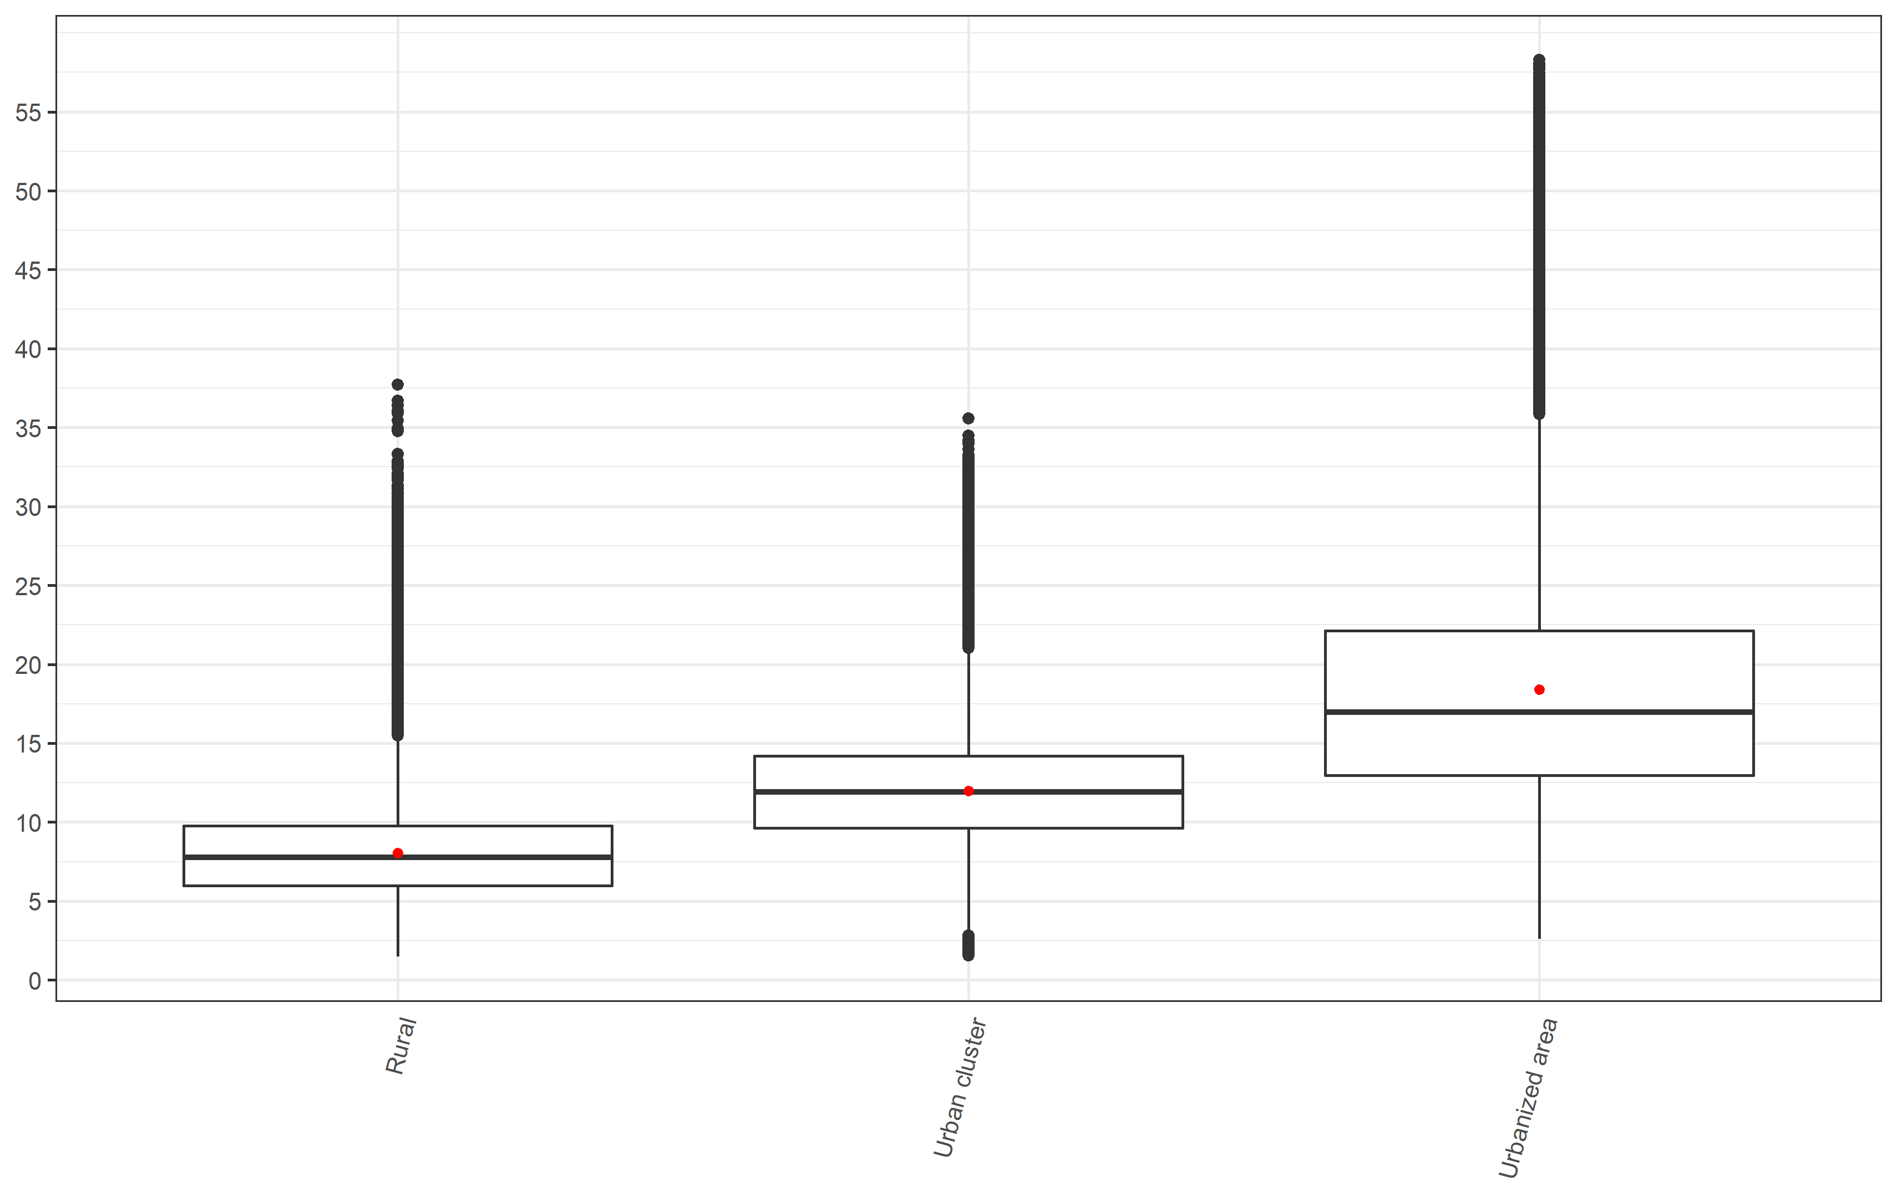

*\*Red dot represents the mean value while the midline represents the median value*

*Figure S2: NO2 concentration (ug/m3) by median household income group*

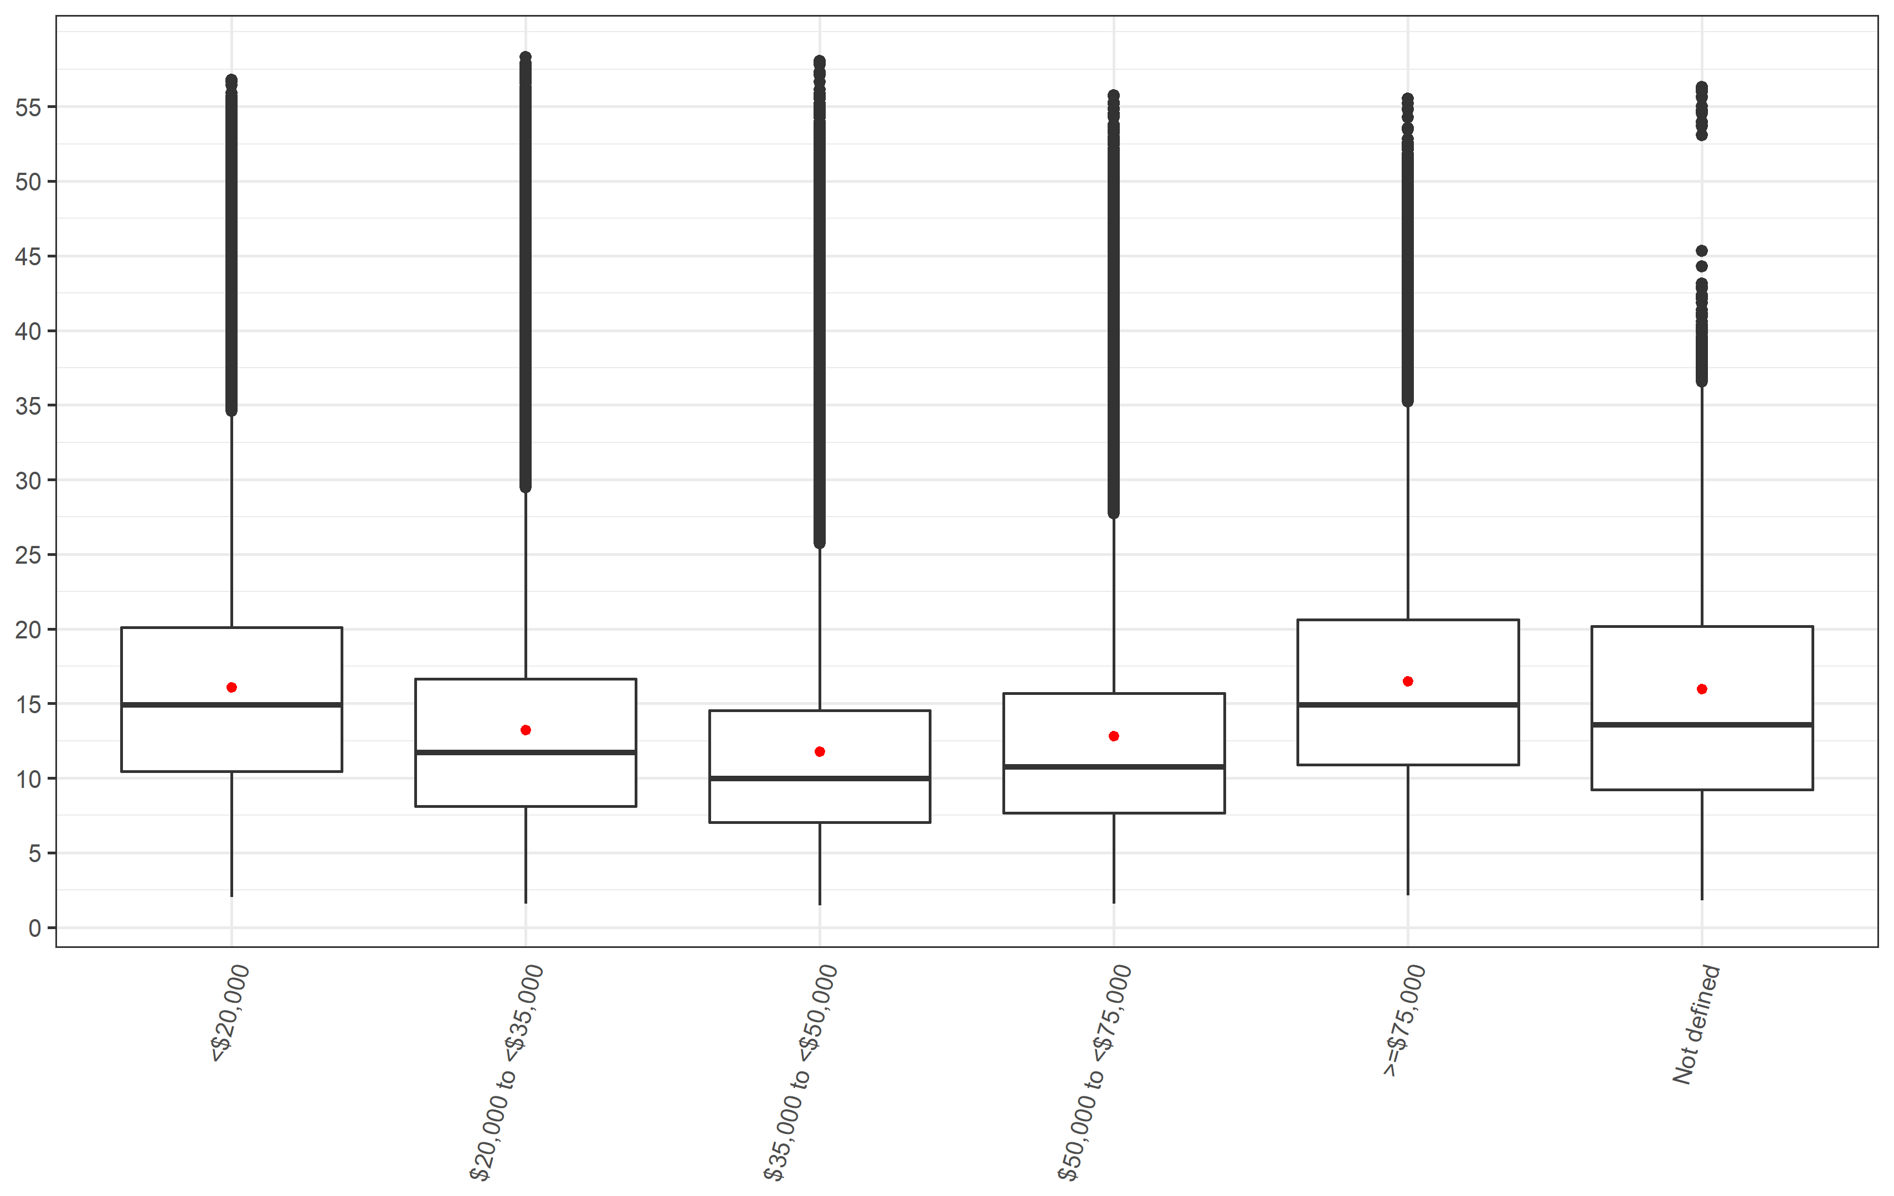

*Figure S3: NO2 concentration (ug/m3) by living location stratified into median household income group*

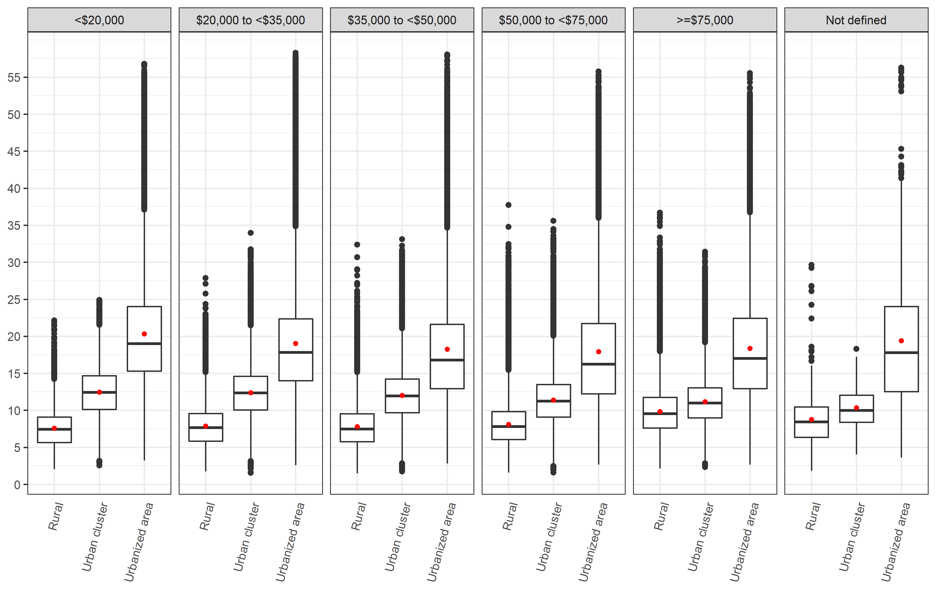

*Figure S4: NO2 concentration (ug/m3) by median household income group stratified into living location*

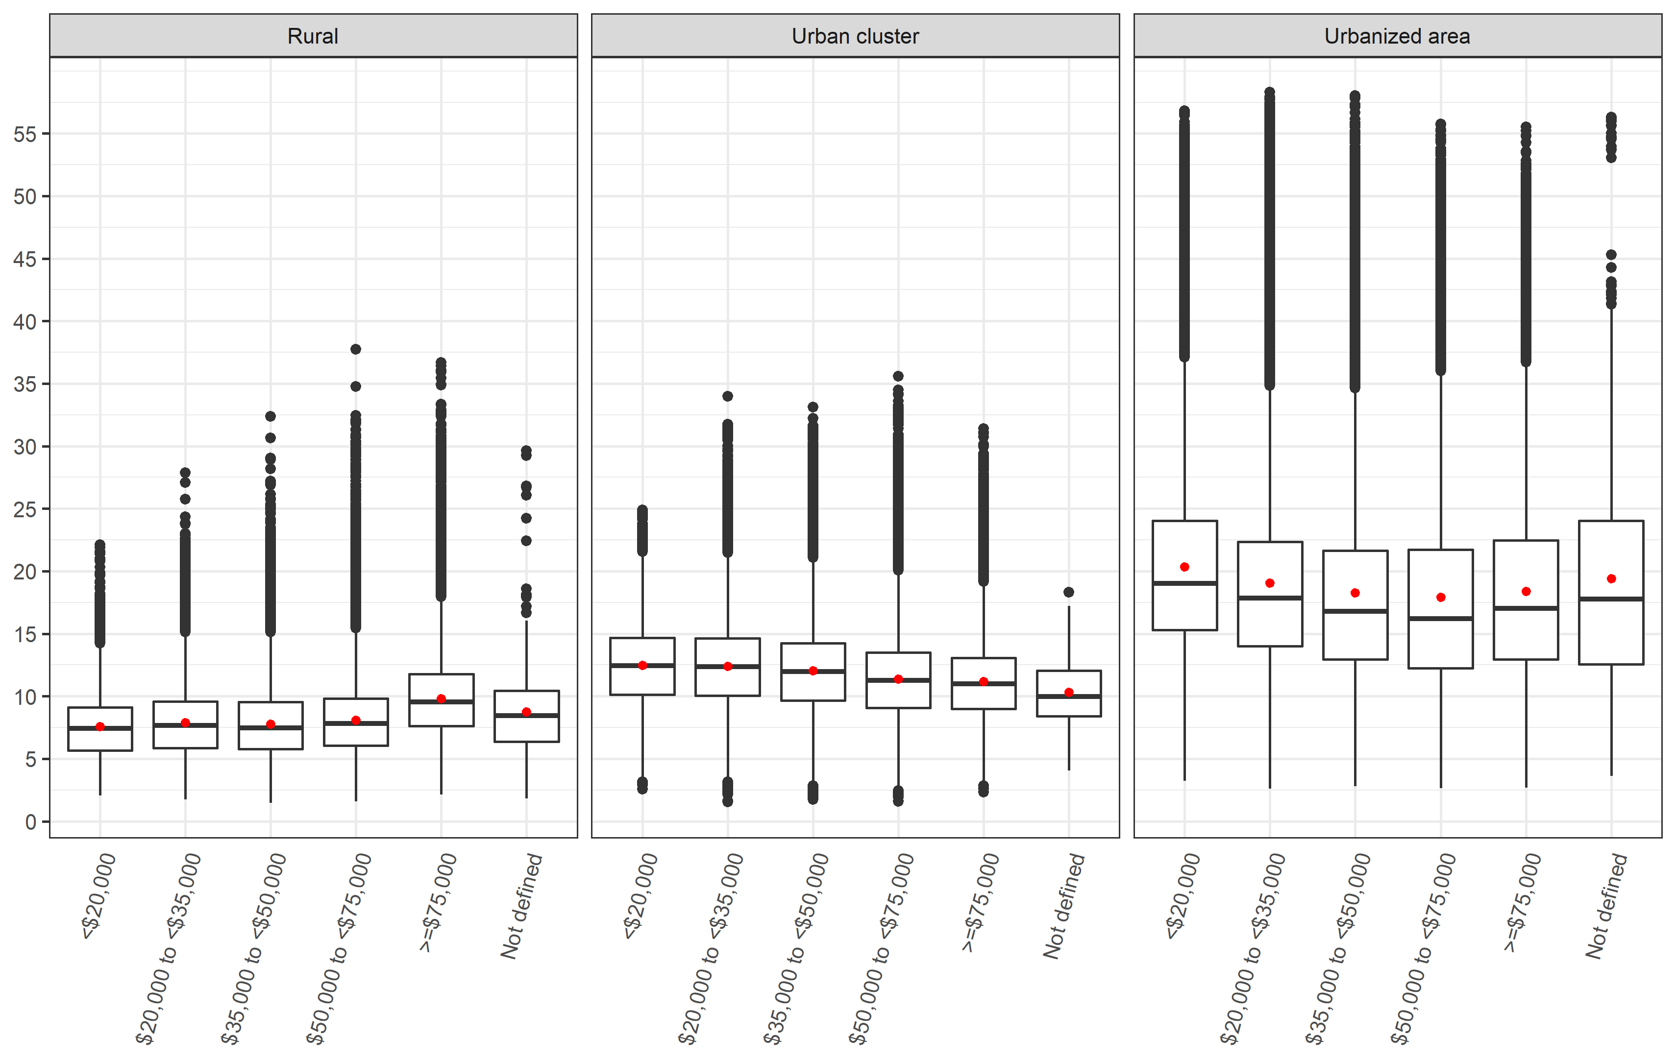

*Figure S5: NO2 concentration (ug/m3) by state*

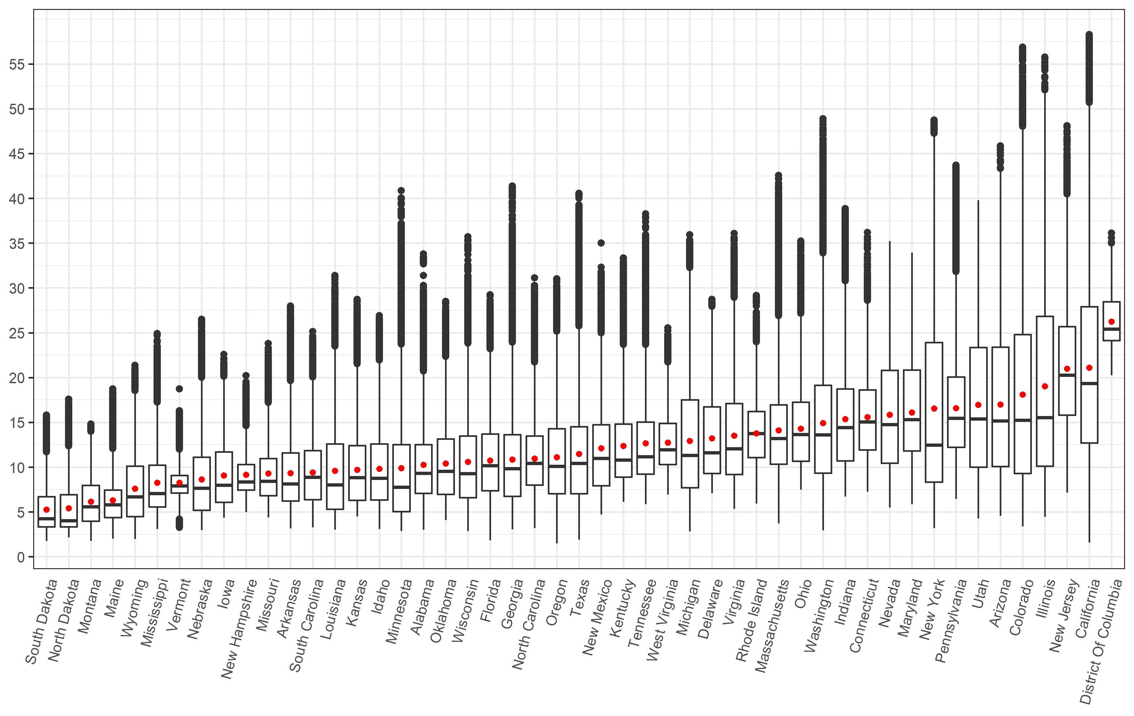

*Figure S6: NO2 concentration (ug/m3) by state and median household income group*

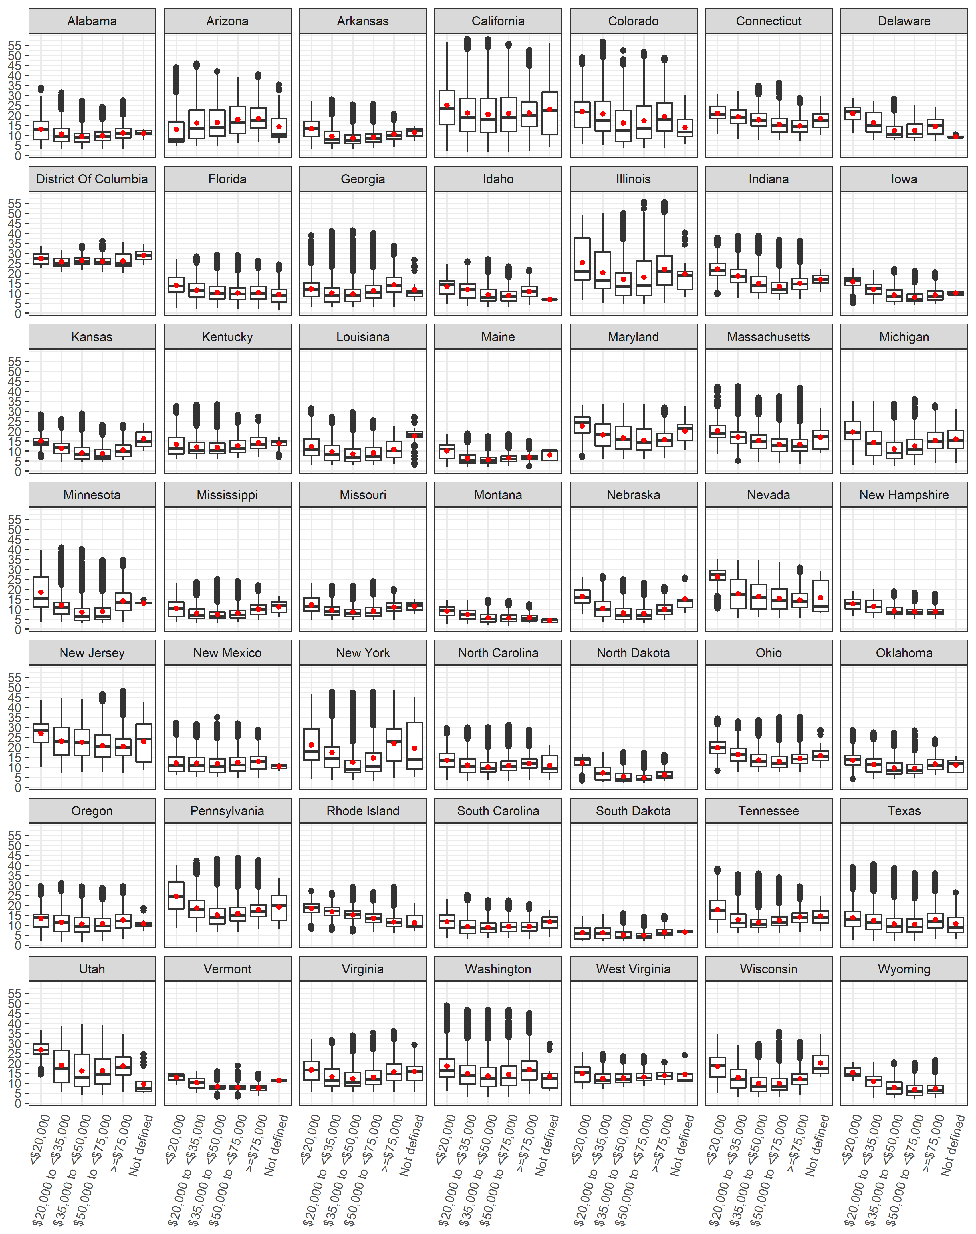

*Figure S7: NO2 concentration (ug/m3) by state and living location*

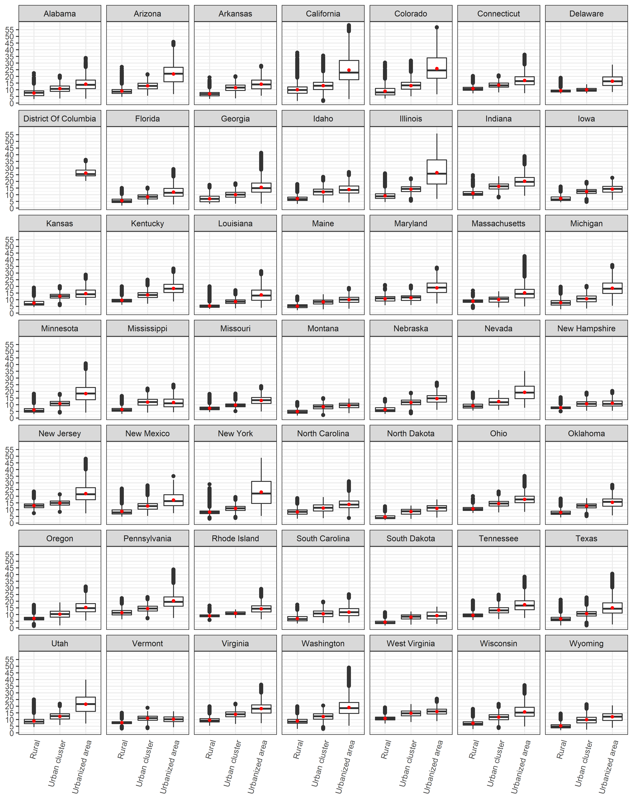

*Figure S8: Attributable Fraction by living location*

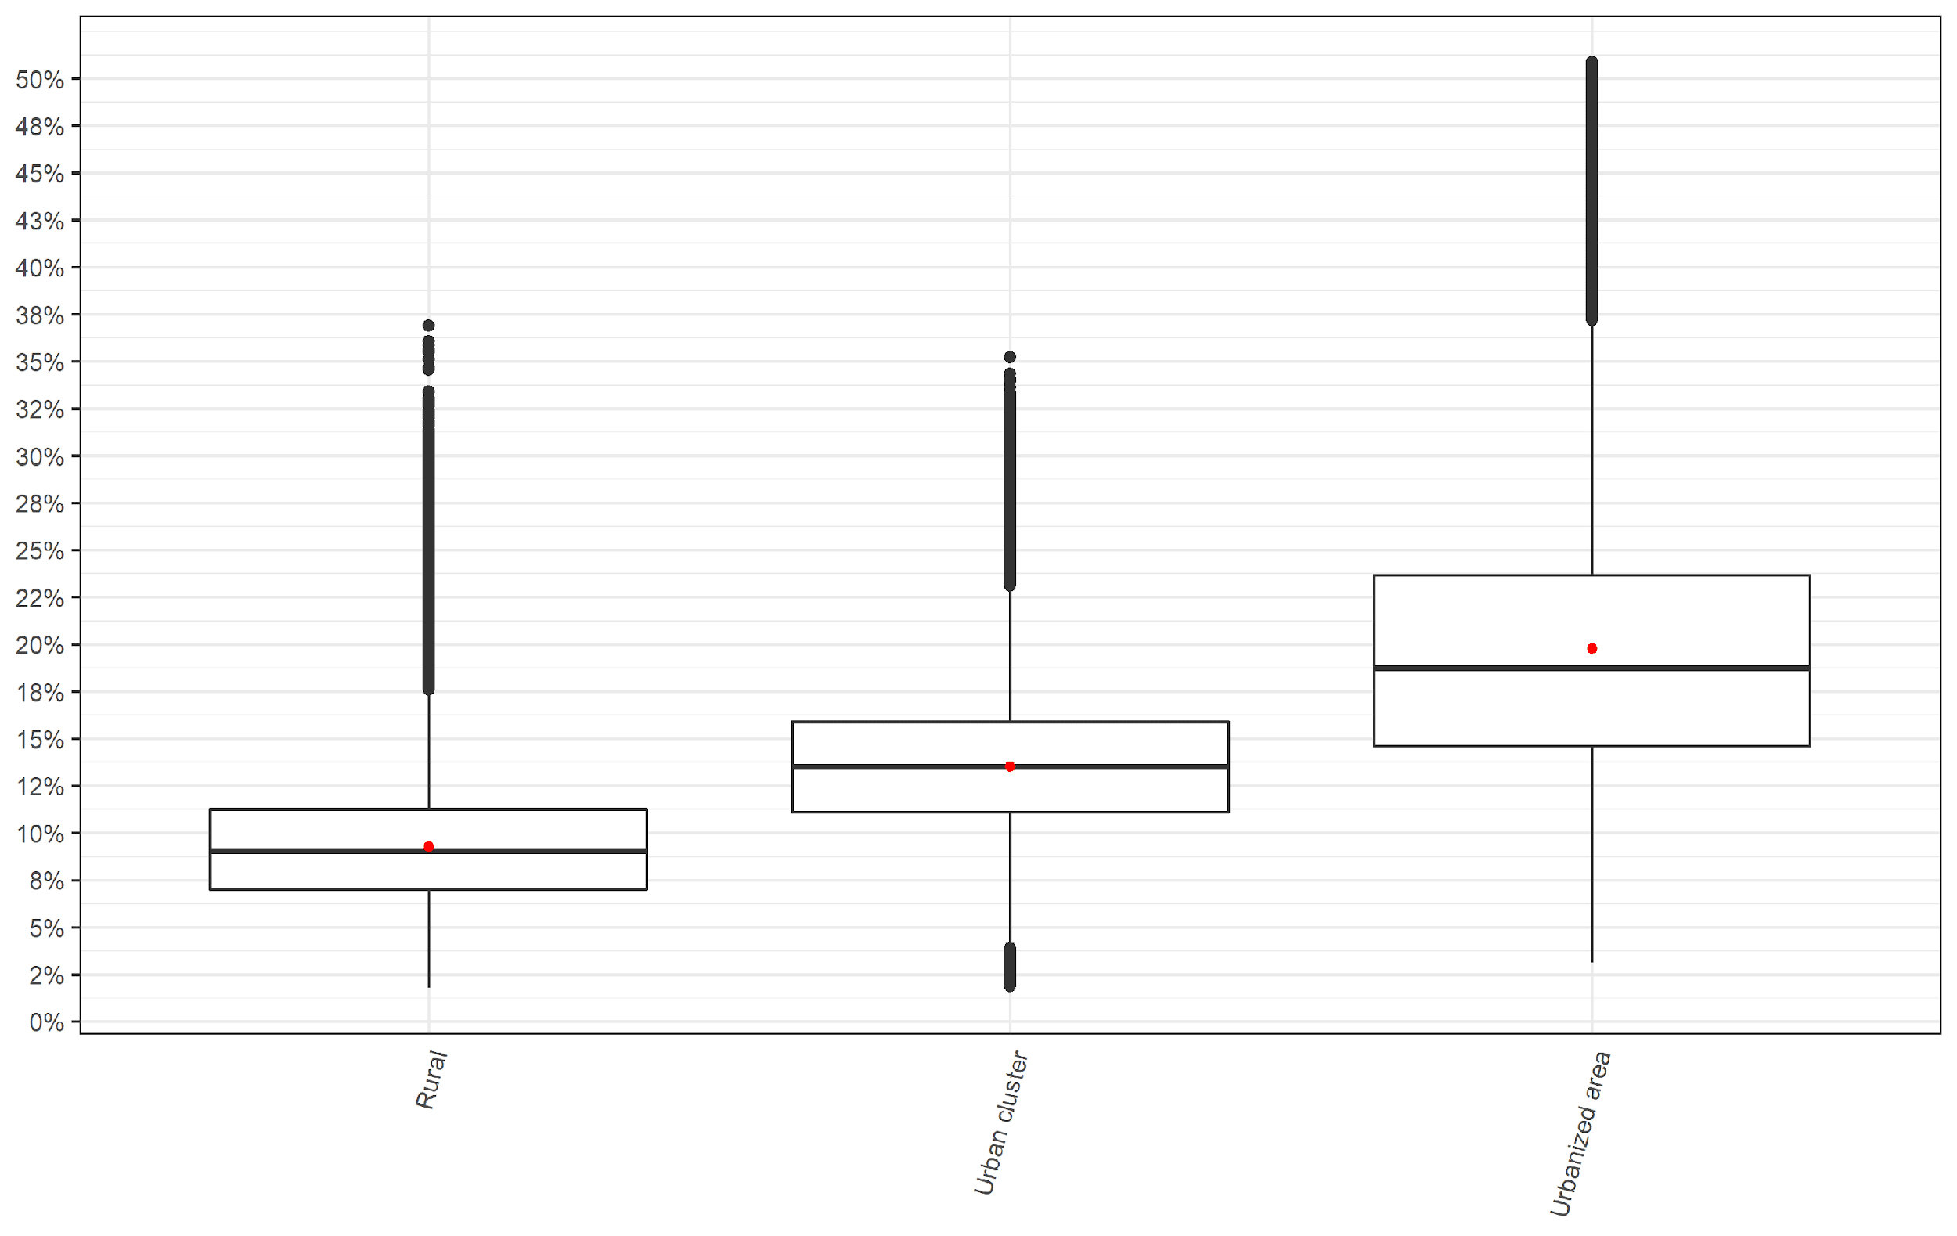

*Figure S9: Attributable Fraction by median household income group*

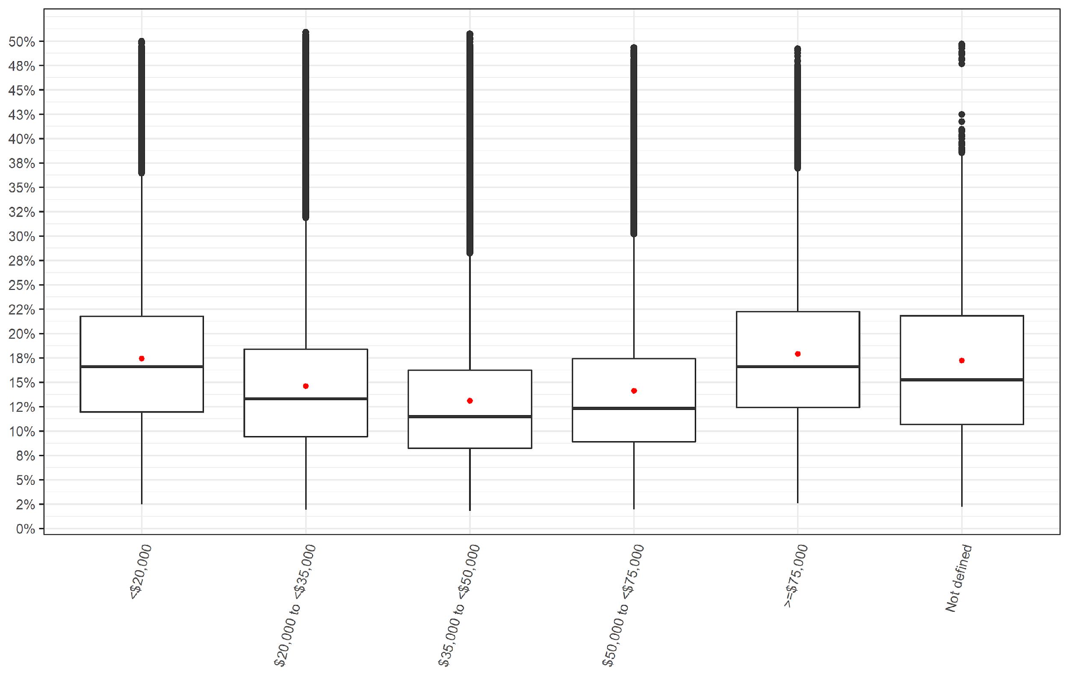

*Figure S10: Attributable Fraction by median household income group stratified into living location*

