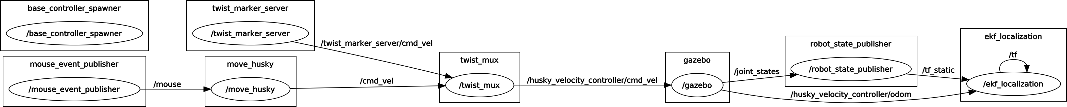
Using rostopic pub I discovered that the robot moves when there are messages of type geometry_msgs/Twist on topic 'cmd_vel' – the subscriber of node twist_mux of the Husky robot subscribes to those messages.

I then created move_husky node that publishes geometry_msgs/Twist messages (with some linear and angular values set so the robot drives in circles) onto 'cmd_vel' topic, when boolean move_r is true. The boolean is toggled based on messages of type mouse_reader/mouse_event_msg on topic 'mouse'.

The mouse_event_msg has four values of which only the last is used – mouseValue, which is 1 when a mouse button is pressed. If mouseValue is 1 the move_husky node's 'mouse' topic subscriber callback toggles the node's move_r boolean.

The mouse_event_publisher publishes mouse_event_msg onto the 'mouse' topic – it's reused node from the practicals.

Juhan Raedov

