Extending BlockSim with Energy and Carbon Footprint Modeling for Sustainable Blockchain Evaluation
No funding was received for conducting this study…

Raed S. Rasheed
Faculty of Engineering, Islamic University of Gaza
Gaza, P.O. Box 108, Palestine
rrasheed@iugaza.edu.ps
Aiman A. AbuSamra
Faculty of Engineering, Islamic University of Gaza
Gaza, P.O. Box 108, Palestine
aasamra@iugaza.edu.ps

Abstract –This paper extends BlockSim by introducing energy-consumption and carbon-footprint metrics that are tightly integrated with its event-driven execution model, enabling sustainability-aware evaluation alongside conventional performance metrics. The proposed extension instruments core simulation events to estimate computational and communication energy at both node and network levels, then converts electricity demand to CO₂ emissions using an emission-factor formulation that can be configured to represent different grid carbon intensities. Using the extended simulator, controlled experiments are conducted on representative PoW and PoS consensus scenarios under varying miner populations and workloads. The framework reports aggregate energy and CO₂, as well as normalized indicators per block and per transaction, supporting reproducible “what-if” analysis without external post-processing and enabling direct comparison of protocol configurations as networks scale. The framework additionally distinguishes economically driven Proof-of-Work (PoW) energy consumption, in which the expected mining reward and cryptocurrency price are explicit inputs, from validator-count-driven Proof-of-Stake (PoS) energy consumption; it varies the carbon emission factor across grid scenarios; and it is positioned as a scenario-based evaluation tool for preliminary what-if analysis rather than a precise real-world energy estimator.

Keywords: Blockchain Simulation, BlockSim, Consensus Algorithms, Energy Consumption, PoW, PoS, Carbon Footprint, Energy Modeling, Sustainability.

Introduction
Blockchain technology has become a crucial infrastructure for decentralized applications, facilitating trustless coordination within distributed systems. Following Bitcoin's inception, blockchains have seen widespread adoption in sectors including finance, supply chain management, and digital governance. Nevertheless, the swift expansion of blockchain networks has prompted considerable apprehension regarding their energy consumption and environmental consequences, especially concerning consensus mechanisms reliant on computationally intensive processes like Proof of Work (PoW) [1].
Numerous studies have shown that large-scale blockchain systems can consume energy levels comparable to those of entire nations, leading to significant carbon dioxide (CO₂) emissions [2], [3]. These environmental issues have spurred the development of more energy-efficient consensus protocols and the necessity for robust evaluation tools capable of assessing sustainability alongside conventional performance and security metrics.
In this context, analysis using simulations is crucial. It allows for controlled experiments, avoiding the costs and risks associated with using real blockchain networks.
BlockSim, developed by Alharby and van Moorsel, is a prominent example of a blockchain simulator, distinguished by its adaptability and layered design. This architectural framework facilitates the examination of design compromises spanning network, consensus, and incentive layers via discrete-event simulation [4]. BlockSim offers functionality for assessing a range of system-level metrics, such as latency, throughput, and fork rates, and has been extensively employed to analyze blockchain performance across different configurations. Nevertheless, like numerous blockchain simulators, BlockSim does not inherently model energy consumption or carbon emissions, which limits its applicability in research centered on sustainability.
Concurrently, energy modeling has been effectively incorporated into versatile network simulators like ns-3, thereby illustrating the capacity of discrete-event simulation to accurately represent power and energy behaviors within distributed systems [5]. This observation implies that analogous modeling methodologies could be applied to blockchain simulators.
This study expands upon BlockSim by incorporating energy consumption and carbon footprint metrics, which are closely integrated with its event-driven execution model. This enhancement facilitates a quantitative assessment of blockchain protocols, considering both performance and environmental impacts, thus furnishing researchers and protocol designers with a comprehensive framework for the sustainable analysis of blockchain systems.
It is important to clarify the energy characteristics of the consensus mechanisms considered. Proof-of-Work (PoW) energy consumption is economically driven: a rational miner invests in electricity up to the fiat value of the expected block reward, so total PoW energy depends primarily on the cryptocurrency price, the block subsidy, transaction fees, the electricity price, mining hardware efficiency, and the difficulty/hashrate equilibrium, rather than on the raw number of miners [16], [4]. Proof-of-Stake (PoS), by contrast, secures the network through stake and its energy is dominated by the number of validators kept online and their hardware power, essentially independent of coin price [19]. Accordingly, this paper treats PoW and PoS as distinct energy regimes and presents its experiments as generic PoW and PoS consensus scenarios rather than tying them to any specific cryptocurrency.

Background and Related Work
Blockchain systems are often evaluated using analytical models, empirical measurements, or simulation-based approaches. Simulation, in particular, has gained prominence due to its capacity to effectively model complex interactions among networking, consensus, and incentive mechanisms within controlled and reproducible settings. Consequently, as blockchain protocols evolve, simulators have become essential tools for examining scalability, security, and performance trade-offs, thus eliminating the necessity for costly real-world infrastructure implementations.
Numerous blockchain simulators have been created in existing research. For example, SimBlock focuses on how blocks spread and how forks behave in large peer-to-peer networks. This makes it useful for studying network delays and their impact on the security of consensus mechanisms [6].
JABS builds upon this research by incorporating support for diverse consensus mechanisms and accommodating extensive network scales, thereby prioritizing both performance and fault tolerance [7]. In contrast, other simulators, including those developed on the ns-3 platform, offer high-precision network modeling; however, they necessitate considerable resources to integrate blockchain logic and consensus processes [8].
BlockSim, as described by Alharby and van Moorsel, utilizes a layered discrete-event simulation model, which differentiates among network, consensus, and incentive components [4]. This architectural framework allows for adaptable examination of protocol design alternatives, and it has been employed in various studies to evaluate throughput, latency, and fork rates. Moreover, BlockSim's modular structure makes it particularly well-suited for extensions and experimentation, thereby positioning it as a valuable foundation for future enhancements.
Despite these advancements, blockchain simulation frameworks still largely overlook energy consumption and environmental effects. Although many studies have quantified the energy use and carbon footprint of blockchain networks, particularly permissionless PoW networks [2], [3], using real-world data and statistical models, these analyses are often retrospective and lack the flexibility needed for "what-if" experiments.
General-purpose simulators, like ns-3, include energy frameworks that can model power consumption in networked systems [9]; however, most blockchain-specific simulators don't have these features built-in.
Recent investigations have underscored the necessity for evaluation instruments that incorporate sustainability considerations, thereby integrating performance, security, and environmental metrics within a unified framework [3]. Nevertheless, existing methodologies frequently depend on external post-processing or imprecise approximations, rather than employing tightly integrated simulation models. This deficiency underscores the imperative to augment blockchain simulators, including BlockSim, with explicit modeling of energy consumption and carbon emissions, thus facilitating systematic and comparative sustainability assessments throughout the protocol design process.

Energy, Permissionlessness, and Sybil Resistance
The energy gap between PoW and PoS is tied to how each mechanism resists Sybil attacks in a permissionless setting. PoW achieves Sybil resistance by binding influence to an external, costly resource (computation and therefore electricity), so PoW is not “free”: its permissionlessness is purchased through continuous resource expenditure, which is precisely why its energy use is large and coupled to coin price [16], [4]. PoS instead binds influence to internal economic stake and validator participation, removing most computational waste but introducing different trust and economic assumptions [19]. Platt, Platt and McBurney formalise these tensions as a Sybil-attack vulnerability trilemma among permissionlessness, Sybil resistance, and freeness [20], and De Vries shows how Ethereum’s transition from PoW to PoS after The Merge illustrates why current PoS systems should not be modelled as historical PoW systems [21]. These distinctions motivate treating PoW and PoS as two separate energy models in the remainder of the paper.

Overview of BlockSim (Alharby & van Moorsel)
BlockSim is a discrete-event simulation framework that facilitates the systematic assessment of blockchain systems by abstractly modeling their fundamental architectural layers, while also allowing for extensibility. Developed by Alharby and van Moorsel, BlockSim was conceived to overcome the constraints inherent in analytical and empirical evaluation techniques when examining intricate blockchain design trade-offs across diverse configurations [4].
The simulator's architecture is structured in layers, dividing the blockchain system into three main components: the network layer, the consensus layer, and the incentive layer. The network layer simulates message propagation delays and peer connectivity, which allows for the analysis of latency and communication overhead.
The consensus layer, which includes the processes of block creation, validation, and fork resolution, allows researchers to study how protocol parameters, such as block intervals and the distribution of mining power, affect the system.
The incentive layer models economic aspects, including rewards and penalties, providing insight into miner behavior and system stability [4].
BlockSim, constructed using Python, operates within a discrete-event framework, wherein system dynamics unfold through pre-scheduled events encompassing block creation, message dissemination, and chain modifications. This methodology facilitates repeatable experimentation and precise manipulation of simulation variables, while simultaneously providing the necessary abstraction to accommodate extensive scenario analysis. Prior research has demonstrated BlockSim's efficacy in assessing throughput, block propagation latency, and stale block frequencies across diverse blockchain architectures [4], [10].
A significant advantage of BlockSim is its inherent modularity and capacity for extension. The framework is deliberately structured to empower researchers to modify or augment internal models, encompassing node functionality, transaction processing, and consensus mechanisms, without necessitating a complete overhaul of the simulator.
BlockSim's design makes it particularly well-suited for "what-if" analyses and comparative studies of different protocol designs [10]. While it is versatile, BlockSim mainly focuses on performance, security, and incentive-related metrics. The original framework doesn't explicitly model environmental factors like energy use and carbon emissions. Given the growing importance of sustainable blockchain design and the proven ability to integrate energy models into discrete-event simulators [9], BlockSim offers a solid foundation for extensions that include energy and carbon-aware evaluations while preserving its original architectural principles..

Energy Consumption Modeling Extension
Energy consumption in blockchain systems is primarily driven by computational operations associated with consensus execution and communication activities related to block and transaction propagation. To support sustainability-oriented analysis, this work extends BlockSim by integrating an explicit energy consumption model into its discrete-event simulation framework.
Following established practices in energy-aware modeling of distributed systems, energy usage is expressed as a function of discrete events and their associated resource costs [11], [9]. In the proposed extension, each node $i$ maintains a cumulative energy counter $E_{i}$, which is incremented whenever a computation or communication event is executed.

A. Computational Energy Model
Computational energy consumption is modeled based on consensus-related operations such as block generation and validation. For a node $i$, the computational energy consumed during a simulation interval is defined as:
$$E_{i}^{comp}=\sum_{k=1}^{N_{i}^{comp}}{e_{comp}^{\left(k\right)}}$$ | (1)

where $N_{i}^{comp}$ denotes the number of computational events executed by node $i$, and $e_{comp}^{\left(k\right)}$ represents the energy cost of the $k$-th computational event.
For Proof of Work–based mechanisms, $e_{comp}$is proportional to the number of hash attempts:
$$e_{comp}=α⋅H_{i}$$ | (2)

where $H_{i}$ is the number of hash computations performed by node $i$, and $α$ is the energy cost per hash operation, consistent with prior empirical analyses of blockchain energy usage [2]. For less computation-intensive consensus mechanisms, fixed or lower per-event energy coefficients are applied, reflecting reduced processing requirements [12].

B. Communication Energy Model
Communication energy consumption accounts for message transmission and reception events in the network layer. The communication energy for node $i$ is defined as:
$$E_{i}^{comm}=N_{i}^{tx}⋅e_{tx}+N_{i}^{rx}⋅e_{rx}$$ | (3)

where $N_{i}^{tx}$ and $N_{i}^{rx}$ represent the number of transmitted and received messages, respectively, and $e_{tx}$, $e_{rx}$ denote the energy costs of transmission and reception. This formulation aligns with packet-level energy models commonly used in network simulators such as ns-3 [9].
Although defined here, communication energy was not analysed in the previous version. In this revision it is instrumented with explicit transmit/receive counters for block and transaction messages and analysed in Section (Results) as a function of transaction rate, block size, and peer connectivity, and reported separately from consensus energy.

C. Total Energy Consumption
The total energy consumption per node and for the entire network is computed as:
$$E_{i}=E_{i}^{comp}+E_{i}^{comm},E_{total}=\sum_{i=1}^{N}{E_{i}}$$ | (4)

This integrated energy model enables BlockSim to quantify energy usage per block, per transaction, and per simulation run, forming a foundation for subsequent carbon footprint analysis.

D. Proof-of-Work Economic Energy Model
Because PoW energy is bounded by mining economics, we add an economic model. The expected per-block reward in fiat is given by Eq. (5), where $B_{t}$ is the block subsidy, $F_{t}$ the transaction fees, and $P_{t}$ the coin price. A rational mining market spends a fraction $κ$ ∈ [0,1] of this reward on electricity, giving the economic energy budget per block in Eq. (6), where $C_{elec,t}$ is the electricity price per kWh. When hardware data are available, a technical bound $E_{technical}=H_{block}·ε_{hash}$ is derived from the expected hashes per block ($H_{block}=D·2^{32}$) and the per-hash efficiency $ε_{hash}$, and the network per-block energy is $E_{PoW,t}=min\left(E_{technical}, E_{budget,t}\right)$. The miner-level allocation by hashpower share $s_{i,t}$ is given by Eq. (7). Thus PoW energy depends on coin price, reward, electricity price, efficiency, and difficulty/hashrate, and only the distribution depends on the number of miners.
$$R_{t}=\left(B_{t}+F_{t}\right)·P_{t}$$ | (5)

$$E_{budget,t}=\frac{κ·R_{t}}{C_{elec,t}}$$ | (6)

$$E_{i,t}=s_{i,t}·E_{PoW,t}$$ | (7)

E. Proof-of-Stake Validator Energy Model
For PoS we add a validator-count model: the network energy is given by Eq. (8), where $P_{v}$ is per-validator power (W), $T$ the horizon (h), $u_{v}$ ∈ [0,1] the uptime, $V$ the number of validators, and $E_{comm}$ the communication energy. PoS energy therefore scales with validator count and hardware power and is independent of coin price.
$$E_{PoS}=\frac{\sum_{v=1}^{V}{\left(P_{v}·T·u_{v}\right)}}{1000}+E_{comm}$$ | (8)

Carbon Footprint Modeling
While energy consumption provides a direct measure of resource usage, assessing the environmental impact of blockchain systems requires translating energy demand into associated carbon dioxide (CO₂) emissions. Carbon footprint modeling enables sustainability-oriented evaluation by linking simulated energy consumption to greenhouse gas emissions attributable to electricity generation.
In this work, carbon emissions are derived directly from the energy consumption metrics produced by the extended BlockSim framework. Following widely adopted carbon accounting practices, total CO₂ emissions are modeled as a linear function of energy usage and an emission factor that represents the carbon intensity of electricity generation [13], [14].

A. Carbon Emission Model
Let $E_{i}$ denote the total energy consumption of node $i$, measured in kilowatt-hours (kWh), as obtained from the energy consumption model. The corresponding carbon emissions $C_{i}$ are calculated as:
$$C_{i}=E_{i}⋅γ$$ | (9)

where $γ$is the electricity emission factor expressed in kilograms of CO₂ per kilowatt-hour (kgCO₂/kWh). The value of $γ$ depends on the energy mix of the assumed electricity grid and can be configured to represent global averages or region-specific scenarios, consistent with prior studies on blockchain carbon emissions [3], [15].
Because γ captures the carbon intensity of the underlying grid, the same energy yields very different emissions across regions and times. We therefore treat γ as an experimental variable with three scenarios: a low-carbon grid (γ = 0.05 kgCO₂e/kWh), a global-average grid (γ = 0.475), and a high-carbon grid (γ = 0.82); the sensitivity is reported in the Results.
The total carbon footprint of the blockchain network over a simulation run is computed as:
$$C_{total}=\sum_{i=1}^{N}{C_{i}}=γ\sum_{i=1}^{N}{E_{i}}$$ | (10)

where $N$ denotes the total number of participating nodes.

B. Granular Emission Metrics
To enable fine-grained sustainability analysis, carbon emissions are further normalized with respect to blockchain outputs. Carbon emissions per block $C_{block}$ and per transaction $C_{tx}$ are defined as:
$$C_{block}=\frac{C_{total}}{B},C_{tx}=\frac{C_{total}}{T}$$ | (11)

where $B$ is the total number of confirmed blocks and $T$ is the total number of processed transactions during the simulation. These normalized metrics are commonly used in empirical blockchain sustainability studies to compare protocol efficiency across different workloads and configurations [3], [16].

C. Integration with BlockSim
By embedding carbon footprint computation directly into BlockSim’s event-driven execution, the simulator produces time-series and aggregate emission statistics without external post-processing. This tight coupling enables comparative evaluation of blockchain protocols with respect to performance, energy efficiency, and environmental impact within a unified simulation framework.

Experimental Setup
To evaluate the effectiveness of the proposed energy and carbon footprint extensions, a series of controlled simulation experiments were conducted using the extended BlockSim framework. The experimental design follows best practices for blockchain performance evaluation, ensuring reproducibility and comparability with prior studies [4], [16].
Table 1 consolidates every parameter required to reproduce the experiments, distinguishing economic-PoW, fixed-power baseline, PoS, communication, and carbon parameters, and marking each as a deterministic input, a swept level, or a stochastic (seed-varying) quantity.
Parameter | Symbol | Value / range | Unit | Model / scenario | Type | Source / justification
Block subsidy | B_t | 3.125 (swept 1.5625 / 3.125 / 6.25) | coin/block | PoW economic | Input (swept) | Post-2024-halving anchor (assumption)
Avg. transaction fees | F_t | 0.30 (±40% across seeds) | coin/block | PoW economic | Stochastic | Scenario assumption
Coin price | P_t | 60,000 (swept 20,000 / 60,000 / 100,000; ±5% across seeds) | USD/coin | PoW economic | Input (swept)/stochastic | Scenario assumption
Electricity price | C_elec | 0.05 (swept 0.03 / 0.05 / 0.10) | USD/kWh | PoW economic | Input (swept) | Industrial-mining assumption
Electricity-spend ratio | κ | 0.80 | - | PoW economic | Deterministic input | Assumption, κ ∈ [0,1]
Mining efficiency | - | 21.5 | J/TH | PoW economic (technical bound) | Deterministic input | ASIC-class anchor (assumption)
Block interval (PoW) | - | 600 | s | PoW economic | Deterministic input | ~10-min target (assumption)
Miner count | N | 50; 100; 500; 1000 | miners | PoW economic | Swept | Small-to-moderate networks [6]
Per-miner power (fixed-power contrast baseline) | P_miner | 2500 (illustrative) | W | Naïve fixed-power baseline | Deterministic input | Contrast only; not used for network-level estimates
Validator power | P_v | 10 / 100 / 500 (low / standard / high; ±10% across seeds) | W | PoS validator | Input (swept)/stochastic | Hardware-class assumptions
Validator uptime | u_v | 0.99 (swept 0.90 / 0.99 / 1.00; ±1% across seeds) | - | PoS validator | Input/stochastic | Assumption
Validator count | V | 100; 500; 1000; 5000 | validators | PoS validator | Swept | -
Validator gossip message rate | - | 5 | msg/validator/s | PoS validator | Deterministic input | Attestation/gossip assumption
Peer degree | - | 4; 8; 16 | peers | Communication | Swept | Connectivity assumption
Block size | - | 0.5; 1; 2 | MB | Communication | Swept | -
Transaction rate | - | 1; 10; 100 | tx/s | Communication | Swept | -
Transaction size | - | 512 | bytes | Communication | Deterministic input | Assumption
TX energy per message | e_tx | 0.10 | J/msg | Communication | Deterministic input | Radio/NIC order-of-magnitude [11]
RX energy per message | e_rx | 0.05 | J/msg | Communication | Deterministic input | Radio/NIC order-of-magnitude [11]
TX energy per byte | - | 2×10⁻⁶ | J/byte | Communication | Deterministic input | [11]
RX energy per byte | - | 1×10⁻⁶ | J/byte | Communication | Deterministic input | [11]
Nodes (comm. overlay) | - | 500 | nodes | Communication | Deterministic input | -
Grid emission factor | γ | 0.05 / 0.475 / 0.82 (low / average / high) | kgCO₂e/kWh | Carbon | Swept | IEA/IPCC ranges [13], [14]
Transactions per block (normalization) | - | 2000 | tx/block | Carbon | Deterministic input | Throughput assumption
Simulation horizon | T | 86,400 (24 h) | s | All models | Deterministic input | Common horizon (normalizes energy totals)
Random seeds | - | 30 (20260101-20260130; base + i, i = 0..29) | - | All stochastic runs | - | Reproducible seeding
Confidence interval | - | 95% (Student-t across seeds) | - | All stochastic runs | - | Across-seed CI of the mean
Table 1. Consolidated experimental parameters (all values verified against the released code, CSV outputs, and equations).

A. Network and System Configuration
The simulated blockchain network consists of $N$ nodes, where $N∈\{50,100,500,1000\}$, representing small to moderately sized permissionless networks commonly analyzed in the literature [6]. Nodes are connected via a peer-to-peer overlay with randomly assigned propagation delays drawn from a bounded distribution, consistent with established modeling approaches for blockchain network latency [8]. BlockSim’s discrete-event scheduler is used to model message dissemination, block arrival, and chain updates.

B. Consensus and Workload Parameters
The primary evaluation uses the economically driven Proof-of-Work model (Section D) with a ten-minute (600 s) target block interval, together with the validator-count Proof-of-Stake model (Section E). Transaction workloads are modelled as a Poisson process, a common assumption in blockchain performance studies [4], [17]. To assess scaling behaviour, the miner population is varied over {50, 100, 500, 1000} and the validator population over {100, 500, 1000, 5000} while the simulation horizon is held fixed at 24 hours; additional sensitivity sweeps vary the coin price, block reward, and electricity price for PoW and the hardware class and uptime for PoS. All parameter values are consolidated in Table 1.
To assess the sensitivity of energy and emission metrics, additional scenarios vary mining power distribution among nodes and transaction throughput. These variations allow for an analysis of how network size and the intensity of the workload affect results related to sustainability.

C. Energy and Carbon Parameters
Energy consumption is computed at runtime from the consensus-aware models: Proof-of-Work energy from the economic model (Eqs. 5-7), driven by the block reward, coin price, electricity price, hardware efficiency, and the electricity-spend ratio κ, and Proof-of-Stake energy from the validator-count model (Eq. 8). Carbon emissions are computed with the configurable emission factor γ, varied across low, average, and high grid scenarios (see Results) rather than held fixed, following established blockchain carbon-footprint analyses [3]. Concretely, carbon is derived via the standard emission-factor formulation (electricity use × emission factor), consistent with common GHG accounting practice.

D. Evaluation Metrics and Methodology
The subsequent metrics are gathered for each simulation scenario: aggregate energy consumption, energy expenditure per block, energy usage per transaction, total CO₂ emissions, and CO₂ emissions per block and transaction. Concurrently, performance metrics, encompassing throughput, propagation delay, and the rate of stale blocks, are documented to facilitate an analysis of the trade-offs inherent in balancing efficiency and sustainability. Each scenario is replicated across 30 independent random seeds (generated deterministically as base + i, i = 0..29), and results are reported as the mean with sample standard deviation and 95% confidence interval (Student t).

E. Randomness, Replications, and Confidence-Interval Construction
The consensus-aware energy equations (Sections D and E) are deterministic in their inputs: for fixed power and horizon a configuration reproduces the closed-form E = P·T exactly (maximum relative error 0.00 across the fixed-power sanity check). The reported 30-seed confidence intervals therefore do not arise from the closed-form expressions themselves, but from scenario-level stochasticity in the inputs a protocol designer cannot fix exactly. For Proof-of-Work, each seed draws the number of blocks realized in the horizon from a Poisson distribution around the horizon divided by the target block interval, and applies independent Gaussian jitter to the coin price (standard deviation 5%) and to the average transaction fees (standard deviation 40%); hashpower shares are drawn from a Dirichlet(1,…,1) distribution, which affects the per-miner allocation. For Proof-of-Stake, each seed applies Gaussian jitter to per-validator power (standard deviation 10%) and uptime (standard deviation 1%). Each of the 30 seeds (20260101-20260130, generated deterministically as base + i, i = 0..29) drives one independent realization, and the reported intervals are Student-t 95% confidence intervals of the mean across seeds. Purely deterministic quantities - such as the fixed-power check E = P·T - reproduce identically across seeds and are reported as exact values without confidence intervals.
The extended implementation and all code-level modifications to the BlockSim simulator (including the added energy-consumption and carbon-footprint modeling components) are made publicly available in a version-controlled GitHub repository at [18].

Results and Analysis
The simulation results demonstrate that integrating energy and carbon-footprint modelling into BlockSim enables meaningful sustainability analysis while preserving the simulator's original performance-evaluation capabilities. The consensus-aware models make the distinct energy drivers of each family explicit: Proof-of-Work energy is governed by mining economics, whereas Proof-of-Stake energy is governed by validator count and hardware power, as detailed below.

A. Energy Consumption Analysis

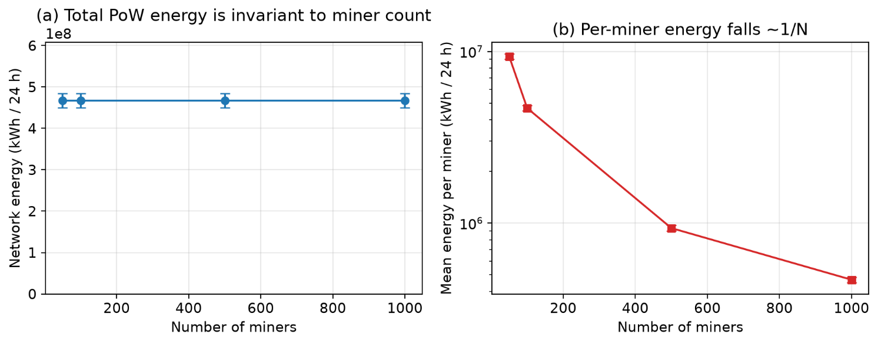
Under the economically driven Proof-of-Work model (Section D), total network energy is governed by mining economics rather than by the number of miners. Holding the economic inputs fixed over a 24-hour horizon, the PoW network total is approximately 467.5 GWh and is essentially invariant across 50-1000 miners (95% CI ± 17.1 GWh), while the mean per-miner energy falls approximately as 1/N.
Figure 1. PoW energy vs number of miners (economic model; 30 seeds, 95% CI). Total network energy is invariant to miner count (a); per-miner energy falls ~1/N (b).
Network energy scales linearly with coin price, rising from 155.8 GWh at 20,000 USD/coin to 779.1 GWh at 100,000 USD/coin, and inversely with electricity price, confirming the economic argument of Section D. Increasing the number of participating miners therefore redistributes a fixed, economically bounded energy budget rather than increasing it, correcting the common misconception that Proof-of-Work energy grows with the raw miner count. These absolute magnitudes are scenario-based model outputs for the chosen economic assumptions, not real-world measurements of any specific cryptocurrency. Figure 1 summarizes the sensitivity of PoW network energy to the number of miners: the network total is invariant to miner count, while the mean per-miner energy falls approximately as 1/N.
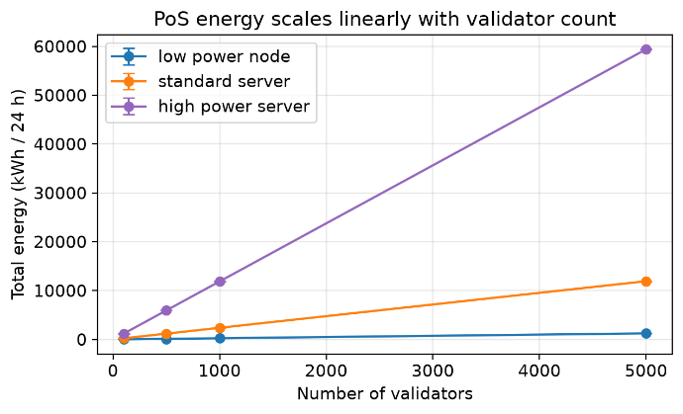
For Proof-of-Stake, the validator-count model yields far smaller totals: a 1000-validator network of standard 100 W servers consumes about 2387 kWh over 24 h, scaling linearly with validator count (239 kWh at 100 validators). The PoW/PoS energy ratio is on the order of 196,846×, consistent with the order-of-magnitude reductions reported in the literature [16], [19] and the ~99.95% reduction at Ethereum’s Merge [21]. As an analytical sanity check, fixed-power configurations reproduce the closed-form $E=P·T$ exactly (maximum relative error 0.00e+00). As shown in Figure 2, PoS total energy scales linearly with the number of validators across the low-power, standard-server, and high-power hardware classes.
Figure 2. PoS total energy vs validator count for three hardware classes (30 seeds, 95% CI).
Communication energy was also analysed. At peer degree 8 with 1 MB blocks it grows from 15.0 kWh/day at 1 tx/s to 1455 kWh/day at 100 tx/s. Relative to PoW consensus energy this is negligible (ratio ~3e-06), but at high throughput it becomes comparable to PoS consensus energy, so communication energy matters mainly in PoS and high-throughput settings. Figure 3 compares computational (consensus) energy with communication energy under the evaluated scenarios on logarithmic axes.

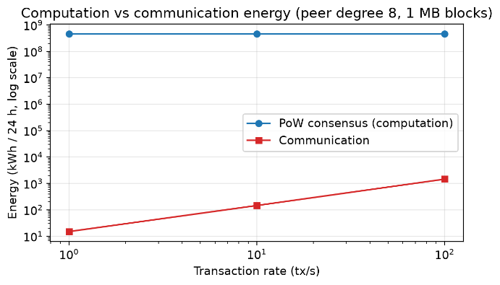
Figure 3. Computation vs communication energy (log-log; peer degree 8, 1 MB blocks, 30 seeds).
Overall, these results reinforce that, in the economically driven regime, aggregate Proof-of-Work energy is bounded by mining economics - responding to coin price, block reward, and electricity price rather than to the raw number of miners - while per-miner energy falls as 1/N. Skewed hashpower distributions (not shown) redistribute this bounded budget toward dominant miners without increasing the network total [8].

B. Carbon Footprint Analysis
Because emissions are computed directly from electricity use via the emission-factor relation C = E·γ (Eq. 9), the carbon results inherit the energy behaviour: Proof-of-Work emissions are governed by mining economics and Proof-of-Stake emissions by validator count. For a given energy level, the dominant driver of carbon is the grid emission factor.

Varying the grid emission factor shows that geography dominates carbon outcomes for a given energy level. For the PoW reference, daily emissions range from 23,374 t at γ = 0.05 to 383,332 t at γ = 0.82 (about a 16× spread from grid choice alone), while the PoS reference spans only 119-1947 kg. A single fixed emission factor is therefore insufficient. Figure 4 reports the carbon-emission sensitivity under low, average, and high electricity emission factors γ.
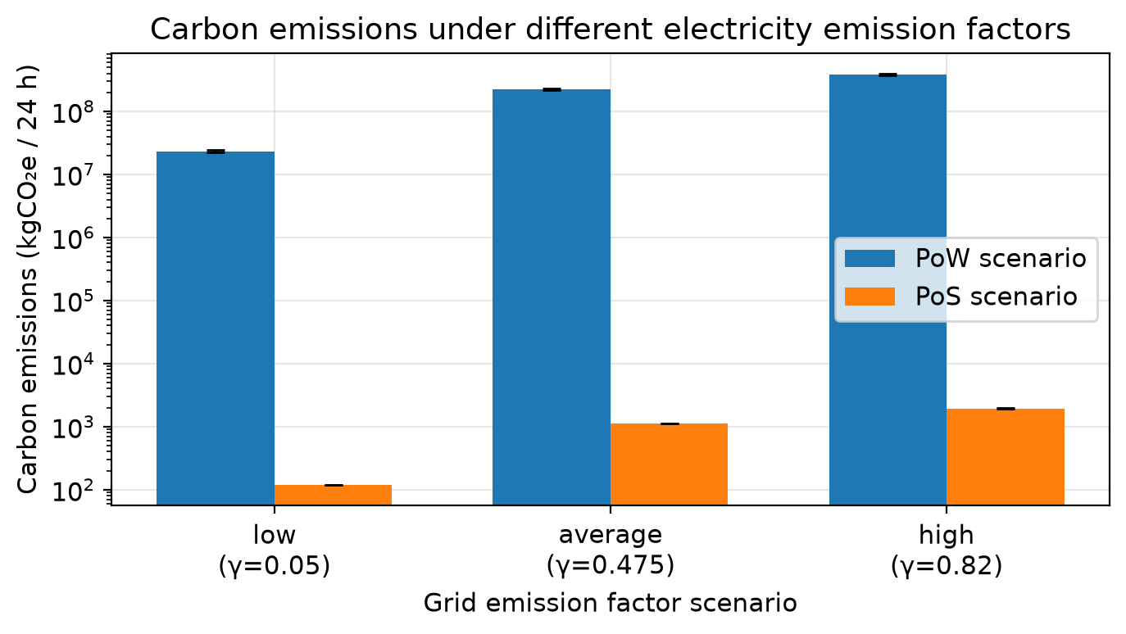
By normalizing emissions at the block and transaction levels, the simulator enables direct comparison between protocol configurations, a feature that is often missing in retrospective carbon analyses [3], [15]. These metrics provide actionable insights into how protocol parameters and workloads influence environmental impact.

C. Performance and Sustainability Trade-offs
When performance metrics are analyzed alongside sustainability indicators, a clear trade-off emerges between throughput and environmental efficiency. Scenarios optimized for higher throughput exhibit increased energy consumption and carbon emissions, reinforcing concerns raised in prior work regarding the environmental cost of scaling blockchain systems [2], [17]. The integrated results demonstrate the value of a unified simulation framework that captures performance, energy, and carbon metrics simultaneously.
Overall, the results confirm that the proposed extensions enable BlockSim to serve as an effective tool for sustainability-aware blockchain evaluation, bridging the gap between performance analysis and environmental impact assessment.

Discussion and Threats to Validity

A. Discussion
The findings underscore the necessity of incorporating sustainability metrics directly into blockchain simulation frameworks. This study's extension of BlockSim, incorporating energy consumption and carbon footprint modeling, facilitates a unified assessment of performance, energy efficiency, and environmental impact within a single experimental setting. This integrated approach is crucial, given that previous research has demonstrated that enhancements in throughput and scalability frequently entail increased energy consumption and emissions [4], [17].
A key methodological observation is that Proof-of-Work energy and CO₂ outcomes depend critically on how mining power is modelled. A naïve fixed-power baseline that assigns a constant wattage to every miner makes total network power scale directly with miner count; this is the intuitive but misleading picture that motivated the economic model, because it conflates a growing mining industry (more miners ⇒ more total watts) with the economically constrained reality in which rational miners collectively spend only up to the fiat value of the block reward. The economic Proof-of-Work model adopted here instead makes total network energy invariant to miner count and driven by coin price, reward, and electricity price (Section D; Figure 1). We therefore report PoW energy through the economic model and treat the fixed-power, per-miner picture only as a conceptual contrast, not as a network-level estimate.
The results corroborate that energy and carbon metrics exhibit predictable scaling in relation to the economic and hardware drivers of each consensus mechanism and to workload intensity, consistent with empirical data derived from actual blockchain systems [3]. Furthermore, the capacity to normalize emissions on a per-block and per-transaction basis offers a valuable framework for comparing protocol configurations, thereby mitigating a constraint observed in numerous retrospective sustainability analyses that depend on broad, system-wide estimations [15]. Consequently, this strengthens the efficacy of simulation-based methodologies for investigating "what-if" scenarios during the design phase of blockchain protocols.
Figure 4. Carbon emissions under low/average/high grid emission factors (log axis; 30 seeds, 95% CI).
Incorporating energy and carbon accounting into BlockSim, from a methodological standpoint, preserves its fundamental modularity and abstraction advantages, simultaneously expanding its applicability to sustainability-oriented research. Consequently, the simulator becomes an essential tool for evaluating innovative consensus mechanisms and optimization approaches aimed at reducing environmental effects, thus augmenting current performance-centered studies [16].

B. Threats to Validity
Several threats to validity should be considered when interpreting the results. Modeling assumptions represent a primary internal validity concern. Energy consumption is approximated via mining-interval accounting and configurable coefficients/power assumptions rather than hardware-specific measurements, which may not fully capture the diversity of real-world mining and validation infrastructures. However, this abstraction is consistent with prior simulation-based energy studies and is necessary for scalable experimentation [9].
Although the analysis evaluates three discrete emission-factor scenarios (low, average, and high grids), these values do not capture the full temporal and geographical variability of electricity-grid carbon intensity, nor do they represent real-time or marginal grid emissions. The resulting carbon estimates should therefore be interpreted as scenario-based comparisons rather than location-specific operational measurements.
Construct validity is, in the final analysis, shaped by the degree of abstraction present within BlockSim. Discrete-event simulation, although capable of accurately modeling system-level behavior, is inherently limited in its capacity to fully capture low-level hardware optimizations or the complex nuances of real-world network dynamics. Despite these constraints, this degree of abstraction is a commonly accepted compromise within blockchain research, facilitating systematic comparisons across a variety of protocol designs [4], [16].
Additional limitations follow from the revised scope. First, the framework is a scenario-based explorer; the absolute energy and carbon values are model outputs for the chosen assumptions and are not intended to predict the exact real-world consumption of any specific cryptocurrency.
Second, PoW energy is sensitive to coin price, block reward, transaction fees, electricity price, mining efficiency, and difficulty/hashrate dynamics, and to the spend ratio κ; PoS energy is sensitive to validator count, node hardware, uptime, redundancy, and communication overhead.
Third, carbon depends strongly on region- and time-specific grid mixes; the γ scenarios bracket but do not resolve this variability. Finally, the PoW results represent scenario configurations rather than any specific cryptocurrency, and communication energy, while small under PoW, can matter in PoS and high-throughput scenarios.

Conclusion and Future Work
This paper presented an extension of the BlockSim simulation framework that integrates energy consumption and carbon footprint modeling into its discrete-event architecture. By embedding mining-interval energy accounting and deriving carbon emissions using established emission-factor–based formulations, the proposed approach enables unified evaluation of blockchain systems in terms of performance, energy efficiency, and environmental impact. Unlike retrospective measurement studies, the extended simulator supports controlled “what-if” experimentation, allowing protocol designers to analyze sustainability implications during the early design phase.
The experimental results demonstrate that energy usage and carbon emissions scale predictably with the economic and hardware drivers of each consensus mechanism, workload intensity, and grid carbon intensity, in line with prior empirical and analytical studies of blockchain systems [16], [2]. Furthermore, the capacity to normalize environmental impact on a per-block and per-transaction basis offers a valuable foundation for evaluating different protocol designs, thereby overcoming a significant constraint observed in numerous current blockchain simulation tools [4]. These results corroborate that augmenting BlockSim maintains its advantages in terms of flexibility and abstraction, while simultaneously expanding its utility for research centered on sustainability.
Several avenues for future research are suggested by the findings of this study. Initially, the energy model's accuracy could be enhanced by integrating hardware-specific parameters obtained from empirical data on mining rigs, validator nodes, and networking infrastructure, thereby improving realism while preserving scalability. Furthermore, subsequent developments could incorporate dynamic and region-specific carbon intensity models, allowing for the simulation of diverse energy compositions and renewable energy adoption levels, which have demonstrably influenced blockchain carbon footprints [3]. Furthermore, the framework's scope could be broadened to incorporate emerging low-energy consensus mechanisms, thus facilitating direct comparisons between traditional Proof of Work and alternative, sustainability-oriented designs [12]. Ultimately, integrating the improved BlockSim with more advanced network simulators or real-world data offers a potentially effective approach to reconcile the gap between theoretical modeling and practical blockchain applications.
Overall, this work contributes a practical and extensible foundation for sustainability-aware blockchain simulation, supporting future research on environmentally responsible decentralized systems.

Declarations

Ethics approval: Not applicable. This study is based solely on simulation and does not involve human participants, human data, human tissue, or animals; therefore, ethics committee/IRB approval was not required.

Consent to participate: Not applicable.

Consent for publication: Not applicable. This manuscript does not contain any individual person’s data in any form (including identifiable details, images, or videos).

Funding: No funding was received for conducting this study.

References
- S. Nakamoto, “Bitcoin: A Peer-to-Peer Electronic Cash System,” 2008.
- A. de Vries, “Bitcoin’s Growing Energy Problem,” Joule, vol. 2, no. 5, pp. 801–805, 2018.
https://doi.org/10.1016/j.joule.2018.04.016
- C. Stoll, L. Klaaßen, and U. Gallersdörfer, “The Carbon Footprint of Bitcoin,” Nature Climate Change, vol. 9, no. 10, pp. 798–800, 2019.
https://doi.org/10.1016/j.joule.2019.05.012
- M. Alharby and A. van Moorsel, “BlockSim: A Simulation Framework for Blockchain Systems,” Frontiers in Blockchain, vol. 3, Art. no. 28, 2020.
https://dl.acm.org/doi/10.1145/3308897.3308956
- Singh, Brijendra Pratap, and Manoj Madhava Gore. "Cyber-physical energy system simulation tool: framework for network co-simulation, GridLAB-D and ns-3." International Journal of Simulation and Process Modelling 18, no. 4 (2022): 314-328.
https://doi.org/10.1504/IJSPM.2022.128289
- Y. Aoki, K. Otsuki, T. Kaneko, R. Banno, and K. Shudo, “SimBlock: A Blockchain Network Simulator,” IEEE INFOCOM Workshops, pp. 325–329, 2019.
https://doi.org/10.1109/INFCOMW.2019.8845253
- J. B. Schwartz et al., “JABS: A Framework for Blockchain Consensus Evaluation,” IEEE Transactions on Network and Service Management, vol. 17, no. 2, pp. 1274–1287, 2020.
https://doi.org/10.1109/TNSE.2023.3282916
- C. Gervais et al., “On the Security and Performance of Proof of Work Blockchains,” ACM CCS, pp. 3–16, 2016.
https://doi.org/10.1145/2976749.2978341
- D. R. Figueiredo et al., “An Energy Framework for the ns-3 Network Simulator (ns-3),” Simulation Modelling Practice and Theory, vol. 29, pp. 1–15, 2012.
https://doi.org/10.4108/icst.simutools.2011.245534
- Lund, Eirik Harald, Letizia Jaccheri, Jingyue Li, Orges Cico, and Xiaoying Bai. "Blockchain and sustainability: A systematic mapping study." In 2019 IEEE/ACM 2nd International Workshop on Emerging Trends in Software Engineering for Blockchain (WETSEB), pp. 16-23. IEEE, 2019.
https://doi.org/10.1109/WETSEB.2019.00009 .
- L. M. Feeney and M. Nilsson, “Investigating the Energy Consumption of a Wireless Network Interface in an Ad Hoc Networking Environment,” IEEE INFOCOM, pp. 1548–1557, 2001.
https://doi.org/10.1109/INFCOM.2001.916651
- Y. Xiao, N. Zhang, W. Lou, and Y. T. Hou, “A Survey of Distributed Consensus Protocols for Blockchain Networks,” IEEE Communications Surveys & Tutorials, vol. 22, no. 2, pp. 1432–1465, 2020.
https://doi.org/10.1109/COMST.2020.2969706
- G. P. Peters, R. M. Andrew, T. Boden, J. G. Canadell, and P. Friedlingstein, “The Challenge to Keep Global Warming Below 2 °C,” Nature Climate Change, vol. 3, no. 1, pp. 4–6, 2013.
https://doi.org/10.1038/nclimate1783
- IPCC, “2019 Refinement to the 2006 IPCC Guidelines for National Greenhouse Gas Inventories,” Intergovernmental Panel on Climate Change, 2019.
Website:https://www.ipcc.ch/report/2019-refinement-to-the-2006-ipcc-guidelines-for-national-greenhouse-gas-inventories/
Last access 21/01/2026.
- A. de Vries, “Renewable Energy Will Not Solve Bitcoin’s Sustainability Problem,” Joule, vol. 3, no. 4, pp. 893–898, 2019.
https://doi.org/10.1016/j.joule.2019.02.007
- M. Sedlmeir, H. U. Buhl, G. Fridgen, and R. Keller, “The Energy Consumption of Blockchain Technology: Beyond Myth,” Business & Information Systems Engineering, vol. 62, no. 6, pp. 599–608, 2020.
https://doi.org/10.1007/s12599-020-00656-x
- K. Croman et al., “On Scaling Decentralized Blockchains,” Financial Cryptography and Data Security, pp. 106–125, 2016.
https://doi.org/10.1007/978-3-662-53357-4_8 .
- R. S. Rasheed, “BlockSim (modified implementation),” GitHub repository, accessed Feb. 2, 2026
https://github.com/raedrasheed/BlockSim
- M. Platt, J. Sedlmeir, D. Platt, J. Xu, P. Tasca, N. Vadgama, and J. I. Ibanez, “The Energy Footprint of Blockchain Consensus Mechanisms Beyond Proof-of-Work,” IEEE 21st Int. Conf. on Software Quality, Reliability and Security Companion (QRS-C), 2021, pp. 1135–1144.
https://doi.org/10.1109/QRS-C55045.2021.00168
- M. Platt, D. Platt, and P. McBurney, “Sybil attack vulnerability trilemma,” International Journal of Parallel, Emergent and Distributed Systems, vol. 39, no. 4, pp. 446–460, 2024.
https://doi.org/10.1080/17445760.2024.2352740
- A. de Vries, “Cryptocurrencies on the Road to Sustainability: Ethereum Paving the Way for Bitcoin,” Patterns, vol. 4, no. 1, art. 100633, 2023.
https://doi.org/10.1016/j.patter.2022.100633

Corresponding author: Raed S. Rasheed Note: No funding was received. Raed S. Rasheed will pay the total of APC.

