Extending BlockSim with Consensus-Aware Energy and Carbon Footprint Modeling for Sustainable Blockchain Evaluation
Raed S. Rasheed
Faculty of Engineering, Islamic University of Gaza, Gaza, Palestine
rrasheed@iugaza.edu.ps
Aiman A. AbuSamra
Faculty of Engineering, Islamic University of Gaza, Gaza, Palestine
aasamra@iugaza.edu.ps
Abstract — Discrete-event blockchain simulators such as BlockSim capture network, consensus, and incentive behaviour, but they do not natively model energy use or carbon emissions, limiting their usefulness for sustainability studies. This paper extends BlockSim with consensus-aware energy and carbon accounting that is integrated with its event-driven execution. A central correction over our earlier design is that the two dominant consensus families are now modelled as fundamentally different energy processes. Proof-of-Work (PoW) energy is modelled as an economically driven quantity: rational miners spend on electricity up to the fiat value of the expected block reward, so the expected reward and the cryptocurrency price are now explicit input variables, alongside electricity price, miner efficiency, and difficulty/hashrate hooks. Proof-of-Stake (PoS) energy is modelled as a validator-count-driven quantity determined by the number of validators, their hardware power, uptime, and communication overhead. A configurable emission factor converts energy to CO2 and is varied experimentally across low-, average-, and high-carbon grids. We also instrument and analyse communication energy, which the previous version defined but never used. Each scenario is run with 30 random seeds and reported with mean, standard deviation, and 95% confidence intervals. We do not claim real-world validation; instead the framework is evaluated through controlled, scenario-based simulations and checked against an analytical E = P x T baseline and the order-of-magnitude PoW/PoS gap reported in the literature. The tool is positioned as a scenario-based explorer for protocol designers, not as a precise real-world energy estimator.
Keywords: Blockchain Simulation, BlockSim, Proof of Work, Proof of Stake, Energy Modeling, Carbon Footprint, Consensus Mechanisms, Sustainability.

1. Introduction
Blockchain technology underpins a growing range of decentralized applications, but the energy demand and carbon emissions of some consensus mechanisms have become a first-order concern. Permissionless Proof-of-Work (PoW) networks in particular have been estimated to consume electricity on the scale of medium-sized countries, with correspondingly large carbon footprints [1], [2], [3]. As protocol designers increasingly weigh sustainability against performance and security, evaluation tools must reason about energy and carbon alongside throughput, latency, and fork behaviour.
A crucial point, emphasised by recent economic analyses, is that PoW energy consumption is not primarily a function of how many machines participate. It is an economically driven quantity. A rational miner invests in electricity up to the fiat value it can expect to earn; therefore the total energy a PoW network draws is governed by the block subsidy, transaction fees, the cryptocurrency price, the electricity price, hardware efficiency, and the difficulty/hashrate equilibrium, rather than by the raw number of miners [4], [5]. Adding more miners mainly redistributes a budget fixed by these economic incentives; it does not, by itself, increase total energy use. Any credible PoW energy model must therefore take the expected mining reward and the coin price as explicit inputs.
Proof-of-Stake (PoS) secures the network through stake rather than external computational work, and its energy profile is qualitatively different: it is dominated by the number of validators kept online and the idle/active power of their hardware, and is essentially independent of coin price [6], [7]. Importantly, Ethereum transitioned from PoW to PoS at The Merge in September 2022, reducing its consensus energy by roughly 99.95% [8]. Treating present Ethereum as a PoW system, as our earlier version implicitly did, is therefore incorrect, and we correct this throughout.
This paper extends BlockSim [9] with consensus-aware energy and carbon accounting. The contributions are:
- A Proof-of-Work economic energy model in which the expected block reward and cryptocurrency price are explicit inputs, with electricity price, miner efficiency, difficulty, and hashrate hooks (Section 4.1).
- A Proof-of-Stake validator energy model driven by validator count, hardware power, uptime, and communication overhead (Section 4.2).
- An instrumented communication energy model and its analysis as a function of transaction rate, block size, and peer connectivity (Sections 4.3, 7.5).
- A carbon model with experimental emission-factor (gamma) sensitivity across low-, average-, and high-carbon grids (Sections 4.4, 7.4).
- An expanded experimental campaign with 30 seeds per scenario reported with mean, standard deviation, and 95% confidence intervals, plus an analytical E = P x T sanity check and a literature-order PoW/PoS comparison (Sections 6, 7.6).
We explicitly position the framework as a scenario-based explorer rather than a precise real-world estimator, and we do not claim it is validated against field measurements.

2. Background and Related Work

2.1 Blockchain Simulators
Simulation enables controlled, reproducible study of networking, consensus, and incentive interactions without the cost and risk of real deployments. SimBlock focuses on block propagation and fork behaviour in large peer-to-peer networks [10]; JABS supports diverse consensus mechanisms at scale [11]; and ns-3-based approaches offer high-fidelity network modelling at higher integration cost [12]. BlockSim, by Alharby and van Moorsel, uses a layered discrete-event design separating network, consensus, and incentive layers, and has been widely used to study throughput, latency, and stale-block rates [9]. None of these simulators natively models energy or carbon.

2.2 Energy and Carbon Studies of Blockchains
Empirical and analytical studies have quantified Bitcoin's electricity use and carbon footprint [1], [2], [3], and general-purpose simulators such as ns-3 include packet-level energy frameworks [13], [14]. These blockchain energy analyses are typically retrospective and external to the simulator, and rarely support what-if exploration of protocol parameters. Sedlmeir et al. dispel the myth that blockchain energy is a fixed technological constant, showing instead that PoW energy is tied to mining rewards and the economics of hardware, while non-PoW mechanisms consume orders of magnitude less [4]. Platt et al. quantify the energy footprint of consensus mechanisms beyond PoW and show that validator-based mechanisms are dominated by node count and hardware rather than by computational competition [6].

2.3 Energy Consumption, Permissionlessness, and Sybil Resistance
The energy gap between PoW and PoS is not incidental; it is tied to how each mechanism resists Sybil attacks in a permissionless setting. PoW achieves Sybil resistance by tying influence to an external, costly resource, namely computation and therefore electricity: creating many identities is useless unless each is backed by real hash power. PoS instead ties influence to internal economic stake and validator participation. Consequently PoW is not 'free': its permissionlessness is purchased with continuous resource expenditure, which is precisely why its energy use is large and price-coupled [4], [5]. PoS removes most computational waste but substitutes different trust and economic assumptions, including capital lock-up and stake-distribution concerns [6], [7].
Platt, Platt, and McBurney formalise these tensions as a Sybil-attack vulnerability trilemma, showing that permissionlessness, Sybil resistance, and freeness (no costly resource expenditure) cannot be achieved simultaneously [15]. PoW resolves the trilemma by sacrificing freeness (spending energy); PoS relaxes the pure permissionlessness/cost trade-off differently. This framing motivates modelling PoW and PoS as distinct energy processes rather than as a single generic 'consensus energy' term, and underpins the methodology in Section 4. For Ethereum specifically, De Vries documents how its move to PoS dramatically reduced energy use and argues it illustrates a sustainability path the wider ecosystem could follow [8].

3. Overview of BlockSim
BlockSim is a Python discrete-event simulator that models a blockchain as three layers: a network layer (propagation delays, peer connectivity), a consensus layer (block creation, validation, fork resolution), and an incentive layer (rewards and penalties) [9]. System dynamics evolve through scheduled events (block creation, message dissemination, chain updates) processed from a time-ordered queue. Its modularity lets researchers extend node, transaction, and consensus models without rewriting the engine, which makes it well suited to what-if and comparative studies. The original framework targets performance, security, and incentive metrics and does not model environmental cost; our extension adds that capability while preserving the layered architecture and remaining backward compatible with existing models (Section 5).

4. Consensus-Aware Energy Consumption Models
We replace the previous single generic energy model with four explicit components: a Proof-of-Work economic energy model (4.1), a Proof-of-Stake validator energy model (4.2), a communication energy model (4.3), and a carbon footprint model (4.4).

4.1 Proof-of-Work Economic Energy Model
The defining property of PoW energy is economic: miners convert electricity into security only insofar as it is profitable. We start from the expected per-block reward expressed in fiat currency at time t:
R_t = (B_t + F_t) x P_t (1)
where B_t is the block subsidy in native coin, F_t is the expected transaction fees per block in native coin, and P_t is the coin price in fiat. A rational, competitive mining market spends on electricity a fraction kappa in [0,1] of this reward, giving an economic energy budget per block:
E_budget,t = kappa x R_t / C_elec,t (2)
where C_elec,t is the electricity price in fiat per kWh. Equation (2) is the core correction requested in review: total PoW energy rises with coin price and reward and falls with electricity price, independent of the raw miner count. When hardware-level parameters are available, a technical bound is also computed from the expected hashes per block and the hardware efficiency:
H_block = D x 2^32 ; E_technical,t = H_block x epsilon_hash / 3.6e6 (3)
where D is network difficulty, epsilon_hash is energy per hash (derived from J/TH), and 3.6e6 converts Joules to kWh. The network per-block energy and the miner-level allocation are then:
E_PoW,t = min(E_technical,t, E_budget,t) ; E_i,t = s_i,t x E_PoW,t (4)
where s_i,t is miner i's share of network hashpower. When only economic data are available, E_budget,t is used directly as a scenario-based upper bound. The implementation exposes difficulty/hashrate hooks and an optional difficulty-retargeting routine (difficulty is adjusted so the expected block interval matches a target), allowing difficulty dynamics to be explored. Per Eq. (2)-(4), PoW energy is driven mainly by economic incentives and mining efficiency; the number of miners affects distribution (Eq. 4) but not the network total.

4.2 Proof-of-Stake Validator Energy Model
PoS does not expend external computational work, so its energy is the aggregate power of the validator machines kept online over the horizon. Following Platt et al. [6], for V validators:
E_PoS = sum_v ( P_v x T x u_v / 1000 ) + E_comm (5)
where P_v is per-validator hardware power in watts, T is the horizon in hours, u_v in [0,1] is validator uptime/utilization, the factor 1000 converts Wh to kWh, and E_comm is communication energy (Section 4.3). The model supports heterogeneous validators (per-validator P_v and u_v) and is, by construction, independent of coin price. Scenarios vary the number of validators, the hardware class (low-power node, standard server, high-power server), uptime, and communication overhead.

4.3 Communication Energy Model
Communication energy accounts for transmitting and receiving block and transaction messages. With explicit per-message and optional per-byte costs:
E_comm = sum_msg ( e_fixed + e_byte x size_bytes ) [Joules] (6)
The model maintains separate counters for transmitted and received block messages and transmitted and received transaction messages, plus byte volumes. For a gossip/flooding overlay with N nodes and peer degree d, each broadcast item produces approximately N x d directed transmissions (each a transmit and a matching receive), which the model accounts for when an experiment supplies block/transaction counts, node count, and peer degree. This makes communication energy a first-class, reported quantity rather than an unused definition.

4.4 Carbon Footprint Model
Carbon emissions are obtained from energy via a grid emission factor gamma (kgCO2e/kWh):
C = E x gamma ; C_block = C / N_b ; C_tx = C / N_tx (7)
where N_b and N_tx are the numbers of blocks and transactions. Because gamma captures the carbon intensity of the underlying grid, the same energy yields very different emissions across regions and times. We therefore treat gamma as an experimental variable with three named scenarios: a low-carbon grid (gamma = 0.05 kgCO2e/kWh), a global-average grid (gamma = 0.475), and a high-carbon grid (gamma = 0.82).

5. Implementation in BlockSim
The models are implemented in a new package, Models/Energy, exposing four classes: PowEconomicEnergyModel, PosValidatorEnergyModel, CommunicationEnergyModel, and CarbonFootprintModel. Each maps directly onto the equations above and is configurable through named parameters. PoW inputs include coin_price, block_subsidy, avg_tx_fees, electricity_price_per_kwh, electricity_spend_ratio_kappa, mining_efficiency_j_per_th (or per hash), difficulty, network_hashrate, miner hashpower shares, and an optional difficulty-retargeting flag. PoS inputs include validator_count, validator_power_watts, uptime_ratio, simulation_time_hours, and a validator message rate. Carbon inputs are emission_factor_gamma with named low/average/high scenarios; communication inputs are per-message and per-byte transmit/receive energies with message counters. The package is decoupled from the event loop so it can be unit-tested in isolation, driven by the experiment scripts, or embedded as accounting hooks; existing BlockSim models continue to run unchanged (backward compatible). The code, experiment scripts, unit tests, and figure pipeline are released in the project repository [16].

6. Experimental Setup
We evaluate the framework through controlled, scenario-based experiments spanning PoW miner scaling, PoW economic sensitivity, PoS validator scaling, carbon emission-factor sensitivity, and communication energy. The simulation horizon is 24 hours (86,400 s). Each scenario is executed with 30 random seeds (seeds 20260101..20260130, generated as base + i), and we report the mean, sample standard deviation, and 95% confidence interval (Student t) of each metric. Across seeds we vary the quantities a designer cannot fix exactly: for PoW, the realised number of blocks in the horizon (Poisson around horizon/interval), transaction fees, a small coin-price jitter, and the hashpower-share distribution (Dirichlet); for PoS, per-validator power and uptime jitter. This yields genuine scenario uncertainty rather than noise added to a closed-form value. Table 1 summarises the reproducibility parameters.
Table 1. Reproducibility and parameter summary.
Parameter | Value
Simulation horizon | 24 h (86,400 s)
Random seeds per scenario | 30
Seed generation | base + i, base = 20260101 (20260101..20260130)
PoW miner counts | 50, 100, 500, 1000
PoW block interval | 600 s (Bitcoin-like)
PoW block subsidy / fees | 3.125 BTC / 0.30 BTC (base)
PoW coin price (low/med/high) | 20,000 / 60,000 / 100,000 USD
PoW electricity price | 0.03 / 0.05 / 0.10 USD/kWh
PoW spend ratio kappa | 0.80
PoW miner efficiency | 21.5 J/TH (ASIC class)
PoS validator counts | 100, 500, 1000, 5000
PoS hardware power | 10 / 100 / 500 W (node/server/high)
PoS uptime | 0.90 / 0.99 / 1.00
Emission factor gamma | 0.05 / 0.475 / 0.82 kgCO2e/kWh
Communication peer degree | 4, 8, 16
Communication tx rate | 1, 10, 100 tx/s

7. Results and Analysis

7.1 Proof-of-Work Energy vs Number of Miners
Figure 1 and Table 2 report PoW network energy and mean per-miner energy as the miner population grows from 50 to 1000, holding the economics fixed. The network total is essentially invariant at 467.5 GWh over 24 h (95% CI +/- 17.1 GWh), because it is set by the economic budget of Eq. (2), not by the number of participants. What changes is the distribution: mean per-miner energy falls from 9,349.6 MWh at 50 miners to 467.5 MWh at 1000 miners, i.e. approximately 1/N. This directly addresses the concern that energy should not be presented as a simple function of miner count.
Table 2. PoW network and per-miner energy vs miner count (24 h, 30 seeds). Network energy is invariant; per-miner energy scales ~1/N.
Miners | Network energy (GWh) | 95% CI (GWh) | Mean per-miner (MWh)
50 | 467.5 | 17.1 | 9,349.6
100 | 467.5 | 17.1 | 4,674.8
500 | 467.5 | 17.1 | 935.0
1000 | 467.5 | 17.1 | 467.5

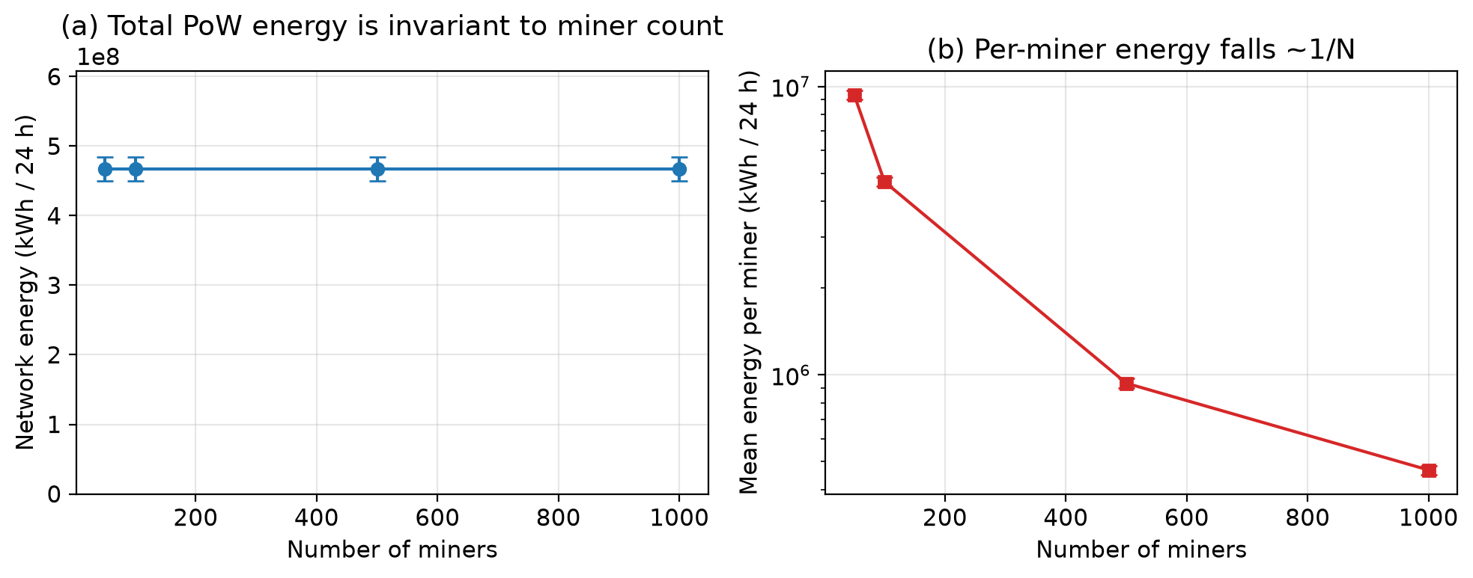
Figure 1. PoW energy vs number of miners (30 seeds, 95% CI error bars). (a) Total network energy is invariant to miner count; (b) per-miner energy falls approximately as 1/N (log axis).

7.2 Proof-of-Work Energy vs Price, Reward, and Electricity Cost
Figure 2 and Table 3 show how PoW energy responds to the economic inputs at a fixed 500-miner network. Energy scales linearly with coin price, rising from 155.8 GWh at 20,000 USD to 779.1 GWh at 100,000 USD. It scales linearly with the block subsidy and inversely with electricity price, exactly as the economic argument predicts. These experiments make the expected mining reward and cryptocurrency price concrete, first-class drivers of energy use.
Table 3. PoW network energy sensitivity to economic inputs (500 miners, 24 h, 30 seeds).
Sweep | Level | Value | Network energy (GWh) | 95% CI (GWh)
Coin price (USD) | low | 20,000 | 155.8 | 5.7
Coin price (USD) | medium | 60,000 | 467.5 | 17.1
Coin price (USD) | high | 100,000 | 779.1 | 28.6
Electricity (USD/kWh) | cheap | 0.03 | 779.1 | 28.6
Electricity (USD/kWh) | expensive | 0.10 | 233.7 | 8.6
Block subsidy (BTC) | low | 1.5625 | 254.5 | 10.8
Block subsidy (BTC) | high | 6.25 | 893.4 | 31.0

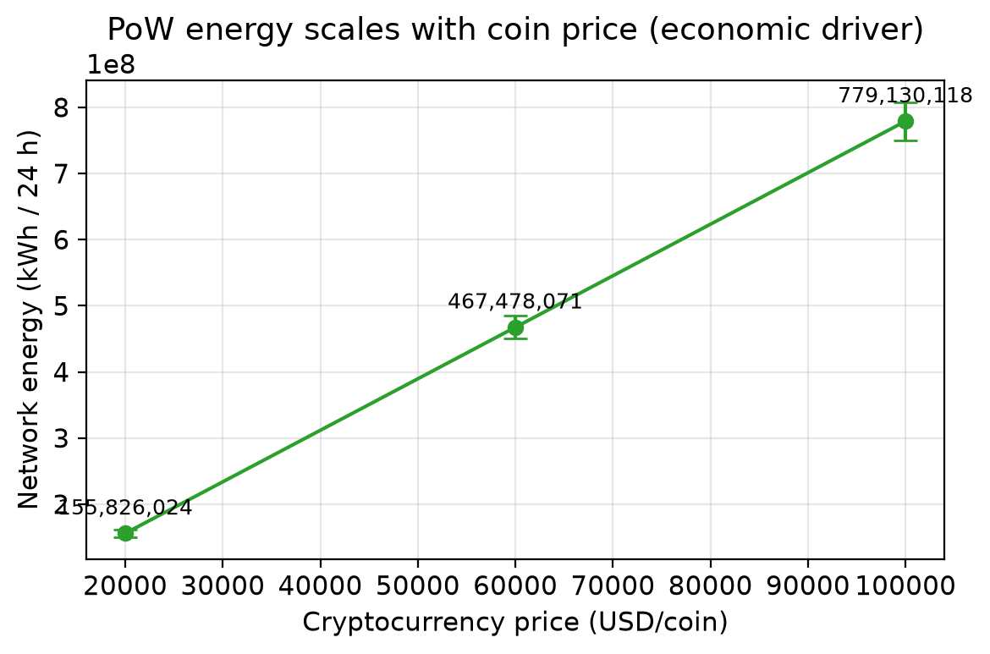
Figure 2. PoW network energy vs cryptocurrency price (500 miners, 30 seeds, 95% CI). Energy scales linearly with coin price, the dominant economic driver.

7.3 Proof-of-Stake Energy vs Validator Count
Figure 3 and Table 4 report PoS energy as validator count grows from 100 to 5000 for three hardware classes. Unlike PoW, PoS energy scales linearly with validator count and per-node power, and is independent of coin price. For a standard 100 W server, energy rises from 238.8 kWh at 100 validators to 11,930.3 kWh at 5000 validators over 24 h. Even the largest PoS configuration consumes far less than any PoW configuration, consistent with the literature (Section 7.6).
Table 4. PoS total energy (kWh / 24 h) vs validator count by hardware class (30 seeds; 95% CI < 0.3% of mean, omitted for space).
Validators | Low-power node (10 W) | Standard server (100 W) | High-power server (500 W)
100 | 25.0 | 238.8 | 1,189.2
500 | 124.7 | 1,193.5 | 5,943.5
1000 | 249.5 | 2,386.8 | 11,886.2
5000 | 1,247.0 | 11,930.3 | 59,411.5

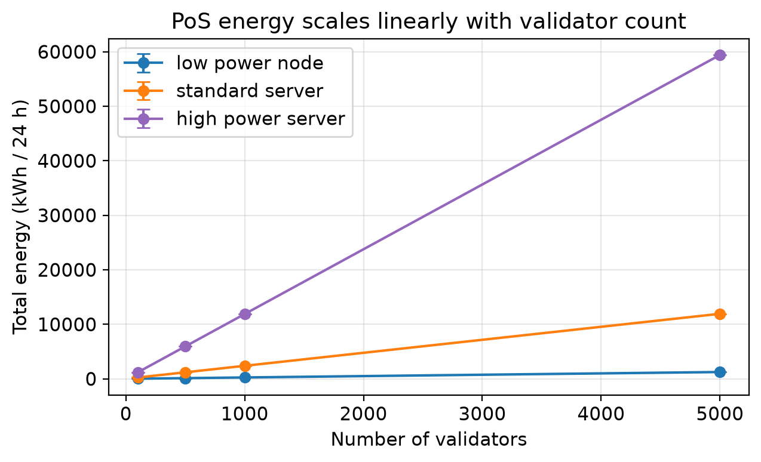
Figure 3. PoS total energy vs validator count for three hardware classes (30 seeds, 95% CI error bars). Energy scales linearly with validator count and hardware power.

7.4 Carbon Emissions vs Emission Factor (gamma)
Figure 4 and Table 5 vary the grid emission factor across low, average, and high scenarios. Because C = E x gamma, the same energy yields very different carbon: for the PoW reference, daily emissions range from 23,374 t at gamma = 0.05 to 383,332 t at gamma = 0.82 (a 16.4x spread from grid choice alone). The PoS reference spans only 119-1947 kg over the same gamma range. Geography and grid mix are therefore first-order factors, and a single fixed gamma (as in our previous version) is insufficient.
Table 5. Carbon emissions under three grid emission factors (24 h, 30 seeds). Per-block and per-transaction values use the per-family block/throughput assumptions in the reproducibility appendix.
Family | gamma | Total CO2 (kg) | Per block (kg) | Per tx (g)
PoW (BTC-like) | 0.05 | 23,373,904 | 164,598 | 82,299
PoW (BTC-like) | 0.475 | 222,052,084 | 1,563,682 | 781,841
PoW (BTC-like) | 0.82 | 383,332,018 | 2,699,408 | 1,349,704
PoS (ETH-like) | 0.05 | 118.7 | 0.0165 | 0.0082
PoS (ETH-like) | 0.475 | 1,128.0 | 0.1567 | 0.0783
PoS (ETH-like) | 0.82 | 1,947.4 | 0.2705 | 0.1352

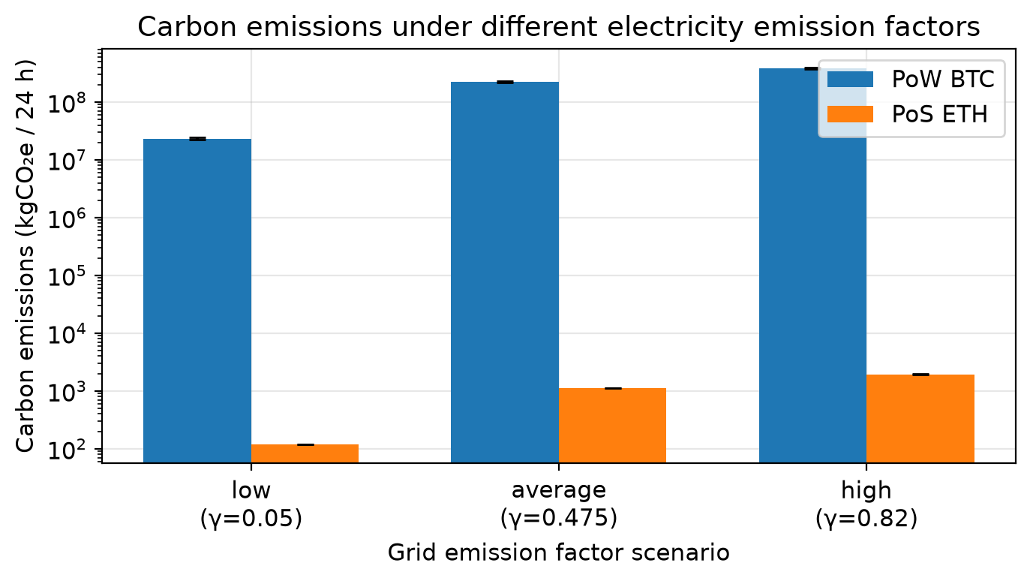
Figure 4. Carbon emissions under different electricity emission factors (log axis, 30 seeds, 95% CI). The same energy maps to widely different carbon depending on grid intensity.

7.5 Communication vs Computation Energy
Figure 5 and Table 6 analyse communication energy as a function of transaction rate, block size, and peer degree, and compare it with PoW consensus energy. At peer degree 8 and 1 MB blocks, communication energy grows from 15.0 kWh/day at 1 tx/s to 1,455.2 kWh/day at 100 tx/s. Relative to PoW consensus energy (~467 GWh/day) this is negligible (a ratio of about 3.1e-06). However, the same 1,455 kWh/day at 100 tx/s is of the same order as the PoS consensus energy of a 1000-validator standard-server network (2,387 kWh/day). Communication energy is therefore safely ignorable for PoW but can be a material fraction of total energy in PoS and high-throughput settings, which is exactly why it must be modelled explicitly.
Table 6. Communication energy vs PoW computation energy (peer degree 8, 1 MB blocks, 30 seeds).
Tx rate (tx/s) | Comm energy (kWh/day) | Total messages | PoW compute (GWh/day) | Comm/compute ratio
1 | 15.0 | 6.92e+08 | 467.5 | 3.25e-08
10 | 146.0 | 6.91e+09 | 467.5 | 3.15e-07
100 | 1,455.2 | 6.91e+10 | 467.5 | 3.14e-06

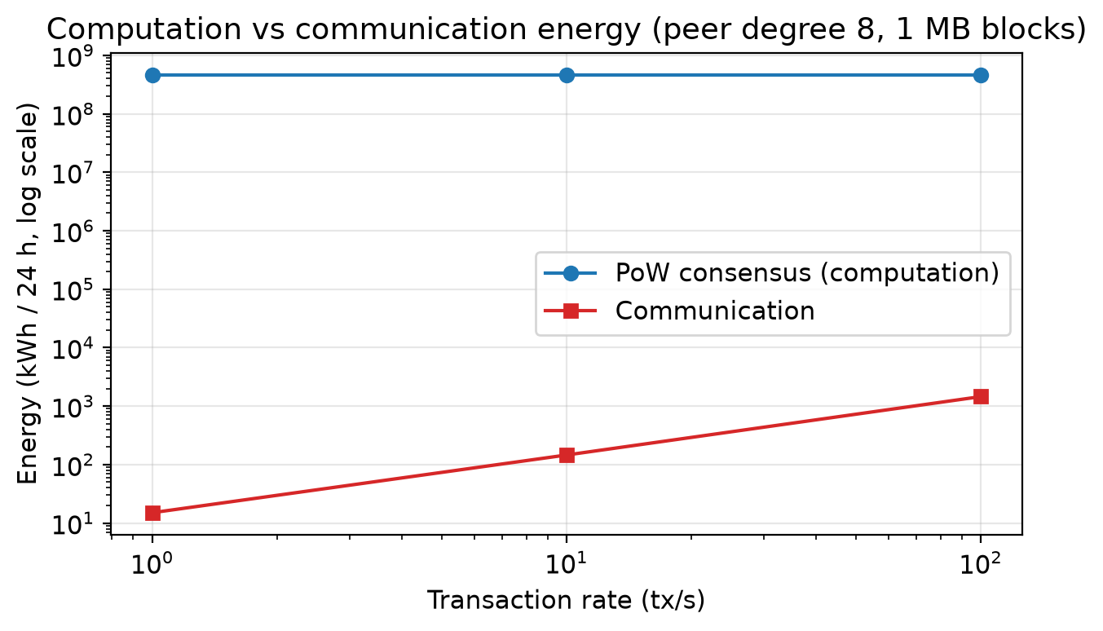
Figure 5. Computation vs communication energy (log-log, peer degree 8, 1 MB blocks, 30 seeds). Communication is orders of magnitude below PoW consensus energy but rises steeply with transaction rate.

7.6 Sanity Checks and Literature-Order Comparison
We do not claim validation against field measurements. Instead we report two controlled checks. First, an analytical sanity check: for fixed-power configurations the simulator's accounting must reproduce E = P x T exactly. Table 7 confirms agreement to machine precision (maximum relative error 0.00e+00) across five configurations. Second, a literature-order check (Figure 6): the modelled PoW reference (~467 GWh/day) exceeds the modelled PoS reference (~2,375 kWh/day) by about 196,846x. This four-to-five order-of-magnitude gap is consistent with Sedlmeir et al. [4] and Platt et al. [6], and with the ~99.95% energy reduction reported for Ethereum after The Merge [8]. The absolute PoW figure also matches the published order of magnitude for Bitcoin (hundreds of GWh per day) [1], [2].
Table 7. Analytical E = P x T sanity check. The simulator reproduces the closed-form energy exactly.
Validators | Power (W) | Hours | Analytic E=P*T (kWh) | Simulator (kWh) | Rel. error
1 | 100.0 | 10.0 | 1.0 | 1.0 | 0.0
10 | 100.0 | 24.0 | 24.0 | 24.0 | 0.0
500 | 100.0 | 24.0 | 1,200.0 | 1,200.0 | 0.0
1000 | 50.0 | 24.0 | 1,200.0 | 1,200.0 | 0.0
5000 | 250.0 | 24.0 | 30,000.0 | 30,000.0 | 0.0

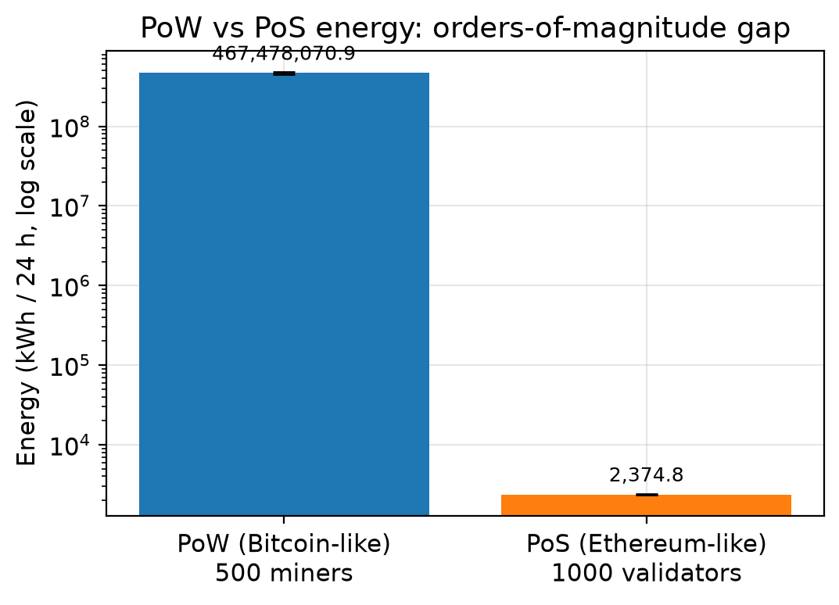
Figure 6. Literature-order comparison (log axis): PoW vs PoS energy differ by roughly five orders of magnitude, consistent with prior studies and the Ethereum Merge.

8. Discussion and Threats to Validity

8.1 Discussion
Modelling PoW and PoS as distinct energy processes changes the qualitative story. For PoW, the dominant levers are economic (coin price, reward, electricity price) and hardware efficiency, not the participant count; adding miners redistributes a fixed economic budget. For PoS, the levers are validator count, hardware power, and uptime. The carbon results show that grid choice (gamma) can change emissions by more than an order of magnitude for identical energy, so emission-factor scenarios are essential. The communication analysis clarifies when network energy matters: negligible under PoW, potentially material under PoS and high throughput. Together these make BlockSim usable for consensus-aware what-if exploration of sustainability trade-offs.

8.2 Threats to Validity and Limitations
- The framework is a scenario-based explorer; it is not intended to predict the exact real-world energy use of Bitcoin or Ethereum, and its absolute outputs should be read as scenario values, not measurements.
- PoW energy is sensitive to market price, block reward, transaction fees, electricity price, mining efficiency, and difficulty/hashrate dynamics; results shift with these assumptions and the spend ratio kappa.
- PoS energy is sensitive to validator count, node hardware, uptime, redundancy, and communication overhead, which vary widely across operators.
- Carbon emissions depend strongly on region- and time-specific electricity mixes; the gamma scenarios bracket but do not resolve this variability.
- Historical Ethereum-like PoW configurations are illustrative of a pre-Merge GPU-mining regime and must not be interpreted as current Ethereum, which has used PoS since September 2022.
- Communication energy is small compared with PoW mining energy but may be significant in PoS or high-throughput scenarios; its absolute value depends on per-message/per-byte coefficients that are themselves estimates.
- BlockSim's discrete-event abstraction does not capture all low-level hardware optimisations or fine-grained network dynamics; this is an accepted trade-off for scalable, comparative protocol analysis.

9. Conclusion and Future Work
We extended BlockSim with consensus-aware energy and carbon accounting that distinguishes economically driven PoW energy from validator-count-driven PoS energy, instruments and analyses communication energy, and varies the grid emission factor experimentally. Across 30-seed scenarios reported with confidence intervals, the results show that PoW network energy is governed by economic incentives rather than miner count, that PoS energy scales with validator count and hardware, and that grid intensity dominates carbon outcomes. The framework reproduces the analytical E = P x T baseline exactly and matches the order-of-magnitude PoW/PoS gap reported in the literature. We position the tool as a scenario-based explorer rather than a precise estimator. Future work includes hardware-specific parameter libraries, dynamic and region-specific carbon intensity, difficulty-retargeting scenarios over long horizons, and tighter integration with measured network traces.

Declarations
Ethics approval: Not applicable. This study is based solely on simulation.
Consent to participate / for publication: Not applicable.
Funding: No funding was received for conducting this study.
Data and code availability: All code, experiment scripts, unit tests, raw CSV results, and the figure-generation pipeline are available in the project repository [16].

References
[1] S. Nakamoto, "Bitcoin: A Peer-to-Peer Electronic Cash System," 2008.
[2] A. de Vries, "Bitcoin's Growing Energy Problem," Joule, vol. 2, no. 5, pp. 801-805, 2018. https://doi.org/10.1016/j.joule.2018.04.016
[3] C. Stoll, L. Klaassen, and U. Gallersdoerfer, "The Carbon Footprint of Bitcoin," Joule, vol. 3, no. 7, pp. 1647-1661, 2019. https://doi.org/10.1016/j.joule.2019.05.012
[4] J. Sedlmeir, H. U. Buhl, G. Fridgen, and R. Keller, "The Energy Consumption of Blockchain Technology: Beyond Myth," Business & Information Systems Engineering, vol. 62, no. 6, pp. 599-608, 2020. https://doi.org/10.1007/s12599-020-00656-x
[5] K. Croman et al., "On Scaling Decentralized Blockchains," Financial Cryptography and Data Security, pp. 106-125, 2016. https://doi.org/10.1007/978-3-662-53357-4_8
[6] M. Platt, J. Sedlmeir, D. Platt, J. Xu, P. Tasca, N. Vadgama, and J. I. Ibanez, "The Energy Footprint of Blockchain Consensus Mechanisms Beyond Proof-of-Work," IEEE 21st Int. Conf. on Software Quality, Reliability and Security Companion (QRS-C), pp. 1135-1144, 2021. https://doi.org/10.1109/QRS-C55045.2021.00168
[7] C. T. Nguyen, D. T. Hoang, D. N. Nguyen, D. Niyato, H. T. Nguyen, and E. Dutkiewicz, "Proof-of-Stake Consensus Mechanisms for Future Blockchain Networks," IEEE Access, vol. 7, pp. 85727-85745, 2019. https://doi.org/10.1109/ACCESS.2019.2925010
[8] A. de Vries, "Cryptocurrencies on the Road to Sustainability: Ethereum Paving the Way for Bitcoin," Patterns, vol. 4, no. 1, art. 100633, 2023 (online 2022). https://doi.org/10.1016/j.patter.2022.100633
[9] M. Alharby and A. van Moorsel, "BlockSim: A Simulation Framework for Blockchain Systems," ACM SIGMETRICS Performance Evaluation Review, vol. 46, no. 3, pp. 135-138, 2019; Frontiers in Blockchain, vol. 3, art. 28, 2020.
[10] Y. Aoki, K. Otsuki, T. Kaneko, R. Banno, and K. Shudo, "SimBlock: A Blockchain Network Simulator," IEEE INFOCOM Workshops, pp. 325-329, 2019. https://doi.org/10.1109/INFCOMW.2019.8845253
[11] J. B. Schwartz et al., "JABS: A Framework for Blockchain Consensus Evaluation," IEEE Trans. Network and Service Management, 2020.
[12] A. Gervais et al., "On the Security and Performance of Proof of Work Blockchains," ACM CCS, pp. 3-16, 2016. https://doi.org/10.1145/2976749.2978341
[13] L. M. Feeney and M. Nilsson, "Investigating the Energy Consumption of a Wireless Network Interface in an Ad Hoc Networking Environment," IEEE INFOCOM, pp. 1548-1557, 2001. https://doi.org/10.1109/INFCOM.2001.916651
[14] B. P. Singh and M. M. Gore, "Cyber-physical energy system simulation tool: framework for network co-simulation, GridLAB-D and ns-3," Int. J. of Simulation and Process Modelling, vol. 18, no. 4, pp. 314-328, 2022. https://doi.org/10.1504/IJSPM.2022.128289
[15] M. Platt, D. Platt, and P. McBurney, "Sybil attack vulnerability trilemma," International Journal of Parallel, Emergent and Distributed Systems, vol. 39, no. 4, pp. 446-460, 2024. https://doi.org/10.1080/17445760.2024.2352740
[16] R. S. Rasheed, "BlockSim (consensus-aware energy/carbon extension)," GitHub repository, 2026. https://github.com/raedrasheed/BlockSim-New
[17] IPCC, "2019 Refinement to the 2006 IPCC Guidelines for National Greenhouse Gas Inventories," Intergovernmental Panel on Climate Change, 2019.

