**FINAL PROJECT REPORT**

**PROJECT PLAN**

**COPYRIGHT**

*The nook. eLibrary website by Raeeba Rahman is licensed under CC BY-NC-SA 4.0.*

**PROJECT DESCRIPTION**

I will be creating a website for a virtual bookstore which holds e-books called “nook.”. The site will have primarily fiction books from different genres. The user will be able to purchase e-books from the site.

The website will contain three (5) pages: a Home page, a Cart page called Your Nook and a Contact Us page, an About Us page as well as a Books page.

The **Home** page will contain:

* A display of the books the website stocks (a quote from the book, a summary, and the cover).
* A description of how the website works.
* An image.

The **Books** page will contain:

* A table with all of the books and their prices, as well as a purchase button for each book.

The **Your Nook** page will contain:

* The books the user has decided to purchase.
* A form for the user to select which other books they would like to purchase.

The **Contact** page will contain:

* A form the user can fill out to provide comments, feedback, and ask questions.

The **About** **Us** page will contain:

* A description of the website’s mission and a video.

Each page will contain:

* A navigation menu.
* The website’s name and logo.

**FUNCTIONALITY**

The website uses Java Fetch API to fetch book data (quote, summary, book cover) from a .csv file and display it to the **Home** page upon clicking the “Previous Book” and “Next Book” buttons. Upon clicking “See More”, the user will be redirected to the Books page.

The **Books** page has a table which contains each book, as well as their price and a purchase button. Upon clicking the “Purchase” button, the selected book will be saved in local storage, and its checkbox will be shown as being selected on the Your Nook page. Only one of each book may be purchased at a time.

The **Your** **Nook** page has a form with all of the books on the website listed. Any previously selected books from the Books page will have their checkbox be shown as being selected. However, the user can still select books on the form directly. Upon reloading the form, the local storage will be cleared, so the user can select any other books. The “Clear” button also clears the total and form. The “Calculate Total” button displays the user’s total and subtotal in the are next to the form. The “Check Out” button displays an alert with the user’s total.

The **About Us** page has a video as well as a short description of the website.

The **Contact Us** page contains a form which the user can fill out if they have any inquiries or would like to send any book recommendations.

**IMPLEMENTATION TASKS**

* Create the layout of each page.
  1. Plan the style of the website (colours, images, theme).
  2. Define the basic formatting style of each page in CSS in a style sheet in a separate file that is linked to each page.
  3. Add the navigation menu to the HTML pages.
  4. Add the HTML elements to the website (buttons, videos, etc.)
* Populate the website with different books.
  1. Add an image for each book.
  2. Add a summary for each book.
  3. Add a quote for each book.
* Create the main features using Javascript:
  1. A .csv file to store the book data which can be accessed using Java Fetch API.
  2. A purchase function.
  3. A form for the Your Nook page which receives data from the books page.

**LAYOUT**

Below you will find the website layout for:

* Large and medium screens.
* Small screens.

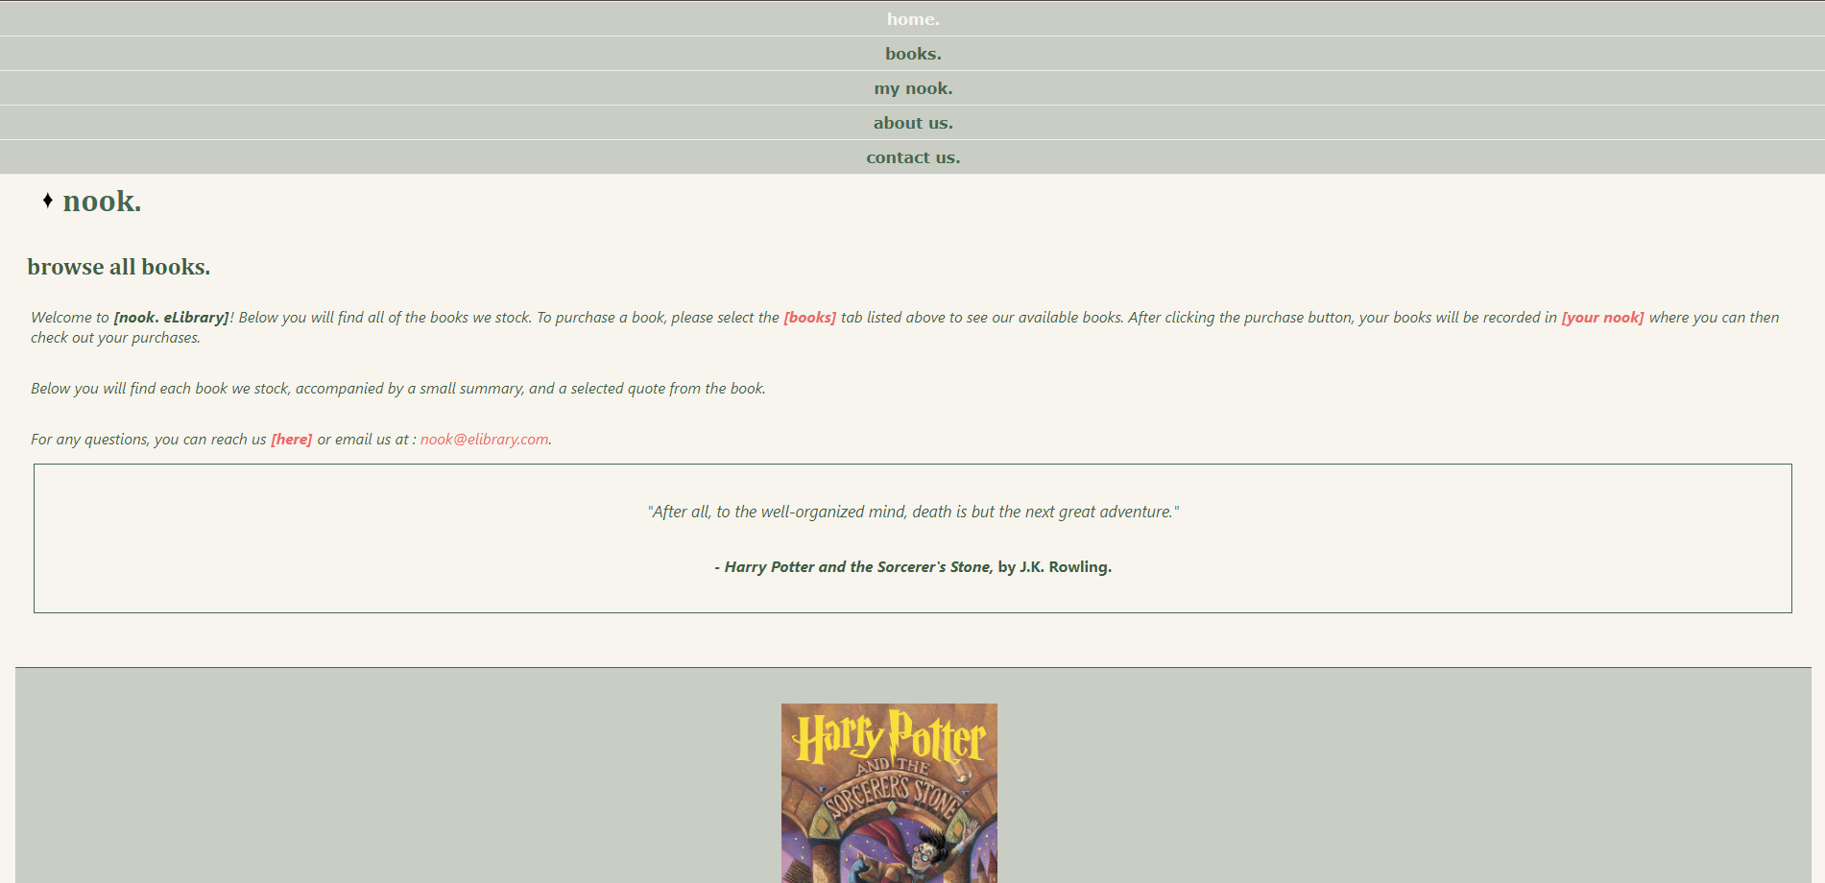

1 Home Page

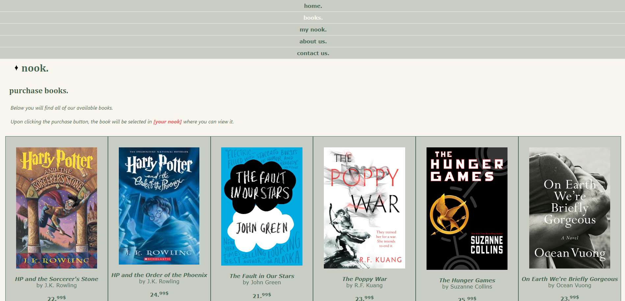

2 Books page

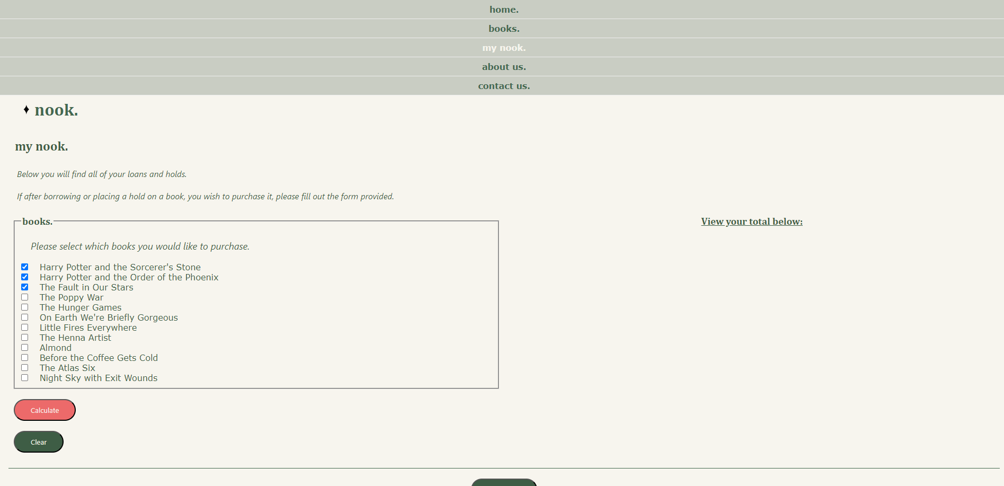

3 Your Nook page

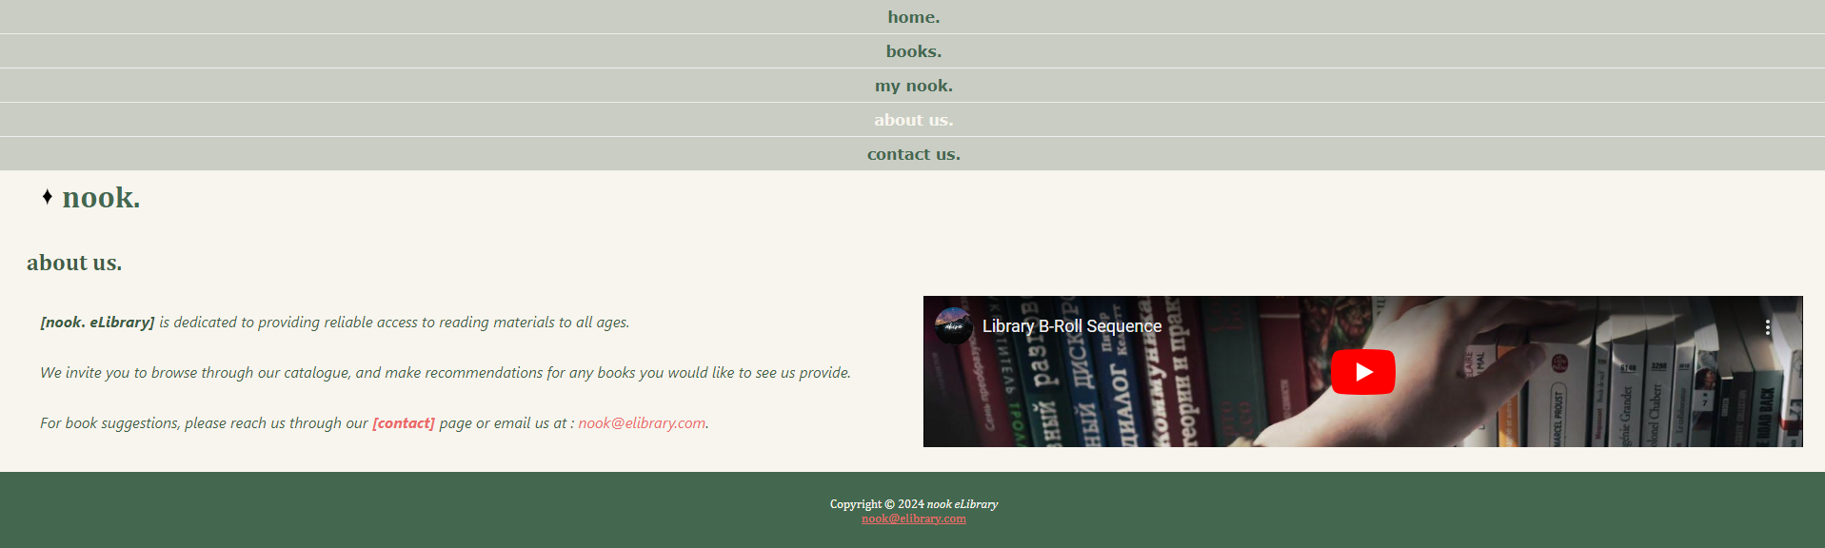

4 About us page

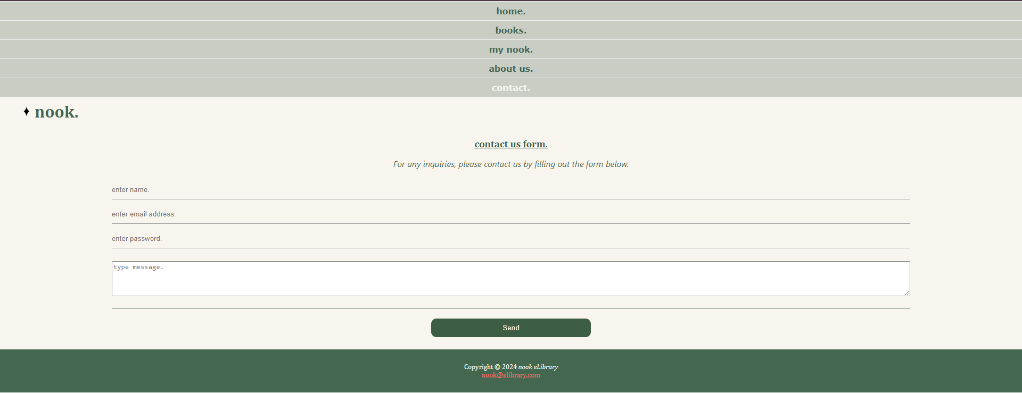

5 Contact Us page

**RESPONSIVE LAYOUT**

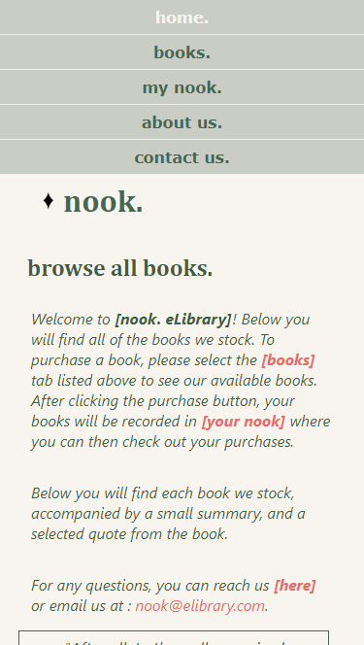 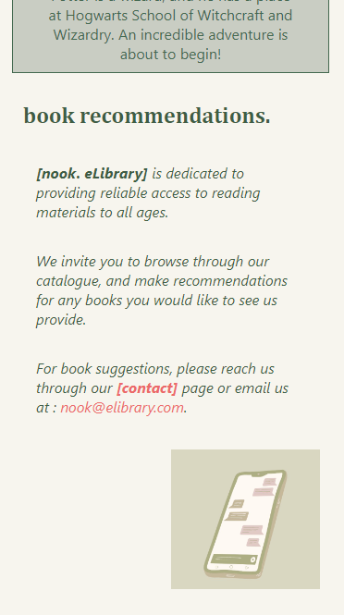 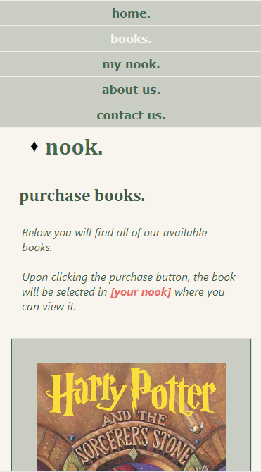 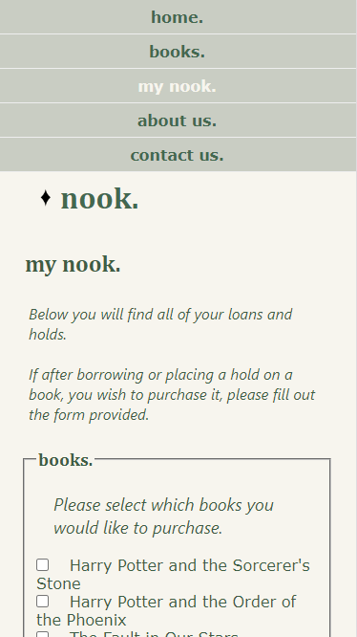 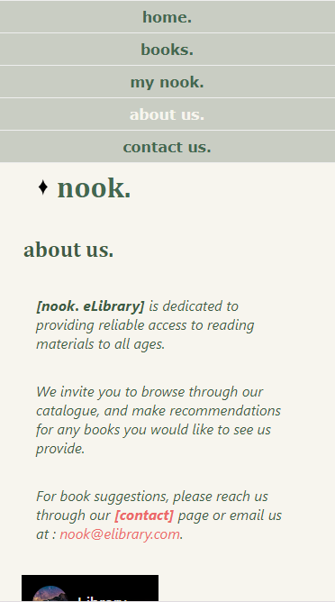 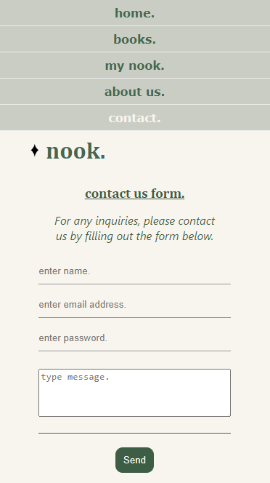

**Video was taken from**: Newbie Learns Video Creation. https://www.youtube.com/embed/ZNSA0NrDeb4?si=cec0nS7bqXp2okzq

**Images were taken** **from**: Canva

**Icon was created** **by** me

**Wireframes were created** **using** Lucidchart.