**LOCATION STRATEGIES IN ANDROID INDEX**

Contents Page No.

1. Android Platform Location API 2
2. Google Location Services API 4

**LOCATION STRATEGIES IN ANDROID**

There are two ways for obtaining location in Android:

1. Android Platform Location API (I have used this) :

(<http://developer.android.com/guide/topics/location/strategies.html>)

1. Google Location Services API (Recently released in Google I/O 2013)

(http://developer.android.com/training/location/index.html)

**Android Platform Location API:**

* Android Location API is available since first versions of android OS emerged.
* It provides following classes for fetching location details:
  + LocationManager
  + LocationListener
* Uses LOCATION_SERVICE of the system for fetching locations.
* We can use following location providers to fetch the location details.

1. GPS
2. Network
3. Passive

|  |  |  |  |
| --- | --- | --- | --- |
|  | GPS | Network | Passive |
| Source | Determines location using satellite | Determines user’s location using cell tower and available WiFi hotspots | This provider can be used to passively receive location updates when other applications or services request them without actually requesting the locations yourself. This provider will return locations generated by other providers. |
| Accuracy | High Accuracy (20ft) | Medium Accuracy (200ft) | Low Accuracy (5300ft/mile) |
| Battery Consumption | High Power Consumption | Less Power Consumption | Negligible power consumption |
| Time required to get first location update | Takes long time to get a fix | Provides fast initial fix | Provides fast initial fix |

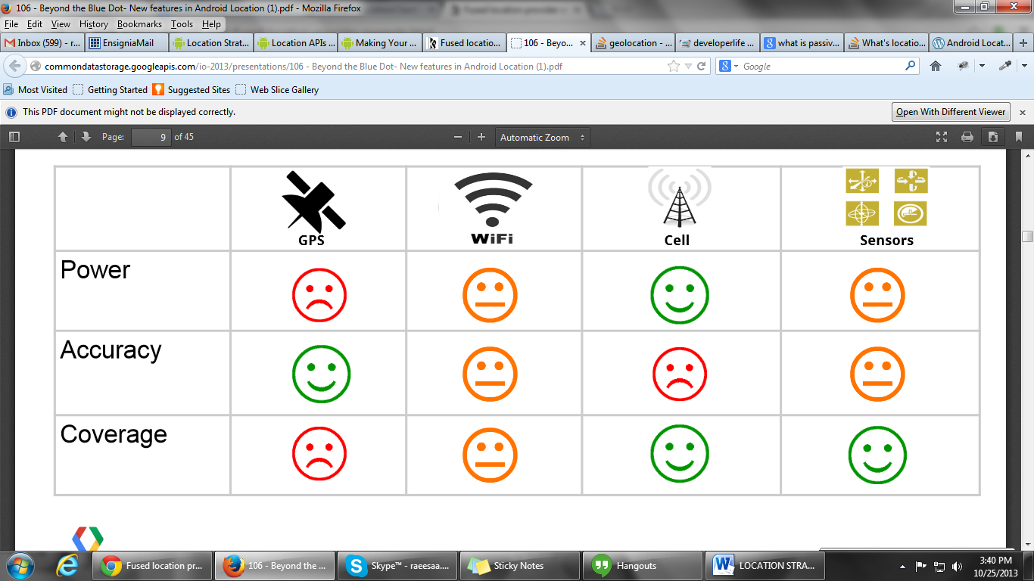

(Image copied from Google I/O 2013 Location Services presentation)

State of Android Location API:

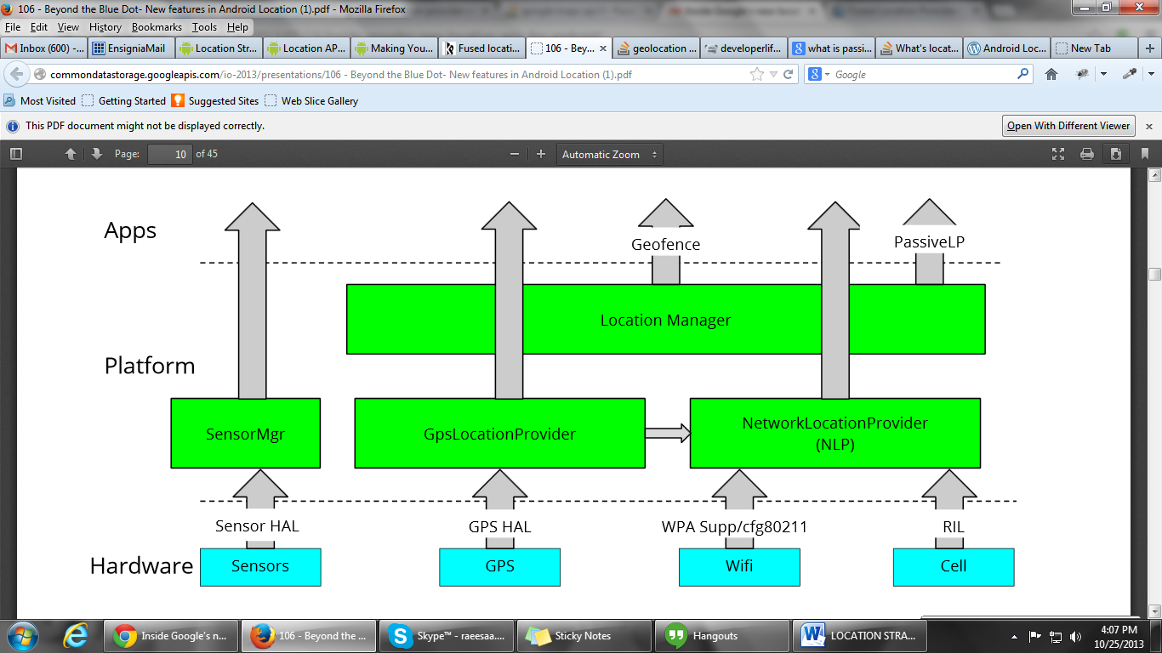

**Detailed comparison between location providers can be found here:**

<http://blog.shinetech.com/2011/10/14/a-good-look-at-android-location-data/>

http://developerlife.com/tutorials/?p=1375

**Google Location Services API:**

* It provides more powerful, high level framework that automatically handles location providers, user movement and location accuracy. According to android developers site, **“In most cases, you'll get better battery performance, as well as more appropriate accuracy, by using the Location Services API. “**
* This service is based on Google Play services client library and hence **works only on devices having latest Google Play Services installed on their device.**
* Provides following classes for fetching location updates of user:
  + LocationClient
  + LocationRequest
* Google Location Services use **fused location provider** for fetching the location details.

**Fused Location Provider:**

(Reference: <http://blog.lemberg.co.uk/fused-location-provider>)

Android Location API was available when the very first versions of Android OS emerged. API calls were simple, and location tracking algorithm was fairly straightforward: you could choose one of the location providers (network or GPS) and request location updates or set up proximity alert.

But there were two main issues with this approach:

1. In case you need to define precise location, you had to switch between network and GPS location providers (as GPS doesn’t work indoors).
2. Proximity alerts were used to notify a user about proximity to a location, and this took its toll on the battery life.

The goal of Fused Location Provider (‘Fused’) is to lessen the workload of developers who want to interact with location information. Instead of having an app talk to different location data sources, and provide them with a single programmable interface to talk to; Google thus does the hard work in sourcing location, simply feeding it to developers’ applications.

**Fused Location Provider analyses GPS, Cellular and Wi-Fi network location data in order to provide the highest accuracy data.** Also, this provider **uses different device sensors to define if a user is walking, riding a bicycle, driving a car or just standing** in order to adjust the frequency of location updates.

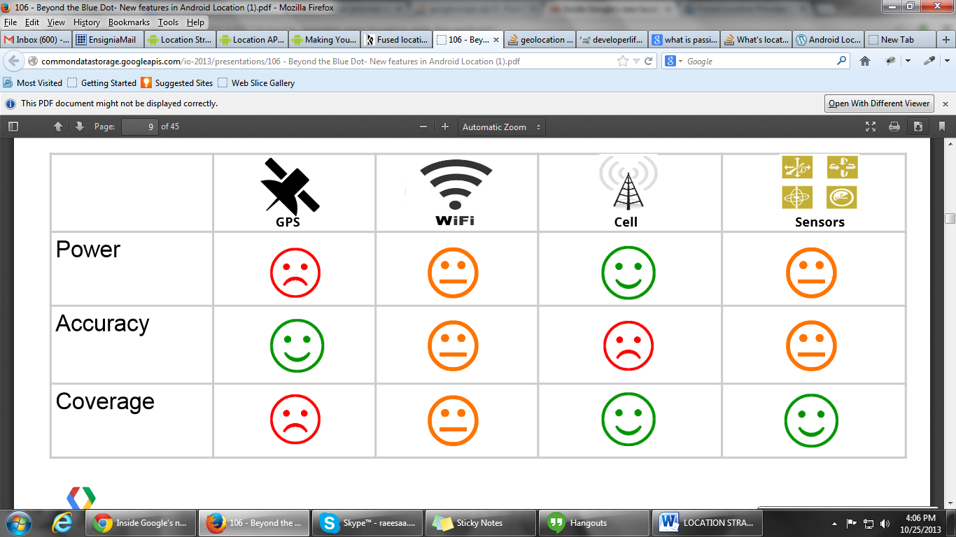

Fused Location Provider:

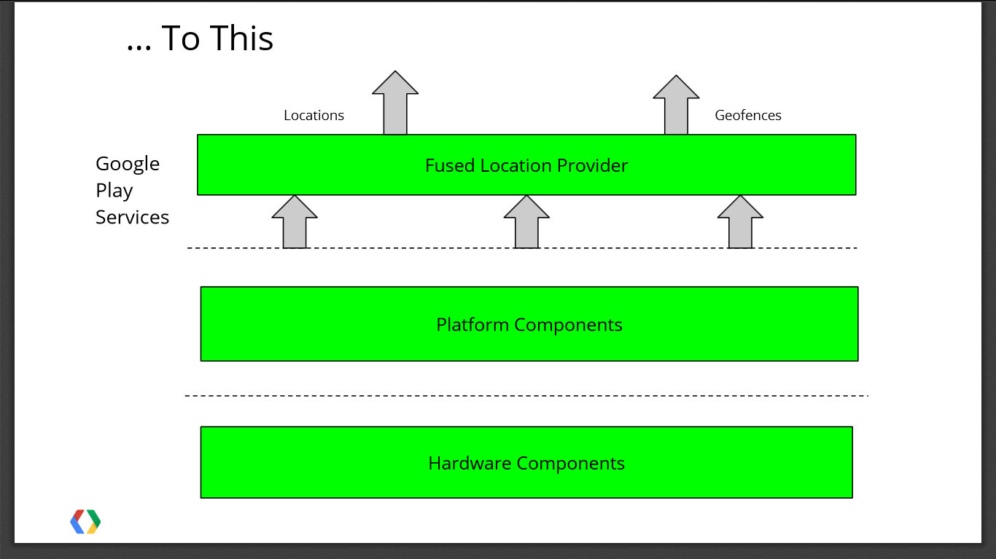

**Developer can define one of the following three Fused Location Provider Modes to set priority:**

1. HIGH_ACCURACY
2. BALANCED_POWER
3. NO_POWER

Table comparing the priorities:

(Taken from Google I/O 2013 presentation)

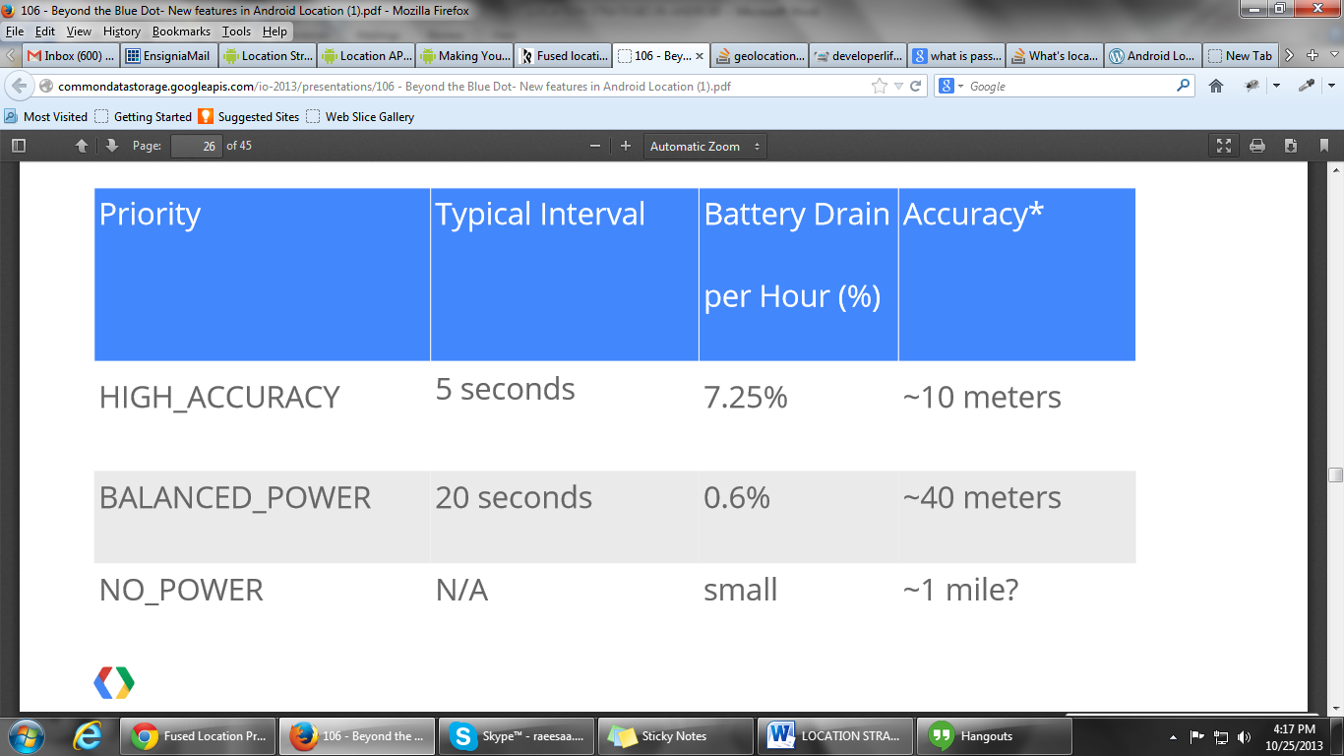

Issues:

When I was studying these strategies, I came across few stackoverflow questions regarding the issues with LocationClient (of Google Location Services API):

<http://stackoverflow.com/questions/16902098/using-google-play-services-locationclient-in-background-service>

<http://stackoverflow.com/questions/17121881/checking-gps-status-with-google-play-services>

<http://stackoverflow.com/questions/17239006/android-locations-got-from-locationclient-doesnt-support-speed>