**PARSE FEATURES INDEX**

Feature Page No.

1. Parse Data 2
2. Parse Push 3
3. Parse Social 4
4. Parse Analytics 4
5. Parse Hosting 4
6. Cloud Code 5

**PARSE FEATURES**

Parse.com provides backend services for desktop and mobile applications. They provide SDK for Android, iOS, Javascript, Windows Phone 8, Windows 8(.NET SDK) and OSX.

**PARSE FEATURES:**

1. **Parse Data:**

With Parse, one can store app’s data in cloud. No servers are needed. Parse handles everything one needs to store data securely and efficiently in the cloud. One can store data of basic data types, locations, photos and query accross them in just few lines of code.

**Update over the air:**

One can upload new assets to parse cloud and push them to their app without having to resubmit the app.

**Powerful Data Management:**

Parse provides ‘Data Browser’ that lets one manage their objects (records) in a spreadsheet-like interface. One can view data in full screen mode, sort by columns and more. It is also possible to update objects (records) directly from data browser without writing the code. We simply need to select the field to be changed and update it.

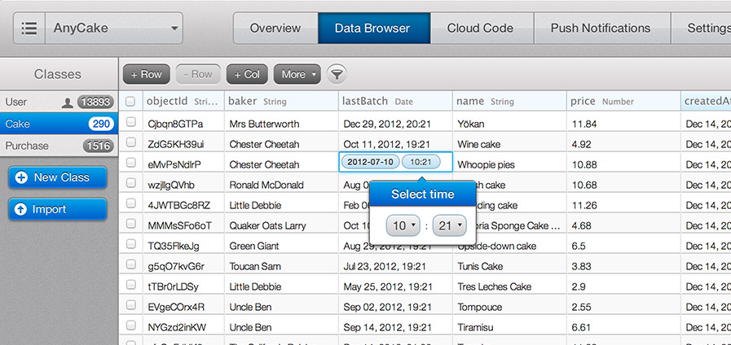

*The Parse Android API guide for uploading, retrieving and saving the data in the cloud from app code can be found here* [*https://parse.com/docs/android_guide*](https://parse.com/docs/android_guide)*.*

1. **Parse Push:**

Parse simplifies the process of sending push notifications and enables powerful targeting. **One can send push notification via:**

* **Web console**
* **REST API**
* **Client SDK’s**

**Sending push notification from web console:**

The push console allows any user (technical or no) to send notifications directly from the Parse web interface.

* **Push composer:**

Sending new push notification is as easy as sending an email or text message. Simply type a message in a text box and instantly see what will message look like on an iPhone or Android device. Clicking send notification will result in sending push notification to multiple devices having your app installed.

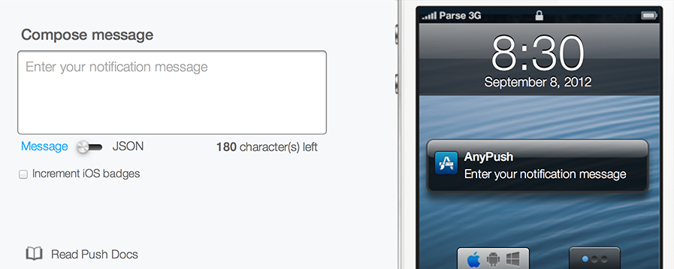

* **Advanced Targeting:**

**Pro and enterprise Parse users** can segment their target audience based on any condition (location, language, etc.) through easy to use Parse Push Console and send notifications only to targeted audience.

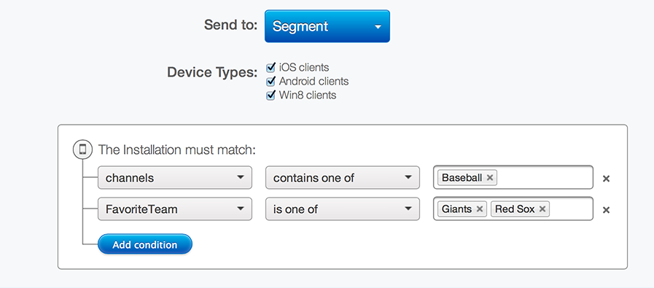

* **Advanced Scheduling:**

In addition to Advanced targeting, **Pro and enterprise users** can also schedule their upcoming push notifications. Say one need to send push notification to people across different time zones at exactly 7PM local time. Parse can do that automatically for you once you schedule your notification.

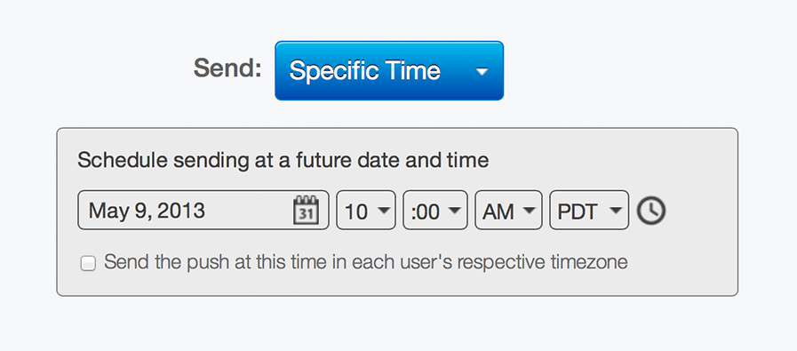

1. **Parse Social:**

Parse allows one to connect their users via traditional logins or third party social networks.

Parse take care of linking accounts over networks, resetting passwords, and keeping everything safe and secure.

Parse also allows one’s users to login on multiple devices. Whether they are on iPad, Android Phone or a web browser, Parse knows who your users are and who they are connected to.

1. **Parse Analytics:**

Parse enables its user to view app open rates and API request data via Parse Dashboard.

* **Optimize Push Campaigns:**

Parse enables its user to monitor effectiveness of its push campaigns with easy-to-use analytics tools. One can view open rates of entire push strategy or measure individual push notification open rates.

* **Track Custom Analytics:**

With a single line of code, one can track any data point he wants to in the app.

1. **Parse Hosting:**

Parse Hosting lets you develop a website without worrying about servers or scaling, whether you’re designing a landing page or building a rich web app.

The hosting environment can handle a landing page that can support a developer’s mobile app. The page can be coded in HTML, JavaScript, and CSS, while also integrated with Cloud Code.

1. **Cloud Code:**

Using cloud code one can add rich and custom logic to apps backend without using any server.

* **Javascript in the cloud:**

Parse cloud runs the Parse Javascript SDK to access your data. It is the same SDK on the client and in the cloud.

* **Easily manage documents:**

Parse provides an intuitive command line tool for deploying cloud code. One can easily manage the code versions as one develops and deploys code.

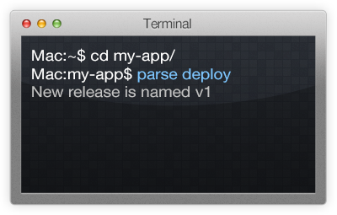

* Parse cloud can be used to add custom validations and endpoints. These validations and endpoints are instantly accessible by clients whether it is Android, iOS or HTML5.

**Cloud Modules:** (https://parse.com/docs/cloud_modules_guide)

Cloud modules are easiest ways to integrate with virtually any third-party services and libraries. For example, one can send a simple text message with Twilio or email customers with Mailgun without maintaining his own servers.