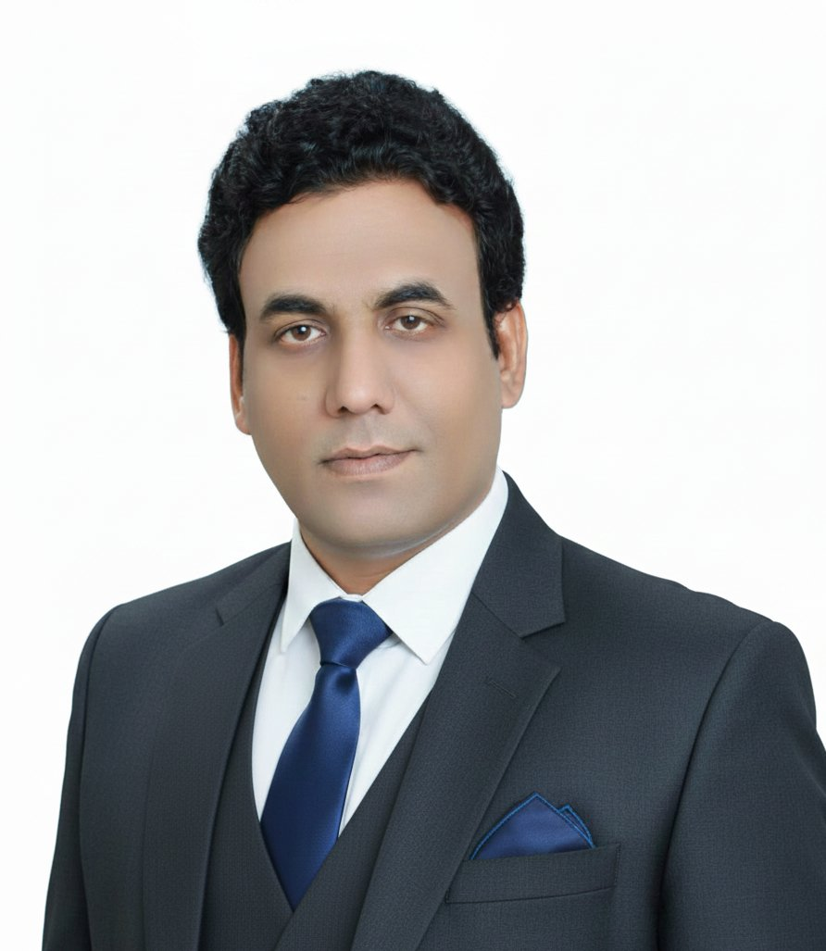 | Muhammad Raees  AIOps & DevOps Engineer | Cloud & Cybersecurity Specialist  📍 Islamabad, Pakistan 📧 raees.malik89@gmail.com  📞 +92-316-881-8693 🔗 linkedin.com/in/muhammad-raees081489  💻 github.com/raeesmalik89-oss

PERSONAL INFO  Nationality  Pakistani  Availability  Immediate  Work Type  Full-time | Remote | Hybrid  LANGUAGES  English  Professional Working Proficiency  Urdu  Native / Full Professional  EDUCATION  Diploma – AI Operations  Level 6 | UK Equivalent  Al Nafi International College  2024 – 2026  Doctor of Pharmacy  Pharm-D  Riphah International University  Islamabad  BA – Sociology  University of Sargodha  INTERESTS  ▸ AI/ML in Production  ▸ Cloud-Native Architecture  ▸ Site Reliability Engineering  ▸ Cybersecurity & Threat Intel  ▸ Health Technology (HealthTech)  ▸ Open-Source DevOps Tooling | PROFESSIONAL SUMMARY  Results-driven AIOps & DevOps Engineer with a Level 6 Diploma in Artificial Intelligence Operations (UK equivalent) and 18 months of hands-on experience across cloud infrastructure, cybersecurity operations, ML model deployment, and CI/CD automation. Proficient in AWS, Azure, Kubernetes, Terraform, Docker, and Python. Brings a unique analytical edge from a Doctor of Pharmacy background — ideal for high-responsibility, compliance-driven environments. Immediately available for AIOps, DevOps, Cloud Engineering, or Cybersecurity roles.  CORE TECHNICAL SKILLS  Cloud Platforms: AWS (EC2, S3, Lambda, RDS, VPC, IAM) | Microsoft Azure (VM, AKS, Monitor, DevOps)  DevOps & CI/CD: Jenkins | GitHub Actions | GitLab CI | ArgoCD | Azure DevOps Pipelines  Containers & IaC: Docker | Kubernetes (K8s, Helm) | Terraform | Ansible | Packer  AIOps & ML: Python (scikit-learn, TensorFlow, NLP) | Flask APIs | MLflow | Jupyter | Computer Vision  Monitoring: Prometheus | Grafana | ELK Stack | Datadog | PagerDuty | CloudWatch  Scripting: Python | Bash | YAML | JSON | Selenium | REST APIs  CYBERSECURITY SKILLS  Security-conscious engineering across IAM, compliance frameworks, incident response, and threat monitoring — applied throughout all cloud and DevOps workflows.  Frameworks & Standards: ISO 27001 | GDPR | HIPAA Awareness | NIST CSF basics  Identity & Access: IAM Least-Privilege | RBAC | MFA | Azure AD | AWS IAM Policies  Network Security: VPC Security Groups | NACLs | WAF | SSL/TLS | Firewall Rules  Secrets & Vault: HashiCorp Vault | AWS Secrets Manager | Env-var hardening  SIEM & Monitoring: ELK SIEM basics | CloudTrail | AWS GuardDuty | Azure Sentinel awareness  Incident Response: Root-cause analysis | Runbooks | MTTR reduction | Post-mortems  Container Security: Docker image scanning | K8s RBAC | Network Policies | Pod Security  Secure Dev Practices: Secrets scanning in CI/CD | OWASP awareness | Dependency auditing  PROFESSIONAL EXPERIENCE  AIOps / DevOps Engineer – Intern Jan 2024 – Present  Al Nafi International College & Al-Razzaq Labs | Islamabad, Pakistan  - Deployed and managed scalable cloud infrastructure on AWS and Azure — EC2, S3, IAM, VPCs, and Azure VM/AKS environments.  - Automated infrastructure provisioning with Terraform (IaC) and Ansible, cutting manual setup time by ~60%.  - Built containerised microservices with Docker and orchestrated multi-node deployments via Kubernetes (Helm, rolling updates, HPA).  - Designed CI/CD pipelines using GitHub Actions and Jenkins with automated test-build-deploy workflows.  - Developed and deployed ML models (classification, NLP) with Python; served via Flask REST APIs in containerised environments.  - Implemented Prometheus + Grafana + ELK observability stack for real-time monitoring, alerting, and log aggregation.  - Applied security-first practices: IAM least-privilege, secrets management, compliance alignment with GDPR & ISO 27001.  - Conducted incident response, root-cause analysis, and performance tuning — measurably reducing MTTR on recurring issues.  Pharmacist – Clinical Role 2023 – 2024  DHQ Hospital Attock | Attock, Pakistan  - Provided medication therapy management and clinical evaluation in a high-responsibility hospital environment.  - Identified drug interactions, optimised treatment plans, and maintained strict compliance with medical standards.  KEY PROJECTS  ▸ MLOps Pipeline – End-to-End Model Deployment  - Trained & packaged ML classification models; deployed as containerised Flask APIs on Kubernetes with Helm.  - Integrated MLflow for experiment tracking and model versioning; automated retraining pipeline via GitHub Actions.  - Provisioned all infrastructure (EC2, S3) with Terraform; achieved zero-downtime rolling deployments.  ▸ Cloud Infrastructure Automation (AWS & Azure)  - Architected multi-tier environments with auto-scaling, load balancers, and VPC security groups on AWS.  - Replaced manual deployments with Ansible playbooks and Terraform modules for one-click repeatable provisioning.  - Added CloudWatch dashboards, SNS alarms, and GuardDuty integration for proactive security monitoring.  ▸ AIOps Monitoring & Security Alerting Platform  - Built Prometheus + Grafana + ELK observability and SIEM-lite stack to aggregate metrics, logs, and security events.  - Created Python anomaly-detection scripts to surface performance and security regressions before SLA breaches.  ▸ Secure Python Automation Suite (Selenium + Jira)  - Automated regression test suites with Selenium WebDriver; CI-integrated results reporting to Jira via REST API.  - Implemented secrets scanning and credential rotation in CI pipeline; reduced manual QA effort by 80%.  ▸ DocBook Islamabad – Real-Time Doctor Booking Platform  - Built a production healthcare booking platform using GitHub Pages, Python, and GitHub Actions CI/CD — live at raeesmalik89-oss.github.io/IslamabadDoctors.  - Developed a Python + Playwright web scraper to aggregate real-time doctor data from Marham, Oladoc, InstaCare, and hospital directories into a live JSON feed.  - Implemented GitHub Actions scheduled pipeline (cron every 6 hours) for fully automated data refresh with zero manual intervention.  - Integrated Formspree API for appointment booking and doctor registration with email notifications; built monetisation model (free + PKR 2,000/month featured listings).

