**TASK 01:**

* Go through the presentation of Basics of Cloud Computing, AWS and EC2.
* Learn about AWS Regions and Availability Zones.
* Learn About AWS Management Console

Completed

**TASK 02:**

* Create an Ec2 Instance.
* Learn all 6 steps while doing that.
  + AMI

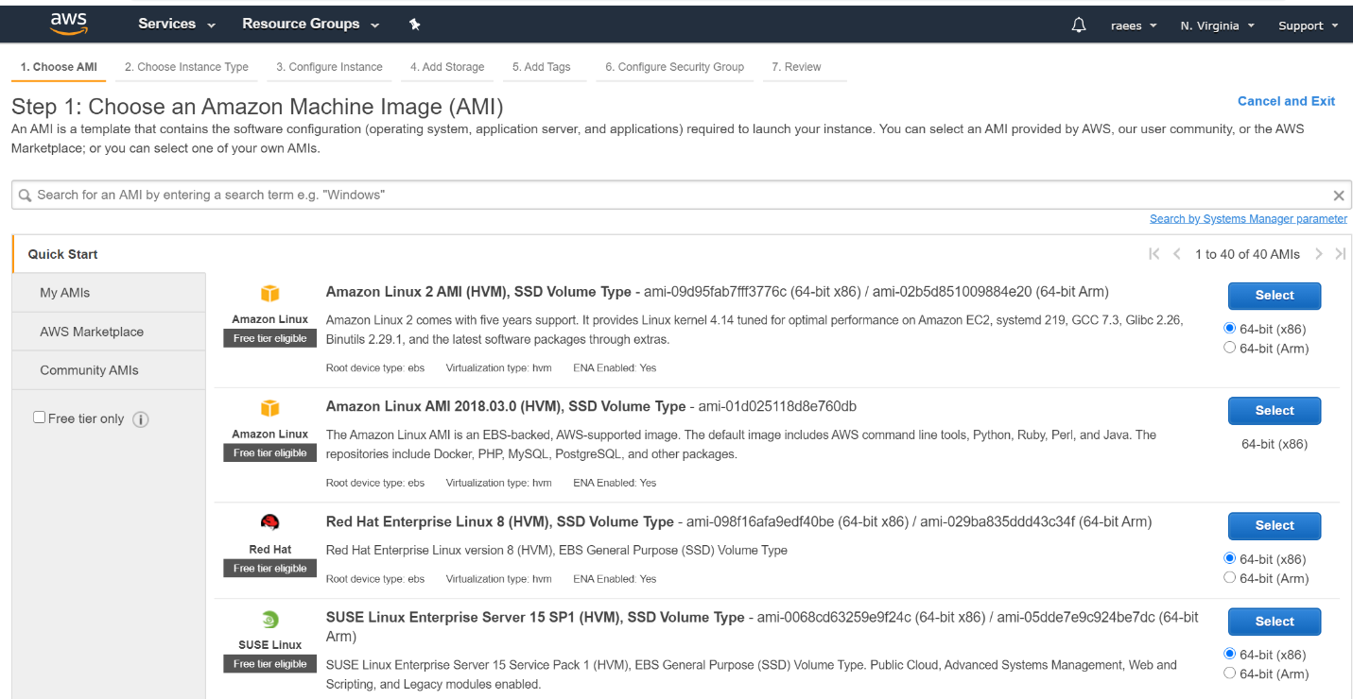

Instance Types

* 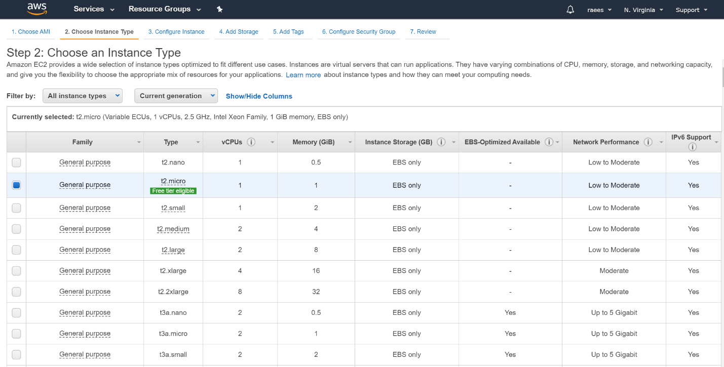

Configuration Page

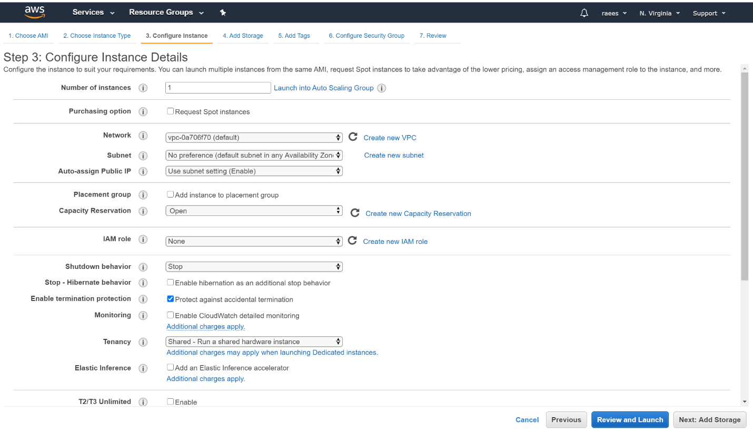

Volume

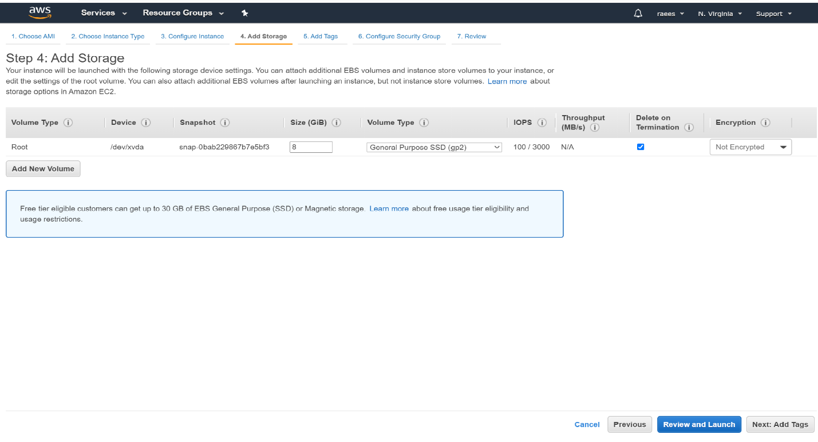

Tags

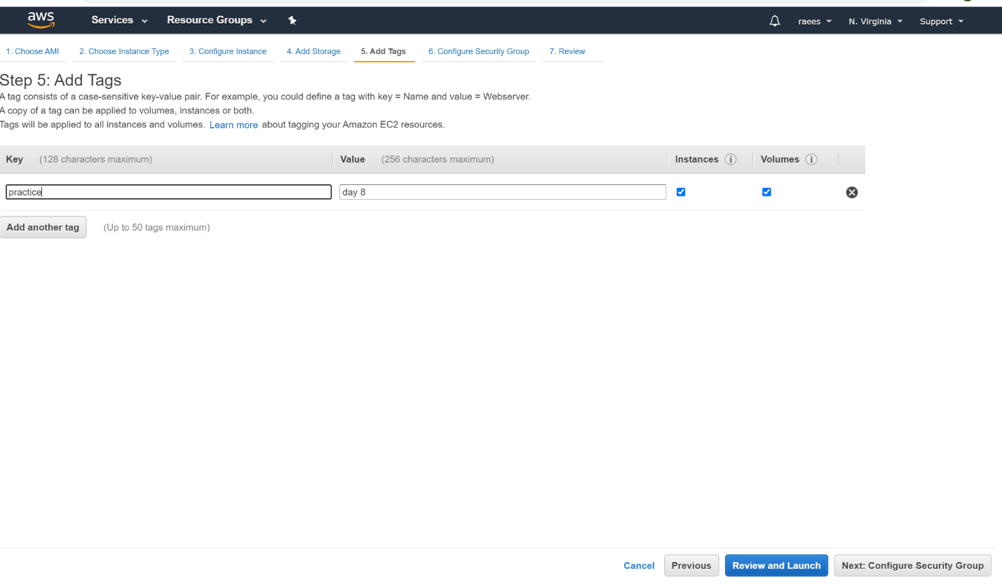

Security

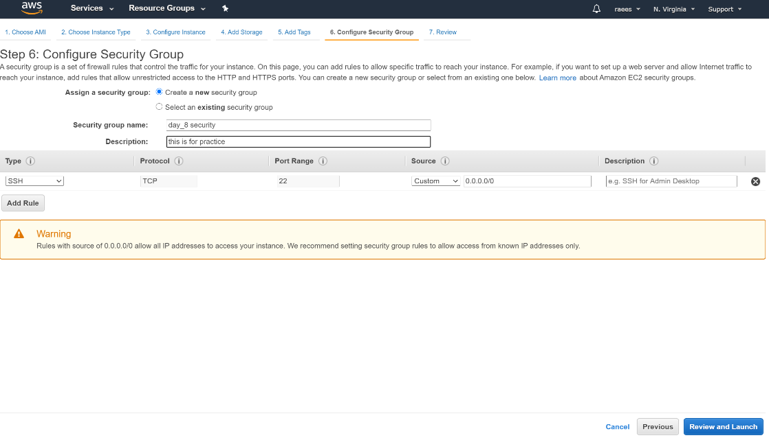

Review

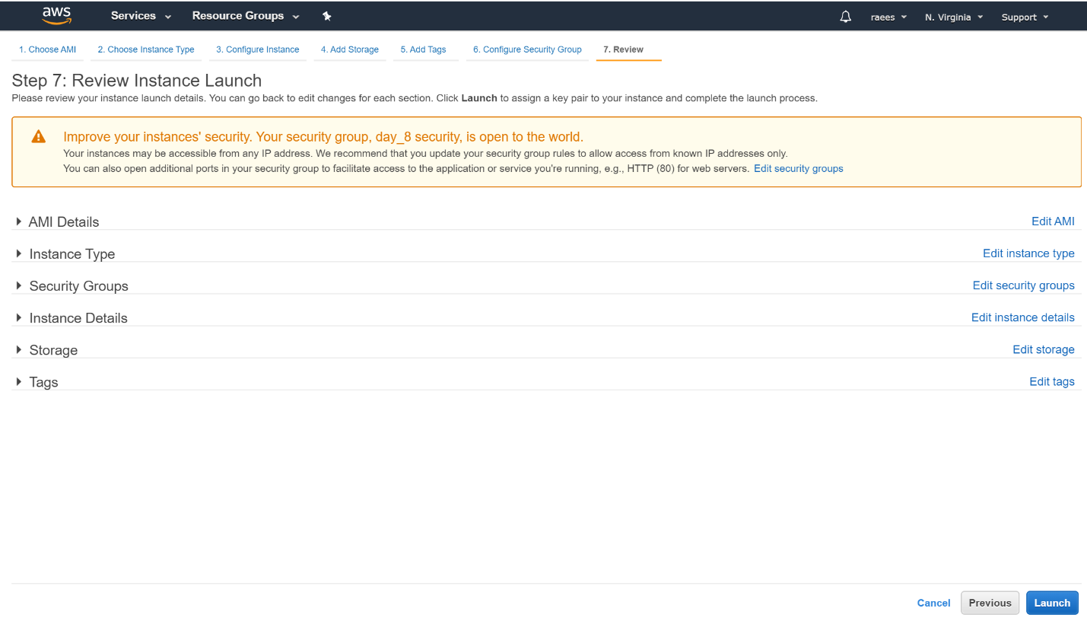

Status

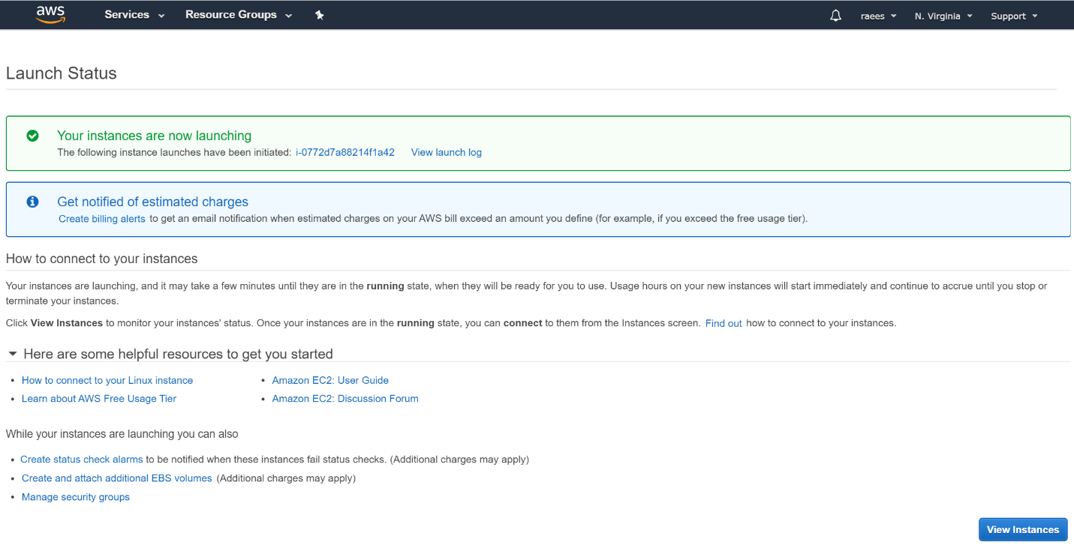

Launch

