Above the exhibit.
Table 1
The Final WInS Portfolio at Cost on the Original $300,000: Laura's Whole Plan in Miniature
Ticker or identifier | Name of investment | Asset type | Amount ($) | % of total | Pays for
IBTM | iShares iBonds Dec 2032 Term Treasury ETF | ETF | 97,489.95 | 32.50 | 2033 and  the floor
IBTO | iShares iBonds Dec 2033 Term Treasury ETF | ETF | 23,408.64 | 7.80 | 2034
IBTP | iShares iBonds Dec 2034 Term Treasury ETF | ETF | 22,155.30 | 7.39 | 2035
IBTQ | iShares iBonds Dec 2035 Term Treasury ETF | ETF | 20,973.24 | 6.99 | 2036
IBTR | iShares iBonds Dec 2036 Term Treasury ETF | ETF | 19,823.72 | 6.61 | 2037
[ID] | T-Bond 4.750% 15-Feb-2037 | Bond | 19,203.80 | 6.40 | 2038
[532281] | T-Bond 4.500% 15-May-2038 | Bond | 18,615.26 | 6.20 | 2039
[ID] | T-Bond 4.375% 15-Nov-2039 | Bond | 16,200.95 | 5.40 | 2040
[ID] | T-Bond 4.250% 15-Nov-2040 | Bond | 15,790.32 | 5.26 | 2041
[ID] | T-Bond 3.125% 15-Nov-2041 | Bond | 14,991.00 | 5.00 | 2042
 | Treasuries for the ten payments and the floor |  | 268,652.18 | 89.55
VT | Vanguard Total World Stock ETF | ETF | 26,524.61 | 8.84 | Range top,  flexibility
N/A | Cash | Cash | 3,513.79 | 1.17
N/A | Commissions and accrued interest at purchase | Cost | 1,309.42 | 0.44
Total |  |  | 300,000.00 | 100.00
Note. [Note to carry: amounts at cost: quantity held x price paid on 6-7 Oct 2026 (U.S. Eastern), on the original $300,000 (8g); Pays for: the payment (1 January of that year) each holding stands for; the full-size plan for both deposits is Figure 1 and Table 2 (8g, 23 Oct snapshot); the floor: the least Laura can promise co-sponsors in 2031; IBTM stands in for the plan's late-2032 floor fund (TNA l.13, CANON A24, 8g); costs row = $200 of commissions + $1,109.42 of bond interest accrued at purchase, which comes back with each bond's next coupon (8g v2).]

Below the exhibit.
Above the exhibit.
Figure 1
Each Payment Has Its Own Treasury; Extra Treasuries Bought With the 2028 Deposit Pay Any Gap if Nothing Earns Interest (Laura's Plan for Both Deposits, $450,000, Modelled)
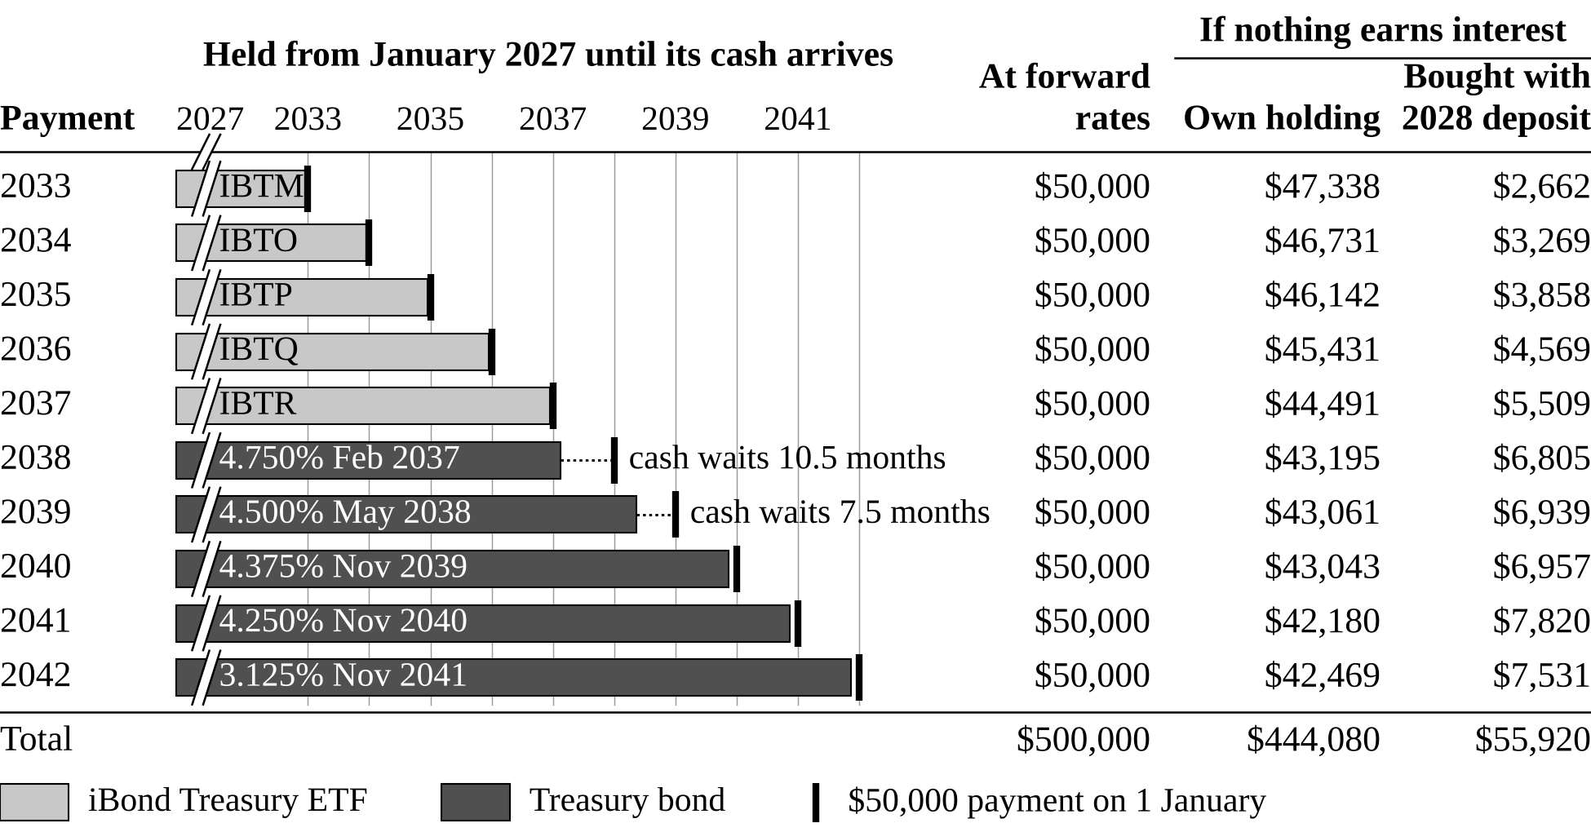
Note. [Note to carry: MODEL, at forward rates on the Treasury par yield curve of 6 Nov 2026; the right-hand columns are what each payment gets if nothing earns interest from 2027 and waiting money pays the Treasury-bill ETF's 0.15% fee: the $500,000 of payments split between the payment's own holding ($444,080) and the Treasuries bought with the 2028 deposit ($55,920); not the reserve's value on 1 Jan 2033 ($444,545 at forward rates) (8h); if room: those extra Treasuries cost $34,369 in 1 Jan 2027 money (section 2); not in the WInS book; rows may not add to the totals because of rounding.]

Below the exhibit.
Above the exhibit.
Table 2
Laura's Plan for Both Deposits ($450,000) in Five Markets and 585 History Replays, Modelled
World | Ten payments | Stated in 2031 |  | Flexibility  (Jan 2033)
World | Ten payments | Bottom | Top | Flexibility  (Jan 2033)
Today's forward rates | All paid | $95,000 | $115,000 | $29,800
Replay from 2006: shares fall | All paid | $95,000 | $105,000 | $19,500
Rates 3 points lower for good | All paid | $80,000 | $95,000 | $21,100
Replay from 2007: rates fall early | All paid | $80,000 | $95,000 | $21,900
Inflation: rates 3 points higher | All paid | $100,000 | $120,000 | $23,600
All 585 history replays (1962-2010 starts)
1-in-20 low | All paid | $80,000 | $95,000 | $19,700
Median | All paid | $95,000 | $115,000 | $31,800
1-in-20 high | All paid | $115,000 | $140,000 | $49,600
In every world and every replay, the facility contribution in January 2033 equals the stated top.
Note. [Note to carry: MODEL, not forecasts; Treasury curve of 6 Nov 2026; shares 7.5% a year in rows 1 and 3; replays: U.S. yields and stocks from the start month (method in 3e); inflation row: prices up 5% a year; flexibility: the half of VT promised to no one plus whatever the funds pay above the stated top, to the nearest $100 (8i); spread rows: each column's own percentile.]

Below the exhibit.

