PLEASE CHECK THE ERD FOR THE REQUIRED DETAILS:  
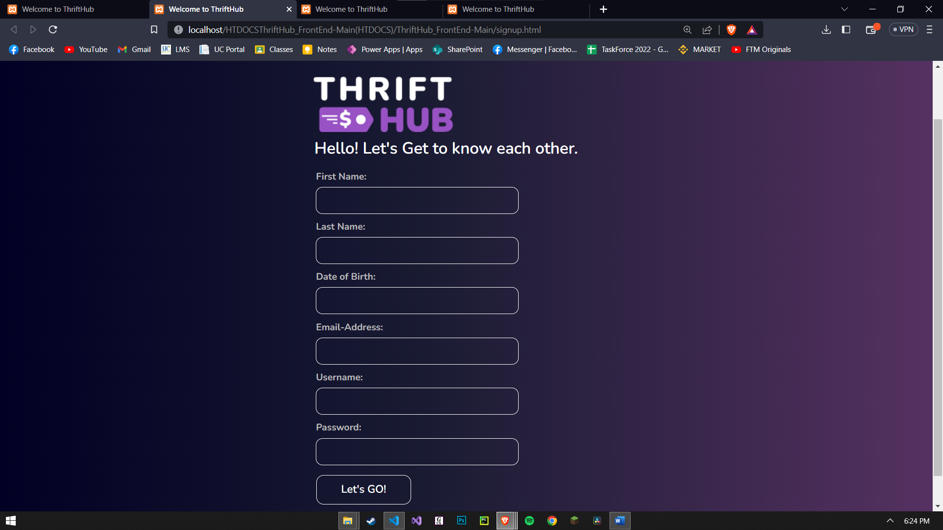

Remove remember me add underline sa forgot password para mura siyag clickable

:  
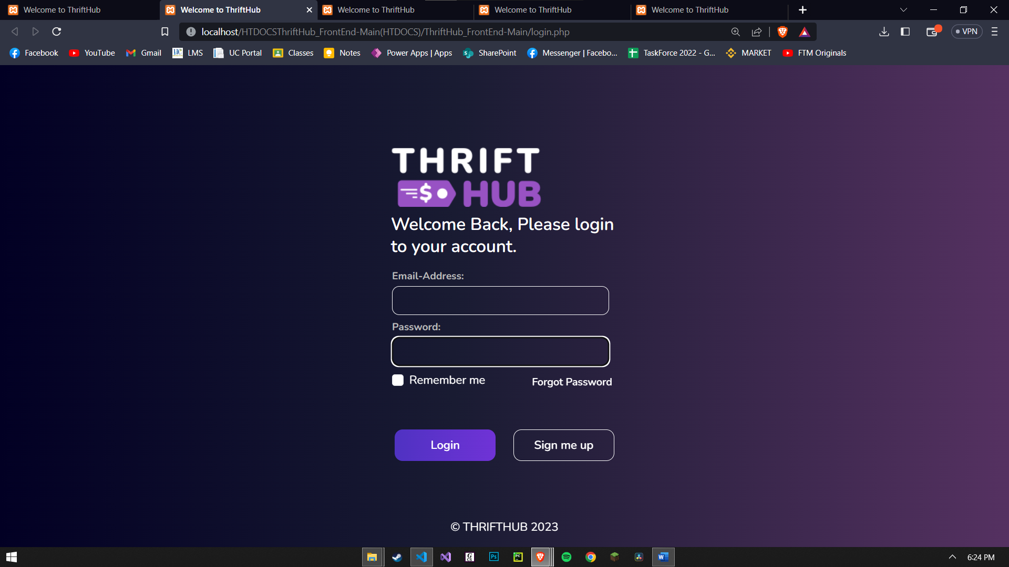

Lower gamay ang spacing niya, must be equal

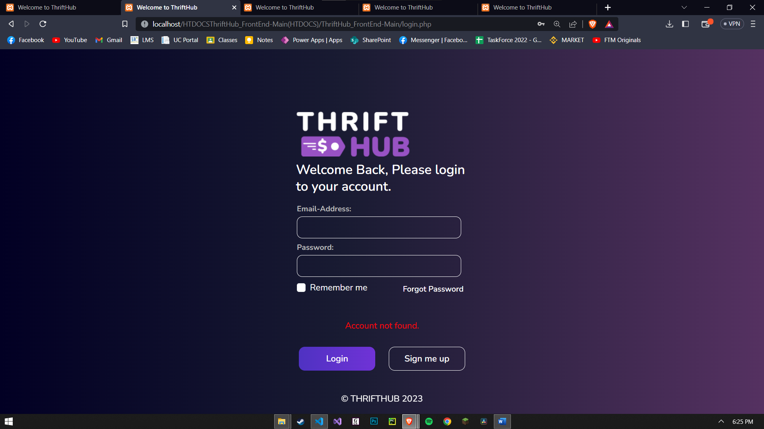

Fix the buttons, make it more appealing (be consistent sa buttons)  
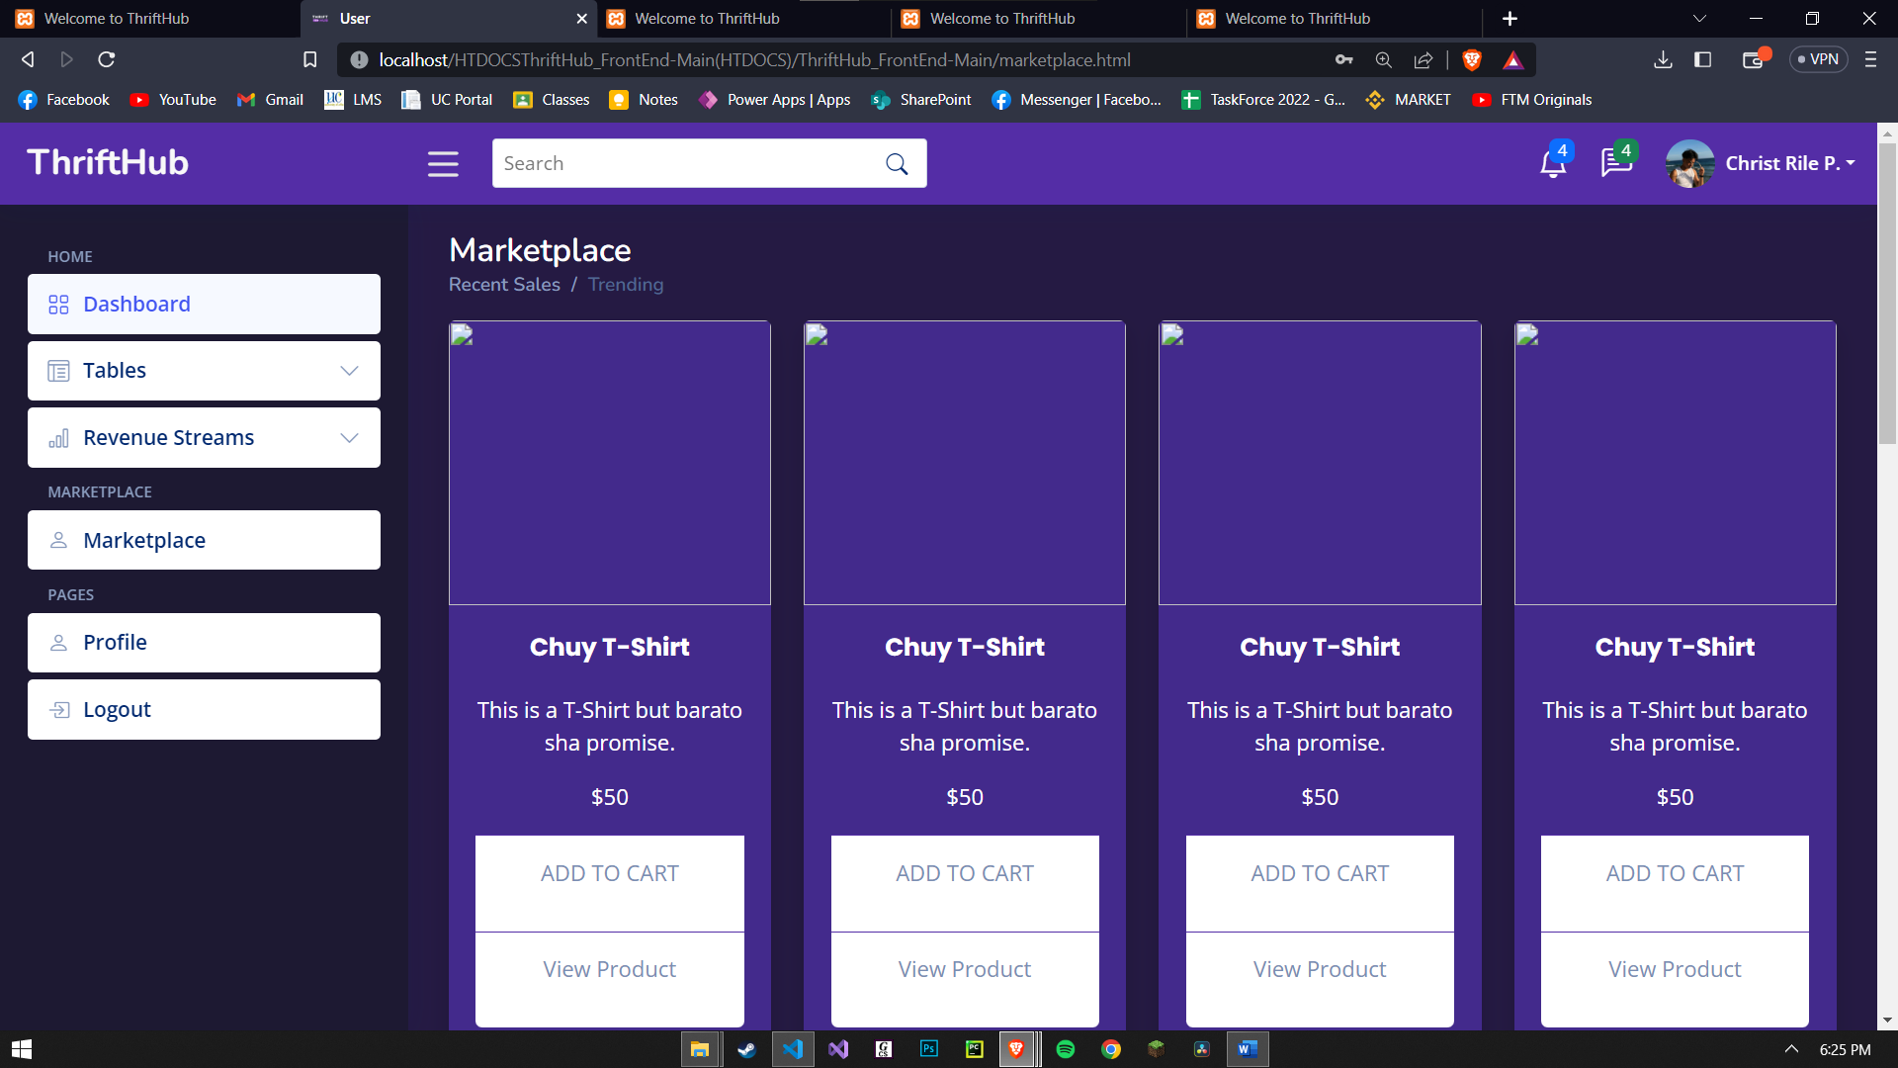

Add add to cart  


Delete revenue streams (Remember one account ra ang seller ug ang buyer)

Delete also dashboard, please refer to facebook marketplace sa functions, mura ratag facebook marketplace pero mas secured lang