PROJECT ON
HI-TECH COLLEGE MANAGEMENT SYSTEM

Developed by

Name : Rahul.E Reg. No.: R140030100722



HI-TECH COLLEGE MANAGEMENT SYSTEM

Batch Code: B140120

Start Date: 11-Feb-2014 End Date: 28-Feb-2014

Name of the Coordinator: Mrs Abitha

Name of the Developer: Rahul. E

Date of Submission: 02-March-2014

CERTIFICATE

This is to certify that this report, titled Hi-Tech College Management System, embodies the original work done by RAHUL.E in partial fulfilment of his course requirement at NIIT.

Coordinator: Mrs Abitha

Acknowledgement

I have benefitted a lot from the feedback and suggestions given to me by Mrs Abitha and other faculty members, and the machine room coordinator.

SYSTEM ANALYSIS

System Summary: The Hi-Tech College Management System involves the creation of a Web Application that will enables its users to:
When used by students to:
- View and update their details in a neat interface.
- View their attendance records.
- View their exam scores.
- View and register for courses online.
When used by teachers to:
- View the students that are appointed for them.
- Update the attendance of the students.
- Update the exam scores of the students.
When used by the administrator:
- To view, add, edit or delete student records.
- To view, add, edit or delete the courses available.
- To view, add, edit or delete the teachers employed.
- To view, add, edit or delete the information regarding the users who have access to the application.

Each of the three type of users are also able to change their passwords.
Hi-Tech College Management System has a computerized system in a place that maintains the details of all the students, courses, teachers and users. The proposed Web application will use the database created to obtain the above mentioned details. Some additional tables may have to be created in the database to accommodate the specific requirements of the Web application.

HARDWARE AND SOFTWARE REQUIREMENTS

Hardware: A node with PIII Processor(800 MHz or higher), SCSI Hard disk of 20GB, 256MB RAM, CDROM and
1-10/100 Mbps network card.

Operating System: Windows XP Professional with SP2.

Software: Microsoft Visual Studio 2008 Professional Edition, Microsoft Windows XP Service Pack (SP),
SQL Server 2008 Standard Edition.

INDIVIDUAL PROJECT SCHEDULE

S. No. | Activity Description | Planned Date of Completion | Actual Date | Responsibility | Remarks
1 | Creating the Login page | 11th Feb 2013 | 11th Feb 2013 | Rahul
2 | Creating the Home pages for all 3 user types | 12th Feb 2013 | 12th Feb 2013 | Rahul
3 | Creating the pages supporting Student user | 12th Feb 2013 | 12th Feb 2013 | Rahul
4 | Creating the pages supporting Teacher user | 13th Feb 2013 | 13th Feb 2013 | Rahul
5 | Creating the pages supporting the Administrator user | 13th Feb 2013 | 13th Feb 2013 | Rahul
6 | Creating a rich interface and fine tuning the web application | 14th Feb 2013 | 14th Feb 2013 | Rahul
7 | Creating the documentation and supporting information | 28th Feb 2013 | 28th Feb 2013 | Rahul

ACTIVITY DIAGRAM FOR VIEWING AND UPDATING STUDENT DETAILS

Login as student
Select the Student Profile link. Click on various buttons to see the required information
To update the details, click on Update Student Profile link
Change the details you wish to by correcting the details in the textboxes displayed
After editing, click on Submit button. The details are updated and you are redirected to Student Profile to view
ACTIVITY DIAGRAM FOR REGISTERING AND VIEWING COURSES ONLINE

Login as student
Select the Online Course Registration link. Click on the Edit button to view the course.
Click on the Update button to register for the course.
Select View Course Registration link to view the registered courses.

Click on Delete button, if you want to remove registration from any course.
ACTIVITY DIAGRAM FOR VIEWING ATTENDANCE SUMMARY AND EXAM REPORTS

Login as student
Select the Attendance Summary link. Click on various buttons to see the required information
Click on Home image at top to return to the Student’s Home
Select the Exam Reports link. Click on various buttons to see the required information

After viewing, click on the Key image to logout of the account.
ACTIVITY DIAGRAM FOR UPDATING ATTENDANCE/ EXAM SCORES

Login as teacher
Select the Update Attendance/Exam Scores. Click on various buttons to see the required information
To update the details, click on Edit link
Change the details you wish to by correcting the details in the textboxes displayed
After editing, click on Update link. The details are updated and the contents are refreshed
ACTIVITY DIAGRAM FOR VIEWING AND UPDATING USERS LIST

Login as administrator
Select the Users List link. Click on various buttons to see the required information
To update the details, click on Update Student Profile link. To add details, enter the information in the textboxes

Change the details you wish to by correcting the details in the textboxes displayed
After editing, click on Update link or Add Record button for new record. The details are updated or added and the contents are refreshed
USE CASE DIAGRAM FOR FUNCTIONALITIES AVAILABLE TO A STUDENT

<<include>>

View Student Profile
Update Student Profile
View Attendance
View Exam Reports
Course Registration
Change Password
Login
Student
<<include>>
<<include>>
<<include>>
<<include>>
<<include>>
USE CASE DIAGRAM FOR FUNCTIONALITIES AVAILABLE TO A TEACHER

<<include>>

View Student Lists
View Student Attendance
Update Student Attendance

View Student Exam Reports
Update Student Exam Reports
Change Password
Login
Teacher
<<include>>
<<include>>
<<include>>
<<include>>
<<include>>
USE CASE DIAGRAM FOR FUNCTIONALITIES AVAILABLE TO AN ADMINISTRATOR

<<include>>

View Student Lists
View Course Lists
View Teachers List

View Users List
Update All above Lists
Change Password
Login
Administrator
<<include>>
<<include>>
<<include>>
<<include>>
<<include>>

SNAPSHOTS

LOGIN PAGE:
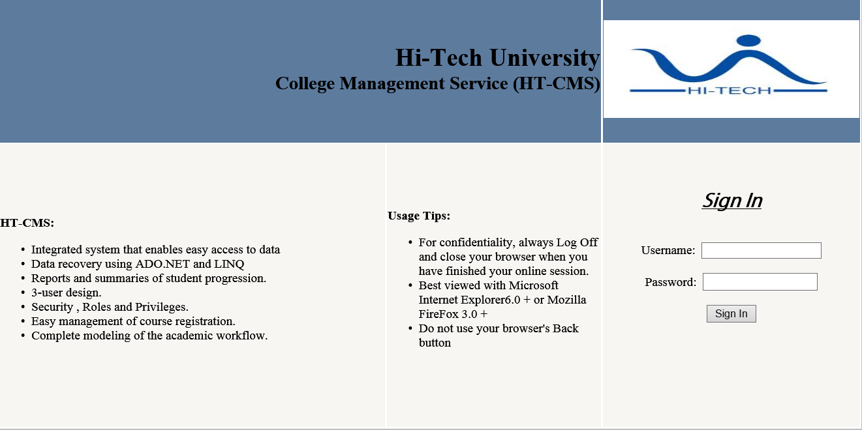

STUDENT HOME:

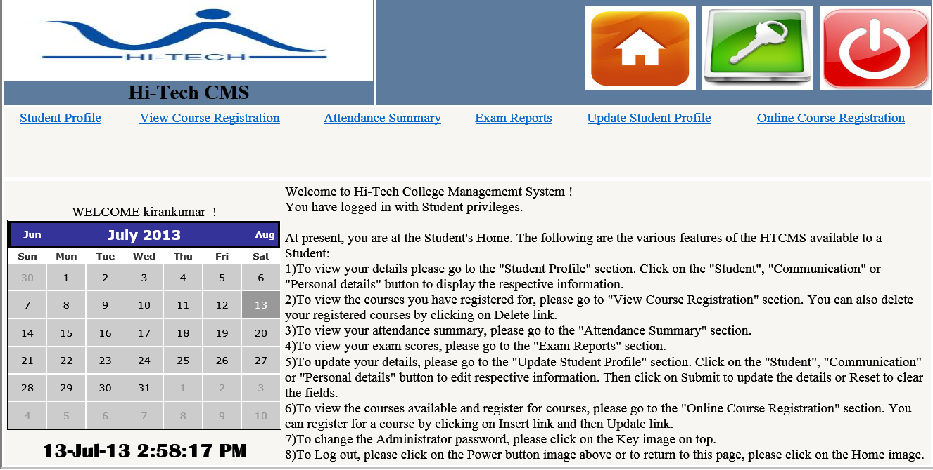

STUDENT PROFILE:

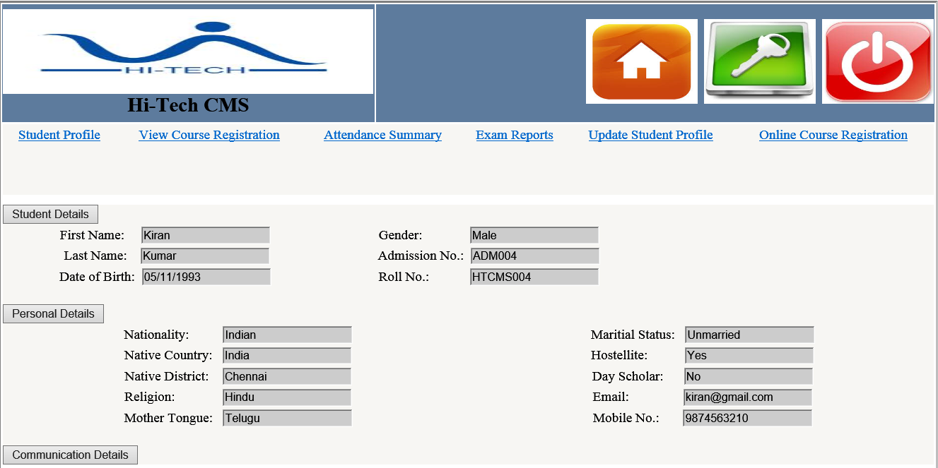

UPDATE STUDENT PROFILE:

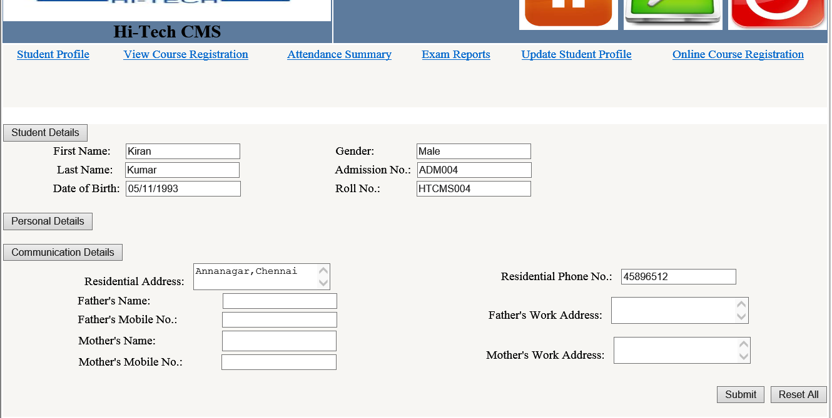

ATTENDANCE SUMMARY:

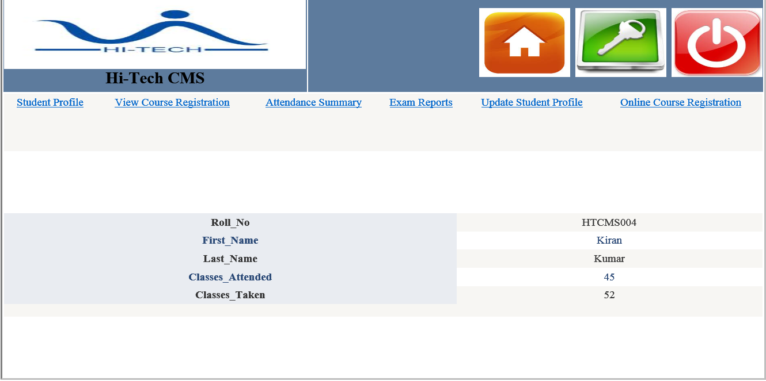

EXAM REPORTS:

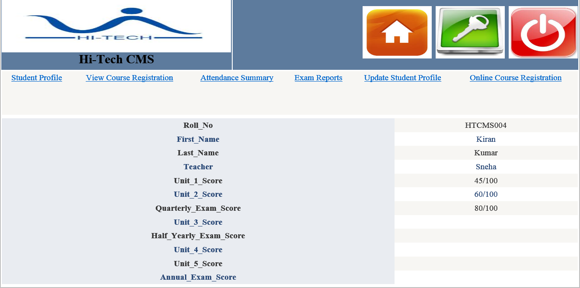

ONLINE COURSE REGISTRATION:

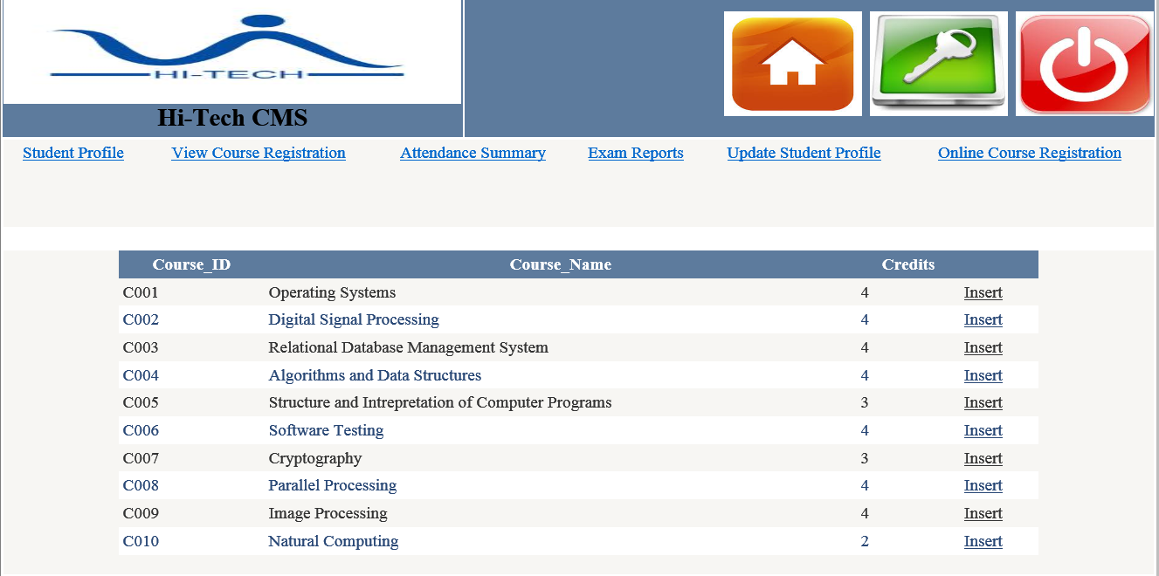

VIEW COURSE REGISTRATION:

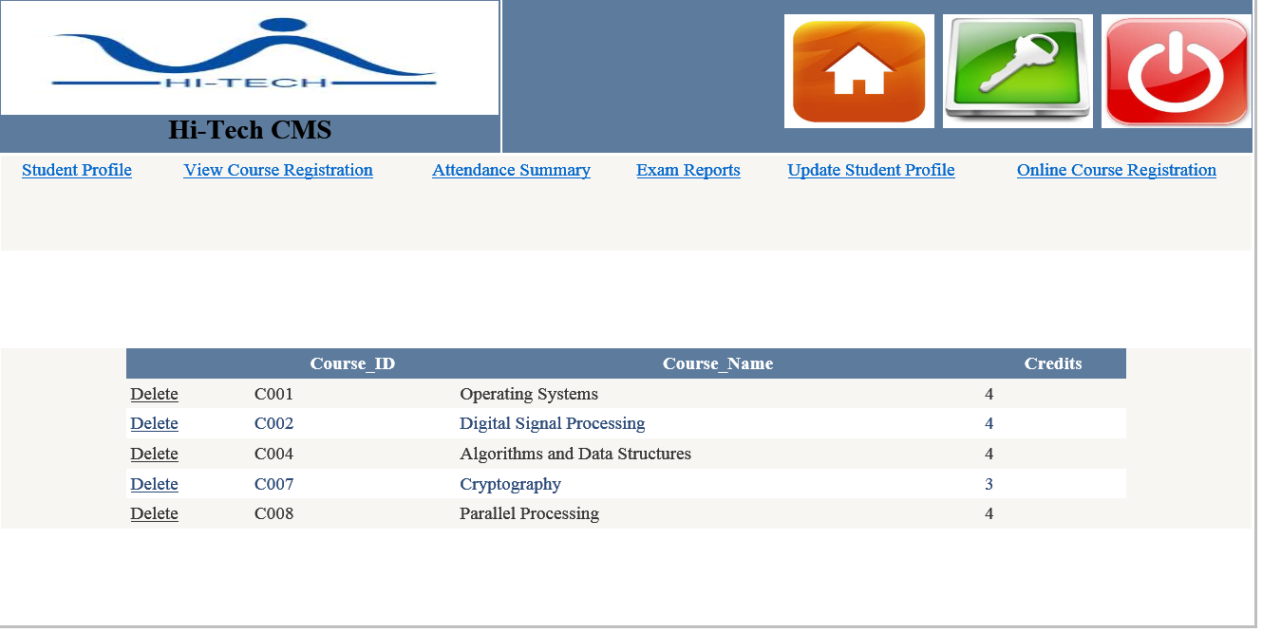

TEACHER HOME:

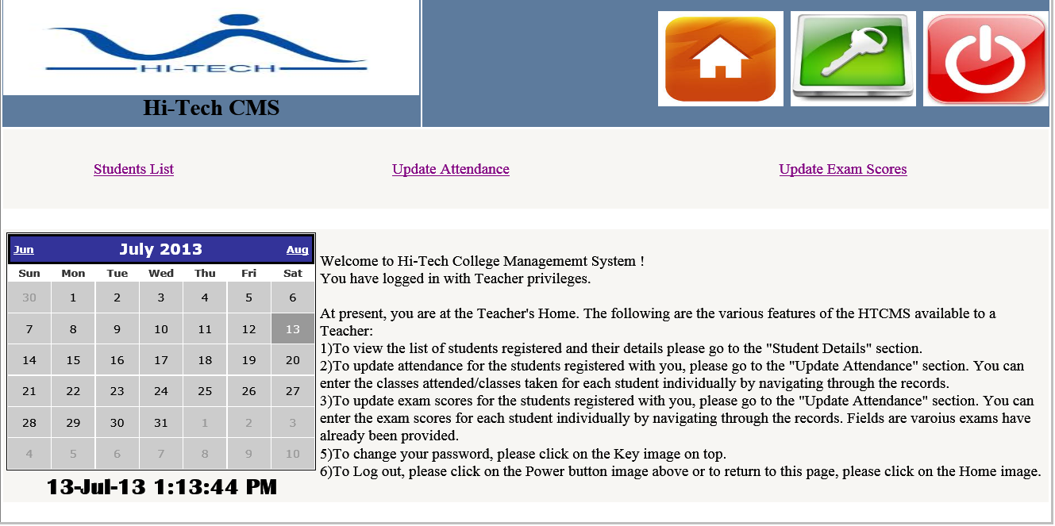

STUDENTS LIST:

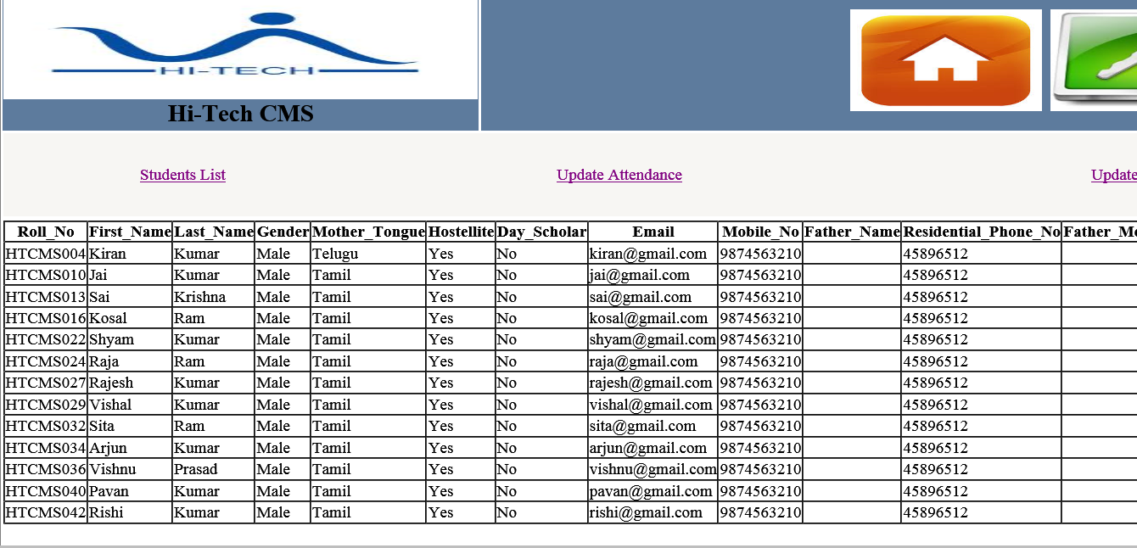

UPDATE ATTENDANCE:
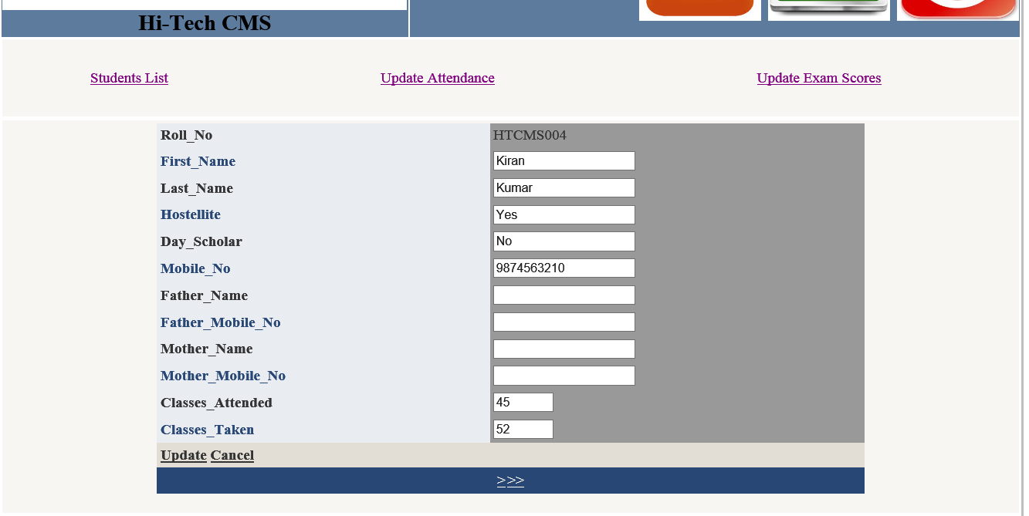

UPDATE EXAM SCORES:

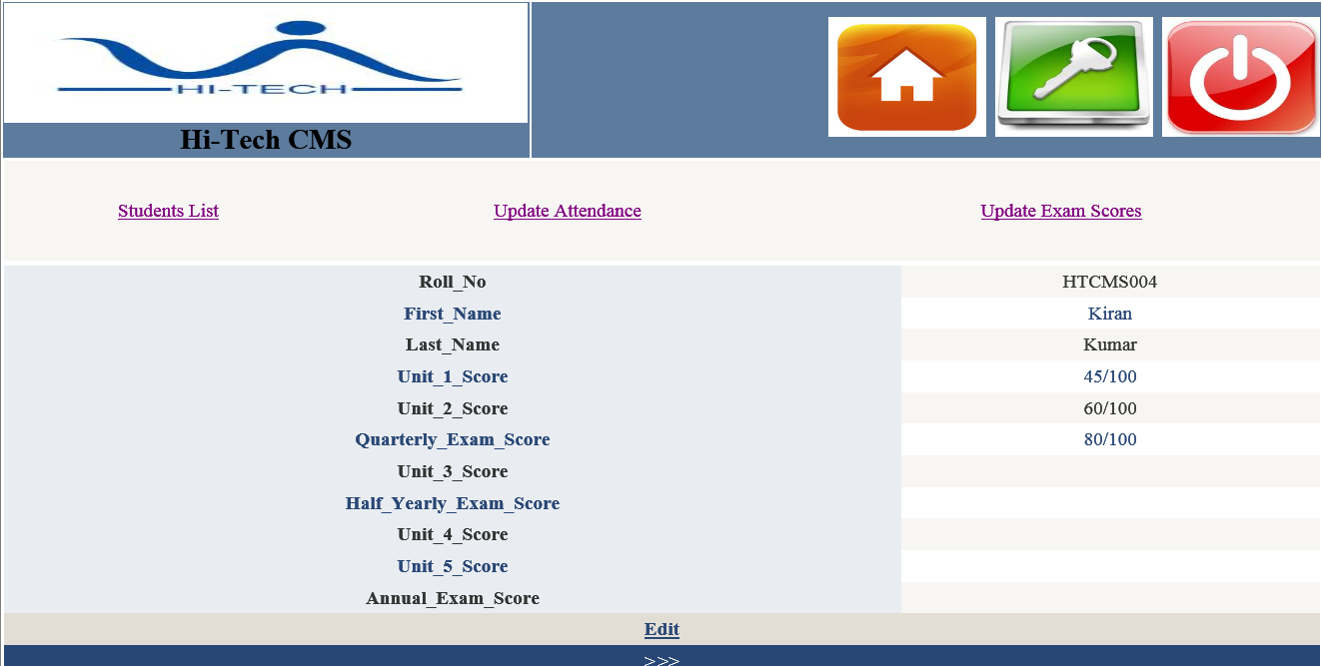

ADMINISTRATOR HOME:

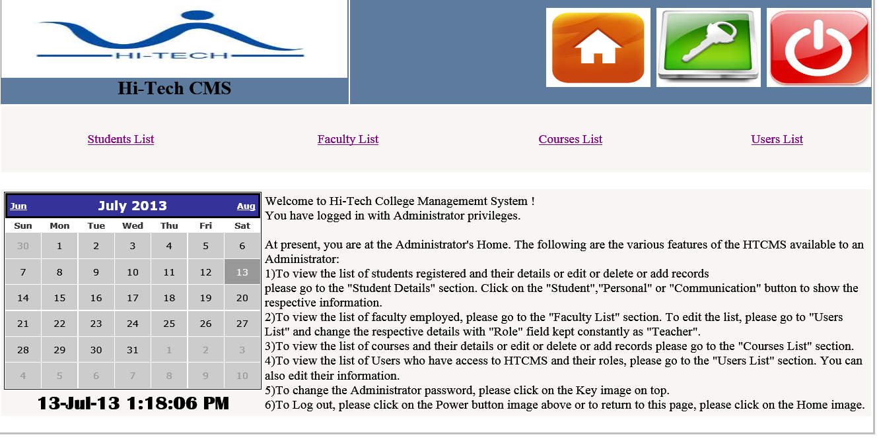

STUDENTS LIST:

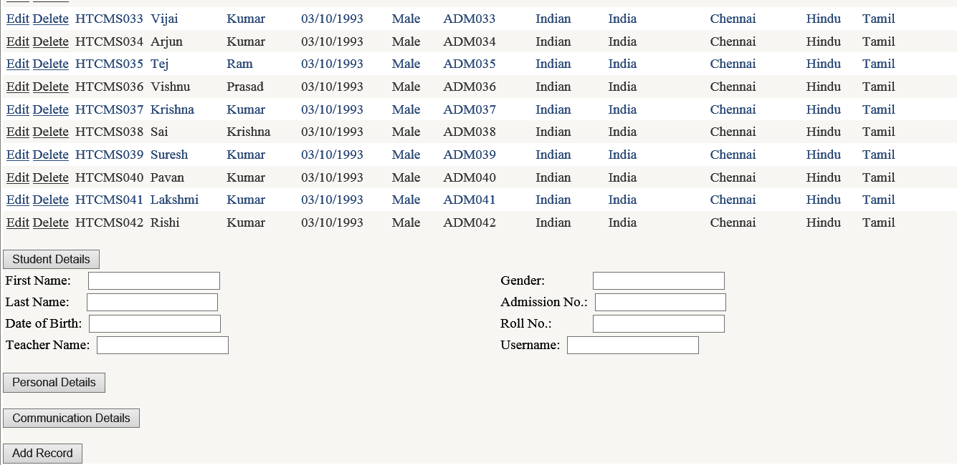

FACULTY LIST:
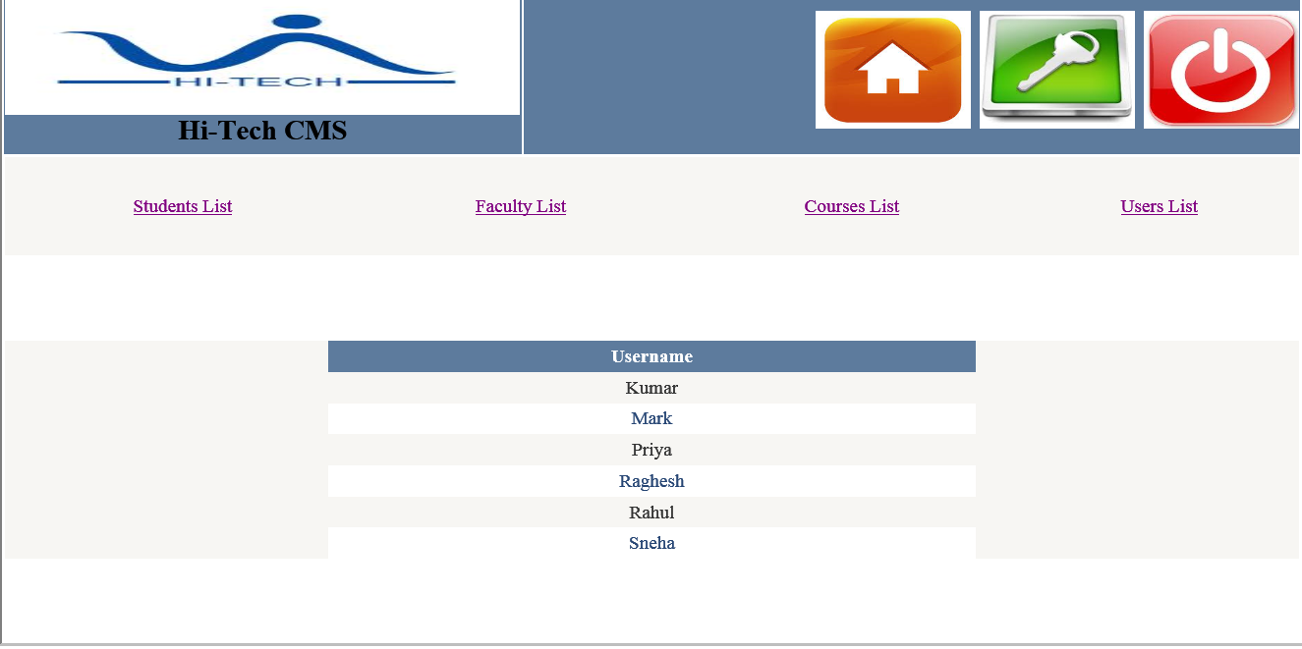

COURSES LIST:

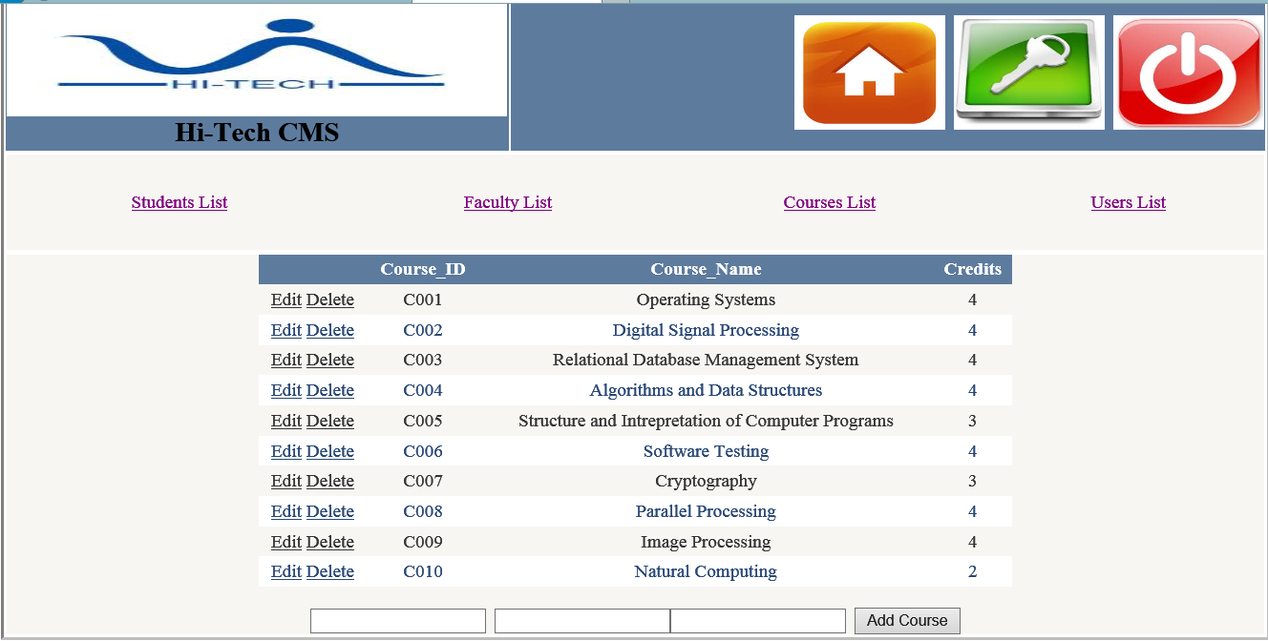

USERS LIST:

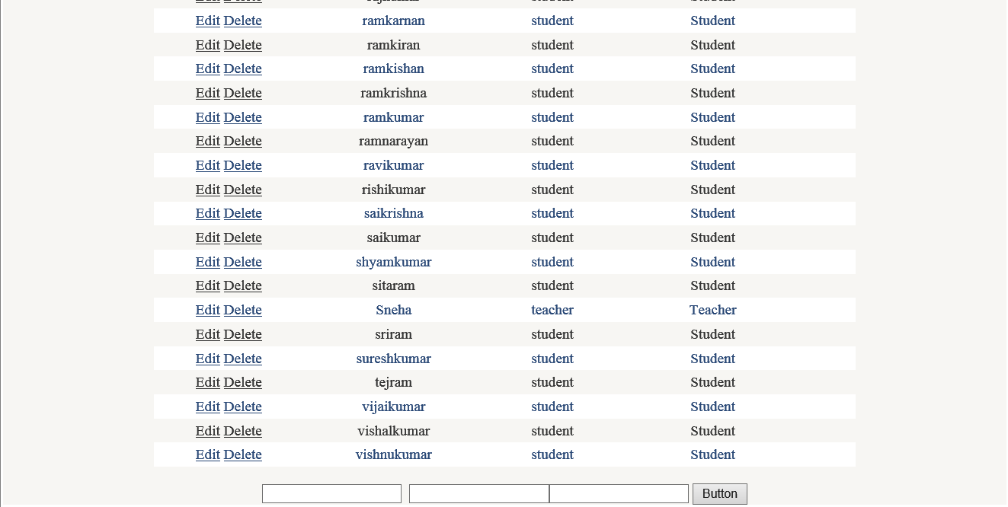

CHANGE PASSWORD:
