Summer 2018
COCOMO Team
FINAL REPORT
YULIE FELICE, SHRIRAKSHA RAO, RAHUL ETHIRAJ

Project Objective
The main objective of the project was to fix the bug after regression testing and to implement the feature that is present in old COCOMO version to the newer COCOMO II Java version. We implemented all the feature present in the old model so that the project can be used by the customers for cost estimation.
The following section describe in detail about task accomplished and functionalities added:

Software Development

Post Architectural/Early Design model drop down.
- Started with the Early Design model implementation of COCOMO II, two forms for effort estimation selection and default values were created.
- Added the PM equation to the equation form for the user’s reference.
- Created a drop-down menu to select between Post Architectural and Early Design model
The major difference between them is in the number of effort estimators (Cost drivers).
- The cost drivers in early design model are combined cost drivers of post architectural model.
RCPX - RELY, DATA, CPLX, DOCU
RUSE- RUSE
PDIF - TIME, STOR, PVOL
PERS - ACAP, PCAP, PCON
FCIL - TOOL, SITE
SCED - SCED
- The rating for each Early Design cost drivers varies from Extra Low to Extra High.

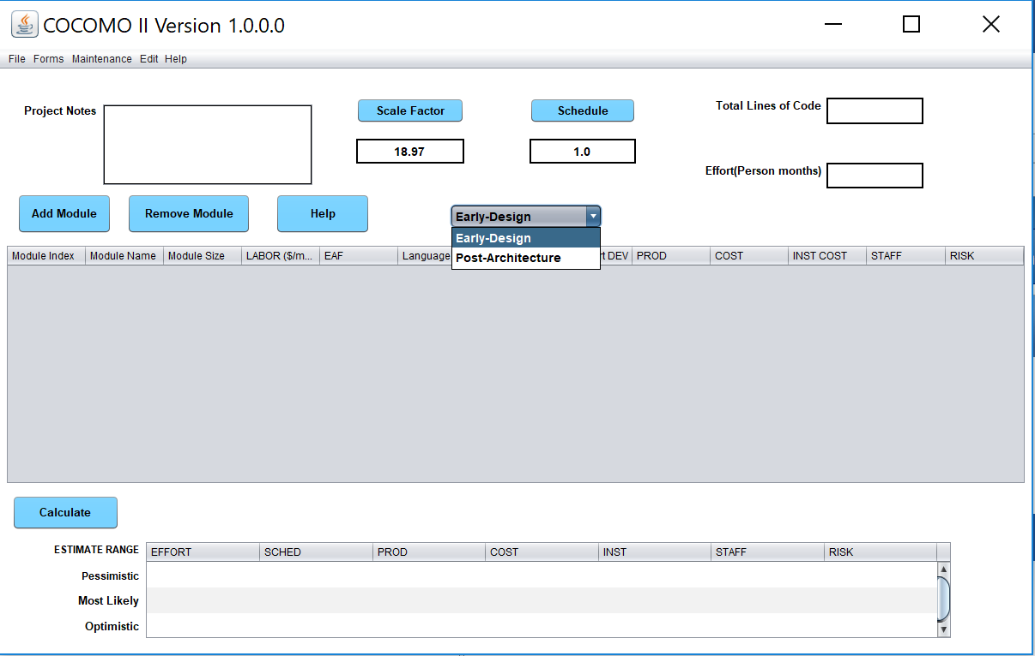

Update the button color on the main dashboard to light blue to increase readability.

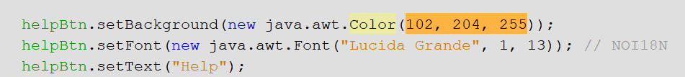

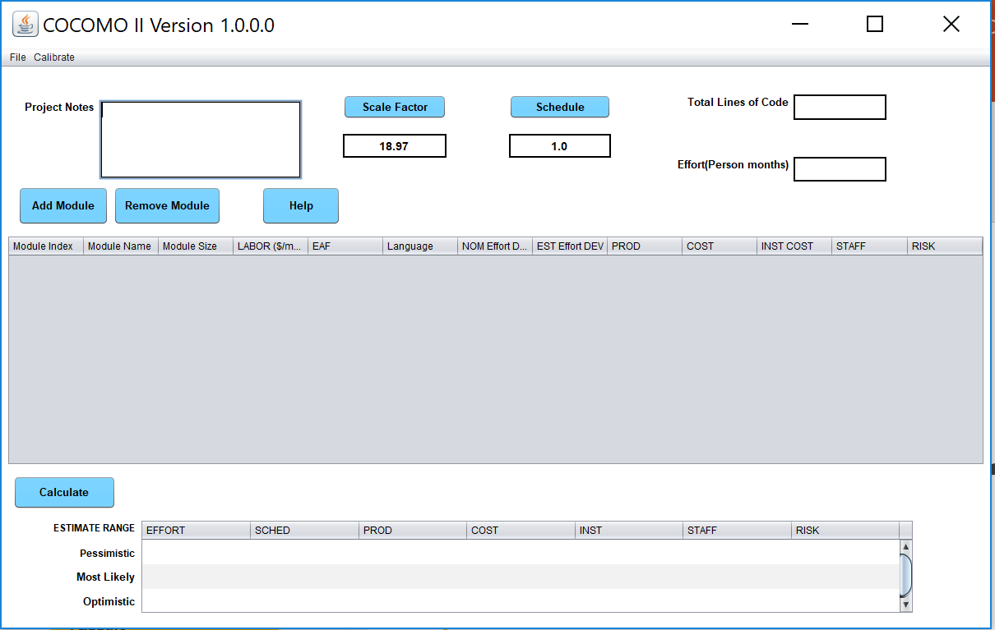

Help Menu

- Previously, help button hand restriction that Manual file has to be present in dist/lib folder for the help button to work properly
- We have modified this functionality by opening the manual directly on the browser to enhance the user experience
- Additionally, the credit window is added which highlights the contributor of COCOMO II Java version

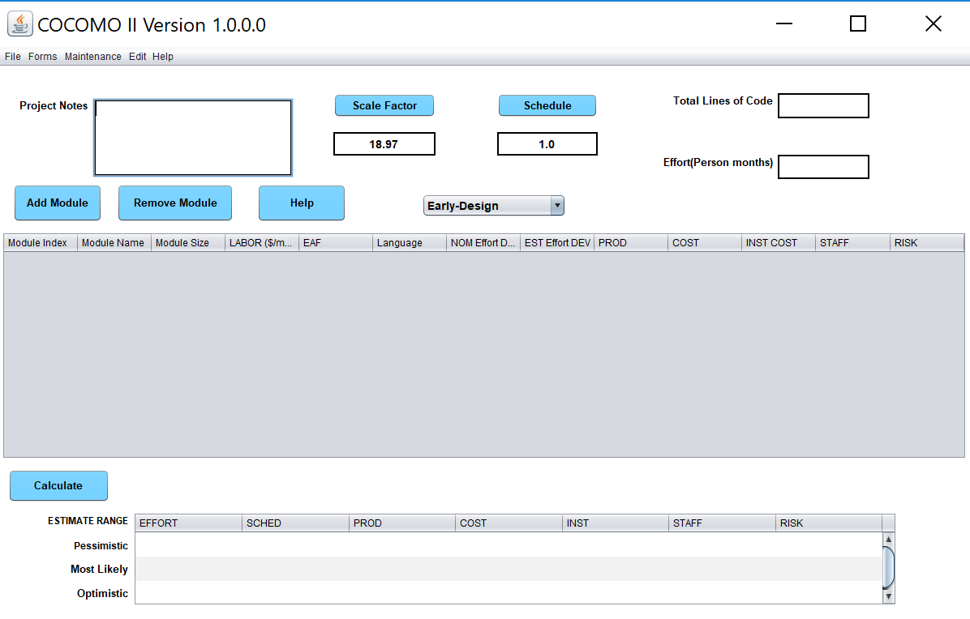

Addition of the credit window:

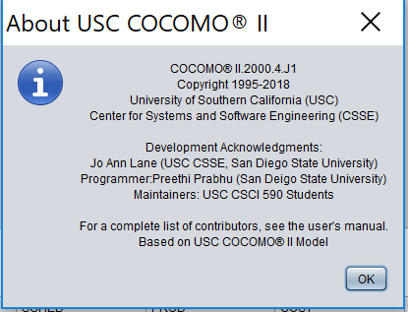

Edit Menu

- The Edit button functionality which include Cut, Copy, Paste, Add Module, remove module and Calculate were added.

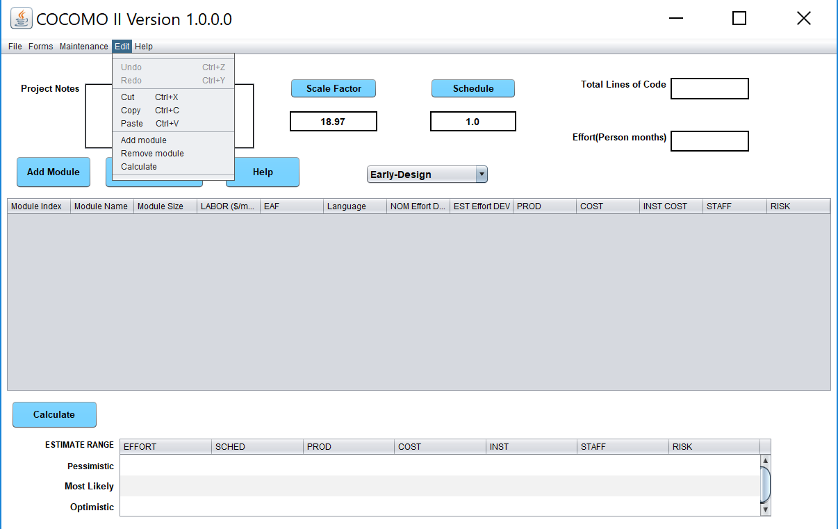

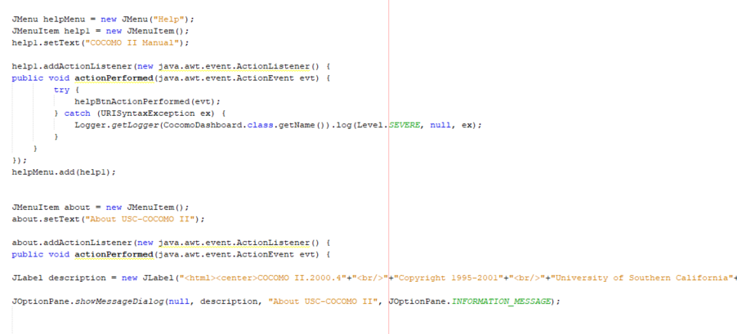
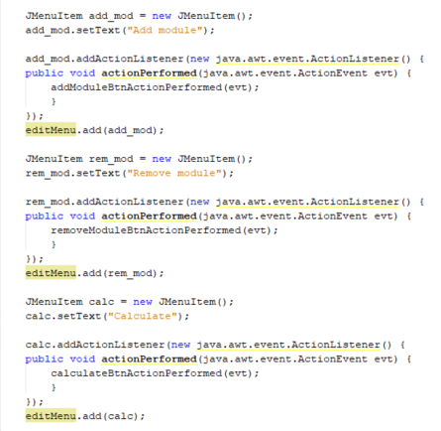

Maintenance
- Maintenance is the major feature that we have implemented in addition to Early Design model implementation.
- In this feature we have put together the Module and Project maintenance functionality.
- User has to add modules in order to modify the maintenance parameter.

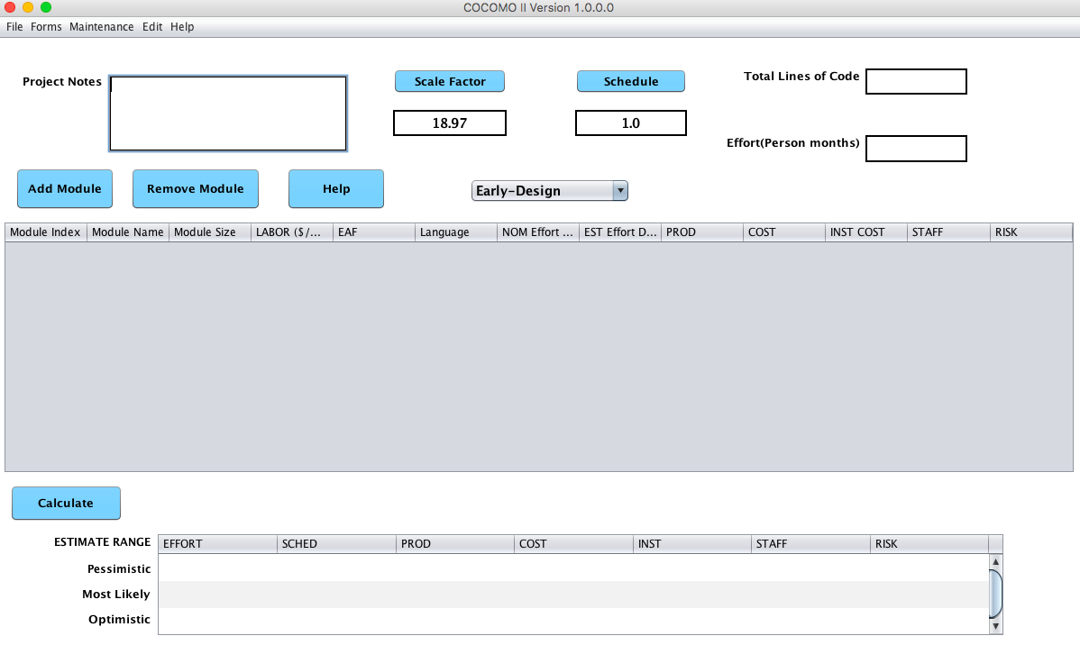

- Additionally, the maintenance is applicable to Post Architectural model as a result of which the maintenance item in the menu bar was disabled for Early Design model.

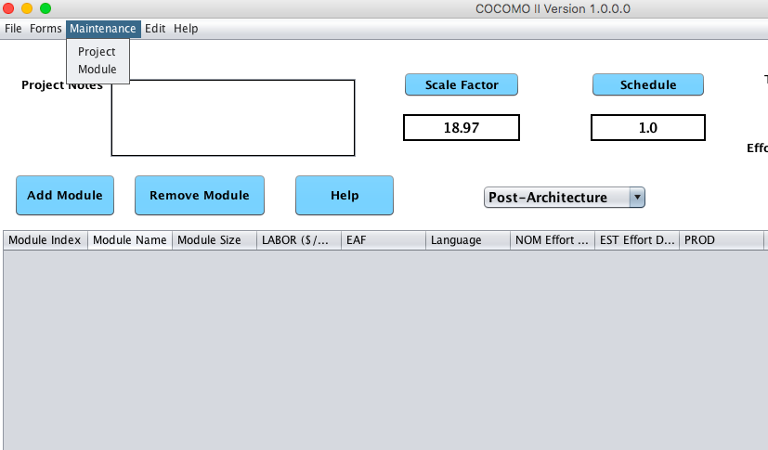

- The maintenance feature is disabled when user choose Early-Design model

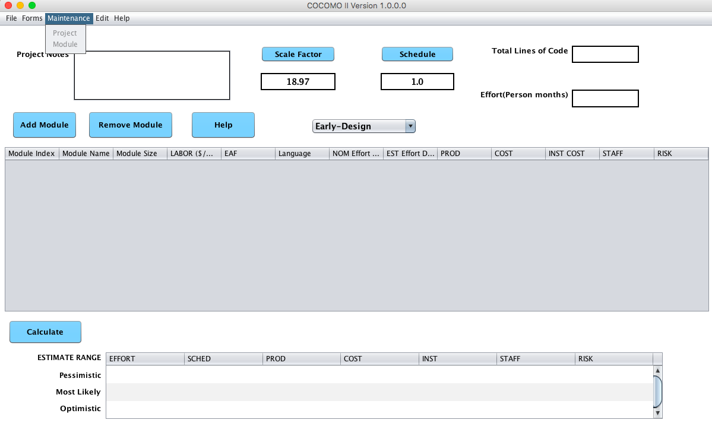
- Based on the preference user can choose any one module at time.
User can also update the maintenance details via this form.

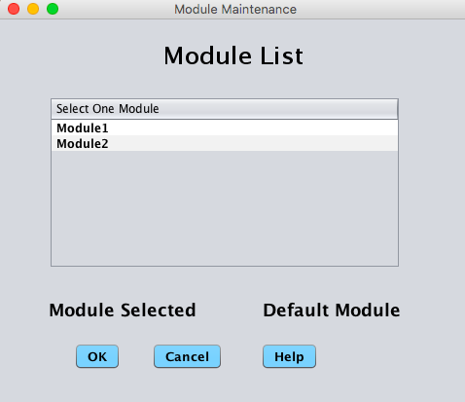

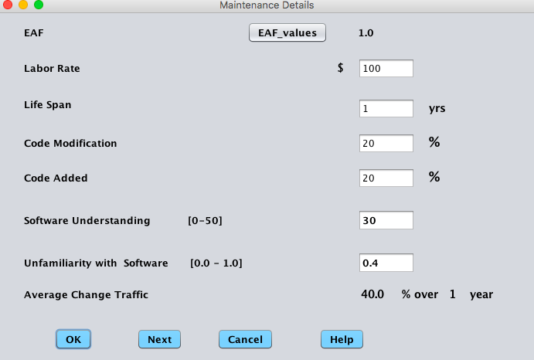

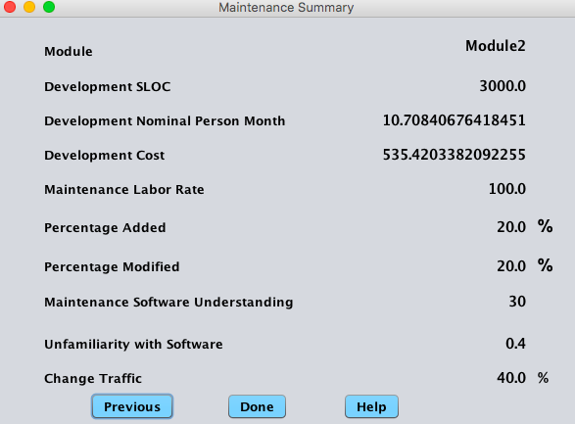

- Cumulative results are shown under Maintenance -> Module:

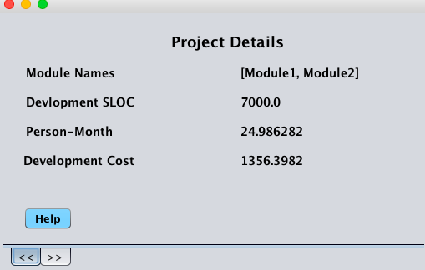

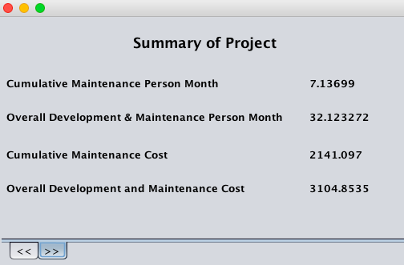

Print Screen

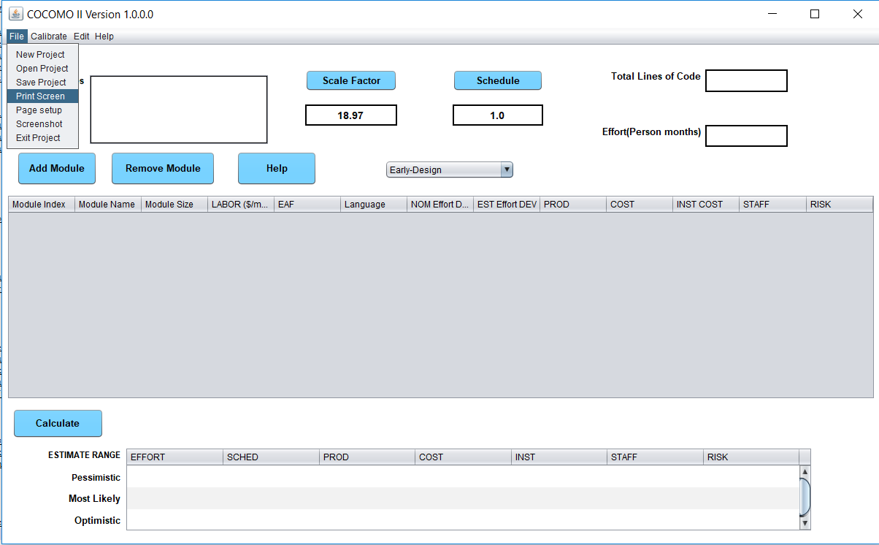

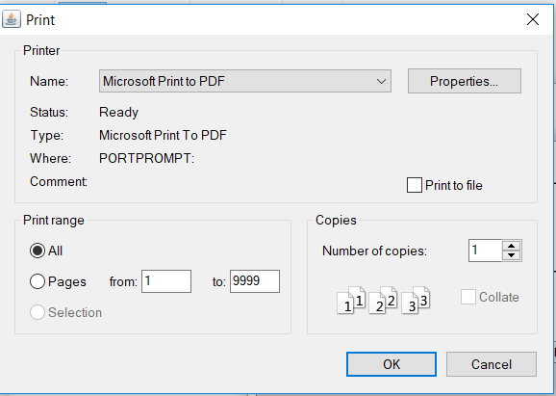

Page Setup

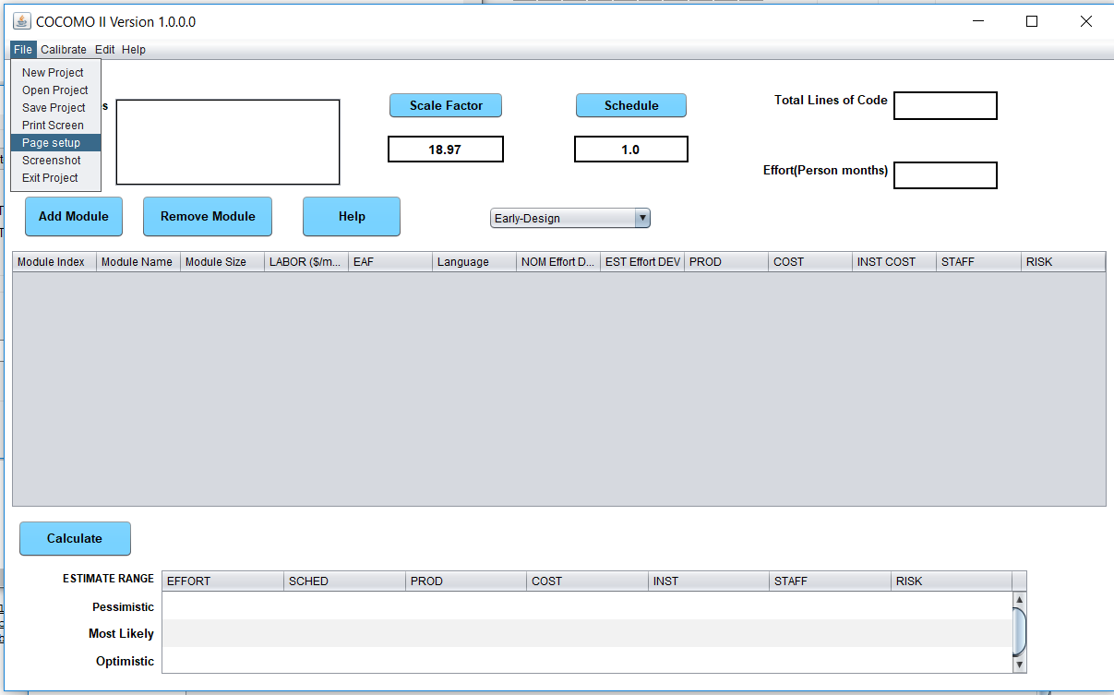

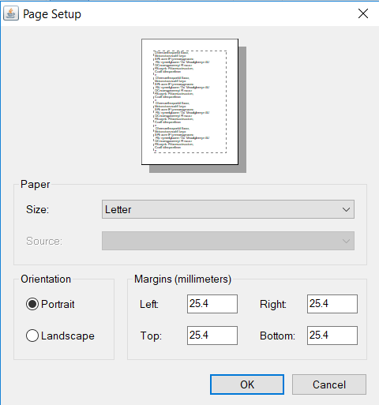

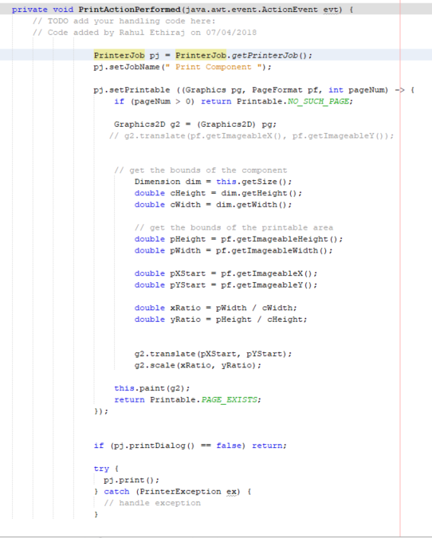

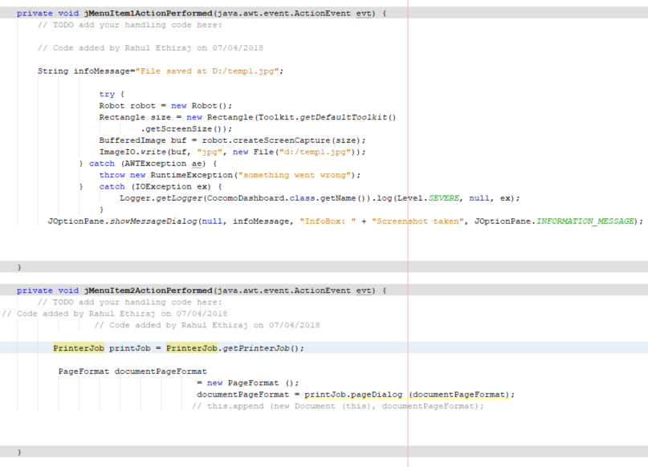

Screenshot

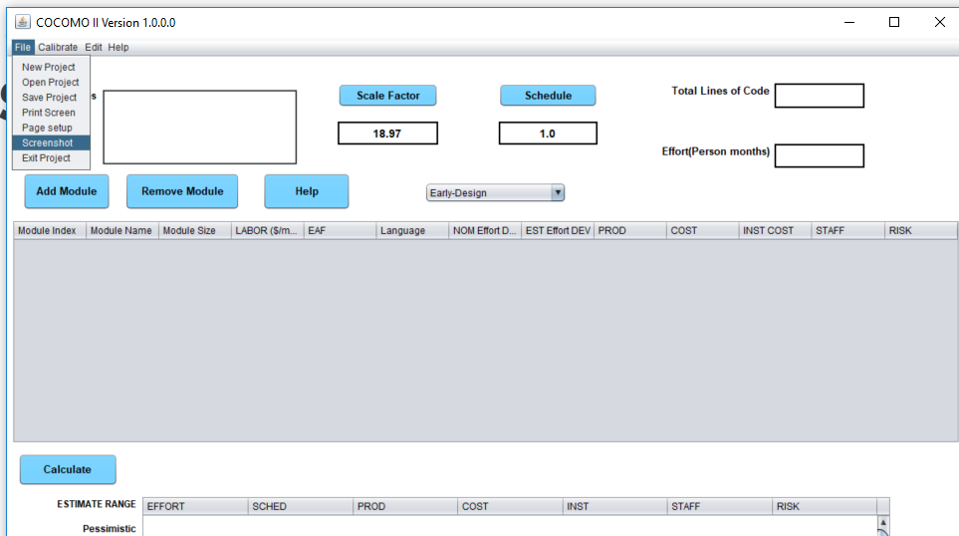

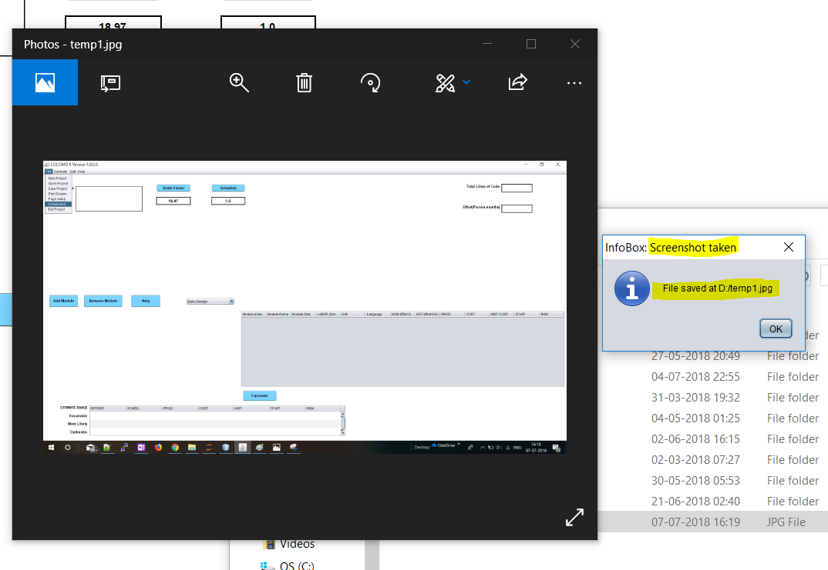

Bug Fixes

Number Format Exception in the SLOC text input.
Description:
There is no response after clicking OK button when inputting a big number in the SLOC text field such as 999999999999999999999999999999999999999999999. No error message is displayed. If the number is out of the allowed range but is still smaller (for example: 10000000) a pop-up error telling the user to input a number between 0 and 9999999 appears. The exception below appears on the terminal when the issue is observed:

Exception in thread "AWT-EventQueue-0" java.lang.NumberFormatException: For input string: "999999999999999999999999999999999999999999999999999999“

*Note: the same behavior is also observed for the DM, CM, IM and AT text fields

Solution:

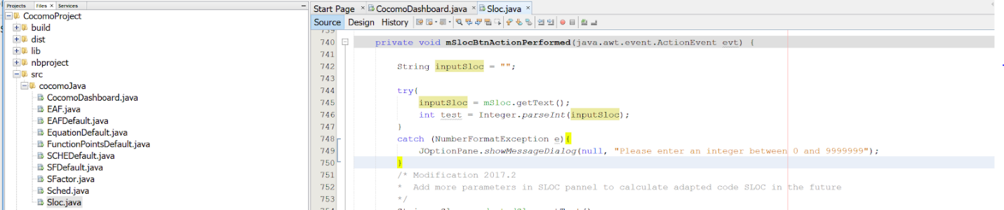

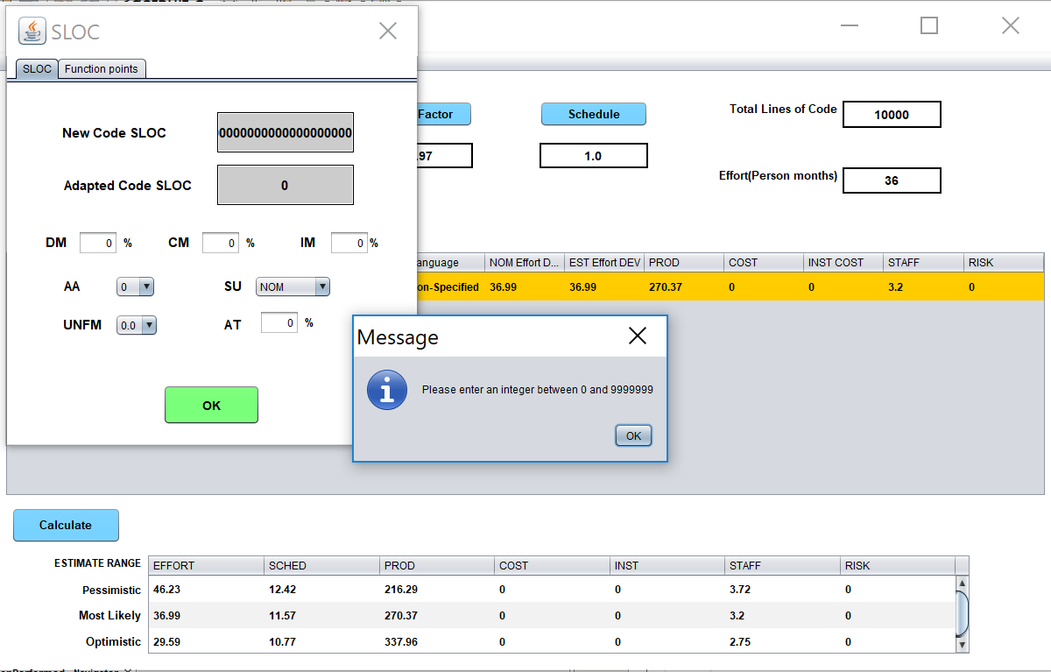
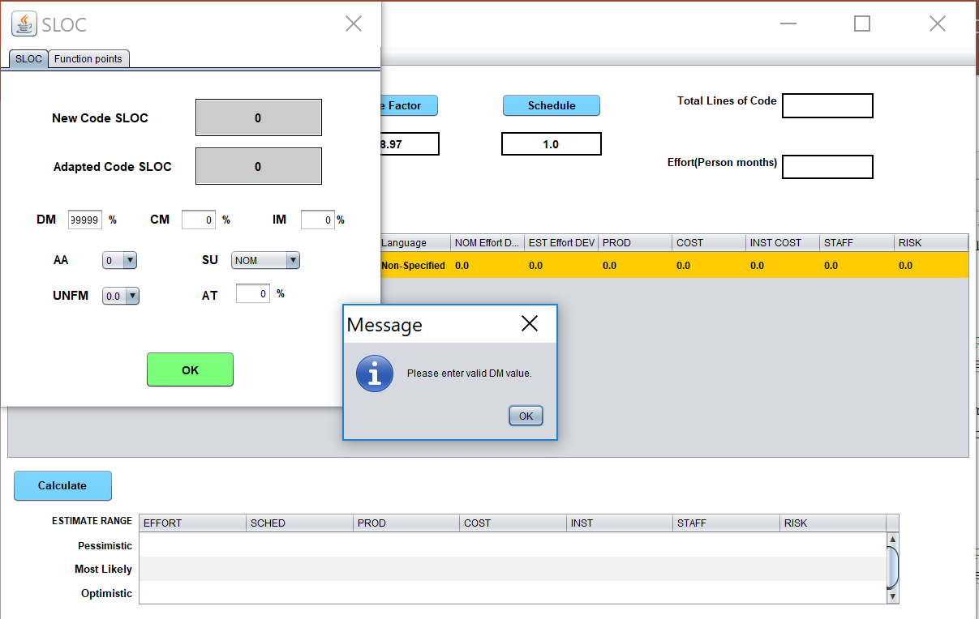

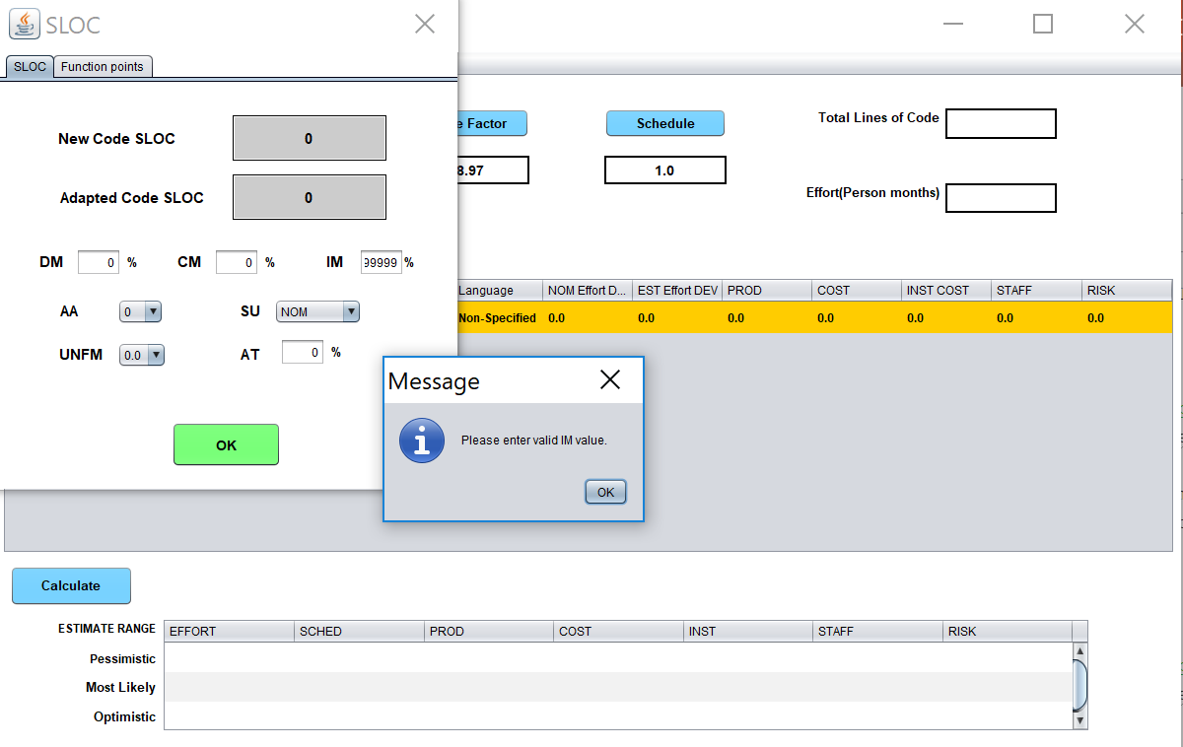

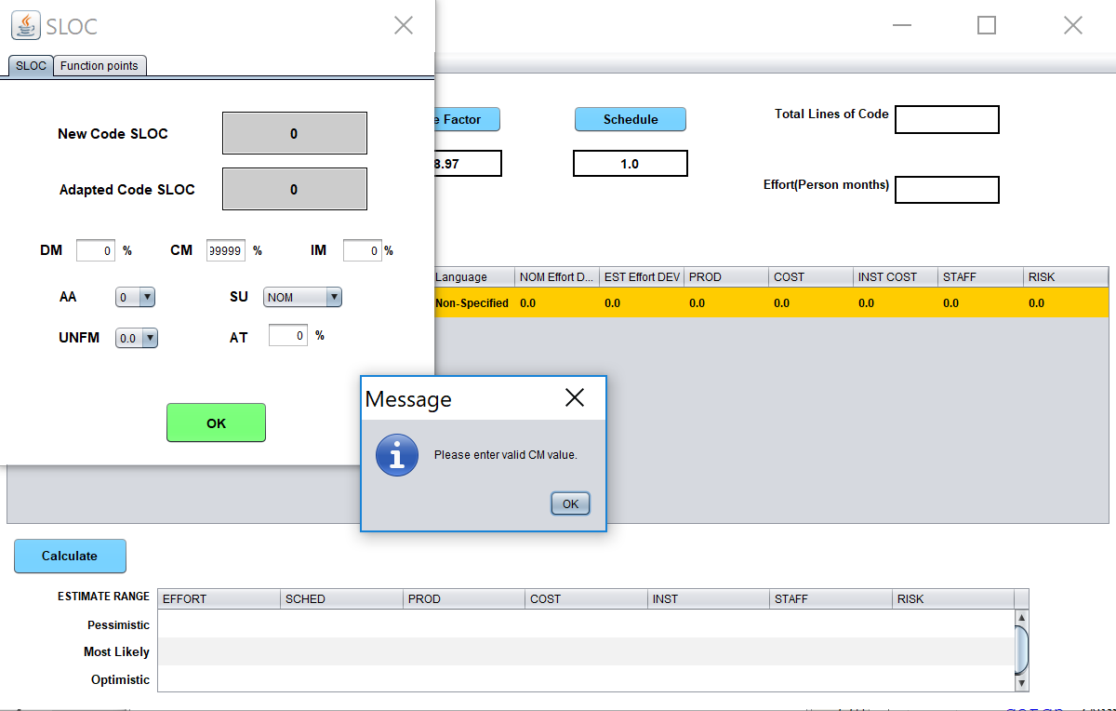

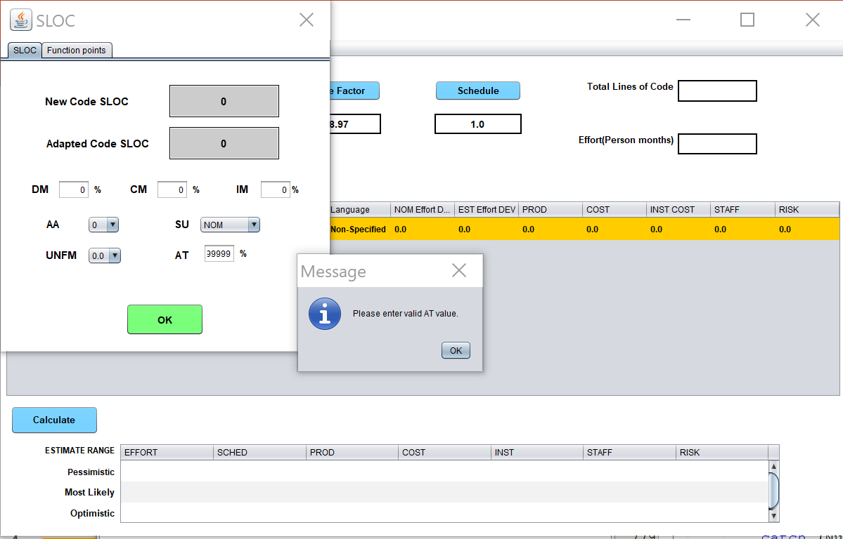

Help Button functionality
Description:
- Help button was giving exception when clicked
- Fixed this error and gave the path directly to the manual found in CSSE website.

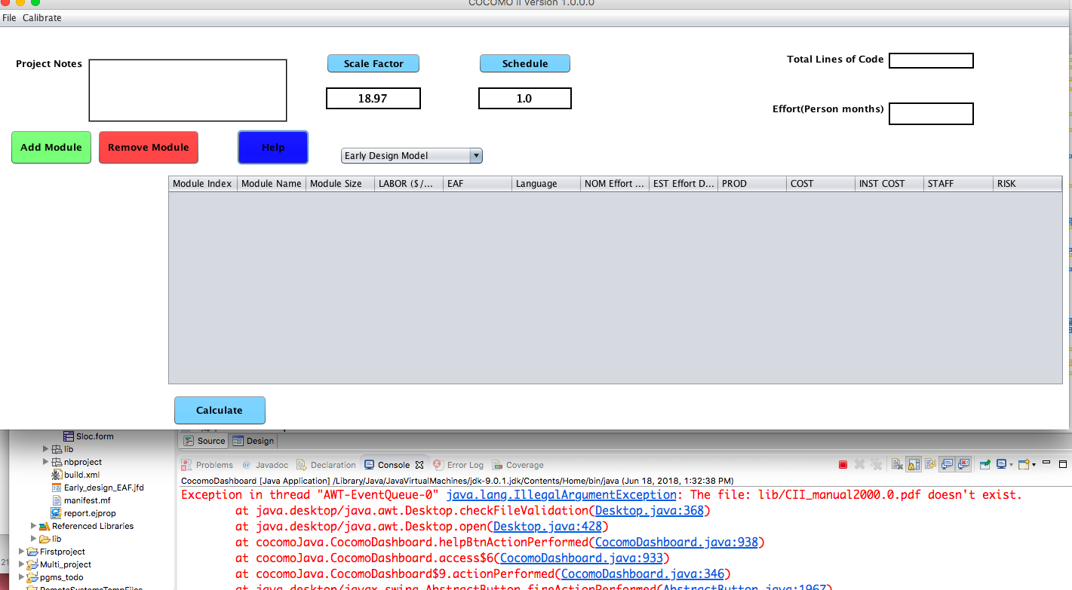
Solution:
Opens the manual in browser directed to URL: http://csse.usc.edu/csse/affiliate/private/COCOMOII_Driver+Calc_Ss/Manual-PostArch2000.pdf

EAF labels are not aligned with the drop-down field.
Description:
The labels on the EAF window seem to have their position fixed to the right side of the window.
This causes them to be misaligned to the respective drop -own menus as the window size is stretched, impacting user experience.

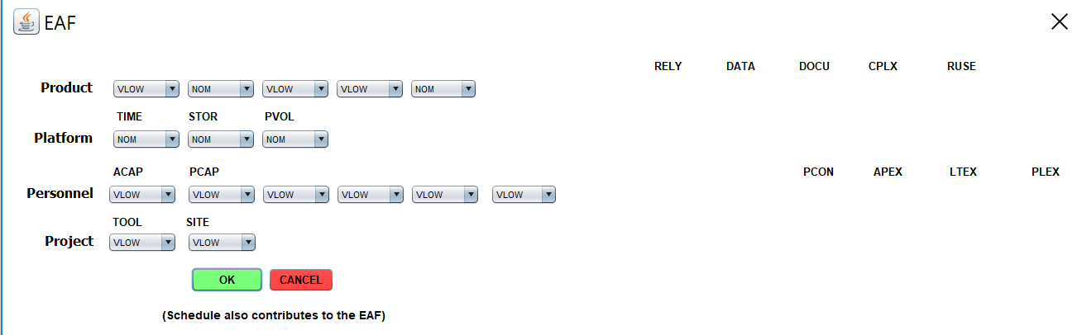

Solution:
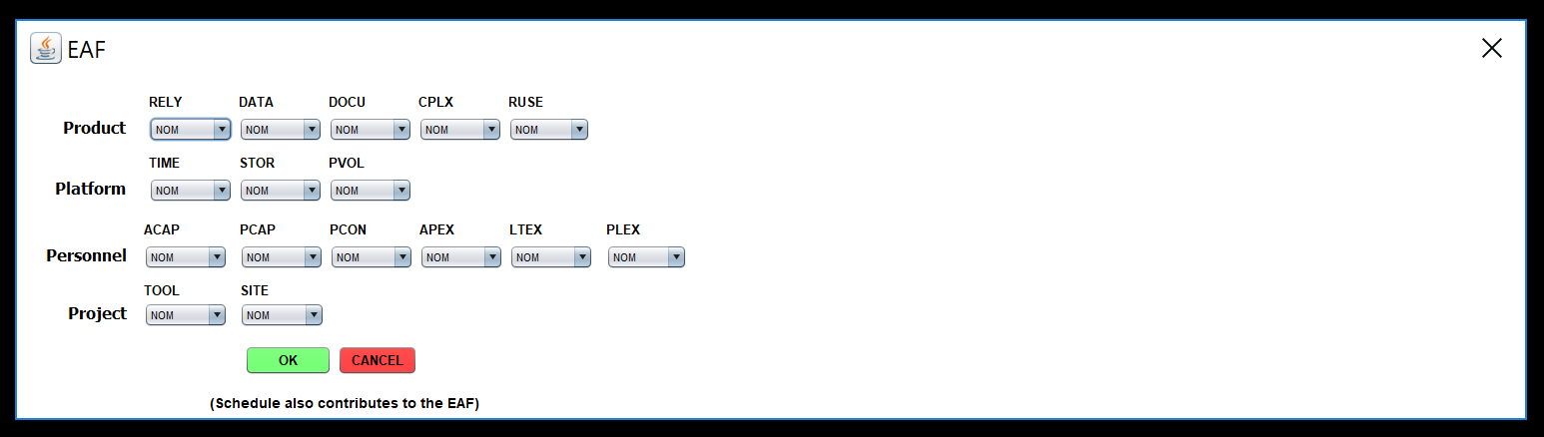

Wrong equation in the Equation form.
Description:
- In the equation for Person month the size factor has to be raised to the power of E.
- This modification will not have any effect in the person month calculation.

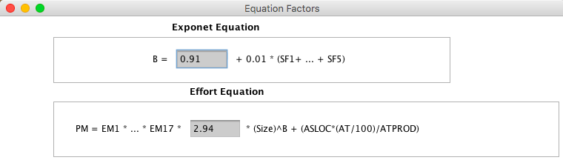

Solution:
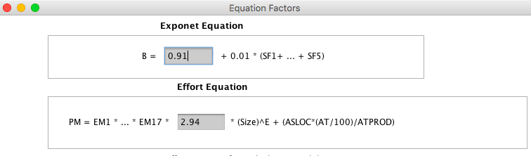

Software Testing

Calculation Result Test

- Person Month and Cost estimation for Early Design model

- Scale Factors and Effort Multipliers set to Extra Low
- Scale Factors and Effort Multipliers set to Very Low
- Scale Factors and Effort Multipliers set to Low
- Scale Factors and Effort Multipliers set to Nominal
- Scale Factors and Effort Multipliers set to High
- Scale Factors and Effort Multipliers set to Extra High
Test no | 1 | 2 | 3 | 4 | 5 | 6 | 7
SLOC | 9999999 | 9999999 | 9999999 | 9999999 | 9999999 | 99999999 | 99999999
Labor | 8000 | 8000 | 8000 | 8000 | 8000 | 8000 | 8000
Level | Extra low | Very Low | Low | Nominal | High | Very High | Extra High
Scale Factor
PREC | NOM | 6.20 | 4.96 | 3.72 | 2.48 | 1.24 | NOM
FLEX | NOM | 5.07 | 4.05 | 3.04 | 2.03 | 1.01 | NOM
RESL | NOM | 7.07 | 5.65 | 4.24 | 2.83 | 1.41 | NOM
TEAM | NOM | 5.48 | 4.38 | 3.29 | 2.19 | 1.10 | NOM
PMAT | NOM | 7.80 | 6.24 | 4.68 | 3.12 | 1.56 | NOM
EM
PERS | 2.12 | 1.62 | 1.26 | 1 | 0.83 | 0.63 | 0.5
RCPX | 0.49 | 0.6 | 0.83 | 1 | 1.33 | 1.91 | 2.72
PDIF | NOM | NOM | 0.87 | 1 | 1.29 | 1.81 | 2.61
PREX | 1.59 | 1.33 | 1.12 | 1 | 0.87 | 0.74 | 0.62
FCIL | 1.43 | 1.3 | 1.1 | 1 | 0.87 | 0.73 | 0.62
RUSE | NOM | NOM | NOM | NOM | 1.07 | 1.15 | 1.24
SCED | NOM | 1.43 | 1.14 | 1 | 1 | 1 | NOM
Manual Cal | 173803.8072 | 566706.3 | 159342.71 | 73645.681 | 47320.042 | 31008.521 | 124461.2
Cocomo II (Mac) | 173803.81 | 567273.63 | 159342.88 | 73645.68 | 47320.04 | 31008.52 | 124461.2
COCOMO II (Windows) | 173803.81 | 567273.63 | 159342.88 | 73645.68 | 47320.04 | 31008.52 | 124461.2
COCOMO II (Linux) | 173803.81 | 567273.63 | 159342.88 | 73645.68 | 47320.04 | 31008.52 | 124461.2

- Maintenance
- Parameters set to Very Low
- Parameters set to Low
- Parameters set to Nominal
- Parameters set to High
- Parameters set to Very High
- Mix parameters (Column 6)
Test no | 1 | 2 | 3 | 4 | 5 | 6
SLOC | 9,999,999 | 9,999,999 | 9,999,999 | 9,999,999 | 9,999,999 | 9,999,999
Labor [$/month] | 8,000.00 | 8,000.00 | 8,000.00 | 8,000.00 | 8,000.00 | 8,000.00
Code Modified [%] | 20.00 | 20.00 | 20.00 | 20.00 | 20.00 | 20.00
Code Added [%] | 20.00 | 20.00 | 20.00 | 20.00 | 20.00 | 20.00
SU | 30.00 | 30.00 | 30.00 | 30.00 | 30.00 | 30.00
UNFM | 0.40 | 0.40 | 0.40 | 0.40 | 0.40 | 0.40
MAF | 1.12 | 1.12 | 1.12 | 1.12 | 1.12 | 1.12
Adjusted size | 4,479,999.55 | 4,479,999.55 | 4,479,999.55 | 4,479,999.55 | 4,479,999.55 | 4,479,999.55
Scale Factor
Level | VL | L | N | H | VH | VL
PREC | 6.20 | 4.96 | 3.72 | 2.48 | 1.24 | 6.20
FLEX | 5.07 | 4.05 | 3.04 | 2.03 | 1.01 | 5.07
RESL | 7.07 | 5.65 | 4.24 | 2.83 | 1.41 | 7.07
TEAM | 5.48 | 4.38 | 3.29 | 2.19 | 1.10 | 5.48
PMAT | 7.80 | 6.24 | 4.68 | 3.12 | 1.56 | 7.80
E | 1.23 | 1.16 | 1.10 | 1.04 | 0.97 | 1.23
Effort Multiplier
RELY | 1.23 | 1.1 | 1 | 0.99 | 1.07 | 1.1
DATA | 1 | 0.9 | 1 | 1.14 | 1.28 | 0.9
CPLX | 0.73 | 0.87 | 1 | 1.17 | 1.34 | 0.87
RUSE | 1 | 1 | 1 | 1 | 1 | 1
DOCU | 0.81 | 0.91 | 1 | 1.11 | 1.23 | 0.91
TIME | 1 | 1 | 1 | 1.11 | 1.29 | 1.11
STOR | 1 | 1 | 1 | 1.05 | 1.17 | 1.05
PVOL | 1 | 0.87 | 1 | 1.15 | 1.3 | 1.15
ACAP | 1.42 | 1.19 | 1 | 0.85 | 0.71 | 0.71
PCAP | 1.34 | 1.15 | 1 | 0.88 | 0.76 | 0.76
PCON | 1.29 | 1.12 | 1 | 0.9 | 0.81 | 0.81
APEX | 1.22 | 1.1 | 1 | 0.88 | 0.81 | 0.81
PLEX | 1.19 | 1.09 | 1 | 0.91 | 0.85 | 0.85
LTEX | 1.2 | 1.09 | 1 | 0.91 | 0.84 | 0.84
TOOL | 1.17 | 1.09 | 1 | 0.9 | 0.78 | 1.17
SITE | 1.22 | 1.09 | 1 | 0.93 | 0.86 | 1.22
SCED | 1.43 | 1.14 | 1.00 | 1.00 | 1.00 | 1.43
EM | 4.44 | 1.62 | 1.00 | 0.81 | 0.75 | 0.38
PM | 391,628.20 | 84,009.80 | 30,454.94 | 14,440.79 | 7,896.36 | 33,437.69
Cost Estimate [$] | 3,133,025,566.92 | 672,078,395.80 | 243,639,501.16 | 115,526,325.64 | 63,170,870.90 | 267,501,490.13
Java Windows
PM | 391,628.20 | 84,009.80 | 30,454.94 | 14,440.79 | 7,896.36 | 33,437.69
Cost Estimate [$] | 3,133,025,568.29 | 672,078,395.18 | 243,639,500.50 | 115,526,326.27 | 63,170,869.78 | 267,501,490.70
Java Mac
PM | 391,628.20 | 84,009.80 | 30,454.94 | 14,440.79 | 7,896.36 | 33,437.69
Cost Estimate [$] | 3,133,025,568.29 | 672,078,395.18 | 243,639,500.50 | 115,536,326.27 | 63,170,869.78 | 267,501,490.70
Java Linux
PM | 391,628.20 | 84,009.80 | 30,454.94 | 14,440.79 | 7,896.36 | 33,437.69
Cost Estimate [$] | 3,133,025,568.29 | 672,078,395.18 | 243,639,500.50 | 115,536,326.27 | 63,170,869.78 | 267,501,490.70

User Interface Test

- Error Message pop up if the user exceeds the SLOC limit. This pop up help the user to enter value less than 9999999
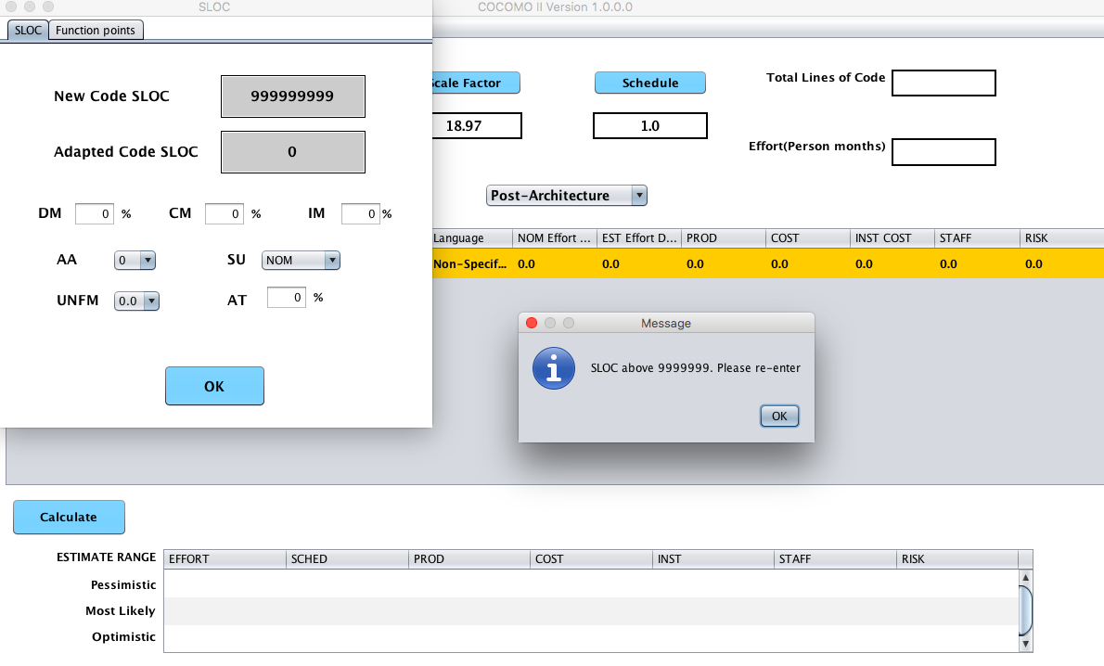
- Error Message: Pop up appear if user does not entire the Effort Multiplier values for module maintenance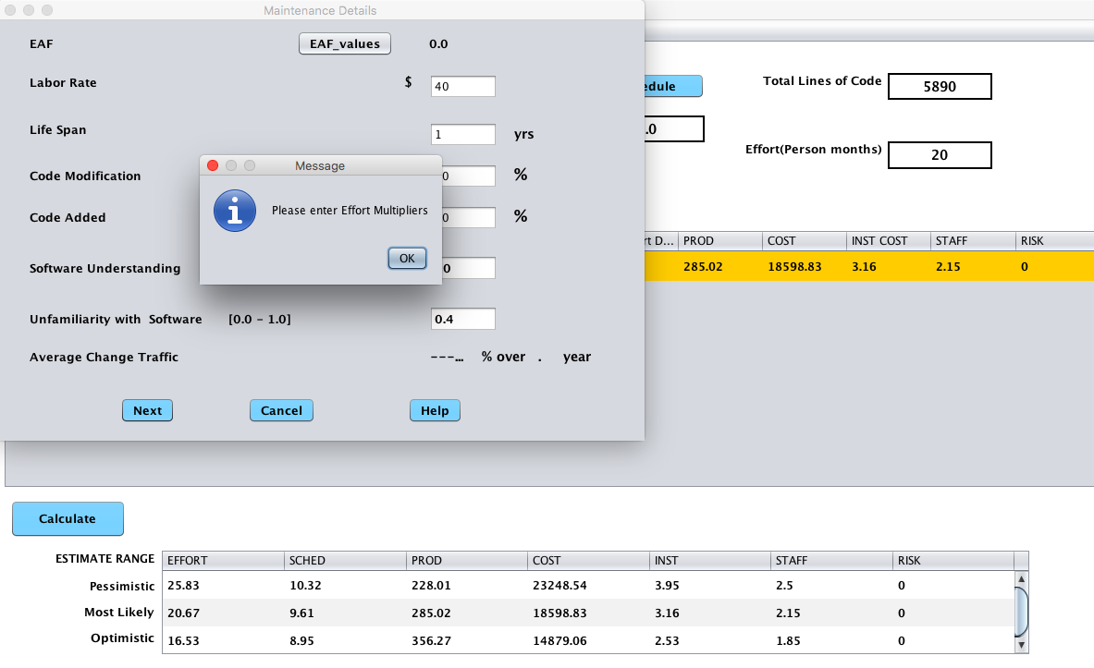

- Error message is displayed if the user does not have any module and try to perform maintenance modification.
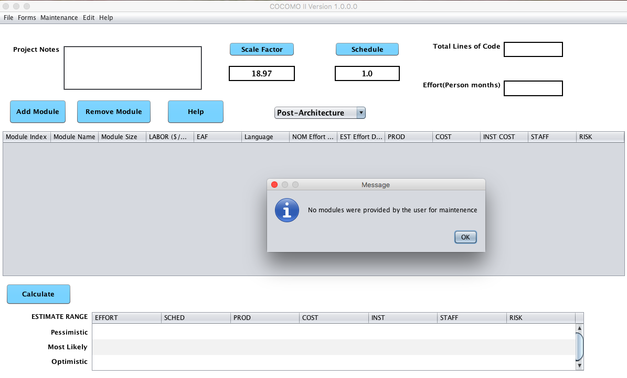
- When user selects early design model from the drop down the maintenance in the menu item is disabled
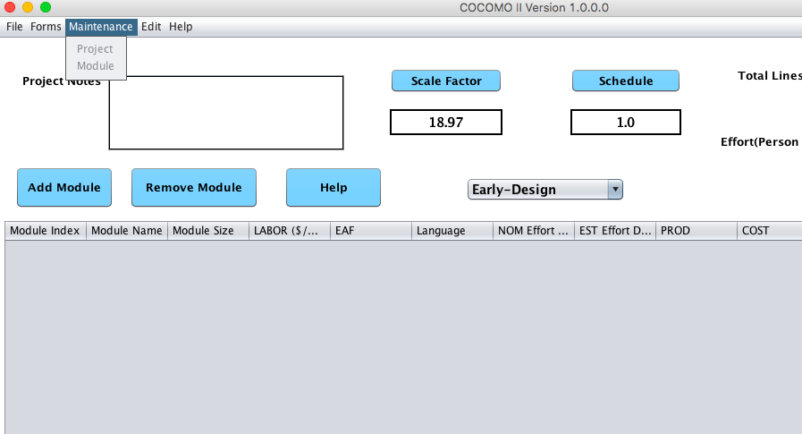

- Equation accuracy – added all the equation used in the application for user understandability and reference
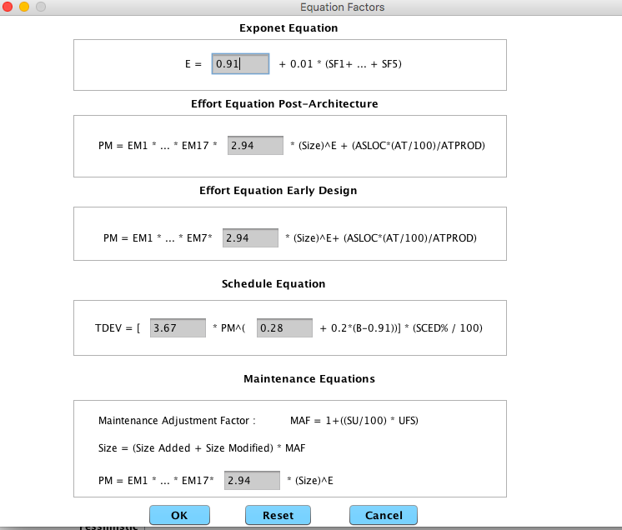
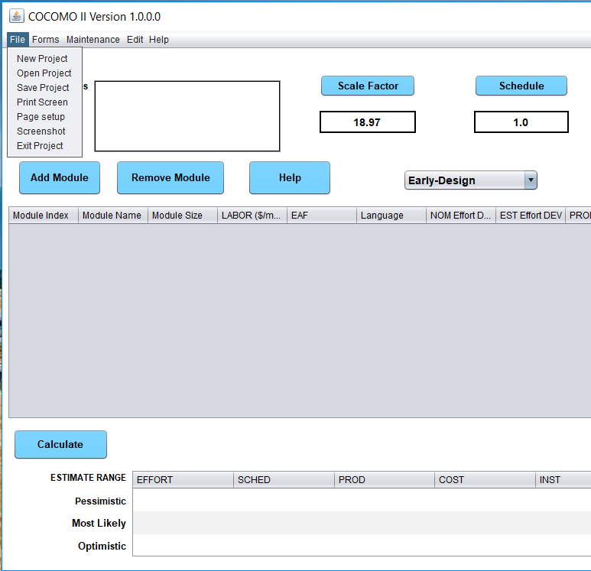

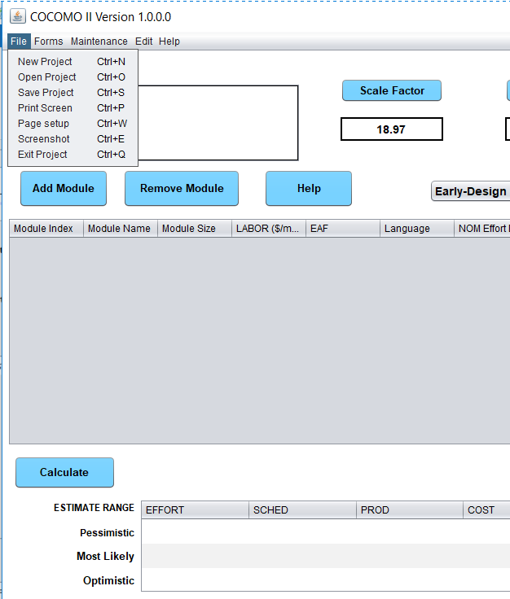

Credit page is accurate:
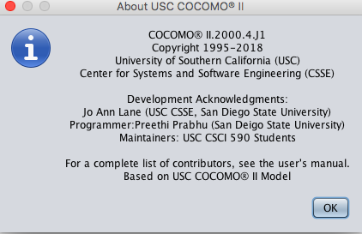

Project Summary:
During summer semester, our focus was primarily on developing the software as the older COCOMO application. We implemented the application with all the feature so that the software can be given to the customers. To achieve this goal, we primarily started off with bug fixing, functionality addition every week and simultaneously testing the functionality added from the previous weeks.
Previously, the default forms were under calibrate menu item, which has been modified to Forms for user’s understandability.
Additionally, we created users manual for the software so that it could be handed over to customer’s along with the project.
Description of the task accomplished during Summer 2018
- Bug Fix – help, equation, user interface
- Implemented Early design model
- Added Maintenance feature
- Enhance user experience with having edit option in the menu bar
- Tested the handed over software with older version of COCOMO and implemented testing on additional functionality and modification added every week.
- Compared manual output and output from the software both in new and older version of the application for accuracy.
- Created documentation with details on all the feature and functionality added.
Known Issues
- Calibrate feature is not implemented due to time constraints
- Risk value is always zero for whatever value of input

Set Up Instruction
Recommended IDE NetBeans
- The entire project is developed using NetBeans IDE. In order to run the project the user need to download the zip folder to any desired location on the system. From there use NetBeans to open the project by selecting File -> Import Project -> from zip, the select the zipped file.
- We recommend using NetBeans compared to Eclipse because of UI changes in NetBeans generate automated code.
- This method works in all platform like OS X, Windows and Linux.

