**Exodus Font Tests:**

The Album Cover and Exodus Font Compared

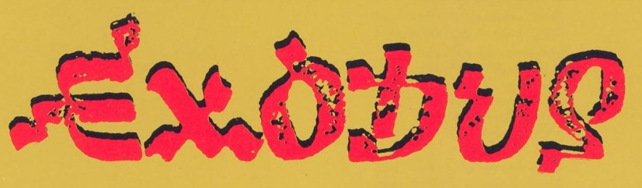

EXODUS

**Uppercase:**

ABCDEFGHIJKLMNOPQRSTUVWXYZ

**Lowercase:**

abcdefghijklmnopqrstuvwxyz