IoT-Based Smart Pill Dispenser with Real-Time Notification System

A Capstone
Presented to the Faculty of
College of Computing Studies
Don Honorio Ventura State University
In Partial Fulfillment

of the Requirements for the Degree
Bachelor of Science in Information Technology

by:

Hipolito, Francine T.
Macapagal, Angel L.
Macasu, Rome John Y.
Pangilinan, Lester S.
Soriano, Michaela Joy

April 2026

CHAPTER I

The Problem and It’s Background
Introduction
Medication adherence plays a vital role in ensuring the effectiveness of medical treatments and improving patient health outcomes. However, medication non-adherence remains a significant challenge worldwide, particularly among elderly individuals and patients with chronic illnesses such as hypertension, diabetes, and cardiovascular diseases. Many patients struggle to follow prescribed medication schedules due to forgetfulness, complex treatment regimens, busy lifestyles, cognitive limitations, or lack of proper monitoring. Failure to take medications on time may lead to disease progression, increased hospitalization rates, higher healthcare costs, and reduced quality of life.
Traditional methods of medication management, including handwritten schedules, alarm clocks, and conventional pill organizers, have been widely used to assist patients in remembering their medications. Although these methods provide basic support, they often rely heavily on the patient's memory and active participation. Furthermore, caregivers and family members may not always be available to monitor medication intake, making it difficult to ensure adherence, particularly for elderly patients living independently. As a result, there is a growing need for more intelligent and automated solutions that can assist patients in managing their medications accurately and consistently.
Recent advancements in the Internet of Things (IoT) have transformed healthcare by enabling the development of smart systems capable of automation, remote monitoring, and real-time communication. IoT technologies allow devices to collect, process, and transmit data through internet connectivity, providing users and caregivers with timely information and system updates. In healthcare applications, IoT has been utilized in patient monitoring, health tracking, medical alert systems, and medication management solutions. These innovations have demonstrated the potential to improve healthcare delivery, enhance patient safety, and increase treatment compliance. In integrating automated dispenser while its real-time connection is up, the system will address the issue for non-adherence, which will frequently result in not optimal health results and increase in medical expenses (Asha et al., 2025)
The integration of IoT technology into medication management systems offers a practical approach to addressing medication non-adherence. Smart pill dispensers can automate medication dispensing based on predefined schedules while simultaneously providing notifications and monitoring functions. In transmitting real-time alerts though the mobile application, these systems will effectively reduce the risk of missed doses and ensure timely administration (Ghozali, 2023).
This study proposes the development of an IoT-Based Smart Pill Dispenser with a Real-Time Notification System designed to improve medication adherence through automation and remote monitoring. The system utilizes an ESP32 microcontroller, Raspberry Pi, Real-Time Clock (RTC) module, servo motor, DRV8825, infrared sensor, Firebase cloud database, GSM communication, and a mobile application to automate medication dispensing, monitor pill removal, store medication records, and send real-time notifications to users and caregivers. The infrared sensor is used to detect whether the dispensed medication has been removed from the dispenser, while the mobile application provides access to medication schedules, dispensing logs, and adherence records.
Through the integration of hardware and software technologies, the proposed system aims to provide a reliable, efficient, and user-friendly medication management solution. By automating dispensing operations and enabling real-time monitoring and notifications, the study seeks to reduce missed doses, improve medication adherence, and support patients who require regular medication schedules. Ultimately, the system contributes to the advancement of smart healthcare technologies and promotes better health outcomes through improved medication management practices.

Purpose and Description
The main goal of this capstone project is to modernize medication management in selected households in Poblacion Candaba, Pampanga by replacing manual reminders and human-dependent monitoring with an automated and reliable system. The project will be developed in response to the recurring problem of medication non-adherence, which is commonly experienced by elderly individuals and patients with chronic conditions who require strict and timely medication intake. Traditional methods such as verbal reminders, handwritten schedules, and pill organizers will often fail to ensure consistency because they rely heavily on memory, the availability of caregivers, and continuous supervision, which may lead to missed doses and health complications.
The IoT-Based Smart Pill Dispenser with a Real-Time Notification System will be developed as an integrated hardware and software solution that will automate medication dispensing and improve adherence monitoring. It will use an ESP32 microcontroller as the central unit, along with an RTC module for accurate scheduling, DRV8825 and servo motors for controlled dispensing across multiple compartments, and sensors to detect whether medication has been taken. A Raspberry Pi with camera module will also be integrated to provide visual monitoring and additional confirmation of medication intake. As an IoT-based system, it will connect to a cloud database through Firebase and will be paired with a mobile application developed in Flutter, allowing users to set schedules, monitor intake, and receive real-time updates. The system will also send SMS and push notifications to the patient and to family and caregivers when a dose is missed or not confirmed, ensuring timely intervention even without constant internet access.

Objectives of the Study
The primary objective of this capstone project is to design and develop an IoT-Based Smart Pill Dispenser with a real-time notification and monitoring system. The study aims to automate medication dispensing, verify dosage intake, and provide real-time remote monitoring through a mobile application to improve medication adherence among patients in selected households in Poblacion Candaba, Pampanga.

General Objective
To design and develop and IoT-Based Smart Pill Dispenser with Real-Time Notification System that will automate medication dispensing and managed through a mobile application to assist patients take their medications correctly on time. The system will use Internet of Things technology, which includes ESP32 microcontroller, Raspberry Pi, Real Time Clock , sensors, cloud database, and mobile application to automate medication dispensing, monitor medication intake, and send real-time notifications to patients, family members, and caregivers. These features aim the system to improve medication adherence, reduce missed doses, and provide convenience, reliability, and efficiency in terms of managing daily medication schedules.
Specific Objectives
- To design and develop an automated pill dispensing mechanism integrated with an ESP32 microcontroller and Real-Time Clock (RTC) module for accurate medication scheduling across multiple compartments.
- To develop a mobile application that will enable real-time remote monitoring of medication schedules, dispensing logs, and system status for patients, family, and caregivers.
- To implement sensor-based dosage verification to confirm correct pill dispensing and detect whether the medication has been removed within a defined time period.
- To integrate real-time push notifications and SMS alerts to notify users regarding missed doses, dispensing events, emergency medication requests, and low medicine supply.
- To incorporate system features such as Raspberry Pi camera-based monitoring, emergency medication dispensing button, and remote device management through the mobile application.
- To evaluate the functionality, usability, reliability, performance efficiency, and notification accuracy of the Smart Pill Dispenser system through system testing and user evaluation.

Significance of the Study
The capstone project will develop an IoT-Based Smart Pill Dispenser with a real-time notification and monitoring system intended for selected households in Poblacion Candaba, Pampanga. By integrating automated medication dispensing, sensor-based intake confirmation, camera-assisted monitoring, and mobile application connectivity, the study will address common challenges in medication management such as missed doses, incorrect intake, and lack of continuous supervision. The system will provide real-time alerts and remote monitoring, offering a more reliable and organized approach to household medication management.

For Patients - The system will benefit patients by ensuring that medications will be dispensed accurately and on schedule based on the programmed settings. It will help reduce missed doses and improve medication adherence, particularly for elderly individuals and patients with chronic conditions who require strict medication routines. The inclusion of automated dispensing, sensor-based confirmation, camera monitoring, and emergency medication access will provide additional safety and support in daily medication intake.

For Family and Caregivers - The system will assist family members and caregivers by providing real-time notifications and updates regarding medication schedules, dispensing events, and missed doses. Through the mobile application, they will be able to monitor patient adherence even when they are not physically present. This will reduce the need for constant supervision while improving communication and response time in cases of missed or unconfirmed medication intake.

For Healthcare Professionals - The cloud-based adherence logs provided healthcare providers with objective, time-stamped data on patient medication behavior. This information could support clinical decision-making, therapy adjustments, and patient consultations, improving the overall quality of chronic disease management.

For Future Researchers - The study will serve as a reference for future research in the field of IoT-based healthcare systems. It will provide a foundation for further development of smart medication management technologies, including enhancements such as advanced sensor integration, artificial intelligence for adherence prediction, and improved remote healthcare monitoring systems.

Scope and Limitation
This section will present the coverage and boundaries of the IoT-Based Smart Pill Dispenser with Real-Time Notification System. It will describe the features which include the system and identify the limitations that will affect its implementation and evaluation.
Scope
This study will involve the design and development of the SmartDose system that is intended for households in Poblacion, Candaba, Pampanga. The system will be designed to automate medication dispensing, monitor medication intake, and provide real-time notifications through the SmartDose app to improve medication adherence.
- The system uses an ESP32 microcontroller that integrates a Real-Time Clock module to automate medication dispensing based on input schedules.
- The dispenser will consist of ten (10) medication compartments, which are operated by servo motors and DRV8825 to accurately release the scheduled medication.
- The system will monitor the dispensing and intake through integrated sensors and a Raspberry Pi with camera module that provides confirmation of medication removal and supports patient monitoring.
- A mobile application named “SmartDose” will be developed using Flutter integrated with Firebase that allows patients, family members, and caregivers to do the following:
  - Configure medication schedules
  - Monitor medication dispensing activities and adherence records.
  - Receive real-time notifications and alerts.
  - View Medication history and system status.
- The system is backed by a cloud-based database for data storage and synchronization by Firebase for maintaining medication records and enabling monitoring with the mobile application.
- Notifications and Alerts are provided to alert users during situations with limited or unstable internet connectivity.
- The system includes features such as:
  - Emergency Manual Medication Dispensing.
  - Medicine stock level monitoring.
  - Refill reminders.
  - Basic system diagnostics.
Limitation
The “SmartDose” system prototype will have the following constraints such as the following:
- The system only supports solid oral medications, such as capsules and tablets. Liquid medicines, injections, syrups, powders, and other forms of medications are not in the scope of this study.
- This study is intended only for home medication management and will not be implemented or evaluated as a standard necessity for hospitals, clinics, or other healthcare facilities.
- The mobile application will only be developed exclusively for Android devices and does not support other mobile platforms.
- Most real-time functions will depend on a stable internet connection. Cloud synchronization, remote monitoring, and mobile application updates may be delayed or unavailable when internet connectivity is poor.
- The evaluation of the system is limited to households in Poblacion, Candaba, Pampanga, and will only select a limited number of participants for a specific testing period.

Conceptual Framework
The conceptual framework of this study is based on the Input-Process-Output (IPO) model, which illustrates how the system transforms gathered resources into a functional IoT-Based Smart Pill Dispenser with Real-Time Notification System.

INPUT
Knowledge Requirements
- Medication management principles
- IoT system concepts
- Mobile application development
- Sensor-based monitoring
- Real-time notification systems

Software Requirements
- Arduino IDE
- Visual Studio Code
- Flutter (Dart)
- Firebase (Firestore & Cloud Messaging)
- Android OS

Hardware Requirements
- ESP32 Microcontroller
- DS3231 RTC Module
- Servo Motors
- IR Sensors
- Hall Sensor
- Camera Module
- SIM800L GSM Module
- 16x2 LCD Display
- Power Supply
- Raspberry Pi
- DRV8825
- Servo
- Buttons
- Buck Converter

Methodology:
- Agile Methodology

Software Development:
- Requirements Gathering
- System Design
- Implementation (Mobile App & Firmware)
- Testing and Debugging
- Deployment

Hardware Development
- Prototyping

Integration of Software and Hardware:
- Testing and Maintenance

PROCESS
OUTPUT
IoT-Based Smart Pill Dispenser with Real-Time Notification System

FEEDBACK

Figure 1. Conceptual Framework of Smart Pill Dispenser
The Input refers to the necessary resources and components that will be needed in developing the system, which are categorized by the following sections:
- Knowledge Requirements: areas of understanding of medication management, Internet of Things (IoT), mobile application development, sensor monitoring, and real-time notification systems will be essential for developing and integrating the system.
- Software Requirements: software tools and platforms will be used for the development of the system, which include Arduino IDE, Visual Studio Code, Flutter (Dart), Firebase Firestore and Cloud Messaging, and Android OS. These software components will support the development of mobile applications, firmware, cloud database, and real-time communication.
- Hardware Requirements: these are the physical components that will be required for the development of the prototype which are the following: ESP32 Microcontroller, DS3231 RTC Module, Servo Motors, DRV8825, IR Sensors, Raspberry Pi, Camera Module, SIM800L GSM Module, 16x2 LCD Display, and Power Supply. These components will handle the dispensing mechanism, medication dispensed count, present the system information, and give alerts to users.
The Process will highlight the Agile Methodology, which will guide the system's development through an iterative approach. It will allow the researchers to continuously develop, test, evaluate, and improve the system based on the results gathered during each stage of the development.
These are the following phases that will be implemented:
1. Requirements Gathering – will identify the functional and non-functional requirements of the system, which include the medication scheduling, automated dispensing, medication monitoring, and notification features.
2. System Design – this will plan the overall structure of the system, including the hardware components, dispensing mechanism, mobile application, database, and communication between the different system components.
3. Implementation – this will involve the development of the mobile application using Flutter and the programming of the ESP32 firmware. The Firebase database and notification services will also be integrated into the system.
4. Testing – this will evaluate the functionality of the hardware and software components, identify errors, and apply important corrections to further improve the accuracy and reliability of the prototype.
5. Deployment – this will involve the integration and preparation of the completed system for actual testing and use in the intended home environment.
Software Development Process will include the following:
Requirements gathering
- System design
- Mobile application development
- Firmware development
- Database and Notification Integration
- Testing and debugging
- Deployment
The Hardware Development will involve the construction and prototyping of the pill dispensing mechanism and its integration of the ESP32, RTC Module, DRV8825, servo motors, sensors, Raspberry Pi, camera module, LCD, and GSM module. The hardware will then be integrated with the software components that will establish communication between the dispenser, cloud sync, and mobile application.
The entire system will undergo testing and maintenance, which will ensure that the medication schedules, dispensing mechanism, medication monitoring, and notification features will function properly and reliably. The system will be designed to support accurate medication dispensing, real-time monitoring, and notifications that involve medication activities.
The Output will result in the development of the IoT-based Smart Pill Dispenser with Real-Time Notification System. The system that will be completed will automate the dispensing of scheduled medications, monitor medication removal, record medication activities, and provide notifications to patients, family members, and caregivers.
The system is expected to provide a more convenient and organized way of managing medication schedules while helping to improve medication adherence. It will also allow users to monitor the actions through the mobile application and receive notifications about the scheduled doses and missed medications.
Lastly, the feedback loop will be integrated throughout the development process, allowing the continuous evaluation and improvement of the system. Feedback that is gathered from testing, system evaluation, and users will be used to identify problems, improve existing features, and make the necessary adjustments to both the hardware and software components. Though the feedback, the SmartDose system will ensure in refining the system’s performance, functionality, reliability, and usability.

Definition of Terms
To provide a clear understanding of this capstone project, the following terms are defined both conceptually and operationally:
- Automated Pill Dispensing - The process of releasing medication from a device without human intervention at a pre-programmed time. In this study, it refers to the DRV8825 and servo motor-driven mechanism that rotates a compartmentalized pill holder to release the correct medication at the scheduled time.
- ESP32 Microcontroller - A low-cost, dual-core microcontroller with built-in Wi-Fi and Bluetooth capabilities. In this project, it serves as the central processing unit of the Smart Pill Dispenser, coordinating all hardware inputs, outputs, and internet communications.
- Firebase - A cloud platform developed by Google that provides real-time database management, secure authentication, and push notification services. In this system, Firebase Firestore stores all medication logs and adherence records, while Firebase Cloud Messaging sends real-time alerts to the mobile app.
- Flutter - An open-source UI development framework created by Google for building natively compiled applications across multiple platforms from a single codebase. In this project, it was used to develop the Android mobile application for patient and caregiver monitoring.
- GSM Module (SIM800L) - A global system for mobile communications module that enables devices to send and receive SMS messages via a cellular network. In this system, it serves as a backup alert mechanism to send missed-dose notifications to register users without requiring internet connectivity.
- Internet of Things (IoT) - A network of interconnected physical devices embedded with sensors and software that exchange data over the internet. Operationally, this refers to the connected architecture linking the Smart Pill Dispenser hardware, Firebase cloud, and the mobile application.
- Medication Adherence - The degree to which a patient follows a prescribed medication regimen, including taking the correct dose at the correct time. In this study, adherence is measured by the system through dispensing logs and pill removal confirmation.
- Time Clock (RTC) - A hardware module that keeps accurate track of current time and date, independently of the main microcontroller. The DS3231 RTC in this project ensures that medication schedules remain accurate even when the device loses internet connectivity.
- Servo Motor - An electromechanical actuator that uses feedback control to achieve precise angular positioning. In this system, it physically drives the rotation of the pill compartment carousel to dispense the correct medication compartment at the scheduled time.

CHAPTER II

Review of Related Literature and Studies
This chapter presented a comprehensive review of related literature and studies that support the development of the IoT-Based Smart Pill Dispenser with Real-Time Notification System. It provided an overview of existing research and relevant theories, thereby establishing a solid foundation for understanding the context of the study.

Related Literature

Foreign Literature
IoT-Based Smart Medication Reminder and Dispensing Machine Based on Internet of Things
The study conducted by Chandana et al. (2022), presents the design and development of a medicine reminder and dispensing machine integrated within the healthcare system. This system was proposed during the pandemic to minimize direct interaction between healthcare workers and patients, thereby reducing the risk of infection. The device is capable of storing medication doses for an entire week and dispensing them at scheduled times. It also records medication intake data using an SD card for future reference by medical professionals. Additionally, the system is beneficial for home use, particularly for elderly patients who may forget to take their medications on time. The inclusion of scheduled reminders related to food intake and exercise further enhances medication effectiveness, as certain drugs require specific timing in relation to meals.
This research is highly relevant to the Smart Pill Dispenser proposed, due to the need for adherence and proper usage of an IoT-based medicine delivery system. With capabilities of scheduled drug delivery, dispensing of the correct amount of medicine, and the usage of local or cloud-based systems for storage, these solutions can create a more practical and useful health system. These solutions may aid in creating a pill dispenser that is easy to use, and helps patients take their medications consistently.
The current solution does lack some features, however. Chandana et al. (2022) created a system that does not include whether the user takes the pill once dispensed, but rather stops after it has been delivered. The proposed Smart Pill Dispenser adds to this system by incorporating a refined verification process, which not only releases the medication, but confirms ingestion.

IoT-Based Real-Time Medicine Reminder and Dispenser for Elderly Patients
People who follow a routine medication face a challenge when taking these medicines at regular intervals. It is observed that most older citizens face these problems if they have no one to take care of them. These people are not that smart to set reminders or alarms on their smartphones to remind them of their medication routines. A device such as an IoT-based Real-Time Medicine Reminder and Dispenser Robot can help these individuals. This device will have a reminder for each medicine the user might take by four methods, it will have a speaker that will call out the name of the medicine, a Display that shall show the name of the medicine, a dispenser system that will dispense the right medicine and a mobile notification will be send to the user's phone (SS Sadi et al., 2024).
Though there are benefits when applying various reminder function in one automatically pill dispenser, the system has no mechanism to confirm whether the patient has already ingested the medication after it had been administered. Similarly, to the Smart Pill Dispenser, all the methods have a combination of sound and visual alerts as well as mobile reminders which can improve adherence. Also, it incorporates an automated dispenser so that the medicines dispensed could be as accurate as possible, lessening any chance of human error, that can be integrated to the system and could potentially help out in medication dispensing and accurate medicine dispensing to avoid any form of mistake.
Despite the advantages of the system on incorporating different reminder methods with an automated dispenser, it does not contain any kind of function that can confirm that the patient did consume the medicine even though it has been dispensed to him already. This may cause an inaccurate information as it can dispense the medicine to the user but not necessarily take by the patient. The Smart Pill Dispenser overcomes this problem by using a sensor to detect that the medicine was already taken by the patient.

Smart Medication Management Using IoT-Based Pill Dispenser and Smart Cup
In today's fast-paced environment, medication errors present a pressing challenge, especially among vulnerable populations such as the elderly and individuals with cognitive or mental health conditions. The study of Peddisetti et al. (2024) introduced an IoT-based medication management system composed of a Smart Pill Dispenser, Smart Cup, and an Android application for real-time notifications. The Smart Pill Dispenser, powered by an Arduino Nano RP2040 microcontroller, ensures accurate and timely dispensing of medication, while the Smart Cup utilizes accelerometers, gyroscopes, and ultrasonic sensors to verify actual medication intake. These devices are interconnected through Bluetooth Low Energy (BLE), enabling real-time data sharing and monitoring of medication adherence.
The system prioritizes the use of sensor-based verification in combination with automated dispensing to ensure compliance and avoid human errors. Through a smart device, it is established that in conjunction with several IoT enabled device a much more reliable system could be devised which monitors the consumption and provides feedback in real time. The patient/caregiver can make use of an application which can keep a track on the progress of medication in real time.
This can provide huge advantage in for “Smart Pill Dispenser” prototype, as the use of sensor-based verification in supplement with automatic dispensing as identified is a clear indicator of a greater degree of accuracy and reliability of the researcher’s proposed system in medication management. This system uses multiple networked devices including Smart cup to check for actual medication consumption. But their device may require a separate component in the package and can increase maintenance and overall complexity compared to the Smart Pill Dispenser.

Smart Pill Dispensers and IoT: Advancements in Medication Administration
Smart pill dispensers have transformed medication delivery using Internet of Things (IoT) technology. Smart pill dispensers and their seamless interaction with IoT devices have improved medication administration. These novel methods increase medication adherence, error reduction, and patient outcomes. It includes sensors and connections for remote monitoring and control. Real-time data sharing with IoT allows healthcare practitioners to monitor adherence and intervene as needed. Smart pill dispensers use face recognition and biometric verification to ensure medicine is given to the right person. Patients and doctors get notifications for missing doses or wrong medicine. The system can be connected to the IoT and stored in the cloud. Improved medicine distribution and real-time tracking maintenance. Healthcare delivery improves patient outcomes for enhanced adherence and fewer medication mistakes. Hospital readmissions and adverse events may be reduced by drug adherence (Tiwari & Raman, 2024).
In the paper by Tiwari & Raman (2024) it was examined how the Internet of Things technology could assist medication management through smart pill dispensers. It points out that IoT supported medical devices have the capacity to change the conventional system of delivering medicines through using the combination of sensor-based systems, the internet and cloud based technologies to remotely control and monitor system real-time. This allows healthcare professionals to remotely monitor patients 'medication adherence and system performance through transmission of data. There is also automated indication of inappropriate ingestion and misses. Further, the system uses biometrics and face detection to ascertain that the correct medication is administered to the correct patient. The paper is pertinent to the present study because it demonstrates the improvement of medication adherence and patient care using IoT based systems. It shows the importance of cloud integration, real time monitoring and automated indications for better reliability and reduction of medication errors. The main problem found by the paper is the use of biometrics and facial detection to integrate high security systems which is not cost efficient and also it is very complex to use, so the Smart Pill Dispenser takes an easier route of considering sensor integration for verification only which would be cost-efficient and user-friendly for clinical and domestic use.

IoT-Based Smart Medicine Dispenser to Control and Supervise Medication Intake
This paper presents a system consisting of a smart medicine dispenser of solid medications (pills, capsules) and a mobile application for its configuration and management. The main idea is to offer a solution to help people (especially vulnerable ones) to avoid incorrect medication intakes. In this regard, the smart dispenser delivers the required medication if two conditions are met: (1) it is the scheduled time for a medication intake, and (2) the person who removes the medication from the dispenser (patient or caregiver) can be identified and is authorized to do so. Person identification and authorization is performed through facial recognition by the dispenser and through a username and a password by the mobile application. Moreover, the system reminds the users whenever a medication intake should take place through mobile notifications and lights and sounds emitted by the dispenser. The system development has been guided by a Test-Driven Development Methodology for Internet of Things (IoT)-based Systems to promote its quality and reliability (Guerrero-Ulloa et al., 2020).
The study proposes an IoT-based smart medicine dispensing system that focuses on controlled and monitored medicine dispensation. The study addresses the inclusion of security features such as user validation through facial recognition, medicine dispensing reminder through mobile notification and continuous monitoring of medicine usage. This approach proves how the technology of IoT could be incorporated to develop controlled, secured and monitored medicine dispensing.
This study is relevant to the present research in that it addresses how to implement authentication and monitoring features in a smart medicine dispenser to achieve secure accessibility and better patient compliance with medicine administration. The usage of IoT-based tracking and mobile notification emphasizes the significance of securely managed and timely administered medicine that helps to build up a dependable medicine dispenser.
The study has a limit since it addresses only the authentication and access control rather than including other extended functionalities such as monitoring by caregiver, alert system or sensors for checking the real medicine consumption. On the contrary, the present Smart Pill Dispenser not only includes the features of authentication and access control but also adds on features such as real-time caregiver monitoring, alert system and sensors for checking the real medicine dispensing, making it a far more complete, practical and dependable medicine dispenser.

Development of a Pill Dispenser: System Requirements and Product Architecture
The study by Lima et al. (2022), focuses on the growing elderly population worldwide, which has created an increasing need to develop products that support daily living activities and promote independence in the domestic environment. This study is part of the second phase of an investigation project aimed at creating a device that stores and dispenses pills automatically with the integration of a virtual assistant. In this phase, the objective was to define the system requirements and product architecture of the device based on state-of-the-art research, user experiences, and a previously defined business model. As a result, the study identified user needs and translated them into specific device requirements, which contributed to defining the product architecture. This includes a diagram of the system electronics and a basic representation of the device, which supports the conception and development of the pill dispenser system.
Compared to this study, the “Smart Pill Dispenser” focuses on the implementation of a functional IoT-based medication dispensing system rather than only defining system requirements and product architecture. The study by Lima et al. (2022) emphasizes the design phase of a pill dispenser system, where user needs, system requirements, and product architecture are identified and translated into conceptual designs, including system electronics diagrams and basic device representations. It primarily focuses on planning and developing the structure of the device to support elderly independence in medication management. In contrast, the “Smart Pill Dispenser” moves beyond the design and conceptual stage by implementing a working system that automates medication dispensing and supports practical usage in real-world scenarios. As a result, while both studies aim to support elderly users in medication management, the referenced study focuses on system design and architecture development, whereas the system focuses on full implementation and operational functionality.

A Systematic Review on Pill and Medication Dispensers from a Human-Centered Perspective
The study by Lgargioni et al. (2024), highlights that medication adherence represents a critical challenge in healthcare, and pill and medication dispensers have gained increasing attention as potential solutions to promote adherence and improve patient outcomes. Following the PRISMA (Preferred Reporting Items for Systematic reviews and Meta-Analyses) methodology, the study conducted a systematic literature review on papers indexed in Scopus and PubMed that present solutions for pill or medication dispensers. Given the importance of user acceptance for these solutions, the research questions of the survey are driven by a human-centered perspective. The study provides an overview of different dispenser solutions by classifying them according to their stage of development. It then analyzes each solution considering its hardware and software architecture. Furthermore, it reviews the characteristics of user interfaces designed for interacting with pill and medication dispensers and examines the involvement of different types of users in dispenser management. Based on this analysis, the study draws findings and indications for future research intended to provide insights for healthcare professionals, researchers, and designers interested in developing and using pill and medication dispensers.
The Smart Pill Dispenser system differs from the described study because the emphasis of the described study is to comprehensively review and analyze various existing technologies through a wide systematic review, not to develop and deploy the actual, functional, IoT-based pill dispenser. The work by Lgargioni et al. (2024) is primarily an examination of pill and medicine dispensers from a human aspect in the form of a literature review based on the PRISMA methodology to group current systems by its development phase and assess their hardware and software structures and user interfaces, and places particular attention to user acceptance and the different kinds of users involved in medicine taking and has conclusions and suggestions for further research and development of new systems. In comparison, The Smart Pill Dispenser system is devoted to building a functional, operational system that directly automates taking pills. In so, the mentioned system, by having performed an inclusive evaluation and review of existent systems, will be able to contribute toward more robust medication dispensers of the future, but the system contributes to this field by building and deploying an IoT-based one.

A Review on Dispenser Mechanism of Medicine Dispenser
The study by Kini et al. (2021), highlights that in the modern age it is difficult for family members to be available all the time to support the aged, and in many societies most families are nuclear. Caring for the aged is of serious concern in developing countries. Sometimes despite their best effort, the aged fail to remember to take their medication on time. There are issues concerning seniors' ability to remember to take and handle their medicine on their own. Automatic medicine dispenser is one approach as a solution to this problem. It dispenses medicines on prescribed time with notifying the caretaker. There are various medicine dispensers with same functionality and IoT but different dispenser mechanism and design. The design and mechanism vary with the type and size of medicine. The main concern is dispenser design as the medicines are in various shapes and sizes. Hence an optimal dispensing mechanism for storing and dispensing all types of medicines is required. In this paper, a detailed review of dispensing mechanism of the Automatic Medicine Dispensers and its design is presented.
In comparison to this study, the “Smart Pill Dispenser” primary focus is on the actual construction and operation of an actual working IoT-based medicine dispensing device instead of the evaluation and examination of various kinds of medicine dispenser mechanism and designs. The study of Kini et al. (2021) is basically the elaboration study on various existing automatic medicine dispenser mechanisms and designs, where it discusses the requirement to develop an efficient dispenser system that is capable to hold and handle different forms and sizes of medicine in correct manner, and emphasizes various design aspect and issues. But in case of the “Smart Pill Dispenser”, the aim is to design and construct an IoT based smart medicine dispensing device that can automatically dispense medicines for user and hence in comparison, where the former involves exhaustive review study on dispenser mechanism, the system is an actual construction of automatic medicine dispensing device with the focus of ensuring its real-time application and usage.

Improving Medication Adherence in Elderly Patients Through IoMT-Enabled Smart Pill Dispensers: A Narrative Review
The study by Razizatunnisa et al. (2025), highlights that non-adherence to medications represents a major complication among elderly patients, with serious consequences on health outcomes and healthcare costs. The study explains that the emergence of Internet of Medical Things (IoMT)-enabled dispensers provides a promising solution to these issues through real-time monitoring, automated personal reminders, and caregiver interfacing. These devices address common barriers to medication adherence by improving patient and caregiver experience. The review aimed to evaluate the contribution of IoMT-enabled dispensers in improving medication compliance among elderly patients, using evidence from Scopus, PubMed, and the Cochrane Library. Findings suggest high adherence rates, reduced missed doses, and improved satisfaction among both patients and caregivers, attributed to real-time personalized reminders, tailored interventions, and integration with healthcare systems. However, the study also identifies limitations such as poor internet connectivity, data privacy concerns, and financial constraints. It further suggests future improvements through AI integration, policy support, and educational programs to enhance accessibility and performance of such systems.
Unlike this study, the Smart Pill Dispenser primarily addresses on the real development and application of a working IoT-based smart pill dispenser as opposed to reviewing and summarizing existing IoMT-based systems. A narrative review presented by Razizatunnisa et al. (2025) aims to review the role of IoMT-based smart pill dispensers in promoting adherence to medication for the elderly by taking evidence from three database of Scopus, PubMed, and the Cochrane Library. This study asserts that such systems improve medication adherence via its capability for remote monitoring, automated alarms, and caregiver alert system which leads to better medication adherence, a lower rate of missed doses and higher satisfaction from the patients and caregivers, although some challenges for these devices which are internet connection instability, privacy of patient data, and expense are discussed, with a conclusion and future improvement suggested involving implementation of AI, support policies, and education. In comparison, the development of Smart Pill Dispenser is targeted at establishing a tangible and operating IoT-based system for automated medication dispenser. Thus, while the above referenced study offers a complete evaluation of IoMT-based pill dispenser and its efficacy, the system contributes on the creation of an operating solution for real-time medication adherence improvement.

Developing a Smart Pill Dispenser to Support Aging Individuals
The study by Viana et al. (2024), entitled Developing a Smart Pill Dispenser to Support Aging Individuals, explains that as a person ages, there is a tendency for the progressive degeneration of the body, which usually manifests as a loss of motor, cognitive and sensory abilities. This introduces new challenges to the independent accomplishment of previously routine tasks. Through the analysis of this issue, the authors identify that the adherence to complex medication regimes might pose a particularly difficult challenge for elderly patients, whose limitations can introduce the risk of ineffective treatments and health hazards by the wrongful taking of medicine. The solution proposed is the development of an automatic pill dispenser, designed to counteract the adverse effects of aging and enable the elderly to retain a degree of autonomy in their daily care, or support family and professional caretakers. This chapter follows the project’s development through the identification and analysis of the challenges faced by elderly individuals; a comparative study of the options currently available to support them in the identified issue; the proposal of a solution; and concluding with the construction of a preliminary prototype.
Compared to this study, the “Smart Pill Dispenser” also targets the needs of elderly to assist them taking medication, but the approach is more inclined toward a functional IoT based application to dispense medication and keep track of adherence in real-time. The paper in Viana et al. (2024) puts more emphasis on the conceptualization of a smart pill dispenser system which aims to overcome the issues posed by age related cognitive and physical deterioration. The user issues, analysis and comparison of other devices along with the development of an initial prototype were discussed in this study, while the Smart Pill Dispenser focuses on the development and operation of a fully working IoT based automated device for reliable, timely and efficient pill dispensing.

Local Literature
SmartMed: An IoT-Enabled Pill Dispensing and Monitoring System for Medication Adherence of AFib Patients
A study introduces an IoT-enabled smart medication system designed for patients with atrial fibrillation (AFib), a condition that requires strict and continuous medication adherence to prevent serious complications such as stroke and thromboembolic events. The SmartMed system integrates automated medication scheduling, real-time dose verification, and caregiver support through a mobile application. It utilizes an ESP32 microcontroller, ultrasonic sensors for pill retrieval detection, and cloud-based synchronization via Firebase to ensure real-time communication between the device and mobile platforms. The system also supports remote emergency dispensing by caregivers and provides real-time alerts to ensure proper medication intake and monitoring. Testing results demonstrated a 100% adherence rate and high usability, showing strong effectiveness in medication management for AFib patients (Maaño et al., 2025).
This application presents the application of IoT to smart medicine management by enabling automatic dispensing of medication and simultaneous monitoring and sensors for validation of intake. Mobile applications and cloud applications would provide remote monitoring of patients by care providers and physicians as well as timely notifications and notifications when needed to provide a quick response during emergencies. This demonstrates the way that systems enabled by the IoT technology would provide better medication safety, accuracy, and compliance via intelligent communication networks and ongoing supervision. This study complements the proposed Smart Pill Dispenser in its demonstration of the importance of combining automatic medication dispensing with both real-time tracking and sensor verification for medication intake. The use of a mobile application and cloud-based system for remote monitoring of patients would enable a better overview of compliance for care providers and enable a rapid response during emergencies. The latter would provide a means for increasing medication compliance and system safety in ways applicable to this system design. Nonetheless, its features require reliable internet access due to real-time cloud synchronization and mobile communication for proper functioning. An integrated emergency dispensing function and continuous cloud-based monitoring can also lead to higher costs and increased system complexity. In comparison to the described limitation, the proposed Smart Pill Dispenser is designed as a more economical and practical system by omitting some of the more sophisticated system features while providing necessities like medication dispensing, sensor verification, and alerts.

MediMinder: A Smart Device for Medication Adherence
The study presents a smart medication adherence device designed to address medication non-adherence, which remains a major public health concern, particularly among individuals with chronic non-communicable diseases (NCDs) in low-resource settings such as the Philippines. The system integrates key features such as medication reminders, real-time monitoring, and storage components to support proper medication intake. Grounded in ISO 9241-210 and ISO/IEC 25010 standards, the device was evaluated using a quantitative prototyping approach involving healthcare professionals, technical experts, and regular medication users. Results showed consistently high ratings in functional suitability (M = 4.58), performance efficiency (M = 4.63), usability (M = 4.47), and reliability (M = 4.35), indicating that the system is effective, acceptable, and user-friendly for medication management. The study further emphasizes that MediMinder provides a practical and scalable solution for improving medication adherence, with recommendations for future enhancements such as improved alarm customization, caregiver integration, portability, and stronger connectivity features (Aquino et al., 2025).
In relation to this, the Smart Pill Dispenser is the advancement of MediMinder through additional advancements in medication control by making it more centralized. The MediMinder provides the reminder, monitoring and storage functions but the system attempts to gain better reliability by including the dispensing as part of the systems functions along with the real time monitoring and alarm functions. Such a function would be the improvement upon one of the inherent weaknesses in current systems which is the fact that there is no controlled dispensing; instead, it is left to the reminders system and patient compliance. Adding a dispensing feature would not only provide a reminder but also adds the physical medication becoming available to the patient, hence not just providing a reminder but adding to the patient receiving the medication. Smart Pill Dispenser, therefore, builds upon the functionality provided by current IoT-based medication systems by giving a more complete, automatic and reliable system.

Optimizing Medication Adherence with Time Pill Dispenser: A Research Project
This study explains that time-based pill dispensers are effective in improving medication adherence among patients with chronic diseases such as hypertension and diabetes. It highlights that many patients experience difficulties in following prescribed medication schedules due to forgetfulness, complex prescriptions, and lack of proper reminders, which often lead to missed doses and poor health outcomes. The study emphasizes that time-based pill dispenser systems, which use scheduled alerts and dispensing mechanisms, help guide patients in taking their medication consistently and correctly, thereby improving adherence and supporting better disease management (Optimizing Medication Adherence with Time Pill Dispenser: A Research Project, n.d.).
This study is important as it illustrates that reminder systems based on technologies are effective for solving non-compliance problem among patients. It suggests that a well-structured reminder system (like a pill dispenser) is required to help patients take medicines in a systematic manner. These results are related to design of the Smart Pill Dispenser, as the researchers attempt to improve medicine compliance using a technology-based reminder and dispenser system.
This study, on the other hand, primarily uses time-based reminders and simple dispensing but it fails to incorporate comprehensive additional features like a remote patient monitoring system or caregiver notifications. In response to the study limitation, the Smart Pill Dispenser uses automatic dispensing, remote monitoring, alerts to improve the system more effectively and systematically.

Smart Pill Dispenser for Elderly Care
A notable issue in elderly healthcare is that not all individuals have caregivers, and even those who do may still experience difficulties in medication adherence. This situation may result from various factors such as financial constraints that limit access to consistent caregiving support, or the inability of family members to provide continuous assistance. In some cases, caregivers themselves may also forget medication schedules or be uncertain about correct dosages, revealing gaps in the current caregiving system and highlighting the need for technological support in medication management (Gorospe, 2022). Ensuring timely medication intake is essential as it improves treatment effectiveness, supports faster recovery, and enhances overall health outcomes (Santos & Almonte, 2020). In addition, smart medication systems are increasingly explored as a way to address these challenges, particularly for elderly individuals who manage multiple medications. These systems aim to reduce caregiver burden while promoting independence and improving medication compliance (Villanueva & Santos, 2023).
Addressing these issues, a research reports on an automatic smart pill dispenser created for elderly and disabled in Philippines. The system includes an automated drug dispensing capability with a voice prompt and light notification, making the system useful for taking prescribed medication accurately and at the correct dosage. The system directly targets key problems faced by the users such as lack of medication compliance, limited caregiver accessibility, medication regimen management, and dependency of patients and independence from caregivers (St. Paul University Study, 2024).
This research has great relevance with the present research since it has successfully established that the usage of a smart dispensing system can enhance medication compliance in the local elderly care facilities. The study showed that, a combination of an automated dispensing system and medication reminders is efficient for the patients' memory and correct dosage. The present study is parallel to the goals of the Smart Pill Dispenser, in which medication compliance is a priority through technology solutions.
However, the present smart pill dispenser does not include IoT-integrated functions such as real-time remote monitoring and multiple notification channel systems. The smart pill dispenser includes automated dispensing only and basic reminder function; The present Smart Pill Dispenser proposes a fully functional IoT based automated smart pill dispenser with real time monitoring and alert notifications to help users manage medication taking correctly.
Automatic Pill Dispenser with SMS Notification
This study explains that an automatic pill dispenser with SMS notification was developed to address medication non-adherence among Filipino patients. According to the study of Sibbaluca, n.d., the system uses a microcontroller and a real-time clock (RTC) module to automate the scheduling and dispensing of medication, while SMS alerts are sent to both patients and caregivers to remind them of the correct intake time. The research emphasizes that medication non-adherence is a persistent problem in the Philippines, and integrating automated dispensing with mobile communication technology can significantly improve adherence and ensure timely medication intake.
This study was important as it demonstrated that using an auto-dispenser and SMS reminder is possible for motivating medication compliance in this local setting. Alert the caregiver by SMS provides better control over the patient which can contribute to the system's objective of ensuring medication adherence to patients by applying convenient and accessible technology.
However, this system utilizes merely SMS reminder and manual automated dispenser and does not exploit full potential of modern capabilities that can be integrated by IoT devices such as real time monitoring, mobile application interface and cloud monitoring and tracking. Thus, comparing with the prototype, the Smart Pill Dispenser developed in this paper is an advancement, by integrating automatic dispenser, real time monitoring, multi-channel alert methods in one interface, providing a more holistic solution.

Factors associated with medication adherence of hypertensive patients in the Philippines: a systematic review
The study on medication adherence among Filipino hypertensive patients highlights that hypertension remains a leading cause of mortality in the Philippines, with a prevalence rate of 28% and a low control rate of 20%. Despite the effectiveness of pharmacologic treatment, medication adherence is reported to be as low as 66%. The review identified various factors influencing adherence, including healthcare system-related factors such as patient-health provider relationships and access to services, socioeconomic factors such as age, education, and employment status, patient-related factors such as health literacy and awareness, therapy-related factors such as inconsistent drug schedules, and condition-related factors such as illness perception. The study concludes that since healthcare system-related factors are modifiable, they can be targeted for interventions to improve medication adherence among Filipino hypertensive patients.
This research is relevant to the Smart Pill Dispenser as the researchers proposed system directly addresses one of the main problem discussed-patients’ low medication adherence caused by forgotten drugs, low health literacy, or unstable taking intervals of medicines. The device dispenses drugs and gives reminders on time, reducing the dependence of patient on his/her memory and making the interval of medication taking regular. Though the study focuses more on the factors in behavioral, social and health system aspects that are affecting medication adherence, the system is intended to be a technological solution to solve it.

Utilization of Artificial Intelligence in Reducing the Incidence of Medication Error: A Bibliometric Analysis
The study by Dino et al. (2025, highlights that medication errors (MEs) represent a significant challenge in healthcare, compromising patient safety and contributing to adverse outcomes. The study emphasizes that Artificial Intelligence (AI) has emerged as a promising tool to address this issue by enhancing medication management processes and decision support systems. Using bibliometric analysis based on data from the Scopus database, the study identified 184 relevant articles and analyzed them using VOS Viewer software to examine citations, keyword relationships, and research networks. The results revealed a steady increase in publications since 1991, peaking in 2023, with key themes such as “medication error,” “artificial intelligence,” and “patient safety.” Clustering analysis further identified major themes related to the “6Rs” in medication administration (right patient, right dose, right time, right assessment, right route, and right drug), highlighting AI’s role in reducing medication errors. The study concludes that empirical research on AI is essential and that its application in healthcare shows strong potential in improving medication safety and reducing errors, especially in clinical settings.
To differentiate from the stated research, the Smart Pill Dispenser concentrates on a real-life, IoT-based system for medication administration instead of conducting a bibliometric and research trends evaluation using AI in the field of studies. Dino et al. (2025) illustrates the usage of Artificial Intelligence for decreasing medication error through the analysis of the published research in order to define significant research trends on patient safety, decision support system and the "6R's" of administration of medication. This research also emphasizes how Artificial Intelligence can be used in the health-care system through data-driven analysis and clinical decision support. The Smart Pill Dispenser is a ready hardware that makes sure the users, especially the aged patients, can have medication in right time and the right dose. Moreover, while Dino et al. (2025) concentrates on using Artificial Intelligence for analyzing healthcare data and on improving medication error reduction measures, the study makes emphasis on the automation of medication administration as an easy-to-use solution that benefits to patient's adherence and actual medication delivery. Both address on decreasing medication error and improving its safety in different directions.

Related Studies
Foreign Studies
IoT-Based Smart Medicine Dispenser with Real-Time Alerts and Monitoring
The increasing demand for personalized healthcare and patient adherence to prescribed medication schedules has driven the development of intelligent health monitoring systems. This paper presents the design and implementation of an IoT-based smart medicine dispenser equipped with real-time alerts and remote monitoring capabilities. The proposed system automates medication dispensing based on predefined schedules, while integrating sensors, microcontrollers, and IoT connectivity to ensure timely administration. Real-time alerts via mobile applications or SMS notify patients and caregivers of missed doses or irregularities, enhancing treatment compliance and safety. Additionally, healthcare providers can monitor dosage history and patient adherence remotely through a secure cloud platform. The system is particularly beneficial for elderly individuals, chronically ill patients, and those requiring strict medication routines. Experimental results demonstrate the system’s reliability, ease of use, and effectiveness in reducing human error, ultimately contributing to smarter, more responsive healthcare solutions (Mitra et al., 2025).
The Smart Pill Dispenser may prove useful based on this study, since it discusses the automation and efficiency of medicine management using IoT enabled devices, automated reminders and cloud-based monitoring. A major portion of this study deals with the monitoring of the patient compliance and schedules through the cloud and the automated sending of reminders via SMS or mobile application if a patient miss the dose. The ability to send notification to the people is one useful feature especially for old people. The cloud-based monitoring and notification is an interesting highlight of this study, as it demonstrates the potential to reduce human intervention, increase accuracy and reliability with an integration of sensors to effectively monitor the medication.
This system does not feature a confirmer to ensure the medication was consumed. Despite this system's capability to automate dispensation and sending of outpatient reminders, there is still no guarantee that the patient has consumed the medicine dispensed. As a result, the accuracy of monitoring the progress of medication is compromised. The Smart Pill Dispenser addresses this concern by equipping sensors with confirmation capabilities; a system that not only dispenses medication but can also confirm it was consumed. This enables a more accurate and precise medication monitoring system.
IoT and ML based Smart Pill Dispenser (SPD) Application for Monitoring Elderly People
With the increase in health issues these days, a majority of the people are adhered to medication. There might be a chance that most of them may forget to take their medications as prescribed due to a variety of factors such as busy schedule, mental stress, health issues, and so on. As a result, it may take longer to recover from illness and origin for side effects as well, especially for elderly. Henceforth, it is necessary that the patient must take the relevant medications in the correct dosage and at the correct time. In this paper, an approach has been proposed using internet of things (loT) that guides the elderly people to take the proper medication on time. The proposed smart pill Dispenser (SPD) system is economical and effective. Also, a web application is integrated that collects the information about the diabetes and heart disease of each patient. Further, machine learning models are embedded in order to predict the chance of diabetes, heart stroke, and kidney disease for the patient. This would be economical and effective model to dispense the medicines on time to the elderly people (Avvari et al., 2023).
This paper produced by Avvari et al. (2023) introduces an IoT and ML-based smart pill dispenser that aids the elderly population in managing their medicine regimen. The system tackles the problem of patients skipping their medication due to hectic schedules, stress and illness. This system comprises of an IoT smart pill dispenser with a web application that records and logs patient health information such as diabetes, heart disease. Machine learning algorithms are also used to predict potential health risks like diabetes, heart stroke, kidney disease in the system which makes it more intelligent and beneficial for healthcare.
The paper discusses the combination of IoT and machine learning in medicine adherence and provides predictive health information. Continuous logging of information by using the system on a remote web interface provides better medical assistance for patients as they are more regularly monitored and their medical records available at the same time. This data then allows for much more effective diagnosis and monitoring of health states through predictive algorithms in a way that they are no longer reactive.
The Smart Pill Dispenser agrees with this paper, as both systems utilize IoT and cloud-based systems for optimal medication adherence, through a constant monitoring and data availability. Similarly, with the use of a web application the health professionals will have more effective access and monitor over the patient’s medical records, prescription log and by integrating ML it is possible to produce much more effective predictive health monitoring system for the doctors. These elements of the paper are relevant in the terms of the intelligence of the system, by being data-driven and for the monitoring aspect.
However, the paper monitors, schedules and predict rather than a system with physical monitoring. As in the system described, the medication is recorded and logged but does not guarantee that the patient has consumed the medicine, the addition of a physical confirmation through the system using sensors would make it much more effective and efficient.

IoT-based Smart Pill Reminding System
The study presents an IoT-based smart pill reminding system designed to improve medication adherence through an automated and cost-effective approach. The system alerts patients to take their prescribed medication at scheduled times using an RTC (real-time clock) module. It integrates components such as IR sensors to detect hand movement during medication intake, an LCD display for pill count monitoring, and a buzzer for real-time alerts. If the patient fails to take the medication within the given buffer time, the system sends notifications to caregivers via a mobile application and email. The system achieved approximately 90% accuracy during testing and was found to be effective in supporting timely medication intake (Nagchandi et al., 2024).
The presented research depicts how the integration of IoT-based reminder systems with microcontrollers, sensors, and notification services can help boost up medication adherence by automating alerts and constant surveillance. Features like buzzing alert to patients, display to give visual conformation of the alert and notifiers for the caregivers allow a persistent reminder to the patient and surveillance of their missed dose to relatives even while they are away. It illustrates how with IoT patients overcome the tendency to forget drugs and adhere to their prescription. Elderly people and people working are found to have fewer skipped dosage issues.
This particular research topic is quite relatable to the current study, as this one also talks about the integration of the reminder system for medication adherence in a better way with the use of the IoT. It has been stated that integration with sensors and communication systems help improve adherence to medication by patients and lower down the chances of missed dosages. This system had a disadvantage that it does not have a physical controlling part for the drug; it does not provide medicine, the user has to get medicine by their own so it can have some error due to human negligence. Related to this disadvantage the current Smart Pill Dispenser can be very beneficial.

A Smart Pill Reminder with Configurable Alerts, Multi-Modal Notifications, and Integrated Health Monitoring for Medical Adherence
The study explains that patients are often required to follow long-term medication regimens with strict schedules in order to recover from illnesses and manage chronic diseases. Medication adherence is defined as the patient’s ability and commitment to take prescribed medicines on time and complete the full course of treatment. However, adherence is especially challenging for elderly patients with conditions such as Alzheimer’s, dementia, diabetes, and liver diseases due to complex prescriptions, forgetfulness, and lack of awareness. These factors contribute to medication errors, where studies show that a significant percentage occur during administration, leading to disease progression, higher healthcare costs, and increased mortality. To address these issues, the study proposes a smart pill reminder system designed to improve adherence through timely and structured medication reminders, ultimately enhancing patient outcomes and healthcare efficiency (Mohanty et al., 2025).
The system makes use of the IoT by using microcontrollers, sensors and a cloud-based system for reminding the user to take their medicine at a pre-determined time in real-time. It comes equipped with multi-modal reminders which can either be buzzer reminders, LED indicators or mobile phone application notification. Health parameters such as temperature, humidity, heartbeat and oxygen levels can also be monitored through this system and the caregiver would also be able to see past medication history. The above are good examples of how an IoT based system could benefit health.
In contrast to the above system, the system that is demonstrated in this study still focuses mostly on the notification, monitoring and tracking aspects. The system effectively reminds the users with a multi modal alarm but is unable to guarantee that the medication has actually been taken. Some systems might also need additional mechanisms in place for full integration for confirmation.
To address this, the current Smart Pill Dispenser is to develop a more improved IoT based medication management system which provides a notification system, and tracking of the system together in a single platform. The aim of combining adjustable reminders and multi-modal alerts, tracking system would provide a much better solution against missed pills and adherence.

AutoMedic: Framework of Automatic Pill Dispenser System with Human Centered Design Method
The study by Hidayat and Irianto (2025), highlights medication non-adherence as a serious problem in Indonesia, with low adherence rates reaching 41.5% in hypertension patients and 78.1% in type 2 diabetes mellitus patients, due to memory loss, complexity of medication schedules, and physical limitations, especially in the elderly population. This study aims to develop an IoT-based automatic pill medicine dispenser to improve medication adherence through a Human Centered Design approach that focuses on user needs. The research methodology uses three stages of HCD: Inspiration through in-depth interviews with users of various ages and health experts, Ideation to design a system concept that integrates ESP32, RTC DS3231, servo motor, and mobile application with Firebase as a real-time database, and Implementation to develop functional prototypes and usability evaluation. The test results show that the system can function well in providing reminder notifications, automatic dispensing, and real-time monitoring of medicine consumption. Evaluation with ten respondents showed good ease of use, although elderly users had difficulty in setting schedules through the application and needed improvements in portability and notification customization. This research contributes user-friendly health technology solutions and an HCD-based IoT development framework to improve medication adherence in patients with chronic diseases.
In comparison to the system developed by Hidayat & Irianto (2025), which intends to improve medication compliance through an IoT-based automatic pill dispenser with reminder notification, automated dispensing and real-time tracking, The Smart Pill Dispenser provides a higher degree of functionality and reliability in ensuring actual medication compliance. While their system implements ESP32, RTC DS3231, servo motor and a mobile application with Firebase in real-time monitoring and notifying the users, the system's function only emphasizes medication dispensing and reminds the user to take their medication. However, one of the disadvantages cited in their paper is the difficulty in setting up medication schedules for elderly users through the application and most importantly the system doesn't ensure that the user takes the medication after dispensing.
The Smart Pill Dispenser system overcomes the issues by including automated medication dispensing and reminders in conjunction with sensors to confirm the actual taking of medication by the user. With this feature the accuracy of medication monitoring will increase since it not only displays medication dispense event, but a confirm dispensed event which implies taking of medication by the user. And also, the system is easy to set up to make it user friendly for the elderly, who are one of the target user groups.

Automated pill dispenser to improve medication compliance, efficiency, and accuracy
The study by Anisha Vaish, (2024), highlights that millions of people need to manually sort various medications into pill boxes, causing medication inaccuracies which is detrimental to public safety and an important cause of hospitalizations. It is especially challenging for seniors living alone and people with physical and mental disabilities to sort out pills and may need reminders to take their medications on time. There is an urgent need for a user-friendly home-based pill dispenser system to keep track of dosage and changes, in real-time, and dispense pills per schedule on time without the need to sort out pills in advance. Public safety personnel especially emergency response personnel who respond to medication overdoses and who temporally dispense medications during disaster relief, would benefit from having an automated pill dispenser device. There is currently no affordable, portable, and reliable automated pill dispensing and reminder device. A smart electronic pill dispenser was designed and 3D printed. An Arduino system and a custom-made Android application is used to electronically program a patient’s medication schedule. Two different pills are loaded into respective individual compartments. The android application guides the Arduino system to drop the individual pills into a receptacle below and an audio alarm alerts the patient to take the pills. The pill dispenser can accurately dispense medications without the need for manual sorting. In conclusion, the automated pill dispenser is a valuable device for use by patients and public safety personnel to be able to dispense medications conveniently and accurately.
The Smart Pill Dispenser is another advanced system designed to optimize medication management when contrasted to this study. Not only is the accuracy of medication dosage and timing the focal point, but the added monitoring and interaction capabilities also aid in this aspect of management. Where the study primarily relies on the mobile and Arduino setup for automated dispensing to verify appropriate medication delivery and for timely medication reminders, The Smart Pill Dispenser aims to improve user compliance and the reliability of monitoring for the management of long-term medication adherence.

Automatic Pill Dispenser for Pharmacy
The study by Aung and Maneetham (2023), discusses the essential role of medication in people’s daily lives, especially for treating common illnesses such as headaches, fever, stomach pain, and other conditions influenced by lifestyle factors such as long working hours, limited rest, extreme weather changes, and irregular eating and sleeping patterns. The study explains that many individuals also rely on over-the-counter (OTC) medicines and vitamin supplements, which are commonly purchased in pharmacies without prescriptions. To address long queues and improve dispensing efficiency, an Automatic Pill Dispenser for Pharmacies was developed as a self-service system similar to a vending machine. The prototype uses cost-effective materials and is controlled by an Arduino Mega microcontroller, with a coin validator system for payment processing. Its modular dispensing design allows different pill types to be accommodated by replacing dispensing discs. Experimental testing focused on servo motor performance, dispensing accuracy, and system efficiency compared to manual dispensing. Results show that the system extends pharmacy service hours and provides a fast, automated dispensing process with performance comparable to existing studies.
The main difference between the Smart Pill Dispenser and the study by Aung et al. (2023) is the intended purpose and application. Aung et al. Study (2023) focuses on building an Automatic Pill Dispenser for pharmacies which is intended to enhance the accuracy, efficiency, and convenience of dispensing OTC medications, drugs, and supplements. This particular design acts more like a vending machine where customers can access over-the-counter medicines and supplements from a self-service kiosk that utilizes Arduino Mega Microcontroller, a coin-operated system and modular dispensing disks to automatically dispense medications in a pharmacy. This system's objective is to minimize waiting time, increase pharmacy accessibility and service hours, and improve dispensing accuracy of customer purchasing the medications. On the other hand, the Smart Pill Dispenser that the researchers are proposing is intended for individual patient's use rather than for a commercial setup in pharmacies. Unlike a system that focuses on commercial dispensing and transactions with customers, The Smart Pill Dispenser focuses more on continuous medication management in patients who need to take medications at regular intervals and consistently prescribed intervals in their own homes and it aims to enhance personal medication management for these patients. Therefore, while there may be common systems implemented in these designs, it's the difference in target environment which distinguishes the pharmacy system from the Smart Pill Dispenser.

Smarter Medic Monitoring System with Pill Dispenser for Patients Receiving Medication
The study by Vijayalakshmi et al. (2026), discusses how real-time health monitoring technologies enabled by the Internet of Things (IoT) have significantly improved human well-being in both urban and rural areas. However, it also highlights that many existing methods are ineffective in developing countries such as Bangladesh due to the lack of reliable communication infrastructure. To address this, the study proposes a real-time IoT-based health monitoring system that allows users to test, track, and report their health status online from any location. The system is capable of rapidly transmitting sensitive health data to caregivers and medical facilities using GSM, NodeMCU, Arduino UNO, and other modules. It monitors various health parameters such as room temperature, air quality, oxygen saturation, body temperature, and pulse rate in a smart home environment, and also provides access to patients’ historical health data. The system was tested and found to operate smoothly and accurately, demonstrating strong potential for use in both urban and rural areas of developing countries. The proposed system also includes a pill dispenser as part of its health monitoring framework.
In contrast to this research, the study of a smart health monitoring system has concentrated mainly on the dispensing of medicine and medicine adherence only, rather than implementing the entire aspect of IoT-based health monitoring system. The study of Vijayalakshmi et al. (2026) has implemented not just a medicine dispenser system as a component of smart home healthcare system, but also includes other monitoring of physiological health parameters with other sensors including: oxygen saturation, body temperature, pulse rate, air quality, room temperature along with the pill dispenser and this implemented smart home health monitoring system is to transmit the real-time health monitoring details of the patient and room, and also enables the viewing of historic patient's health data at caregivers and the medical institution. Unlike that, in this case, the Smart Pill Dispenser has been developed in the focus of maintaining accurate medicine dispensing at the specified time in order to increase medicine adherence among patients with emphasis in medicine dispensing than monitoring the several physiological health parameters.

Design and Development of Smart Pill Dispenser
The study by Chavan et al. (2023), a unique plan to produce reminders and automatically dispense medicines for patients at the right dosage time. Nowadays, many people may not remember to take their medicines as per instructions given by medical professionals due to mental stress. Consequently, the disease will take a long time to recover. Sometimes, aged patients are gulping tablets, and their indefinite quantity level incorrectly causes a severe drawback. Therefore, the patient should take the correct medicines in prescribed quantities and time. To beat these issues, a unique Smart Pill Dispenser system is projected. This method uses Microcontroller, LCD, and Real-Time clock (RTC) module, Buzzer. This transportable and economical prototype of the Smart Pill Dispenser system would facilitate aged patients, particularly illiterate patients. Gerontology recognizes that taking pharmaceuticals helps seniors to maintain their health, but convoluted medication schedules can lead to errors like missing doses, taking too much medication, or taking it at the wrong time. These errors may result in more medical or hospital visits, illness, or even death. To help older people take their medications on time, it is desirable to design a medication dispensing device. This could prevent unwanted hospital or doctor visits brought on by the misuse of medications. This paper suggests a design for a smart gadget that delivers medication in accordance with the recommended timetable. This device can be further modified and interface with the web application by implementing Internet of Things.
In comparison with Chavan et al (2023), The Smart Pill Dispenser system aims at the same functionality of improving medication compliance but more sophisticated and connected approach. While Chavan et al(2023) developed a standalone smart pill dispenser with the help of microcontroller, LCD display, RTC module and a buzzer to give reminders and dispensing medication at specific dosage time, it works solely as a local device and it does not allow any real-time monitoring system or system connection. However, the researcher’s presented system Smart Pill Dispenser, IoT features are incorporated in it so that there is better monitoring system, data tracking system and interaction with system beyond local dispensing system. Hence both of the system tries to avoid medication error and maintain correct dosage of medicine but the system presented by us Smart Pill Dispenser is an intelligent and connected approach for medication compliance.

Pill Dispenser for Elderly Care using IOT
The study by Sharanya and TR (2024), construct to ease the medicine consumption for elderly who forgets the medicine on time. Thousands of cases were affected due to wrong consumption of medicine. This paper aims to construct the automatic pill dispenser for elderly that indicates the alarm between time intervals and records the medicine dispenses and sent the messages to care taker, guardian and doctors through IOT Things speak and blynk application. The IOT-based pill dispenser is equipped with a microcontroller, sensors, actuators, and a secure network connection, enabling automated medication dispensing at scheduled times. Users, especially those with complex medication regimens or cognitive impairments, benefit from timely and accurate doses, reducing the risk of missed medications. Facial/Finger print recognition technology is integrated into the system to ensure medication administration to the correct patient. Users are identified through facial /fingerprint biometrics, ensuring that only authorized individuals can access the medication. In cases of unauthorized access or medication errors, the system generates alerts for caregivers or healthcare providers, thus enhancing patient safety. Users must register on the system, providing their personal details, medication prescriptions, dosages, and schedules. This information is stored securely in a database associated with the user's account. Each user is provided with a smart pill dispenser device, which is connected to the internet via Wi-Fi or cellular network. The dispenser has compartments for different medications, each equipped with sensors and actuators for pills. The user loads the dispenser with their prescribed medications, ensuring that each medication is placed in the correct compartment.
In the Smart Pill Dispenser is used for betterment of medication compliance using less complicated and user-friendly IoT based dispensing mechanism. Although the research by Sharanya and TR (2024) includes several enhanced facilities like biometric authentications (face and fingerprint recognition), sending immediate messages to caregivers, guardian, doctors and a highly secured cloud-based system with the facility of user registration and storage of database, it serves as a highly secure and a smart healthcare environment. Such type of system can be too complicated to use for an elderly person requiring many set up and user inputs which can be too problematic for their use. Therefore, Smart Pill Dispenser is designed such that its usage is less complicated while it still efficiently dispenses the medicines.

Local Studies
Medication Reminder System (MRS) for Hypertensive Patients
This study explains the effectiveness of a Medication Reminder System (MRS) in improving medication compliance among diagnosed hypertensive patients in Barangay New Barili, Tampilisan, Zamboanga del Norte. According to the study, a one-group pre-test and post-test interventional research design was used involving 35 participants, where the system was implemented over a three-month period. The results, measured using the Morisky Medication Adherence Scale (MMAS-8), showed a significant improvement in medication compliance, with high compliance increasing from 0% in the pre-intervention phase to 62.9% after repeated monitoring, while low compliance decreased from 62.9% to 8.6%. This demonstrates that the Medication Reminder System has a strong positive effect on improving adherence among hypertensive patients, provided that medications are consistently available (2021).
This finding is of significance as it showed the impact of a reminder system to medication adherence in chronic conditions for patients in a Philippine community setting. Its implication indicates that planned reminders can effectively impact patient compliance and treatment outcomes which is a central part of the purpose of the system that the study supports.
However, this study is limited to reminder interventions. More advanced functionalities of IoT such as automated dispensing, real-time monitoring of intake or integration to caregiver notification systems are not yet utilized in the existing system. In the system Smart Pill Dispenser, the researchers not only provide an alert reminder but they enhance it by integrating it with an automated dispenser, real-time monitoring and multi-channel alerts.

Medication Reminder and Tracker Application
This study explains the development of an Android-based Medication Reminder and Tracker Application designed to help users manage their medication schedules more effectively. According to Catindoy et al. (2024), Medication adherence is a critical concern for persons suffering from chronic illnesses. People may struggle to remember to take their prescriptions on time, especially if they have a hectic schedule or are traveling. Developing and providing a reliable application can help those in need to remind individuals to take their respective medicine. The system allows users to manually input their medication details such as drug name, dosage, and prescribed time of intake. It then provides scheduled reminders, healthcare tips, and illness-related information through a user-friendly interface, making it easier for individuals to monitor and follow their medication routines consistently.
This study is applicable to Smart Pill Dispenser because it clearly indicates that a mobile phone reminders could have a high impact on medication compliance by overcoming two major problems, such as forgetting the doses and improper time management. Using an Android application shows how affordable technology can help patients in managing their medications as it emphasizes on need of reminder based system to improve the medication adherence.
Although the existing system only uses manual entry and reminding facilities and there are no automated medicine dispensing or patient real time monitoring and caregiver alerts facility. The designed system Smart Pill Dispenser will expand this idea of patient medication management system by using automated medication dispensing and patient real time monitoring and also uses multi-channel notifications to remind patients that would enable it to be smarter, reliable and comprehensive system.

The smart pill sticker: Introducing a smart pill management system based on touch-point technology
This study explains the development of a smart medicine box system integrated with alarm and mobile-based tracking features designed to support proper medication management, especially for older adults experiencing multi-morbidity and poly-pharmacy. According to the study, elderly patients often struggle with complex medication schedules, which leads to common issues such as missed doses, wrong medication intake, and irregular drug administration. To address this problem, the system uses a mobile application combined with conductive ink stickers attached to pill containers. These stickers interact with touch points on a smartphone to identify medication details, provide dosage instructions, track pills taken and remaining, and send timely reminders for medication intake. The study also highlights that existing medication management solutions are often costly, non-portable, and lack robustness, making them less effective for real-world use ( Kataria et al., 2021).
This is because this indicates that coupling the mobile technology with the smart tracking and reminder system is going to be beneficial in improving the medication adherence especially with the elderly people who are prone to taking their medication the wrong way. In this system these are being better with the proposed system by making use of auto-dispensing of combination medicine, continuous monitoring and multi-channel notification service all together on one system. Although, the Smart Pill Dispenser works based on the mobile and conductive sticker communication system, the system does not really make use of latest IoT capabilities like continuous monitoring, automatic medication dispensing or alerts to caregiver.

Effects of SMS reminders to medication adherence among hypertensives in an outpatient clinic: A 12-week two-arm, parallel group randomized clinical trial.
This study explains the effectiveness of using Short Messaging System (SMS) reminders as an intervention to improve medication adherence among hypertensive patients in the outpatient department of Cebu South Medical Center. According to the study of Barbadillo, a two-arm randomized controlled trial was conducted involving 102 hypertensive patients divided into intervention and control groups over a 12-week period. The intervention group received SMS reminders for medication intake, while the control group did not. Using the Hill-Bone Medication Adherence Scale (HB-MAS), results showed that although there was no significant difference within each group before and after the intervention, there was a significant improvement in medication adherence between the intervention and control groups after the implementation (p = 0.001). Additionally, patients in the intervention group showed improved blood pressure levels compared to baseline, indicating better disease control as a result of improved adherence.
This helps to know the significance in proving that even simple and user-friendly mobile-based reminders such as SMS can significantly improve medication adherence in hypertensive patients in the Philippines context. Supporting evidence was presented that reminder service is helpful in managing medication adherence, which links to the proposed Smart Pill Dispenser where its purpose is to obtain similar effects using the aid of technology. Unlike simply offering only reminder service by means of SMS messages that lacked the features that go beyond a simple text, such as automatic drug dispensing, real-time monitoring or integrated record-keeping of drug intake. The proposed Smart Pill Dispenser aims to deliver all of the following and adds an alert message delivery with combined channels of reminder services.

A Comparative Study on the Effect of Alarm Reminder versus Calendar based System in Improving Medication Adherence Among diagnosed Hypertensive Patients of Tampilisan Zamboanga Del Norte
This study explains that hypertension is a chronic disease that requires strict medication adherence, as failure to comply may lead to serious complications and disease progression. According to the World Health Organization (WHO), fewer than 1 in 5 people with hypertension have their condition under control, highlighting the importance of maintaining consistent anti-hypertensive therapy. In response to this issue, the study addressed barriers to medication adherence by conducting a randomized controlled trial in the Philippines comparing the effectiveness of alarm-based reminders versus a calendar-based system in improving medication adherence among patients with hypertension. A total of 111 respondents with low to medium adherence, based on the Morisky Medication Adherence Scale (MMAS-8), were divided into an alarm group, a calendar group, and a control group. The alarm group used mobile phones as reminder devices, while the calendar group used a physical medication calendar placed in a visible area of their homes. The intervention was evaluated through pre-intervention, post-intervention I, and post-intervention II assessments over a two-month period. Results showed that both interventions improved medication adherence, with the alarm group achieving a higher mean score (6.78) compared to the calendar group (6.24); however, both methods were found to be equally effective, and no definitive conclusion could be made due to study limitations.
The relevance of this study is demonstrated by showing that low-cost reminder techniques (alarms, mobile phone based reminders) work to promote adherence among hypertensive Filipino patients suffering from chronic disease, validating the use of easily accessible and low cost reminder technologies to help alleviate non-adherence associated with long term treatments as planned for the proposed system. However, the only reminders employed are simple alarm reminders and calendars and not automated dispensing or real-time patient monitoring with caregiver alert systems, which are integrated with automated dispensing, real-time monitoring, and multiple communication alerts in the Smart Pill Dispenser.

Smart Pill Dispenser with Medicine Detection for Senior Citizens
The study by Lacap et al. (2025), presents a Smart Medicine Box integrated with a Tesseract OCR-based classification system designed to assist elderly individuals in efficient medication management and reduce health risks. The system identifies medications through optical character recognition by scanning and classifying pill expiration labels and packaging. It utilizes a microcontroller-based hardware platform to provide scheduling, alarm-like reminders, and controlled compartment access to minimize user error and improve daily usability. The interface allows customizable alarm intervals and stores medication data for real-time access by caregivers or family members. In terms of performance, the YOLOv8n model demonstrated strong classification capability, achieving a precision of 95.15% and recall of 97.33% for barcode detection, and 93.36% precision and 95.96% recall for expiration date recognition, resulting in high F1-scores. Overall, the study demonstrates the potential of integrating advanced technologies in healthcare systems to support elderly patients in medication management.
Although Lacap et al. (2025) concentrates on state-of-the-art AI assisted identification and smart monitoring of drugs, The Smart Pill Dispenser aims to be simple, has a real time dispensing detection and user-friendly approach for the purpose of compliance. The approach of the researchers proposed would be suitable for cheap deployment while Lacap et al. (2025) would suit an automation and intelligent system.

Mobile Phone Adherence Support for HIV Patients in Manila, Philippines
The study by O’Connor (2024), discusses the growing need for behavioral interventions to support HIV treatment adherence in the Philippines, particularly among men who have sex with men (MSM). It explores the development, implementation, and evaluation of a mobile health (mHealth) intervention designed to support adherence to antiretroviral therapy (ART) among people living with HIV in Metro Manila. The intervention was developed using a behavioral science-informed and user-informed approach and included services such as pill reminders, health tips, appointment reminders, and adherence feedback delivered via voice calls or text messages at user-selected times. A mixed methods process evaluation assessed feasibility, acceptability, and fidelity, while a prospective cohort study involving 462 participants examined adherence and related factors. Results showed that adherence improved over time, with patients taking more than 95% of their ART doses increasing from 78.6% to 90.3% over 48 weeks. However, challenges such as poor fidelity due to telecommunications issues were observed, and no significant association was found between intervention exposure and viral load suppression. The study concludes that while mHealth interventions are acceptable, their effectiveness remains mixed and should incorporate additional elements such as social support and harm reduction strategies.
The Smart Pill Dispenser provides an automate hardware approach on medication adherence instead of a mobile-based behavioral intervention. O'Connor (2024) highlighted mobile phone-based reminder and services such as short messages and voice call help medication adherence; however, the adherence is based on users' respond on reminders and the support is derived from the telecommunication network such as mobile phone which can be limited due to poor network performance. The Smart Pill Dispenser can effectively dose the medicine at the correct times directly so that users may no need to respond to the reminding and then get the correct medicines. Different to the mentioned study where emphasizes the behavioral support and communication strategies, the Smart Pill Dispenser emphasis the automation on the real time dosing and then enhance the accurate medication intake consistency.

A cross-sectional study on the perceived usefulness and acceptance of automated dispensing cabinets in the Emergency Department of a Philippine tertiary hospital
The study by Jimenez et al. (2025), examines the role of automated dispensing cabinets (ADCs) as pharmacy-related healthcare technologies that provide secure, controlled, and efficient medication management in hospital settings. Conducted in the Philippines, the study aims to determine the perceived usefulness and acceptance of ADCs among emergency department healthcare professionals. A prospective questionnaire survey involving 123 respondents was used to measure perceptions based on usefulness and acceptance indices. Statistical analyses, including chi-square and Fisher’s exact tests, were applied to identify predictors of acceptance and usability. Results revealed a high level of perceived usefulness (mean index of 0.79 ± 0.10) and acceptance (mean index of 0.68 ± 0.68) among users. It was also found that nurses were more accepting of the system, while younger and less experienced staff encountered more challenges in using the technology. Overall, the study highlights the promising potential of ADCs in improving hospital pharmacy operations and medication management efficiency.
The Smart Pill Dispenser which offers a home-based medication management for the patients, it focuses on a clinical pharmacy automation for the hospital environment rather than on patient's medication management in home based environment. The research presented in Jimenez et al. (2025) is more about how ADCs dispense the medications to a selected number of professionals for security and control in a hospital context (emergency department in this case), and evaluation by healthcare providers and a measure of usefulness and acceptances. Instead, the Smart Pill Dispenser is targeted to individual users (elderly people are mainly considered for now) to remind them and dispense the pills daily in a home environment and with a monitoring system that sends the information to caregivers. Different from the institution focused automation and the acceptance for professionals shown in the reference, the system requires the ease of use and the reliability for the average people, and therefore the ease to use is one of the most important requirements. Consequently, the Smart Pill Dispenser has automated dispensing technology like the reference, but its main topic is the patient's real time medication adherence in their house while the reference is about institutional medication management.

Smart medicine dispenser with online dispensing capabilities
The study by Castillo (2021), entitled Smart Medicine Dispenser with Online Dispensing Capabilities, emphasizes the importance of aligning healthcare systems with technological advancements to improve efficiency and reduce medication errors. It highlights that one of the most common medicinal errors is delayed medicine intake due to aging and caregivers needing to manually memorize medication schedules. To address this issue, the study presents a Smart Medicine Dispenser that allows patients or caregivers to access the device manually through a keypad and remotely through Wi-Fi. This remote access feature enables caregivers to manage medication timing without being physically present, thereby reducing delays and improving convenience in medication administration.
In comparison with this study, the Smart Pill Dispenser is more concerned with a fully automatic and dependent way to remind patient to take medicine. Castillo (2021) proposes a smart medicine dispenser which provides remote dispensing with manual command via keypad and accessible through Wi-Fi. Although it requires intervention from patients or caretaker to control or execute the medicine dispatching process. The Smart Pill Dispenser can dispense medicine automatically at a given schedule which reduced the necessity of intensive manual supervision or caregiver caretaking. Furthermore, it is implied that the reference article tries to relieve medication delay through accessibility via remote access and caregiver caretaking to increase the convenience of taking medication while the researchers focus on fully automation, immediate dispensing, the higher independence of aged person. Though both works aim to avoid the medicine mistake and increase the medication adherence, the former needs a semi-automatic remote operation while the latter has a more independent system of pill dispenser.

IoT-Based Automatic Pill Dispenser
The study highlights that medication non-adherence remains a persistent health problem in the Philippines and worldwide, often resulting in preventable complications, hospitalizations, and financial strain on families. Many patients, especially the elderly and those managing chronic diseases, fail to take medicines at the right time due to forgetfulness or lack of supervision. To address this, the researchers developed an Automatic Pill Dispenser that automatically releases pills at scheduled times, provides a buzzer reminder, and records button confirmation from the user. The system also includes a website where caregivers can monitor intake logs and adjust medication schedules remotely. Unlike other complex or expensive smart dispensers, this project focuses on simplicity, affordability, and reliability by using a button-based confirmation system instead of sensors. The study further evaluated the system’s accuracy, reliability, responsiveness, and usability to ensure effective real-world performance.
The prototype “Smart Pill Dispenser” is designed to improve medication compliance with its unique sensor-based validation instead of user-based button confirmation when compared to the existing system above. Although the proposed system is designed to be automatic, provides buzzer notification and caregiver monitoring via the web, the confirmation of whether medication has been consumed is still done through button press and in case the user fails to press the button, there may be inconsistency in the recorded data which will affect medication compliance accuracy. The “Smart Pill Dispenser” will ensures verification of whether the medication has been taken through the sensors thereby relying less on the user for the confirmation of whether the medication has been ingested and also leading to greater accuracy in the data which can be collected. With the existing system and “SmartDose” system being automated, affordable and capable of real-time monitoring, the system enhances the accuracy of medication compliance by verifying the ingest of the medication through sensors. Both systems are aimed at improving medication adherence, but the Smart Pill Dispenser improves it more accurately by having a strong sensor-based confirmation.

System Technical Background
The Smart Pill Dispenser is designed with an integrated Internet of Things (IoT) architecture that combines hardware and software components to deliver an automated, reliable, and real-time medication management system. The system operates through a distributed setup where the ESP32 microcontroller functions as the central control unit, coordinating sensor inputs, dispensing mechanisms, and communication with cloud-based services. Firebase serves as the cloud backbone for real-time data synchronization, while the mobile application enables continuous monitoring and notification for both users and caregivers. This architecture ensures accurate medication dispensing, adherence tracking, and remote accessibility.
ESP32
The brain of the entire system is the ESP32; all system functionalities are taken care of by it including medication scheduling, processing of sensor data and cloud communication. The time provided by the RTC module to the ESP32 triggers the dispensing system as required. Real-time updates are sent to Firebase at defined intervals from the ESP32 to synchronize the device and the mobile application.
Servo Motor
This is the dispensing mechanism of the system which releases a specified amount of medicine at specified intervals of time. The movement of the servo motor is precisely controlled by the ESP32 so that incorrect dosage is minimized.
DRV8825
This is the component that controls the dispensing mechanism of the medicine with the servo motor that follows the specified schedule.
Infrared (IR) Sensor
This sensor is used to detect whether the medicine has been dispensed or removed, providing feedback to the system. It helps ensure that no dose is missed by alerting the caregiver when a medication has not been taken or has been removed from the dispenser.
Real-Time Clock (RTC) Module
RTC is used to accurately keep track of time so that correct amount of medicine can be dispensed on correct time without dependence on internet.

Raspberry Pi
The raspberry pi will be the component that will handle the camera module for the prototype system that will serve as the visual validation when medication is dispense and intake for the patient.
LCD Display
The LCD is present for local interface so that user does not solely depend on mobile application and can check the schedule of medication on the device. Instructions can be provided to the user through LCD.
Firebase
This forms the cloud part of the system that ensures real-time data update and notification delivery. It stores medication schedule and records of doses taken along with system logs. Caregivers can check adherence from remote locations. It also facilitates handling the continuous stream of updates from the device in its scalable database.
Mobile Application
The mobile application is for remote interface to check and update medication schedule and receive notifications. All information provided by the device through Firebase is accessible and presented to the user in a convenient manner.

CHAPTER III

Methodology of the Study
Methodology
This chapter will present the methodologies, materials, and processes that will be used in the development and launch of the IoT-Based Smart Pill Dispenser with Real-Time Notification System. It will cover the research design, software and hardware development, system evaluation, data collection, and the approaches to be followed during development and testing. It will also discuss the important components of the study, which include the respondents, sampling technique, research tools and instruments, statistical treatment, development and testing process, and implementation procedures.
This study will adopt the Agile methodology as an approach for developing and evaluating the system prototype. Agile methodology will allow researchers to develop the system through incremental and continuous improvements of the system through the feedback loop from the stakeholders, who are the caregivers and family members from selected households in Poblacion, Candaba, Pampanga. This approach will ensure development with collaboration and flexibility, with continuous feedback from the stakeholders.

Research Design
This study will use the Mixed-Method Research Design in supporting the development, refinement, and evaluation of the IoT-Based Smart Pill Dispenser with Real-Time Notification System. This will be the appropriate design because it covers the evaluation of both its measurable performance and the user experiences that are within the selected community in Poblacion, Candaba, Pampanga.
The quantitative approach will guide the evaluation of the system’s functionality, usability, and performance. Numerical data will be collected from system logs, testing records, and questionnaire data. The main performance indicators, such as dispensing accuracy, counting, sensor detection reliability, notification speed, and system responsiveness, will be measured. The respondents will also evaluate the system through questionnaires made base on the ISO/IEC 25010 Software Quality Model and ISO/IEC 30141:2024 Internet of Things Reference Architecture, and the collected data will be analyzed using descriptive statistics. At the same time, the qualitative approach will gather perspective from selected users, which include elderly patients, individuals with chronic illnesses, and their caregivers, through open-ended questions or short interviews.
By combining quantitative and qualitative research approaches together, it will allow the study to measure the technical performance of the prototype while also considering the experiences, challenges, benefits, and suggestions of its intended users. The qualitative data will be analyzed to identify the common patterns and feedback regarding the system’s usability and acceptance. Through the integration of these approaches, this study will provide a complete evaluation of the SmartDose system and determine if it will meet its objectives as a reliable medication management dispenser.

System Development Methodology
This project will use the Agile Methodology, which is a flexible and iterative approach that prioritizes adaptability and continuous improvement with collaboration from the stakeholders. The researcher will focus on each functional development of its components, which covers both the hardware, software and its interaction which can be adjusted based on the feedback. This methodology will enable the SmartDose system prototype to evolve based on requirements and testing conditions.
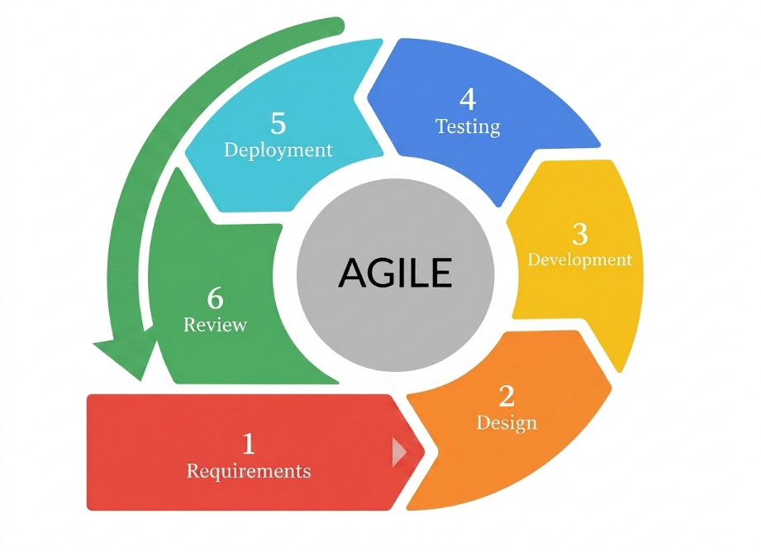
Figure 2. Agile Model
. Figure 2 shows the Agile model for the following: Requirements, Design, Development, Testing, Deployment, and Review.
The Requirements phase, where the proponents will gather information through interviews and consultations with potential users, including patients, family members, and caregivers in selected households in Poblacion Candaba, Pampanga. The researchers will also review related literature and identify system needs such as medication scheduling, notification features, and monitoring requirements, which will serve as the basis for the system specifications.
The Design phase, where the proponents will create a comprehensive system plan that includes both the mobile application and the physical device. This will involve developing system architecture diagrams, flowcharts, use case diagrams, and wireframes for the application interface, as well as drafting circuit diagrams for the ESP32, sensors, DRV8825, servo motors, and raspberry pi with camera module to ensure proper integration.
The Development phase, this is where the hardware and software components will be developed for the system. This will include the building the tangible prototype, programming the ESP32 microcontroller, and developing the mobile application using Flutter. Firebase will be configured for real-time data sync and notification services, while each features will be tested individually before the full system setup.
The Testing phase, where each component will undergo validation in a controlled environment to ensure proper functionality. This will include unit testing of individual parts such as the servo motors, DRV8825, sensors, camera, and RTC module, integration testing to verify communication between the device and the mobile application, and system testing to verify functions in a simulated environment to test its function and reliability.
The Deployment phase, where the system will be implemented in a simulated home environment, followed by testing in selected households in Poblacion Candaba, Pampanga to observe real-world performance and usability.
The Review phase, where feedback from testing and user evaluation will be collected and analyzed to improve the system. Necessary adjustments and refinements will be made to both hardware and software components to enhance performance, usability, and reliability in succeeding iterations of the system.

Requirement Analysis and Documentation
The requirement analysis and documentation for the IoT-Based Smart Pill Dispenser with Real-Time Notification System will outline the functional and non-functional requirements necessary for developing a reliable and efficient prototype for home-based medication management. This documentation will serve as the foundation for identifying and defining the system’s essential features, which aim to improve medication adherence and support patients, family members, and caregivers in managing daily medication routines.
The system’s functional requirements will include the automated release of medications based on scheduled time and date settings configured through the mobile application, along with sensor-based detection to determine whether the medication has been taken within a specified time. A camera module will be integrated to provide visual monitoring of the dispensing process. The system will also send real-time notifications through a mobile application and SMS alerts to inform users of scheduled doses, missed intake, and system status. In addition, the system will allow remote control features such as disabling the device when the patient is not at home, as well as an emergency button for immediate medication access. All medication events, schedules, and system activities will be stored in a cloud-based database for monitoring and review.
For user interaction, the system will include a mobile application with role-based access, allowing patients and family members or caregivers to use a single application with different interfaces and permissions. The application will provide features such as schedule setting, real-time monitoring, notification alerts, and medication history tracking. A display module will also be included in the device to show basic system information and assist users during operation.
Regarding non-functional requirements, the system will prioritize data security through secure authentication and protected data transmission. It will be designed to be scalable, allowing additional users and medication compartments if needed. Reliability and accuracy will be emphasized to ensure consistent system performance under typical household conditions. The system will also consider usability by ensuring that both the device and mobile application are easy to understand and operate, especially for elderly users or those with limited technical experience. Finally, the system will be designed to function effectively under varying internet conditions, with SMS alerts serving as an alternative notification method when connectivity is limited.

Software Requirement Specification
This table below will show the software requirements on what should the system must do.
A. Functional Requirements
Feature | Function
1. Camera-based Verification | - System should provide visual for medicine intake  - System should retrieve and save the events when validating the dispensed medication and intake.
2. Smart Dispensing | - Automatically releases the correction medication to the correct validated patient at the scheduled time.
3. Manual Dispensing | - Allows the immediate medication access when an emergency or unscheduled need happens.
4. Intake Verification and Adherence Monitoring | - Verifies if dispensed medication were removed using the IR sensor and camera  - Records doses dispensed or missed and maintains activity logs
5. Real-Time Notifications and Fallback Mode | - Sends reminders, dose miss alerts, and storage notifications.  - In the absence of internet, notifications will be sent SMS through GSM.
6. SmartDose Mobile Application | - Will be the interface for remote monitoring and management of medication activity and scheduling.
7. Medicine Storage and Refilling | - Sensor monitors the medication supply and sends alerts when stock reaches an input threshold.
8. LCD Display | - Shows the system information and buzzer provided by the prototype
9. User Authentication and Access Permission | - System should support user login accounts for caretakers and family members  - Caretakers should be able manage stored schedules for patients and their assigned medicine
B. Non-Functional Requirements
1. Security Database Management | - Maintain the data integrity  - Encrypting user credentials and saved schedule settings.
2. Reliable Wireless Communications | - Full functions if its connected via reliable internet connection  - Can operate remotely with mobile data
3. Mobile Application Responsiveness | - Remote management controls are in the SmartDose app  - Gives feedback after interactions  - Accessible and clear
Table 1. Software Requirements Specification Descriptions

Hardware Requirements Specification
The table below shows the hardware components of the system.
A. Main Functioning Components
Component | Specification/Purpose
ESP32 Microcontroller | Main controller responsible for system operations and connectivity
DS3231 RTC Module | Maintains accurate time for scheduled medication dispensing
DRV8825 | Controls the drop or dispense of medication
Servo Motors | Controls the movement of medication compartments
IR Sensor | Detects whether medication has been taken
Camera Module | Provides visual monitoring of medication dispensing
Raspberry Pi | Handles the camera module for the prototype
SIM800L GSM Module | Sends SMS alerts for notifications
16x2 LCD Display | Displays system status and schedule information
Power Supply | Provides stable power for the system components
Firebase Cloud Database | Stores system data, logs, and schedules
B. Supporting Hardware
- Buck Converters
- Buttons
- Circuits and Wires
- Droppers and Storage
C. Mobile Device
Smartphone with Android OS for SmartDose mobile application
Table 2. Hardware Specification
Description of Materials
This part describes the materials that will be used and their role in the IoT-Based Smart Pill Dispenser with Real-Time Notification System.
A. Control and Time Tracking Component
- ESP32 Microcontroller – serves as the main control unit for processing sensor inputs, servo motors, and managing system operations.
- DS3231 RTC Module – maintains the accurate date and time to ensure medication dispensing schedule even during power interruption.
B. Medication Dispensing Components
- Servo Motors – controls the movement of the pill compartments and position the correct slot during scheduled dispensing.
- DRV8825 - controls the movement of the dispensing medication.
- IR Sensor – detects whether the dispensed medication has been removed from the storage and identify the missed medication intake.
- Raspberry Pi and Camera Module – provides the visual to validate medication dispense and intake.
C. Communication and Notification Components
- SIM800L GSM Module – sends the SMS notifications to users such as the caregiver, or family member as the backup communication method when internet connectivity is interrupted or unstable.
- Wi-Fi Communication – enables the ESP32 to connect to the internet for the real-time data synchronization, cloud sync, and notifications.
D. Display and Power Components
- 16x2 LCD Display with I2C – displays the information such as the current time, medication schedules, and system status.
- Power Supply – provides the stable and continuous electrical power to the ESP32, sensors, DRV8825, servo motors, display, and communication modules.
E. Software and Cloud Components
- Firebase Cloud Database and FireStore – stores the medication schedule, activity logs and events, user data with real-time synchronization between the SmartDose prototype and mobile application.
- Mobile Application (SmartDose) – made with Flutter, will provide as the main user interface for patients, caregivers, and family members to manage medication schedules, receive notifications, and monitor medication events, and system settings.
- Arduino IDE – used for the programming and development for the ESP32 and controlling the hardware components.
- Visual Studio Code – used for developing and managing of SmartDose mobile application process and software components support.
- Android OS – serves as the supported mobile platform for installing and running the SmartDose application.

Design of the System
This section will present the technical blueprint used to transform the project’s requirements into a functional system, beginning with the Use Case Diagram to define how users will interact with the system. It will then outline the system logic and data movement through the Data Flow Diagram (DFD) and System Flow Chart, which will guide the structure of the database presented in the Entity Relationship Diagram (ERD). The overall integration of components will be shown through the System Architecture, followed by hardware implementation starting from the Block Diagram and finalized through the detailed Schematic Diagram that illustrates the complete wiring layout.

Use Case Diagram
The Use Case Diagram will visually represent the functional requirements, illustrating interactions between the primary actors and the IoT-Based Smart Pill Dispenser with Real-Time Notification System. It will showcase the interactions between the primary actors and the different functions of the system. The system will involve four main actors: the Patient, Caregiver, Admin, and SmartDose Device, which together will share the system services that will support the notifications and communications between the different functions.

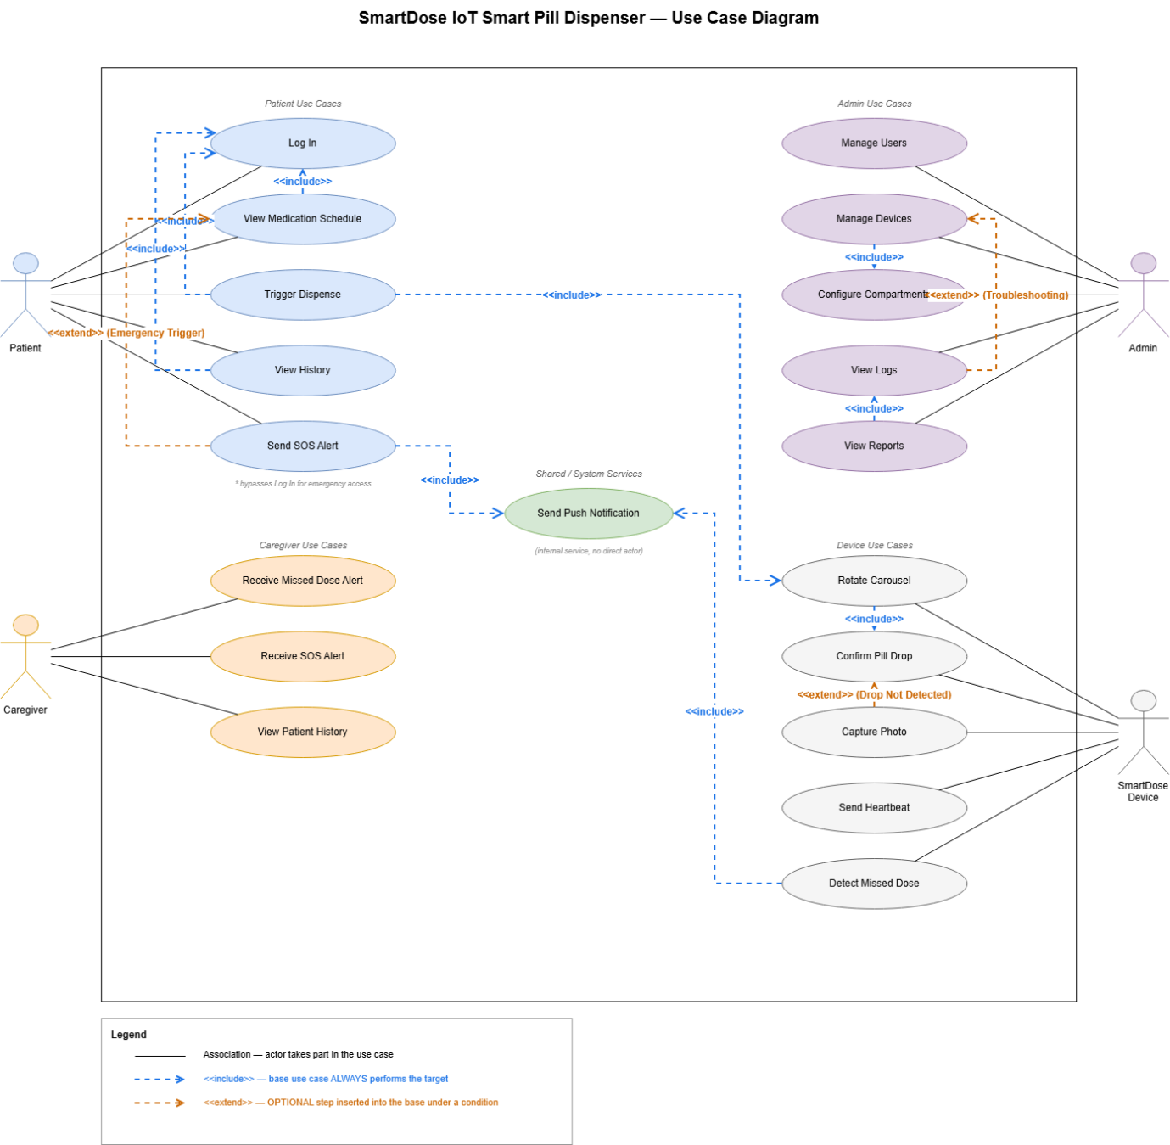
Figure 3. Use Case Diagram of IoT-Based Smart Pill Dispenser
Figure 3 illustrates the use case diagram system where the Patient will be able to log in, view the medication schedule, trigger medication dispensing, view medication history, and send an SOS alert during emergencies. The Caregiver will receive the missed-dose and SOS alerts and will be able to view the patient’s medication history. Meanwhile, the Admin will manage users and devices, configure the medication compartments, view system logs, and view reports. These interactions will allow the users to access the correct functions according to their roles in the system.
The SmartDose Device will perform the automated operations of the system, which include rotating the medication carousel, confirming pill dispensing, capturing photos when required, sending device heartbeat or status information, and detecting missed doses. These functions will work together with the shared notification services to send the relevant alert information and updates to the users. Through these interactions, the system will support automated medication dispensing, medication monitoring, emergency alerts, medication history, device management, and real-time notifications, which will be consistent with the functions that are defined in the current scope of the SmartDose system.
Data Flow Diagram
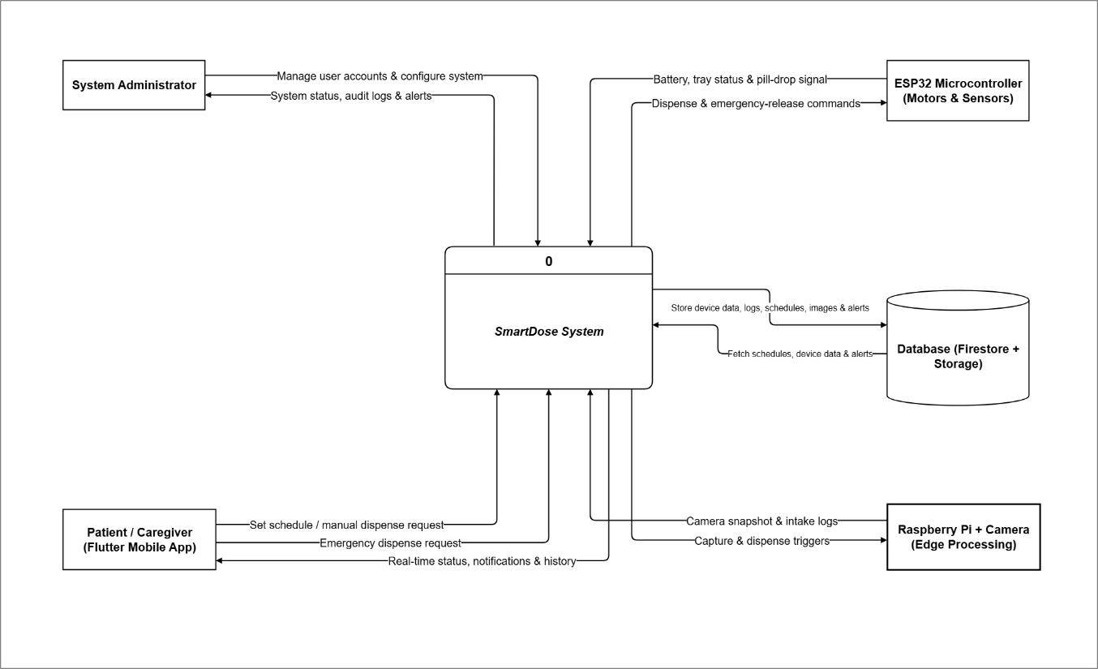
The Level 0 Data Flow Diagram, also known as the Context Diagram, shown in Figure 4.0 provides a high-level overview of the Smart Pill Dispenser system as a single process and its interactions with external entities. The external entities identified are the Patient, the Caregiver/Family, the Firebase cloud platform, the Flutter Mobile Application, and the GSM module. The diagram illustrates the primary data flows into and out of the system without detailing the internal processes.
Figure 4. Level 0 Data Flow Diagram
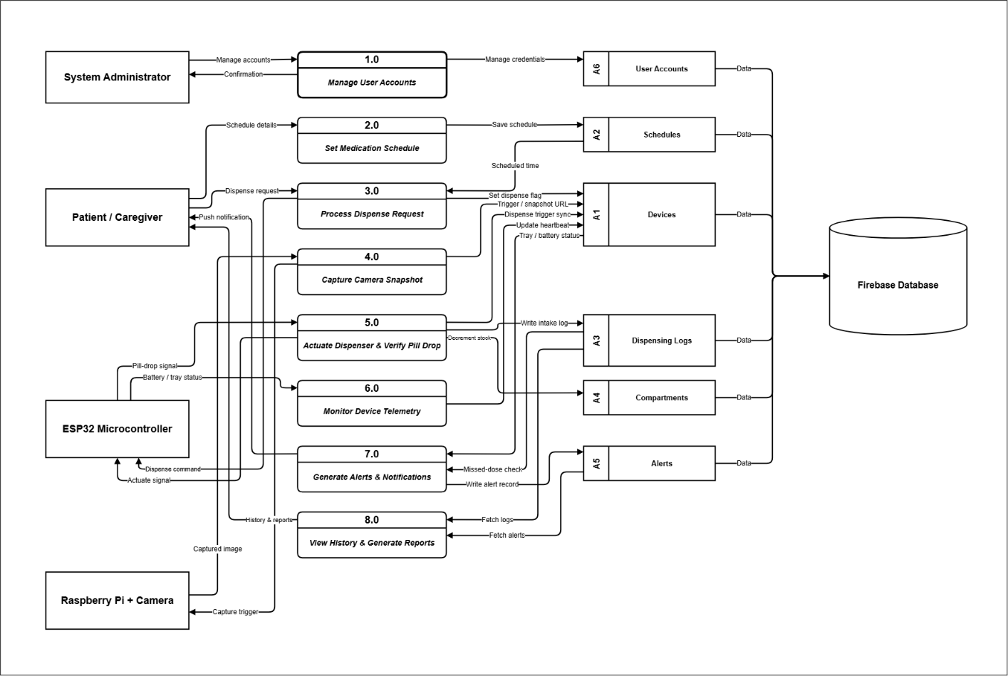
The Patient/Caregiver uses the SmartDose mobile application made with Flutter to set medication schedules, manual or emergency dispensing, and receive real-time system status, notifications, and medication history. The System Administrator manages the user accounts and system configurations and receives system status, audit logs, and alerts. The ESP32 Microcontroller handles medication dispensing and manual/emergency release commands while providing status for batter, tray, and pill dispense or drop information of the system. The Raspberry Pi with Camera handles camera snapshots, intake logs, and capture or dispensing triggers for monitoring and verification. The Database Firestore and cloud storage will serve as the central storage for device data, medication schedules, logs, images, and alerts while also providing stored schedules, device data, and alerts to the SmartDose System.
Figure 4.1 Level 1 Data Flow Diagram
The Level 1 Data Flow Diagram in Figure 4.1 expands the central system process from the Context Diagram into eight interconnected sub-processes which area the following: Manage User Accounts, Set Medication Schedule, Process Dispense Request, Capture Camera Snapshot, Actuate Dispenser & Verify Pill Drop, Monitor Device Telemetry, Generate Alerts & Notifications, and View History & Generate Reports. These processes will show how information moves between the System Administrator, Patient/Caregiver, ESP32 Microcontroller, Raspberry Pi with Camera, the system internal data storing, and Firebase Database
Manage User Accounts (1.0) receives the account management instructions from the System Administrator, manages users, and stores account information in the User Accounts data store. Set Medication Schedule (2.0) receives schedule details from the Patient/Caregiver and saves them in the Schedules data store. The stored schedule information will then be used by the Process Dispense Request (3.0) to determine when medication should be dispensed.
Process Dispense Request (3.0) handles dispense requests and communicates the dispense commands towards the ESP32 Microcontroller. Capture Camera Snapshot (4.0) sends a capture trigger to the Raspberry Pi + Camera and receives the captured image for verification or recording purposes. Actuate Dispenser and Verify Pill Drop (5.0) will control the dispensing mechanism through the ESP32 and verify the pill-drop event, while also updating the relevant components and information.
Monitor Device Telemetry (6.0) will receive device status information such as battery level and tray status from the ESP32 and updates the Devices and Compartments data. Generate Alerts and Notifications (7.0) evaluate the events such as the missed doses and device conditions, generate notifications for the Patient/Caregiver, and record the alert information in the Alerts data store. View History & Generate Reports (8.0) retrieves the dispensing logs and alerts to provide history and reports to the Patient/Caregiver.
The system uses Firebase Database as the centralized backend for storing and synchronizing User Accounts, Schedules, Devices, Dispensing Logs, Compartments, and Alerts. This structure will allow medication schedules, dispensing events device telemetry, alerts and historical records to be consistent to storing and accessing across the SmartDose system.

System Flowchart
In this section, the proponents will present the System Flowchart, which will serve as the architectural skeleton of the Smart Pill Dispenser system. By bridging the gap between abstract code and functional logic, this diagram will trace the precise lifecycle of data from input to output. It will provide a definitive map of control flow, ensuring that every loop, decision branch, and data store will be accounted for and optimized.
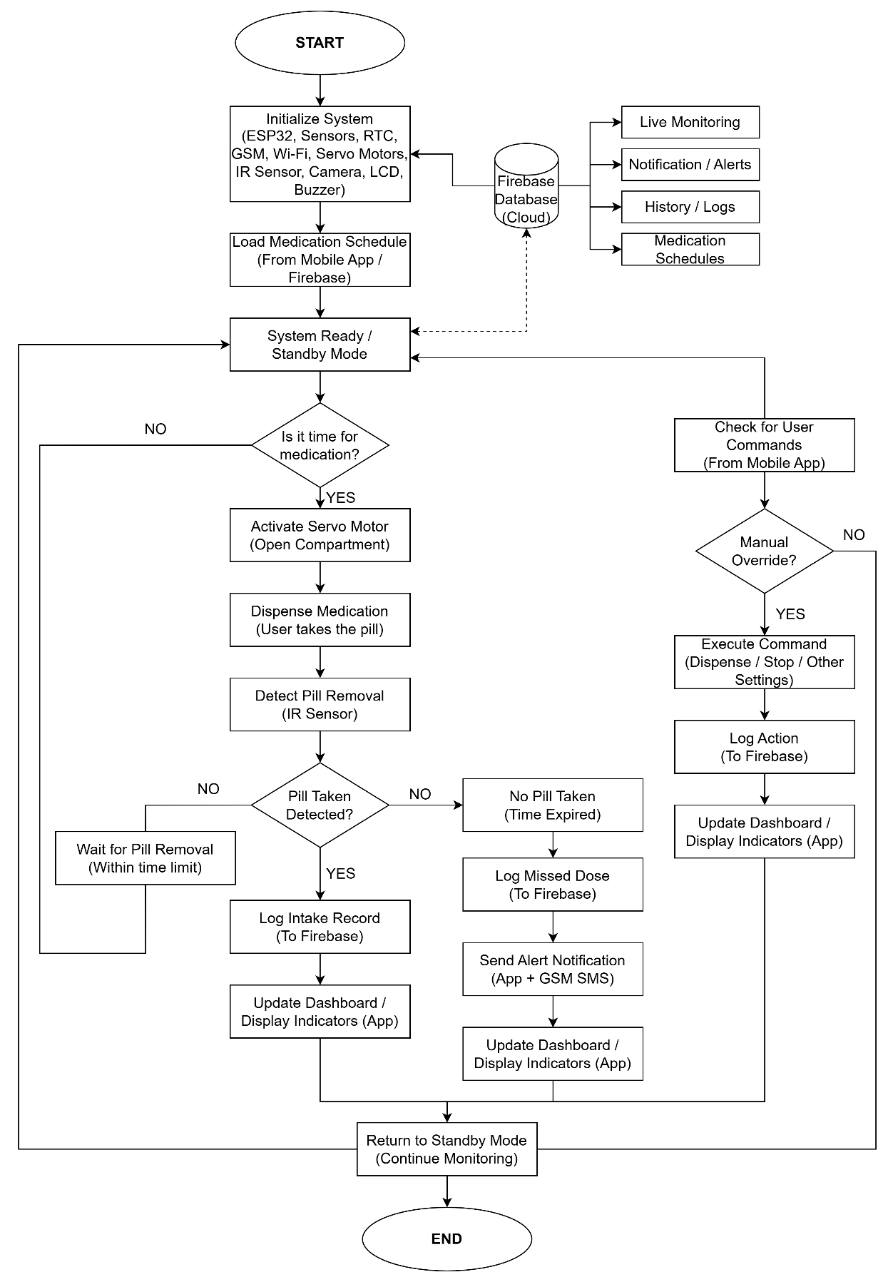
Figure 5. IoT-Based Smart Pill Dispenser Hardware Flowchart

Figure 5 will illustrate the overall operational workflow of the Smart Pill Dispenser system, detailing the interaction between the hardware components, the central processing unit, the cloud database, and the mobile application interface.
The process will begin with system initialization, where the ESP32 microcontroller, sensors, RTC module, GSM module, Wi-Fi connectivity, servo motors, IR sensor, camera, LCD, and buzzer will be configured. After initialization, the system will load the prescribed medication schedule from the mobile application or Firebase database. Once the schedule has been retrieved, the system will enter a standby or ready state, continuously monitor the time and awaiting scheduled operations.
A real-time clock (RTC) module will be used to determine whether it is time to dispense medication. When the system time matches the scheduled medication time, the system will activate the servo motor to open the designated compartment. The medication will then be dispensed, allowing the user to take the pill. An IR sensor will be utilized to detect whether the pill has been removed within a specified time limit.
If pill intake will be successfully detected, the system will log the intake record to the Firebase database and update the mobile application dashboard to reflect successful medication adherence. Conversely, if no pill removal will be detected within the allotted time, the system will classify the event as a missed dose. It will then log the missed dose in the database and send alert notifications to the user through the mobile application and GSM SMS module. The dashboard will also be updated accordingly to reflect the missed medication event.
In parallel, the system will support remote interaction through the mobile application. It will continuously check for user commands, such as manual dispensing, stopping operations, or adjusting system settings. If a manual override will be requested, the system will execute the corresponding command, log the action to the Firebase database, and update the application dashboard in real time.
Additionally, the Firebase database will function as the central cloud repository, enabling features such as live monitoring, notification management, history logs, and medication schedule management. This integration will ensure seamless synchronization between the hardware system and the mobile application.
The operational cycle will conclude by returning the system to standby mode, where it will continue monitoring for the next scheduled medication event or user command. This continuous loop will ensure that the system remains responsive, reliable, and capable of maintaining accurate medication dispensing and monitoring at all times.

ESP32 Flowchart
This section outlined the operational logic established for the ESP32-based Smart Pill Dispenser system. As the flowchart illustrated, the process began by initializing the necessary communication modules, sensors, and dispensing components. It then moved into a continuous monitoring cycle that managed medication schedules, dispensing operations, dosage verification, and real-time notification services.
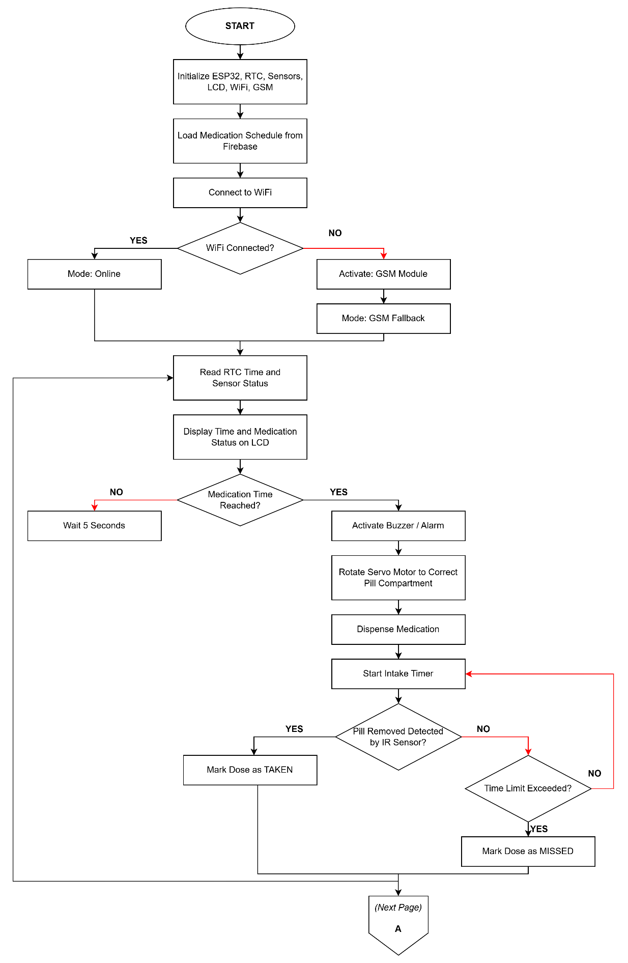
Figure 5.1 ESP32 Flowchart (Smart Pill Dispenser Control Unit)
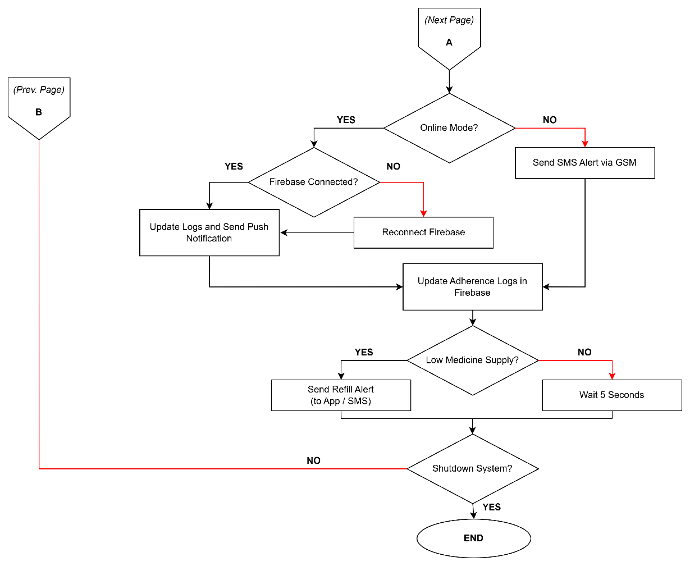
Figure 5.1 (Continued) ESP32 Flowchart (Smart Pill Dispenser Control Unit)
The functionality of the ESP32 Control Unit, illustrated in Figure 5.1 and Figure 5.1 (Continued), demonstrated a fault-tolerant control algorithm designed to maintain medication dispensing operations even during network instability. The process began with the initialization of the ESP32 microcontroller, RTC module, IR sensor, LCD display, Wi-Fi interface, and GSM communication module. Upon booting, the system immediately loaded the medication schedules stored in Firebase and attempted to connect to the local Wi-Fi network.
A decision logic evaluated the connection state: if the Wi-Fi connection succeeded, the system entered Online Mode; if the connection failed, it activated the SIM800L GSM module and shifted into GSM Fallback Mode to maintain notification capabilities through the cellular network. In either operating mode, the system entered a continuous monitoring loop where the RTC module provided real-time schedule tracking while the ESP32 continuously monitored sensor status and dispensing conditions. Current time information and medication schedule status were simultaneously displayed on the LCD interface for local monitoring.
The workflow then diverged based on the programmed medication schedule. If no medication event was scheduled, the system entered a short standby delay before restarting the monitoring cycle. Once the scheduled medication time was reached, the ESP32 activated the buzzer alarm to alert the patient and rotated the servo motor to align the correct pill compartment with the dispensing slot. The dispensing mechanism then released the medication while the intake timer simultaneously began counting the allowable confirmation period.
The system then performed dosage verification using the IR sensor detection mechanism. If pill removal was successfully detected, the system recorded the medication event as TAKEN and updated the adherence logs accordingly. However, if the IR sensor failed to detect pill removal within the configured time limit, the system classified the dose as MISSED. At this stage, the workflow evaluated the active operating mode. If the system remained in Online Mode, it verified the Firebase connection and transmitted updated adherence logs together with push notifications to the mobile application. If the Firebase connection was unavailable, the ESP32 attempted automatic cloud reconnection before retrying the synchronization process.
In GSM Fallback Mode, the system shifted to an offline notification strategy. Once a missed-dose event was detected, the SIM800L GSM module transmitted an SMS alert directly to the registered caregiver or family member to ensure that medication adherence notifications remained functional even without internet connectivity. The workflow also monitored medication inventory levels within the dispenser. If the remaining medication supply dropped below the configured threshold, the system generated refill alerts through either Firebase notifications or SMS messaging. The operational cycle concluded with a short stabilization delay and a shutdown verification stage before returning to the continuous medication monitoring loop.

Servo Motor Flowchart (The Actuator)
Figure 5.2 illustrated the workflow of the Servo Motor Actuator subsystem, which will be designed to automate the dispensing of medication compartments in the IoT-Based Smart Pill Dispenser system. The subsystem will ensure accurate positioning of the pill container and will control the dispensing process without interrupting the continuous operation of the ESP32 controller.
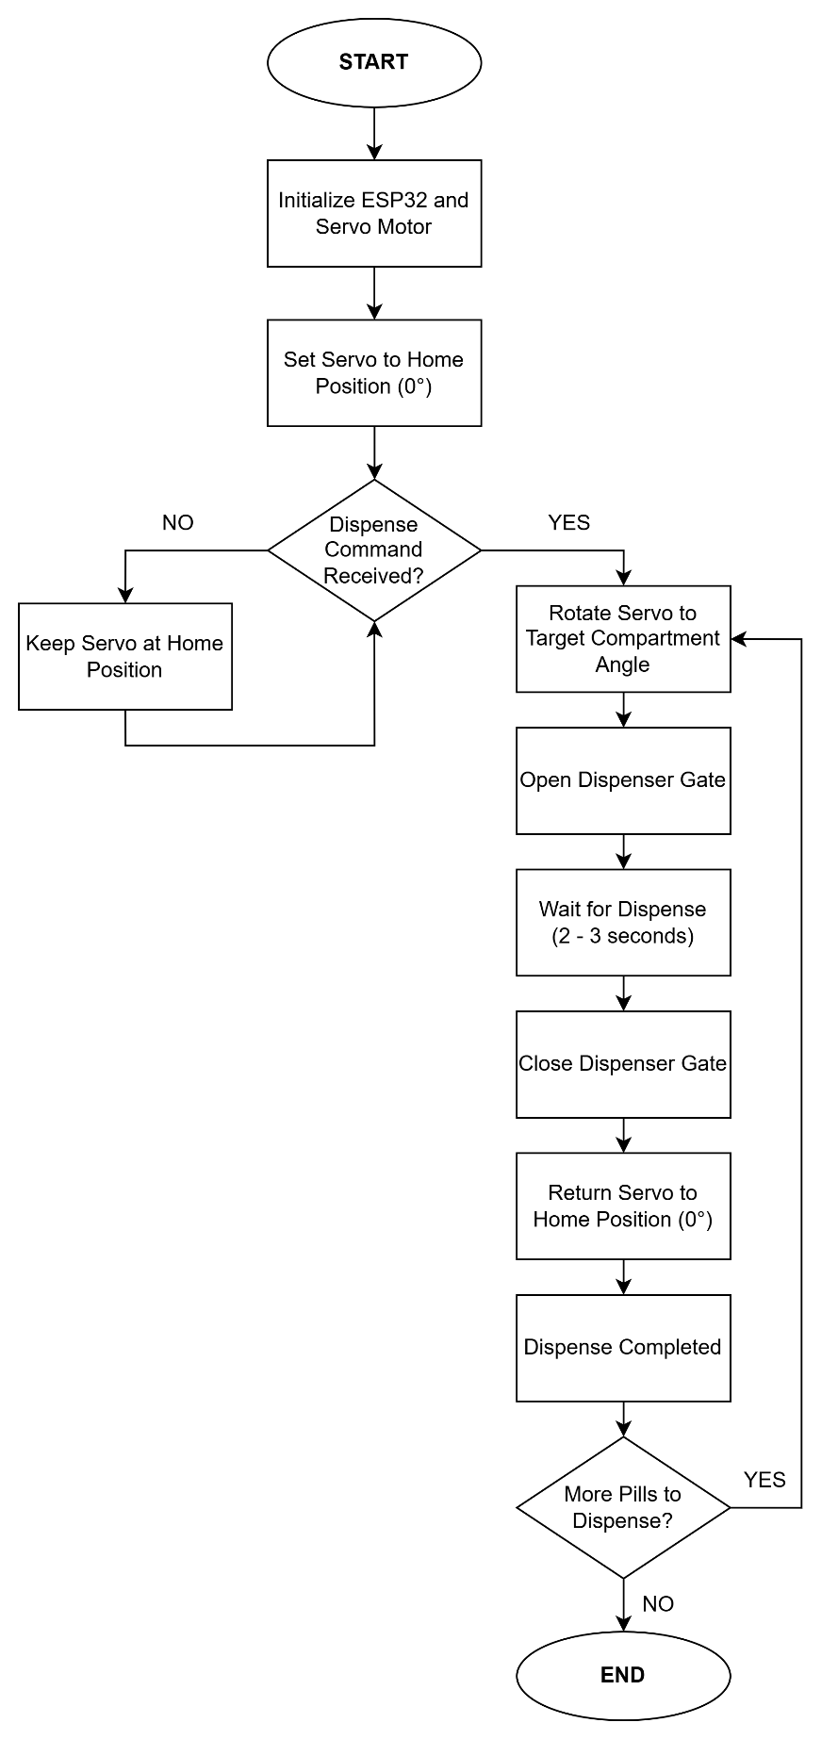
Figure 5.2 Servo Motor (Actuator) Flowchart
Figure 5.2 illustrated the operational workflow of the servo motor actuator subsystem, which will function as the primary dispensing mechanism of the Smart Pill Dispenser. The process will begin by initializing the ESP32 microcontroller and configuring the servo motor to its default home position at 0 degrees. Once initialization is completed, the system will continuously monitor for dispensing commands generated from the medication schedule stored in the database and synchronized through the ESP32 controller.
When a dispense command is detected, the system will read the assigned medication compartment and calculate the corresponding servo motor angle required for dispensing. The servo motor will then rotate to the target position to align the correct medication compartment with the dispensing slot. After reaching the target angle, the dispenser gate will be activated to release the medication into the dispensing tray. The actuator will remain active for a short dispensing duration to ensure that the medicine is properly released.
After the dispensing process is completed, the system will automatically close the dispenser gate and return the servo motor to its original home position. The system will then update the dispensing status as “Dispense Completed” and check whether additional medication schedules are queued for operation. If another dispensing request exists, the cycle will repeat for the next medication compartment. Otherwise, the actuator subsystem will remain in standby mode while waiting for the next scheduled command from the ESP32 controller.
This automated actuator design will ensure accurate medication dispensing, minimize mechanical errors, and maintain continuous readiness for future dispensing operations. The implementation of the servo motor mechanism will also support reliable medication scheduling and improve the overall efficiency of the Smart Pill Dispenser system.

Entity Relationship Diagram
The Entity Relationship Diagram (ERD) in Figure 6.0 showed the database architecture of the IoT-Based Smart Pill Dispenser with Real-Time Notification System. The researchers designed the schema as a user-centered structure to organize the relationships between medication schedules, dispensing records, notification services, and dosage verification processes.
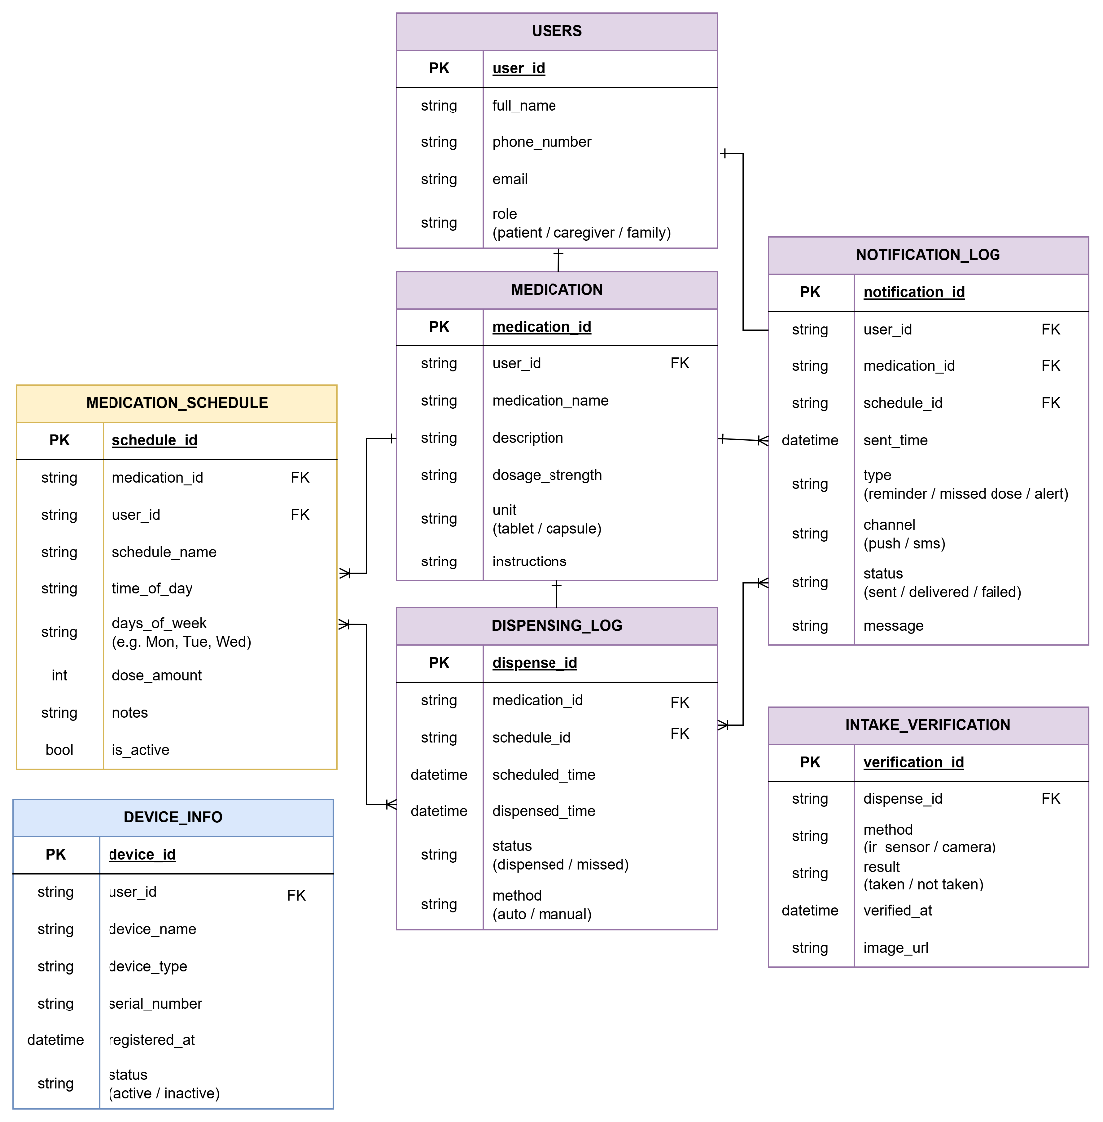
Figure 6. Entity Relationship Diagram
Figure 6 illustrated the Entity Relationship Diagram (ERD) for the Smart Pill Dispenser system, showing the logical database schema that would support the operation of the prototype. The database design followed a hierarchical structure centered on the User entity as the primary control unit. At the highest level, the User entity would manage system access by storing account credentials, contact information, and assigned roles such as Patient, Caregiver, or Family Member. A one-to-many relationship would exist between the User and Medication entities, meaning that a single user account could manage multiple medications and treatment routines simultaneously.
The system would utilize two primary scheduling and monitoring entities connected to the Medication entity to manage dispensing operations and adherence tracking. The Medication Schedule entity would store all programmed intake schedules, including dosage amounts, intake frequency, selected days, and scheduled administration times. This structure would allow the system to automate dispensing operations according to the prescribed treatment plan. Complementing this would be the Dispensing Log entity, which would record all dispensing activities performed by the device. The table would maintain timestamped records of scheduled doses, actual dispensing times, dispensing methods, and missed-dose events to support long-term adherence monitoring and historical reporting.
The system would monitor notification delivery and medication intake verification through two additional logging entities. The Notification Log entity would function as the centralized communication record for all alerts transmitted through Firebase Cloud Messaging and the SIM800L GSM module. This entity would store notification types, delivery channels, timestamps, and notification status to verify successful reminder transmission and missed-dose escalation procedures. Meanwhile, the Intake Verification entity would focus specifically on confirming medication intake using IR sensor detection and optional camera-based monitoring. This table would document the verification method used, the confirmation result, and the associated dispensing record, ensuring that adherence reports reflected actual medication removal events rather than simple dispensing actions.
To support device management and system maintenance, the Device Information entity would store details related to registered Smart Pill Dispenser units, including device identifiers, hardware status, registration timestamps, and device ownership mappings. All operational entities would maintain one-to-many relationships with the User and Medication entities, enabling the system to generate comprehensive medication adherence histories, notification records, and dispensing analytics for each individual patient profile.

System Architecture
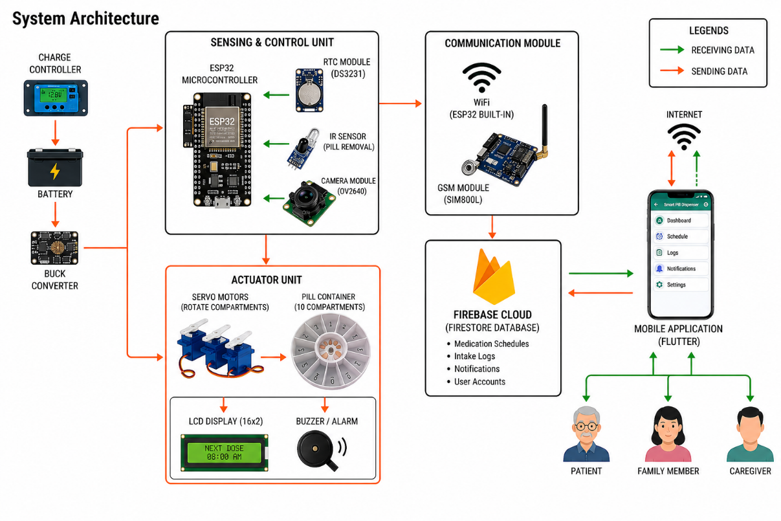
Figure 7. System Architecture
Figure 7.0 The System Architecture illustrated the integration of embedded hardware, IoT communication, and mobile application technologies for the IoT-Based Smart Pill Dispenser with Real-Time Notification System. It began with a power management subsystem where a charge controller maintained a rechargeable battery, with a buck converter providing stable power distribution to all components for continuous and reliable system operation.
The hardware was structured into two primary units: an ESP32 microcontroller that managed real-time medication scheduling, sensor monitoring, and wireless communication through the RTC module, IR sensor, and OV2640 camera module, and an actuator unit that handled hardware actuation using servo motors to rotate the pill compartments for automated medication dispensing. The actuator unit also incorporated a 16x2 LCD display for real-time schedule and status monitoring, alongside a buzzer or alarm module for medication reminders and alerts.
The Firebase Cloud acted as the central communication and database platform, consolidated data from the ESP32 and communication modules, and served as the cloud hub for the entire system. It utilized Firebase Firestore as a real-time database for bidirectional data flow, storing medication schedules, intake logs, notifications, and user account information. Through internet connectivity and the SIM800L GSM module, the system enabled users via a Flutter-based Mobile Application to monitor medication adherence, receive real-time notifications, review logs, and remotely manage medication schedules from selected households in Candaba, Pampanga.

Schematic Diagram
These schematic diagrams presented the overall layout of the hardware connections and power distribution within the setup. This visual guide demonstrated how the various components were integrated to form the complete monitoring system.
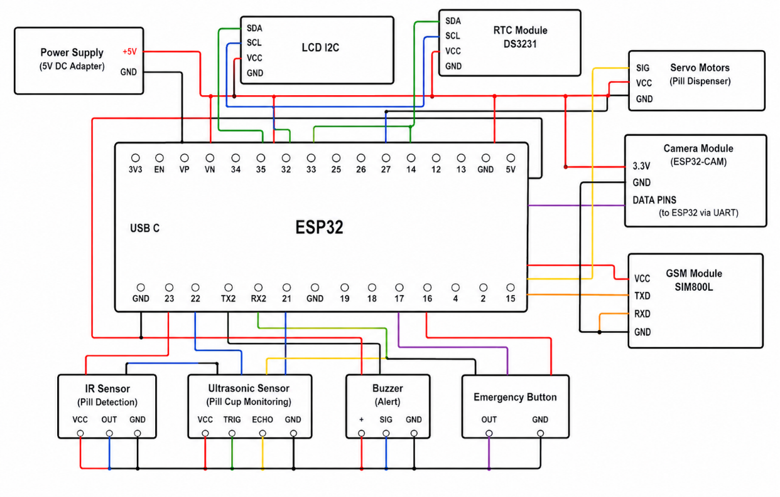
Figure 8. Schematic from ESP32 to Sensors
Figure 8 illustrated the schematic layout in which the ESP32 microcontroller operated as the central hub, powered by a regulated 5-volt supply. It connected to a suite of sensors including the IR sensor for pill detection and the ultrasonic sensor for pill cup monitoring. The diagram detailed the specific wiring for each device, distinguishing the digital connections sent to the ESP32’s GPIO pins for signal transmission. Additionally, the buzzer served as an alert mechanism, while the emergency button functioned as a manual input control. The included connections represented how the ESP32 interpreted incoming signals and triggered corresponding outputs, enabling real-time monitoring and reliable operation of the Smart Pill Dispenser system.
Figure 9.1 illustrated the power distribution network designed to support the reliable and continuous operation of the Smart Pill Dispenser system. The design focused on ensuring stable power delivery to all electronic components involved in sensing, processing, communication, and actuation within the system.
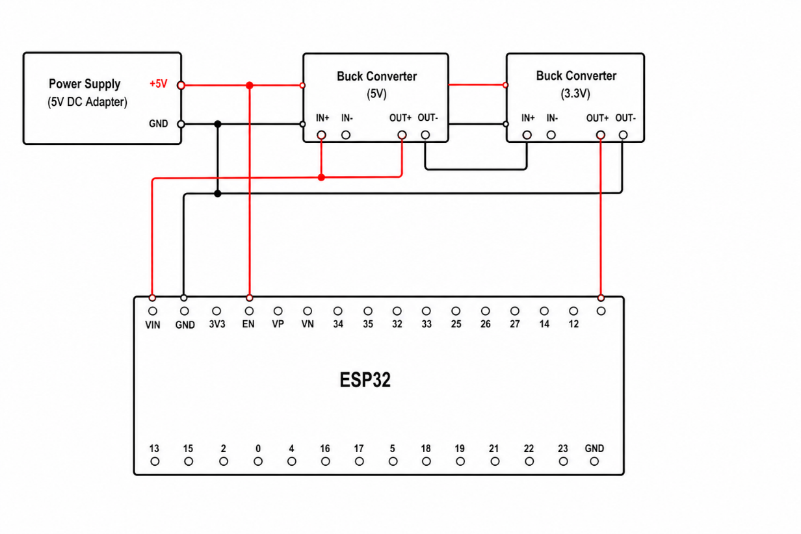
Figure 8.1 Schematic from Power Supply to ESP32
The power delivery process began with a 5V DC power supply adapter, which served as the primary energy source of the system. This input was regulated and routed into a stable 5V supply line, which then powered the ESP32 microcontroller as the central control unit responsible for coordinating all system operations and decision-making processes.
From the main supply line, power was distributed through a shared 5V and GND rail to ensure consistent voltage levels across all connected modules. The ESP32 managed system functionality while also interfacing with peripheral devices such as the servo motors, IR sensor, ultrasonic sensor, GSM module, LCD I2C display, and RTC module. For components requiring lower voltage, a 3.3V line was provided to support devices such as the ESP32-CAM, ensuring proper voltage compatibility and safe operation.
Communication and control were maintained through multiple interfaces integrated into the system architecture. The LCD I2C display and RTC module were connected via I2C lines (SDA and SCL) for real-time monitoring and time-based functions, while the GSM module and ESP32-CAM utilized UART communication for data transmission. Overall, this integrated power distribution design ensured that all system components operated efficiently and harmoniously within a single, stable electrical network.
Figure 9.2 illustrated the electrical schematic for the system's dispensing and monitoring subsystem, establishing the ESP32 as the core controller. The circuit utilized a regulated power distribution network where the ESP32 supplied control signals and power to peripheral components including the servo motor, sensors, communication modules, and alert devices, ensuring coordinated operation within the automated pill dispensing system.
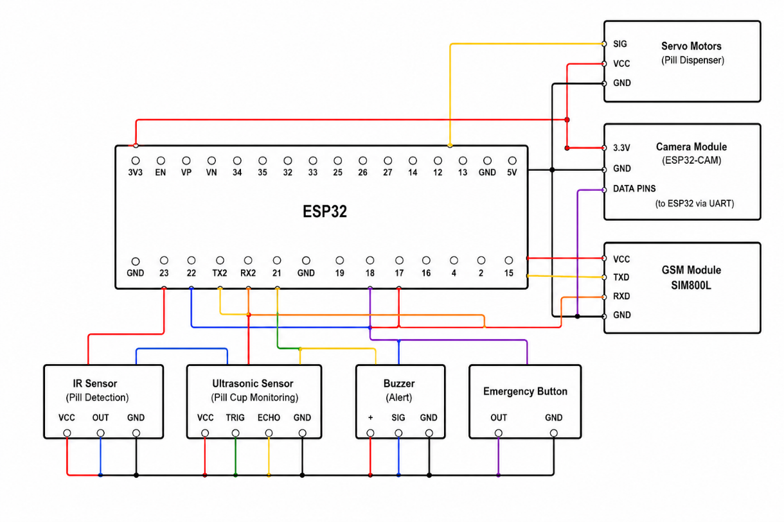
Figure 8.2 Schematic from Servo Motors to Sensors
The diagram detailed an integrated control system where a Servo Motor regulated the pill dispensing mechanism through a PWM-enabled GPIO pin of the ESP32. A Camera Module (ESP32-CAM) was incorporated to provide visual monitoring of the dispensing process, while the SIM800L GSM module enabled wireless communication through UART connections, allowing the system to transmit notifications or alerts to caregivers. For pill monitoring, an IR Sensor detected the presence of dispensed medication, while an Ultrasonic Sensor measured the distance within the pill cup to monitor dispensing status. A Buzzer was included to provide audible alerts during scheduled medication times, and an Emergency Button allowed the user to manually trigger an alert in case of urgent situations. This design ensured reliable coordination between actuation, sensing, and communication components while maintaining stable electrical connections through a shared grounding network
Block Diagram
The design of the IoT-Based Smart Pill Dispenser with Real-Time Notification System was mapped out in the block diagram shown in Figure 8.0. This illustration separated the system into its key components, which helped explain the data flow, communication process, and control logic that will be used throughout the medication management system.
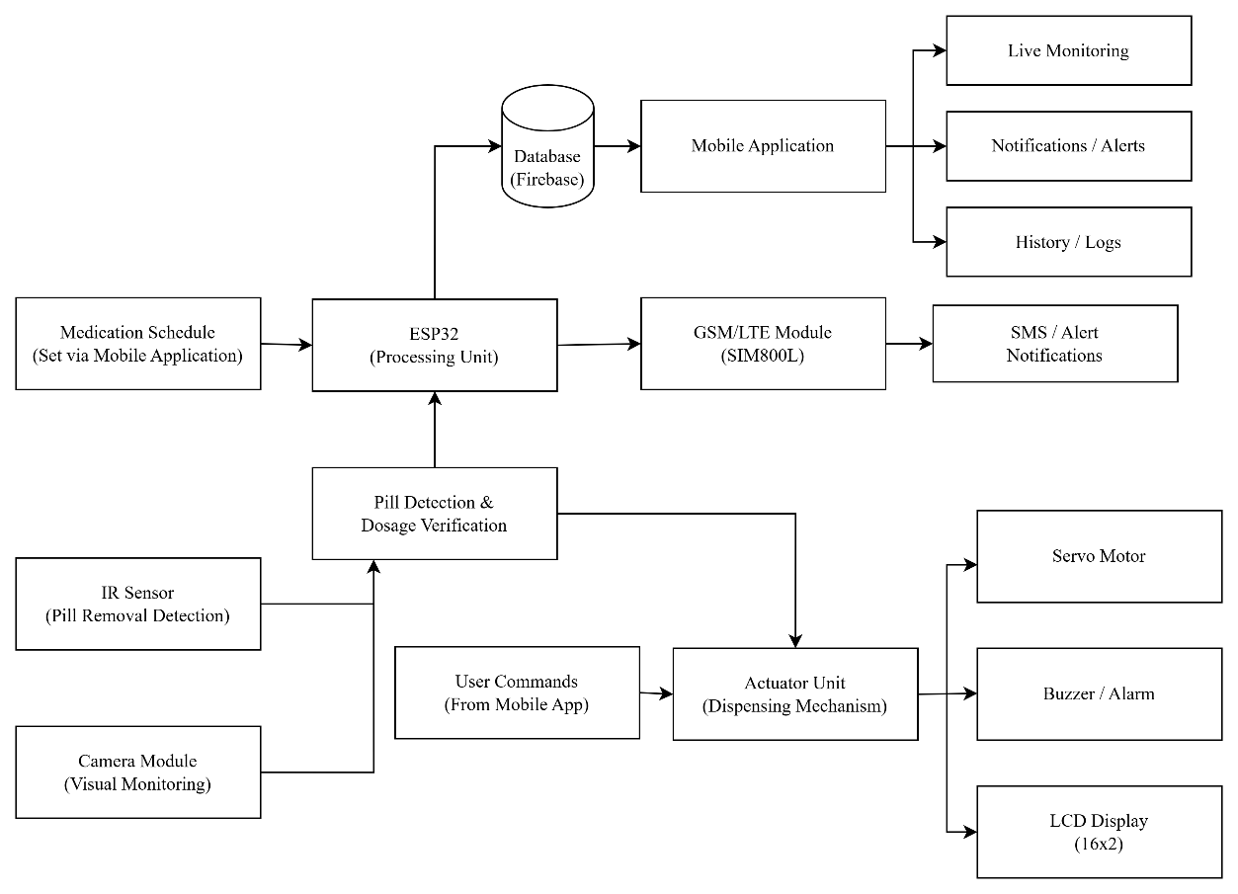
Figure 9. Block Diagram
The Block Diagram in Figure 8.0 will illustrate the overall design and operational flow of the Smart Pill Dispenser system, showing how the processing unit, cloud database, sensors, actuators, and mobile application will interact with one another. At the core of the system, the ESP32 microcontroller will serve as the main processing unit responsible for coordinating medication scheduling, sensor monitoring, dispensing operations, and communication with the cloud database and mobile application.
The process will begin with medication schedules configured through the mobile application, which will be stored in the Firebase database and transmitted to the ESP32. The ESP32 will then process the scheduling data and control the dispensing mechanism at the designated medication time. For communication and notification services, the system will utilize Firebase Cloud for real-time synchronization and the SIM800L GSM/LTE module for SMS-based alert notifications during low or unstable internet connectivity. Through the mobile application, users will be able to perform live monitoring, receive notifications or alerts, and review medication history and intake logs in real time.
For monitoring and verification, the system will incorporate an IR sensor for pill removal detection and a camera module for visual monitoring. These components will support pill detection and dosage verification by confirming whether the medication has been removed from the dispensing tray after release. The collected verification data will then be transmitted back to the ESP32 for processing and logging.
For physical control and user interaction, the actuator unit will function as the dispensing mechanism of the system. It will receive commands from both the ESP32 and the mobile application to operate the servo motor responsible for rotating the pill compartments. The actuator unit will also control the buzzer or alarm module for audible medication reminders and the 16x2 LCD display for showing real-time schedule and system status information. This integrated structure will enable automated medication dispensing, real-time adherence monitoring, and remote supervision through the cloud-connected mobile application.

Design of the Software System
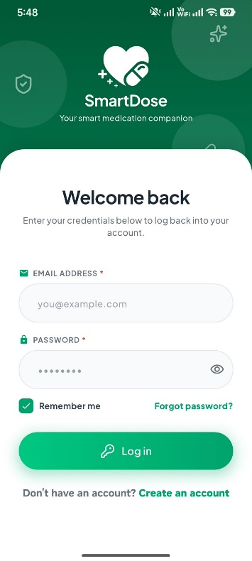
This part will showcase the mobile interface of the SmartDose app, that will enable caregivers and family members to remotely access the prototype and manage its medication dispensing, scheduling, notifications, and validation. It will also include system status, history logs, hardware status, network status, and more to ensure that each components are up and running. The following screens will be designed mainly for usability, ease of use and clarity for end-users to understand
Figure 10. Log-in Screen
Figure 10 shows the Log-in screen display where users can login to the SmartDose system with their email and password. Once credentials are entered and validated, the user can access the dashboard of the SmartDose interface.

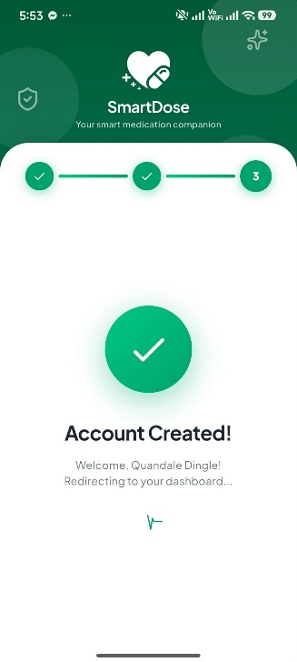
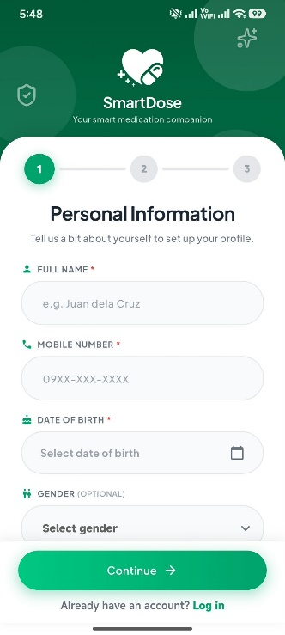
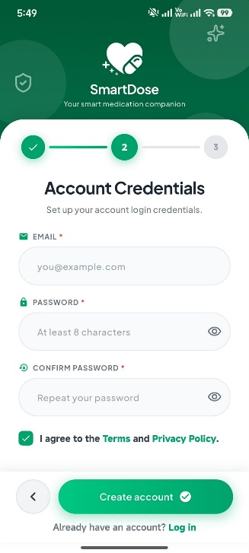
Figure 11. Account Registration Screen
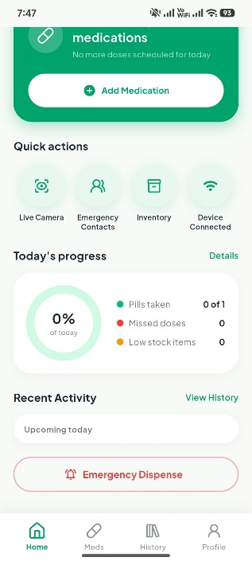
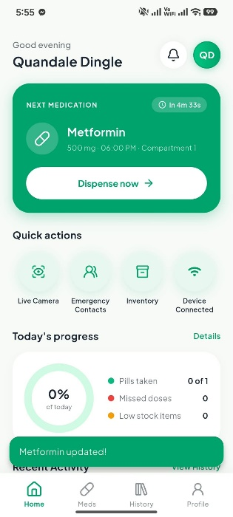
Figure 11 shows the Account Registration Screen where users can register an account with by filling in the needed information and credentials. After registering, the users can login and will be led to the SmartDose dashboard.
Figure 12. SmartDose Dashboard Screen
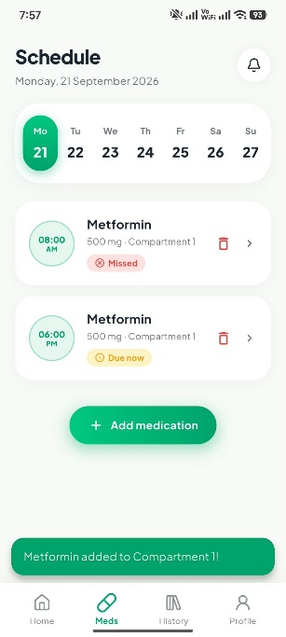
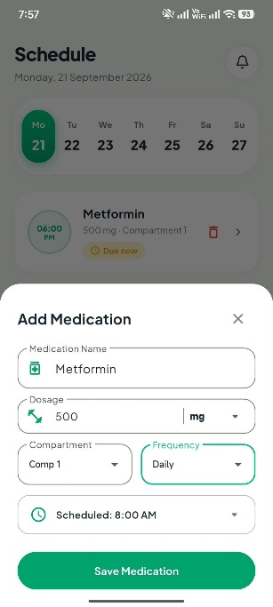
Figure 12 displays the SmartDose app dashboard where users will be greeted by the main functions of the system. Users can see various buttons such as medication dispense and scheduling settings, live camera feed, emergency contacts, inventory, device connection, then the pills taken status, missed doses, and stock quantity. Lastly, the emergency dispense button to manually dispense medicine in case of interruption or error.

Figure 13. SmartDose Medication Scheduling
Figure 13 shows the Medication Scheduling display of the mobile application. This is the main function of the SmartDose system whereas users can configure the scheduling of the medication dispense with the following: medication name, dosage (by grams of milligrams), compartments, frequency, and exact time schedule. After saving the medication, it will show up to the dashboard and the other scheduled medications. It will also properly label them if they were taken on time, missed and so on.

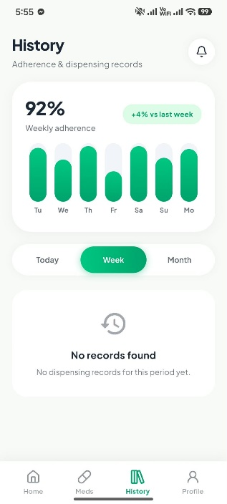
Figure 14. SmartDose

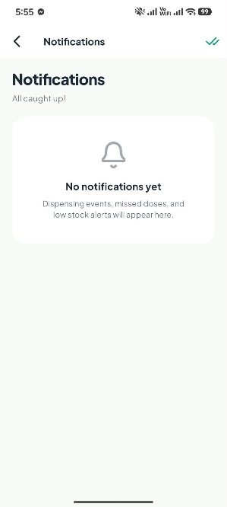
Figure 14 shows the history logs of the SmartDose system. It shows frequency, amount, and records by today, week, or the month. It will keep track of the medication activity throughout its runtime for each account.
Figure 15. SmartDose Notification and Alerts

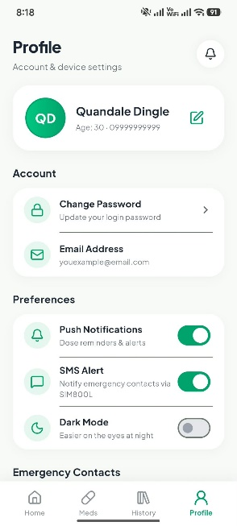
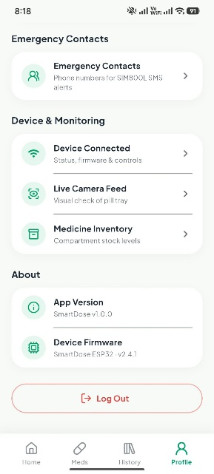
Figure 15 shows the notification and alerts tab of the system. In here, this will notify users by the following: upcoming medication schedule, current or missed medication, and medication storage alerts. This will ensure that users can get information even if the mobile application is closed.
Figure 16. SmartDose Profile Screen

Figure 16 shows the profile screen of the SmartDose system. In this display, it shows the Account settings for password and email. Preference for enabling and disabling Push Notifications, SMS Alert, or Dark Mode UI. Then the Device and Monitoring where it shows the connected devices, live camera feed, and medicine inventory for each compartments and their stock levels. Lastly, the About section where it shows the App Version, and Device Firmware version, which under it is the Log Out button if the users want to return to the login page.

Product and Process
The IoT-Based Smart Pill Dispenser with Real-Time Notification System will automate medication processes such as dispensing and intake monitoring, and provide real-time notifications to patients, family members, and caregivers. The system will integrate Internet of Things technology, sensors, cloud database storage, and the mobile application “SmartDose” that will provide a convenient and organized approach to managing daily medication schedules. It will allow users to configure the medication schedules, monitor dispensing activities and activity records, receive notification alerts and SMS, and view medication history and system status through the mobile application.
The project’s core functionality will include the following:
- Automated medication dispensing based on the configured schedules
- Medication schedule management through the SmartDose app
- Sensor and actuator-based medication dispensing and intake monitoring
- Raspberry Pi and camera module monitoring
- Medication adherence records and dispensing history
- Emergency manual medication dispensing
- Medicine stock level monitoring compartment and refill reminders
- Remote monitoring through the mobile application
- Basic system diagnostics and status monitoring
These functionalities will be consistent with the specific objectives and clear scope of the system, which includes automated dispensing, sensor-based verification, dispensing actuators, real-time notifications, manual emergency dispensing, and mobile application management.
The system will be developed using the ESP32 microcontroller as the main controller for the hardware components. The DS3231 Real-Time Clock (RTC) module will maintain the medication schedule, while the DRV8825 and servo motors will control the medication dispensing mechanism. IR sensors will assist with medication dispensing and removal detection, while the Raspberry Pi with a camera module will provide visual monitoring and more confirmation of medication intake. The system will also include the SIM800L GSM module, LCD display, and other supporting components that are required for the prototype.
The software components will include Flutter (Dart) for the SmartDose app, which is only available for Android, and Firebase Firestore and Cloud Messaging for the cloud database, synchronization, and notifications. The Arduino IDE will be used for microcontroller development, and Visual Studio Code will be used as the development environment. The hardware and software components will communicate to support medication scheduling, automated dispensing, monitoring, and record management, and real-time communication between the hardware and mobile application.
The project development will follow the Agile Methodology, which will allow the researchers to develop the SmartDose system through an iterative approach, in which the system will be continuously developed, tested, evaluated, and improved based on the given results and feedback that will be gathered throughout the development process. This approach will support adjustments to both the hardware and software components, as issues and improvements will be identified during the development and testing.
The development processes are the following:
1. Requirements Gathering
In this first phase, the researchers will identify and organize the functional and non-functional requirements that are needed for the SmartDose system. The requirements will serve as the basis for determining the necessary hardware, software, and system features.
The requirements will include:
- Medication scheduling
- Automated medication dispensing
- Medication intake monitoring
- Real-time notifications and alerts
- Mobile application monitoring and management
- Emergency manual medication dispensing
- Compartment stock and refill monitoring
- System status and diagnostics
This phase will ensure that the identified requirements are aligned with the intended purpose of assisting patients, family members, and caregivers in medication management.
2. System Design
During the System Design phase, the researchers will plan the overall structure and operations of the SmartDose system. This will include the design of the pill dispensing actuators, hardware connections, mobile application interface, Firebase database, notification system, and connection between the different hardware and software components.
The researchers will determine how the ESP32, RTC module, DRV 8825, servo motors, sensors, Raspberry Pi, camera module, GSM module, LCD, Firebase, and SmartDose mobile application will interact as an integrated smart medication dispenser management system. The design will serve as the foundation for the construction and implementation of the prototype.
3. Implementation
This phase will involve the actual development of the hardware and software components of SmartDose. The SmartDose app will be developed with the use of Flutter, while the ESP32 firmware will be programmed to control medication scheduling, dispensing, sensors, and other connected components.
Firebase will be integrated for cloud database, synchronization, and notification services. The hardware prototype will also be constructed by integrating the ESP32, RTC module, DRV8825, servo motors, sensors, Raspberry Pi, camera module, LCD, and GSM module with the dispensing mechanism.
4. Testing and Debugging
The completed hardware and software components will go through testing to determine whether the intended functions are operating properly. The researchers will test medication scheduling, dispensing operations, medication monitoring, sensor detection, mobile application connection, database sync, and notifications.
Errors or any encountered problems will be identified during the testing and will be documented and corrected. Necessary modifications will be applied to improve the functionality, accuracy, reliability, and usability of the prototype. Testing and debugging will also support the iterative nature of the Agile Methodology, which allows researchers to continuously refine the system.

5. Deployment
After the required development, integration, testing, and debugging activities have been completed, the SmartDose system will be prepared for the actual testing and use in its intended home environment. The hardware and software components will operate as an integrated system, which will allow users to manage medication schedules and monitor any medication activities through the mobile application.
The prototype will provide the following major functions;
- Automated scheduled medication dispensing
- Medication removal and intake monitoring
- Real-time alerts and notifications
- Medication dispensing and records
- Mobile application interface monitoring and management
- Emergency manual medication dispensing
- Medicine stock monitoring and refill reminders
- SMS notification support during unstable connection
The completed system will be intended for the selected households in Poblacion, Candaba, Pampanga, and will support solid oral medications such as the tablets and capsules. The mobile application will only be developed for Android devices, while the cloud synchronization, mobile monitoring, and other real-time functions will mainly depend on an internet connection.
Continuous feedback and improvement will be applied during the development process. The feedback from system testing, evaluation, and users will be considered in identifying the areas that will require improvement. The needed adjustments will be applied to the hardware and software components, such as the development phase processes. This continuous feedback process will support the Agile Methodology which will allow the SmartDose system to be refined based on testing results and user evaluation, which will always hit in terms of functionality, reliability, performance, and usability.

Statistical Treatment
To ensure a rigorous and systematic interpretation of the data gathered in this study, descriptive statistical tools will be utilized in accordance with a quantitative research design. These methods will be applied to evaluate both the system performance and user feedback of the Smart Pill Dispenser.
A. Data Analysis Tools
The quantitative data to be gathered from system evaluation results and user assessments will be analyzed using descriptive statistics to determine system efficiency, reliability, and user satisfaction.
1. Weighted Mean
The Weighted Mean will be used to measure the central tendency of the respondents’ evaluations in terms of usability, functionality, reliability, and overall system performance. This will be applied to the Likert-scale responses gathered from both technical experts during Alpha testing and end-users during Beta testing.
The study will utilize a four-point Likert scale, where each response is assigned a corresponding weight: Strongly Agree (4), Agree (3), Disagree (2), and Strongly Disagree (1). These values will be multiplied by their respective frequencies and divided by the total number of respondents to obtain the Weighted Mean.
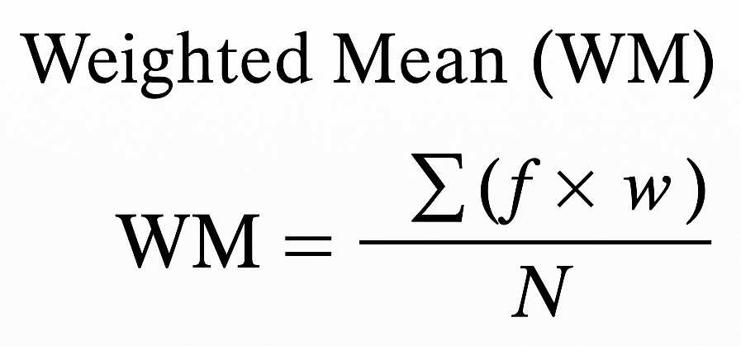
Where:
- f = frequency of responses
- w = assigned weight
- N = total number of respondents

A higher weighted mean will indicate a higher level of satisfaction, agreement, or system acceptability.
2. Likert Scale Interpretation
To properly interpret the computed results, the study will use a four-point Likert scale with corresponding verbal interpretations. The weighted mean results will be classified using the following range and descriptive equivalents:
Scale | Range | Verbal Interpretation | Description Evaluation
4 | 3.26 – 4.00 | Strongly Agree | Excellent
3 | 2.51 – 3.25 | Agree | Good
2 | 1.76 – 2.50 | Disagree | Poor
1 | 1.00 – 1.75 | Strongly Disagree | Needs Improvement
Table 3. Four-Point Likert Scale
This scale will guarantee a clear-cut view of the way the prototype system will operate with its usability, functionality, and general user satisfaction. The outcomes of the mean and the Likert scale interpretation will help the researchers to define the strong areas and corners that would need additional improvement.
The computed results from both user evaluation and system-generated data will be used to assess the overall performance of the Smart Pill Dispenser in terms of functionality, reliability, and usability.

Sampling Technique
The sampling method for the testing phase of the IoT-Based Smart Pill Dispenser with Real-Time Notification System will be purposive sampling, a non-probability sampling approach. This method is used when respondents are selected based on their knowledge, experience, or suitability for the project prototype. The approach will be appropriate for the study since it will focus on specific participants who are involved in technical system evaluation or regular medication management.
The test will be done in two stages:
Phase 1 – Expert Evaluation (Alpha Test): The first phase will involve the selected external technical evaluators, specifically Information Technology professionals and individuals with backgrounds in system development, IoT, or mobile application development. Alpha testers' evaluation will focus on the technical sections of the system prototype, such as the system’s functionality, integration, architecture, and overall performance which will be assessed based on the ISO/IEC 25010 Software Quality Model and ISO/IEC 30141:2024 IoT Reference Architecture. Their feedback will help identify the technical issues and improve the system further before proceeding to the field testing.
Phase 2 – End-User Testing (Beta Test): The second phase will involve the selected households in Poblacion, Candaba, Pampanga, particularly the patients who require regular medication and their family members or caregivers who assist with medication management. These participants will test the system in an actual home environment and will provide feedback in regard to its usability, reliability, functionality, and practicality in managing daily medication routines.
By selecting respondents who have relevance in technical knowledge and direct experience with medication management, the study will obtain meaningful feedback from both technical evaluators and actual users. Their responses will help the proponents identify areas for improvement and refine the prototype according to the Agile Framework, while ensuring that the system will both meet the technical requirements and the practical needs of the intended users.

Respondents
The respondents of this study will consist of two distinct groups that will be selected to evaluate the IoT-Based Smart Pill Dispenser with Real-Time Notification System based on their relevance to the system development and end-user perspective.
The first group will include the selected Information Technology (IT) experts and technical professionals who will be chosen through purposive sampling. These experts will have professional backgrounds in Information Technology, embedded systems, Internet of Things, or mobile application development. Their primary role will be to provide assessments of the system’s technical components, which include its hardware and software, that will be guided by standards such as ISO/IEC 25010 and ISO/IEC 30141:2024. The evaluation will mainly focus on aspects such as functionality, reliability, usability, performance, and IoT system architecture.
The second group will consist of the targeted users, who are the selected patients and their family members or caregivers from households in Poblacion, Candaba, Pampanga. Their role will be to evaluate the practical usability, functionality, reliability, and overall acceptability of the SmartDose prototype in a real home environment. The participants will be selected based on their regular medication management. To determine the minimum number of respondents needed from this group, the researchers will apply Slovin’s Formula once the total population of qualified respondents has been finalized.

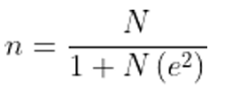
Slovin’s Formula:

Where:
- n = required sample size
- N = population size
- e = margin of error

This formula will ensure that the number of respondents that are selected from the qualified population will be statistically appropriate, considering an acceptable margin of error. The calculated sample size will be used to gather evaluations and feedback from the actual users of the system, which will guide further incremental improvement of the SmartDose prototype through its development process under the Agile methodology.

Research Tools and Instrument
The survey questionnaires that will be constructed to evaluate the system will be based on the ISO/IEC 25010 Software Quality Model and ISO/IEC 30141: Internet of Things (IoT) Reference Architecture, which will serve as the standards for judging the software quality and Internet of Things architecture of the prototype system. The IoT-Based Smart Pill Dispenser with Real-Time Notification System, will be evaluated by the selected respondents, which include IT experts and family members or caregivers from selected households in Poblacion, Candaba, Pampanga. The ISO/IEC 25010 evaluation will focus on quality characteristics such as functional suitability, performance efficiency, compatibility, usability, reliability, security, maintainability, and portability. The ISO/IEC 30141:2024 will be used to evaluate the IoT architecture components in terms of the foundational view, business view, usage view, functional view, trustworthiness view, and construction view. These views will form the main core of the research instrument.
The weighted mean and Likert scale will be the main tools for interpreting the gathered data. The Likert Scale will be a 4-point rating system, which removes the neutral option, encourages decisive responses, and allows respondents to rate whether they find the prototype system satisfactory or not, with no neutral or in-between rating. Each response will be assigned a numerical value, and the weighted mean will be calculated to determine the overall assessment of the system’s performance quality. This will help in analyzing how well the SmartDose prototype will meet the expected technical and user requirements.
The data gathering process will utilize multiple instruments such as the following:
- A pre-survey questionnaire will be conducted with family members, caregivers, and patients to identify the common challenges in medication intake with the provided context in household scenarios.
- A system evaluation questionnaire will be based on ISO/IEC 25010 and ISO/IEC 30141:2024 and will be administered after the system testing to both the selected IT experts and end-users, who will assess the aspects and features of the prototype.
- User feedback and open-ended questions will be gathered from the selected households for the patients, family members, or caregivers to further add their experiences and difficulties that can be possible features, as well as clarity for the use of the SmartDose prototype.
All the survey items will be carefully developed to align with the prototype system’s specific objectives, such as automating medication dispensing, medication schedule management, verification of medication intake, monitoring adherence, and providing real-time notifications, SMS alerts, manual dispensing, and the ability for end-users to monitor medication activity. These tools will collectively form a comprehensive data collection set, which will enable a thorough analysis of the functionality, reliability, usability, performance, and overall acceptability of the SmartDose prototype in providing support for medication management in homes.
Data Gathering of the Respondents
The data gathering process for the IoT-Based Smart Pill Dispenser with Real-Time Notification System will involve an evaluation that will be conducted in two key phases: technical validation by the IT Experts (alpha test) and field testing by the intended users, the family members or caregivers (beta test), from the selected households in Poblacion, Candaba, Pampanga.
Phase 1 – Technical Evaluation by IT Experts (Alpha Test)
In the initial phase, the alpha test will involve the selected IT professionals with an expert background in software development, embedded systems, Internet of Things devices, or mobile development. These experts will assess the SmartDose prototype through structured testing procedures by interacting with the system and evaluating its hardware and software components, architecture, integration, and communication between the ESP32, Raspberry Pi, sensors, camera modules, dispensing mechanisms, cloud database, and mobile application. Special attention will be given to system functionality, responsiveness, reliability, and software quality based on the ISO/IEC 25010 and IoT Architecture based on the ISO/IEC 30141:2024.
Phase 2 – End-User Evaluation by Family Members and Caregivers
The second phase will involve the hands-on testing of the SmartDose prototype by selected family members and caregivers from the households in Poblacion, Candaba, Pampanga. These respondents will use the system in realistic home environment scenarios to evaluate its usability, functionality, and reliability in managing regular medication routines. The respondents will assess the performance of the core of the following features such as:
- Automating medication dispensing based on scheduled medication time
- Medication schedule management with the mobile application
- Medication intake verification using the IR sensor
- Medication activities monitoring and history
- Real-time notification and missed-dose alerts
- Emergency or manual medication dispensing
- Camera module monitoring and validating dispensing process
- Medicine stock monitoring and refill reminders
- LCD and system status information
- Mobile application responsiveness with clarity and ease of use
The feedback and evaluation data that will be gathered through the survey questionnaires based on the ISO/IEC 25010 Software Quality Model and ISO/IEC 30141:2024 Internet of Things (IoT) Reference Architecture. The responses will then be measured with the use of 4-point Likert scale to determine the respondents' rating of satisfaction with the system’s quality and performance. In addition, system performance logs will be used to record the objective data such as dispensing accuracy, sensor detection results, notification delivery speed, and system behavior.
The two data collection layers will ensure that the SmartDose prototype will undergo both technical validation and end-user evaluation. By combining the assessments of technical experts with the experiences of the family members and caregivers, the researchers will obtain data regarding the system’s technical performance and practical use in a home environment. The feedback that will be gathered will help identify the areas for improvement and support the incremental refinement of the SmartDose prototype throughout its development process under the Agile methodology.

ISO/IEC 25010 Software Quality Model
The system prototype that will be developed, named IoT-Based Smart Pill Dispenser with Real-Time Notification System, will be evaluated under the ISO/IEC 25010 Software Quality Requirements. This will recognize the international standard that will provide the framework for evaluating the quality of the SmartDose system, including the mobile application and software components. The evaluations will be conducted:
Phase 1 – IT Expert Evaluation (Alpha Test)
In this phase, the selected IT experts and professionals will assess the system’s hardware and software components, system architecture, integration, and overall performance. Their evaluation will focus on technical areas such as the functionality, reliability, usability, and performance.
Phase 2 – End-User Evaluation (Beta Test)
This phase will involve the selected households. The users are the family members and caregivers from Poblacion, Candaba, Pampanga. The participants will test the SmartDose prototype in a home environment and will judge base from its usability, functionality, reliability, and overall acceptability in managing daily medication routines.
Both sampled groups of respondents will assess the system based on the criteria highlighted in the ISO/IEC 25010 model, which are the following characteristics:
- Functional Suitability
- Performance Efficiency
- Compatibility
- Usability
- Reliability
- Security
- Maintainability
- Portability
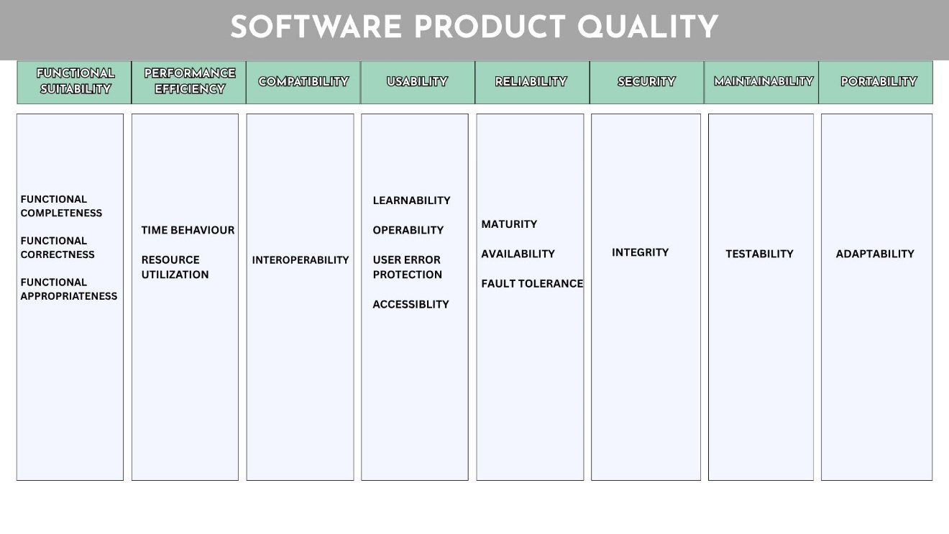
These categories will help to see whether the developed system will meet the expectations of respondents in terms of its functionality and reliability.
Figure 17. Software Product Quality
The results that will be collected will be used as a guide for researchers in identifying the areas of improvement and refinement to ensure that the final prototype will meet the specific objectives and national standards, as well as user expectations.
ISO/IEC 30141:2024 Internet of Things (IoT) Reference Architecture
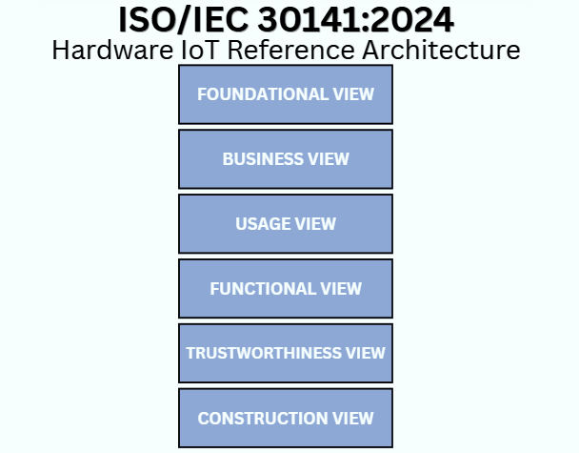
The IoT-Based Smart Pill Dispenser with Real-Time Notification System will be evaluated based on ISO/IEC 30141:2024, which will provide the standardized reference architecture for the Internet of Things (IoT) systems. This framework will provide the basis for examining how the different components of the SmartDose system will work together, mainly the ESP32 microcontroller, Raspberry Pi, sensors, dispensing mechanism, cloud database, notification system, and mobile application. The evaluation will consider the connectivity, data flow, device integration, and communication between the device, cloud database, and its mobile application in the home environment.
Figure 18. Hardware IoT Reference Architecture (2024)
1. Foundational View – this will define the basic requirements and architectural needs of the SmartDose system. The prototype will establish the following requirements:
- Automated medication dispensing according to scheduled time.
- Medication intake monitoring and verification
- Real-time communication between the device, cloud database, and mobile application
- Reliable operation within the home environment
- Integration of hardware and software components for medication management.
2. Business View – this will focus on the end-users, their roles, and the intended purpose of the SmartDose system. This will include the following:
- Patients who will receive medication according to regular medication schedules
- Family members and caregivers who will use the system to handle monitoring medication intake and management of schedules.
- Researchers who will be responsible for developing, testing, and improving the prototype.
- The system’s purpose is to support medication management through automated dispensing, monitoring, and notifications.
3. Usage View – this part will describe how the patients and caregivers interact with the SmartDose system through the mobile application and dispensing mechanism. The prototype will involve the following:
- Setting and managing medication schedules through the mobile application
- Monitoring medication activity and intake status
- Receiving real-time medication reminders, alerts, and missed-dose notifications
- Viewing medication history and system status
- Using the system within a home environment to manage medication
4. Functional View – this viewpoint will show the main functions of the SmartDose IoT architecture. It covers the following:
- ESP32 microcontroller processing and controlling system operations
- DS3231 RTC maintaining accurate time for schedule mediation
- Sensors and dispensing mechanisms monitoring and releasing medication
- Raspberry Pi and camera module providing visual monitoring of medication dispensing
- Firebase cloud database storing and syncing of medication schedules, data, and activity logs.
- SmartDose mobile application giving remote monitoring capabilities, scheduling, and management.
5. Trustworthiness View – this viewpoint will focus on the reliability, security, and integrity of the SmartDose systems. It will consider the following:
- Secure user authentication and access permissions for caregivers and family members
- Protection of user credentials and medication schedule information
- Reliable communication between the device, cloud database, and mobile application
- Accuracy and reliability of medication dispensing and intake monitoring
- Notification, alerts, and SMS through the GSM module if internet connectivity is unstable.
6. Construction View – this viewpoint will describe the physical and technical implementation of the SmartDose system correctly. It will include the:
  - Hardware Structure
  - Device Connections
  - Cloud Integration
  - Mobile Application
  - Communication System
These viewpoints will ensure that the hardware, software, and communication components of the SmartDose prototype are in line with the ISO/IEC 30141: 2024 version.

Development and Testing
The development of the IoT-Based Smart Pill Dispenser with Real-Time Notification System will follow the Agile methodology, which will allow the researchers to develop, test, evaluate, and improve the system continuously throughout the development process. This approach will be suitable because it integrates both hardware and software components and applies modifications based on the testing results and feedback from the intended users. The development process will focus on achieving the primary functions of the SmartDose system, which will include automated dispensing, medication intake monitoring, notifications and alerts, medication scheduling management, and remote monitoring through the mobile application.
The software component of the system will develop the SmartDose mobile application, which will be developed with the use of Flutter (Dart) for Android devices. Firebase Cloud will provide the real-time notifications. Arduino IDE will be used for programming the ESP32 microcontroller, then the Visual Studio Code will serve as environment for development. These software components will promote the communication between the SmartDose mobile application, cloud database, and hardware prototype.
The evaluation of the SmartDose prototype will be conducted in two major phases:
- Alpha Testing (Phase 1) – this phase will involve the selected Information Technology (IT) experts and technical professionals with backgrounds in areas such as Information Technology, embedded systems, Internet of Things, system development, or mobile application development. The technical evaluators will assess the hardware and software components of the SmartDose prototype, which includes integration, architecture, communication, functionality, responsiveness, reliability, and overall system performance. The evaluation will also examine the communication between the ESP32, Raspberry Pi, sensors, camera module, dispensing mechanism, Firebase cloud database, and the SmartDose mobile application. The results and feedback from the technical evaluators will be used to find technical problems and apply the needed improvements before the system proceeds to end-user evaluation.
- Beta Test (Phase 2) – This phase will involve the selected family members and caregivers from households in Poblacion, Candaba, Pampanga as the intended end-users of the SmartDose prototype. The respondents will use the system under realistic home environment scenarios to measure its usability, functionality, and reliability in managing regular medication routines. The evaluation will cover the automated medication dispensing based on the schedule medication time, medication schedule management, IR sensors dispense verification, medication activity and history logs, real-time notifications and missed-dose alerts, manual emergency medication dispensing, camera monitoring, medicine stock levels and refill reminders, LCD and system status information, and the responsiveness and ease of use of the mobile application.
Both phases will use evaluation questionnaires based on the ISO/IEC 25010 Software Quality Model and ISO/IEC 30141:2024 Internet of Things (IoT) Reference Architecture. ISO/IEC 25010 will be used in evaluating the quality characteristics of the software and system, while ISO/IEC 30141:2024 will guide it in evaluating its IoT architecture and interaction among the different components. System performance logs will also record information such as dispensing accuracy, sensor detection results, notification delivery speed, and system behavior.

Hardware Development and Testing
The hardware prototype will be developed using the ESP32 microcontroller as the main controller of the SmartDose system. The DS3221 Real-Time Clock (RTC) module will maintain the medication schedule, while the DRV8825 and servo motors will operate the medication dispensing actuators. The system will also add the IR sensors, Raspberry Pi, camera module, SIM800L GSM module, 16x2 LCD, buttons, buck converter, and power supply as part of the prototype.
The hardware and its integration with the software will go through the three main testing processes:
- Unit Testing
  - Individual hardware and software components will be tested independently to verify their functionality and operation.
  - Servo motors and DRV8825 will be tested to verify the operation of the dispensing mechanism.
  - RTC module will be tested to verify the medication scheduling and timing.
  - The sensors will be tested to verify medication dispensing and removal detection.
  - The Raspberry Pi and camera module will be tested for monitoring functions.
  - The GSM module will be tested for the delivery of SMS notifications.
  - Individual software functions, which include the scheduling logic and notification triggers, will also be tested before complete system integration.

- Integration Testing
  - The hardware components will be connected and integrated with the ESP32 and Raspberry Pi to verify the communication between the different parts of the prototype.
  - Communication between the SmartDose hardware, Firebase cloud database, and mobile application will be tested.
  - The researchers will verify whether the medication schedules configured through the app are properly instructed to the dispenser.
  - Sensor results, dispensing logs, medication records, and notification events will be checked to determine whether the information is properly transmitted between the hardware, cloud database, and mobile application.

- System Testing
  - The complete SmartDose prototype will be tested initially in a controlled or simulated home environment.
  - The researchers will test the complete operation of the medication scheduling, automated dispensing, medication monitoring, notifications, medication records, and mobile application functions.
  - The system will be evaluated to determine whether the integrated hardware and software components will operate properly and reliably as one complete IoT-based medication management system.
  - After testing, the system will proceed to evaluation by IT experts and testing with selected households in Poblacion, Candaba, Pampanga to observe its performance and usability under home environment scenarios.

The Continuous Improvement Cycle, such as the feedback and results gathered throughout the development, developer testing, alpha testing, and beta testing, will be reviewed as part of the Review phase of the Agile Methodology. Identified problems that involve the hardware, software, dispensing mechanisms, sensors, communication, mobile application, or notification and alerts functions will be documented and used as the basis for the needed adjustments and refinements.
The researchers will continuously improve the SmartDose prototype that is based on the testing results and user evaluation. Necessary modifications will be applied to both the hardware and software components in improving the system’s functionality, performance, usability, and reliability. This iterative development, testing, evaluation, and feedback process will allow each version of the SmartDose prototype to further improve progressively until the intended system requirements are met.
By the end of the development and testing process, the SmartDose prototype will aim to provide the following:
- Automated medication dispensing based on configured schedules
- Medication schedule management through the SmartDose mobile application
- Sensor-based medication dispensing and intake monitoring
- Raspberry Pi and live camera monitoring
- Real-time push notification and SMS alerts
- Medication activity records of adherence and dispensing
- Medicine stock level monitoring and refill reminders
- Remote monitoring through the mobile application
- Basic system diagnostics and status monitoring
- Evaluation will be based on ISO/IEC 25010 and ISO/IEC 30141:2024
The completed development and testing process will result in a functional IoT-Based Smart Pill Dispenser with a real-time notification System that is intended for home medication management. The prototype will automate scheduled medication dispensing, monitor medication removal, record medication activities, and provide notifications for patients, family members, and caregivers. Feedback will remain part of the development process to support further improvements to the system’s performance, functionality, reliability, and usability.
Implementation Plan
The implementation of the IoT-Based Smart Pill Dispenser with Real-Time Notification System will show the structured development process from requirements gathering to system deployment and continuous improvement. This process will ensure that both the technical requirements and the needs of the intended users are always considered throughout the entire development process of the SmartDose system. The implementation will follow the Agile Methodology, which will allow the researchers to continuously develop, test, evaluate, and improve the system based on testing results and user feedback.
1. Requirements Gathering Phase
In this initial phase, the researchers will gather and identify the system and user requirements through the literature review and interviews with patients, family members, and caregivers who are involved in managing medication adherence. The researchers will determine the functional and non-functional requirements of the system, which include medication scheduling, automated medication dispensing, medication monitoring, real-time notifications, and other features that are needed for home medication management.
The main tools, platforms, and components for development will be selected:
- ESP32 Microcontroller for controlling and connecting the hardware components.
- DS3231 RTC Module for maintaining accurate medication schedules.
- Flutter (Dart) for developing the SmartDose Android mobile application.
- Firebase Firestore and Cloud Messaging for cloud data storage, synchronization, notifications, and alerts.
- Raspberry Pi and Camera Module for visual monitoring and additional confirmation.
- IR Sensors for monitoring the medication dispensing and pill removal.
- DRV8825 and Servo Motors for operating the medication dispensing mechanism.
- SIM800L GSM Module for providing SMS notifications as a backup alert mechanism.
- 16x2 LCD Display for presenting the system information on the hardware.
- Arduino IDE and Visual Studio Code for firmware and software development.
These listed components will serve as the foundation for the development of the SmartDose hardware and software components. The current system requirements specifically identify the Arduino IDE, Visual Studio Code, Flutter, Firebase, Android OS, ESP32, DS3231 RTC, servo motors, sensors, Raspberry Pi, camera module, SIM800L, LCD, DRV8825, buttons, and supporting components.

2. Design Phase
In this phase, the proponents will develop the design of the SmartDose system prototype and mobile application that will emphasize the simplicity, accessibility, and usability for patients, family members, and caregivers. The mobile application interface will be designed to support medication schedule configuration, medication dispensing monitoring, records and logs, notifications and alerts, medication history, and system status.
In addition, the system architecture will be planned, which will showcase the following:
- Interconnection of the ESP32, RTC module, sensors, Raspberry Pi, and camera module.
- Medication dispensing mechanism using the DRV8825 and servo motors.
- Communication between the SmartDose hardware, Firebase cloud database, and mobile application.
- Integration of the SIM800L GSM Module for SMS notifications.
- Integration of the LCD for viewing the system information.
- Arrangement of the ten (10) medication compartments for proper scheduled medication dispensing.
The design documentation will include the system architecture diagrams, flowcharts, use case diagrams, mobile application wireframes, and circuit diagrams to visualize the overall structure and function of the SmartDose system. The dispensing mechanism will also be planned to support the controlled medication release from its ten medication compartments.

3. Development Phase
This phase will involve the implementation of both the software and hardware components of the SmartDose system, which are:
- Mobile Application: It will be created using Flutter and sync with the Firebase. The mobile app will let the users set up the medication scheduling, monitor medication dispensing activities and intake records, receive notifications and alerts, and view history and system status.
- Hardware System: The ESP32 microcontroller will be programmed as the main controller of the SmartDose prototype and will work with the medication schedule, dispensing mechanism, sensors, and communication between the different hardware components.
- Dispensing Mechanism: The DRV8825 and servo motors will be integrated for each medication compartment to control the dispensing of the scheduled medications. The actuator mechanism will be calibrated and tested to ensure the proper alignment and control of the medication release.
- Sensors and Monitoring Setup: The IR sensors will be integrated to monitor the medication dispensing and detect whether the dispensed medication has been removed or taken. The Raspberry Pi and camera module will provide visual monitoring and additional confirmation of medication activities. The current paper will define the medication adherence operations through the dispensing logs and pill removal confirmation.
- Database and Notification Support: Firebase Firestore will save the medication schedules, dispensing logs, and related records, while Firebase Cloud Messaging will provide the real-time push notifications. The SIM800L GSM module will provide a backup method for sending the missed doses SMS notification without during network interruptions.
The researchers will develop and integrate these components progressively. Each completed function will be tested and refined before proceeding with the further system integration, which will follow the iterative process of the Agile Methodology.

4. Testing Phase
This testing will be divided into hardware and software validation through unit testing, integration testing, system testing, alpha testing, and beta testing. This will cover the following:
- Hardware Testing: It will include the unit testing of individual components such as the servo motors, DRV8825, RTC module, sensors, Raspberry Pi, camera module, GSM module, and LCD. Integration testing will then go through whether the hardware components are properly communicating with the ESP32, Firebase, and SmartDose mobile application. System testing will evaluate the complete hardware and software operation in the controlled or simulated home environment.
- Alpha Testing: It will be conducted with the selected IT experts and technical professionals. This phase will focus on evaluating the functionality, hardware and software integration, communication, responsiveness, reliability, and overall performance of the SmartDose prototype. The technical evaluators will examine the interaction among the ESP32, Raspberry Pi, sensors, camera module, dispensing mechanisms, cloud database, and mobile application.
- Beta Testing: Selected family members and caregivers from households in Poblacion, Candaba, Pampanga will evaluate the SmartDose prototype under the realistic home environment scenarios. Their evaluation will focus on the system’s usability, functionality, and reliability, which includes the medication scheduling, automated dispensing, pill removal monitoring, medication history, notifications and alerts, emergency medication dispensing, camera monitoring, medicine stock and refill reminders, and mobile application usability.
The evaluation questionnaires for Alpha and Beta Testing will be based on the ISO/IEC 25010 Software Quality Model and ISO/IEC 30141:2024 Internet of Things (IoT) Reference Architecture. Feedback and testing results will be used to identify the errors and determine the needed adjustments to improve the functionality, reliability, performance, and usability of the SmartDose system.

5. Deployment Phase
After the successful development, testing, and refinement, the SmartDose system will be deployed in the home environment before proceeding with the real scenarios in selected households of Poblacion, Candaba, Pampanga for actual user evaluation. The deployment will include the following:
- Full integration of the ESP32, RTC module, dispensing mechanism, sensors, Raspberry Pi, camera module, GSM module, LCD, and supporting hardware components.
- The working SmartDose mobile application will be installed on supported Android devices.
- Connectivity and synchronization with Firebase for medication records, monitoring, and real-time notifications.
- SMS notification support through the SIM800L GSM module.
- Configuration of medication schedules and the ten compartments
- Testing of the emergency manual medication dispensing, medicine stock monitoring, refill reminders, and basic system diagnostics.

The deployed prototype will be intended specifically for home medication management and will support solid oral medication such as tablets and capsules. The mobile application will be limited to Android devices, while most cloud database real-time functions will depend on an internet connection.

6. Continuous Feedback and Improvement
Through the entire development and deployment of the SmartDose prototype, the researchers will keep collecting feedback results that are obtained from testing and user evaluations. The feedback will be used to identify problems that involve the hardware, software, and dispensing mechanism, sensors, communication, notifications, and mobile application.
Continuous improvement will always include:
- Monitoring system testing results to identify possible improvements.
- Correcting hardware and software errors and issues discovered during testing.
- Refining the dispensing mechanism and sensor functions when needed.
- Improving the mobile app functionality, usability, and clarity based on user feedback.
- Reviewing system performance, reliability, responsiveness, and notification functions.
- Maintaining technical documentation to support the further development and improvement of the prototype system.

The feedback process will always fall under the Agile development cycle so that the needed adjustments and fixes are applied to each sector of the hardware and software system. The refinement of the prototype will always make sure that the system is focused on the aspects of performance, functionality, reliability, and usability.
REFERENCES
      - N., A. C., P., Y., P., P. M., G., S. N., & Akshaya, V. (2025). IoT based Kit for Medication Monitoring. IRO Journal on Sustainable Wireless Systems, 6(4), 333-341. https://doi.org/10.36548/jsws.2024.4.004
      - Ghozali, M. T. (2023). Implementation of IoT-based technology on patient medication adherence: A comprehensive bibliometric and systematic review. Journal of Information and Communication Technology, 22(4), 503-544. https://doi.org/10.32890/jict2023.22.4.1
- Jimmy, B., & Jose, J. (2011). Patient medication adherence: Measures in daily practice. Oman Medical Journal, 26(3), 155–159. https://doi.org/10.5001/omj.2011.38
- Kini, V., Ho, P. M., & Granger, B. B. (2021). Medication adherence: Importance, issues and policy: A policy statement from the American Heart Association. Circulation, 143(17), e1–e18. https://doi.org/10.1161/CIR.0000000000000963
- Sabaté, E. (Ed.). (2003). Adherence to long-term therapies: Evidence for action. World Health Organization
- Chandana et al. (2022). IoT-Based Smart Medication Reminder and Dispensing Machine. https://ieeexplore.ieee.org/document/9743097
- SS Sadi et al. (2024). IoT-Based Real-Time Medicine Reminder and Dispenser for Elderly Patients. https://ieeexplore.ieee.org/document/10691910
- Peddisetti et al. (2024). Smart Medication Management Using IoT-Based Pill Dispenser and Smart Cup. https://ieeexplore.ieee.org/document/10504319
- Tiwari & Raman, (2024). Smart Pill Dispenser and IoT: Advancements in Medication Administration. https://ieeexplore.ieee.org/document/10481624
- Guerrero-Ulloa et al. (2020). IoT-Based Smart Medicine Dispenser to Control and Supervise Medication Intake. https://journals.sagepub.com/doi/10.3233/AISE200021
- Lima et al. (2022). Development of a Pill Dispenser: System Requirements and Product Architecture. https://link.springer.com/chapter/10.1007/978-3-031-20364-0_29
- Lgargioni et al. (2024). A Systematic Review on Pill and Medication Dispensers from a Human-Centered Perspective. https://link.springer.com/article/10.1007/s41666-024-00161-w A Review on Kini et al. (2021). Dispenser Mechanisms of Medicine Dispenser. https://d1wqtxts1xzle7.cloudfront.net
- Razizatunnisa et al. (2025) Improving Medication Adherence in Elderly Patients Through IoMT-Enabled Smart Pill Dispensers: A Narrative Review. (2025). https://ieeexplore.ieee.org/document/11132209
- Viana, et al. (2024). Developing a Smart Pill Dispenser to Support Aging Individuals. https://link.springer.com/chapter/10.1007/978-3-031-76156-0_3
- Mitra et al., (2025). IoT-Based Smart Medicine Dispenser with Real-Time Alerts and Monitoring. https://ijsci.com/index.php/home/article/view/308
- Avvari et al. (2023). IoT and ML-Based Smart Pill Dispenser (SPD) Application for Monitoring Elderly People. https://researcher.manipal.edu
- Nagchandi et al., (2024). IoT-Based Smart Pill Reminding System. https://doi.org/10.2174/2666255816666230911151545
- Mohanty et al., (2025).A Smart Pill Reminder with Configurable Alerts, Multi-Modal Notifications, and Integrated Health Monitoring for Medical Adherence. https://doi.org/10.36548/jismac.2025.2.002
- Hidayat and Irianto (2025) AutoMedic: Framework of Automatic Pill Dispenser System with Human-Centered Design Method. https://ijicom.respati.ac.id
- Anisha Vaish, (2024). Automated Pill Dispenser to Improve Medication Compliance, Efficiency, and Accuracy. https://ieeexplore.ieee.org/document/10607078
- Aung and Maneetham (2023). Automatic Pill Dispenser for Pharmacy. https://d1wqtxts1xzle7.cloudfront.net
- Vijayalakshmi et al. (2026) Smarter Medic Monitoring System with Pill Dispenser for Patients Receiving Medication. https://ieeexplore.ieee.org/document/11407660
- Chavan, et al. (2023). Design and Development of Smart Pill Dispenser. https://ieeexplore.ieee.org/document/10180698
- Sharanya and TR (2024). Pill Dispenser for Elderly Care Using IoT. (2024). https://ieeexplore.ieee.org/document/10837916
- Maaño et al., (2025). SmartMed: An IoT-Enabled Pill Dispensing and Monitoring System for Medication Adherence of AFib Patients. https://mseuf.edu.ph
- Aquino et al. (2025). MediMinder: A Smart Device for Medication Adherence. https://journals.umak.edu.ph
- Optimizing Medication Adherence with Time Pill Dispenser: A Research Project. (n.d). https://www.studocu.com
- St. Paul University Study, (2024). Smart Pill Dispenser for Elderly Care. https://www.scribd.com
- Automatic Pill Dispenser with SMS Notification. (2023). https://www.scribd.com
- Factors Associated with Medication Adherence of Hypertensive Patients in the Philippines: A Systematic Review. (2021). https://link.springer.com
- Dino et al. (2025). Utilization of Artificial Intelligence in Reducing the Incidence of Medication Error: A Bibliometric Analysis. https://onlinelibrary.wiley.com
- Medication Reminder System (MRS) for Hypertensive Patients. (2023). https://www.herdin.ph
- Catindoy et al. (2024). Medication Reminder and Tracker Application. https://doi.org/10.1109/ICVEE63912.2024.10823699
- Kataria et al. (2021). The Smart Pill Sticker: Introducing a Smart Pill Management System Based on Touch-Point Technology. https://pubmed.ncbi.nlm.nih.gov
- Effects of SMS Reminders on Medication Adherence Among Hypertensive Patients: A Randomized Clinical Trial. https://spud.herdin.ph
- A Comparative Study on Alarm Reminder Versus Calendar-Based System in Improving Medication Adherence. (2023). https://www.herdin.ph
- Lacap et al. (2025). Smart Pill Dispenser with Medicine Detection for Senior Citizens. https://ieeexplore.ieee.org/document/11282129
- O’Connor, C. E. (2024). Mobile Phone Adherence Support for HIV Patients in Manila, Philippines. https://researchonline.lshtm.ac.uk
- Jimenez et al. (2025). A Cross-Sectional Study on the Usefulness and Acceptance of Automated Dispensing Cabinets in a Philippine Hospital. https://www.researchgate.net
- Castillo (2021). Smart Medicine Dispenser with Online Dispensing Capabilities. https://animorepository.dlsu.edu.ph
- IoT-Based Automatic Pill Dispenser. (2024). https://www.scribd.com

