Rodrigo Solana Chao A01129839
Rafael Correa Engelhardt A01019498

El tiempo puesto en las tablas está en milisegundos y es el tiempo total en cada caso.

La N max para GPU fue de 100 Millones – en las pruebas de 1000 Millones siempre hubo fallas a la hra de verificar los resultados del vector c por lo que el tiempo se puso como 0 pero en realidad sería NULL

Características de la computadora ( La actividad se realizó en Alienware 17 R3)

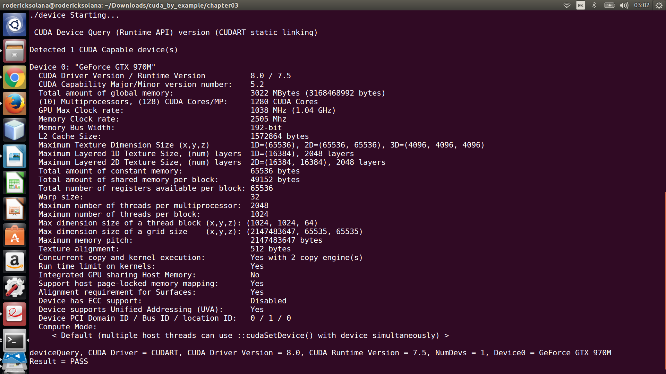

N = 1 Millón Bloques= 4000 Threads= 1000 B= 4000 T= 250
Iteración | CPU | CPUopenMP | GPU Bloques | GPU threads | GPU Bloques y Threads
1 | 3.241984 | 11.850048 | 7.370176 | 7.500736 | 3.394912
2 | 3.351040 | 36.490719 | 6.949472 | 7.557888 | 3.352896
3 | 3.758944 | 11.789824 | 6.879680 | 7.564928 | 3.311904
4 | 3.022656 | 20.324833 | 6.833184 | 7.451328 | 3.297952
5 | 3.066624 | 27.422815 | 6.967104 | 7.532064 | 3.364064
6 | 3.246304 | 26.859167 | 7.276864 | 7.472096 | 3.210656
7 | 2.888672 | 19.646015 | 6.891840 | 7.508736 | 3.288576
8 | 3.096320 | 20.743776 | 7.116640 | 7.621728 | 3.388448
9 | 2.966144 | 22.680449 | 6.937728 | 7.498592 | 3.232800
10 | 3.328224 | 19.710079 | 6.967200 | 7.415360 | 3.254976
Promedio | 3.2 | 21.75 | 7.02 | 7.51 | 3.31

N = 10 Millones Bloques= 4000 Threads=1000 B= 12500 T=800
Iteración | CPU | CPUopenMP | GPU Bloques | GPU threads | GPU Bloques y Threads
1 | 28.821953 | 39.500736 | 59.463390 | 65.369057 | 22.496416
2 | 29.670719 | 37.288769 | 59.097118 | 65.092354 | 23.130337
3 | 28.872768 | 31.419712 | 58.925182 | 65.505730 | 22.848801
4 | 30.639488 | 42.481663 | 77.562752 | 65.259171 | 22.428543
5 | 27.963327 | 22.815264 | 60.539009 | 65.357216 | 22.883137
6 | 27.865280 | 33.435616 | 59.199520 | 65.543587 | 22.937952
7 | 29.582432 | 39.756767 | 59.170208 | 65.509506 | 22.985088
8 | 30.576481 | 32.772350 | 61.040127 | 64.979485 | 22.969313
9 | 28.754496 | 33.093601 | 61.513439 | 65.204514 | 23.254848
10 | 27.612097 | 30.510529 | 61.611458 | 65.673409 | 23.057728
Promedio | 29.04 | 34.31 | 61.81 | 65.35 | 22.9

N = 100 Millones Bloques= 4000 Threads=1000 B= 125000 T=800
Iteración | CPU | CPUopenMP | GPU Bloques | GPU threads | GPU Bloques y Threads
1 | 276.489563 | 102.864510 | 571.508972 | 631.693115 | 207.599976
2 | 280.657074 | 97.437088 | 574.811035 | 630.203796 | 207.871552
3 | 274.494324 | 102.841507 | 575.057434 | 631.041443 | 208.222275
4 | 269.880707 | 103.061470 | 573.425354 | 631.097168 | 207.346268
5 | 277.811615 | 122.785088 | 575.285889 | 629.753784 | 207.449158
6 | 270.565582 | 102.405533 | 573.419373 | 629.526611 | 206.549118
7 | 270.836609 | 106.328514 | 575.235962 | 629.925659 | 207.289764
8 | 270.365784 | 118.336227 | 574.932007 | 642.982178 | 207.099548
9 | 273.613892 | 111.690430 | 575.270142 | 632.446533 | 207.197479
10 | 272.525909 | 109.879715 | 574.685181 | 634.706116 | 207.815842
Promedio | 273.72 | 107.76 | 574.36 | 632.34 | 207.44

N = 1000 Millones Bloques= 4000 Threads=1000 No es posible
Iteración | CPU | CPUopenMP | GPU Bloques | GPU threads | GPU Bloques y Threads
1 | 3860.511963 | 817.016541 | 0 | 0 | 0
2 | 3934.106689 | 825.287537 | 0 | 0 | 0
3 | 3991.462402 | 829.399780 | 0 | 0 | 0
4 | 4015.370850 | 855.154541 | 0 | 0 | 0
5 | 3259.372803 | 821.148743 | 0 | 0 | 0
6 | 2745.174316 | 824.306458 | 0 | 0 | 0
7 | 2741.780029 | 823.618408 | 0 | 0 | 0
8 | 2737.892822 | 863.205261 | 0 | 0 | 0
9 | 2770.422607 | 834.603333 | 0 | 0 | 0
10 | 2761.623535 | 819.460083 | 0 | 0 | 0
Promedio | 3281.77 | 831.32 | 0 | 0 | 0

