CPRS Patch OR*3.0*312

Release Notes

October 2014

Department of Veterans Affairs
Office of Information & Technology (OI&T)
Product Development (PD)

This page left blank intentionally.
Table of Contents
Table of Contents 3
Installation Requirements 5
Required Patches 5
Release Method 5
Patient Safety Issues 5
Other Changes 7

This page left blank intentionally.
Installation Requirements
Required Patches
Below is a list of patches that you must verify are properly installed on your system before OR*3.0*312 can be installed:
- OR*3*243
- OR*3*298

Release Method
OR*3.0*312 will be released using the National Patch Module. The Kernel Installation and Distribution (KIDS) build will be a part of the PackMan message that will be distributed.

Installation instructions are included in the patch description.
Note: If your site has made any local changes to entries in the OE/RR REPORTS file (#101.24) with an internal entry number greater than 999, you will need to save those changes off and redo them after installing this patch. Or, you will need to move the changed entries to internal entry numbers less than 999.

Patient Safety Issues
- PSPO 970: Inpatient Meds Data Not Complete in Medications View
This patient safety issue is resolved by patches from the VistAWeb and Computerized Patient Record System (CPRS) applications. The VistAWeb application first released a patch that contained a warning and then CPRS is releasing patch OR*3.0*312 that distributes a new report. The same data from the report will be available to VistAWeb and through Remote Data Views in CPRS.
VistAWeb Changes: First, VistAWeb released patch WEBV*1*13 on 11/12/08 and promoted it to production server on 11/12/08 9pm.
From the patch description: VistAWeb V8.0 includes the following enhancements and fixes: 1. Resolved PSP0-970 (Remedy #259376) - Inpatient Medications from a previous VA inpatient stay may not display in Remote Data View (RDV) and VistAWeb "Pharmacy - Medications" view of medications, depending on the current VA patient status.
With this patch, the VistAWeb “Pharmacy -> Medications” report displays the following warning:
NOTE: INPATIENT medications with a status other than ACTIVE may not display in this view. Please see the Unit Dose and ALL IV reports for a comprehensive list of the patient's current and recent inpatient medications.
CPRS Changes: In addition to the VistAWeb changes, OR*3.0*312 makes changes to address this problem. Specifically, this patch adds a new All Medications report to the Pharmacy section of Clinical Reports on the Reports Tab in CPRS.
The All Medications report includes All Inpatient and Outpatient Pharmacy data for a patient. The user can limit the data in the report by using date range parameters. To determine the data that is included, based on date range selection, the logic is to first look for Last Fill Date, then Issue Date, then Order date (depends on if the date exists for the drug/RX being screened).
The report is initially sorted by STATUS in the following order:
- Active Susp
- Active
- Discontinued
- Expired
- Pending
- And then alphabetically within each of those groups.
Users can also sort the by selecting a column header, thus sorting by that column.
The All Medications report will be placed as the first item on the Pharmacy menu on the CPRS Reports tab.
The All Medications report supports Remote Data Views (RDV) from remote Facilities.
Note: Remote data will not be available from all sites until every VA site has installed this patch. Only sites that have installed this patch will return remote data for this report when being queried. If a remote site is queried that has not installed the patch, no data is returned and no message is given to the user indicating that the remote site may or may not have data. This will not be a problem once all sites have installed the patch, usually within 30 days of the patch being released.

The API's (Application Program Interface) created by this effort will also be used by the VistaWeb application to create the same report in VistaWeb. VistaWeb is a web based inter-facility patient reporting application.

Example of the All Medications report:
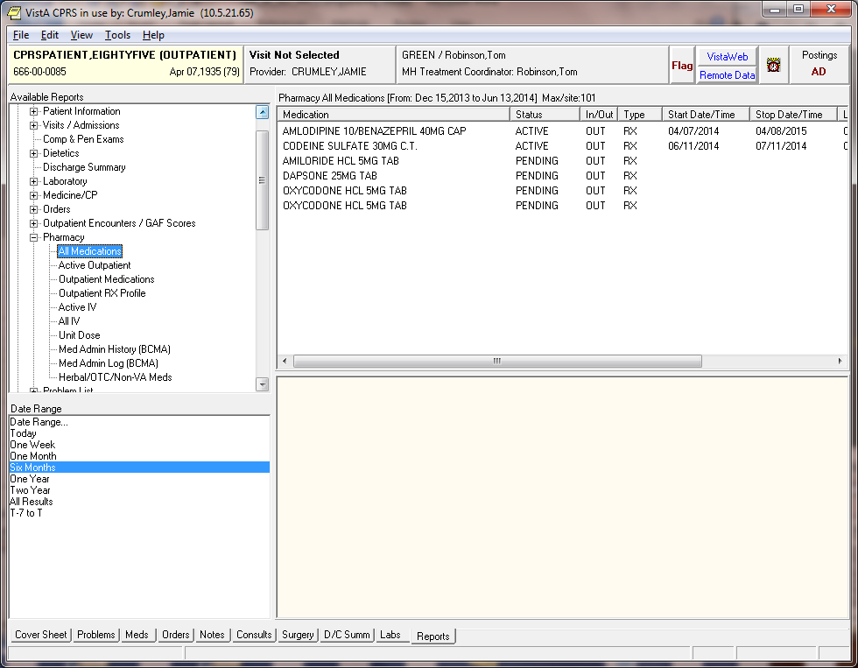

Other Changes
- Pharmacy All Outpatient Report: This patch changes the Date Range selection logic for the Pharmacy All Outpatient report. Prior to this change, the report did not honor any date selection but would display all data when the report was selected. With this change, the user can specify a date range for pulling outpatient pharmacy data. To determine the medications that are included, based on date range selection, CPRS looks at
- Last Fill Date
- Issue Date
- Order date (depends on if the date exists for the drug/RX being screened).
This change is being made at the request of the Department of Defense (DoD) BHIE AHLTA Project to allow more flexibility and so that Date Range parameters are passed to external interfaces like VistaWeb and DoD queries.
Report Name Change: As part of this change the name of the report is being changed in CPRS to more accurately reflect the data being selected/displayed. The report name will change from "Pharmacy All Outpatient" to simply "Outpatient Medications". To be consistent, VistaWeb will also be making this change sometime in the future.
This report not only exists on the Dept. of Defense Reports, but also on the Clinical Reports | Pharmacy menu. The same change to the report name will also be made there.
All Reports under Dept. of Defense Now Have Remote Data Only: In the past, most of the DoD reports under the Dept. of Defense category would include local VA data when the report was selected. With the installation of this patch, Local VA data will not be included with any of the DoD reports found under the Dept. of Defense Reports menu. It will still be possible to get local data, as well as DoD data, on the same display for these reports by selecting the same report under the Clinical Reports menu.
For example, if the user goes to the Dept. of Defense category and chooses Allergies, the report will include remote DoD and remote VA data, but no local VA data. Under Clinical Reports, the Allergies report will include remote DoD data, remote VA data, and local VA data.
In addition, some reports are specific to the DoD (e.g., Family History), and the VA does not have a comparable report. Therefore, these reports are “DoD Remote data only”.

Example of the Outpatient Medications report:

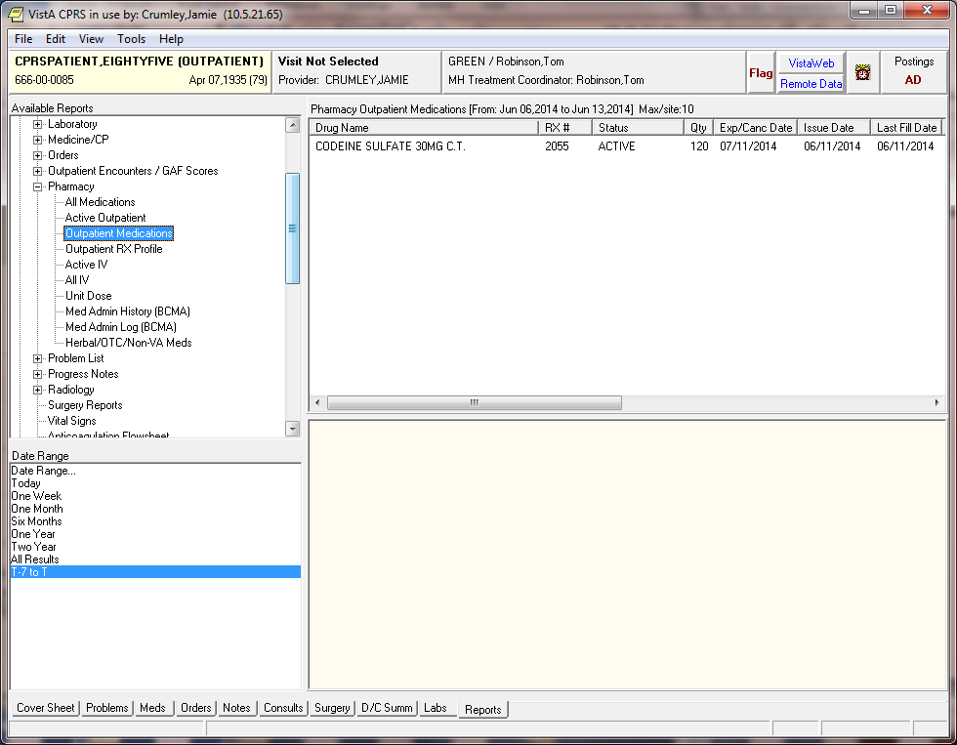

- Reports Display Lab Accession Number: This patch fixes a potential problem with printed reports that show the Lab Accession number in the header. Accession numbers that extend beyond 10 characters got truncated when printed at the top of the report. For example, an Accession # of "SPLB 03 1648" was printing as "SPLB 03 16". This patch corrects this problem by extending the Accession # column in the OE/RR Reports File (#101.24) to 16 characters for all reports that contain the Accession # column.

- Re-exporting Reports: This patch re-exports entries with internal numbers greater than 999 and entries 3 (ORRP AP ALL) and 24 (ORL ANATOMIC PATHOLOGY) from the OE/RR Reports file (#101.24). This is a common occurrence when new entries are being sent out in this file. Entries above 999 are considered nationally controlled entries in this file. Locally created entries in this file are generally done in entry numbers less than 999. If you have created or modified entries in this file with an internal number greater than 999 or #3 and #24, those changes will be lost. To preserve any local changes, either save them off someplace before installing this patch, or move the changed entries to internal numbers less than 999.

