Computerized Patient Record System (CPRS) v33SWD (OR*3.0*608)

Release Notes

August 2024
Department of Veterans Affairs

Artifact Rationale
Release Notes describe changes to existing software and new features and functions of a subsequent release of software, which makes them useful as a marketing tool.
For the initial distribution of software, Release Notes are optional. Revisions to a product that involve major changes to technical specifications or end-user functionality require Release Notes. Changes to software or documentation that have a minimal impact do not require Release Notes. The project manager, as the authoritative source and in consultation with the technical writer, determines if a Release Notes document is a required artifact for the project.

Table of Contents
Introduction 4
Purpose 4
Audience 4
This Release 4
New Features and Functions Added 4
Enhancements and Modifications to Existing Features 4
Known Issues 10
Patient Safety Issues (PSIs) 13
Defects 13
Access Violation Troubleshooting Feature 16
Product Documentation 19

Introduction
The Computerized Patient Record System (CPRS) is part of the Veterans Health Information Systems and Technology Architecture (VistA) suite of application packages. CPRS enables you to enter, review, and continuously update information connected with a patient. With CPRS, you can order lab tests, medications, diets, radiology tests and procedures, record a patient’s allergies or adverse reactions to medications, request and track consults, enter progress notes, diagnoses, and treatments for each encounter, and enter discharge summaries. In addition, CPRS supports clinical decision-making and enables you to review and analyze patient data.
This document describes enhancements and defect corrections included in CPRS v33SWD, consisting of a combined build, and a Graphical User Interface (GUI) executable, and a Dynamic Link Library (DLL). The combined build for CPRS v33SWD includes three patches: OR*3.0*608, TIU*1.0*318, and YS*5.01*237.

Purpose
These release notes cover the changes to CPRS delivered in the CPRS v33SWD release.

Audience
This document targets users and administrators of the applications modified by the CPRS v33SWD release: CPRS, Mental Health, and Text Integration Utilities and applies to the changes made between this release and any previous release for this software.

This Release
The following sections provide a summary of the new features and functions added, enhancements and modifications to the existing software, and any known issues for CPRS v33SWD.

New Features and Functions Added
CPRS v33SWD includes enhancements and defect corrections.

Enhancements and Modifications to Existing Features
The following are the enhancements and modifications for CPRS v33SWD. Many are New Service Requests (NSRs):
- NSR 20110405 – Notifications from Consults - Part 1
Notifications from Consults aims to overhaul the approach to generating notifications for actions taken on consults and procedures. The overarching goal is to better separate clinical and administrative actions, and to generate notifications only to the users needing to take action and/or be informed about updates.

A small portion of this NSR is being delivered in this version of CPRS. The text displayed on the Add Comment to Consult action dialog is being updated. The aim of the text update is to better inform users as to when the ordering provider will be notified for an Add Comment to Consult action, and also prevent users from needlessly sending notifications to providers when no action is required on the provider’s part.

The current text is generated based on the role and update authority of who is taking the action and can be one of three versions:
- “An alert will automatically be sent to the ordering provider.”
- “An alert will automatically be sent to notification recipients for this service.”
- “An alert will automatically be sent to the ordering provider and to notification recipients for this service.”

With this release, the text has been updated and, only during the Add Comment to Consult action, regardless of user role/update authority, will be the following.
“Only alert Providers when their action is required.”
“++ NOTE: To alert Provider use “Send additional alerts” option below, or use Significant Findings. ++”

- NSR 20130305: Gender/Sex (SIGI) Field in CPRS
Currently, VHA CPRS displays a patient’s biological sex but does not display gender identity. These are related but distinct demographic characteristics. There are clinical and medicolegal reasons to capture both as distinct data elements. This NSR request is to change the label “Sex” to “Birth Sex” and add Self-Identified Gender Identity (SIGI) to demographic displays. There will also be context sensitive help where appropriate.
Below is a screen capture showing the change of labels from Sex to Birth Sex and where context sensitive help was added to the patient selection screen:
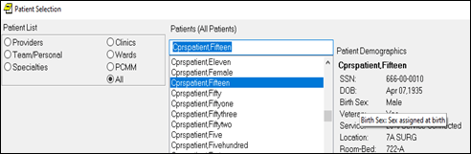

Below is an example of the context sensitive help on patient selection screen for SIGI:
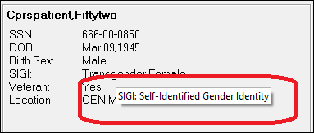

- NSR 20131005: Patient Selection Similar Patients Box
This NSR aims to reduce the likelihood of selecting the wrong patient, a patient safety issue. To assist the user in selecting the correct patient, the patient selection screen has been modified to include additional information: Primary Care Provider, Attending Physician, Last Visit, and Last Visit Date and Time.
Below is an example of the additional information that displays on the patient selection screen when the user highlights a patient name.
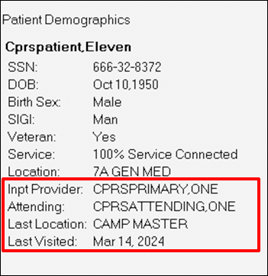

In addition to the information displaying on the main screen, when the user selects a patient and there are other patients with similar names, the Similar Patient dialog displays and shows the additional information also. For the pop-up box, physician (dependent on the last visit), last location, and last visit have been added.
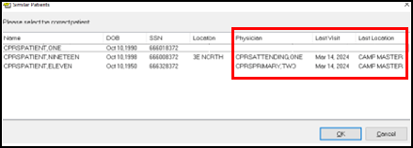

- NSR 20150513: Functionality of CPRS Weight Display
CPRS has been modified to allow sites to change how certain vitals are displayed on the coversheet, in the encounter portion of the Note display on the Notes tab, and on the Vitals tab in the encounter form. By division or for the entire system, a site may now choose to display either metric or imperial values first, for those vitals that have both.

In addition to the coversheet, Notes tab and the Encounter form have also been enhanced to display these values in the order determined by the new parameter. The coversheet and Encounter form will also display both values in a single column.

Vitals Pane on the Coversheet with the system set to display metric values first:
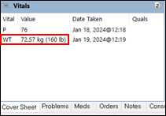

Excerpt of the Notes tab, showing the encounter information with the system set to show metric values first:
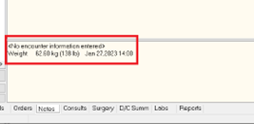

Vitals tab on the Encounter form, showing metric and imperial values for weight in a single column. The metric value shows first since the system is set to show metric first.
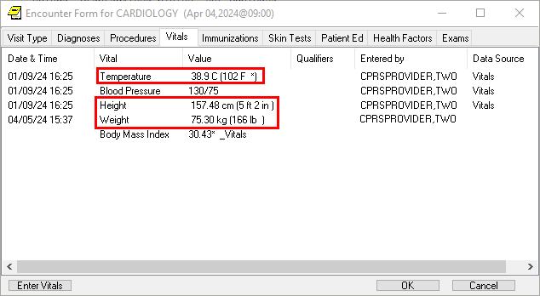

- NSR 20160415: Progress Note Flag Actions Sort (SHRPE)
Progress Note Flag Actions Sort (SHRPE) allows CPRS to display the “Originating Facility” data in the Progress Notes Properties dialog’s unlinked Patient Record Flags (PRF) flag actions section.
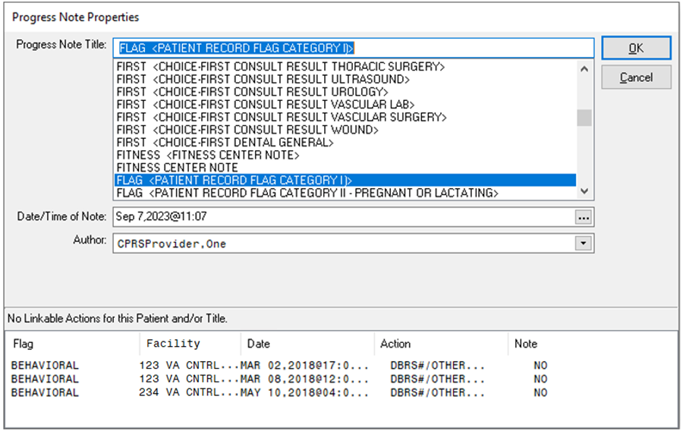
- NSR 20201003: Add Pronouns to Demographics bar next to new SIGI field
The LGBTQ+ Health Program Office is requesting an enhancement in the VistA Registration and Enrollment (REE) application and Master Patient Index (MPI). Currently, there is not a Preferred Pronoun field that reflects a person’s gender identity and expression. Requesting that a Preferred Pronoun field be added in VistA REE and MPI, so it can be used with direct patient care and exchanged with Cerner Millennium. Preferred pronoun refers to the pronouns that reflect a person’s gender identity and expression (e.g., he/him/his, she/her/hers, they/them/theirs, etc.).

The benefit of this enhancement request is to provide inclusive, affirming care for transgender and gender diverse patients that will help Veterans feel welcome at VHA facilities. Non-inclusive care (e.g., misgendering Veterans) leads to patient safety risks and the risk of lawsuits.

As part of this request, there was a request to display pronouns next to the SIGI field in the patient demographics “box” in CPRS.

IMPORTANT NOTE: As of the release of CPRS v33SWD, no method has been deployed for entering the pronoun. The new fields have been added to the PATIENT file (#2). While not advisable, in an urgent situation that could be helped by entering a Veteran’s pronouns, if there is a department at your medical center that has FileMan access to update the PATIENT file (#2), they may update the field using FileMan.

Of pronouns have been entered, the following illustrates how pronoun will display.

Below is an example of where the pronouns display. This one is She/Her.
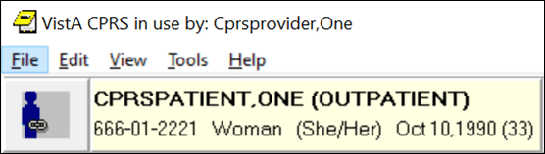

This example shows the pronouns She/Her and They/Them.
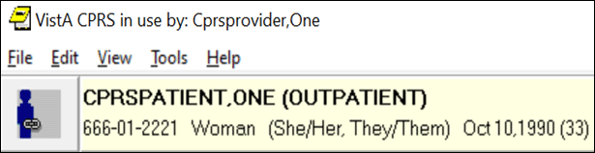

- NSR 20220818: Limit Date Selection for CPRS Orders in the Extreme Future
The VHA Office of Informatics and Analytics is requesting the ability to limit the Clinically Indicated Date (CID) in CPRS for future orders to no more than 390 days when ordering diagnostic exams in CPRS to prevent delaying diagnosis and treatment of patients. This release of CPRS addresses Imaging and Consult orders. Lab orders will be addressed in a future release.

- New Version of Mental Health DLL
This release of CPRS GUI also includes an updated version of the Mental Health DLL, YS_MHA_A_XE10.dll, version 1.0.5.16. Due to the CPRS project moving to a new version of the software used to create CPRS (Delphi version 11.3), an updated version of the DLL was required. This is a technical enhancement only, there are no user-facing enhancements in this updated DLL.

- CPRS Upgrade to Delphi 11.3 Affecting Cursor Location on Right-Click and Paste
The CPRS GUI is created using a software product named DelphiTM by Embarcadero Inc. This release of CPRS GUI has moved from Delphi 10.4 to Delphi 11.3. Oftentimes, users will not notice any changes when CPRS upgrades to a new version of Delphi. One change in behavior however has been noted regarding the cursor position when working in a text field.

In previous releases of Delphi, upon right-clicking in a text field (when pasting, for example) the cursor position would remain unchanged.

In Delphi 11, a more modern version of the Microsoft Windows text field is being used. Right-clicking in a text field will now move the cursor to wherever the right click occurred. This change brings Delphi-based application in line with the behavior found in modern Windows applications, including Office 365.

Known Issues
- VISTAOR-36805 Different Font Sizes Cuts off Checkboxes and Text in Encounter Visit Type Tab

Issue: When the user is on the CPRS Notes tab and entering encounter information, specifically Service Connected conditions, font issues may cause the checkboxes and part of the text to be cut off.

Workaround: There is currently no work around.

- VISTAOR-37565 Buttons in Release to Service window slowly disappear when the Font increases

Issue: When taking the “Release Delayed Orders” action on an order in CPRS GUI, the OK and Cancel buttons begin to appear cutoff at font size 10. At font size 12, the cutoff is very noticeable and at font size 14, the buttons are no longer visible.

Workaround: The only workaround is to use a font size smaller than 14pt.

- VISTAOR-37962 When writing delayed orders, buttons on Release Orders disappear as font increases

Issue: When using font size 12 or 14 in CPRS GUI and choosing Write Delayed Orders from the Orders Tab, the OK and Cancel buttons are not visible on the Release Orders window

Workaround: The only workaround is to use a smaller font size, such as 8 or 10pt.

- Access Violation Errors

Issue: Access Violation are errors that are difficult to troubleshoot because it is difficult to detect where in the code it occurs. When an access violation occurs, a dialog similar to the one below displays.
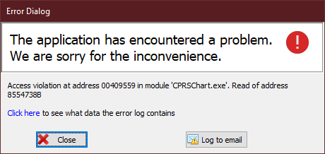

To help troubleshoot these problems, use the Log to email option, which will send additional information.

Workaround: There is no specific workaround to avoid the error. Users should close the Error Dialog and continue using CPRS. If the error occurs again, close CPRS and reopen it.

Note: It is NOT necessary to reboot the computer or workstation. The workstation does not need to be replaced or reimaged.

Below is a list of access violations that have occurred.
- VISTAOR-37356 EAccessViolation - Access violation at address 004E24FF in module 'CPRSChart.exe'. Read of address 00000014
- VISTAOR-37474 EInvalidPointer - Invalid pointer operation - TIU GET REQUEST
- VISTAOR-37544 EAccessViolation - Access violation at address 0040B18C in module 'CPRSChart.exe'. Read of address 0000000D - UStrAddRef
- VISTAOR-37545 EAccessViolation - Access violation at address 005FFC20 in module 'CPRSChart.exe'. Read of address 00000290 - HandleAllocated
- VISTAOR-37564 EAccessViolation - Access violation at address 0070E377 in module 'CPRSChart.exe'. Read of address 00000010 - IsFormSizeStored
- VISTAOR-37332 EAccessViolation - Access violation at address 005F7C9C in module 'CPRSChart.exe'. Read of address 0000039A - WMLButtonUp
- VISTAOR-37463 EAccessViolation - Access violation at address 00000010 in module 'CPRSChart.exe' - FTempLanguages
- VISTAOR-37464 EInvalidPointer - Invalid pointer operation - ORWDX UNLOCK
- VISTAOR-37466 EAccessViolation - Multiple addresses - GetDynaMethod
- VISTAOR-37566 EAccessViolation - Access violation at address 00CB8297 in module 'CPRSChart.exe'. Read of address 0031005E – fReminderDialog

Patient Safety Issues (PSIs)
- HITPS 196 – Allergy ingredient order checks not triggering. Released in ​CPRS v32a (OR*3.0*539).​ CPRS v33SWD corrects a defect where a double-click on a causative agent lookup can bypass the warning checkbox confirming correct selection item​.
- HITPS 521 (also PSPO 540): Requesting popup box or a flag alerting staff when there are two or more patients with same last name. Corrected by NSR 20131005.
- HITPS 1596 (PSI-07-087, Remedy Ticket #189451): Addresses the issue of the likelihood of the wrong patient being chosen when two patients have similar names. To prevent the likelihood of this occurring, each chosen patient will show the patient’s Inpatient Provider, Primary Care Provider, Last Location Name, and Last Visit Date. Corrected by NSR 20131005.
- HITPS 2453 (also PSPO 3657): Patient Safety Issue with “Add Comment to Consult” dialog box. Corrected by NSR 20110405.
- HITPS 7598: Radiology Orders with Scheduled Dates Greater than 390 Days. Corrected by NSR 20220818.

Defects
- INC18782546 - CPRS - Display of some vitals are duplicated in the PCE display area below the progress note view.
Problem:
When displaying the patient’s vitals below the note editor, sometimes the Weight information is displayed twice. This happens because the result string for function FormatVitalForNote was not being properly initialized, thus “defaulting” to the previous return value in some cases.

Resolution:
The result string for function FormatVitalForNote is now set to '' (empty string) on entering.

- INC11869026 – Available Reminders window Scrolling Issue
Duplicates: INC29725716, INC29684548
Problem:
In the Available Reminders form in CPRS, the DUE DATES and other information aren’t scrolling when the mouse wheel is used to scroll the tree of reminders.

Resolution:
The Available Reminders form overrides the mouse wheel handling to keep both right and left sides of the reminders in sync.

- INC13824577 - VISN 23 has frequent reports of consult order dialogs disappearing after data is entered and before it is accepted or signed.
Problem:
When the Order a Consult form is opened from an order menu, and the user selects the Lexicon menu to choose a diagnosis, sometimes the Order a Consult form is getting hidden behind the order menu.

Resolution:
After closing the Lexicon form, the Order a Consult form brings itself to the front of the stack of open CPRS forms.

- INC12188466 - In this new version of CPRS, when I use a template, the lines that should be blank now have a space at the beginning, and the lines that should have a space at the end do not.
Problem:
When inserting boilerplate templates, lines with formatting spaces at the end are having those spaces stripped. And what were blank lines in the template now have a space.

Resolution:
Lines shorter than 70 characters are no longer subject to having ending whitespace removed, and blank lines are restored.

- INC16329726 - CPRS coversheet reminder view Education Topic Definition not working.
Problem:
When working with clinical reminders in CPRS GUI, right-clicking on a reminder definition produces a context menu. This can be seen from the Notes Tab Reminders drawer, Available Reminders window shown when clicking on the Reminders clock, or the Clinical Reminders pane of the Cover Sheet.
When a reminder definition contains education topics, one of the available options on the context menu is to see the details about any of those education topics.
(Reminder Options… > Education Topic Definition > Choose topic from the list).

In a previous release of CPRS GUI, the education topic detail inquiry was inadvertently changed and tried to retrieve the reminder definition details. This would result in no data being returned “NO RECORDS TO PRINT”, or potentially incorrect data being returned if an internal entry number (IEN) match was found in the reminder definition file, for an education topic file IEN.

Resolution:
The correct functionality has now been restored. When selecting Education Topic Definition from the context menu, the education topic detail will now be returned and displayed in CPRS GUI.

- INC28129476 (numerous child tickets) CPRS Spell Check Broken
Problem:
In mid-2023, a Microsoft update to Office 365 introduced a defect to the Office functionality used by CPRS to invoke spell checking. Misspelled words were no longer appearing in the “Not in dictionary” section of the spell check window. A manual workaround was identified where users had to click on the Options button of the spell check window, and then close the
Options window. This action restored visibility of any text appearing in the “Not in dictionary” section.

Resolution:
In this version of CPRS, a change has been made that automates the manual workaround and keeps the Options window from being seen as it is opened and then closed. Effectively, users will see spell checking behave as it previously had before Microsoft introduced the defect.

- INC29884189 - CPRS Diet error: Access Violation at address 00FB5694 in Module 'CPRSchart.exe'. Read Address 00000014
Problem:
CPRS v32c (v32.515.2) introduced a potential bug where some order dialog configurations could cause an access violation when trying to create diet orders.

Resolution:
This access violation should no longer occur regardless of order dialog configuration.

- INC31027958 - Add legacy pop-up box to the list of boxes that will retain user sizing/settings when stretched to a different size.
Problem:
The Patient Lookup Messages window that displays when a patient requires a means test or when the patient has legacy data does not retain any user settings for sizing.

Resolution:
This window will now retain size settings when the user has stretched the window to a different size than default.

- INC29657166 (INC25256062) - Consult Reason for Request text still in reverse order.
Problem:
If a new consult includes a template, the content of the template is sometimes being inserted line-by-line backward into the “Reason for Request” field. This is due to the Windows richedit control sometimes returning 0 for the number lines in the “Reason for Request” field, and how TStrings.Text processes assigning a string.

Resolution:
CPRS GUI has been updated to use the Windows Rich Edit control more directly, to stream the content into the control, rather than through the extra layer of Delphi’s abstraction classes.

- INC20159582 ATTN: CLIN2/CPRS Developers - Reproducible TIU Template CPRS Crash.
Problem:
Certain combinations of required fields in nested templates, that are selected and deselected multiple times can generate an access violation in the CPRS GUI.
When working in a template, CPRS keeps track of the template fields and their state (i.e., a checkbox is checked or unchecked). CPRS also tracks a list of the required fields in each template. In certain scenarios, as required items are selected or deselected, the required field list is not always updated and when CPRS tries to read that list, an access violation occurs.

Resolution:
The required field tracking logic in CPRS GUI templates has been updated to correct the access violation.

Access Violation Troubleshooting Feature
To help CPRS developers and support personnel address access violations that sometimes occur, the team has enhanced the feature that helps users report an access violation.
When an access violation occurs, CPRS gathers information and makes a log. The information in the log may help those troubleshooting to track down the source of the problem so that it can be addressed.
- If an access violation error occurs, the user may see a dialog on the screen such as those shown below: the first one is an example of a GUI error, while the second represents a MUMPS error:

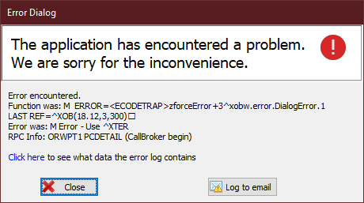
- Please select the “Log to email” button.
- CPRS will attempt to automatically email the log so that those troubleshooting can use it.
- If CPRS cannot send the email automatically, it will prepopulate an email. Please send the email.

Note: Most users would not find most of the log information useful, but it can be viewed. If the user selects the Click here to see what data the error log contains link, the Error Dialog will display with the contents of the log. This is an example of what that dialog might look like. You can select Log to email to send the log to troubleshooters.
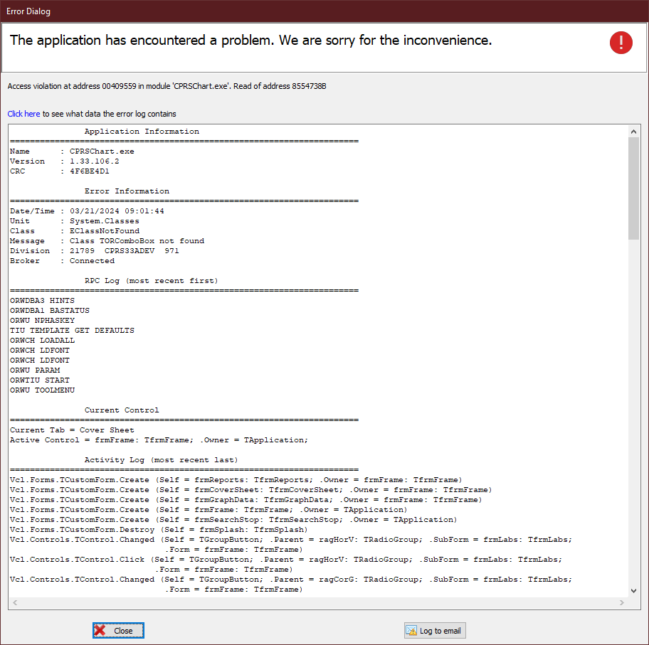

Product Documentation
The following documents apply to this release:
- CPRS v33 SWD (OR*3.0*608) Deployment, Installation, Back-Out, and Rollback Guide (DIBOR)
- CPRS v33SWD (OR*3.0*608) Release Notes
- Computerized Patient Record System (CPRS) Technical Manual: List Manager Version
- Computerized Patient Record System (CPRS) User Guide: GUI Version
- Computerized Patient Record System (CPRS) Technical Manual: GUI Version

All CPRS documents are available at the VA (Software) Documentation Library (VDL) web site.
This website is usually updated within 1-3 days of the patch release date.

