Benefits of Reminders  “Reminders help us to do the right thing consistently well” – Dr. Jonathan Perlin  What are clinical reminders and what  do they do for clinicians?  - Inform clinicians when a patient is due to receive clinical activity.  - Target the clinicians who can manage and resolve the clinical activity most appropriately.  - Identify patients to whom a reminder applies, based on VISTA patient data.  - Identify the clinical activities that resolve or satisfy reminders.  - Summarize pertinent patient information to help clinicians determine appropriate follow-up activities.  - Allow clinicians to resolve reminders through CPRS.  - Provide aggregate reports that assist clinicians in managing their entire patient caseload.  - Support national clinical practice guidelines. | Supporting  Quality Guidelines  in Patient Care  Clinical Practice Guidelines Goals:  - Assure appropriate levels of care  - Reduce errors and promote patient safety  - Ensure predictable and consistent quality  - Promote learning and research  - Facilitate patient and family education  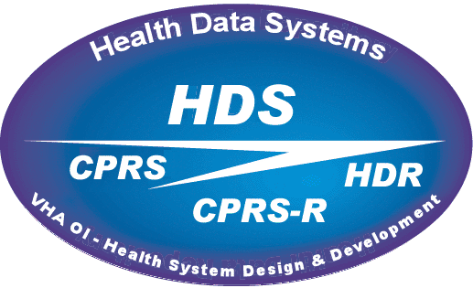  Health Data System  Office of Information  Department of Veterans Affairs  http://vista.med.va.gov/reminders |  |   Clinical  Reminders  Version 2.0  Clinical Reminders furnish clinicians with timely information about the health maintenance schedules of their patients. This information is provided in Encounter Forms, Health Summaries, and the Computerized Medical Record System (CPRS), where clinicians can easily respond to the reminders by placing relevant orders or recording clinical activities on patients’ notes. Thus, Clinical Reminders can become a valuable decision support tool for clinicians.

Viewing Clinical Reminder Information  You can view Clinical Reminder information on your Clinic Health Summary, Encounter Form, or on the CPRS Cover Sheet.  This pane on the CPRS Cover Sheet displays Reminders that are due now or are due soon. You can double-click on a reminder to get basic information about why it is due and what actions it requires.  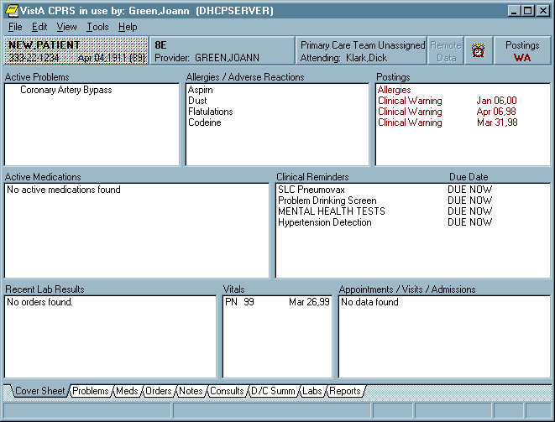  Icons in the upper right corner of the Cover Sheet provide information about reminders.  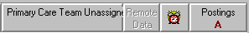   A red, ringing alarm clock means that a reminder is due.  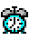 A blue, non-ringing alarm clock means a reminder is not due, but is applicable. I.e., the reminder will be due soon and you might want to consider resolving it now, in case the patient doesn’t have an appointment between now and the due date.  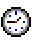 A wall clock means a reminder is not applicable.   A grayed-out alarm clock means that no reminders are due or applicable.   A question mark means that a reminder has yet to be evaluated. (The question mark appears as CPRS checks reminders for the patient.) | Resolving Reminders  1. Log on to CPRS and select the Notes tab.  2. Click on the New Note button.  3. Select any title or type a new title in the title box.  4. Choose a visit with which to associate the note. You can use the TELEPHONE CLINIC selection for telephone notes.  5. When the note opens, "drawers" open in the lower left section of the screen. Click on the Reminders drawer to open it.  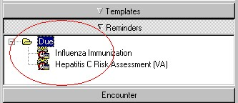6. When the Reminders drawer opens, you can see the reminders on which you can act.  7. Click on a reminder to select it for resolution. A reminder dialog opens. You can resolve one or several reminders in a single note. As you select items in the dialog by clicking on the checkboxes, Clinical Reminders enters text into the progress note and may also automatically write orders for labs, consults, etc. You can click on a selected item to undo the selection.  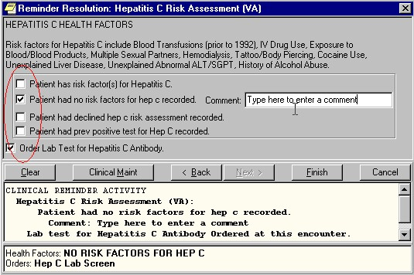  Notice that selections in the dialog have corresponding text in the pane below the dialog. You can edit, add to, or delete any of this text just as you would text in any progress note. | Clinical Reminders Reports  You can use Clinical Reminder reports to:  - Identify patients in a panel or a clinic who have reminders that are due  - Provide aggregate reporting  - Create patient-specific reports for intervention  - Identify inpatients who have reminders that are due  - Identify patients who will be in a specific clinic in the next month and who need an intervention  - Identify patients who have left a specific clinic in the past week and who missed having an intervention  - Identify patients who have lab findings but no diagnoses  - Track employee health  - Obtain information for inpatient education, exams, and immunizations  - Report on patients who are eligible for a study  - Identify high-risk patients  - Report on disease-specific reminders: HCV, HIV, Melanoma, AAA, Diabetes  Health Summary & Reminders  You can define health summaries with three different reminder components and you can define each of these components with selected reminders. The reminders you select for each health summary should target the clinic or clinicians best suited for clinical intervention when the reminders are due. When you run a health summary, Clinical Reminders evaluates the patient’s data and returns the results to the health summary for display. The format of the display is based on the component defined in the health summary.  Clinical Reminders 2 contains new health summary components to support the My HealtheVet project. These components contain less technical information than in most health summary components, to provide a more suitable display of clinical reminder information to patients.

