The Updated Project Plan

7810ICT-2022-Assignment-Liangxian-Rafael

Liangxian Zhao s2869753

Rafael Alexander s5277157

Table of Contents

1.0 Introduction 3

1.1 Problem Background 3

1.2 Scope 3

1.3 Document contents 3

2.0 Work Breakdown Structure 3

3.0 Activity Definition & Estimation 5

4.0 Gantt Chart 6

# Introduction

## Background

In this day and age, data is very important resource. A lot of information, including crucial and important ones, can be taken from data. But extracting the information, which we can accumulate to form knowledge, from raw data is not an easy task. The amount of data to process in order to get a bit of information can be daunting and too much to handle for the normal human being. Thankfully, we have now have the help and power of computers to aid us in processing these data. This project aims to help users gather more meaningful information from data through analysation and visualisation through the creation of a simple software tool. Specifically, the tool will be specifically catered to process "NYC Restaurant Inspections" data. From the analysation and visualisation of this dataset, it is hoped that users may gather and accumulate various information, and eventually knowledge, from the simple dataset of restaurant details and their inspection violations.

## Scope

* This tool specializes in analysing and visualising the "NYC Restaurant Inspections" dataset
* Features are:
* Retrieve relevant inspection details within a user-selected period.
* Plot the distribution of violations over the different suburbs within a user-selected period.
* Retrieve all violations that contain a keyword (user entered) within a user-selected period.
* Analyse the cases related to animals, e.g., rats, mice or others, and their trend over time and distribution over suburbs.
* Retrieve relevant inspection details within a user-selected borough and cuisine description.
* Out of Scope
* Compatible to analyse other datasets
* Customizing interface design (colour, shape, etc) of initial and results page by the user

## Document contents

This document contains the introduction to the project which includes the background and history of the project and its scope, a work breakdown structure, activity definition and estimation and a Gantt chart based on the aforementioned work breakdown structure.

# Work Breakdown Structure

Table 1 demonstrate Work Breakdown structure briefly for this software project. We estimate work time of 4 weeks and 3-5 hours per day. It is estimated that a total of around 120 hours will be necessary to finish the building of the system and any future delivery. With a group size of two people, we plan to finalize this project before the 9 of October in this year, based on the action date on the 1th of September in 2022.

|  |  |  |
| --- | --- | --- |
| **Work Break Down Structure:**  **Part B** | | |
| **Task ID** | **Task Description** | **Effort (Days)** |
| **1** | **Planning** | **1** |
| 1.1 | Work Breakdown Structure Definition | 1 |
| 1.2 | Activity Definition and Estimation | 2 |
| 1.3 | Develop Gantt Chart | 1 |
| **2** | **Design** | 2 |
| 2.1 | Wxpython Instruction and Environment setting | 3 |
| 2.2 | Design Function | 2 |
| 2.3 | Define Function Button | 4 |
| 2.4 | System Design | 2 |
| 2.5 | Program Coding | 4 |
| **3** | **Unit test Design** | **4** |
| 3.1 | Performance testing | 1 |
| 3.2 | Issue Found | 2 |
| 3.3 | Report generation | 2 |
| **4** | **Support Plan** | **1** |
| **4.1** | **Maintenance** | **2** |
| **4.2** | **Manual book instruction design** | **1** |
| 5 | Project part B Submission | **1** |

***Table 1: Work Breakdown Structure***

# Activity Definition & Estimation

|  |  |
| --- | --- |
| **Activity** | **Definition** |
| **Planning** | The plan was specific design for software function design as well as implementation |
| Work Breakdown Structure Definition | It often known as a WBS, is a tool for managing projects that follows a methodical, step-by-step approach to the completion of complex projects that include several moving parts. A WBS allows for the integration of the project's scope and deliverables into a single tool by first dividing the project down into smaller components. |
| Activity Definition and Estimation | Estimates of the activity duration provide an idea of the amount of time required to complete a project assignment. They are often used to refer to work or business times, although they may also take the shape of other time periods, such as days, weeks, or months. |
| Develop Gantt Chart | A Gantt chart is a visual representation of a project schedule that is often used nowadays. It is a form of bar chart that displays the beginning and ending dates of the many aspects of a project, such as the resources, the planning, and the dependencies. |
| **Design** | The software design generally meets the requirement of clients related to data analysis |
| Wxpython Instruction and Environment setting | wxPython is a graphical user interface (GUI) toolkit that can be used with the Python programming language. It is possible for Python programmers to easily and quickly construct applications that have a graphical user interface that is both sturdy and highly functional.  Environment setting is for developers desktop or workstation, which is referred to as the "local environment." This is the location where the code is created, where issues are corrected, and where unit tests are performed locally by the developers in an isolated way. |
| Design Function | Team members design the basic function include read csv file, retrieve data and SQL language |
| Define Function Button | Function button defined as feature of software, regarding on client’s requirement |
| System Design | The process of designing the components of a system, such as architecture, modules, and components, as well as the many components. The data transfer is also referred to as system design. |
| Program Coding | This software is based on python computer language. The computer receives codes directly for which activities to carry out and which tasks to complete from the code. |
| **Unit test Design** | Unit testing is performed before code is distributed to verify, which it is up to the required quality standards. Unit testing is an important part of the software development life cycle since it not only helps developers produce better code in a more efficient manner, but it also potentially detects bugs |
| Performance testing | Initial test of software implementation |
| Issue Found | After several tests running, there might be medium or low priority defects, which cannot be fixed due to time limitation. |
| Report generation | The digital report formatted as Excel, HTML, and PDF by importing unit test and coverage |
| Support Plan | The main purpose of software implements, bug fixed and instruction |
| Maintenance | General maintenance to fully support software implement |
| Manual book instruction design | A document that is given to a user in order to assist them in the smooth operation of a certain system, product, or service is called a user manual. It is also often referred to as a user handbook or an instruction manual. |
| **Project part B Submission** | Final submission of part B |

***Table 2 Activities definition& Estimate***

# 4.0 Gantt Chart

Figure 1 illustrate the estimated work breakdown structure as visualized Gantt chart. The task duration and work date are designed for project schedule arrangement. The Gantt chart document can be attached on Gitlog.

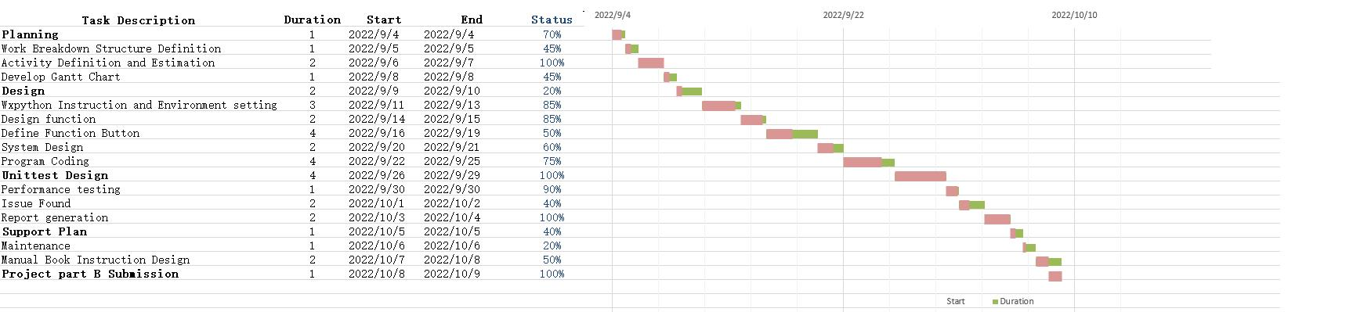

***Figure 1. Gantt chart***