

SIMULADO

70-483

**QUESTION 1**: You are implementing a method named Calculate that performs conversions between value types and reference types. The following code segment implements the method. (Line numbers are included for reference only.) You need to ensure that the application does not throw exceptions on invalid conversions. Which code segment should you insert at line 04?

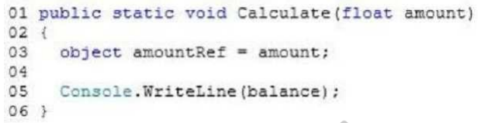

A. int balance = (int) (float)amountRef;

B. int balance = (int)amountRef;

C. int balance = amountRef;

D. int balance = (int) (double) amountRef;

**Correct Answer: A**

**Section: Volume A**

**QUESTION 2** You are creating a console application by using C#. You need to access the application assembly

A. Assembly.GetAssembly(this);

B. this.GetType();

C. Assembly.Load();

D. Assembly.GetExecutingAssembly();

**Correct Answer: D**

**Explanation**

**Explanation/Reference: Explanation:**

**Assembly.GetExecutingAssembly - Gets the assembly that contains the code that is currently executing.**

**Assembly.GetAssembly - Gets the currently loaded assembly in which the specified class is defined.**

**QUESTION 3** You use the Task.Run() method to launch a long-running data processing operation. The data processing operation often fails in times of heavy network congestion. If the data processing operation fails, a second operation must clean up any results of the first operation. You need to ensure that the second operation is invoked only if the data processing operation throws an unhandled exception. What should you do?

A. Create a TaskCompletionSource object and call the TrySetException() method of the object.

B. Create a task by calling the Task.ContinueWith() method.

C. Examine the Task.Status property immediately after the call to the Task.Run() method.

D. Create a task inside the existing Task.Run() method by using the AttachedToParent option.

**Correct Answer: B**

**QUESTION 4** You are developing an application that uses structured exception handling. The application includes a class named ExceptionLogger.

**The ExceptionLogger class implements a method named LogException by using the following code segment: public static void LogException(Exception ex)**

You have the following requirements: Log all exceptions by using the LogException() method of the ExceptionLogger class.

Rethrow the original exception, including the entire exception stack. You need to meet the requirements.

Which code segment should you use?

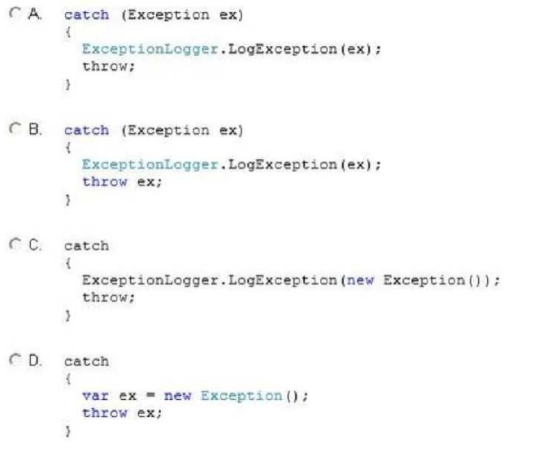

**Correct Answer: A**

**QUESTION 5** You are developing an application that will transmit large amounts of data between a client computer and a server. You need to ensure the validity of the data by using a cryptographic hashing algorithm. Which algorithm should you use?

A. HMACSHA256

B. RNGCryptoServiceProvider

C. DES

D. Aes

**Correct Answer: A**

**Explanation/Reference: Explanation: The .NET Framework provides the following classes that implement hashing algorithms: HMACSHA1. MACTripleDES. MD5CryptoServiceProvider. RIPEMD160. SHA1Managed. SHA256Managed. SHA384Managed. SHA512Managed.**

**HMAC variants of all of the Secure Hash Algorithm (SHA), Message Digest 5 (MD5), and RIPEMD-160 algorithms**

**QUESTION 6** You are developing an assembly that will be used by multiple applications. You need to install the assembly in the Global Assembly Cache (GAC). Which two actions can you perform to achieve this goal? (Each correct answer presents a complete solution. Choose two.)

A. Use the Assembly Registration tool (regasm.exe) to register the assembly and to copy the assembly to the GAC.

B. Use the Strong Name tool (sn.exe) to copy the assembly into the GAC.

C. Use Microsoft Register Server (regsvr32.exe) to add the assembly to the GAC.

D. Use the Global Assembly Cache tool (gacutil.exe) to add the assembly to the GAC.

E. Use Windows Installer 2.0 to add the assembly to the GAC.

**Correct Answer: DE**

**QUESTION 7** You are debugging an application that calculates loan interest. The application includes the following code. (Line numbers are included for reference only.)

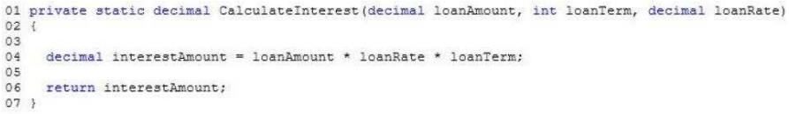

You need to ensure that the debugger breaks execution within the CalculateInterest() method when the loanAmount variable is less than or equal to zero in all builds of the application. What should you do?

A. Insert the following code segment at line 03:Trace.Assert(loanAmount > 0);

B. Insert the following code segment at line 03:Debug.Assert(loanAmount > 0);

C. Insert the following code segment at line 05:Debug.Write(loanAmount > 0);

D. Insert the following code segment at line 05:Trace.Write(loanAmount > 0);

**Correct Answer: A**

**Explanation**

**Explanation/Reference: Explanation: By default, the Debug.Assert method works only in debug builds. Use the Trace.Assert method if you want to do assertions in release builds. For more information, see Assertions in Managed Code.**

**QUESTION 8** You are developing an application by using C#. You provide a public key to the development team during development.

You need to specify that the assembly is not fully signed when it is built. Which two assembly attributes should you include in the source code? (Each correct answer presents part of the solution. Choose two.)

A. AssemblyKeyNameAttribute

B. ObfuscateAssemblyAttribute

C. AssemblyDelaySignAttribute

D. AssemblyKeyFileAttribute

**Correct Answer: CD**

**QUESTION 9** You are developing an application by using C#. The application includes an object that performs a long running process. You need to ensure that the garbage collector does not release the object's resources until the process completes.

Which garbage collector method should you use?

A. WaitForFullGCComplete()

B. WaitForFullGCApproach()

C. KeepAlive()

D. WaitForPendingFinalizers()

**Correct Answer: C**

**Explanation**

**Explanation/Reference: Explanation: The GC.KeepAlive method references the specified object, which makes it ineligible for garbage collection from the start of the current routine to the point where this method is called. The purpose of the KeepAlive method is to ensure the existence of a reference to an object that is at risk of being prematurely reclaimed by the garbage collector. The KeepAlive method performs no operation and produces no side effects other than extending the lifetime of the object passed in as a parameter**

**QUESTION 10** An application includes a class named Person. The Person class includes a method named GetData. You need to ensure that the GetData() method can be used only by the Person class and not by any class derived from the Person class.

Which access modifier should you use for the GetData() method?

A. Public

B. Protected internal

C. Internal

D. Private

E. Protected

**Correct Answer: D**

**Explanation**

**Explanation/Reference: Explanation:**

**The GetData() method should be private. It would then only be visible within the Person class.**

**QUESTION 11** You are developing an application. The application includes classes named Mammal and Animal and an interface named IAnimal. The Mammal class must meet the following requirements: It must either inherit from the Animal class or implement the IAnimal interface.

It must be inheritable by other classes in the application. You need to ensure that the Mammal class meets the requirements. Which two code segments can you use to achieve this goal? (Each correct answer presents a complete solution. Choose two.)

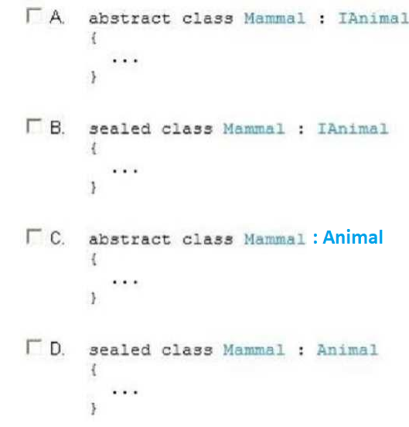

**Correct Answer: AC**

**Explanation/Reference: Explanation: When applied to a class, the sealed modifier prevents other classes from inheriting from it.**

**QUESTION 12** You are developing an application that includes a class named Order. The application will store a collection of Order objects. The collection must meet the following requirements: Internally store a key and a value for each collection item. Provide objects to iterators in ascending order based on the key. Ensure that item are accessible by zero-based index or by key. You need to use a collection type that meets the requirements. Which collection type should you use?

A. LinkedList

B. Queue

C. Array

D. HashTable

E. SortedList

**Correct Answer: E**

**Explanation**

**Explanation/Reference: Explanation: SortedList<TKey, TValue> - Represents a collection of key/value pairs that are sorted by key based on the associated IComparer<T> implementation.**

**QUESTION 13** You use the Task.Run() method to launch a long-running data processing operation. The data processing operation often fails in times of heavy network congestion. If the data processing operation fails, a second operation must clean up any results of the first operation. You need to ensure that the second operation is invoked only if the data processing operation throws an unhandled exception. What should you do?

A. Create a task within the operation, and set the Task.StartOnError property to true.

B. Create a TaskFactory object and call the ContinueWhenAll() method of the object.

C. Create a task by calling the Task.ContinueWith() method.

D. Use the TaskScheduler class to create a task and call the TryExecuteTask() method on the class

**Correct Answer: C**

**Explanation**

**Explanation/Reference: Explanation: Task.ContinueWith - Creates a continuation that executes asynchronously when the target Task completes. The returned Task will not be scheduled for execution until the current task has completed, whether it completes due to running to completion successfully, faulting due to an unhandled exception, or exiting out early due to being canceled.**

**QUESTION 14** You are developing an application. The application contains the following code segment (line numbers are included for reference only):

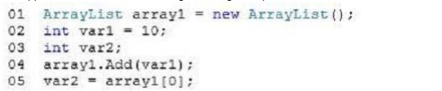

When you run the code, you receive the following error message: "Cannot implicitly convert type 'object'' to 'int'. An explicit conversion exists (are you missing a cast?)." You need to ensure that the code can be compiled. Which code should you use to replace line 05?

A. var2 = arrayl[0] as int;

B. var2 = ((List)arrayl) [0];

C. var2 = arrayl[0].Equals(typeof(int));

D. var2 = (int) arrayl [0];

**Correct Answer: D**

**QUESTION 15** You need to write a method that retrieves data from a Microsoft Access 2013 database. The method must meet the following requirements: Be read-only.

Be able to use the data before the entire data set is retrieved. Minimize the amount of system overhead and the amount of memory usage

Which type of object should you use in the method?

A. SqlDataAdapter

B. DataContext

C. DbDataAdapter

D. OleDbDataReader

**Correct Answer: D**

**Explanation/Reference: Explanation: OleDbDataReader Class Provides a way of reading a forward-only stream of data rows from a data source**

**QUESTION 16** You are developing an application that will parse a large amount of text. You need to parse the text into separate lines and minimize memory use while processing data.

Which object type should you use?

A. DataContractSerializer

B. StringBuilder

C. StringReader

D. JsonSerializer

**Correct Answer: C**

**QUESTION 17** You are modifying an existing application that manages employee payroll. The application includes a class named PayrollProcessor. The PayrollProcessor class connects to a payroll database and processes batches of paychecks once a week.

You need to ensure that the PayrollProcessor class supports iteration and releases database connections after the batch processing completes.

Which two interfaces should you implement? (Each correct answer presents part of the complete solution. Choose two.)

A. IEquatable

B. IEnumerable

C. IDisposable

D. IComparable

**Correct Answer: BC Section: Volume B Explanation**

**Explanation/Reference: Explanation: IEnumerable IDisposable Interface Exposes an enumerator, which supports a simple iteration over a non-generic collection.**

**Defines a method to release allocated resources. The primary use of this interface is to release unmanaged resources.**

**QUESTION 18** You need to create a method that can be called by using a varying number of parameters. What should you use?

A. Method overloading

B. Derived classes

C. Named parameters

D. Enumeration

**Correct Answer: A`**

**QUESTION 19** You need to store the values in a collection. The solution must meet the following requirements: The values must be stored in the order that they were added to the collection. The values must be accessed in a first-in, first-out order.

Which type of collection should you use?

A. SortedList

B. Queue

C. ArrayList

D. Hashtable

**Correct Answer: B**

**QUESTION 20** You have an application that will send confidential information to a Web server. You need to ensure that the data is encrypted when it is sent across the network.

Which class should you use?

A. CryptoStream

B. AuthenticatedStream

C. PipeStream

D. NegotiateStream

**Correct Answer: A**

**QUESTION 21** You have a C# application named App1 that invokes a method in an external assembly named Assembly1. Assembly1 is written in C++ and is natively compile by using a debug build. When you debug App1, you do not see any debug information for Assembly1. You need to ensure that when you debug App1, you see the debug information for Assebly1. What should you do?

A. On the Debugging page of the configuration properties for the C++ project, set the Debugger Type to Native Only.

B. On the Debugging page of the configuration properties for the C++ project, set the Debugger Type to Mixed.

C. On the Debug page of the project properties for App1, click Enable native code debugging.

D. In the project properties for App1, set the working directory to the same directory as Assembly1.

**Correct Answer: B**

**QUESTION 23** You need to write a method that retrieves data from a Microsoft Access 2013 database. The method must meet the following requirements: Be read-only.

Be able to use the data before the entire data set is retrieved. Minimize the amount of system overhead and the amount of memory usage. Which type of object should you use in the method?

A. DbDataReader

B. DataContext

C. unTyped DataSet

D. DbDataAdapter

**Correct Answer: A**

**Explanation**

**Explanation/Reference: Explanation: DbDataReader Class Reads a forward-only stream of rows from a data source.**

**QUESTION 24** You are implementing a new method named ProcessData. The ProcessData() method calls a third-party component that performs a long-running operation to retrieve stock information from a web service.

The third-party component uses the IAsyncResult pattern to signal completion of the long-running operation. You need to ensure that the calling code handles the long-running operation as a System.Threading.Tasks.Task object.

Which two actions should you perform? (Each correct answer presents part of the solution. Choose two.)

A. Call the component by using the TaskFactory.FromAsync() method.

B. Create a TaskCompletionSource object.

C. Apply the async modifier to the method signature.

D. Apply the following attribute to the method signature: [MethodImpl(MethodImplOptions.Synchronized)]

**Correct Answer: AB**

**QUESTION 25** You develop a class named MyClass. MyClass has a method that uses a COM object. You need to ensure that when MyClass is instantiated by using the using keyword, the COM object is released at the end of the using scope.

Which interface should you implement?

A. ISerializable

B. IDisposable

C. ICloneable

D. IFormattable

**Correct Answer: B**

**QUESTION 26** You write the following method (line numbers are included for reference only):

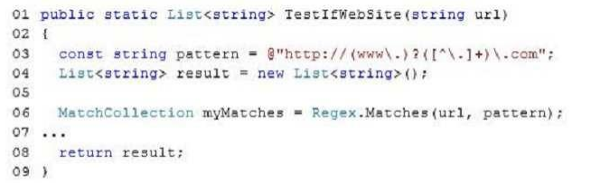

You need to ensure that the method extracts a list of URLs that match the following pattern: **@http://(www\.)?([^\.]+)\.com;**

Which code should you insert at line 07?

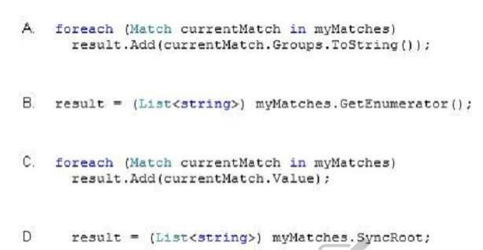

**Correct Answer: C**

**Explanation/Reference: Explanation: MatchCollection Represents the set of successful matches found by iteratively applying a regular expression pattern to the input string. The collection is immutable (read-only) and has no public constructor. The Regex.Matches method returns a MatchCollection object. List<T>.Add Method Adds an object to the end of the List<T>.**