Update on the project:

John and I have been working on figuring out the method for estimating affinity matrix C from a map of individuals to sites. We generated a community distribution from C and a continuous landscape with different soil types. To recover the number of effective soil types and C in the community, we first grid the community into cells. This gridding will affect the recovery result. Then, non-metric multidimensional scaling is used to establish a projection from the high-dimensional species space to 2D while preserving the Bray-Curtis distance between the cells. PAM clustering algorithm is used to find the clusters in the original species space. The clusters are labeled in the 2D space. The best clustering suggests the number of clusters, which is then the estimated number of (ecologically relevant) soil types. C is thus recovered.

Findings:
- Generally, better C recovery with a higher grain-to-cell size ratio. However, the cell has to be big enough to contain enough information. This suggests that we need to find the optimal cell size to recover C from real data.

Figure 1 Higher grain-to-cell ratio
Figure 2 Lower grain-to-cell ratio

- Worse C recovery with more soil types and/or species, holding the size of community constant. This suggests that we may not have enough data to get a good clustering and accurately recover C in the real world.

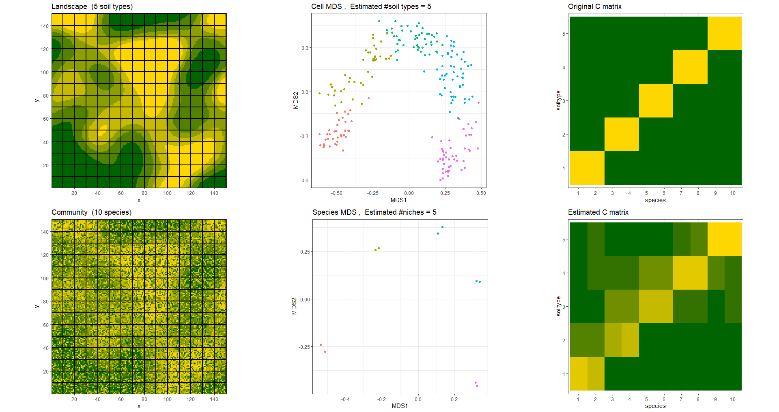
Figure 3 Landscape with 5 soil types

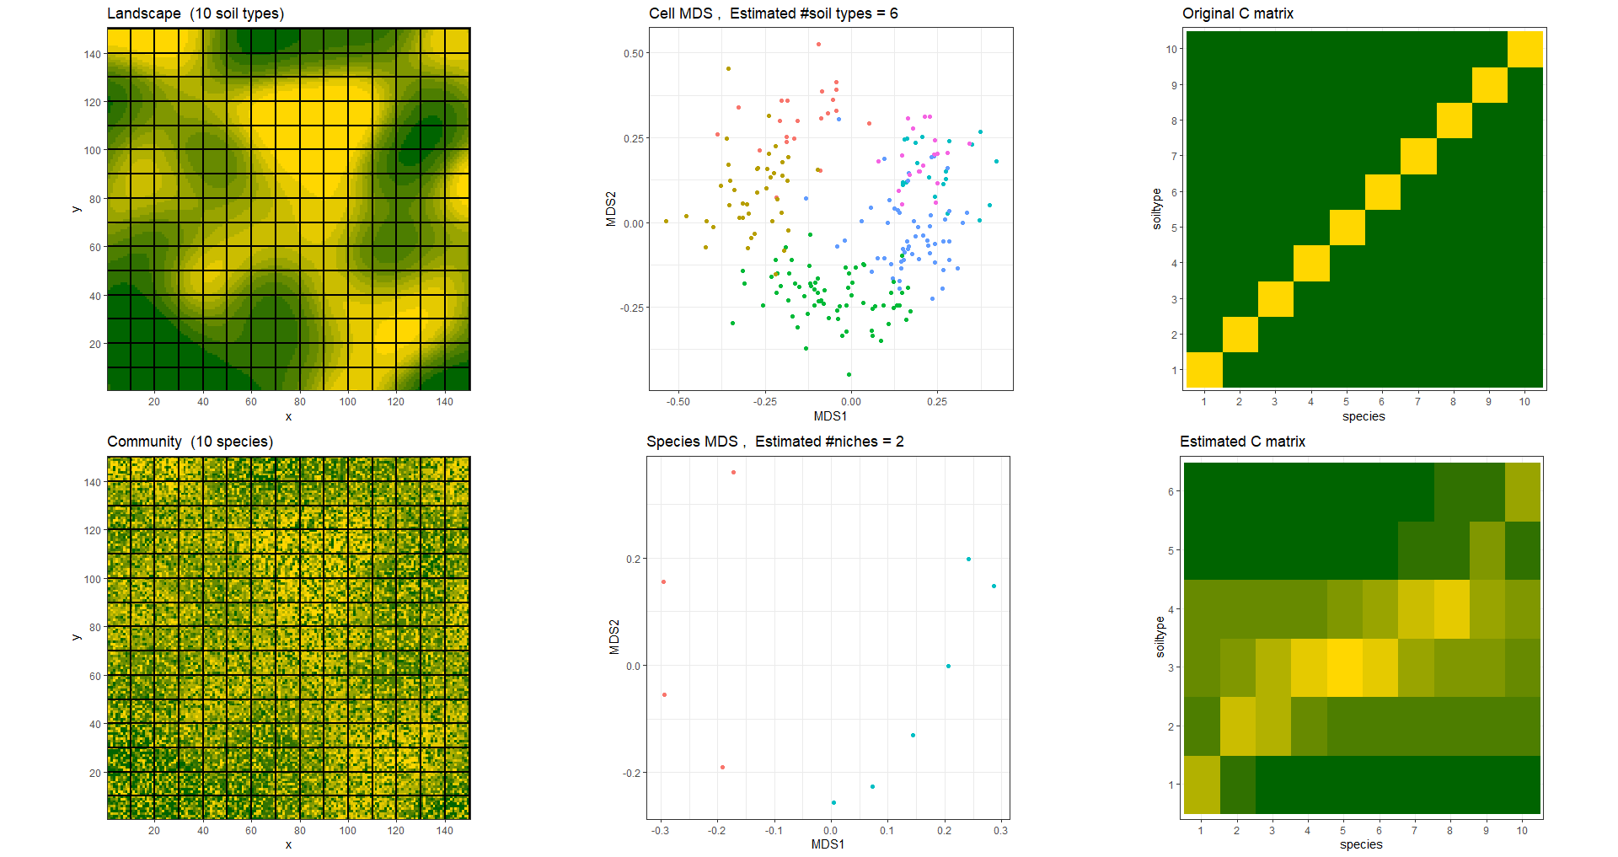
Figure 4 Landscape with 10 soil types

- Better C recovery with lower affinity for non-preferred sites.
- The recovery works with random Gaussian noise added to C.

We are considering the following questions:
- We tried PAM and hierarchical clustering. A different fine-tuned clustering algorithm might yield better/different results.
- How do we quantify the effectiveness of cell gridding? What should we optimize?

