WP4 Deliverable 4.3
Designs of the technical enablers for status, projections and actions

Sa4CPS
ITEA 4 22007

Status: Draft

••••••••••••••••••••••••••••••••••••••••••••••••••••••
Edited by Jiří Havlík (IMA)

Including contributions from:
TODO – put your name below
Tomáš Bureš (CUNI)
Petr Hnětynka (CUNI)

Table of Contents

Table of Contents 3
Table of Figures 5
Abstract 6
List of Abbreviations 7
1 Introduction 9
1.1 Scope of the deliverable 9
1.2 Technical enablers covered 10
2 Concept of digital twins [VTT] 12
3 Integrated Situation Awareness, Risk Assessment, and Operational Response for Drone Operations [ADLC] 13
3.1 Perception, comprehension & risk assessment engine (EN_02) [ADLC] 13
3.2 Operations monitoring dashboard (EN_03) [ADLC] 13
3.3 Response dashboard (EN_04) [ADLC] 13
3.4 State egress adapters (EN_05) [ADLC] 13
4 Unified Operational Awareness and Control for Industrial Forklift Operations [ACD, ERARGE, INOVASYON, Alpata, OTOKAR, PortOfOulu] 14
4.1 Low-Latency Hybrid Communication Module (EN_06) [ACD] 14
4.2 Sa4CPS Web Platform (EN_07) [ACD] 14
4.3 3AM Decentralized Backend (EN_08) [ERARGE] 14
4.4 Digital Twin with Semantic Backend (EN_09) [ERARGE] 14
4.5 PHM Backend & Big Data Ingestion Pipeline (EN_10) [INOVASYON] 15
4.6 Battery PHM (Prognostics & Health Management) Tool (EN_11) [INOVASYON] 15
4.7 Digital Twin Environment for forklift operations (EN_12) [INOVASYON] 15
4.8 Optimum Route Planning and Vehicle-to-Vehicle Cooperation Engine (EN_13) [Alpata] 15
4.9 Digital twin–based situational awareness framework (EN_14) [OTOKAR] 15
4.10 Demonstration site – Port of Oulu [PortOfOulu] 15
5 A language, formal model, and tools to describe, model, and identify situations [CUNI, IMA] 16
6 Behaviour-Based Digital Risk Detection and Situational Awareness [F-Secure] 17
6.1 DNS Fingerprinting Data Processing Pipeline (EN_16) [F-Secure] 17
6.2 Behavioural data hub (EN_17) [F-Secure] 17
7 Real-Time Operational Data Integration and Visualization [Vintecc] 18
7.1 Capture platform (EN_18) [Vintecc] 18
8 Geospatial Situational Awareness and Event Detection [Modirum Gespi] 19
8.1 Map, Map Engine, and Visualization Technologies (EN_19) [Modirum Gespi] 19
8.2 AI-Enabled Integration of Location Data into the NSC3 Environment (EN_20) [Modirum Gespi] 19
8.3 AI-Based Event Detection and Real-Time Alerting (EN_21) [Modirum Gespi] 19
8.4 Integrating Camera Sources to NSC3 Environment (EN_22) [Modirum Gespi] 19
8.5 Hardening NSC3 Environment to Zero Trust Authentication and Authorization (EN_23) [Modirum Gespi] 19
8.6 NSC3 system description [Modirum Gespi] 19
9 Integrated Status, Decision Support, and Control for Energy Communities and Distribution Networks [CEL, Digitalmente, Enerim, ISEP] 20
9.1 Energy Community Operational Management and Governance Interface (EN_24) [CEL] 21
9.2 Human-in-the-Loop Community Action Validation Interface (EN_25) [CEL] 21
9.3 Regulatory, Environmental and Community Performance Reporting (EN_26) [CEL] 21
9.4 Energy Community Digital Twin Backbone (EN_27) [Digitalmente] 21
9.5 Energy Community Data Aggregation and Visualization Services (EN_28) [Digitalmente] 21
9.6 Trust-Aware Digital Twin State Confidence Engine (EN_29) [Digitalmente] 21
9.7 Energy data sharing: Development for continuous delivery of meter data (EN_30) [Enerim] 21
9.8 Energy data sharing: REST APIs (EN_31) [Enerim] 21
9.9 Flexibility services: Load control capabilities (EN_32) [Enerim] 21
9.10 Digital twin for electricity distribution network with distributed generation and flexible load (EN_33) [ISEP] 21
9.11 Dashboard for energy community management (EN_34) [ISEP] 21
9.12 Activation of flexible resources, like storage and electric vehicles (EN_35) [ISEP] 22
9.13 Autonomous detection and mitigation of voltage issues (EN_36) [ISEP] 22
10 Human-Centric Digital Twins, Tracking, and Spatial Situational Awareness [Natlink, Polar] 23
10.1 Multicommunicator to mobile, web, car and watch interface (EN_37) [Natlink] 23
10.2 Real-time monitoring services for Multicommunicator environment in server (EN_38) [Natlink] 23
10.3 Data sharing (EN_39) [Natlink] 23
10.4 Autonomous media optimized data traffic between components (EN_40) [Natlink] 23
10.5 3D Map Engine, Server, and Research (EN_41) [Natlink] 24
10.6 Multiplace Digital Twin (EN_42) [Natlink] 24
10.7 Biometric Data Transfer Device (EN_43) [Polar] 24
11 Conclusions 25
12 References 26

Table of Figures

Figure 1 WP4 in the overall project architecture 10

Abstract
This deliverable, Design of the technical enablers for status, projections and actions, provides TODO

List of Abbreviations
Abbreviation | Explanation
3AM | Triangular Accountability Model
ADS | (Beckhoff) Automation Device Specification
AI | Artificial Intelligence
API | Application Programming Interface
AWS | Amazon Web Services
BLE | Bluetooth Low Energy
BFF | Backend-for-Frontend
CAN | Controller Area Network
CPS | Cyber-Physical System
DID | Decentralized Identifier
DNS | Domain Name System
DSO | Distribution System Operator
DTD | Data Transfer Device
GNSS | Global Navigation Satellite System
HTTP | Hypertext Transfer Protocol
IIoT | Industrial Internet of Things
IoT | Internet of Things
IPFS | InterPlanetary File System
KPI | Key Performance Indicator
ML | Machine Learning
MQTT | Message Queuing Telemetry Transport
NATS | Neural Autonomic Transport System
NSC3 | National Secure Command and Control Center
NSS | Network Streaming Service
OGC | Open Geospatial Consortium
OPC-UA | Open Platform Communications – Unified Architecture
PHM | Prognostics and Health Management
PLC | Programmable Logic Controller
RBAC | Role-Based Access Control
REST | Representational State Transfer
SDK | Software Development Kit
SOC | State of Charge
SOH | State of Health
SPARQL | SPARQL Protocol and RDF Query Language
ToF | Time-of-Flight
UC | Use Case
UNS | Unified Namespace
URP | Universal Render Pipeline
UTM | Unmanned Traffic Management
VC | Verifiable Credential
WFS | Web Feature Service
WMS | Web Map Service
WMTS | Web Map Tile Service

Introduction
The Sa4CPS project addresses the challenge of achieving secure and trustworthy situational awareness in complex cyber-physical systems operating across multiple domains, stakeholders, and operational environments. The core project objective, as defined in the Full Project Proposal (FPP), is to enable systems that can reliably perceive their environment, understand and interpret evolving situations, project future developments, and support or execute appropriate actions under explicit security and trust assumptions. This objective is pursued through a structured work plan that separates conceptual foundations, technical enablers, and validation activities while maintaining strong integration across work packages.
Within this structure, WP1 and WP2 establish the conceptual and architectural foundations of Sa4CPS. WP2, in particular, defines the overarching Sa4CPS architecture and coordinates the technical contributions of the solution-oriented work packages. WP3, WP4, and WP5 then develop the concrete technical capabilities that populate this architecture, following a situational-awareness pipeline perspective. WP3 focuses on perception and comprehension, including sensing, data acquisition, and initial interpretation of the environment. WP4 addresses the subsequent stages of this pipeline by providing enablers for representing the current situation, projecting future states, and reasoning about or executing actions. WP5 complements these capabilities by addressing trust, security, and privacy, ensuring that situational awareness is not only technically correct but also reliable, verifiable, and usable across organizational boundaries. WP6 provides the experimentation and validation framework in which the integrated results of WP1–WP5 are evaluated in realistic operational settings.
Within this context, WP4 has a central integrative role. It is responsible for transforming heterogeneous, potentially uncertain inputs into operationally meaningful representations of system status, for enabling reasoning about risks and future developments, and for supporting responses that keep the system within safe and intended operating conditions. WP4 explicitly covers digital twins and dashboards, positioning and tracking of objects, autonomous and semi-autonomous operations, detection of unexpected events and emergencies, reasoning about appropriate responses, and the presentation of overlapping operational views through 3D maps and tools. These capabilities are organized in WP4 through five tasks (T4.1–T4.5), which together define the functional scope within which the WP4 enablers are developed.
Deliverable D4.3 is TODO

Scope of the deliverable
The scope of this deliverable is TODO
Figure 1 illustrates the overall concept architecture of the project, with a focus on WP4. The figure also provides an overview of areas where each use case makes contributions (the colored dots correspond to the color of each use case in the top row). The yellow triangles indicate areas affected by the project story.

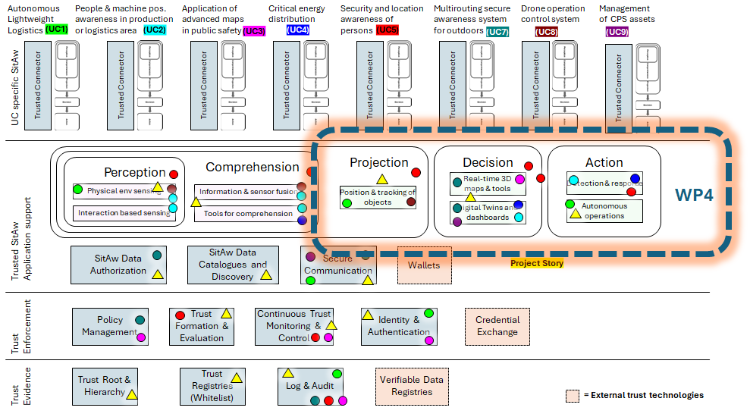
Figure 1 WP4 in the overall project architecture

Technical enablers covered
This deliverable specifies a comprehensive set of technical enablers being developed within WP4 that support status representation, projection of future states, and execution of actions. The enablers are specified at a functional and technical level and are organised according to the main capability areas of WP4 and their instantiation across different application domains and use cases.
The scope of the technical enablers covered in this deliverable includes:
- Digital twin concepts and foundations (Section 2), defining the role of digital twins and dashboards as authoritative representations of physical and digital entities, system state, and operational context, including semantic enrichment and historical state management.
- Integrated situation awareness, risk assessment, and operational response for drone operations (Section 3), specifying enablers that combine status monitoring, risk detection, projection, and response mechanisms tailored to safety-critical and highly dynamic drone operation environments.
- Unified operational awareness and control for industrial forklift operations (Section 4), covering a comprehensive set of enablers for industrial logistics, including communication infrastructure, digital twins, tracking, autonomous and cooperative operations, detection and response mechanisms, accountability-supporting backends, and operational dashboards, with validation in realistic industrial and port environments.
- Formal language, model, and tools for situation description and identification (Section 5), providing cross-cutting enablers for modelling, describing, and identifying situations in cyber-physical systems, supporting systematic reasoning about people–machine interactions and safety-relevant situations at runtime.
- Behaviour-based digital risk detection and situational awareness (Section 6), specifying enablers for detecting and analysing risk situations based on behavioural patterns, illustrated through cybersecurity-oriented and anomaly-detection scenarios.
- Real-time operational data integration and visualization (Section 7), defining enablers for edge-to-cloud data ingestion, real-time and historical data processing, and standardized interfaces that support dashboards, analytics, and integration with external systems.
- Geospatial situational awareness and event detection (Section 8), addressing enablers for positioning, spatial reasoning, geospatial and 3D map-based visualization, and detection of spatially defined events in safety- and mission-critical environments.
- Integrated status, decision support, and control for energy communities and distribution networks (Section 9), specifying enablers that combine digital twin–based state representation, decision support, and controlled actions in distributed, multi-stakeholder energy systems.
- Human-centric digital twins, tracking, and spatial situational awareness (Section 10), covering enablers that treat humans as first-class entities, including tracking, wearable and biometric data integration, multi-device interaction, and human-in-the-loop situational awareness capabilities.
The enablers are specified across multiple use cases, including industrial logistics, drone operations, port operations, emergency response, energy communities, cybersecurity, and human-centric monitoring scenarios. Each enabler is described in terms of its functional scope, technical architecture, and contribution to the relevant WP4 tasks and use-case objectives.
Together, the specified enablers form an integrated toolbox that enables WP4 to move from consolidated system status to informed projections and controlled actions, while remaining modular, reusable, and applicable across heterogeneous cyber-physical environments.

Concept of digital twins [VTT]
ID | Enabler Name | Related Tasks | Addressed Requirements | Related Use Case
EN_01 | Digital twin | T4.1, T4.4 | REQ_COMMON_5 | ALL

Digital twins play a major role in Sa4CPS backend services. Digital twin platforms enable an easy and safe way to manage digital twins. These platforms provide solutions for several tasks, such as digital twin databases, connectivity APIs, data visualization, and authorization.
In the Oulu Port case, when a new user is registered to the backend, they also get their personal digital twin. The user connects to the digital twin and automatically updates it with whatever data needs to be collected, e.g., the user’s location data. The digital twin platform keeps the user’s status up to date and saves the past statuses in its database. Digital twins of port equipment and devices may be linked to users and are then able to monitor the devices they are responsible for.
The port admin has broader access to digital twins stored in the platform. The port author can view the status of digital twins, set rules for digital twin attributes, and receive alerts when attributes exceed or fall below a threshold set. Depending on the set rules, the platform can take the necessary action or alert the port operator who takes charge of the situation.
The digital twins create a holistic image of the situation. With dashboards and maps visualizing the digital twin data, the port operator can check the situation immediately. Historical data saved in the platform’s database may also have various uses. For example, in an accident investigation, it is possible to retrieve the stored data and inspect the events that occurred before and led up to the accident. Long-term data can also be useful for optimizing port operations and for training in port-related artificial intelligence.

Integrated Situation Awareness, Risk Assessment, and Operational Response for Drone Operations [ADLC]

ID | Enabler Name | Related Tasks | Addressed Requirements | Related Use Case
EN_02 | Perception, comprehension & risk assessment engine | T4.2, T4.4 | REQ_UC8.3, REQ_UC8.4,  REQ_UC8.6  REQ_UC8.7  REQ_UC8.8  REQ_UC8.9  REQ_UC8.10  REQ_UC8.11 | UC8
EN_03 | Operations monitoring dashboard | T4.1 | REQ_UC8.1, REQ_UC8.2 , REQ_UC8.12  REQ_UC8.13  REQ_UC8.9  REQ_UC8.11 | UC8
EN_04 | Response dashboard | T4.1, T4.4 | REQ_UC8.7 | UC8
EN_05 | State egress adapters | T4.2 | REQ_UC8.5 | UC8

Perception, comprehension & risk assessment engine (EN_02) [ADLC]

Operations monitoring dashboard (EN_03) [ADLC]

Response dashboard (EN_04) [ADLC]

State egress adapters (EN_05) [ADLC]

Unified Operational Awareness and Control for Industrial Forklift Operations [ACD, ERARGE, INOVASYON, Alpata, OTOKAR, PortOfOulu]
ID | Enabler Name | Related Tasks | Addressed Requirements | Related Use Case
EN_06 | Low-Latency Hybrid Communication Module | T4.2, T4.3 | REQ_UC1.14 | UC1
EN_07 | Sa4CPS Web-Based Monitoring Platform | T4.1 | REQ_UC1.13 | UC1
EN_08 | 3AM Decentralized Backend | T4.3, T4.4 | REQ_UC1.26 | UC1
EN_09 | Digital Twin with Semantic Backend | T4.1, T4.2, T4.3, T4.4 | REQ_UC1.29, REQ_UC1.30 | UC1
EN_10 | PHM Backend & Big Data Ingestion Pipeline | T4.1, T4.2, T4.3, T4.4 | REQ_UC1.18, REQ_UC1.20 | UC1
EN_11 | Battery PHM (Prognostics & Health Management) Tool | T4.4 | REQ_UC1.23 | UC1
EN_12 | Digital Twin Environment for forklift operations | T4.1, T4.2, T4.4, T4.5 |  | UC1
EN_13 | Optimum Route Planning and Vehicle-to-Vehicle Cooperation Engine | T4.2, T4.3, T4.4 | REQ_UC1.31, REQ_UC1.32, REQ_UC1.33, REQ_UC1.41, REQ_UC1.42 | UC1
EN_14 | Digital twin–based situational awareness framework | T4.1 | REQ_UC1.3, REQ_UC1.10 | UC1

Low-Latency Hybrid Communication Module (EN_06) [ACD]

Sa4CPS Web Platform (EN_07) [ACD]

3AM Decentralized Backend (EN_08) [ERARGE]

Digital Twin with Semantic Backend (EN_09) [ERARGE]

PHM Backend & Big Data Ingestion Pipeline (EN_10) [INOVASYON]

Battery PHM (Prognostics & Health Management) Tool (EN_11) [INOVASYON]

Digital Twin Environment for forklift operations (EN_12) [INOVASYON]

Optimum Route Planning and Vehicle-to-Vehicle Cooperation Engine (EN_13) [Alpata]

Digital twin–based situational awareness framework (EN_14) [OTOKAR]

Demonstration site – Port of Oulu [PortOfOulu]

A language, formal model, and tools to describe, model, and identify situations [CUNI, IMA]

ID | Enabler Name | Related Tasks | Addressed Requirements | Related Use Case
EN_15 | A language, formal model, and tools to describe, model, and identify situations | T4.1, T4.2, T4.3, T4.4, T4.5 | REQ_UC2.3  REQ_UC2.17  REQ_UC2.19  REQ_UC2.20  REQ_UC2.21  REQ_COMMON_1  REQ_COMMON_2  REQ_COMMON_4 | UC2

This section refines and extends the work initiated in Deliverable D4.2 by focusing specifically on the technical enabler EN_15, which targets the definition of a language, a formal model, and supporting tools for describing, modelling, and identifying situations in cyber-physical systems. D4.2 defined the initial design of the meta-model and especially a DSL (domain-specific language) for specifying situations. In this deliverable, we provide an updated version of the DSL together with its formal semantics. Also, we introduce the tooling support we have started to design and developed together with the modern approach for developing situation-aware controllers for CPS.

Overview and example
The enabler EN_15 designed in this section is realized through the proposed language and formal model. By establishing a unified representation of physical entities, observed properties, and their evolving relationships, it supports the systematic recognition of situations such as unsafe proximity, abnormal behavior, or deviations from expected operational conditions. Supporting tools enable these models to be instantiated and evaluated during runtime, allowing higher-level detection and response components to operate on structured situation representations rather than raw data streams. In this manner, EN_15 complements the previously described platform-level enablers by providing the formal basis necessary for consistent, interpretable, and extensible situation awareness across human–machine interaction scenarios in industrial and logistics contexts.
As a concrete illustration used to present the DSL and supporting tools, we rely on the same running example introduced in D4.2, originating from use case UC2 (People and machine position awareness in production or logistics area). This example captures a representative scenario involving interactions between humans and machines in a shared operational environment, where monitoring positions and identifying potentially hazardous situations is essential. The example demonstrates how relevant entities—such as workers and robotic systems—can be described together with their properties (e.g., position, state) and mutual relationships within a structured environment model. Based on these descriptions, situations of interest, including safety-critical configurations like unsafe proximity or unexpected movements, can be formally specified as sets of conditions over the model. By reusing this UC2-based scenario, the section illustrates how the proposed language and formal model support the explicit and unambiguous definition of such situations, as well as their evaluation at runtime. This provides a concrete basis for understanding how situation definitions can be operationalized, enabling systematic identification of relevant system states in practical deployments.

Meta-model
Even though the meta-model (Figure 2) looks different, it remained, in principle, the same as defined in D4.2. The changes are “cosmetic” ones, and they do not change the meta-model semantics, and the changes target only the classes related to the description of the environment and not the situations. The most important changes are as follows:
- The abstract nodes and traits are modeled as separate classes to explicitly express their separation. For this reason, the abstract class BaseEntity has been added to model their common properties, and the AbstractNode and Trait classes extend it.
- The conflicts (the Conflict class) have been added to the abstract nodes and traits to express situations where the use of one trait is mutually exclusive with another.
- The Node class does not extend AbstractNode, as a node can be based on multiple abstract nodes (via the with and always-with references).
To recapitulate the
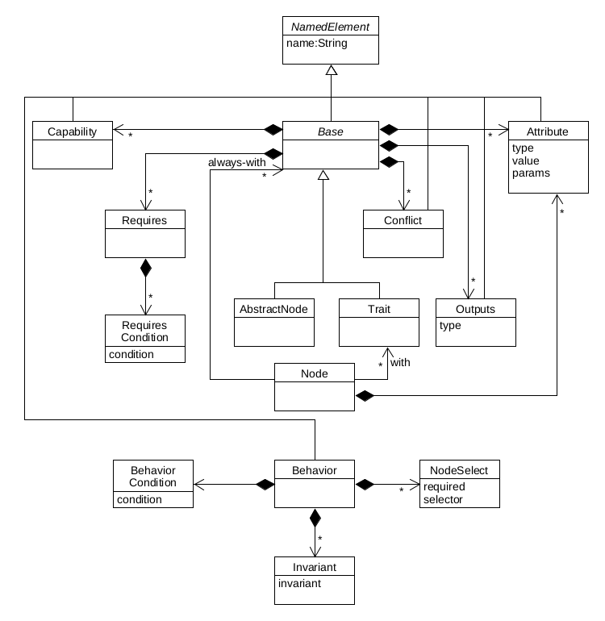
Figure 2 A meta-model describing situations

DSL

DSL semantics

Development approach (and tooling)

Behaviour-Based Digital Risk Detection and Situational Awareness [F-Secure]

ID | Enabler Name | Related Tasks | Addressed Requirements | Related Use Case
EN_16 | DNS Fingerprinting Data Processing Pipeline | T4.1, T4.4 | REQ_UC5.7  REQ_UC5.8 | UC5
EN_17 | Behavioural data hub | T4.1, T4.4 | REQ_UC5.7  REQ_UC5.8 | UC5

DNS Fingerprinting Data Processing Pipeline (EN_16) [F-Secure]

Behavioural data hub (EN_17) [F-Secure]

Real-Time Operational Data Integration and Visualization [Vintecc]

ID | Enabler Name | Related Tasks | Addressed Requirements | Related Use Case
EN_18 | Capture Platform | T4.1 | REQ_UC9.7 | UC9

Capture platform (EN_18) [Vintecc]

Geospatial Situational Awareness and Event Detection [Modirum Gespi]

ID | Enabler Name | Related Tasks | Addressed Requirements | Related Use Case
EN_19 | Map, Map Engine, and Visualization Technologies | T4.1, T4.4, T4.5 | REQ_UC3.9, REQ_UC3.11, REQ_UC3.17 | UC3
EN_20 | AI-Enabled Integration of Location Data into the NSC3 Environment | T4.1, T4.2, T4.3, T4.4, T4.5 | REQ_UC3.12, REQ_UC3.13, REQ_UC3.15, REQ_UC3.16 | UC3
EN_21 | AI-Based Event Detection and Real-Time Alerting | T4.2, T4.4, T4.5 | REQ_UC3.18 | UC3
EN_22 | Integrating camera sources to NSC3 environment | T4.1, T4.2, T4.4 | REQ_UC3.8, REQ_UC3.14 | UC3
EN_23 | Hardening NSC3 environment to Zero Trust Authentication and authorization | T4.2, T4.4, T4.5 | REQ_UC3.4 | UC3

Map, Map Engine, and Visualization Technologies (EN_19) [Modirum Gespi]

AI-Enabled Integration of Location Data into the NSC3 Environment (EN_20) [Modirum Gespi]

AI-Based Event Detection and Real-Time Alerting (EN_21) [Modirum Gespi]

Integrating Camera Sources to NSC3 Environment (EN_22) [Modirum Gespi]

Hardening NSC3 Environment to Zero Trust Authentication and Authorization (EN_23) [Modirum Gespi]

NSC3 system description [Modirum Gespi]

Integrated Status, Decision Support, and Control for Energy Communities and Distribution Networks [CEL, Digitalmente, Enerim, ISEP]

ID | Enabler Name | Related Tasks | Addressed Requirements | Related Use Case
EN_24 | Energy Community Operational Management and Governance Interface | T4.1, T4.3 | REQ_UC4.7, REQ_UC4.13, REQ_UC4.14 | UC4
EN_25 | Human-in-the-Loop Community Action Validation Interface | T4.3 | REQ_UC4.7 | UC4
EN_26 | Regulatory, Environmental and Community Performance Reporting | T4.2, T4.3 | REQ_UC4.11  REQ_UC4.15  REQ_UC4.17  REQ_UC4.18 | UC4
EN_27 | Energy Community Digital Twin Backbone | T4.1, T4.2 | REQ_UC4.1, REQ_UC4.2, REQ_UC4.10 | UC4
EN_28 | Energy Community Data Aggregation and Visualization Services | T4.1, T4.2 | REQ_UC4.13, REQ_UC4.14 | UC4
EN_29 | Trust-Aware Digital Twin State Confidence Engine | T4.1, T4.2, T4.3 | REQ_UC4.1  REQ_UC4.2  REQ_UC4.3  REQ_UC4.11 | UC4
EN_30 | Energy data sharing: Development for continuous delivery of meter data | T4.4 | REQ_UC4.7 | UC4
EN_31 | Energy data sharing: REST APIs | T4.4 | REQ_UC4.7 | UC4
EN_32 | Flexibility services: Load control capabilities | T4.4 | REQ_UC4.7 | UC4
EN_33 | Digital twin for electricity distribution network with distributed generation and flexible load | T4.1 | REQ_UC4.1, REQ_UC4.2 | UC4
EN_34 | Dashboard for energy community management | T4.1 | REQ_UC4.7, REQ_UC4.13, REQ_UC4.14 | UC4
EN_35 | Activation of flexible resources, like storage and electric vehicles | T4.3 | REQ_UC4.10 | UC4
EN_36 | Autonomous detection and mitigation of voltage issues | T4.4 |  | UC4

Energy Community Operational Management and Governance Interface (EN_24) [CEL]

Human-in-the-Loop Community Action Validation Interface (EN_25) [CEL]

Regulatory, Environmental and Community Performance Reporting (EN_26) [CEL]

Energy Community Digital Twin Backbone (EN_27) [Digitalmente]

Energy Community Data Aggregation and Visualization Services (EN_28) [Digitalmente]

Trust-Aware Digital Twin State Confidence Engine (EN_29) [Digitalmente]

Energy data sharing: Development for continuous delivery of meter data (EN_30) [Enerim]

Energy data sharing: REST APIs (EN_31) [Enerim]

Flexibility services: Load control capabilities (EN_32) [Enerim]

Digital twin for electricity distribution network with distributed generation and flexible load (EN_33) [ISEP]

Dashboard for energy community management (EN_34) [ISEP]

Activation of flexible resources, like storage and electric vehicles (EN_35) [ISEP]

Autonomous detection and mitigation of voltage issues (EN_36) [ISEP]

Human-Centric Digital Twins, Tracking, and Spatial Situational Awareness [Natlink, Polar]

ID | Enabler Name | Related Tasks | Addressed Requirements | Related Use Case
EN_37 | Multicommunicator to mobile, web, car and watch interface | T4.1 | REQ_UC7.13,  REQ_UC7.16,  REQ_UC7.17,  REQ_UC7.18,  REQ_UC7.19 | UC7
EN_38 | Real-time monitoring services for Multicommunicator environment in server | T4.1 | REQ_UC7.16 | UC7
EN_39 | Data sharing | T4.2, T4.3, T4.4 | REQ_UC7.2 | UC7
EN_40 | Autonomous media optimized data traffic between components | T4.2, T4.4 | REQ_UC7.20,  REQ_UC7.21 | UC7
EN_41 | 3D map engine, server and research | T4.1, T4.5 | REQ_UC7.23,  REQ_UC7.24 | UC7
EN_42 | Multiplace Digital Twin | T4.1 | REQ_UC7.25,  REQ_UC7.26,  REQ_UC7.27 | UC7
EN_43 | Biometric Data Transfer Device | T4.1, T4.2, T4.3, T4.4, T4.5 | REQ_UC7.4,  REQ_UC7.25 | UC7

Multicommunicator to mobile, web, car and watch interface (EN_37) [Natlink]

Real-time monitoring services for Multicommunicator environment in server (EN_38) [Natlink]

Data sharing (EN_39) [Natlink]

Autonomous media optimized data traffic between components (EN_40) [Natlink]

3D Map Engine, Server, and Research (EN_41) [Natlink]

Multiplace Digital Twin (EN_42) [Natlink]

Biometric Data Transfer Device (EN_43) [Polar]

Conclusions
This deliverable TODO

References
All the references have been provided as footnotes is this document.

