WP3 Deliverable 3.3
Designs of the technical enablers for perception and comprehension v1

Sa4CPS
ITEA 4 22007

Status: Draft

••••••••••••••••••••••••••••••••••••••••••••••••••••••
Edited by Dilara Bayar Başlık (ACD)

Including contributions from:

Dilara Bayar Başlık (ACD)
Muhammed Özberk (ACD)
Edanur Balkış (Inovasyon)
Grégoire Moreau (ADLC)
Lander Vanhaverbeke (Vintecc)

TABLE OF CONTENTS

Abstract 4
List of Abbreviations 5
1 Introduction 6
2 Use Case Specific Technical Enabler Designs 7
2.1 UC1: Connected & Autonomous lightweight logistics for in-factor/out-factory supply chain 7
2.1.1 Perception Designs 7
2.1.2 Comprehension Designs 7
2.2 UC2: People and Machine position awareness in production or logistics area 8
2.2.1 Perception Designs 8
2.2.2 Comprehension Designs 8
2.3 UC3: Map at the centre of situational awareness in addition to real time video 9
2.3.1 Perception Designs 9
2.3.2 Comprehension Designs 10
2.4 UC4: Critical electricity distribution grid operation in energy communities 10
2.4.1 Perception Designs 10
2.4.2 Comprehension Designs 11
2.5 UC7: Multirouting secure awareness system for hunting and outdoors 11
2.5.1 Perception Designs 11
2.6 UC8: Secure, trustworthy and reliable drone operation control system 12
2.6.1 Perception Designs 12
2.6.2 Comprehension Designs 12
2.7 UC9: Situational awareness and secure management of digital twin assets 13
2.7.1 Perception Designs 13
2.7.2 Comprehension Designs 13
2.8 Technical enabler from the project story: 3D situational awareness map of Oulu port 14
2.8.1 Perception Designs 14
2.8.2 Comprehension Designs 14
3 Conclusions 16
4 References 17

TABLE OF FIGURES

Figure 1. Sa4CPS Perception and Comprehension Architecture for Situational Awareness 6

Abstract
TBU

List of Abbreviations
Abbreviation | Explanation
xxx | zzz

Introduction
Situational awareness in critical cyber-physical systems (CPS) requires reliable mechanisms for perceiving the operational environment and understanding the evolving state of the system. These capabilities are essential in domains where physical infrastructure, digital services, and human actors interact in dynamic and potentially safety-critical contexts. The Sa4CPS project addresses these challenges by developing technological solutions that enable secure situational awareness across different sectors, including logistics, mobility, energy, and security.

Within the Sa4CPS architecture, perception refers to the acquisition and processing of information from various sources such as sensors, cameras, IoT devices, and external information systems. These mechanisms enable the detection of relevant environmental events, system states, and asset conditions. Comprehension builds on this information by applying advanced data processing, modelling, and artificial intelligence techniques to interpret the collected data and transform it into meaningful situational knowledge. Together, these capabilities form the foundation for informed decision-making, predictive analysis, and resilient system operation.

This deliverable, D3.3 Designs of the Technical Enablers for Perception and Comprehension (v1), presents the design of the technical enablers that support these capabilities in the Sa4CPS framework. The designs are derived from the technological requirements identified in Deliverable D3.1 and the technical enablers specified in Deliverable D3.2. While D3.1 defined the requirements for perception and comprehension across the targeted use cases and D3.2 described the enabling technologies addressing those requirements, this deliverable focuses on how these technologies are designed and structured for implementation within the Sa4CPS ecosystem.

The presented designs are organised according to the project use cases, which represent different operational environments where secure situational awareness is required. For each use case, the deliverable describes the perception and comprehension designs that enable the acquisition, processing, and interpretation of relevant data. These designs illustrate how different technological components including sensing systems, communication infrastructures, data processing pipelines, and artificial intelligence models are integrated to support situational awareness in real-world scenarios.

The remainder of this document is structured as follows. Section 2 presents the use case specific technical enabler designs for perception and comprehension across the different Sa4CPS use cases. Finally, Section 3 summarises the main conclusions and provides an overview of the key contributions of the deliverable.
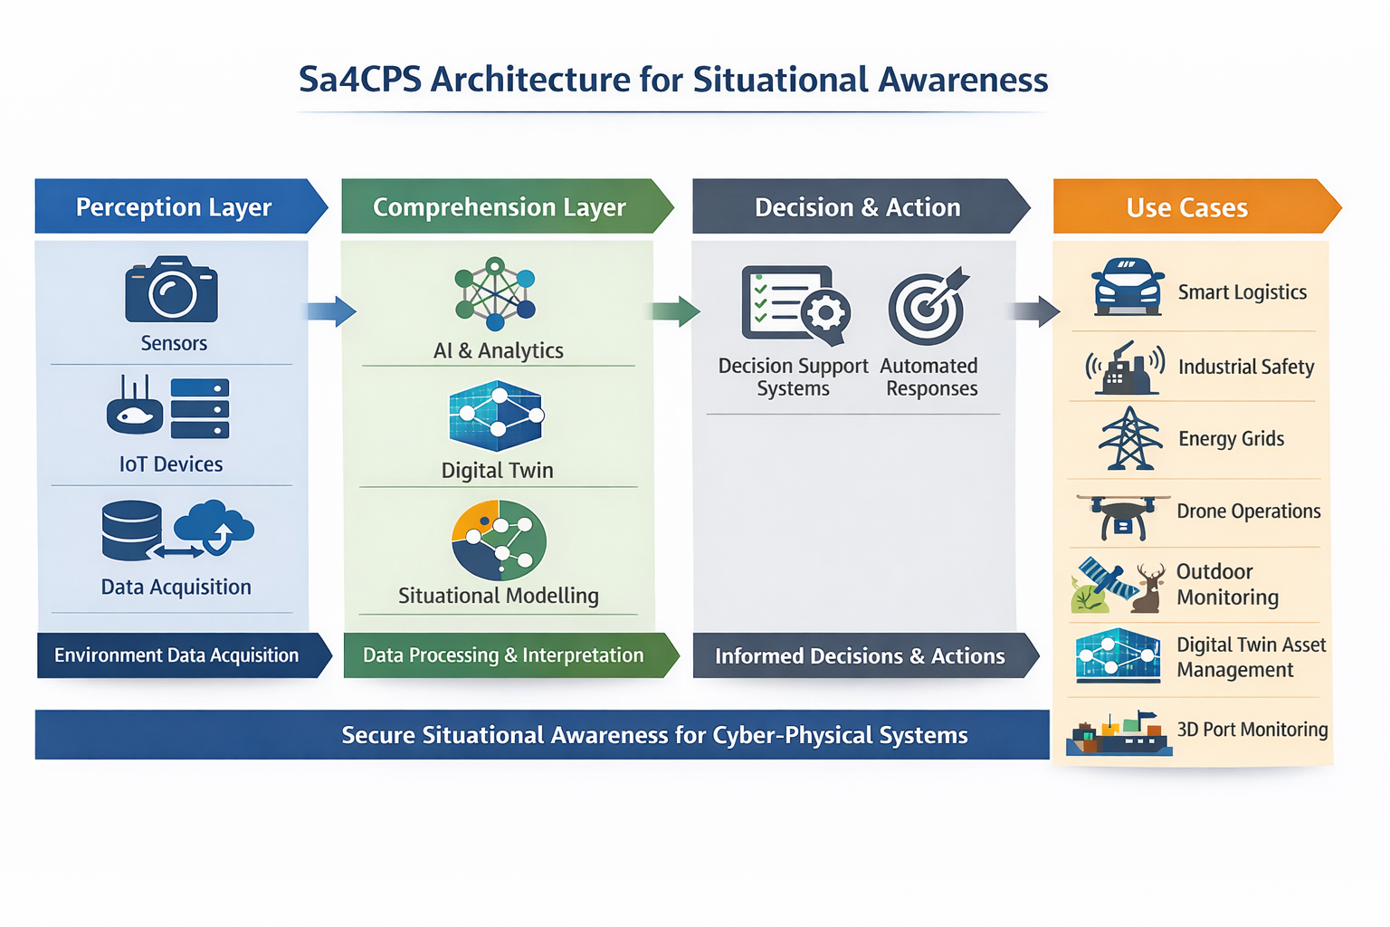
Figure 1. Sa4CPS Perception and Comprehension Architecture for Situational Awareness

Use Case Specific Technical Enabler Designs

UC1: Connected & Autonomous lightweight logistics for in-factor/out-factory supply chain

Perception Designs
// This section describes the design of the perception components developed for the corresponding use case. The perception layer is responsible for acquiring data from the environment and system components through sensors, IoT devices, communication infrastructures, and data acquisition mechanisms.

For each technical enabler, the following aspects should be described:

- The purpose of the perception mechanism and its role in the use case
- The sensors, devices, or data sources used to collect information
- The system architecture and main components involved in data acquisition
- The data collection and transmission processes
- The communication technologies and protocols used
- If applicable, the security and data integrity mechanisms implemented
- The types of data generated by the system and how they are forwarded to higher layers

Where appropriate, architectural diagrams or data flow diagrams should be included to illustrate the design. The description should clearly explain how the perception mechanism contributes to establishing situational awareness in the given use case.

Low-Latency Hybrid Communication Module (ACD)
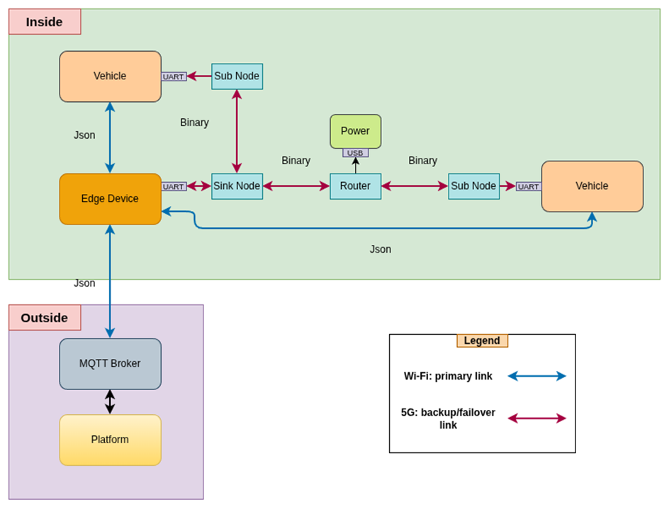
Figure X. Hybrid Wi-Fi/5G communication architecture for resilient autonomous vehicle connectivity.

The Low-Latency Hybrid Communication Module is designed to ensure continuous and reliable connectivity between autonomous vehicles operating in a logistics field and the upper-level software platform that monitors and manages them. Within the scope of UC1, vehicles are planned to use the existing local Wi-Fi infrastructure for routine communication. However, to address industrial field conditions such as coverage gaps, radio interference, and short-term connection instability, this will be supported by a secondary 5G mesh network. In this way, the hybrid structure aims to preserve the high-speed local communication advantages of Wi-Fi while providing a more resilient and wider-coverage backup communication path when the primary connection weakens.

The architecture consists of two main communication layers. The primary path is the Wi-Fi connection established between the vehicle and an edge device within the field. The secondary path is a 5G mesh chain composed of Sub Node, Router, and Sink Node roles. In this structure, the Sub Node communicates with the vehicle via a local interface, Router nodes carry data across the field through multi-hop transmission, and the Sink Node acts as a bridge between the mesh network and the edge layer. The edge device is expected to collect data from both communication paths in a unified application format and transmit it to the platform layer via an MQTT broker. In the reverse direction, platform commands are delivered to the vehicle through the currently active communication path.

The communication strategy is designed to operate based on a primary connection and backup/failover logic. Under normal conditions, the Wi-Fi connection is used. If the connection quality degrades or data flow is interrupted, traffic is expected to continue over the 5G mesh network. Once the primary connection regains sufficient stability, communication is switched back to Wi-Fi. This approach is expected to reduce unnecessary switching between connections, maintain continuity in data flow, and limit the impact of outdated or out-of-order messages during recovery periods.

In this design, Wi-Fi is positioned as the primary local and low-latency access method, while the 5G mesh network serves as a resilient backup communication infrastructure thanks to its self-forming and self-healing capabilities. Local data exchange between field devices and network nodes is carried out through lightweight interfaces, while upper-layer integration is achieved via MQTT and application-level JSON-based message structures. By routing all data through a common edge integration layer, it becomes possible to apply the same validation, authentication, and access control mechanisms regardless of the communication path used. This module is expected to reliably deliver vehicle telemetry, operational status information, connectivity indicators, and command messages to upper layers, thereby contributing to the continuity of situational awareness within the scope of UC1.

Secure Data Sharing via IPFS (ACD)
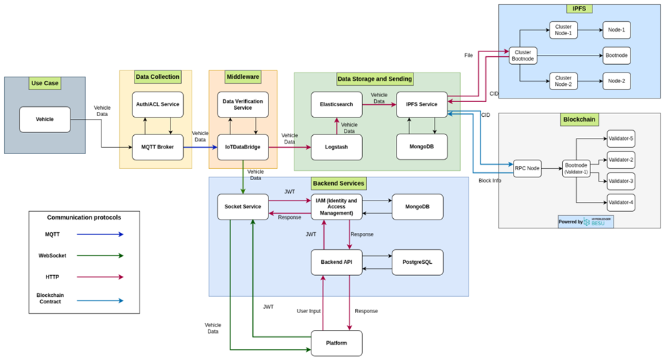
Figure X. General system architecture for secure data sharing.

The IPFS-Based Secure Data Sharing Enabler is designed to enable secure, verifiable, and long-term sharing of operational and IoT-based data generated within the scope of UC1. The main objective of this structure is not only to monitor incoming field data in real time, but also to ensure that it is archived in an immutable manner, can be accessed in a controlled way by different stakeholders when needed, and that its integrity can be verified afterward. Therefore, the enabler is considered not merely as a storage solution, but as a data sharing and validation infrastructure that supports the reliable transfer of data collected at the perception layer to upper layers.
In the design, the data flow is expected to start from an MQTT-based data collection layer. Data from vehicles and field components is first received by the IoT Data Bridge service; from there, it is routed to the platform for real-time monitoring, to the Elasticsearch/ELK stack for analytics and historical queries, and to the IPFS layer for long-term storage. Data to be transferred to IPFS is not planned to be stored as raw streams, but rather as structured data packages grouped over specific time intervals while preserving meaningful fields. For this purpose, daily, weekly, monthly, and yearly datasets are to be generated, converted into an appropriate file format, and then uploaded to the IPFS network. This enables a clear separation between real-time data processing and archival data sharing.

The IPFS layer is planned to be used as the core storage mechanism that stores data in a distributed and content-addressed manner. For each uploaded data package, a CID (Content Identifier) is generated, allowing decentralized access to the corresponding content. Since the same data is represented with the same identifier as long as its content does not change, this approach provides a strong foundation for data integrity. At the infrastructure level, a dedicated IPFS network is supported by a bootstrap node, participant nodes, and a cluster coordination layer, ensuring data replication, network continuity, and manageability.

To strengthen data integrity and trust, it is planned to associate file identifiers stored on IPFS with a blockchain-based proof layer. In this context, CID information and selected transaction summaries of data packages uploaded to IPFS are intended to be written to a permissioned blockchain infrastructure based on Hyperledger Besu. In this way, an immutable verification trail is created without storing the raw data itself on the chain. When a dataset is retrieved, its CID can be recalculated and compared with the records stored on the blockchain, allowing verification of whether the data has been altered. This mechanism aligns with a zero-trust validation approach, ensuring that shared data is not only accessible but also verifiable.

At the application layer, it is planned not to leave the IPFS and blockchain infrastructure standalone, but to integrate them with a manageable platform service. For this purpose, metadata such as file name, uploader, CID, MIME type, size, and (if available) blockchain transaction summary will be stored in a MongoDB-based model. This creates a mapping layer between the distributed storage system and application-level authorization and querying needs. On the platform API side, functionalities such as file listing, association with specific vehicles or vehicle types, creation of file access logs, and controlled access to IPFS services are planned to be provided via REST-based endpoints. This allows client-side applications to use file access and sharing functions without needing to understand IPFS internal protocol details.

Another important aspect of the secure sharing mechanism is access control. The design includes JWT-based authentication and role-based authorization. Administrative users are expected to have broader listing and sharing permissions, while standard users will only be able to view files associated with or authorized for them. By maintaining file access logs at the application level, it becomes possible to track which user accessed which dataset. Thus, by addressing distributed storage and access control together, the system aims to establish a data-sharing structure that is not only technically secure but also operationally manageable.

In conclusion, this enabler is expected to support a secure situational awareness infrastructure within UC1 by transforming data collected at the perception layer into long-term, verifiable data assets. Real-time monitoring data flows and the auditable archive/data sharing layer are positioned as two complementary structures. Through the combined operation of IPFS, blockchain, data bridge, and platform services, it is aimed to handle data collection, archiving, sharing, access authorization, and integrity verification processes within a single architectural framework. This structure provides a foundation that enables not only the storage but also the reliable and auditable sharing of critical logistics data generated throughout the supply chain.

Network Component Health Monitor (ACD)
The Network Component Health Monitoring Mechanism is designed to enable monitoring of the communication status and operational health information between vehicles and the platform within the scope of UC1. The main objective of this structure is to make not only the operational content of the data coming from the field visible, but also the communication path through which it is transmitted. In this way, the platform can evaluate the online status of vehicles, the communication type, and potential error conditions together, allowing operators to interpret current communication conditions more accurately.

In this design, the IoT Data Bridge service is positioned as a central middleware layer. Data from vehicles and field components first reaches the system via MQTT. The IoT Data Bridge processes this data, determines which communication channel the data came through, and enriches it accordingly. At this point, the service acts not only as a transmission layer but also as a bridge that interprets the communication context. Thus, the goal is to deliver not only raw vehicle data to upper layers but also context-aware data enriched with connection type and health monitoring information.

On the platform side, it is an important architectural choice that the data source is not directly MQTT. Instead of the client application connecting directly to the MQTT infrastructure, it is planned to use the data stream transferred to a WebSocket service via the IoT Data Bridge. In this way, the platform is fed with centrally processed and standardized data; protocol complexity on the client side is reduced, and real-time monitoring becomes more manageable. The WebSocket layer provides low-latency delivery of health and connectivity data processed by the IoT Data Bridge to the platform interface, enabling real-time visibility on the operator screen.

Thanks to this mechanism, the platform can display, for each vehicle, its online status, operational status, and the type of network being used. For example, whether a vehicle is communicating via Wi-Fi or 5G can be directly observed on the status interface. Additionally, presenting errors, alarms, or abnormal conditions through the same interface supports the joint evaluation of network components and operational status. As a result, this enabler is expected to enhance situational awareness within UC1 by preserving the communication context of the data source and making it visible at the operator level while transferring it to upper layers.
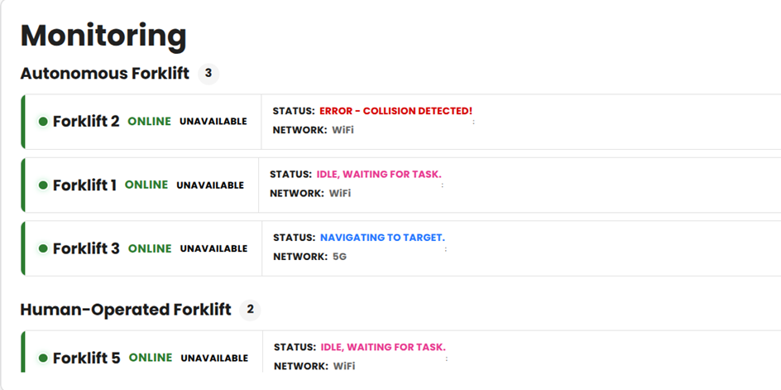
Figure X. Displaying vehicle network information on the platform.

PHM Big Data Ingestion Pipeline (INO)
The PHM Big Data Ingestion Pipeline is designed to collect, process, and transfer high-volume operational data generated from vehicles and battery systems to upper layers within the scope of UC1. The primary role of this enabler is not only to enable real-time monitoring of battery health and performance data but also to ensure that such data is stored in a manner suitable for retrospective analysis and PHM-based evaluations. Therefore, the structure is considered as a data collection and preparation infrastructure within the perception layer.

In the design, the data flow is expected to start from an MQTT-based communication layer. Battery voltage, current, temperature, cell voltages, and similar operational data from vehicles are received via relevant MQTT topics and centrally collected within a Node.js-based backend service. This telemetry stream serves as the primary data source for PHM services. The system aims to associate messages coming from different topics based on vehicle identity and aggregate them under a unified data context. In this way, cell data, battery pack data, and operational measurements are brought together within the same processing pipeline, creating a consistent data foundation for upper-layer analysis.

Within the processing pipeline, the goal is not only to transport messages but also to prepare them for PHM usage. This includes transforming incoming data into standardized fields, filtering out incomplete or inconsistent records, merging data from different sources within the same time window, and adding derived fields when necessary. Metrics such as energy consumption are calculated from raw voltage and current data; minimum, maximum, and average values can be derived for temperature; and cell data is transformed into structures suitable for dedicated monitoring components. For cases where data is used by anomaly detection or prediction modules, data preparation steps such as windowing, merging, numerical transformation, and scaling are also expected to be part of the pipeline.

As part of this enabler, an ElasticSearch-based storage layer is planned. Time-series data such as voltage, current, energy consumption, and temperature will be stored in ElasticSearch, supporting both historical queries and the generation of visualizations and dashboards. This approach enables the production of indicators such as historical energy consumption trends, voltage-current graphs, and temperature distributions on the PHM interface. At the same time, the ingestion pipeline is designed to provide a sustainable foundation not only for live data streaming but also for historical data analysis.

In terms of real-time visibility, the backend service is designed not only as a data collection component but also as a publishing layer that delivers processed data to the platform. After passing through necessary preprocessing steps, data received via MQTT is transmitted to clients through Socket.IO. This allows the platform-side PHM interface to be fed with centrally processed and standardized data streams without directly connecting to the MQTT infrastructure. This architectural choice reduces client-side complexity and supports low-latency monitoring of up-to-date battery data.

It is also planned that PHM services running on this ingestion pipeline will transmit additional results derived from the collected data to the platform via the same publishing mechanism. After collecting battery voltage, current, temperature, and cell data, derived indicators such as energy consumption, state-of-charge (SOC) estimation, remaining time, and range estimation are intended to be added to the data package. Similarly, outputs from anomaly detection modules such as status indicators, threshold comparisons, alerts, and analysis results are expected to be delivered to clients within the same data stream. This enables the platform to display not only raw sensor data but also derived PHM results in real time.

From a perception layer perspective, the primary function of this structure is data collection, aggregation, normalization, and distribution to upper layers. Although advanced PHM functions such as prediction, SOC estimation, or anomaly detection can operate on the same infrastructure, the main focus here is the ingestion pipeline that feeds these functions. At the same time, the ability to deliver PHM outputs through the same data pipeline demonstrates that the data collection layer is not merely a passive storage component but also an active integration layer supporting real-time decision-making interfaces.

In conclusion, the PHM Big Data Ingestion Pipeline is expected to ensure reliable collection of battery and vehicle data within UC1, storage in a time-series structure, and real-time delivery to the platform layer. Through this structure, critical measurements such as battery temperature, voltage, current, cell data, and energy consumption become accessible for both real-time monitoring and retrospective evaluation. Thus, the enabler strengthens the technical foundation of situational awareness by providing the data backbone required by higher-level comprehension components such as the Battery PHM Tool.
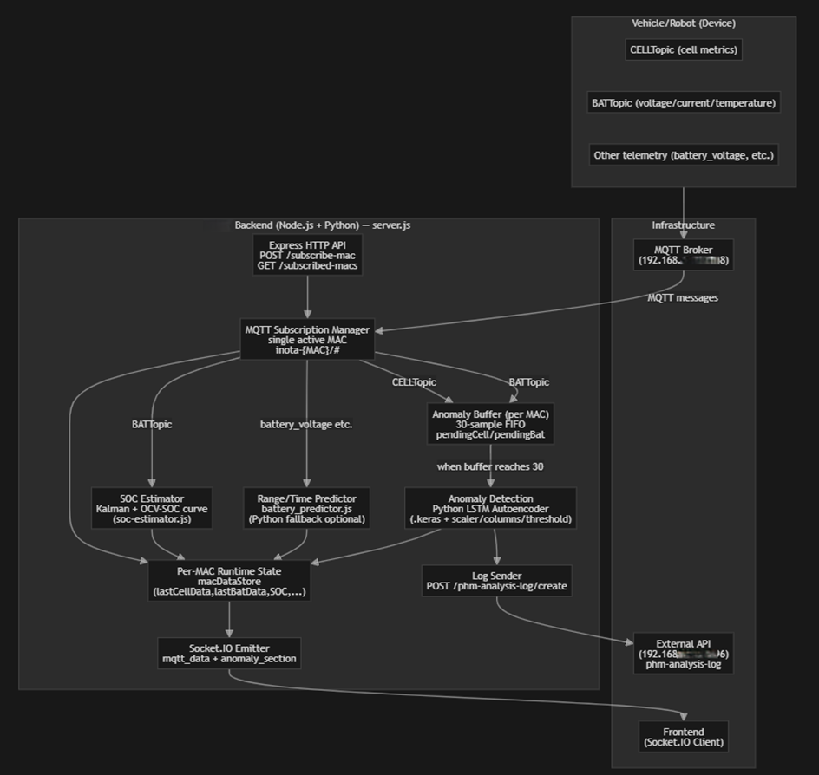
Figure X. PHM data collection, processing, and platform integration architecture.

IoT-based Secure Data Communication Enabler (ERARGE)

IoT-based Asset Identification and Tracking (OTOKAR)

Comprehension Designs

// This section describes the design of the comprehension components developed for the corresponding use case. The comprehension layer is responsible for processing, analysing, and interpreting the data obtained from the perception layer in order to generate meaningful situational information.

For each technical enabler, the following aspects should be described:

- The purpose of the comprehension mechanism and its role in the use case
- How data from the perception layer is processed and integrated
- The data processing methods, algorithms, or AI/ML models used
- The system architecture and data processing pipeline
- The outputs produced by the system, such as insights, predictions, alerts, or decision support information
- If applicable, the anomaly detection, prediction, or optimisation mechanisms implemented
- How the generated information supports operational awareness and decision-making

The description should clearly demonstrate how raw data collected from sensors and other sources is transformed into meaningful situational knowledge that supports the operation of the system in the specific use case.

Battery PHM (Prognostics & Health Management) Tool (INO)
The Battery PHM Tool is designed as a comprehension-layer component within the scope of UC1 to generate health status, remaining useful life, range, and potential anomaly information from operational data related to the battery system. The main objective of this enabler is to transform raw data collected at the perception layer into analytical outputs that can directly support decision-making. Thus, the system will not only display real-time measurements but will also interpret battery behavior to make potential risks visible in advance.
In this design, the primary data source of the Battery PHM Tool is the battery and vehicle telemetry data collected through the PHM Big Data Ingestion Pipeline. Battery voltage, current, temperature, cell voltages, energy consumption, and related operational data are planned to be used as inputs to the model. Rather than processing the incoming data directly, it is intended to first group the data by vehicle identity, filter out missing fields, apply interpolation or standardization when necessary, and transform it into a format suitable for model usage. For functions requiring temporal patterns, generating sequential data blocks using a sliding window approach is also considered part of this preparation process.

Multiple analytical functions are planned to operate together within the Battery PHM Tool. The first of these is predictive functions based on the current state of the battery. In this context, it is aimed to calculate indicators such as remaining useful life, estimated range, State of Charge (SOC), and State of Health (SoH). Filtering-based methods are planned for SOC estimation, while data-driven modeling approaches are foreseen for SoH and remaining useful life. These real-time calculations are intended to be supported by historical data to produce more stable and reliable results.

The second main function is anomaly detection. In this scope, abnormal patterns in battery behavior are planned to be evaluated not only through single instantaneous threshold violations but also through temporal change patterns. By considering cell-level data, battery pack data, and temperature/current relationships together, it is aimed to generate anomaly scores, status messages, and alert information. This approach enables early detection of both directly measurable critical conditions such as low voltage and more complex behavioral deviations. In this way, the system becomes an analytical layer that supports predictive maintenance.

The model execution architecture is designed to be separated yet integrated between the operational backend and analytical modules. Data collection and orchestration functions are planned to be handled in a Node.js-based service layer, while more computationally intensive analytics and model execution steps are carried out in appropriate machine learning components. This structure is intended to support both real-time inference and offline model update processes. It is also aimed to enable the activation of different model components when needed, the execution of alternative prediction mechanisms, and the combination of outputs into a unified result object.

The real-time delivery of generated PHM outputs to the platform is a critical part of the design. Outputs derived from battery data such as remaining time, range, SOC, SoH, energy consumption, cell status, and anomaly information will be added to processed data packages by the backend service and transmitted to clients via Socket.IO. This allows the PHM interface on the platform side to display not only raw sensor data but also interpreted, decision-supporting results within the same data stream. As a result, operators will be able to monitor the current state of the battery, risk levels, and short-term behavioral trends through a single interface.

In conclusion, the Battery PHM Tool is expected to serve as a core software component that interprets battery data at the comprehension level within UC1. By combining fast data processing, accurate modeling, and AI-based evaluation capabilities, this enabler aims to produce high-value outputs for both operational monitoring and predictive maintenance. The ability to identify battery failures, performance degradation, and abnormal conditions before they impact supply chain operations will directly contribute to the situational awareness and reliability objectives of UC1.

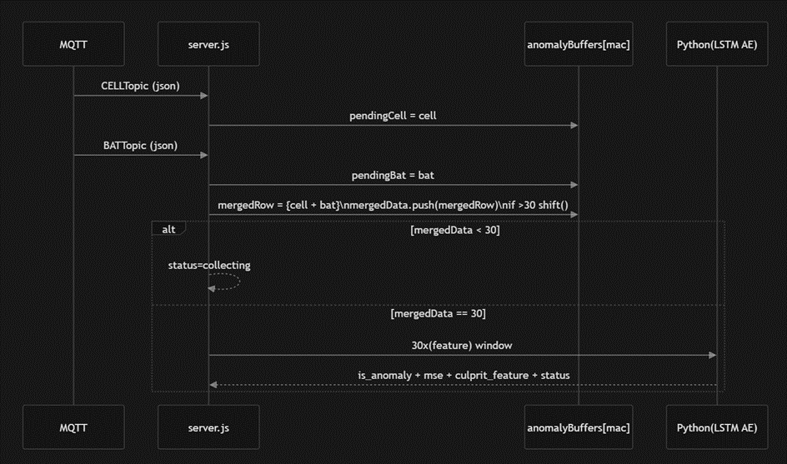
Figure X. Prediction, health assessment, and anomaly detection workflow within the scope of the Battery PHM Tool.

Optimum Route Planning and Vehicle-to-Vehicle Cooperation Engine (ALPATA)

Semantic Data Processing Enabler for Sensor Fusion and AI Outputs (ERARGE)

Digital Twin-based Situational Awareness (OTOKAR)

Real-time Anomaly Detection and Alerting (OTOKAR)

UC2: People and Machine position awareness in production or logistics area

Perception Designs
// This section describes the design of the perception components developed for the corresponding use case. The perception layer is responsible for acquiring data from the environment and system components through sensors, IoT devices, communication infrastructures, and data acquisition mechanisms.

For each technical enabler, the following aspects should be described:

- The purpose of the perception mechanism and its role in the use case
- The sensors, devices, or data sources used to collect information
- The system architecture and main components involved in data acquisition
- The data collection and transmission processes
- The communication technologies and protocols used
- If applicable, the security and data integrity mechanisms implemented
- The types of data generated by the system and how they are forwarded to higher layers

Where appropriate, architectural diagrams or data flow diagrams should be included to illustrate the design. The description should clearly explain how the perception mechanism contributes to establishing situational awareness in the given use case.

ToF camera sensor and radar for object position (IMA)

Data collection from sensors (IMA)

Communication interfaces (IMA, CUNI)

Comprehension Designs
// This section describes the design of the comprehension components developed for the corresponding use case. The comprehension layer is responsible for processing, analysing, and interpreting the data obtained from the perception layer in order to generate meaningful situational information.

For each technical enabler, the following aspects should be described:

- The purpose of the comprehension mechanism and its role in the use case
- How data from the perception layer is processed and integrated
- The data processing methods, algorithms, or AI/ML models used
- The system architecture and data processing pipeline
- The outputs produced by the system, such as insights, predictions, alerts, or decision support information
- If applicable, the anomaly detection, prediction, or optimisation mechanisms implemented
- How the generated information supports operational awareness and decision-making

The description should clearly demonstrate how raw data collected from sensors and other sources is transformed into meaningful situational knowledge that supports the operation of the system in the specific use case.

Data annotation and processing (CUNI)

ML-based training and inference (CUNI)

Object Identification and localization (CUNI)

UC3: Map at the centre of situational awareness in addition to real time video

Perception Designs
// This section describes the design of the perception components developed for the corresponding use case. The perception layer is responsible for acquiring data from the environment and system components through sensors, IoT devices, communication infrastructures, and data acquisition mechanisms.

For each technical enabler, the following aspects should be described:

- The purpose of the perception mechanism and its role in the use case
- The sensors, devices, or data sources used to collect information
- The system architecture and main components involved in data acquisition
- The data collection and transmission processes
- The communication technologies and protocols used
- If applicable, the security and data integrity mechanisms implemented
- The types of data generated by the system and how they are forwarded to higher layers

Where appropriate, architectural diagrams or data flow diagrams should be included to illustrate the design. The description should clearly explain how the perception mechanism contributes to establishing situational awareness in the given use case.

IP camera source (Modirum Gespi)

Comprehension Designs
// This section describes the design of the comprehension components developed for the corresponding use case. The comprehension layer is responsible for processing, analysing, and interpreting the data obtained from the perception layer in order to generate meaningful situational information.

For each technical enabler, the following aspects should be described:

- The purpose of the comprehension mechanism and its role in the use case
- How data from the perception layer is processed and integrated
- The data processing methods, algorithms, or AI/ML models used
- The system architecture and data processing pipeline
- The outputs produced by the system, such as insights, predictions, alerts, or decision support information
- If applicable, the anomaly detection, prediction, or optimisation mechanisms implemented
- How the generated information supports operational awareness and decision-making

The description should clearly demonstrate how raw data collected from sensors and other sources is transformed into meaningful situational knowledge that supports the operation of the system in the specific use case.

Network streaming service for online cameras (Modirum Gespi)

UC4: Critical electricity distribution grid operation in energy communities

Perception Designs
// This section describes the design of the perception components developed for the corresponding use case. The perception layer is responsible for acquiring data from the environment and system components through sensors, IoT devices, communication infrastructures, and data acquisition mechanisms.

For each technical enabler, the following aspects should be described:

- The purpose of the perception mechanism and its role in the use case
- The sensors, devices, or data sources used to collect information
- The system architecture and main components involved in data acquisition
- The data collection and transmission processes
- The communication technologies and protocols used
- If applicable, the security and data integrity mechanisms implemented
- The types of data generated by the system and how they are forwarded to higher layers

Where appropriate, architectural diagrams or data flow diagrams should be included to illustrate the design. The description should clearly explain how the perception mechanism contributes to establishing situational awareness in the given use case.

Autonomous detection and mitigation of voltage issues (ISEP)

Secure Data Ingestion & Validation Layer (Digitalmente)

Consent-Aware Energy Data Perception Module (Digitalmente, CEL)

Comprehension Designs
// This section describes the design of the comprehension components developed for the corresponding use case. The comprehension layer is responsible for processing, analysing, and interpreting the data obtained from the perception layer in order to generate meaningful situational information.

For each technical enabler, the following aspects should be described:

- The purpose of the comprehension mechanism and its role in the use case
- How data from the perception layer is processed and integrated
- The data processing methods, algorithms, or AI/ML models used
- The system architecture and data processing pipeline
- The outputs produced by the system, such as insights, predictions, alerts, or decision support information
- If applicable, the anomaly detection, prediction, or optimisation mechanisms implemented
- How the generated information supports operational awareness and decision-making

The description should clearly demonstrate how raw data collected from sensors and other sources is transformed into meaningful situational knowledge that supports the operation of the system in the specific use case.

Digital twin for electricity distribution network with distributed generation and flexible load (ISEP)

Dashboard for energy community management (ISEP)

Activation of flexible resources (ISEP)

Energy Community Situational Comprehension Engine (Digitalmente, CEL, ISEP)

Trust & Data Quality Assessment Engine (Digitalmente)

UC7: Multirouting secure awareness system for hunting and outdoors

Perception Designs
// This section describes the design of the perception components developed for the corresponding use case. The perception layer is responsible for acquiring data from the environment and system components through sensors, IoT devices, communication infrastructures, and data acquisition mechanisms.

For each technical enabler, the following aspects should be described:

- The purpose of the perception mechanism and its role in the use case
- The sensors, devices, or data sources used to collect information
- The system architecture and main components involved in data acquisition
- The data collection and transmission processes
- The communication technologies and protocols used
- If applicable, the security and data integrity mechanisms implemented
- The types of data generated by the system and how they are forwarded to higher layers

Where appropriate, architectural diagrams or data flow diagrams should be included to illustrate the design. The description should clearly explain how the perception mechanism contributes to establishing situational awareness in the given use case.

Multicommunicator / Sync Hub (Natlink, Polar)

LoRa Dog tracking devices (Natlink)

UC8: Secure, trustworthy and reliable drone operation control system

Perception Designs

Secure Multi-Source Perception Ingress Layer
The Secure Multi-Source Perception Ingress Layer constitutes the entry point of all external and onboard data into the platform and is responsible for acquiring, normalising and securely forwarding heterogeneous data streams required to establish situational awareness.

The primary purpose of this perception mechanism is to ensure that all relevant environmental, operational and system-level data is reliably collected and made available for downstream processing, while preventing unauthorised data injection and preserving data integrity. Within the use case, it forms the foundation of the situational awareness pipeline by transforming raw, heterogeneous inputs into a consistent and trusted internal representation.

The data sources integrated through this layer include onboard drone telemetry (e.g. position, velocity, system health indicators), environmental data providers (e.g. weather services, METAR, KP index), ground-based sensing systems (e.g. weather stations or other IoT devices), and external aviation or infrastructure APIs. These sources are accessed using their native interfaces and protocols.

From an architectural perspective, the ingress layer is implemented as a set of independent services deployed as cloud applications. These services are responsible for connecting to external data sources using supported communication protocols (including MQTT, HTTPS and WebSockets), parsing incoming data, enriching it where necessary (e.g. deriving additional parameters such as altitude above ground level), and transforming it into a unified internal data model. The ingress services are flight-independent and operate continuously, collecting and preparing data for all ongoing and future operations.

Data collection follows a pull or subscription-based model depending on the source. External APIs are queried periodically over HTTPS, while streaming data sources such as telemetry feeds are received via persistent MQTT or WebSocket connections. All incoming data is validated for structural correctness and plausibility before being accepted into the system. Data transmission from the ingress layer to the rest of the platform is performed via message queue topics, ensuring asynchronous, decoupled and resilient data propagation.

Communication technologies and protocols used at this stage include MQTT for telemetry ingestion, HTTPS for external service integration, and secure cloud messaging infrastructure for internal data distribution. All external communications are performed over authenticated and encrypted channels (e.g. TLS), and no unauthenticated push of data into the platform is permitted, preventing the introduction of unauthorised or manipulated data streams.

The data generated by this layer consists of normalised, timestamped and enriched event streams representing telemetry, environmental conditions and external context. These data streams are published to dedicated messaging topics and are subsequently consumed by the fusion and processing layers.

By ensuring secure, reliable and structured acquisition of heterogeneous data sources, this perception enabler establishes a trusted and comprehensive input foundation for situational awareness, enabling higher layers to accurately interpret the operational environment and system state.

Cyber-Physical Sensor Fusion Pipeline

The Cyber-Physical Sensor Fusion Pipeline is responsible for combining, correlating and structuring the heterogeneous data streams acquired by the perception ingress layer into a coherent and operationally meaningful representation of the system and its environment.

The purpose of this perception mechanism is to transform multiple independent data streams into a unified operational perception, enabling the platform to understand the current state of each flight in its full context. Within the use case, it acts as the bridge between raw data acquisition and higher-level comprehension and decision-support functions, directly contributing to the establishment of real-time situational awareness.

The pipeline operates on data originating from multiple sources, including drone telemetry, environmental data (weather, atmospheric conditions), ground activity indicators, and system-level information such as communication link status. These data sources are ingested via the messaging infrastructure and made available to the fusion components.

Architecturally, this functionality is implemented within the worker layer of the platform. The worker application instantiates a dedicated processing context per flight, with worker threads subscribing to relevant message queue topics to receive all required data streams. Each worker processes data independently, ensuring scalability and isolation between concurrent operations.

The fusion process consists of continuously aggregating incoming data, aligning it temporally, and integrating it into a unified flight state representation. This includes correlating spatial information (e.g. drone position with surrounding environment), combining system health indicators with environmental conditions, and maintaining a continuously updated operational state for each flight. The rule engine operates on this fused state to detect inconsistencies, abnormal conditions and deviations from expected behaviour.

Data transmission within this pipeline is fully asynchronous and event-driven. Incoming data is consumed from messaging topics, processed in near real-time, and the resulting fused state, risk indicators and detected events are published back to dedicated topics. This ensures continuous propagation of updated operational perception to downstream components such as dashboards and response systems.

The communication infrastructure relies on Azure Service Bus for internal data exchange, enabling reliable, ordered and decoupled message handling. The system is designed to tolerate delays, missing data or partial failures, supporting the requirement for soft real-time and resilient operation.

Security and data integrity are ensured through continuous validation and consistency checking of incoming data streams. The system explicitly monitors data availability, frequency and plausibility, and treats missing, delayed or inconsistent data as operationally relevant anomalies. This prevents corrupted or manipulated inputs from silently influencing the fused operational state.

The output of this pipeline consists of structured, continuously updated operational state objects, including enriched telemetry, contextual information, detected anomalies and intermediate risk indicators. These outputs are forwarded via messaging topics to higher-level components responsible for risk assessment, decision support and visualization.

By consolidating heterogeneous inputs into a coherent and validated operational state, this perception enabler enables accurate, real-time situational awareness, forming the basis for reliable anomaly detection, risk evaluation and operator decision-making in the use case.

Comprehension Designs

Situational Comprehension Engine
The Situational Comprehension Engine is responsible for processing, analysing and interpreting the data produced by the perception layer in order to generate meaningful, operationally relevant situational awareness for each ongoing flight. It transforms heterogeneous, fused data streams into structured knowledge, risk assessments and actionable insights that support both automated processes and human decision-making.

The primary purpose of this component is to convert the unified operational state generated by the perception layer into an interpretable and decision-oriented representation of the current and projected operational situation. Within the use case, it enables the identification of abnormal conditions, the evaluation of their impact on flight operations, and the prioritisation of operator attention, thereby directly supporting safe and efficient mission execution.

Data from the perception layer, comprising normalised telemetry, environmental conditions, contextual information and system health indicators is consumed via the event-driven messaging infrastructure. These data streams are integrated within a per-flight processing context implemented in the worker layer. Each worker continuously maintains an up-to-date operational state for its associated flight, incorporating both instantaneous measurements and temporal evolution of key parameters.

The core data processing is performed through a combination of rule-based evaluation and statistical analysis. The rule engine evaluates predefined operational constraints and safety conditions, such as loss of telemetry, deviation from flight boundaries, abnormal energy consumption, or degradation of communication links. In parallel, temporal monitoring mechanisms analyse trends and persistence of conditions over time, enabling detection of progressive degradations or emerging risks.

These processing mechanisms produce structured outputs including:

- real-time risk levels associated with each flight,
- categorised alerts and anomaly events with defined severity levels,
- contextual indicators describing the operational state (e.g. nominal, degraded, critical),
- and intermediate decision-support information for downstream components.

The system also implements anomaly detection mechanisms by identifying inconsistencies, missing data, or implausible values within the fused state. Rather than relying on opaque models, these detections are derived from transparent evaluation logic and monitored conditions, ensuring that all generated outputs remain explainable and traceable. All detected events, state transitions and risk evaluations are persisted through the logbook service, enabling post-operational analysis and fulfilling the requirement for explainability of decisions and actions.

From an architectural perspective, the comprehension engine is tightly integrated within the worker processing pipeline. It operates continuously in near real-time, consuming input streams from message queues, updating internal state representations, and publishing results back to dedicated messaging topics. This event-driven design ensures that updated situational information is propagated immediately to downstream components such as operator dashboards and response systems.

The outputs generated by the comprehension engine directly support operational awareness and decision-making. By consolidating complex multi-source data into prioritised alerts, risk scores and simplified operational states, the system reduces cognitive load on operators and enables rapid identification of critical situations. At the same time, the structured and traceable nature of the outputs allows automated components to act upon them in a controlled and verifiable manner.

Through this continuous transformation of raw data into interpretable and actionable knowledge, the Situational Comprehension Engine forms the core of the platform’s ability to maintain accurate, timely and reliable situational awareness in the use case.

UC9: Situational awareness and secure management of digital twin assets

Perception Designs
Perception in UC9 is realized through the continuous acquisition of operational data from CPS assets. The Capture platform supports integration with a wide range of industrial communication protocols, including ADS, S7, MQTT, OPC-UA, MODBUS, CAN, HTTP, and Redis. This enables the platform to collect data from PLCs, embedded systems, edge devices, and higher-level control systems.
The perception layer is responsible for:
- Collecting real-time telemetry (e.g., device status, sensor values, system load)
- Monitoring both hardware and software state of CPS assets
- Handling heterogeneous data sources and formats
- Timestamping and buffering data for reliable ingestion
This results in a unified stream of raw data describing the current state of each CPS asset. The ability to monitor both operational and system-level parameters is essential for later determining whether a device is in a safe condition for management operations.

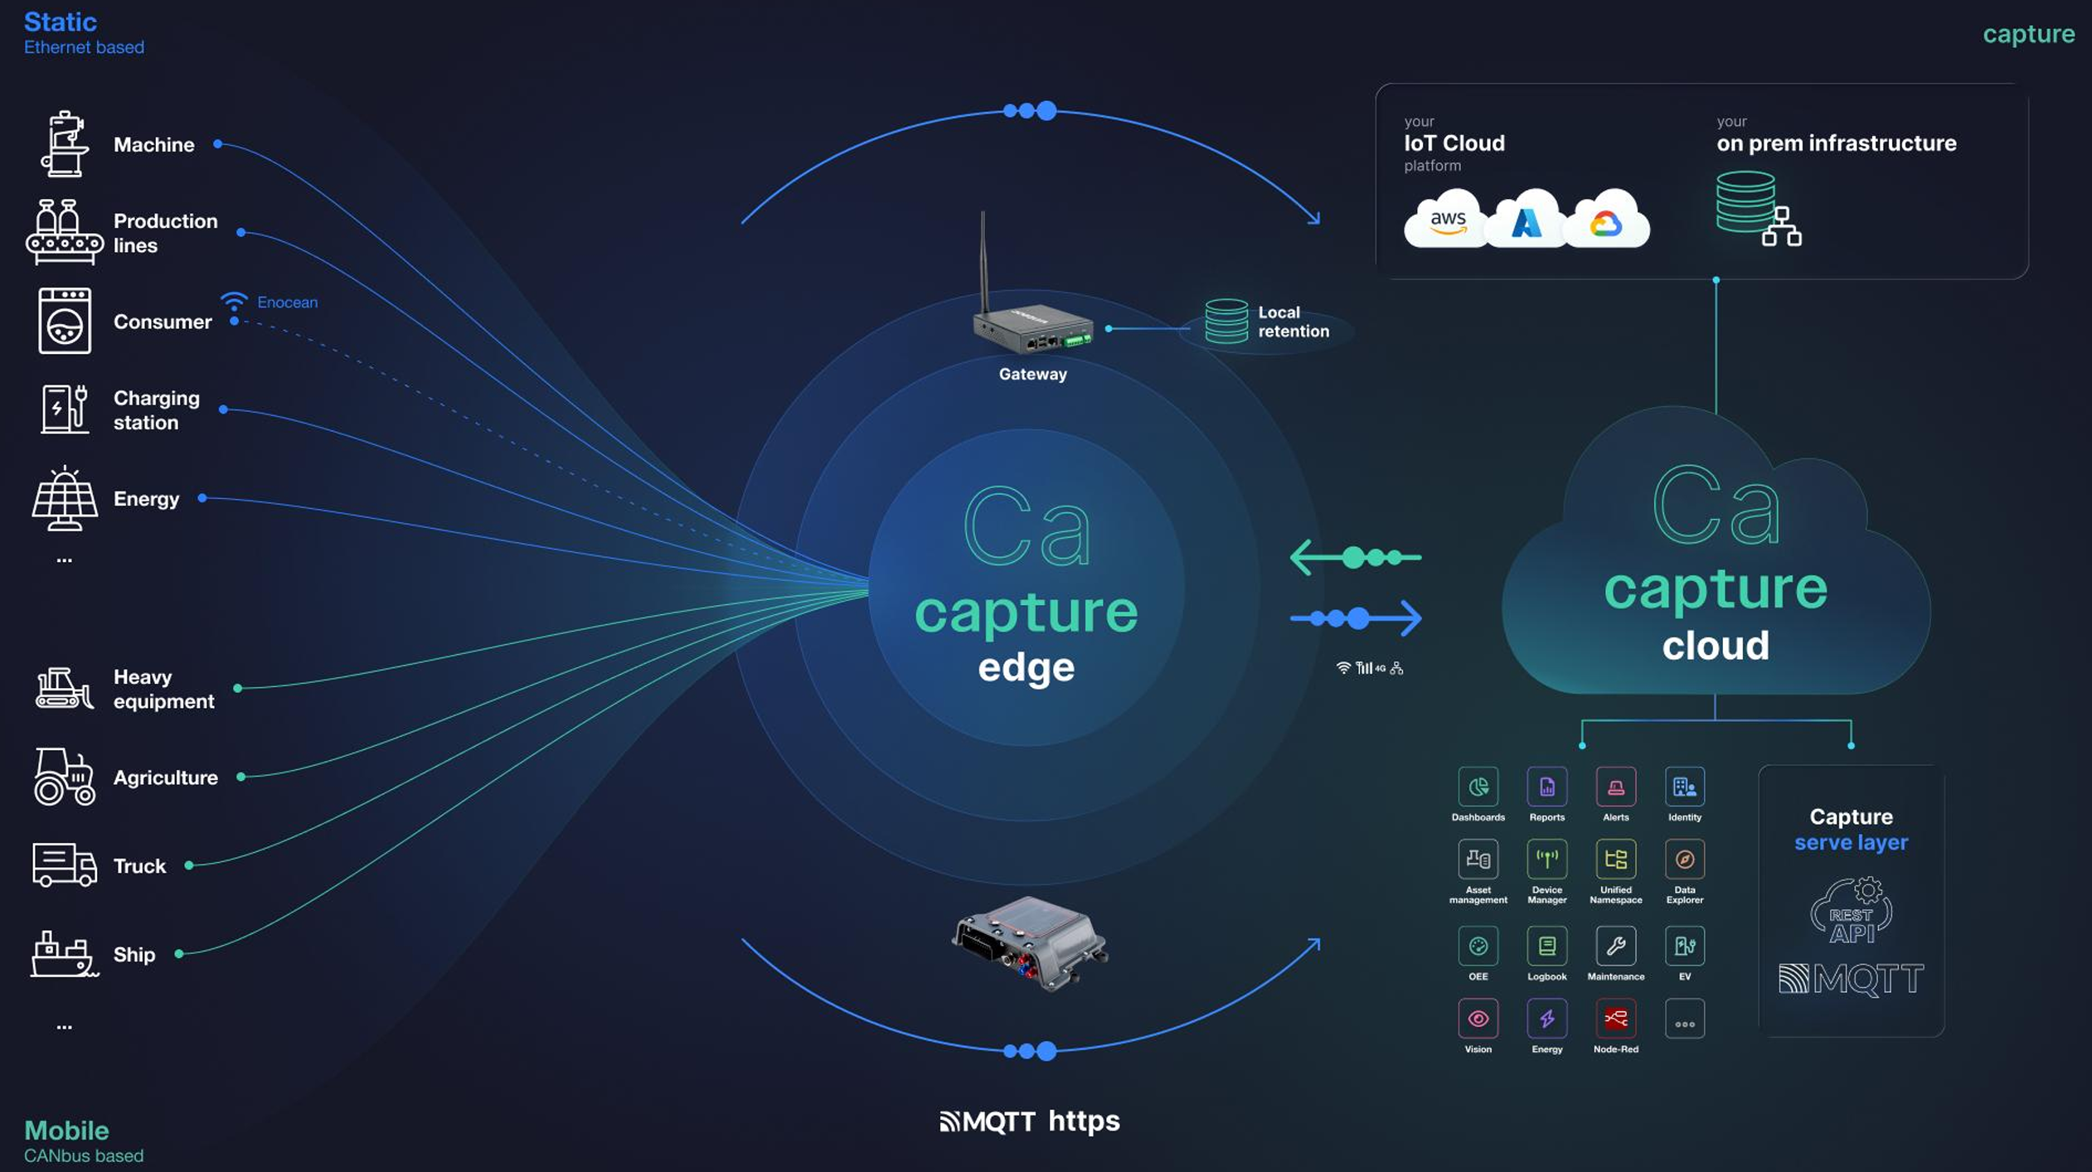

Comprehension Designs
Raw data collected during perception is transformed into meaningful information through contextualization and structuring mechanisms. In UC9, this is achieved through the implementation of a digital twin model within the Capture platform.
Data is enriched with metadata such as:
- Asset identifiers and hierarchy (e.g., device, machine, production line), for example ISA95
- Semantic tags (e.g., operational state, alarm condition, mode)
- Units, thresholds, and data types
The contextualized data is organized using a Unified Namespace (UNS) architecture, which provides a structured and standardized representation of all CPS-related information. This allows data from different sources to be interpreted consistently and enables interoperability across systems.
The UNS provides a single source of truth across the different data levels in a factory: sensors, PLC, Scada, MoM, MES, WMS, ERP, ...
Through this process, the system moves from raw signals to comprehension of system state, including:
- Identification of operational modes (e.g., idle, active, maintenance)
- Detection of abnormal conditions or alarms
- Understanding relationships between different data points and assets

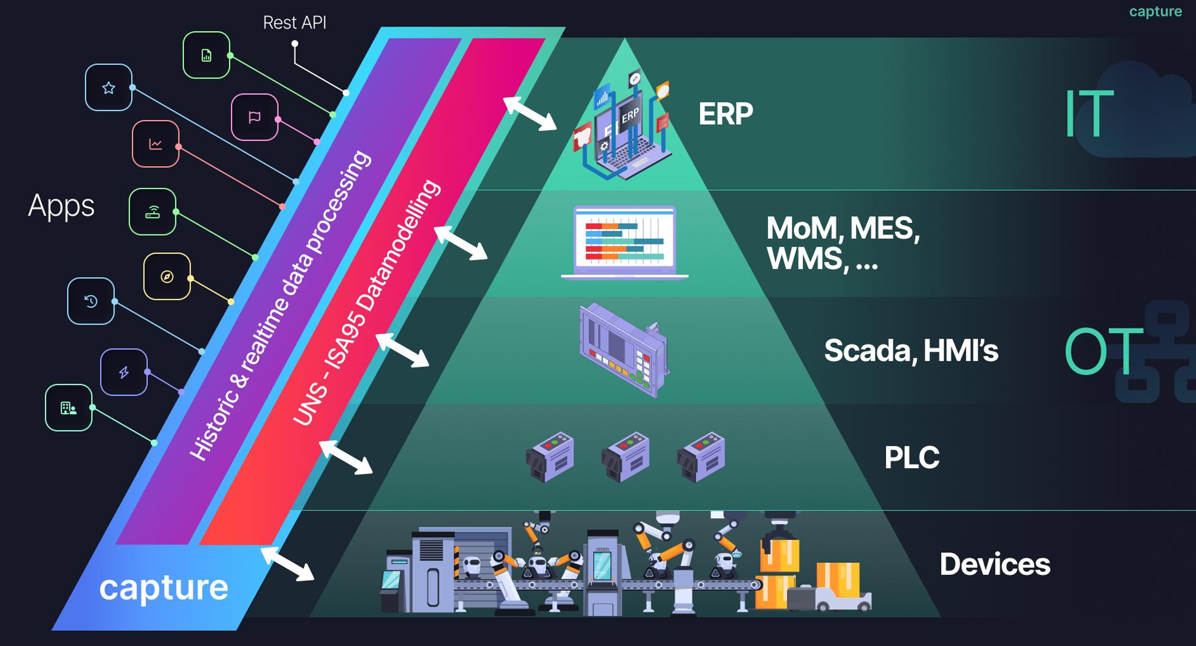

Technical enabler from the project story: 3D situational awareness map of Oulu port

Perception Designs
// This section describes the design of the perception components developed for the corresponding use case. The perception layer is responsible for acquiring data from the environment and system components through sensors, IoT devices, communication infrastructures, and data acquisition mechanisms.

For each technical enabler, the following aspects should be described:

- The purpose of the perception mechanism and its role in the use case
- The sensors, devices, or data sources used to collect information
- The system architecture and main components involved in data acquisition
- The data collection and transmission processes
- The communication technologies and protocols used
- If applicable, the security and data integrity mechanisms implemented
- The types of data generated by the system and how they are forwarded to higher layers

Where appropriate, architectural diagrams or data flow diagrams should be included to illustrate the design. The description should clearly explain how the perception mechanism contributes to establishing situational awareness in the given use case.

3D Sitaw Map (VTT)

Comprehension Designs
// This section describes the design of the comprehension components developed for the corresponding use case. The comprehension layer is responsible for processing, analysing, and interpreting the data obtained from the perception layer in order to generate meaningful situational information.

For each technical enabler, the following aspects should be described:

- The purpose of the comprehension mechanism and its role in the use case
- How data from the perception layer is processed and integrated
- The data processing methods, algorithms, or AI/ML models used
- The system architecture and data processing pipeline
- The outputs produced by the system, such as insights, predictions, alerts, or decision support information
- If applicable, the anomaly detection, prediction, or optimisation mechanisms implemented
- How the generated information supports operational awareness and decision-making

The description should clearly demonstrate how raw data collected from sensors and other sources is transformed into meaningful situational knowledge that supports the operation of the system in the specific use case.

Conclusions

TBU

References
- xxx.xxx

