WP2 Deliverable 2.3
Version 2 of the Sa4CPS concept description

Sa4CPS
ITEA 4 22007

Status: Draft

••••••••••••••••••••••••••••••••••••••••••••••••••••••
Editors (of the preceding version): Juhani Latvakoski and Jussi Ronkainen

Preceding version including contributions from:
Luis Gomes (ISEP)
Pedro Faria (ISEP)
Zita Vale (ISEP)
Juha Häikiö (Port of Oulu)
Miikka Salminen (Modirum | Gespi)
Mika Mononen (Modirum | Gespi)
Joona Vilkko (Modirum | Gespi)
Annanda Rath (Sirris)
Tuuli Lindroos (F-Secure)
Sini Olkanen (F-Secure)
Grégoire Moreau (ADLC)
Hannu Lohi (Natlink)
Juhani Latvakoski (VTT)
Jussi Ronkainen (VTT)
Petr Hnětynka (CUNI)
Tomáš Bureš (CUNI)
Jiří Havlík (IMA)
Lander Vanhaverbeke (Vintecc)
Ömer Şahabaş (Otokar)
M. Ogus Tas (INOVASYON)
Dilara Bayar (ACD)
Feyza Nur Genç (Alpata)
Yasemin Eker (Alpata)

TABLE OF CONTENTS

Abstract 5
List of Abbreviations 6
1 Introduction 7
2 Situational awareness in critical cyber-physical systems 8
2.1 Critical Cyber-Physical Systems 8
2.2 Project story 8
2.3 Situational awareness 11
3 A discussion on architectures and functions of secure situational awareness 14
3.1 An overview of the secure situational awareness architecture 14
3.2 A discussion on functionalities of secure situational awareness 14
3.2.1 Perception and comprehension 14
3.2.2 Status, projection and actions 15
3.2.3 Trust, security and privacy 16
4 Description of the Sa4CPS concept framework 18
4.1 Methodological approach 18
4.2 Functional blocks 18
4.3 Scope of work packages in the Sa4CPS concept development 1
4.4 A deployment example 1
5 Contribution area of the use cases to the Sa4CPS concept 2
5.1 Overview 2
5.2 Autonomous lightweight logistics (UC1) 3
5.3 People and machine position awareness in production or logistics area (UC2) 5
5.4 Application of advanced maps in public safety (UC3) 8
5.5 Critical energy distribution (UC4) 10
5.6 Security and location awareness of persons (UC5) 10
5.7 Multirouting secure awareness system for outdoors (UC7) 12
5.7.1 Natlink & Tracker: Enabling Technologies and Cross-Use Case Contributions 12
5.7.2 Polar data synchronization device for multiple wearables data collection 17
5.8 Drone operation control system (UC8) 20
5.9 Management of CPS assets (UC9) 21
5.10 Contributions derived from the project story 22
5.10.1 Trusted SitAw Application Support 23
5.10.2 Trust Enforcement 24
5.10.3 Trust Evidence 24
6 Key enablers of the Sa4CPS concept 25
6.1 Key enablers of the perception and comprehension (WP3) 25
6.1.1 <name of the enabler> 25
6.1.2 <name of the enabler> 25
6.1.3 <name of the enabler> 25
6.1.4 Discussion about novelty and KPIs 25
6.2 Key enablers of the status, projections and actions (WP4) 25
6.2.1 <name of the enabler> 26
6.2.2 <name of the enabler> 26
6.2.3 <name of the enabler> 26
6.2.4 Discussion about novelty and KPIs 26
6.3 Key enablers of trust, security and privacy (WP5) 26
6.3.1 <name of the enabler> 26
6.3.2 <name of the enabler> 27
6.3.3 <name of the enabler> 27
6.3.4 Discussion about novelty and KPIs 27
7 Discussion 27
8 Concluding remarks 27
References 28

TABLE OF FIGURES

Figure 2. Secure situational awareness concept for critical cyber-physical systems. 7
Figure 4. Project story from arrival to cargo unloading. 9
Figure 5. Project story from an emergency to departure. 10
Figure 6. Summarized description of the enhanced project story. 10
Figure 3. A view to the situational awareness - SA is the perception of environmental elements and events with respect to time or space, the comprehension of their meaning, and projection of their future status [1]. 11
Figure 4. Distributed view to the secure situational awareness. 13
Figure 2. Sa4CPS concept with the application areas, use cases and their potential contribution areas. 17
Figure 3. Sa4CPS concept, the work plan and technical enablers. 18
Figure 5 UC1 Concept 19
Figure 6. High-level overview of UC2. 20
Figure 7. Deployment architecture of UC2 21
Figure 8. The parts of the sensor nodes. 22
Figure 9. An example how NSC3 will operate under Zero trust communication with other devices (camera in this example) and how this data will be utilized when planning further actions, if facing unwanted anomalies/objects. 23
Figure 10. UC4 concept. 25
Figure 11. UC5 targeted ecosystem 26
Figure 12. UC5 approach mapped in the research frame: perception, comprehension, projection & decision 27
Figure 13. Natlink view to the UC7 concept. 28
Figure 14. Setup for Raspberry PI Zero W / Raspberry PI 5 + 4G Module 34
Figure 15. Structure of the experimental prototype. 35
Figure 16. A view to the UC8 concept. 35
Figure 17. A view to the UC9 concept. 37
Figure 22. A preliminary view to the Sa4CPS concept framework – main functional blocks. 39

Abstract
This deliverable describes the preliminary secure situational awareness concept (Sa4CPS concept). First the commonalities of the previously identified requirements towards the concept were analysed, and a set of functional blocks (FBs) have been identified. These FBs, called as data spaces and communication, identity and access management, authorization, perception, comprehension, projection, monitoring and zero trust system, are then clarified relying on the referred requirements. The FBs have been used to structure the preliminary Sa4CPS concept in this report, so that the contributions of UCs and technological tasks towards the concept is a bit more clear. However, it is important to point out that these FBs are still quite abstract in nature, and plan is to continue and open their internal functional structure, relationships and interfaces to practical objects in which the real secure situational awareness capabilities are needed.
The content, focus and plans of the UCs have been described in this report so that their potential contribution areas into the FBs of the Sa4CPS concept are clarified. It is clear now that each UC has a specific role in the development of Sa4CPS concept, its FBs and links to the technological tasks of the project WPs3-5. However, there is still need to continue this work to further clarify the content of the identified contribution areas of the UCs into the concept. The technological tasks of WPs3-5 have been quite much still in the background, and therefore their relationships to the FBs are clarified in this report only in a preliminary way. It is expected that this deliverable provides a solid starting point and working framework for the R&D works in these technological tasks. In addition, the links to the project UCs and the Sa4CPS concept is now a bit clearer.
The project story has been structured and enhanced, and the links of the UCs and WP3-5 contributions towards solving the visions and challenges indicated by the story are now a bit more obvious. This is envisioned to help all of the project partners to adjust their focus and plans so that the resulting actions are beneficial to their business cases but also to the results deployment in the port environment.
As the main result, the preliminary Sa4CPS concept is described here so that the targets are now clearer and the technological WPs3-5 and the UCs of the project can now proceed in the technological R&D towards specification and design of their solutions. The plan is to let them now proceed deeper into the technological development, and then in the next iteration of the project come back and make a new version of the Sa4CPS concept description.

List of Abbreviations
Abbreviation | Explanation
FB | Functional block
DLT | Distributed ledger technology
Req | requirement
SA | situational awareness
Sa4CPS | Secure situational awareness for critical cyber-physical systems.

Introduction
The purpose of this deliverable is to represent the first preliminary description of the secure situational awareness concept (Sa4CPS concept) framework architecture. The preceding phase of the project has analysed the requirements identified by the project use cases (UC). These requirements have been taken as input for this work and further analysed in order to identify required functional blocks (FBs). In parallel, the plans of each UC have proceeded so that the functionalities that the UC could contribute towards the concept have been studied. Accordingly, the planning of WP tasks has proceeded towards identifying the related requirements and functionalities that the WP tasks solutions should support. In addition, the links of each contribution towards the project storyline around port environment have been refreshed. As the result, the 1st preliminary Sa4CPS concept description has been provided, and initially described in this deliverable.
A short description of the situational awareness related terminology is provided in the following. The term situational awareness considers multiple functional aspects such as perception, comprehension, projection, decision making and execution of actions. In addition, the situational awareness can be discussed also from the points of view of the entities, e.g. people, devices and service systems. For example, as a system of devices and information that aims to bring to a person's cognitive situational awareness those physiological variables that concern him or her and the environment, that have an impact on the health, well-being and safety of an individual or a group of people, physical objects and businesses, or digital twins. A digital twin of the virtual/real-world spaces of a company/organization continuously monitors the available resources for observation, understanding, projection, and decision-making in an intelligent way. In addition, it can be discussed from a business point of view, considering issues like productivity, profitability, and improving operational decision-making capacity in matters related to logistics, mobility, energy production and use, and security. Thus, the targeted secure situational awareness system includes various mechanical objects, sensors, measuring devices, intelligent algorithms and applications that are responsible for control and producing situational information on operations at the interfaces of humans and stakeholders to support decision-making. In the situational picture, decision-making is influenced by both the technical safety aspects of the systems and the individual's self-regulation mechanisms, which determine the understanding of the current state of health and well-being, long-term historical development and the future scenario according to which goals are set for the activities to achieve the desired results. Thus, the situational picture affects both concrete actions and mental models, where values, ideals, desires, needs, goals, behaviour, situational awareness and decision-making form a single entity that requires the processing of self-regulation mechanisms and the guidance of actions with the methods described by the organizations implementing this project.
The rest of this deliverable are organized as follows. An overview of the Sa4CPS concept scope is described in the section 2. The commonalities of the requirements towards the functionalities of the Sa4CPS concept are discussed in section 3. After that, the possible contribution areas of project UCs towards the concept are discussed in section 4. Respectively, the possible contributions of project tasks towards the concept are discussed in section 5. The project story has been refreshed in section 6, and the links of contributions into it are updated in section 6. After that, the preliminary Sa4CPS concept framework has been described. Finally, discussion about the next steps and concluding remarks are discussed in sections 9 and 10 respectively.

Situational awareness in critical cyber-physical systems
The aim of this chapter is to open a view to the basic terms of situational awareness in critical cyber-physical systems.

Critical Cyber-Physical Systems
An example of the critical areas in society is port environment, which typically have several critical operations provided by multiple stakeholders from multiple sectors, Figure 1. Multiple logistics, mobility, energy and security companies are operating in the area together. Thus, there are physical devices, people and information services of companies operating in collaboration with the port authority operator, who is typically responsible for the overall safe operation in the area. All of them need to be aware about the situation in their immediate environment, so that they can operate in secure and efficient way. Therefore, we have focused into the R&D of the secure situational awareness concept for critical cyber-physical systems in the Sa4CPS project.

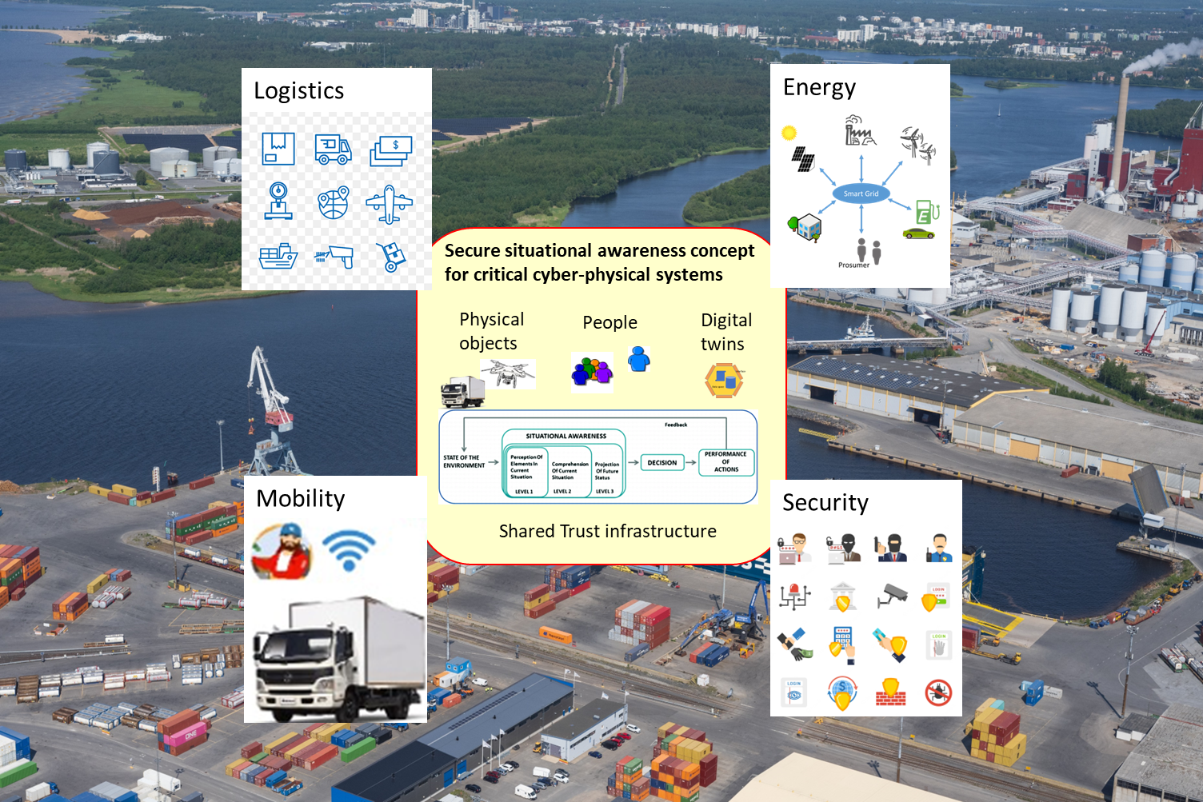

Figure 1. Secure situational awareness concept for critical cyber-physical systems.

Project story
The story of the operation in the port area in simple terms is described in the following:
“Truck driver Ella was driving towards the port of Oulu, carrying fresh northern Finnish sawn timber destined for Egypt. Before departing, Ella had confirmed her arrival in the PORT OULU Smarter app, from which she also received information that the road surface on the way to the port was particularly slippery and there had just been an accident on the shortest route, so Ella chose a slightly longer but less congested route. Additionally, the app informed her that there were currently several trucks unloading similar sawn timber loads at the port, and Ella's unloading time would be in two hours. Ella decided to stop for lunch on the way.
Upon arriving at the port, she drove through the portal, where her vehicle's license plate number and the QR code received from the app were recognized. Cameras also checked that there were no other people in the truck's cab. The portal's cameras and radars also scanned the combination to detect any deviations in load securing, load condition, or vehicle condition or temperature before arriving at the port.
The identification system sends information about Ella's arrival at the port area to the operator, who was already prepared for the arrival based on the advance notice, and an autonomous work machine is already waiting for Ella at the warehouse. Ella is arriving at the port of Oulu for the first time, so she has also ordered a drone to assist her, which projects the route direction and any warnings onto the road. Ella has checked the route guidance and the port's weather and road conditions in advance from the app, as well as the safety instructions video for the port. The route is also visible on the guide board inside the port gate, where Ella can also check that the load documents' codes and schedule match.
The drone projects a stop sign onto the ground, causing Ella to stop her truck and let container handler pass. The same information also appeared as a warning sound on the mobile app. When it is safe to continue, the drone projects the information onto the ground, and the app stops the warning sound.
Ella drives under the safe guidance of the drone to the designated unloading area, where the port operator's autonomously guided forklift is already waiting. When Ella's truck is positioned in the required spot markers and Ella opens the truck's side doors, the forklift unloads the timber load into the warehouse. At the same time, Ella's electric truck is charging at the charging station at the unloading area.
Suddenly, an alarm is triggered in the port area: smoke has been detected in a nearby warehouse. The port’s monitoring system, which utilizes thermal cameras and air quality sensors, has automatically identified a potential fire and sent an alert to all operators and personnel in the area. Ella immediately receives a notification on her mobile app, showing a map with the danger zone and a safe evacuation route. At the same time, the drone that had previously guided Ella reactivates and begins projecting visible guidance signs onto the ground, directing her to a safe area. The port’s digital twin displays real-time locations of all vehicles, machinery, and people, allowing the control center to ensure that everyone is moving away from the danger zone. Autonomous work machines halt their operations and move to safe standby positions.
Emergency services arrive quickly, and the automatic fire suppression system in the warehouse has already managed to contain the spread of the fire. The situation is brought under control in about ten minutes. The control center updates the situational view in the digital twin in real time, and the danger zone is reclassified as safe. The mobile app notifies all operators in the area that the situation is resolved, and normal operations can resume. Ella receives a notification in the app that unloading can now be completed. The autonomous forklift resumes its task and transfers the remaining timber into the warehouse.
When the unloading is complete, Ella thinks she knows the way back and has selected from the app that drone guidance can be stopped, so the drone returns to its charging station. The app informs her that the road is still slippery, but all routes are open, so Ella chooses the shortest route back to the sawmill to pick up a new load. Since Ella is in the area for the first time, she turns in the wrong direction at an intersection. The mobile app gives a notification directing Ella back to the correct route. Additionally, the mobile app asks if Ella wants drone guidance again. However, Ella now trusts that she knows the way and declines the request.
Throughout Ella's visit, the area surveillance cameras, radars, and sensors have been monitoring Ella's movements and ensuring that Ella finds the right route and exits the area. From the digital twin of the area surveillance, the movements of vehicles, work machines, and people can also be monitored in the area and intervene if necessary.”
The project story is summarised below in Figures 4, 5 and 6.
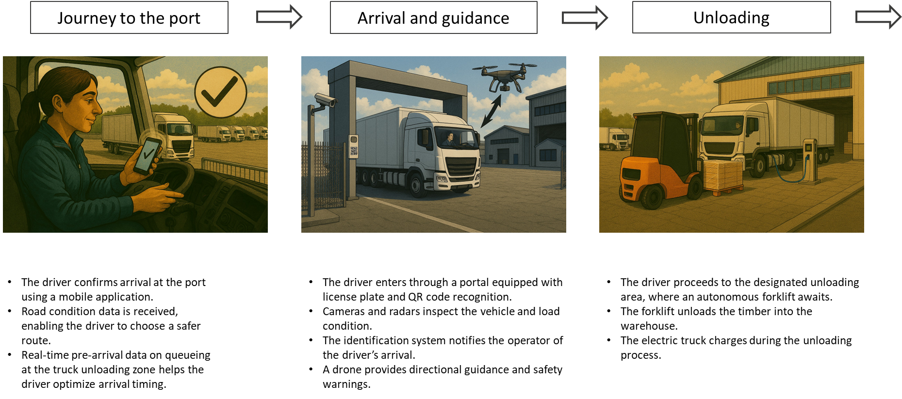
Figure 2. Project story from arrival to cargo unloading.
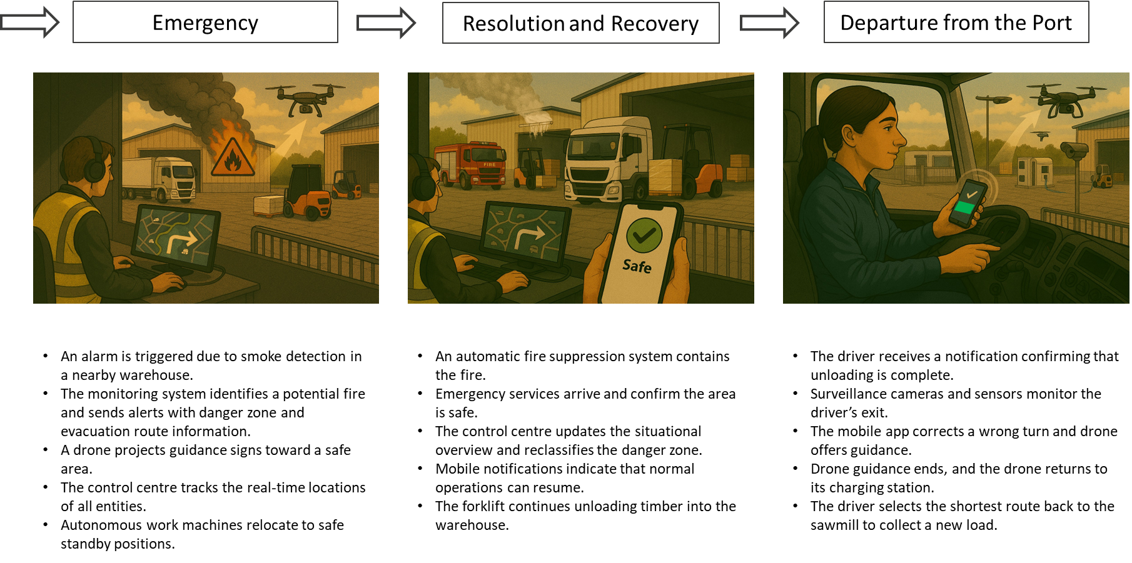
Figure 3. Project story from an emergency to departure.

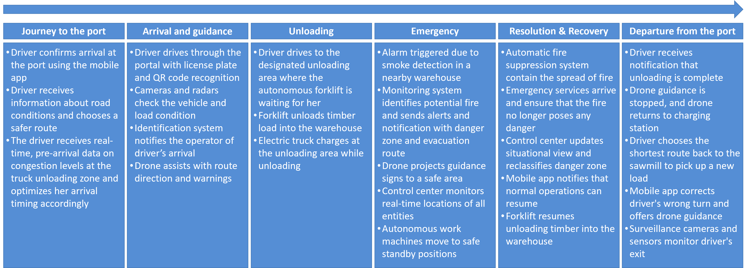

Figure 4. Summarized description of the enhanced project story.

Situational awareness
When looking at the critical areas such as ports, solutions related to several different sectors are needed for smart and secure situation aware operation - for example, logistics, security, mobility and energy. The focused use cases from these sectors share problems and technological needs related to people, physical objects, and companies/digital twins. An individual person needs to get information from the current state of the environment and from all the accessible data spaces of the currently active personal role for perception of elements in current situation. This information is needed for comprehension of the current situation, to reason projection of the future status and finally to make smart decisions and actions accordingly, Figure 1. A specific physical object may have local sensors, cameras, lidars etc. to sense what is happening nearby (local situational awareness). The physical object may also use ad hoc radio capabilities to get information from other local physical objects nearby. In addition, it is maybe possible to enrich the local situational awareness using all the accessible information sources from networks. All this information can then be used to make comprehension of the current situation, make projections of the future status and finally to make smart actions automatically. Respectively, the digital twins of the virtual/real world spaces of a company/organization continuously monitor all kinds of accessible resources available to make perception, comprehension, projection, and decision making for actions in a smart way. ,,,,
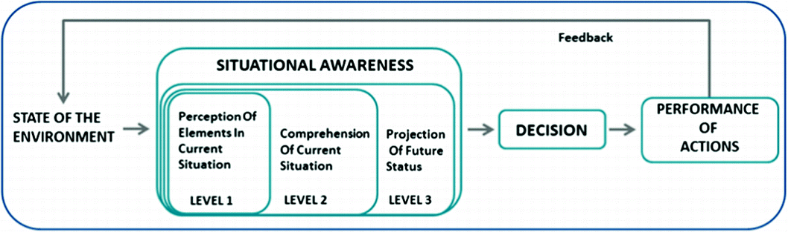

Figure 5. A view to the situational awareness - SA is the perception of environmental elements and events with respect to time or space, the comprehension of their meaning, and projection of their future status [1].
Today, these processes are usually executed using local processing and in tightly coupled company specific silos without sharing the information over stakeholder borders. For example, when goods proceed in a logistics chain from one stakeholder to another, crossing the border between data spaces of stakeholders is needed to track the product in the supply chain and finally to the retailer/end user. Another example can be found in the mobility environment: There are mobile physical assets from multiple stakeholders and disciplines and people acting in an ad hoc way. Each of these assets have an impact to the safety of the other entities and people, and therefore situational awareness crossing the stakeholder borders is inherently needed. A third example can be found in the energy sector: The digital twins of energy distribution systems need information from several sources hosted by different stakeholders to know the situation properly, e.g., frequency of the physical electricity grid, current demand response balance, future production and consumption estimations, flexibility capabilities of energy consumers, producers, and their distributed energy resources. Based on this situation awareness information, the system may be able to decide what actions should be done in the day-ahead markets, and what needs to be done in the intra-day real-time situations with the energy distribution network and with related energy flexibility markets. The fourth example deals with public safety security systems, which have traditionally been quite separated from other industrial systems because of confidentiality reasons. However, today the critical industrial systems e.g. in logistics, mobility and energy have elements that trigger essential challenges compromising public safety. The situation awareness crossing the sectorial borders could establish a better view what is happening in the situation, and what should be done by the public authorities.
Another shared problem and technological needs arise from the security risks. The result from the realization of such risks may be e.g., accident, physical or virtual attacks, blocked use of critical resources, or misuse of privacy sensitive data, which can lead to loss of human lives, lack of critical human needed resources, bankruptcy of companies or even societal instability. The traditional perimeter-based network security model, applied today basically in all the focused use cases, has still serious risks to the assets of the enterprise system, because an attacker may have found a way inside the enterprise system. The trusted Internet connections and perimeter firewalls provide strong Internet gateways, which can block attackers from the Internet. However, they are less useful for detecting and blocking attacks coming from inside the network and they cannot protect subjects outside of the enterprise perimeter such as remote workers, cloud-based services, edge devices etc. Remotely working employees increase the risks for security threats. Phishing of credentials (such as username and password) is more likely to happen, and the likelihood for malicious user to be able to access the resources in the enterprise system increases. The Zero Trust security model has been developed to contribute towards solving these problems. It focuses on resource protection so that trust is never granted implicitly but must be continually evaluated . It is an end-to-end approach to enterprise resource and data security that encompasses identity (person and non-person entities), credentials, access management, operations, endpoints, hosting environments, and the interconnecting infrastructure. The initial aim is on restricting resources only to those who have a need to access and grant only the minimum privileges (e.g., read, write, delete) needed to perform the required mission. When speaking about critical scenarios related to logistics, mobility, energy, and public safety, it is obvious that the traditional perimeter-based network security model is not enough, but the Zero Trust type of security model needs to be applied instead.
The focused critical use cases share these problems, and therefore the major objective of the project is to research and develop the secure situational awareness (SA4CPS) concept together. This has been planned to be done so that each use case has identified their contribution to the concept, which will be evaluated as the part of the referred use case experimentation. The critical port area of Oulu needs the results from these use cases to enable secure situation awareness for operation, and it can act as a potential pilot environment for conceptual validation.

A discussion on architectures and functions of secure situational awareness

An overview of the secure situational awareness architecture
An overview of the secure situational awareness architecture is visualized in the Figure 4. The basic functions of the situational awareness are here depicted according to the Endsley situational awareness model to perception, comprehension, projection, decision and execution of actions, which are establishing more or less continuously executed loop of operation. Sa4CPS aims to enhance these capabilities by adding trust and security functions to control the operation. In addition, the typical operation of cyber-physical systems as distributed information based operation with physical processes with devices, information spaces of digital twins in company servers and their human users are considered. Also the traditional operation of cyber-physical systems as well controlled silos are considered, which means that multiple of such siloed operation are here expected to collaborate for achieving shared secure situational awareness for allowed group of the stakeholders.

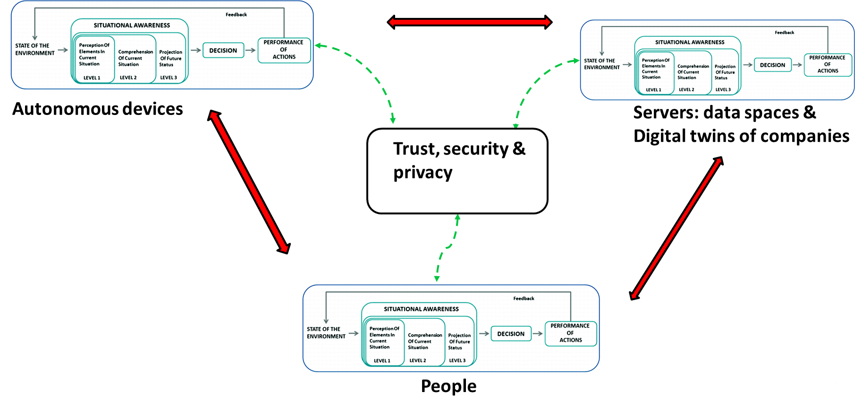
Figure 6. Distributed view to the secure situational awareness.

A discussion on functionalities of secure situational awareness

Perception and comprehension
The traditional perception with one sensor and related sensor data feed is expanding towards multisensing operations. There are physical sensing (ToF/ultrasound, cameras), radio-based sensing (BLE/WiFi/5G), and sensing via external parties information. This reflects the ongoing shift from single-modality sensing to heterogeneous sensing with robust fallback modes (e.g., radio proximity when vision fails, local sensing when cloud is unavailable).
Another essential trend is related to privacy preserving / low-resolution sensing for human centric environments. For example, ToF/ultrasound, controlled environment, human-machine hazard focus aligns with a major state of the art direction, i.e., to reduce reliance on high-resolution RGB video because of privacy/security exposure, sensitivity to lighting/occlusion and computing cost. The Low-resolution depth/ToF and multi-sensor setups are a contemporary tactic for industrial safety monitoring: “good-enough geometry and motion cues ”beat perfect images” when privacy and robustness matter.
The sensor fusion is also enhancing from data merging towards uncertainty-aware, purpose-driven fusion. The fusion is now a core system function rather than an afterthought process. The current modern fusion typically emphasize time synchronization and alignment, confidence/uncertainty propagation, robustness to missing/noisy sensors and fusion strategies chosen by task (safety alerting vs tracking vs classification). For example, such aspects are needed in the perception process of wearable location and behaviour, outdoor mesh awareness, grid/energy inference and drone operational.
In the comprehension process application of machine learning is necessary, but pipelines and lifecycle need to be considered. A distributed training pipeline and automation of preprocessing/architecture exploration forms the current state of the art. The bottleneck is rarely one model, but it is datasets (collection/annotation), repeatable training/validation, deployment variation across sites/stakeholders, and continuous improvement. This needs to be extended by application of AI with modelling and XAI reflecting another state of the art advancing related to auditable/explainable comprehension outputs in safety- and regulation-heavy CPS domains.
The CPS systems are typically splitted into the devices, edge and cloud systems, which has an essential impact into the perception and comprehension processes. Typically, the edge handles low-latency perception and first pass filtering/feature extraction, while cloud/back-office adds heavy analytics, cross-stakeholder context, and fleet-level learning. This is especially required to be concerned in autonomy/drone/industrial safety, where real-time decisions can’t wait for cloud, but fleet insights can’t fit purely on-device.
The cross-stakeholder context sensing is going beyond classing perception. It is about discovering and exploiting context across stakeholder boundaries (devices nearby, other clouds). This is challenging in practice because it requires interoperable discovery/metadata, trust and access control, data quality and provenance handling and consistent semantics across domains.
Summarizing, the Sa4CPs project considers the discussed current state of the art approaches, and goes beyond state of the art especially considering the distribution of perception and comprehension to different levels in CPS systems, real-time requirements for perception and comprehension and especially considering trust and security with zero-trust operating model.

Status, projection and actions

Current approaches to modeling dynamic situations in CPS have usually been addressed using three dominant paradigms: ontology-based models, logic-based formalisms, and learning-based approaches. Ontology-based approaches represent situations as semantic constructs derived from entities, events, and contextual relations, typically using OWL and rule languages. Such models explicitly distinguish between low-level observations and high-level situations and enable reasoning over composite and temporal situations,. Logic-based approaches, in contrast, specify situations using predicate logic, temporal logic, or hybrid automata. Situations are defined as logical predicates over system states and events, enabling formal verification and runtime monitoring,. While these methods provide strong formal guarantees, they often require substantial modeling effort and are less accessible to domain experts. A third line of work relies on learning-based techniques, where situations are implicitly captured through ML. These approaches are powerful in handling uncertainty and complex data, but typically lack explicit semantic structure and interpretability. Our approach, follows the logic-based models, but in comparison to purely predicate-logic-based models, it offers a straightforward, concise, and modular syntax, and it is application-domain agnostic and will be integrated in the complete SA4CPS solution. Further, being based on the perception relying on ML, the approach combines explicit structures with ability to handle uncertainty on the perception level.

Trust, security and privacy

The state of the art in trust, security, and privacy for critical cyber-physical systems reflects diverse approaches across sectors, with common themes emerging around zero-trust architectures, regulatory compliance, and the integration of decentralized technologies. The state of the art related is discussed in the following.

Communication Infrastructure Security
Modern industrial environments increasingly rely on hybrid connectivity solutions combining 5G and other wireless technologies to ensure continuous, reliable operation. Security implementations leverage standardized frameworks such as FIWARE for data interoperability and fine-grained access control, integrated with decentralized storage solutions like IPFS to enhance data integrity and confidentiality in operational settings.

Privacy-by-Design and Regulatory Compliance
Organizations across sectors prioritize adherence to European regulations, particularly GDPR, EU RED2014/53/EU, the Cyber Resilience Act, NIS Directive, and the Data Act. Current practice emphasizes transparency with users, meaningful consent mechanisms, data minimization principles, and privacy-enhancing techniques. Building consumer trust relies heavily on clear communication about data usage, user control over participation, and demonstrable privacy protection measures.

IoT and Edge Security
Security approaches for IoT devices and edge computing environments follow industry standards such as ETSI EN 303 645 and NIST IoT guidelines. Implementation includes secure communication protocols (MQTT over TLS, CoAP with DTLS), defense-in-depth strategies incorporating OWASP Top 10 recommendations, robust authentication and authorization using OAuth 2.0 and OpenID Connect, and role-based access control enforcing least privilege principles. Notably, browser storage APIs (localStorage, sessionStorage) are avoided in favor of in-memory state management to ensure system stability.

Zero-Trust Architecture and Decentralized Identity
The transformation of traditional supply chains into cyber-physical systems has driven adoption of zero-trust security models. Current implementations leverage W3C Verifiable Credentials and Self-Sovereign Identity principles, supported by Distributed Ledger Technologies for traceability and accountability across organizational boundaries. Hardware-integrated solutions using secure cloud-compatible HSMs, blockchain-based accountability mechanisms aligned with European Blockchain Services Infrastructure, and Keycloak-integrated authentication services represent the state of practice.

Human-Centered Security
Recognition that pure technological solutions are insufficient has led to emphasis on human-technology interaction and protection experience. Current approaches focus on AI/ML-powered situational awareness to address the complexity consumers face in sensing security situations. This shift acknowledges that human error remains a significant cybersecurity risk and that declining consumer trust in digital services requires solutions beyond technical protections alone.

Access Control and Authentication
Contemporary access control implementations combine multiple approaches. For drone operations and collaborative robotics, Elliptic Curve Cryptography-based schemes provide mutual authentication and key agreement. However, gaps remain in dynamic access policies, real-time updates of access rights, and efficient mechanisms suitable for time-sensitive scenarios. Role-based access control following ISO 27001 requirements, combined with principle of least privilege enforcement, represents standard practice in enterprise environments.

Data Protection and Cryptography
Current security architectures mandate encryption for data in transit and at rest using modern acknowledged industry standard algorithms, network segmentation and firewalling, frequent patching with documented processes for zero-day vulnerability mitigation, and real-time malware protection. Implementations increasingly adopt zero-trust security models where every input is treated as potentially malicious regardless of source.

Digital Twins and Situational Awareness
Digital twin technologies are emerging as important tools for security monitoring and decision-making. Modern solutions leverage real-time data from sensors and IoT devices to create virtual replicas enabling informed decision-making, operational efficiency improvements, and platforms for continuous testing and refinement in controlled environments. These technologies integrate with distributed ledger systems and decentralized identifiers to establish trustworthy digital ecosystems.

Sector-Specific Challenges
Aviation sectors face requirements for soft real-time resilient systems with explainability for data transformations leading to safety-critical decisions. Automotive and logistics environments require secure parameter modification and system updates with real-time risk assessment, AI-driven state analysis, and fail-safe recovery features. Energy communities must balance flexibility service provision with strict data protection and secure actuation workflows.

Description of the Sa4CPS concept framework

Methodological approach
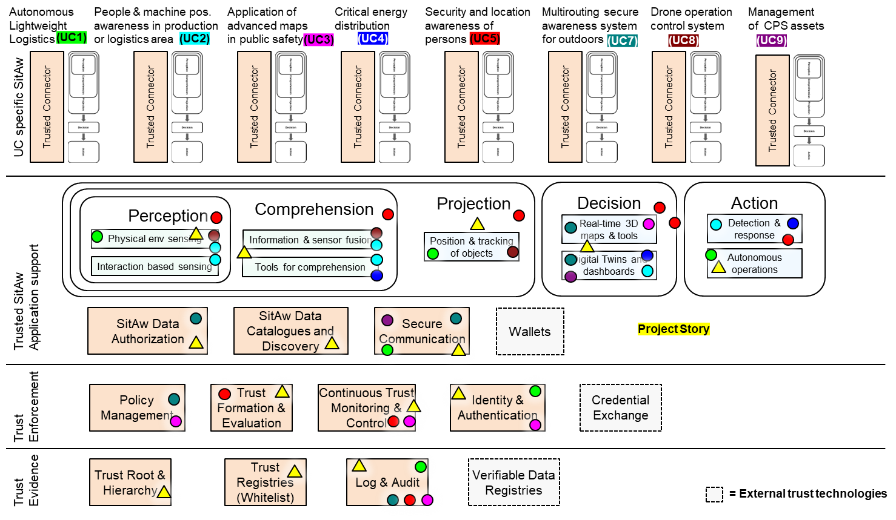
Figure 7. A view to the Sa4CPS concept framework

A preliminary view to the main functional blocks (FB) of the Sa4CPS concept framework is depicted in the Figure 22Figure 22. The reasoning of these functional blocks have been clarified in the section 3 of this report. Short descriptions of the FBs, related tasks of the WP3-5 and main contribution areas of the UCs into the FBs are overviewed in the Table 13Error! Reference source not found.. The UC contributions into the tasks are also further depicted in the Table 14

Functional blocks
<this section need to be rewritten, VTT>
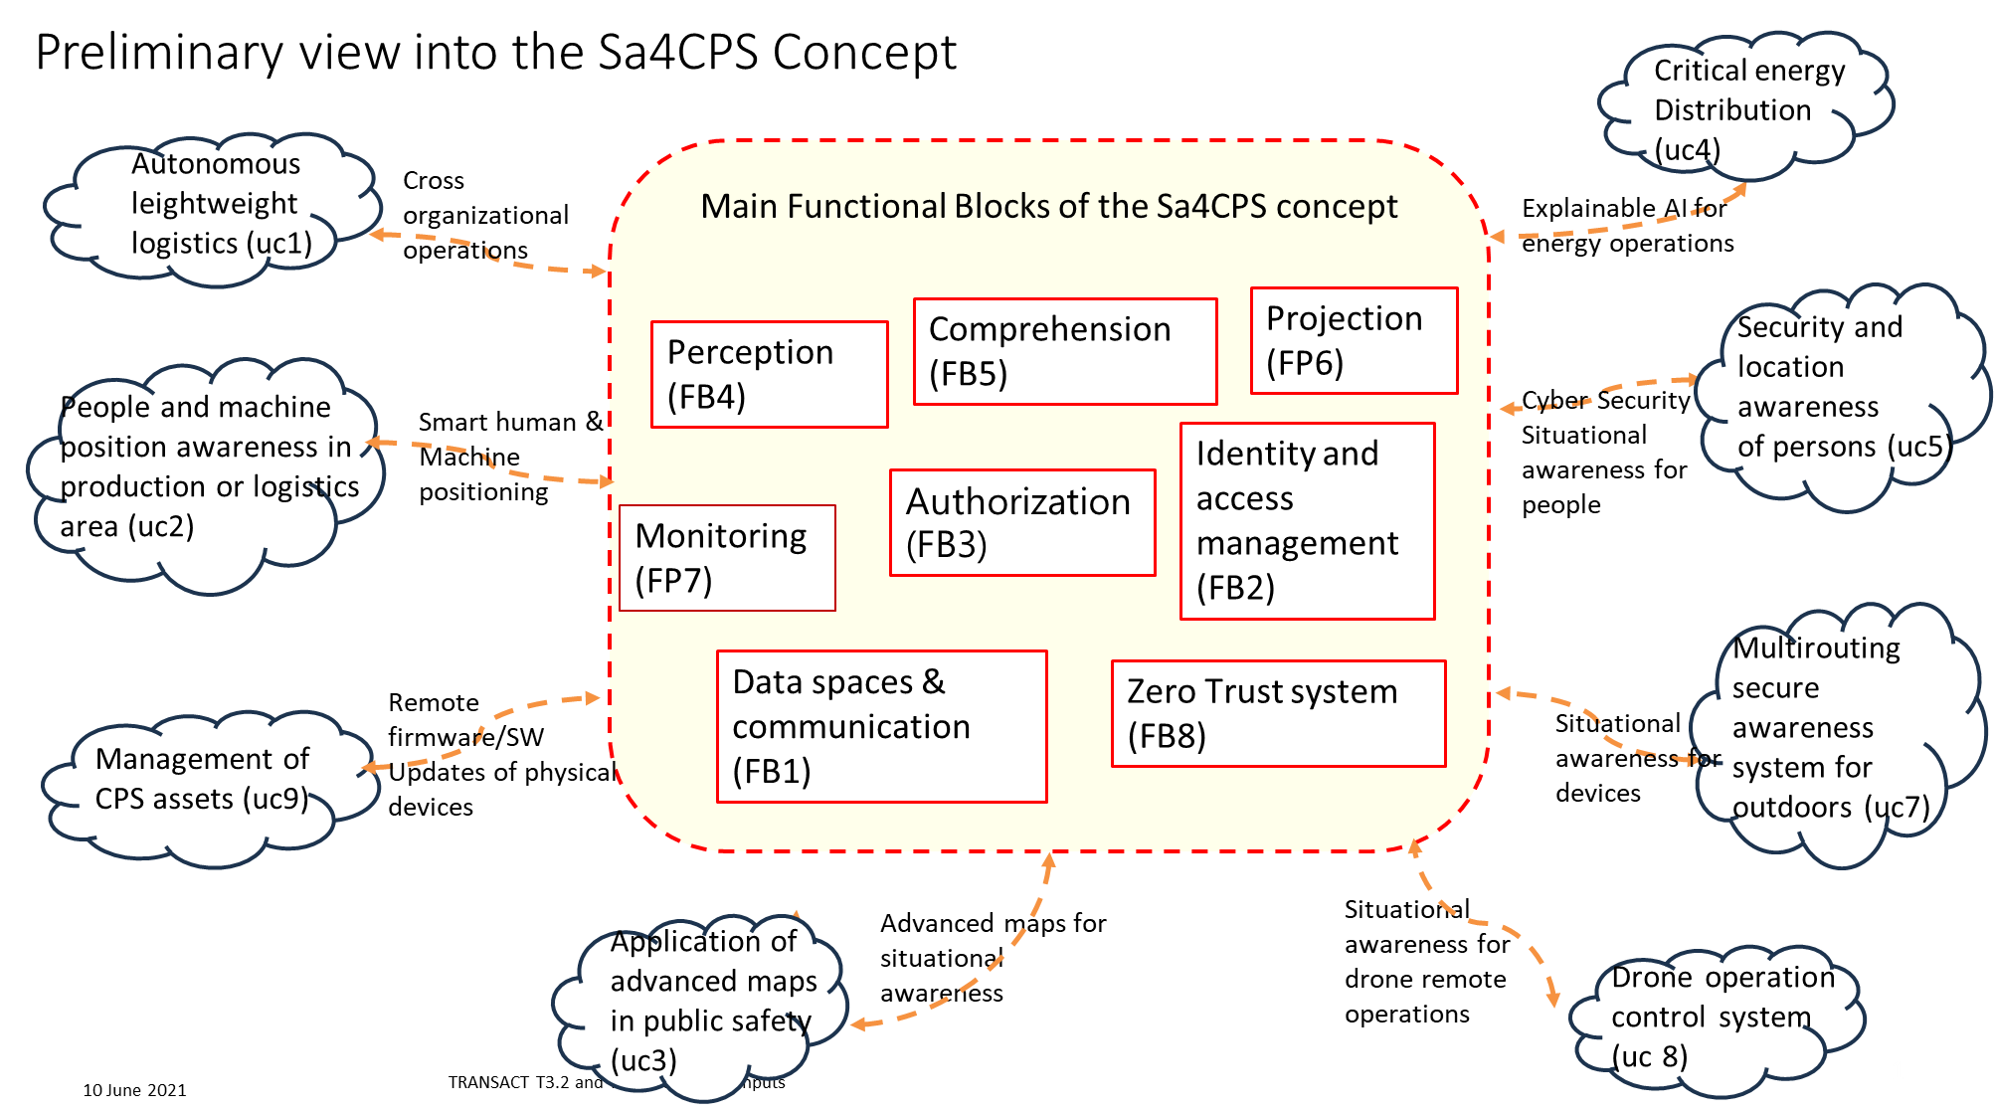
Figure 8. A preliminary view to the Sa4CPS concept framework – main functional blocks.

Table 13. Description of the FBs, related tasks of the WP3-5 and contribution areas of the UCs into the FBs.

Table 14. Contribution areas of the use cases into the functional blocks in different tasks of the WPs3-5.

Scope of work packages in the Sa4CPS concept development

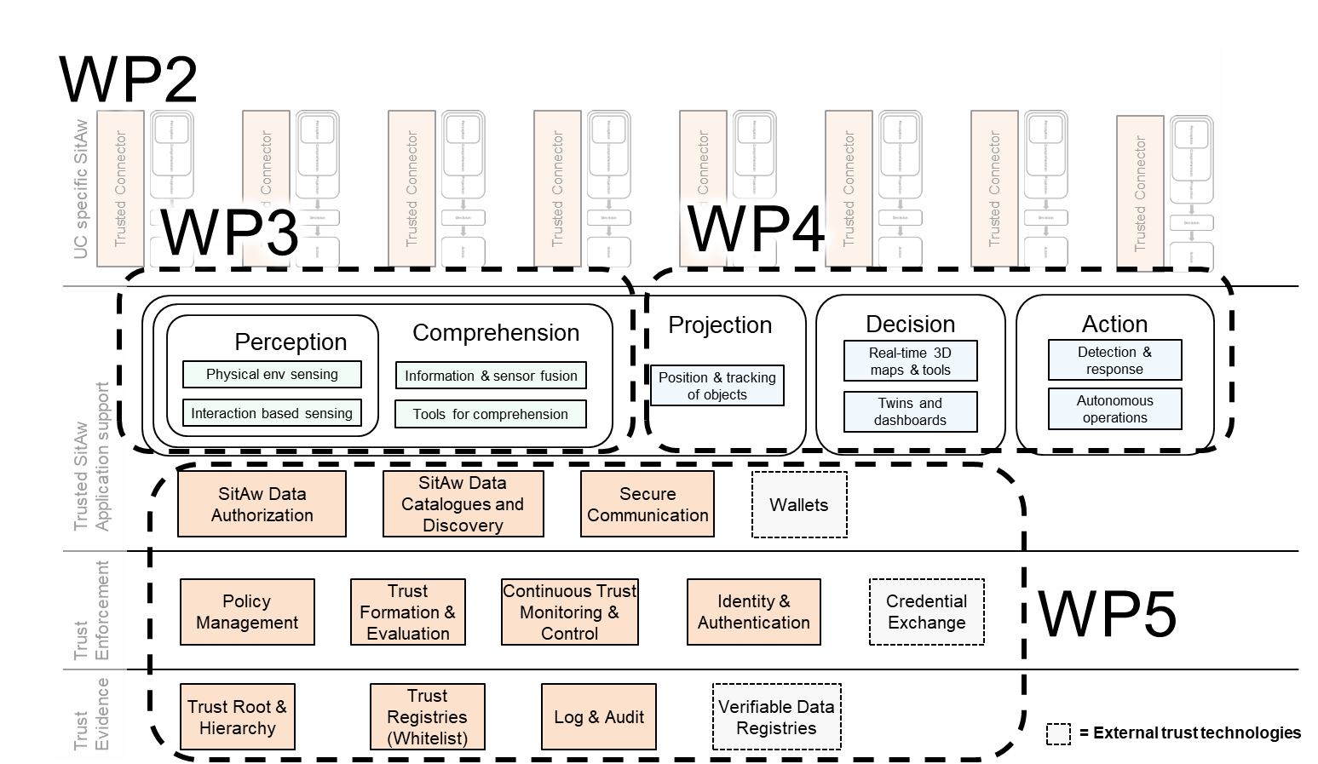

A deployment example

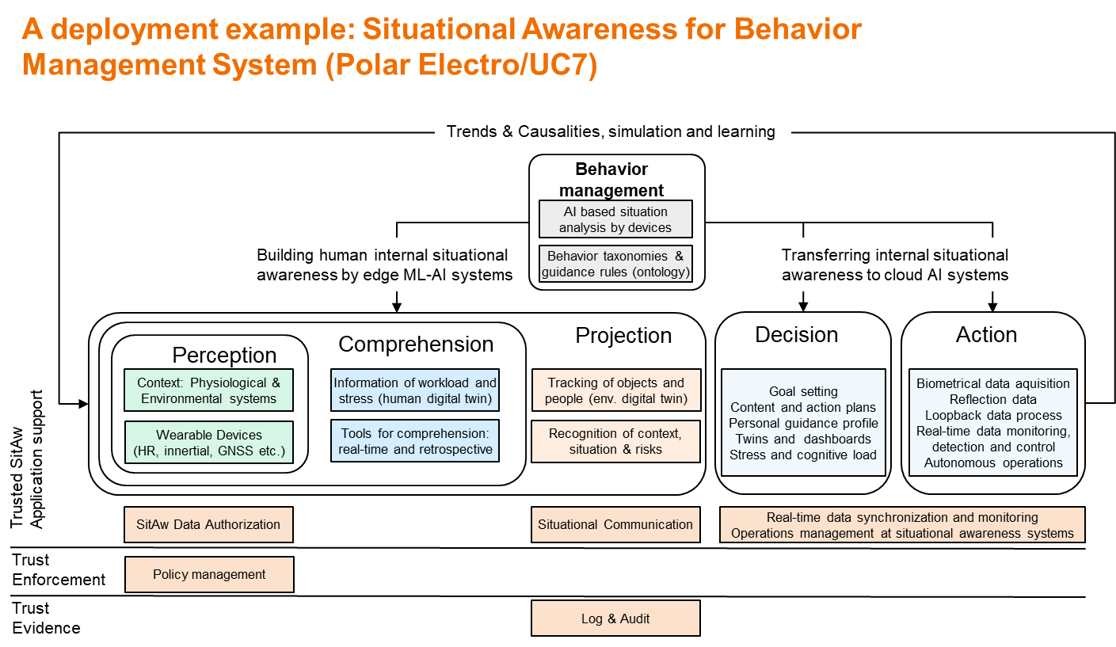

Contribution area of the use cases to the Sa4CPS concept
<The purpose of this section is to describe the functional areas/blocks into which use cases are contributing, explanation of the colored marks in the Figure 7.>

Overview
<this section need to be rewritten, VTT>

The Sa4CPS concept with the application areas, use cases and their potential contribution areas are depicted in Figure 2.. The project has eight use cases, that have both their own surrounding business ecosystem and a possible application in the port environment. The surrounding business ecosystems are represented as clouds in the figure. Each use case will focus on certain aspects of the Sa4CPs concept, represented as rectangular boxes. The Sa4CPS concept is represented in the centre of the figure, consisting all these aspects, or technical enablers, and the combined result will be Sa4CPs concept framework, the elements of which can be applied e.g. in the focused port environment.
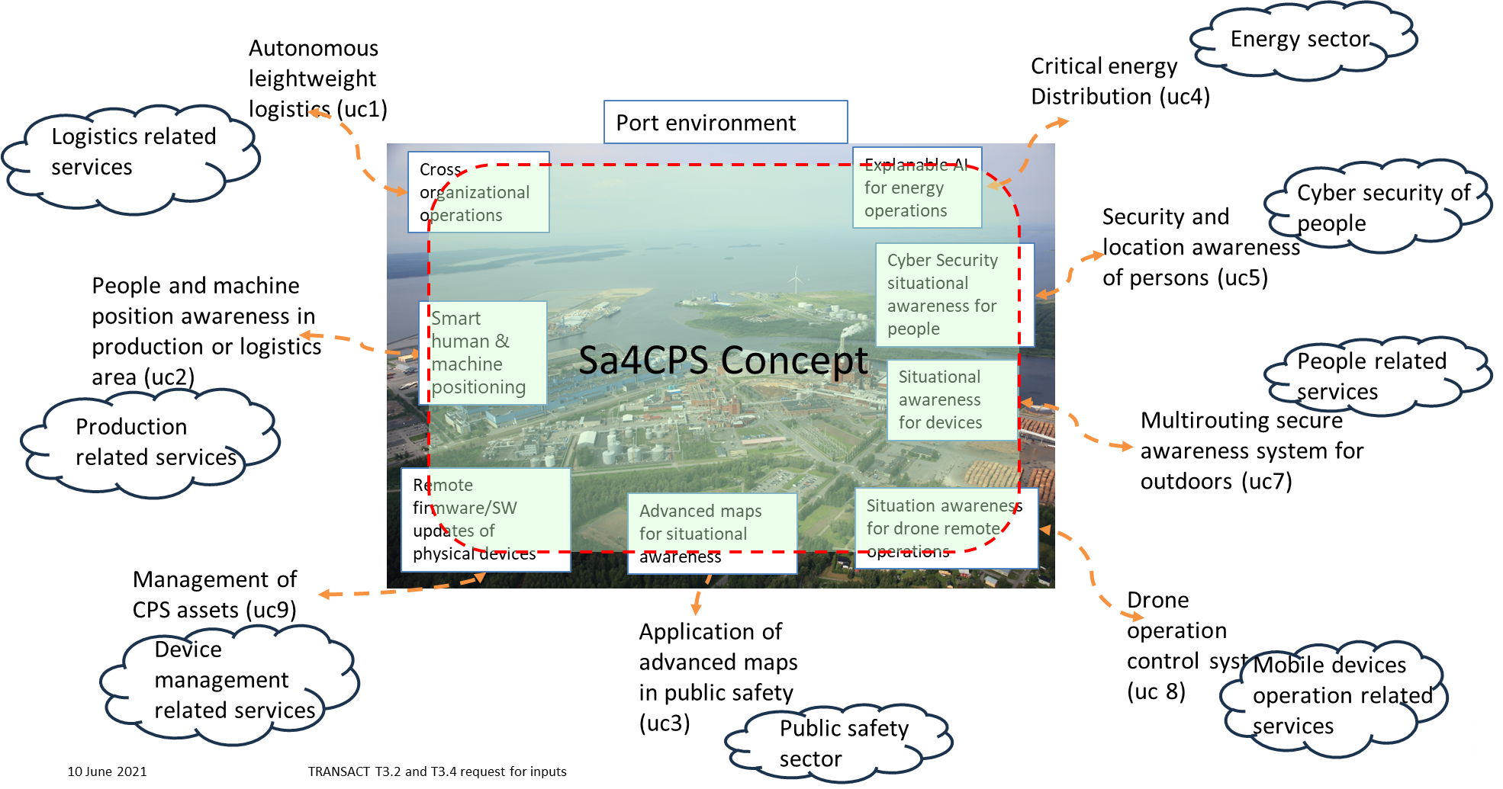

Figure 9. Sa4CPS concept with the application areas, use cases and their potential contribution areas.
The Sa4CPS concept, the work plan and technical enablers are depicted in Figure 3. The secure situational awareness functionalities are divided to work packages according to the functionalities that are required in the Sa4CPS system as follows:
- WP3: perception and comprehension
- WP4: status, projection and actions
- WP5: trust, security and privacy
Each work package area is envisioned to create a set of technical enablers, that are contributed by the project UC(s). Together these technical enablers establish the evaluated core of the secure situational awareness concept (Sa4CPS concept).
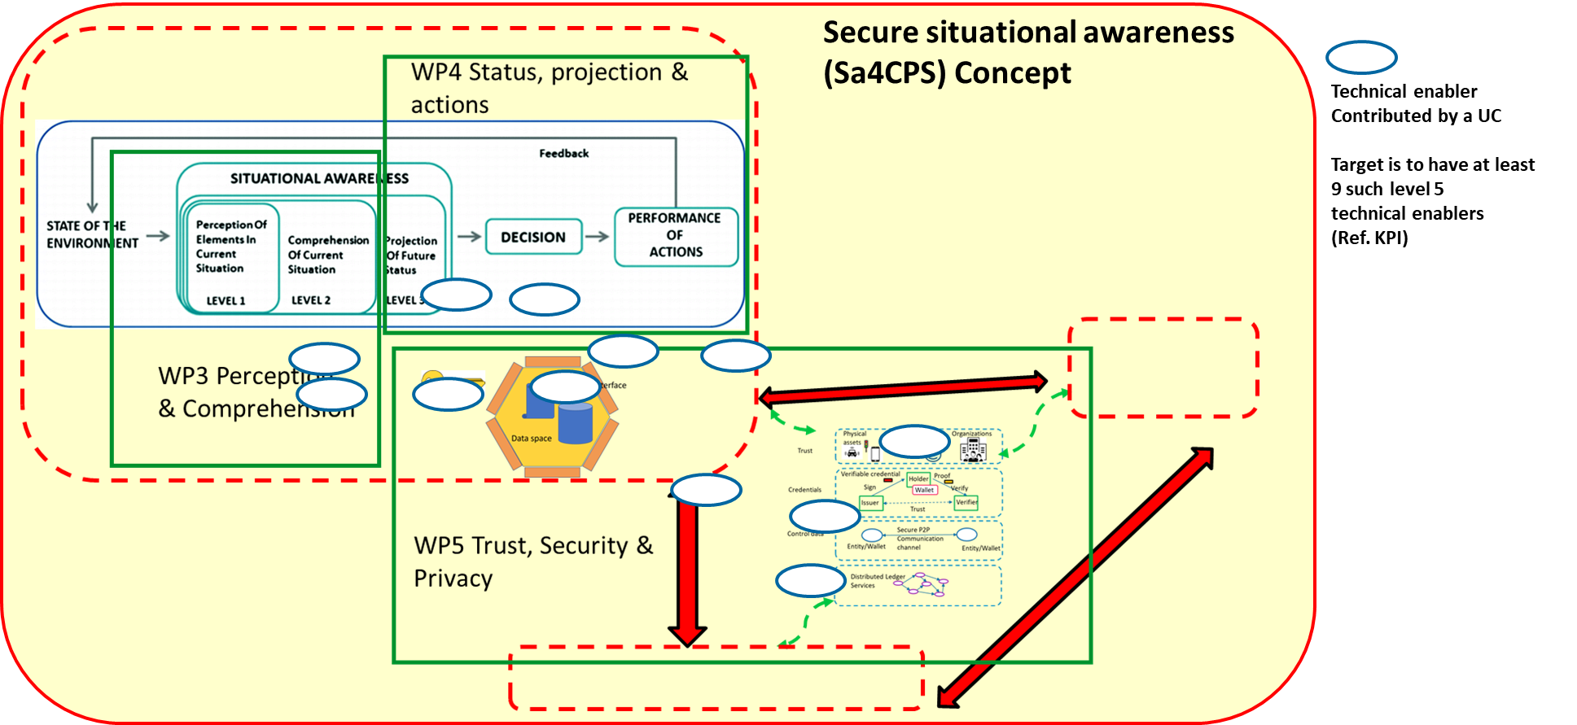

Figure 10. Sa4CPS concept, the work plan and technical enablers.

Autonomous lightweight logistics (UC1)

<The purpose of this section is to describe the functional areas/blocks into which the use case is contributing, explanation of the colored marks in the Figure 7.>

Use Case 1 (UC1) plays a crucial role in contributing to the development and validation of the Sa4CPS concept by addressing secure situational awareness challenges in a real-world cyber-physical system (CPS) scenario within the automotive supply chain domain, Figure 5. UC1 spans both cross-organisational (out-factory) and intra-organisational (in-factory) environments, encompassing a multi-vendor logistics network that includes third-party suppliers and OTOKAR's internal factory logistics.

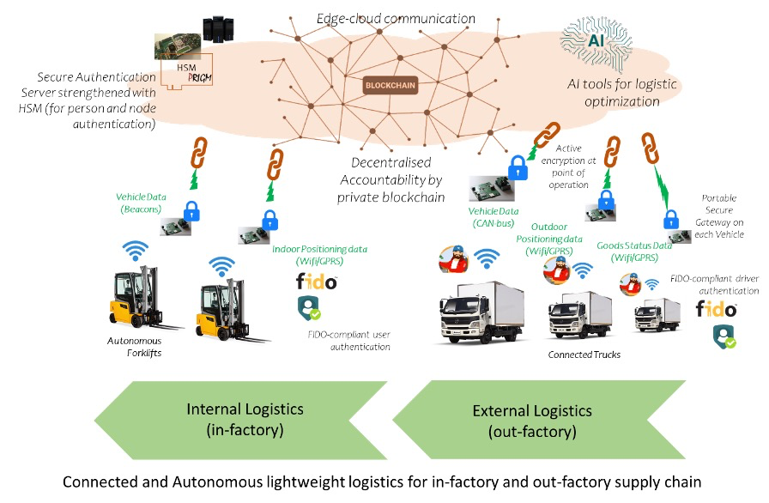
Figure 11 UC1 Concept
At the cross-organisational level, UC1 contributes to the perception and comprehension aspects of situational awareness by implementing IoT-based asset monitoring and decentralized traceability solutions. These ensure real-time visibility and digital trust in the movement and integrity of automotive parts across organisational boundaries. This supports secure information sharing and collaboration in zero-trust conditions, a key goal of the Sa4CPS concept.
Within OTOKAR’s internal logistics environment, UC1 contributes to the projection, decision, and actuation layers of situational awareness through the deployment of autonomous forklifts. These operate in a connected environment via Wi-Fi and beacon-based infrastructure, supported by IoT gateways. The continuous exchange of location and carriage data ensures operational efficiency while maintaining awareness of dynamic elements such as workers, vehicles, and obstacles—enhancing overall safety and coordination.
UC1 further strengthens the cyber-physical resilience component of Sa4CPS by addressing hardware-level and communication backend vulnerabilities. Through lab-scale test cases and countermeasures, UC1 validates mechanisms for resisting service-level attacks, ensuring the robustness and security of data transmission across both cross-organisational and in-factory contexts.
Within UC1, Alpata contributes to the projection and decision layers of situational awareness (FB6, FB7) through an IoT-based route optimization engine developed for logistics environments. The engine processes real shipment data to compute optimal delivery sequences across multiple destinations using Nearest Neighbor, Genetic Algorithm (GA), and Ant Colony Optimization (ACO) approaches. A distance matrix constructed via the Haversine formula provides accurate point-to-point distances, while the GA and ACO implementations consistently produce shorter routes compared to the greedy baseline. The solution supports both inter-city logistics planning and intra-city last-mile routing, demonstrated on real Turkish logistics data covering 13 cities and Istanbul's district-level delivery points. Results are visualized through interactive maps, enabling operator-level situational awareness of fleet routing status. This contributes to the FB6 Projection functional block by enabling demand-aware route forecasting, and to FB7 Monitoring through route outcome dashboards.

Overall, UC1 provides a comprehensive testbed that integrates multiple CPS domains—logistics, mobility, and security—thereby demonstrating how the Sa4CPS concept can be instantiated to enable secure collaboration, trusted information exchange, and adaptive control in critical industrial settings.

People and machine position awareness in production or logistics area (UC2)
<The purpose of this section is to describe the functional areas/blocks into which the use case is contributing, explanation of the colored marks in the Figure 7.>

As described in Deliverables D1.1, D2.2, UC2 showcases the project’s results in a production/logistics area where people and machines must coexist safely and securely. System level overview of UC2 shown in the following figure. The system level follows the high level UC2 processes shown and described in the D2.2.
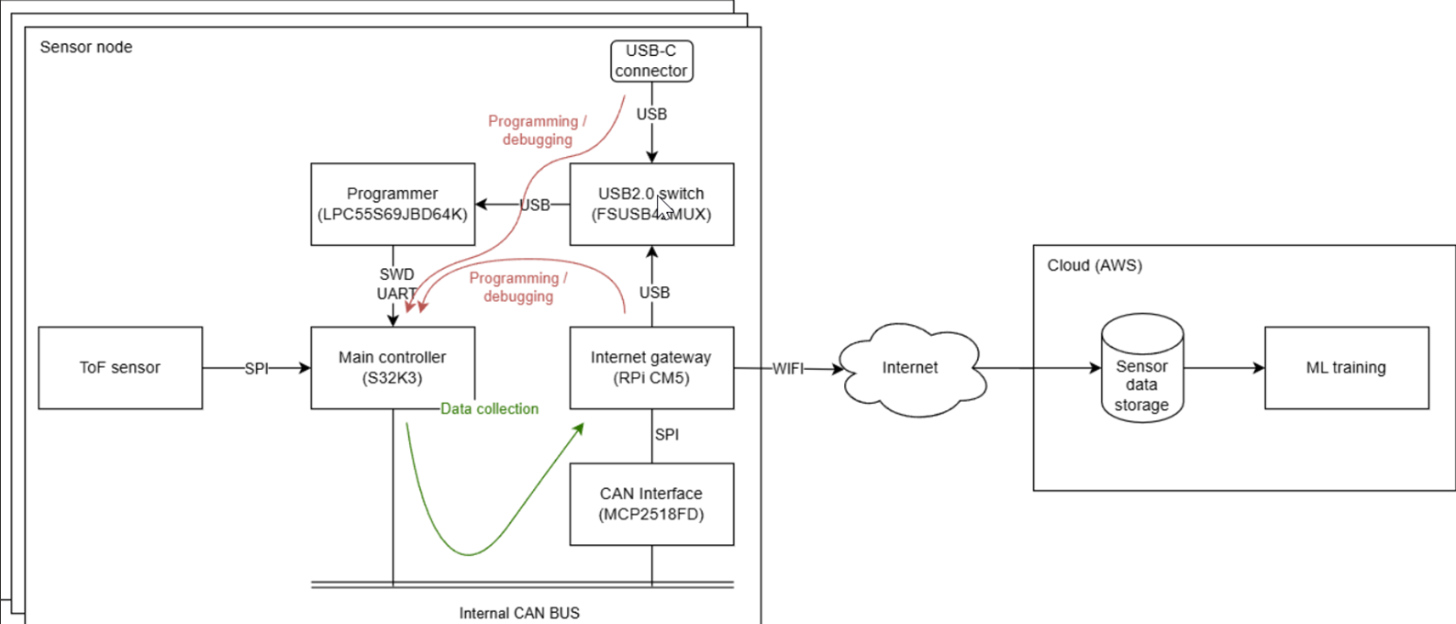
Figure 12. System level overview of UC2.
The Figure 6 shows the deployment architecture of UC2. Software components are divided between two execution environments – the cloud and the edge of the cloud. Individual components were identified based on scenarios and data flow described in Deliverable D1.1.
Sensors deployed within UC2 workplaces (shorten for the deliverable context):
The workplace consists of several work positions (A–D) where humans and machines cooperate.
- WPA: A workstation with a desk and server for configuration, control, visualization, and monitoring; operated exclusively by a human.
- WPB: A table for temporary storage of products.
- WPC: A stationary collaborative robot responsible for material transfer between work positions and for human–robot collaboration.
- WPD: Manufacturing equipment (e.g., a 3D printer) operating autonomously; the human performs only material input and product removal, handing the finished product to the robot.
Access to the workspace is possible only through a gate with UWB-based authorization. Safety and process monitoring are enabled by a sensor system (ToF cameras and UWB sensors) that tracks positions of all elements in real time, prevents collisions, and ensures human safety. All sensor data are processed by the server at WPA, with software components deployed across edge and cloud environments.

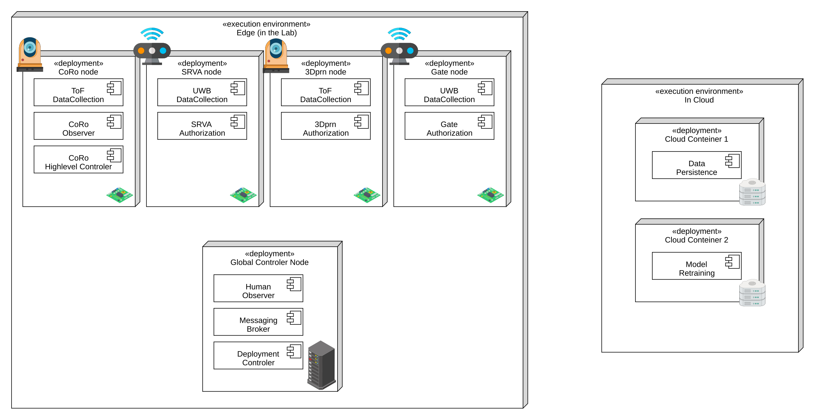
Figure 13. Deployment architecture of UC2
CUNI and IMA are developing a dedicated development platform for the edge nodes. On the edge, the UC will employ a number of sensor nodes (SN). Each sensor node consists of a board that contains an NXP S32-based chip connected to ToF sensor. This takes care of real-time control. The board further integrates with the Raspberry Pi compute module, which provides WiFi-based internet connectivity and acts as a gateway to the cloud. The Figure 8 below illustrates all the parts of SN.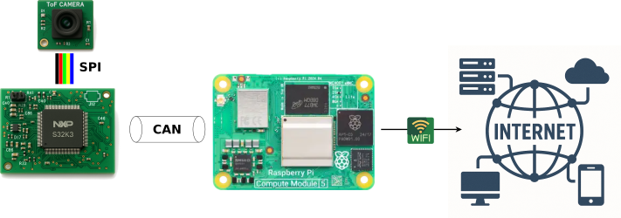
Figure 14. The parts of the sensor nodes.
On SNs, there is always the DataCollection component (specialized based on the particular attached sensor, i.e., UWB or ToF ones), which reads sensor data and sends them to the DataPersistence components deployed in a container in the cloud. Also, the data are sent to the HumanObserver component.
Additionally, on SNs, there are components that control a particular device that is observed by the sensor. These components, in cooperation with the HumanObserver component, control the specific device (CoRo, etc.). Importantly, these components (and the HumanObserver) employ AI models trained based on the collected data from the sensors (the AI training pipeline described below).
The HumanObserver component synthesizes a picture of the overall situation in the workplace and coordinates components controlling the devices.
HumanObserver is deployed on a computer (edge central node – ECN) that also runs at the edge (i.e., on-premises of the workspace). It is a “regular” server-like computer.
For mutual communication, all the components use messages. As a particular messaging technology, we will employ MQTT. The MessagingBroker (i.e., the software component that distributes the messages) will also be deployed on ECN. From the semantic point of view, there will be multiple message topics (queues), one for each message type (i.e., messages from the particular sensor, messages to the specific controller, etc.).
Finally, there is the DeploymentControler component (also deployed on ECN), which monitors all the nodes on the edge, (re)deploys individual components and provides monitoring and controlling UI to humans.
The DataPersistence and ModelRetraining components are deployed in the cloud as they need large data storage (to store all the sensor data) resp. computing power (to (re)train AI models). For the AI training pipeline, we plan to use and adapt an existing framework for MLOps, but a particular one has not been selected yet. The DataPersistence and ModelRetraining components will communicate together via a shared database. The trained AI models will be delivered to specific controllers again via messages (as the AI models must be able to run on S32 ECUs, it is expected they will be rather small).

From the development point of view, all the components will be built over a common basis (a library), which will be developed within the project. This library, together with the DeploymentControler component, UI of the DeploymentControler and AI training pipeline will be developed as use-case neutral and thus directly contribute to the project results. Together, they will provide the basis for the perception (sensor data collection and AI model training) of the current situation in a workspace and comprehension (employment of the AI models and controlling the specific device) of the situation.

The D2.3 focus is on how UC2 contributes to and supports four key application layers of situational awareness: Perception, Comprehension, Decision Making, and Action Performance. The analysis is based on Sa4CPS deliverables D1.2, D2.1 and D2.2, with emphasis on the UC2 description and contribution analysis.

Contribution to Perception
Perception refers to understanding what is happening in the environment at the present moment. UC2 is strongly focused on this layer and provides the foundational sensing capabilities for situational awareness in production and logistics environments.
UC2 employs multi-modal sensing technologies such as Ultra-Wideband (UWB) tokens, Time-of-Flight (ToF) cameras and radar sensors. These technologies enable real-time detection and tracking of people and machines, including their positions, movements and proximity relations. The use of multiple sensor modalities increases robustness and reliability, especially in complex and dynamic industrial environments.
Perception is implemented both at the edge and in the cloud. Edge-level processing allows low-latency perception close to the physical process, which is critical for safety-related scenarios such as human–machine interaction zones. Additionally, UC2 includes perception of platform health, monitoring the status of sensors, edge nodes and cloud components, and generating alerts in case of malfunction.

Contribution to Comprehension
Comprehension involves interpreting perceived data and understanding what the current situation means. UC2 moves beyond raw sensor readings by applying sensor fusion and artificial intelligence techniques to derive meaningful situational context.
Data from UWB, ToF and radar sensors are fused using AI/ML models to distinguish between people and machines, to identify unsafe proximity situations, and to detect deviations from normal operational patterns. This allows the system to understand whether an observed situation is safe, potentially hazardous or anomalous.
UC2 also enriches the operational digital twin with semantic information about the current state of the environment. Instead of representing only static layouts or asset locations, the digital twin reflects live human and machine interactions, enabling shared situational understanding for both automated systems and human operators.

Contribution to Decision Making
Decision making concerns determining what actions should be taken based on the understood situation. UC2 directly supports both automated and human-in-the-loop decision making.
Machine learning models trained on historical and real-time data enable context-aware decisions, such as identifying when an autonomous machine should slow down, stop or reroute due to the presence of personnel nearby. These models are updated continuously via cloud-based training and deployed to edge devices, allowing decisions to adapt to changing layouts, workflows and behaviours.
For human decision makers, UC2 provides visualisation interfaces and alerts that highlight abnormal or unsafe situations. This supports operational decisions related to safety interventions, work reorganisation or escalation procedures.

Contribution to Action Performance
Action performance refers to executing decisions and enforcing them in the physical or digital environment. UC2 closes the situational awareness loop by enabling concrete actions based on the decisions taken.
On the automated side, UC2 supports immediate safety actions such as stopping autonomous forklifts, restricting access to hazardous areas, or blocking machine operation when unauthorised or unsafe human presence is detected. These actions are executed with minimal latency due to edge-level control.
On the human side, UC2 generates alerts and guidance to operators and workers, providing clear feedback on why an action was triggered and how to proceed safely. At the system level, deployment and configuration controllers allow model updates, sensor redeployment and system reconfiguration, ensuring long-term operational effectiveness.

Summary
UC2 is a core enabling use case within Sa4CPS, providing a complete perception-to-action pipeline. It supplies real-time perception of people and machines, comprehension through AI-based interpretation, informed decision making for safety and efficiency, and reliable action performance through automated and human-mediated interventions. As such, UC2 forms a foundational building block for secure situational awareness in production and logistics environments.

Application of advanced maps in public safety (UC3)
<The purpose of this section is to describe the functional areas/blocks into which the use case is contributing, explanation of the colored marks in the Figure 7.>

NSC3 will serve as the mapping component within the SA4CPS project with the current 2D mapping solution to provide spatial awareness capabilities to the overall system (see Figure 9). During the project, NSC3 will introduce zero trust principles to strengthen its security posture while maintaining high operational performance for real-time surveillance scenarios.

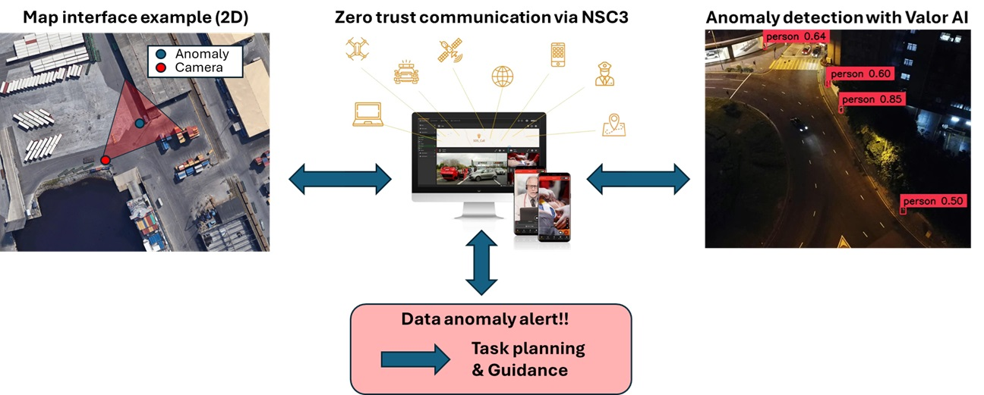
Figure 15. An example how NSC3 will operate under Zero trust communication with other devices (camera in this example) and how this data will be utilized when planning further actions, if facing unwanted anomalies/objects.

Trusted SitAw Application Support

The NSC3 platform contributes to the situational awareness application layer by providing real-time map-centric visualization, live video integration, AI-driven object detection, and geofencing. These components together enable operators to maintain comprehensive, continuous awareness of a secured area.

SitAw Data Authorization

Access to situational awareness data within NSC3 is governed by role-based access control (RBAC). Each user is assigned a role — such as operator or commander — that determines which video streams, map data, and system functions they may access. Authorization is enforced on a per-action basis, ensuring that users can only perform actions for which they have been explicitly granted permission. Unauthenticated access is always blocked.

SitAw Data Catalogues and Discovery

NSC3 manages a registry of connected camera sources through the Network Streaming Service (NSS). Camera sources, together with their spatial metadata (geolocation, field of view, and viewing angle), are registered and maintained by authorised operators. Map layers — including detection overlays and 3D building models — are managed as selectable data layers within the platform. Detection models used by the object detection service are configurable per task, supporting discovery and selection of available models.

Secure Communications

All communications within NSC3 use secured connections to prevent interception or tampering. The platform operates within a closed internal Docker network, with all external traffic mediated through a gateway acting as a reverse proxy, ensuring that no internal service is directly exposed to the internet. Where feasible, data filtering and initial validation are applied at the edge to reduce processing latency without weakening the security boundary.

Trust Enforcement

Identity & Authentication

Every user must verify their identity before gaining access to NSC3. Multi-factor authentication (MFA) is required, combining a password with a secondary factor such as a hardware token or biometric verification. All unauthenticated access attempts are strictly blocked, ensuring that only verified security personnel can access operational data and system controls.

Policy Management

Zero trust policies govern the NSC3 system under the principle of never trusting any user or device by default. RBAC policies define the access rights of each user role, limiting data visibility and action scope to what is operationally necessary. Geofencing rules constitute a further layer of spatial policy, automatically enforcing area access constraints on detected objects and triggering alerts on violations.

Continuous Trust Monitoring & Control

Active sessions are continuously monitored for abnormal behaviour, including unusual access times, unexpected geographic locations, or anomalous action patterns. Devices must sustain ongoing compliance with security requirements throughout their connected sessions; non-compliance triggers re-evaluation or revocation of access.

Trust Evidence

Trust Registries (Whitelist)

Devices and video sources registered in NSC3 are implicitly considered trusted — admission to the system serves as the trust assertion. Camera sources are added exclusively through a manual registration process performed by authorised operators, preventing the injection of unauthorised or adversarial video feeds into the surveillance pipeline. Rather than maintaining an explicit whitelist that must be kept up to date, the system operates with a blocklist mentality: all registered devices are permitted by default, and trust is revoked on a per-device basis if a device is identified as compromised or otherwise unsafe. Blocking a device immediately revokes its access across the platform without requiring changes to other device records.

Log & Audit

Comprehensive audit logging is implemented throughout the platform. Every user action is recorded in a tamper-evident audit trail to support accountability and incident response. All video, audio, and sensor data is cryptographically signed at the source to enable chain-of-custody verification. Periodic hash-based integrity checks are applied to stored recorded material to detect any post-ingestion tampering.

Critical energy distribution (UC4)
<The purpose of this section is to describe the functional areas/blocks into which the use case is contributing, explanation of the colored marks in the Figure 7.>

A distribution network operated by an energy community aggregator, as a cooperative, wants to develop the means to use flexibility in case of reliability issues in the distribution grid or when asked by the upstream network operator. At the same time, this operator is managing an energy community composed of a part of the consumers in the area, targeting to optimize the energy contracts definition considering user’s flexibility, energy prices, and operation costs. A flexibility aggregator gets involved to collect and provide this flexibility.
Main contribution area to the Sa4CPs concept (see Figure 10): Distributed AI/explainable AI, digital twin. Several initiatives in the field focus on energy aspect, ignoring the learning of user's comfort and flexibility.
Targeted innovation boosted by the Sa4CPS concept: Use of Explainable AI (XAI) for situational awareness; Activation of Flexibility with XAI; Use of federated learning models for energy communities Target business impact: Use of flexibility; Optimization of resource use.

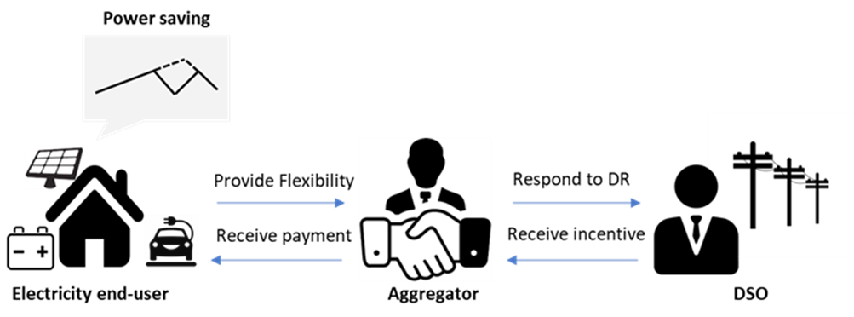

Figure 16. UC4 concept.

Security and location awareness of persons (UC5)

<The purpose of this section is to describe the functional areas/blocks into which the use case is contributing, explanation of the colored marks in the Figure 7.>

UC5 contributions are marked with red dots in Figure 7. Next, these connections and contributions from UC5 to the Sa4CPS framework are described.

Trust Enforcement

Trust Formation & Evaluation

The Behavioural Data Hub developed in UC5 contributes to Trust Formation & Evaluation by constructing a dynamic, behaviour-derived trust model for individual users. Rather than relying on static identity assertions, the hub continuously aggregates behavioural signals – spanning browsing, messaging, device hygiene, and security awareness interactions – and normalises these into a privacy-respecting feature representation. A hybrid risk engine, combining rule-based logic and machine learning models, evaluates the resulting features to form an evidence-based assessment of the user's current risk posture. Privacy-by-design mechanisms, including consent management, data minimisation, and pseudonymisation, ensure that trust formation operates within a governance-compliant framework. An explainability layer translates model outputs into user-facing insights, making the trust evaluation transparent and actionable.

Continuous Trust Monitoring & Control
The Behavioural Data Hub implements Continuous Trust Monitoring & Control by treating trust as a continuously evolving trajectory rather than a point-in-time determination. Behavioural signals from all integrated protection touchpoints – including scam detection, browsing protection, identity monitoring, and device hygiene – are continuously ingested and used to update the user's risk profile. Deviations from established behavioural baselines, or from peer-group norms derived through privacy-preserving analytics, are surfaced as risk indicators triggering re-evaluation. The hub also monitors whether users respond to security awareness signals, connecting protective interventions to observable behavioural outcomes and thereby enabling a closed feedback loop between threat detection and trust state updates. Model governance and evaluation processes ensure the monitoring pipeline remains accurate, auditable, and aligned with evolving threat patterns.

Trust Enforcement

Trust Formation & Evaluation

The Behavioural Data Hub developed in UC5 contributes to Trust Formation & Evaluation by constructing a dynamic, behaviour-derived trust model for individual users. Rather than relying on static identity assertions, the hub continuously aggregates behavioural signals – spanning browsing, messaging, device hygiene, and security awareness interactions – and normalises these into a privacy-respecting feature representation. A hybrid risk engine, combining rule-based logic and machine learning models, evaluates the resulting features to form an evidence-based assessment of the user's current risk posture. Privacy-by-design mechanisms, including consent management, data minimisation, and pseudonymisation, ensure that trust formation operates within a governance-compliant framework. An explainability layer translates model outputs into user-facing insights, making the trust evaluation transparent and actionable.

Continuous Trust Monitoring & Control
The Behavioural Data Hub implements Continuous Trust Monitoring & Control by treating trust as a continuously evolving trajectory rather than a point-in-time determination. Behavioural signals from all integrated protection touchpoints – including scam detection, browsing protection, identity monitoring, and device hygiene – are continuously ingested and used to update the user's risk profile. Deviations from established behavioural baselines, or from peer-group norms derived through privacy-preserving analytics, are surfaced as risk indicators triggering re-evaluation. The hub also monitors whether users respond to security awareness signals, connecting protective interventions to observable behavioural outcomes and thereby enabling a closed feedback loop between threat detection and trust state updates. Model governance and evaluation processes ensure the monitoring pipeline remains accurate, auditable, and aligned with evolving threat patterns.

Trusted SitAw Application Support

Decision: Digital Twins and dashboards

Halo (previously Trusted Companion) is a mobile consumer cybersecurity product concept developed in UC5 and designed around the principle that security awareness requires both clarity and context. The core design challenge is translating complex, multi-layered security data into visualisations that are immediately meaningful to a non-expert user – enabling them to understand their current security posture at a glance, and to act on specific threats without friction. This is achieved through a two-tier information architecture: high-level status visualisations that give the user a continuous, consolidated view of how well they are protected, and contextual detail surfaces that expose the situational signals relevant to a specific moment or risk. The research and design work underpinning this focuses on how data visualisation can bridge the gap between raw security telemetry and genuine user comprehension – turning passive monitoring into active, informed decision-making for everyday consumers.

Action: Detection & response / Autonomous operations

The Behavioural Data Hub connects protection touchpoints to observable behavioural outcomes, enabling detection and response at the human layer. When a risk score crosses a threshold or an anomalous pattern is identified, the system can trigger awareness signals, recommend protective actions, or adapt the product's protection posture. This closes the situational awareness loop from perception through to action, with the hub serving as the intelligence layer that determines what response is contextually appropriate.

Multirouting secure awareness system for outdoors (UC7)

<The purpose of this section is to describe the functional areas/blocks into which the use case is contributing, explanation of the colored marks in the Figure 7.>

Natlink & Tracker: Enabling Technologies and Cross-Use Case Contributions
<The purpose of this section is to describe the functional areas/blocks into which the use case is contributing, explanation of the colored marks in the Figure 7.>

Natlink and Tracker, through Use Case 7 (UC7), will deliver an advanced multirouting secure awareness system tailored for outdoor and mission-critical environments, Figure 13. The UC7 concept is designed to maximize system resilience, operational flexibility, and security, providing a robust reference architecture that can be leveraged by other Sa4CPS use cases. Key findings, technical solutions, and research results will be published to the Sa4CPS consortium, and active collaboration during research and implementation phases is encouraged and preferred to accelerate progress and maximize impact.

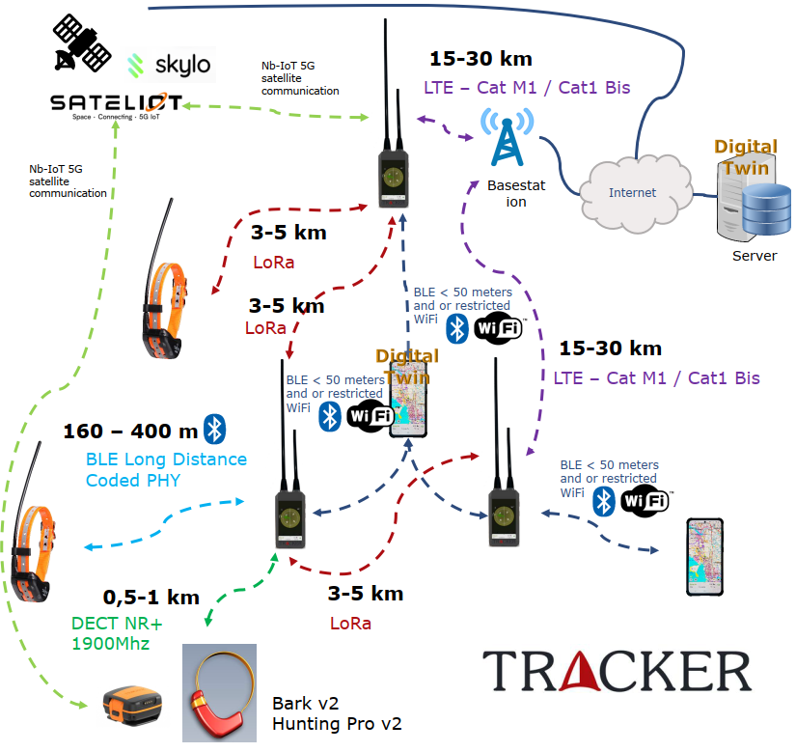

Figure 19. Natlink view to the UC7 concept.

Phased Technology Development and Evaluation
UC7 will begin with a comprehensive evaluation of radio technologies, including LoRa, LoRaWAN, DECT NR+, Bluetooth Low Energy (BLE) Long Range, LTE Cat-M1, LTE CAT 1 bis, and satellite communications (3GPP Rel 17, with providers such as Sateliot and Skylo). Each technology will be assessed for its RF propagation characteristics, link budget, interference resilience, power efficiency, and practical usability in the field. The evaluation will also include a detailed study of radio Power Classes, with a particular focus on the feasibility and practical implications of using Power Class 1 (31 dBm) radios to extend uplink range and reliability. The research will consider device size, battery life, heat dissipation, and regulatory requirements, ensuring that the selected solutions are both effective and compliant.
Antenna design and integration will be a major research focus. The project will investigate multi-band, MIMO (Multiple Input Multiple Output), and diversity antenna configurations, aiming to optimize simultaneous multi-radio performance and minimize intermodulation, desensitization, and cross-talk effects. Special attention will be paid to maximizing antenna efficiency through correct coupling resistances and impedance matching, and to exploring the potential to extract additional output power from modem modules via specific AT commands or firmware settings, leveraging the flexibility allowed by 3GPP Power Class 3 specifications. All antenna solutions will be validated through extensive laboratory and field trials to ensure optimal performance under real-world conditions.oThe research will not only focus on technical performance but also on regulatory and operational constraints, such as duty cycle limitations, frequency allocations, and device certification processes. Collaboration with other consortium partners is encouraged to share test results, harmonize design choices, and accelerate the adoption of best practices across use cases.

Dog Tracking Devices: Communication, Antenna Research, and Security
Dog tracking devices are a cornerstone of the UC7 system, enabling continuous, reliable monitoring of animals in challenging outdoor scenarios. These devices will be equipped with multiple radio interfaces, including LoRa, LoRaWAN, BLE Long Range, LTE Cat-M1, and NB-IoT. LTE Cat-M1 and NB-IoT will provide continuous, low-power cloud connectivity, supporting real-time tracking, health monitoring, and remote configuration. LoRa, in contrast, will be used specifically for direct point-to-point communication between the dog tracking collars and the Multicommunicator, ensuring that critical data can be exchanged even when cellular connectivity is unavailable or unreliable. LoRaWAN may be used as an alternative network solution where infrastructure is available.
Antenna and device size optimization will be approached systematically. By utilizing existing mechanical designs from Tracker Artemis, Luna, and Bark products, the project will conduct comparative studies of various antenna configurations, device enclosures, and placement strategies. The goal is to identify the best trade-offs between device size, antenna efficiency, battery life, and user ergonomics. Field trials will be conducted in diverse environments to assess radio range, signal robustness, and device durability under real operational conditions.LoRa communication presents unique challenges, including limited available frequencies, strict duty cycle regulations, and the constraint of a single 0.5-watt channel. To address these, the data protocol for LoRa (and BLE Long Range) will be highly optimized and compressed, with typical payloads limited to around 20 bytes to maximize transmission range and reliability. Advanced data compression, protocol minimization, and efficient error correction will be explored. All data transmitted over these links will be encrypted to ensure confidentiality and integrity, even in the most constrained environments.Security is a fundamental requirement across the entire system. All dog tracking devices, the Multicommunicator, the mobile application, and backend services will be developed within a unified security framework. This includes the implementation of strong symmetric encryption (AES-128), secure key management, mutual authentication, and compliance with relevant EU and international standards (RED, CRA, GDPR, Data Act, ETSI EN 303 645). Security features will be validated in each device and at every communication interface, ensuring end-to-end protection of data and user privacy throughout the ecosystem. The project will also investigate secure device provisioning, over-the-air (OTA) firmware updates, and secure device addition/removal workflows, ensuring that security is maintained even in offline or low-connectivity scenarios.aMulticommunicator: Versatile Communication Hub
The Multicommunicator is envisioned as a central hub and gateway within the UC7 system, providing seamless connectivity, data aggregation, and network extension capabilities:
- Network Extender & Sharing: The Multicommunicator will aggregate connectivity from multiple uplinks (LoRaWAN, LTE Cat-M1, CAT 1 bis, NB-IoT, satellite) and share this boosted network locally to users’ mobile phones. Network sharing will be realized through technologies such as WiFi, WiFi Direct, Bluetooth, or other suitable methods. A key research objective is to identify the most effective and user-friendly technology for this purpose, balancing performance, energy consumption, and ease of use.
A critical requirement is that network sharing must not block or interfere with normal phone operation: when Natlink-related or other selected data is delivered via the Multicommunicator, other mobile applications and data (such as WhatsApp or general internet access) must continue to function through the phone’s own native network connection. This ensures seamless user experience and system integration.kMulti-Radio Gateway: The Multicommunicator will function as a direct multi-radio receiver and router, aggregating, multiplexing, and routing data from dog collars (via LoRa), environmental sensors, and handheld devices across different PHY/MAC layers. Protocol translation, redundancy, and data prioritization will be implemented to ensure reliable and efficient data flow. LoRaWAN will be one of the key technologies researched and potentially utilized for both uplink and downlink communication between devices and the Multicommunicator, where infrastructure is available.nSatellite Uplink Node: For satellite communication, the Multicommunicator will leverage 3GPP Release 17 NTN (Non-Terrestrial Networks) capabilities, enabling direct device-to-satellite connectivity. Providers such as Sateliot and Skylo will be evaluated, with openness to integrating other suitable satellite IoT service providers as the technology landscape evolves. The system will explore fallback strategies, multi-path routing, and dynamic link selection to maximize availability and resilience.
All system components—including dog tracking devices, Multicommunicator, mobile applications, and backend—are designed with extensibility in mind. This means they will support third-party connectivity, allowing integration of accessories, other vendor devices, and external services. This open architecture approach is aligned with the main goal of the SA4CPS project: to improve secure situational awareness through interoperable, multi-vendor, and collaborative solutions. Secure APIs, modular interfaces, and standardized protocols will be developed to facilitate this integration while maintaining robust security and privacy controls.eAll functionalities will be implemented with modular, extensible hardware and firmware, supporting dynamic reconfiguration, remote management, and future expansion. The project will also investigate power management strategies, ruggedization, and environmental protection to ensure reliable operation in harsh outdoor conditions.

Mobile Application, Offline Operation, and Visualization
A core component of UC7 will be a mobile application that provides users with a comprehensive situational overview and full control of the system. The application will feature an interactive map interface powered by a 3D map engine, enabling real-time visualization of tracked assets, device statuses, and environmental data. Users will have access to versatile visualizations, including 3D terrain, object overlays, historical playback, event notifications, and predictive analytics. The mobile app will serve as the primary control interface, allowing users to configure devices, manage system settings, and issue commands remotely—enabling full system control and situational management directly from a smartphone or tablet.
A critical research and development focus will be to ensure that the mobile application and system are fully operational offline, without continuous IP network connectivity. The system will be designed to handle all essential functions—including secure data encryption and decryption, device addition and removal, and local data storage and synchronization—entirely on the mobile device. This ensures that users can maintain security, privacy, and operational control even in remote areas or during network outages, with all cryptographic operations and device management use cases functioning independently of the backend. The app will also support seamless synchronization and conflict resolution when connectivity is restored. Like other components, the mobile application will be designed to support third-party accessories and services, further enhancing the ecosystem’s flexibility and reach.gBackend: Digital Twin and Visualization Dashboards
The backend architecture will center around a Digital Twin system, providing real-time and historical monitoring, predictive analytics, and operational dashboards. The Digital Twin will maintain a synchronized, structured representation of all devices, assets, and environmental data, supporting advanced analytics, anomaly detection, and decision support. Visualization dashboards will be available for mobile, server, automotive (Android Auto/Apple CarPlay), and wearable platforms, enabling users and support teams to monitor system status, analyze trends, and respond to events.
The backend will leverage containerized microservices (e.g., Kubernetes, Docker), time-series databases (e.g., MongoDB Atlas), and event-driven data pipelines (e.g., Google DataFlow) for scalability, reliability, and maintainability. The architecture will support bidirectional synchronization, role-based access control (RBAC), and secure APIs for integration with third-party systems and services. Key architectural patterns, APIs, and research results will be documented and shared with the consortium to facilitate reuse and cross-use-case adoption.iCybersecurity, Ciphering, and Serialization
UC7 will implement a multi-layered cybersecurity framework aligned with EU and international standards and regulations:
- Encryption & Key Management: AES-128 (Advanced Encryption Standard, FIPS 197) will be used for all sensitive data, with secure key provisioning, storage (e.g., HSM, TPM), and rotation. Asymmetric cryptography (ECC, RSA) will be evaluated for mutual authentication, OTA firmware signing, and secure device onboarding.
- Protocols & Compliance: All communications and data handling will comply with the Radio Equipment Directive (RED, 2014/53/EU), Cyber Resilience Act (CRA), General Data Protection Regulation (GDPR, EU 2016/679), Data Act (EU 2023/2854), and ETSI EN 303 645 (IoT cybersecurity baseline). The NSTP protocol will provide secure session management, mutual authentication, integrity verification (e.g., HMAC, SHA-256), and comprehensive audit logging.
- Serialization: Serialization protocols under consideration include JSON, Protocol Buffers (Protobuf), CBOR (RFC 7049), custom binary formats, and MessagePack. MessagePack is favored for resource-constrained and low-latency environments due to its compactness and speed. The project will evaluate serialization choices for efficiency, security, and interoperability.
- Access Control & Privacy: The backend and mobile application will implement RBAC, fine-grained access policies, pseudonymization/anonymization for personal data, and full audit trails to support regulatory compliance, incident response, and user trust.

Cross-Use Case Value
The multirouting secure awareness system, Multicommunicator, dog tracking devices, and mobile application developed in UC7 will provide a comprehensive, resilient, and secure reference architecture for situational awareness in demanding environments. The approach is modular and extensible, allowing other Sa4CPS use cases to adopt, adapt, or integrate key components and research findings. Key findings, technical solutions, and research results will be published to the Sa4CPS consortium, and active collaboration and co-operation during research and implementation phases is encouraged to maximize impact, accelerate progress, and ensure that the consortium as a whole benefits from shared expertise and innovation.

Polar data synchronization device for multiple wearables data collection

<The purpose of this section is to describe the functional areas/blocks into which the use case is contributing, explanation of the colored marks in the Figure 7.>

Polar Electro's research in improving situational awareness and data connectivity is focused on the development of a biometric data synchronization device that can be used to collect data from several wearable devices at the same time during activities. The purpose of the synchronization device is to serve the real-time monitoring of the information recorded about the group at the individual level, to create the conditions for anticipating control measures and making immediate decisions if the data obtained from the individual and the group so requires, for example, due to a decline in functional capacity.
After the data transfer, the situational awareness information is used in real time on the mobile devices of several different operators separately for each purpose of use and control. The historical data and its statistical processing, analysis and replanning of operations are done in the Polar Guidance Service system.

Table 9. Main use scenarios of the Polar’s view to the UC7 concept.
Data transfer method | User group | Context and Use case | Data items | Power (electrical/battery)
Real-time via BLE | Gym (Group sessions) | HR data visualization during gym training (body pump, spinning) | HR | Battery
 | Schools | HR data visualization during physical education | HR | Battery
 | Sport club premises | Data live stream during practices and matches | HR  Training load (Muscle/Cardio)  Power  Speed  Location | Battery  Electrical
 | Firefighters, First responses, Police | Monitoring Firefighters, polices and first responses physical load during missions | HR  Training load (Muscle/Cardio)  Power  Speed  Location | Battery
 | Clinics and Hospitals | Monitoring patients' data during and after care | HR  RRi/PPi  Skin temp  ACC  GYRO | Battery  Electrical
 | Military | Collecting and visualizing live data during military field events | HR  RRi/PPi  ACC  GYRO  Glucose  Skin/Body temp  GNSS | Battery  Electrical / Power supply
Offline data sync via BLE | Military: Barracks, Vehicles, Base camps | Synchronizing  Offline data recordings  24/7 Smart Coaching algorithm data  24/7 sample data | 24/7 Sample data (HR, PPi, MET, TRIMP, Skin temp)  Offline data (HR, PPi, ACC, GYRO, BARO, Skin/Body temp, Glucose)  Sleep  Activity  Training sessions  Training load  Performance tests  Recovery  Stress | Electrical / Power supply
Offline/Training data sync via USB | Sport performance labs | Synchronizing Training session data after test | Training sessions | Electrical
 | Military: Data collection events, Barracks | Synchronizing offline recordings and training session data | Offline recordings  Training sessions

Synchronize device model:
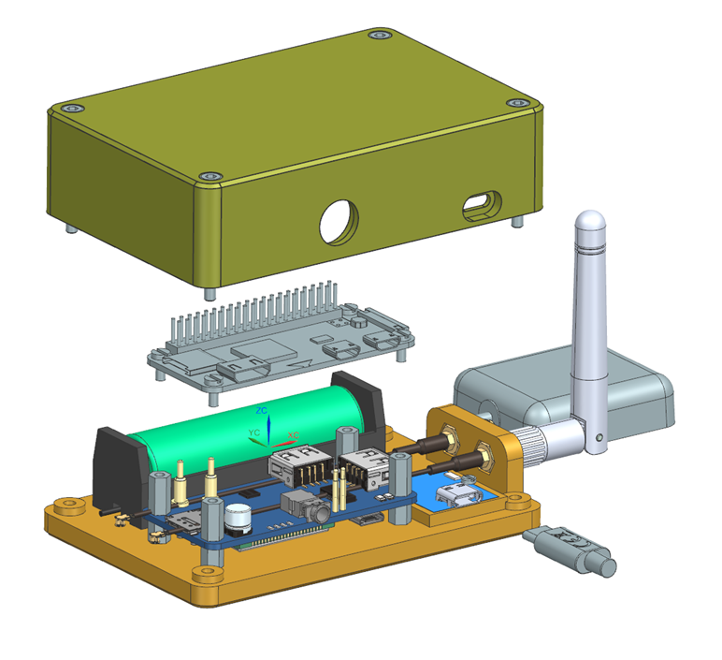
Figure 20. Setup for Raspberry PI Zero W / Raspberry PI 5 + 4G Module

Prerequisites
One of
- Raspberry PI Zero W: https://www.raspberrypi.com/products/raspberry-pi-zero-w/
- Raspberry PI 5
- Sandisk Extreme Pro 64GB microsd memory card https://www.verkkokauppa.com/fi/product/794368/SanDisk-64-Gt-Extreme-Pro-SDXC-UHS-I-muistikortti
- 4G pHAT for Raspberry Pi - LTE Cat-4/3G/2G with GNSS Positioning https://thepihut.com/products/4g-phat-for-raspberry-pi-lte-cat-4-3g-2g-with-gnss-positioning
  - Contains SIM7600G-H circuit. Official manual homepage: https://www.waveshare.com/wiki/SIM7600G-H_4G_HAT_(B)
- A SIM Card for 4G connection
- Raspberry PI Imager v.18.5
- 5V USB power source.
- HDMI Mini/micro (pi 5) connector, keyboard, mouse and a display for local development mode
Indicator LEDS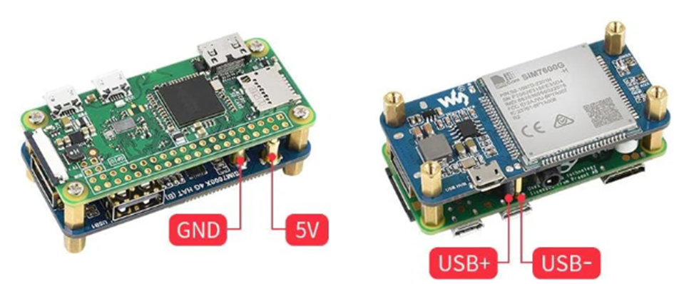
Figure 21. Structure of the experimental prototype.

Drone operation control system (UC8)

<The purpose of this section is to describe the functional areas/blocks into which the use case is contributing, explanation of the colored marks in the Figure 7.>

The Figure 16 represents the core concept of the intended system developed in UC 8: a situational awareness platform for aerial drone operations, receiving and processing all relevant flight information, assessing an operation’s current state, and enabling various outputs and feedback loops enhancing operational safety and automation.

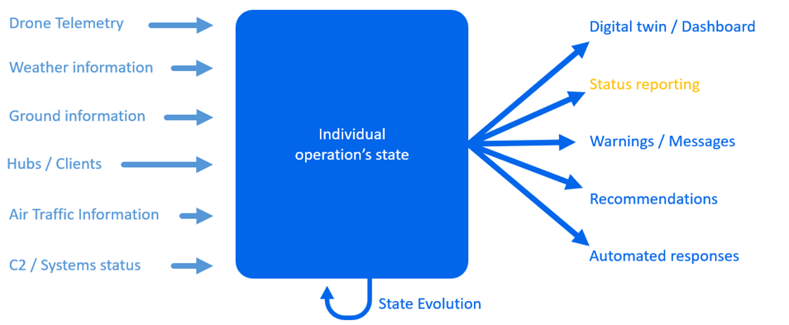
Figure 22. A view to the UC8 concept.

This platform will at first be used to enhance ADLC’s flight operations as part of its growing drone transportation service, but could also become useful for other aerial drone operators (including for other use cases like inspection), and could easily be adapted for other types of remotely monitored automated vehicles.

Key members of this use case ecosystem are:
- Regulatory authorities: Regulations for the remote monitoring for a large scale fleet of unmanned aerial vehicles do not exist or are unclear at this moment, but as it has a safety impact the use of the platform will need to be approved for some of its outputs. The Belgian Civil Aviation Authority is already kept informed of the project.
- Drone manufacturers: They usually design flight control systems to be used directly and continuously during the flight. The developed platform enables control on a higher layer, but does require their cooperation and understanding.
- Existing operational staff: Drone pilots will remain in the loop of the system, and their feedback is key to enable safe high volume operations where they can focus on solving situations which can not be safely automatically resolved.

Use Case 8 contributes to the Sa4CPS project as it explores:
- Situational awareness in the case of automated vehicles, imposing the taking into account of movement in its projections.
- Perception and comprehension of more than the physical system itself, but of all external factors that affect its operation.
- Perception and comprehension through a global control system, not only on the device itself, and therefore including as core components communication links wrt. Reliability and security.
- The inclusion of a human in the loop of the system, also needing to reach comprehension via the system and able to conduct actions and respond to incidents.
- The prospective utilization of the system in high-risk environments, leading to important requirements on reliability and sufficiently low latency.

Management of CPS assets (UC9)
<The purpose of this section is to describe the functional areas/blocks into which the use case is contributing, explanation of the colored marks in the Figure 7.>

Vintecc uses the Capture platform to monitor remote devices (in factories, driving vehicles, etc), Figure 17. The contribition of UC9 is to use Capture to provide the possibility to remotely update the OS and application software of remote devices in a uniform way, regardless if they are running in Windows, Linux or Docker.
Keeping the host OS of CPS secure contributes to T5.1 Identification, verification and access control, through Identity & Access Management (FB2).

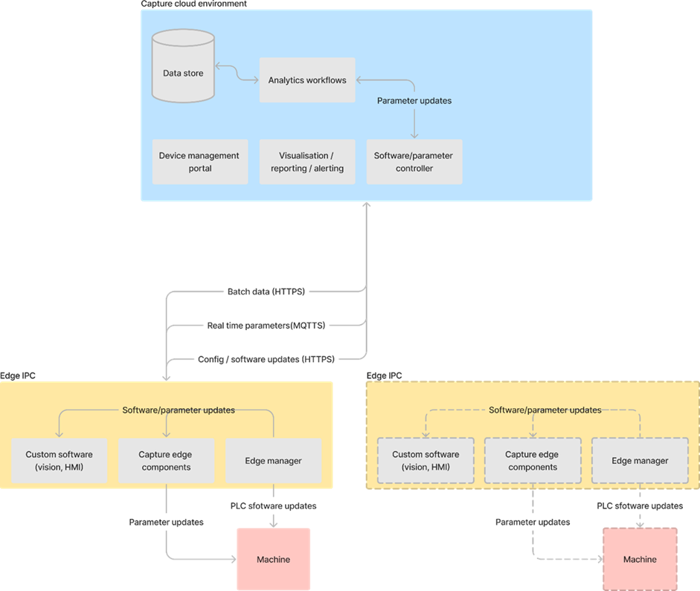

Figure 23. A view to the UC9 concept.
A second contribution is the situational awareness of cyber physical systems regarding updates and device writes (for example configuration of physical machines from the cloud). The situational awareness should allow the system to automatically block actions that could result in a dangerous situation (physical harm to machines, animals or people). This contributes to T4.4 Detection and Responses through Comprehension (FB5). This situational awareness can be situated in the cloud (blocking a dangerous action before it is sent to the CPS), or on the CPS itself. It should also allow the CPS to schedule updates in a time when this update can safely be executed, without intervention of a human.

Contributions derived from the project story
<The purpose of this section is to describe the functional areas/blocks into which the use case is contributing, explanation of the colored marks in the Figure 7. >
Contributions derived from the project story focus on the components marked with a yellow triangle in Figure 7. In the following, level three headings correspond to the layers in the figure with level four headings targeting specific components.

Trusted SitAw Application Support

Physical Environment Sensing, Tools for Comprehension, Position & Tracking of Objects, and Real-time 3D Maps & Tools.

VTT has implemented a Unity-based 3D model of the Port of Oulu environment. This model enables complex dynamic visualization of the environment, including static and moving objects and people.
Together with Modirum, VTT have implemented a way to feed generated video stream from within the 3D model that can be fed to Modirum’s NSC3 system that can further analyse the stream for object identification and coordinates using their ValoR AI models. The detected objects can be then fed back into the 3D model. The current level of implementation facilitates video streaming for object detection in ValoR and will be further developed towards feeding the detected objects back to the 3D model. Once the process is validated with the simulated video stream, it is possible to use an actual camera feed from the port environment, and work towards bringing the detected objects into the 3D model. Port of Oulu has also experimented with drone-based footage, which may also be considered to be analysed via ValoR.

Specifically for Real-time 3D Maps & Tools, the VTT 3D model also enables recording and playback of object locations over time, making it possible to monitor object location history, and to use them as part of later scenario simulations.

Digital Twins and Dashboards
The VTT trust backend uses digital twins to depict dynamic elements in the Port environment, with specific focus on elements that involve trusted data sharing. Eclipse Ditto was initially evaluated as the digital twin platform but as connecting it with other parts of the backend systems required extensive scripting, OpenRemote is studied as the other option.

SitAw Data Authorization
The VTT SituApp is a tool for 2D visualization of the Port, as well as managing each user’s credentials for, e.g., access to the Port area. It can be applied to visualize physical access restrictions as geofences, including violation alerts. In addition, the users can, e.g., authorize the system to have access to their location data. It acts also as the entry point for launching backend resource creation such as wallet creation and building access control lists to Digital Twin data sharing. The W3C DIDs for authentication and W3C Verifiable Credentials are applied for authorization.

VTT is designing a Trusted Data Connector for inter-partner resource sharing relying on DIDs and VCs as its trust foundation. The connector will have different modes of connection to various systems, including a dataspace connector using Eclipse Dataspace Components and a generic REST API connector for existing authentication / authorization systems. The generic REST API connector has been partially designed in co-operation with Natlink and their SteelBridge approach to EU Data Act-compatible user data sharing.

SitAw Data Catalogues and Discovery
As part of Trusted Data Connector, VTT have defined methods for metadata sharing of established inter-partner data connections. One practical implementation is the use of Data Catalogues supported by the Eclipse Dataspace Components.

Trust Enforcement

Trust Formation & Evaluation
The Identities and verifiable credentials are bound to DIDs, which are used by the VTT Trusted Data Connector for establishing trust relationships. MQTT‑based messaging using the VTT CPSHub adds an additional trust‑evaluation layer at the MQTT protocol level, where connections and per-topic permissions are dynamically validated against a trust table that is continuously updated based on users’ authentication and authorization credentials.

Continuous Trust Monitoring & Control
As part of the Trust Backend, VTT has implemented an application (Figure 24) that visualizes the hierarchical status of each user’s required and issued credentials, along with a history log and point-in-time view. The application can be run with superuser authority to visualize the entire trust status. The logged activities can also be played back for simulation purposes to recreate the users and credentials for a given scenario.

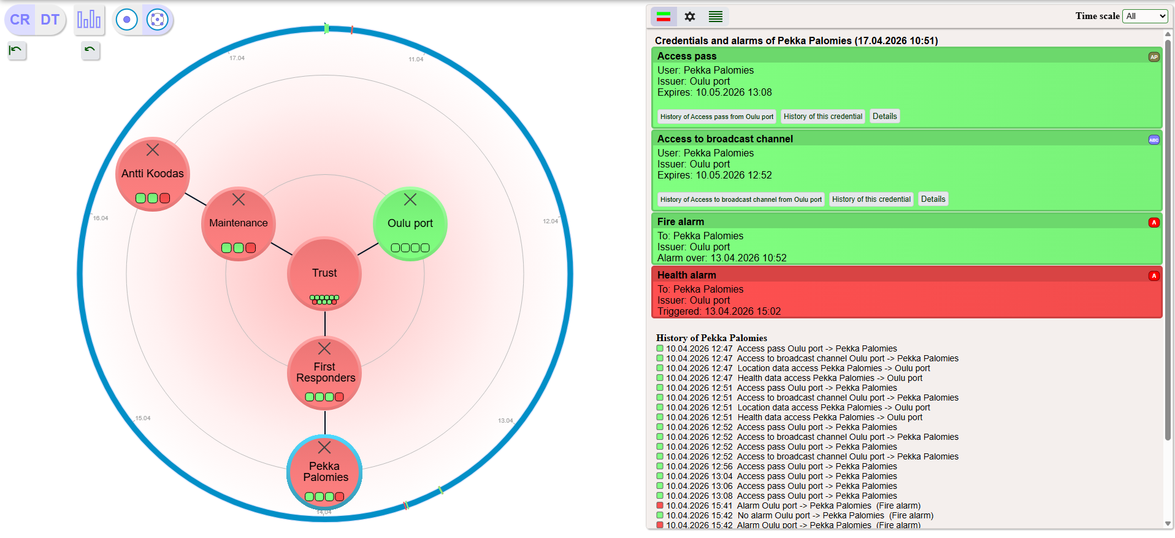
Figure 24. VTT trust status visualization app.

Identity & Authentication
The VTT Trust Backend supports the management of users, devices, roles, alarms and permissions. Both SSI (Self-Sovereign Identity, credentials always stored in user wallets only) and non-SSI (selected user credentials cached at trust backend) modes are supported.

Trust Evidence

Log & Audit
The trust visualization application keeps log of activities such as user creation, credential status / issuance / revocation and any raised alarms, which can be used to later audit the system state and actions at a given point in time.
The application also records digital twin states each time an alarm is raised.

Key enablers of the Sa4CPS concept

Key enablers of the perception and comprehension (WP3)
<short descriptions of the enablers, longer and more detailed descriptions in the D3.3>

<WP3 leader to propose the enabler candidates here>
- Secure low-latency hybdrid communication & network monitoring (ACD + OTOKAR?)
- Presence awareness module and data collection pipeline (CUNI+IMA)
- LoRA-based communication layer and tracking (Natlink+Polar)
- Battery Prognostics and Health Management (INO)

<name of the enabler>

Reasoning < name of the enabler>

Description < name of the enabler>

Solutions < name of the enabler>

Evaluation case < name of the enabler>

<name of the enabler>

Reasoning < name of the enabler>

Description < name of the enabler>

Solutions < name of the enabler>

Evaluation case < name of the enabler>

<name of the enabler>

Reasoning < name of the enabler>

Description < name of the enabler>

Solutions < name of the enabler>

Evaluation case < name of the enabler>

Discussion about novelty and KPIs

Key enablers of the status, projections and actions (WP4)
<short descriptions of the enablers, longer and more detailed descriptions in the D4.3>

<WP4 leader to propose the enabler candidates here>

EN_07 - Sa4CPS Web-Based Monitoring Platform (VigilMesh)

Reasoning
Cyber-physical operational environments involve multiple heterogeneous systems, distributed sensors, autonomous assets, and continuously evolving operational states. Traditional monitoring approaches often provide fragmented and isolated views, limiting operators’ ability to maintain a coherent understanding of ongoing activities and react effectively to operational anomalies.
There is therefore a need for a unified monitoring platform capable of integrating heterogeneous CPS information into a single operational interface, enabling real-time situational awareness, operational transparency, and informed decision-making.
EN_07 addresses this need by providing a web-based operational monitoring environment supporting real-time visibility, contextual awareness, and human-centred interaction across CPS operations.

Description
EN_07 provides the Sa4CPS Web-Based Monitoring Platform (VigilMesh), a unified web-based interface designed to support situational awareness, operational monitoring, and CPS state visualisation.
The platform aggregates heterogeneous information originating from digital twins, telemetry streams, sensor systems, risk assessment modules, event detection components, and operational services into a single integrated monitoring environment.
EN_07 enables operators to:
- monitor operational status in real time,
- visualise CPS state evolution,
- observe operational events and alerts,
- access contextual information for decision support,
- maintain awareness of ongoing system conditions.
The platform supports seamless integration with other WP4 technical enablers, including digital twin infrastructures, risk assessment engines, communication frameworks, and AI-driven event monitoring capabilities.
Key capabilities include:
- web-based operational dashboards,
- real-time data visualisation,
- event and alert monitoring,
- contextual operational awareness,
- scalable integration of CPS services.

Solutions
EN_07 introduces the following technical solutions:

Unified CPS Monitoring Dashboard
Provides a consolidated operational view integrating heterogeneous CPS data streams into a coherent interface.

Real-Time Situational Awareness Interface
Enables continuous visualisation of operational status, asset behaviour, and contextual environmental information.

Event and Alert Monitoring Mechanism
Supports observation and prioritisation of operational events, abnormal situations, and system notifications generated by WP4 intelligence modules.

Digital Twin Integration Layer
Allows seamless visual interaction with digital twin representations and operational state synchronisation.

Scalable Web-Based Architecture
Provides flexible deployment and extensibility for integrating additional CPS services, sensors, and external modules.

Human-Centred Decision Support Interface
Improves operator understanding through intuitive visualisation and contextual information presentation.

Evaluation case
The enabler will be evaluated primarily in UC1 industrial logistics operations, and where applicable in additional CPS operational scenarios, focusing on:

Situational Awareness Performance
Evaluation of operators’ ability to maintain awareness of ongoing operational conditions.

Monitoring Effectiveness
Assessment of the platform’s capability to present heterogeneous operational information in a coherent and usable form.

Event Visibility and Response Support
Measurement of the effectiveness of operational event visualisation and alert awareness.

Usability and Operator Acceptance
Evaluation of user experience, cognitive workload reduction, and operator interaction quality.

Real-Time Performance
Assessment of latency, responsiveness, and continuous monitoring capability under operational load.

Interoperability and Integration Capability
Evaluation of seamless integration with digital twins, telemetry pipelines, risk assessment systems, and communication modules.

EN_09 - Digital Twin with Semantic Backend

Reasoning

Modern cyber-physical logistics environments generate heterogeneous operational data originating from vehicles, sensors, operators, and external systems. Conventional monitoring approaches are insufficient for establishing a coherent and trustworthy understanding of operational state. There is therefore a need for an enabler capable of integrating distributed data sources into a semantically meaningful, traceable, and queryable representation that supports situational awareness and projection of future operational states.

Description
EN_09 provides a semantic digital twin backend enabling trustworthy situational awareness through knowledge-driven system representation. The enabler integrates real-time telemetry, operational events, relational asset information, and blockchain-anchored evidence into a semantic knowledge graph. Using ontology-based modelling, SPARQL reasoning, and provenance-aware state representation, EN_09 supports contextual interpretation of system behaviour, anomaly detection, and explainable operational awareness.
The enabler combines:
- semantic knowledge graph representation,
- ontology-driven CPS modelling,
- real-time state synchronisation,
- blockchain-backed provenance integration,
- reasoning and query mechanisms for operational intelligence.

Solutions
EN_09 introduces the following technical solutions:
- Semantic Digital Twin Modelling using OWL-based ontologies for representing assets, operators, tasks, and events.
- Knowledge Graph Construction from heterogeneous CPS data sources.
- Blockchain-integrated Provenance Layer ensuring verifiable operational evidence.
- SPARQL-based Reasoning Engine for contextual querying and inference.
- Anomaly Detection Support through semantic rule execution and temporal pattern analysis.

Evaluation case
The enabler will be evaluated in UC1 forklift logistics operations, focusing on:
- consistency of operational state representation,
- ability to correlate multi-source CPS information,
- traceability of operational decisions,
- semantic querying performance,
- support for real-time situational awareness dashboards,
- detection of operational inconsistencies and anomalies.

EN_02 – Perception, Comprehension & Risk Assessment Engine

Reasoning
Safety-critical drone operations require real-time understanding of continuously changing operational conditions. Raw telemetry and environmental inputs alone do not provide actionable situational awareness. There is therefore a need for a dedicated intelligence layer capable of transforming heterogeneous operational inputs into contextual risk understanding and operational projections.

Description
EN_02 provides a real-time situational awareness and risk assessment engine for drone operations. The enabler combines telemetry, weather conditions, GNSS status, airspace information, contingency boundaries, and operational context into a continuously updated operational state.
Through rule-based and contextual processing, the enabler supports:
- abnormal situation detection,
- operational risk assessment,
- collision-risk identification,
- cybersecurity-related event awareness,
- real-time situational comprehension.

Solutions
EN_02 introduces:
- Ingress Data Integration Pipeline for heterogeneous operational inputs.
- Context-aware Worker Processing for flight-specific state generation.
- Rule-Based Risk Assessment Engine for operational hazard identification.
- Real-Time Event Generation with severity-based classification.
- Operational State Persistence for recovery and post-event analysis.

Evaluation case
The enabler will be evaluated in UC8 drone operations, focusing on:
- accuracy of operational risk identification,
- timeliness of abnormal event detection,
- quality of situational understanding,
- robustness against telemetry degradation,
- effectiveness of rule-triggered event generation,
- support for safe operational decision-making.

Discussion about novelty and KPIs

Key enablers of trust, security and privacy (WP5)
<short descriptions of the enablers, longer and more detailed descriptions in the D5.3>

<WP5 leader to propose the enabler candidates here>

- Identification, verification & access control: Trusted Device Enrollment + Cloud-Assisted OOB Pairing (Polar, UC7)
- Secure information spaces, sharing & routing: Decentralized Distributed Data Storage via Private IPFS (ACD, UC1)
- Zero trust services with DLT: Triangular Accountability Model / 3AM (ERARGE + OTOKAR, UC1)
- Sensing of security situation: DNS Fingerprinting Pipeline + Behavioural Data Hub (F-Secure, UC5)
- VTT Credential-Based Trust System (VTT, Project Story)
- The technical layer of LoRa (Natlink, UC7)

Identification, verification & access control: Trusted Device Enrollment + Cloud-Assisted OOB Pairing (Polar, UC7>)

Reasoning < name of the enabler>
To ensure secure and reliable device connectivity, the system can leverage Trusted Device Enrollment combined with Cloud-Assisted Out-of-Band (OOB) pairing. This approach provides:
- Secure, zero-touch device onboarding in demanding field conditions
- Protection against unauthorized device access and pairing errors
- Reliable mapping between physical personnel and biosignal data
- Full traceability for operational analysis and compliance purposes

Description < name of the enabler>
Polar sport watches and Polar heart rate sensors support secure Bluetooth Low Energy (BLE) pairing mechanisms.

Devices equipped with a display, such as Polar sport watches, can utilize secure pairing methods including passkey entry or user confirmation, combined with physical proximity, to establish an authenticated connection with the synchronization device.

Screenless devices, such as Polar heart rate sensors, rely on user-triggered pairing mode activation (e.g., button press), ensuring that pairing can only occur when the device is intentionally made discoverable.

In this demonstrator, secure pairing can be further strengthened by leveraging pre-provisioned device credentials and cloud-assisted device enrollment, enabling the synchronization device to accept connections only from trusted and authorized devices.

The pairing process can be extended with Out-of-Band (OOB) mechanisms (e.g., NFC tap or pre-shared credentials), providing an additional layer of protection against unauthorized pairing and man-in-the-middle attacks.

Solutions < Polar data processing framework>
In practice, the Out-of-Band (OOB) pairing mechanism is implemented through pre-provisioned device identities and cloud-assisted enrollment, rather than real-time user interaction during the mission.

Each Polar device is securely provisioned with a unique identity and credentials prior to deployment using a trusted configuration channel. These credentials are registered in the cloud backend.

During mission preparation, the synchronization device retrieves the list of authorized devices and corresponding credentials from the cloud.

In the field, devices establish BLE connections automatically. The synchronization device validates each connection against the pre-provisioned credentials and cloud-based authorization data, ensuring that only trusted devices are accepted.

This approach effectively provides OOB pairing, as the trust relationship is established outside the BLE communication channel, eliminating the need for manual pairing procedures and improving both security and usability in operational conditions.

Evaluation case <the Port of Oulu>
For this demonstrator, Polar will deliver a secure data processing framework to measure firefighters’ biosignals before, during, and after fire and rescue operations. The system ensures the required level of data security by combining trusted device enrollment, secure Bluetooth Low Energy (BLE) communication, and a protected end-to-end data synchronization pipeline to cloud-based dashboards.

Secure information spaces, sharing & routing: Decentralized Distributed Data Storage via Private IPFS (ACD, UC1)

Reasoning < name of the enabler>

Description < name of the enabler>

Solutions < name of the enabler>

Evaluation case < name of the enabler>

Zero trust services with DLT: Triangular Accountability Model / 3AM (ERARGE + OTOKAR, UC1

Reasoning < name of the enabler>

Description < name of the enabler>

Solutions < name of the enabler>

Evaluation case < name of the enabler>

Sensing of security situation: DNS Fingerprinting Pipeline + Behavioural Data Hub (F-Secure, UC5

Reasoning < name of the enabler>

Description < name of the enabler>

Solutions < name of the enabler>

Evaluation case < name of the enabler>

Credential-Based Trust System (VTT, Project Story

Reasoning < name of the enabler>

Description < name of the enabler>

Solutions < name of the enabler>

Evaluation case < name of the enabler>

The technical layer of LoRa (Natlink, UC7
to WP3 ?

Reasoning < name of the enabler>

Description < name of the enabler>

Solutions < name of the enabler>

Evaluation case < name of the enabler>

Discussion about novelty and KPIs

xx

Discussion
<mapping of the key enablers, to the concept framework picture Figure 7>

Concluding remarks
This
.

References
- Endsley, M. R., & Garland, D. J. (Eds.). (2000). Situation awareness analysis and measurement. CRC press.
- Bellekens, X. J., Nieradzinska, K., Bellekens, A., Seeam, P., Hamilton, A. W., & Seeam, A. (2016). A Study on Situational Awareness Security and Privacy of Wearable Health Monitoring Devices. Int. J. Cyber Situational Aware., 1(1), 74-96
- D’Aniello, G., Gravina, R., Gaeta, M., & Fortino, G. (2022). Situation-aware sensor-based wearable computing systems: A reference architecture-driven review. IEEE Sensors Journal, 22(14), 13853-13863.
- Di Tore, P. A. (2015). Situation awareness and complexity: the role of wearable technologies in sports science. Journal of Human Sport and Exercise, 10(1), S500-S506
- Zhang, T., Yang, J., Liang, N., Pitts, B. J., Prakah-Asante, K., Curry, R., ... & Yu, D. (2023). Physiological measurements of situation awareness: a systematic review. Human factors, 65(5), 737-758

Endsley, M. R., & Garland, D. J. (Eds.). (2000). Situation awareness analysis and measurement. CRC press.
Bellekens, X. J., Nieradzinska, K., Bellekens, A., Seeam, P., Hamilton, A. W., & Seeam, A. (2016). A Study on Situational Awareness Security and Privacy of Wearable Health Monitoring Devices. Int. J. Cyber Situational Aware., 1(1), 74-96
D’Aniello, G., Gravina, R., Gaeta, M., & Fortino, G. (2022). Situation-aware sensor-based wearable computing systems: A reference architecture-driven review. IEEE Sensors Journal, 22(14), 13853-13863.
Di Tore, P. A. (2015). Situation awareness and complexity: the role of wearable technologies in sports science. Journal of Human Sport and Exercise, 10(1), S500-S506
Zhang, T., Yang, J., Liang, N., Pitts, B. J., Prakah-Asante, K., Curry, R., ... & Yu, D. (2023). Physiological measurements of situation awareness: a systematic review. Human factors, 65(5), 737-758
Rose S., Borchert O., Mitchell S., Connelly S. Zero Trust Architecture. NIST special publication 800-207. https://doi.org/10.6028/NIST.SP.800-207
Endsley, M. R., & Garland, D. J. (Eds.). (2000). Situation awareness analysis and measurement. CRC press.
Lakehal, A. et al.: Correction to: Real-time ontology-based context-aware situation reasoning framework in pervasive computing. Multimed Tools Appl. 81, 11, 14959–14959 (2022).
Mirza, I.B. et al.: Cyber-Physical-Social Awareness Platform for Comprehensive Situation Awareness. Sensors. 23, 2, 822 (2023)
Henricksen, K., Indulska, J.: Developing context-aware pervasive computing applications: Models and approach. Pervasive and Mobile Computing. 2, 1, 37–64 (2006).
Sioutis, Michael et al.: Towards a Synergy of Qualitative Spatio-Temporal Reasoning and Smart Environments for Assisting the Elderly at Home. 30th International Workshop on Qualitative Reasoning, Melbourne, Australia (2017)
Deniz, D. et al.: Efficient reconfigurable system for home monitoring of the elderly via action recognition. Engineering Applications of Artificial Intelligence. 158, 111383 (2025). https://doi.org/10.1016/j.engappai.2025.111383.

