MUFOLD Alignment Module User’s Guide

Version 2.01

31-March-2015

MUFOLD Protein Prediction Group

University of Missouri – Columbia

Computer Science Department

Engineering Building West

Columbia, MO 65201

**Description**

The MUFOLD Alignment Module *User’s Guide* describes how to run and use the various features of the MUFOLD Alignment Module. This guide includes the capabilities of the program, how to use these capabilities, the necessary input files and formats, and how to run the program on Linux Red Hat Server.

MUFOLD Protein Prediction Group, University of Missouri – Columbia

©2015 MUFOLD. University of Missouri. All Rights Reserved

**Introduction**

MUFold Alignment Module (AM) is a software combined third party alignment software. It is for LINUX platforms designed for protein alignment in protein prediction. It is written in C++ programming language and in objected oriented manner so that it is easy to modify and extend. Since protein alignment is a new field, new algorithms and techniques are continually been developed. AM design allows one to integrate and test new algorithms easily. This document describes how to use AM, its features, and the platforms on which it runs.

**Acknowledgement**

BLAST software from NCBI:

<http://blast.ncbi.nlm.nih.gov/Blast.cgi?CMD=Web&PAGE_TYPE=BlastHome>

HHSearch software from Bioinformatics Toolkit:

<http://toolkit.tuebingen.mpg.de/hhpred>

**What is needed?**

Before running AM, the following are be needed:

* A protein sequence in fasta format. E.g.

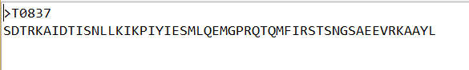

Notice the first row contains the “>” and then the protein name

The second row contains all the protein amino acid, they should be written in one row even if there are a lot of amino acids.

* A json configuration file. E.g. if it is blast experiment:

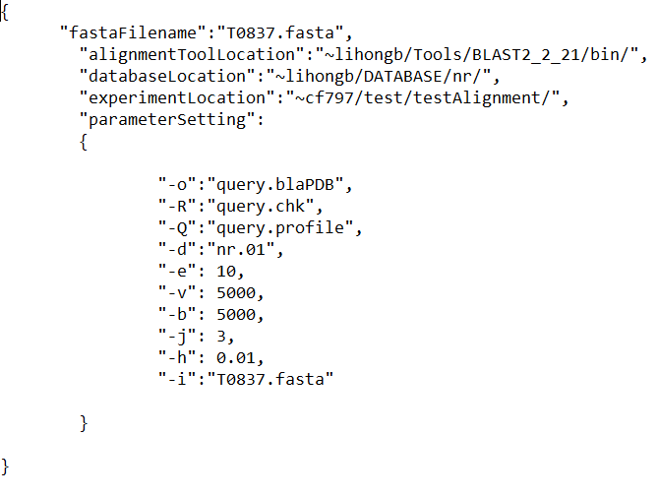

The blast json file should contain following parameters:

fastaFilename: which is the file name of the protein sequence in fasta format

alignmentToolLocation: which is the path at which the alignment tool locates

databaseLocation: which is the location of the blast database

experimentLocation: which is the location that user perform the experiment

parameterSetting: which contains all parameter settings user prefer the blast run in some fashion. Here are some parameters used in MUFOLD alignment module:

-o: output file for alignment [File Out]

-R: input file for PSI-BLAST restart [File In]

-Q: output file for PSI-BLAST Matrix in ASCII [File Out]

-d: database [String]

-e: expectation value [Real]

-v: number of database sequences to show one-line descriptions for V [Integer]

-b: number of database sequences to show alignments for B [Integer]

-j: maximum number of passes to use in multi-pass version [Integer]

-h: e-value threshold for inclusion in multi-pass model [Real]

-i: Query File [File In]

-C: Output File for PSI-BLAST Check-pointing [File Out]

Or if it is hhsearch experiment:

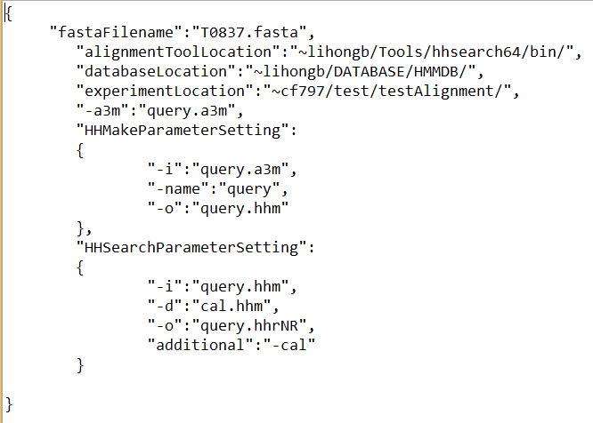

fastaFilename: the filename of the protein sequence in fasta format

alignmentToolLocation: the hhsearch tool location

databaseLocation: the database location that hhsearch tool used

-a3m: output format: all residues upper case, but gaps aligned to inserts omitted

Notice there are another two parameter settings, they are for HHMake and HHSearch main program, respectively.

For HHMake command:

-i: query alignment (should in A2M, A3M, or FASTA format), or query HMM

-o: HMM file to be written to

-name: use this name for HMM

For HHSearch main program:

-i: input query alignment

-d: HMM database of concatenated HHMs in hhm

-o: write results in standard format to file

-additional: use global/local alignment mode for searching/ranking

**How to run?**

1. Download all the code from <https://github.com/rafaelfang/TestJson> to your directory under server which has Linux platform installed.

For example:

All the code are on /home/cf797/test/AlignmentModule

1. Generate the json configuration file for your blast/hhsearch experiment following the examples provided above. Those json files should be in the same directory as the program directory
2. Create the experiment directory as you mentioned in the json file. For example: I create testAlignment folder under test directory to put all alignment results in.
3. Compile the code and generate an executable file by typing the following command:

Make clean

Make

1. If no compile errors, there will be a executable file generated named “all”
2. The most IMPORTANT thing before you run the experiment is you need to set up the before the next step, this command is a must, you need to go to linux shell to run the following command:

//export HHLIB=<install_dir>/lib/hh

//export HHLIB=~lihongb/Tools/hhsearch64/lib/hh

1. Here are some valid example to run the experiment

./all configBlast.json blast

./all configBlast.json blast configHHSearch.json hhserach

./all configBlast1.json blast configBlast2.json blast configHHSearch.json hhserach

Notice that after you type the json configuration filename, the blast/ hhsearch parameter in the command line is there to indicate that this is a blast or hhsearch experiment. They should come in pairs. Also, it is advised that if you want to run hhsearch, the blast should run first because hhsearch need a blaPDB file (generated by BLAST) as a dependency.

**What is the output you can get?**

After running the experiment, go to your experiment folder to get the experiment results. The blast will generate the results which look like: “something.blaPDB”. The hhsearch will generate the results which look like “something.hhr”. There should also be some other intermediate results such as “something.a3m” (the alignhit command), “something.chk” (blast command), and “something.chk” (blast command), etc.

**How to analysis results?**

Currently, all results generated by blast or hhsearch are in their preferred file format, which may not be proper for other module to use. There are two other ways to analysis the results for you to choose from.

1. use java program to convert the blast or hhsearch results into json format files. This is because the json format files are easy to parse into other software module. So at this point, users can use the json files are the result.

The way to generate the json format blast or hhsearch result are as followed:

1. download the jave code from /home/cf797/test/ChangeResultToJson into your experiment directory
2. compile the java program to generate the executable file:

javac ConvertBlastResultToJson.java

javac ConvertHHSearch64ResultToJson.java

If there is no compile error, the program will generate ConvertBlastResultToJson.class and ConvertHHSearch64ResultToJson.class file

1. run the executable file to get the result:

java ConvertBlastResultToJson query.blaPDB will generate blast.json file if successful

java ConvertHHSearch64ResultToJson query.hhr will generate hhsearch.json file if successful

1. Furthermore, user can use the AnalysisJson program to parse the json result into variables for next module experiments.

Download the AnalysisJson from <https://github.com/rafaelfang/AnalysisJson>

Put the json results file into your experiment directory and run the program. In this program, every piece of information is stored as an object (either HHSearch64Result or BlastResult) and printed out on the screen. But user can modify it so that the information is stored in the object being passed. The purpose of this AnalysisJson program is to let information passed through memory instead of being read from hard disk.