MigrationTool is a command line tool that helps in migrating the configuration from fortigate to sophos xg v18.

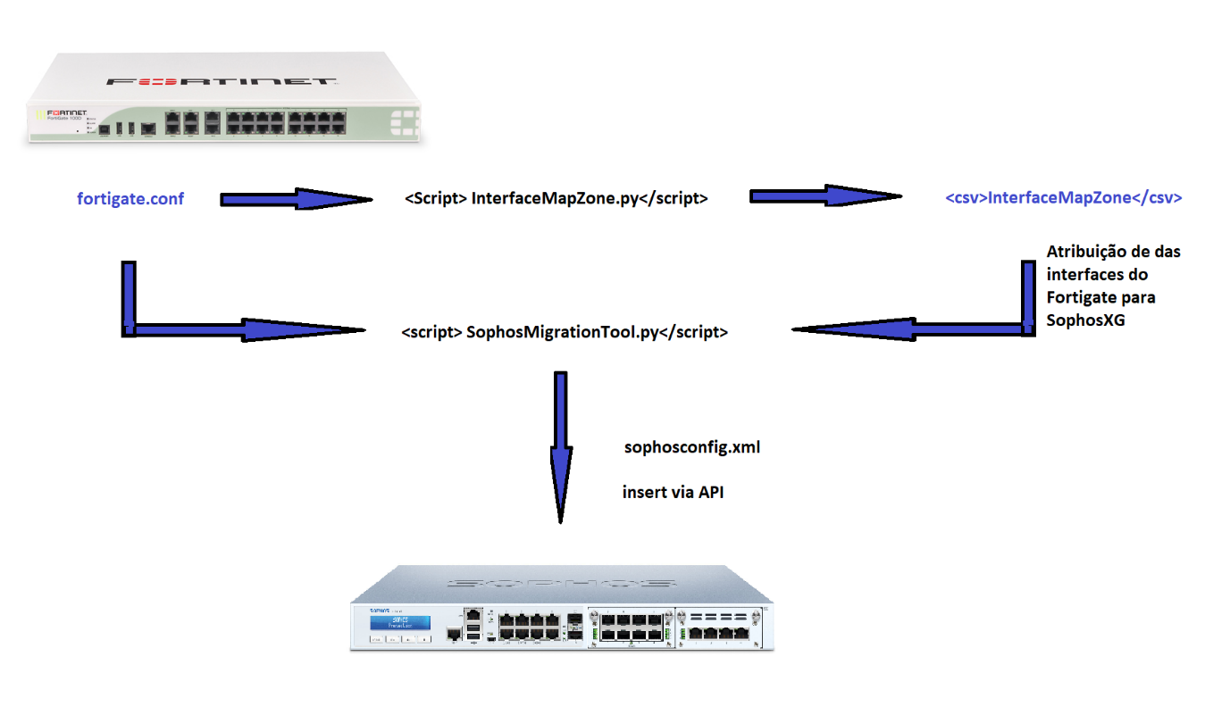

# 1 - The first step is to generate the csv file with the InterfaceZoneMap.exe program:

ex.

InterfaceZoneMap.exe --fgtconf = <FORTIGATE_CONF.conf>

This will generate the file InterfaceZoneMap.csv that should be filled with the comparison, which interface of the fortigate will be sophos xg. This file can be opened with excel:

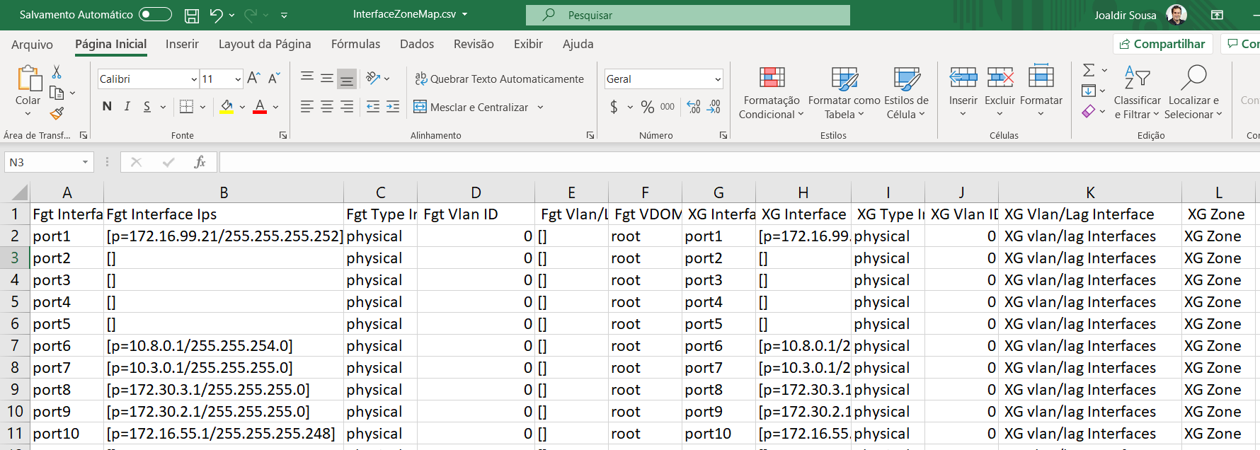

At this moment, the interface information (physical, VLAN, aggregation),vdom, IP(s), Alias, vlan id, interface of vlan / aggregation, zone will be migrated, which will be used as the basis for correctly migrating the settings. For example, we have the sophos xg zone that will be used in rule migration, as fortigate uses an interface in the rule but sophos xg uses a zone.

ex.

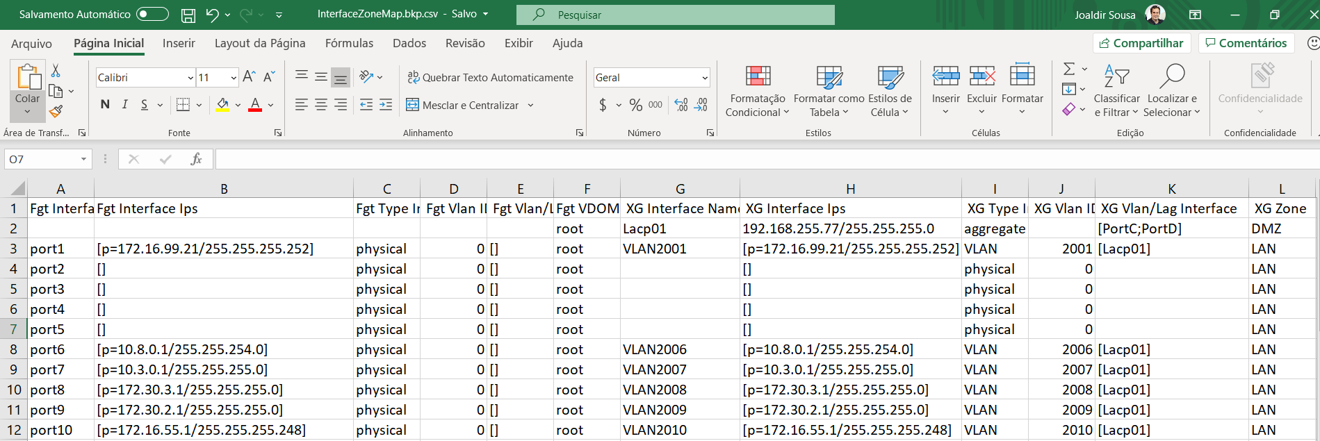

In this example, an aggregation interface Lacp01 (PortC, PortD) is created, you can create interfaces to support vlans in case fortigate has more interfaces than sophosxg. The 2001 vlan will be coupled to the Lacp01 interface through XG Vlan / Lag.

Here is the information populated from the example:

port1->VLAN2001 / port6->VLAN2006 / port7->VLAN2007 / ……..

After the InterfaceZoneMap file has been filled in, let's move on to the second step.

# 2 - The second step is now to use MigrationTool to migrate the configuration of fortigate to sophosxg .xml that will be used to place in sophosxg via api:

Ex.

MigrationTool.exe --fgtconf=<FORTIGATE_CONF.conf> --intmap=<InterfaceZoneMap.csv>

At this point we use --fgtconf = to point the path of the fortigate configuration file and --intmap = to point the path of the InterfaceZoneMap.csv file previously filled in. The output of this program will be Entities.xml. This file will be used to be inserted in sophosxg via api.

What does it migrate?

* Interface (VLAN, aggregation, physical)
* Address / FQDN / Groups
* Services / Groups
* Static Routes
* Rules
* Nats
* Ssl Inspection Rules
* Migrates the names of the profiles creating in Sophos a standard profile inserting in the rules facilitating the profile customization.

Under development:

* Vdom [Separates into separate vdom files (Entities_vdom01.xml, Entities_vdom02.xml)]
* IPSEC Tunnel VPN
* Policy Routes

Migrated aggregation configuration:

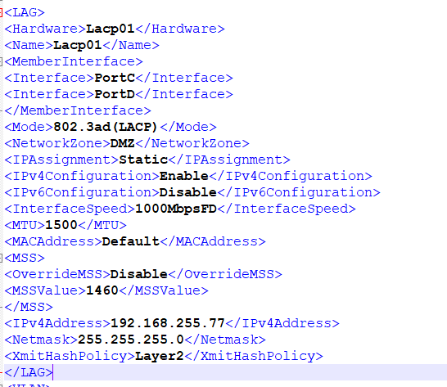

Migrated vlan configuration:

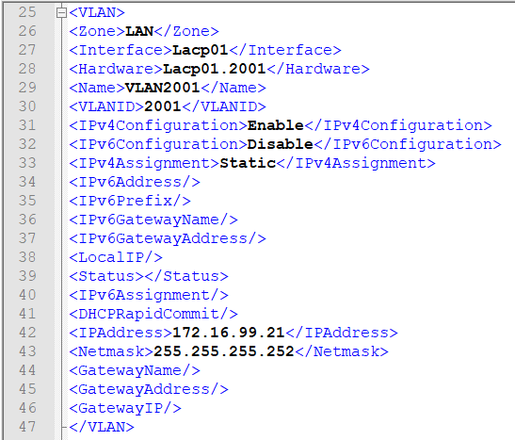

## 3 - The third step is now to send the Entities.xml file to sophosxg via API:

Let's use the program XGAPIpush.exe to send the Entities.xml file to Sophos XG

Ex.

XGAPIpush --xgconf=<Entities.xml> --user=<XG user> --password=<XG password> --xgip=<XG ip>

--xgconf= -> file generated by MigrationTool Entities.xml

--user=-> Api user

--password=-> Password

--xgip=-> Sophos XG IP

To see the progress we will access via ssh or sophos xg:



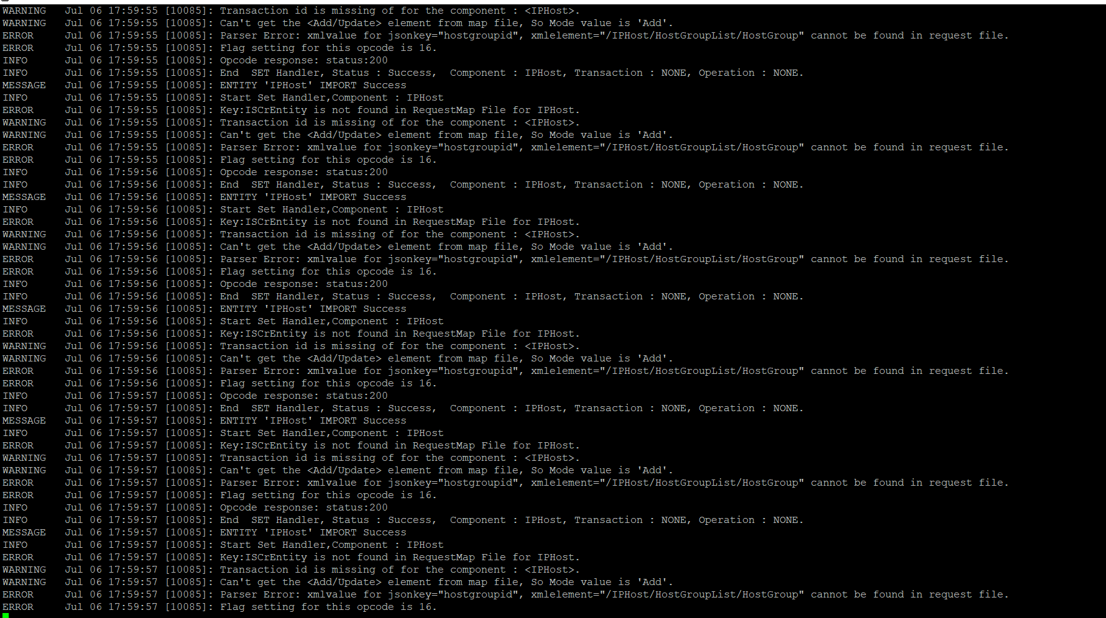

Screens:

VLANS

Conf Fortigate vs SophosXG.xml

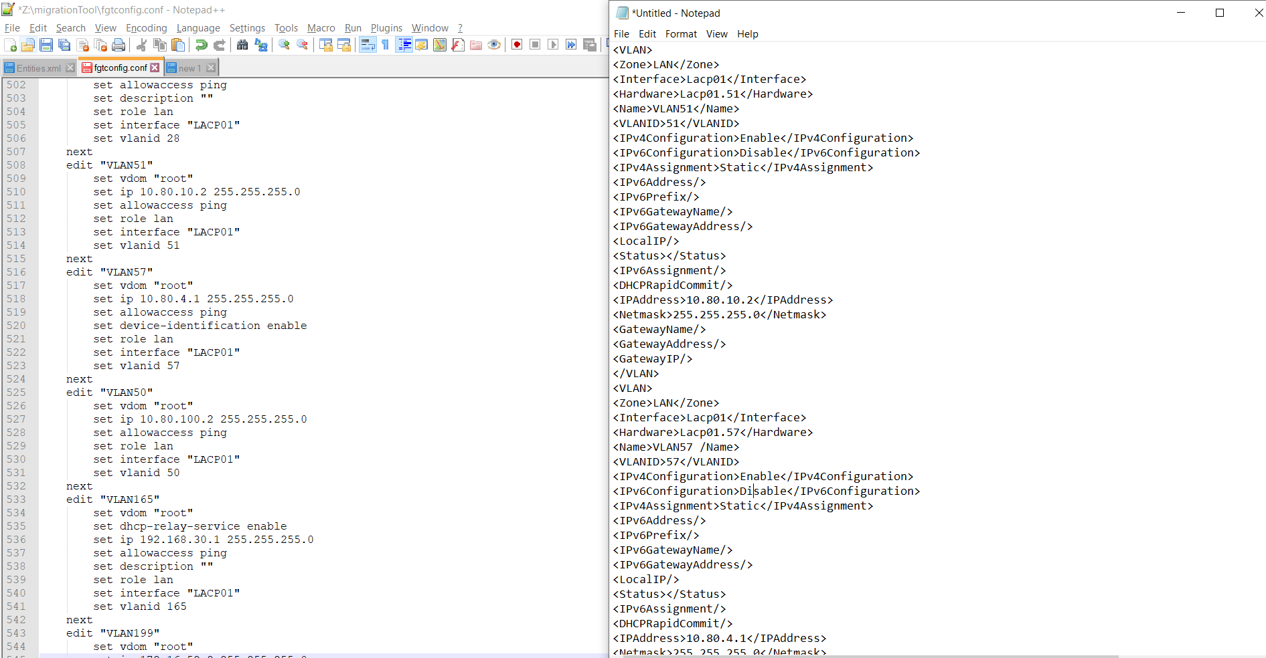

Rules

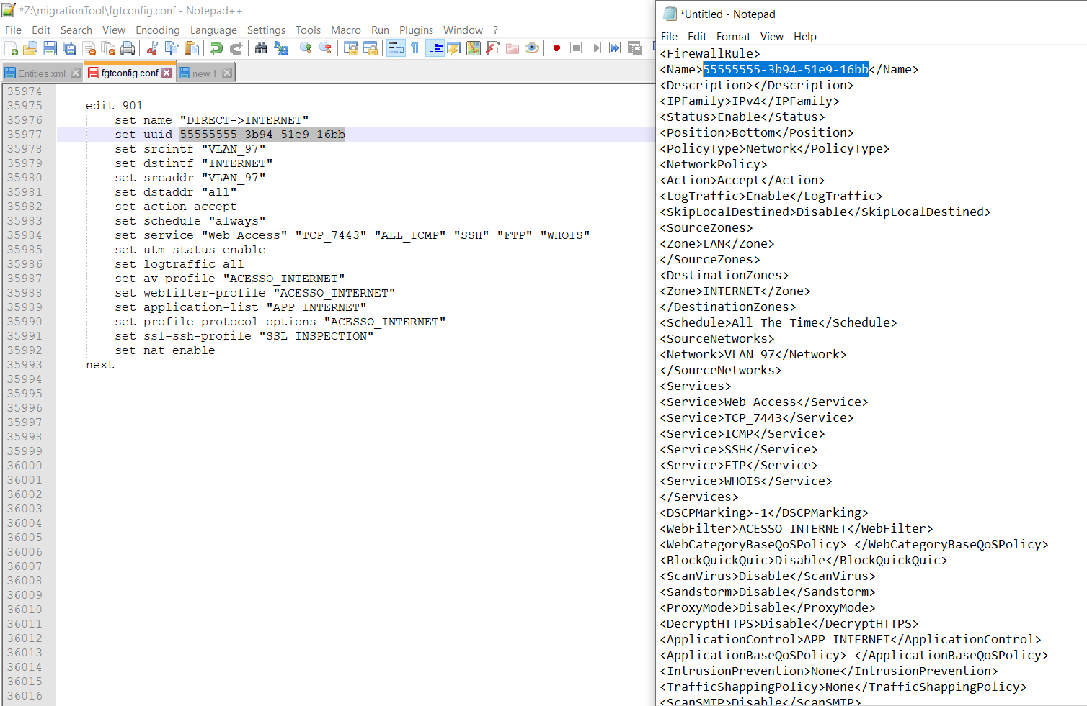

SSL Inspection:

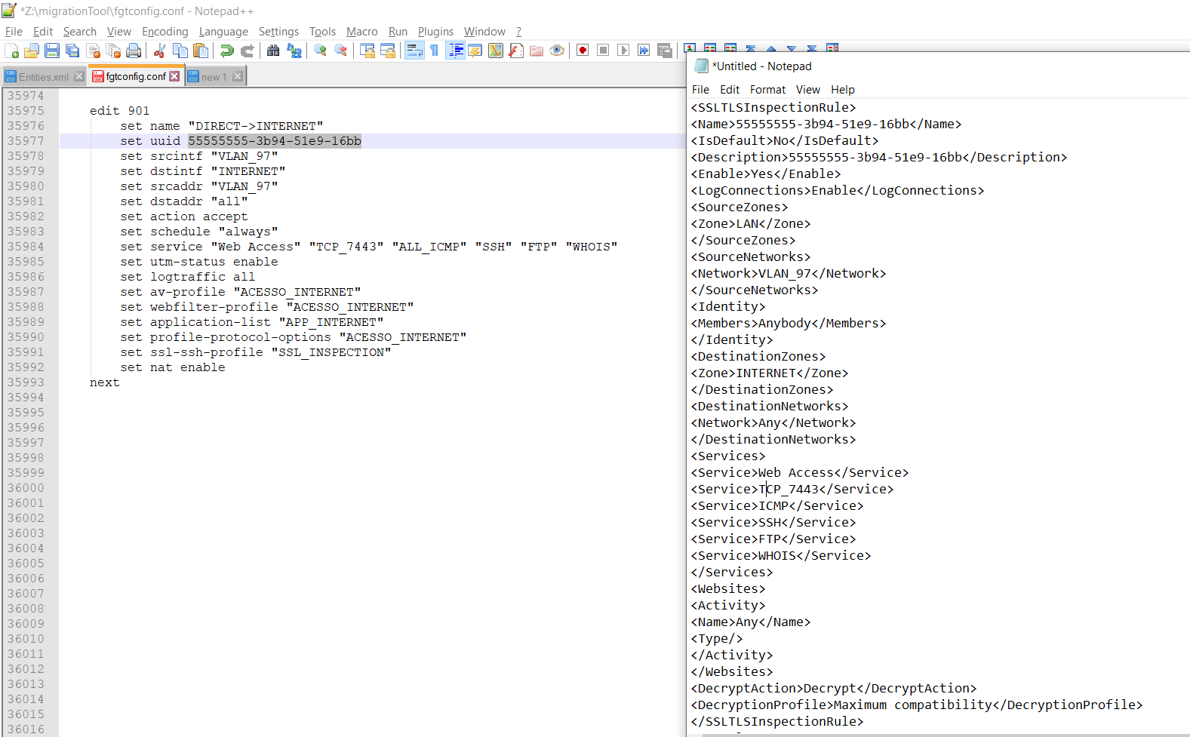

NAT:

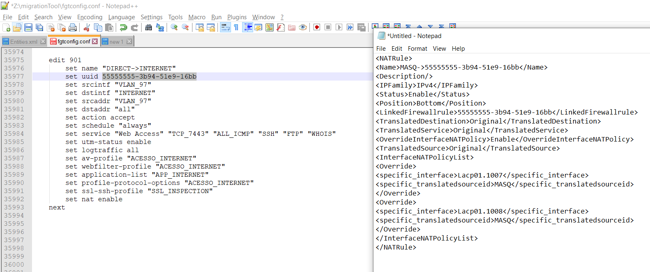

677 rules migrated: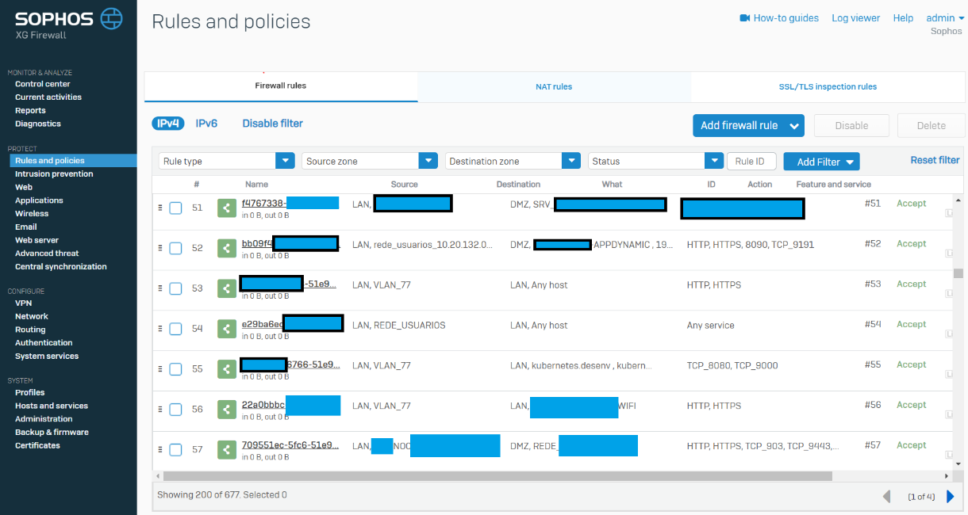

541 NAT Rules Migrated:

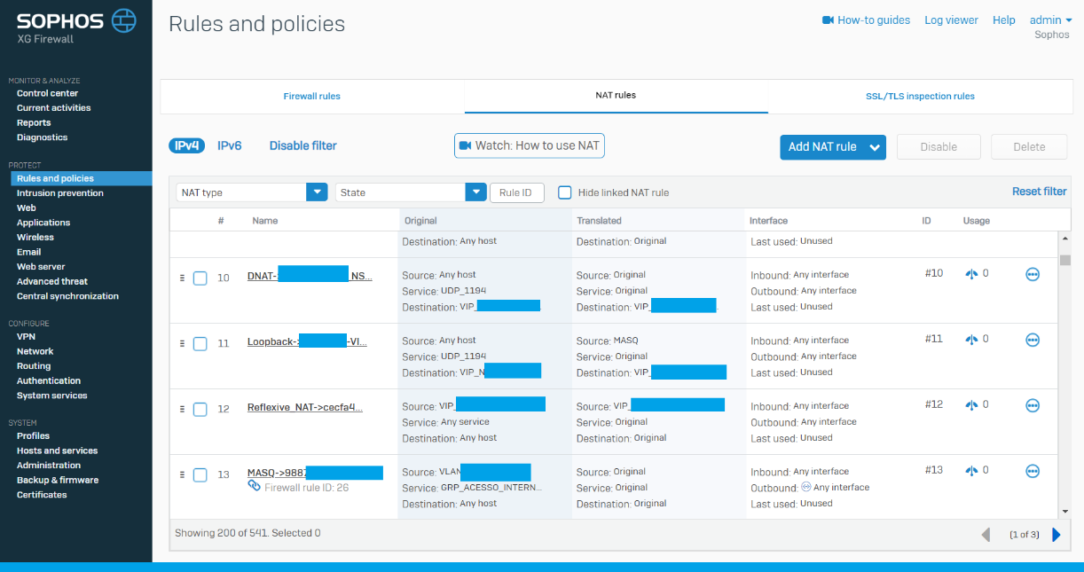

100 SSL Inspection rules migrated:

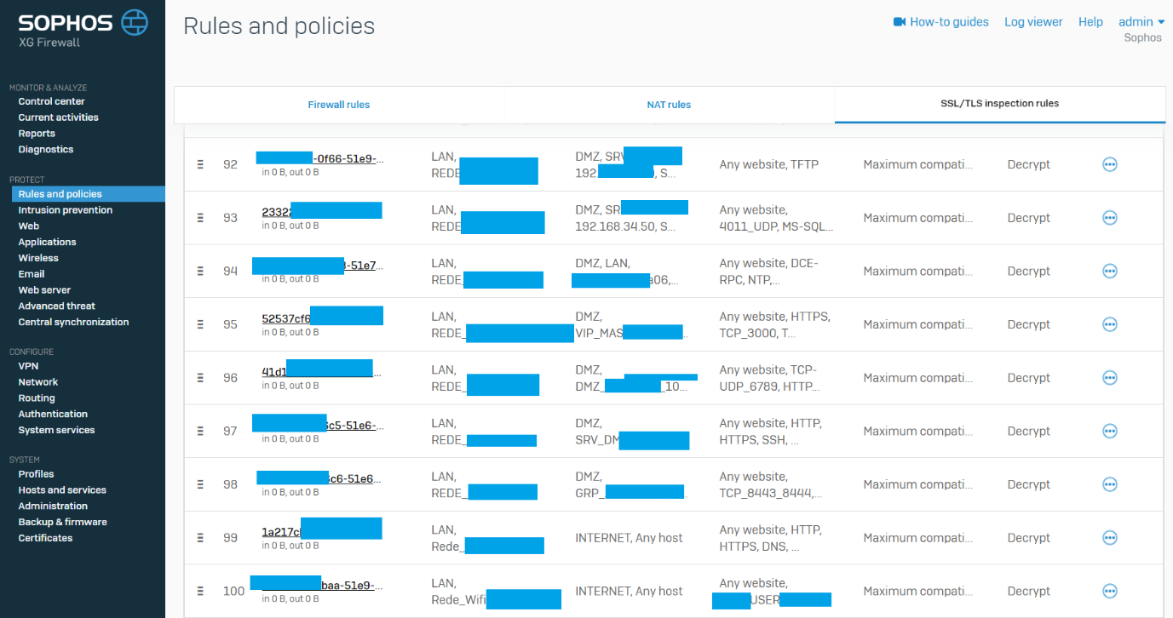

Correct snat ip per interface:

