University of San Jose-Recoletos
College of Information, Communication and Computer Technology

Information Technology Department

SKEMO: The Subject Schedule Recommender

Balili, Edmundo Jr.
Gandiongco, Rafael
Pacaldo, Erra Marjorie

TABLE OF CONTENTS Page

- Project Definition and Organization …………………………………………..… 4
  - Project Overview and Objectives ……………………………………………………….…. 4
  - Critical Success Factors …………………………………………………………………….….. 4
  - Vision Statement ……………………………………………………………………………….….. 4
- Software Requirements Specification ………………………………….……….. 5
  - Functional Requirements ………………………………………………………………..…….. 5
  - User Interface Design .…………………………………………………………………………… 7
  - Database Design ……………………………………………………………………………………. 8
  - Use Case Diagram …………………………………………………………………………………. 10
  - System Process Flow …………………………………………………………………………….. 11
  - Assumption and Software Limitation ……………………………………………………. 14
- Implementation
  - Development Platform and Software Tools …………………………………………… 15
- Testing and Validation ………………………………………………………………… 16
- Architectural Design …………………………………………………………………… 26
- User Manual ………………………………………………………………………………. 27
  - Skemo: The Subject Schedule Recommender System ……………………….… 29
  - Middlewares …………………………………………………………………………………………... 39
- The Recommendation Process ………………………………………………….…. 42
Glossary ………………………………………………………………………………………… 43
Curriculum Vitae …………………………………………………………………………….. 44

ACKNOWLEDGEMENT

Making this project successful and into real is never easy. We need to pass several challenges to be victorious in our goal. First we would like to thank our ever-loving God for blessing and guiding us in making this project. This would never be possible without Him. The success of this project would not also be possible without the help of people who are very precious to us. Namely,

- Our parents who never get tired of extending there support and encouragement to us; for the financial and emotional support

- Our adviser, Mr. Gene Abello for his constant support; for helping us in our database design and come up with a good process in our system

- Our Project Coordinator, Mrs. Jovelyn Cuizon, for making us realize the importance of time and project management

- And lastly, to everyone, our friends, relatives, classmates and special someone who encourages us in doing more.

- SSYSTEM SOFTWARE REQUIREMENT

- Project Definition and Organization

  - Project Overview and Objectives
The project intends to recommend class schedule base on student’s convenience. The students are to set there preferences that will be the bases for the plotting of schedules. The system also includes some features that will help the student such as browsing of subject offerings and viewing of student’s profile (includes there personal data, subjects they have enrolled and not yet enrolled and the preferences they had set).

  - Critical Success Factors
To make this project realistic, the developers should also have resources/data that is realistic. In getting of this said credible resources, the developers need to ask permission from different persons to be able to have a copy of the data.
The availability and quality of resources is one of the major factors that will affect the outcome of the system. If all involved in this project are all enthusiastic in having an output that is no less than the best and if time constraints manageable then the project will be successful.

  - Vision Statement
To come up with a subject schedule recommender that is ideal and is easy to use.

- Software Requirements and Specification

  - Functional Requirements
The functional requirements for the Subject Schedule Recommender system will be in this order: first will be for the system user and next, for the middleware programs.
- Students - can have full access to all system features. They are the only user of the system.

1.1 Sign in

1.1.1 Students will be able to sign in using there student id number.

1.2 mySkemo

1.2.1 Students can set there preferences. This includes start time, end time, campus location and vacant hours for MWF and TTH classes. If they do not set there preferences, default will be used.
1.2.2 Students will save the preferences they set.

1.3 Skemo Browse

1.3.1 Students can search subject offerings by choosing the department they want, by typing the subject number, or both.

1.3.1.1 The departments are:
- CAS
- CICCT
- COE
- COMMERCE
- CRE
- ENGINEERING
- GUIDANCE

1.4 View Profile

1.4.1 Students are provided with their personal profile (name, course and year).
1.4.2 Students can view the subjects they have taken and not yet taken.
1.4.3 Students can view there saved schedule preferences.

1.5 Skemo Now

1.5.1 Students will choose subjects they want to enroll. (The subjects that will be displayed are the subjects that the students are allowed to take and are currently offered.)
1.5.3 After choosing the subjects they want to enroll, the system will provide the generated class schedule.

1.6 Result

1.6.1 Students can save the plotted schedule.
    - Students can print the plotted schedule.

- Skemo Utility – copies data from excel file to MySQL database that will be use by the Skemo system. This serves as a middleware between excel data and MySQL database.

2.1 Skemo utility fetches data from excel files that will be used.
2.2 Skemo utility fetches necessary data and dumps it into MySQL database.
2.3 After fetching all necessary excel files, Skemo utility sleeps for one hour.
2.4 After sleeping for one hour, Skemo utility repeats the same process.
2.5 Skemo utility can be seen/access in the System Tray and runs on background.

- Prospectus Updater – adds new excel prospectus data from excel file to prospectus table in MySQL database.

3.1 Prospectus updater prompts the user to choose an excel file to be used.
3.2 Prospectus updater fetches the data from the excel file then dumps into prospectus table in MySQL database.

  - User Interface Design

Please refer to user’s manual.

  - Database Design

subjects_table
*offer_no
subject_id
subject_no
title
time
*day
room
subjects_enrolled
student_id
offer_no
subject_id
subject_no
grade
term
student_table
*student_id
first_name
last_name
mid_name
course
yearLevel
curriculum

prospectus
*auth_code
subject_no
curr_year
subject_desc
common_data
offer_no
subject_id
subject_no
subject_title
term
prospect_require
*auth_code
*require

SUBJECTS_TABLE
- This table stores all subjects which are available for scheduling.

SUBJECTS_ENROLLED
- This table contains the subjects and its grade of a certain students.

STUDENT_TABLE
- This table contains the information of a student.

PROSPECTUS
- This table stores subjects under a specific curriculum type.

PROSPECT_REQUIRE
- This table contains the pre-requisite/s of a subject.

COMMON_DATA
- This table serves as a reference to all subjects.

2.4 Use Case Diagram

View Profile

Set Preferences

View Plotted Class Schedule

USER
Save Schedule

Print Schedule

Skemo Utility

Update Database

Prospectus Updater
Update Prospectus Table

  - Process Flow

2.5.1 Prospectus Updater

SELECTE EXCEL FILE

CONNECT TO EXCEL

FETCH DATA

CONNECT TO MYSQL

INSERT FETCHED DATA

2.5.2 Skemo Utility Process Flow

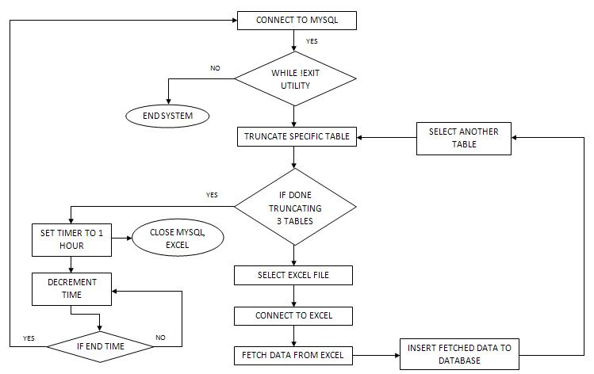

2.5.3 Subject Schedule Recommender System Process Flow

LOGIN

VALID LOGIN

CHOOSES MENU

mySkemo
Skemo Now
Skemo Browse
VIEW PROFILE

SET SCHEDULE PREFERENCES
SELECT SUBJECTS
SELECT SUBJECTS BY DEPARTMENT OR COURSE NUMBER
VIEW SUBJECTS TAKEN
VIEW SUBJECTS NOT TAKEN

PLOT SCHEDULE
VALID SCHEDULE?

SHOW RESULT
SHOW RESULT
SHOW RESULTS

SAVE SCHEDULE

SAVE RESULT
PRINT RESULT

  - Assumption and Software Limitation

Skemo: The Subject Schedule Recommender will support plotting of class schedules during regular semesters. The only requirement that the system has is you should be a student of University of San Jose-Recoletos particularly in the College of Information, Computer and Communication Technology (includes the courses Bachelor of Science in Information Technology and Bachelor of Science in Computer Science). The system will not accept student ID of students enrolled in 2008.

- Implementation

3.1 Development Platform and Software Tools
3.1.1 Software Platforms, Development Environment and Tools
The computing platform of choice is the Windows XP Operating System. For the web interface and scripting, the group chooses PHP scripting language since the group has a thorough knowledge of the said language. For the graphics design, Adobe Photoshop is used. The group also implemented Ajax for some front end behavior. It is insisted that the system should display consistently across Mozilla Firefox 3.0 browser. For the database, the group used VB 6 for fetching and updating data from excel file to MySQL.

3.1.2 Hardware Platforms

To run the system, it needs a computer set with a minimum of 2.0 Ghz processor and a 512 MB Ram.

- TESTING AND VALIDATION
4.1 SIGN IN

Using a wrong or non-existing Student ID number in signing in, the system will generate an error message.
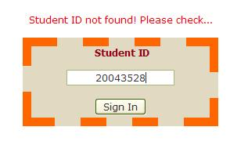
Students enrolled starting 2008 and up will not be accommodated by the system.
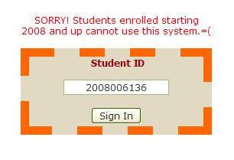
Upon entering a qualifying student ID, you will be directed to mySkemo page.
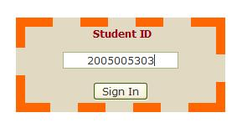

4.2 mySkemo
If start time for vacant hours is set and there is no equivalent end time, an error message will be generated and the preferences set will not be saved. The Save Preferences button will be disabled.

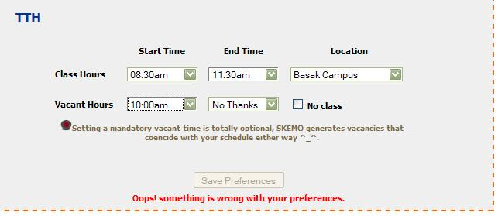

When the check box button for No Class is clicked, textboxes for those particular days will be disabled.

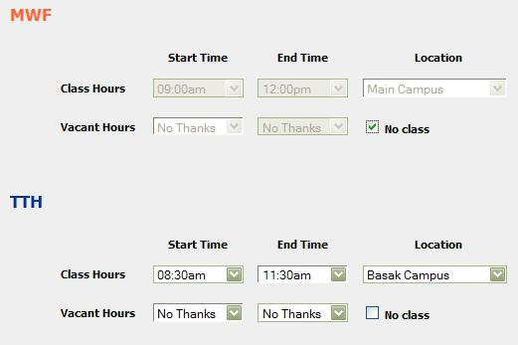
If vacant time is not properly set, there will be an error. (e.g. vacant time is beyond class hours)
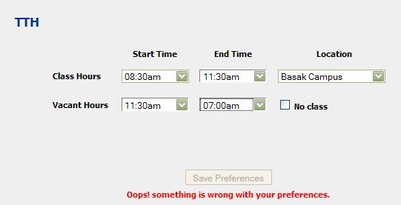

Once the preferences are already set and there were no errors, the preferences can now be saved. If the student will not edit his/her own preferences, a default preferences will be use.
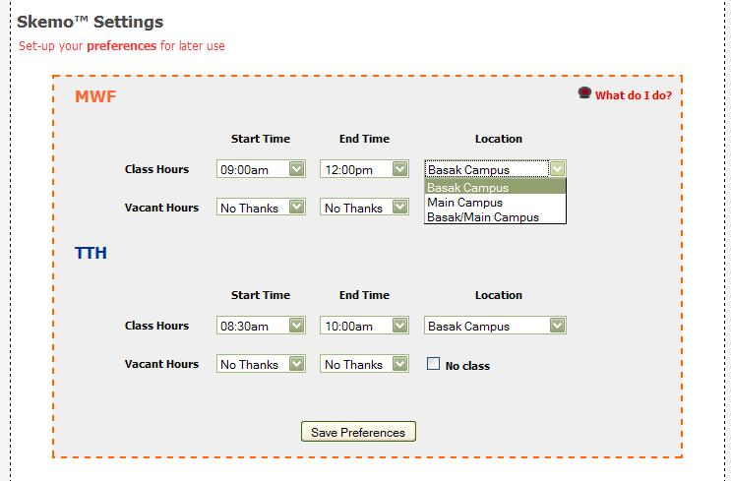

The system will generate a message once the preferences have been successfully saved.
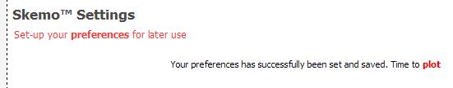
4.3 Skemo Now
Choose subjects you want to enroll. Finalize it then click Plot Schedule to view your plotted schedule.
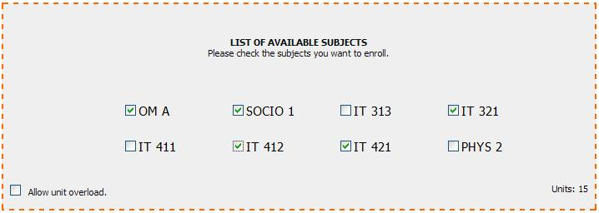

If you had checked subjects beyond your allowable units, the Units in the lower right portion of the available subjects will change its color to orange that denotes you had checked subjects beyond the limit.

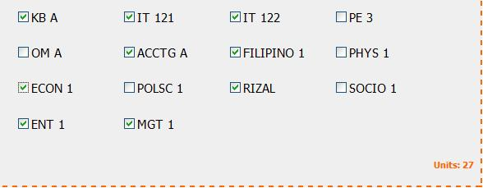

4.4 RESULT

The system will list down the subjects plotted and the subjects that were not plotted.

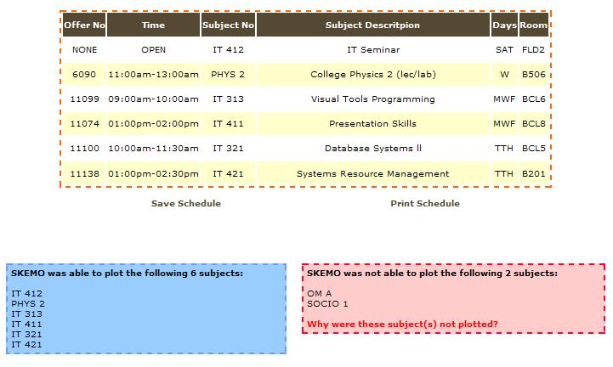

4.5 Skemo Browse
If the user will click the search button without entering any text, the system will generate a no result message so with entering a course number that is not offered.
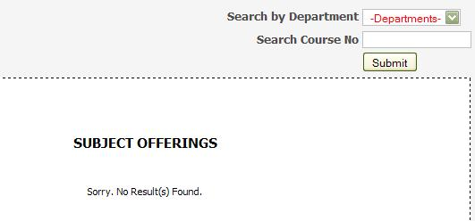
Searching by department will display all subject offerings of a particular department.
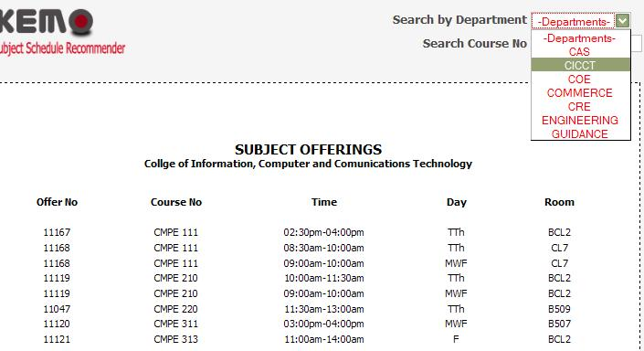
If users will enter course number that is not specific, there will be many possible course number results that will be displayed.
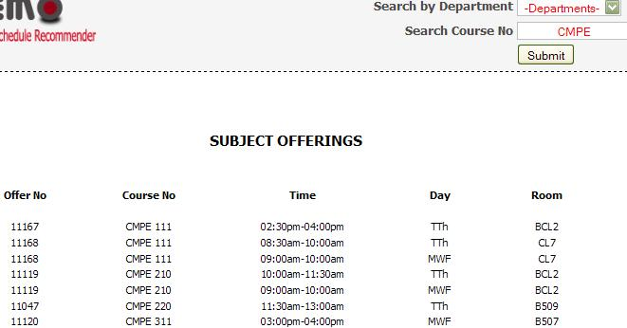
Searching by course number, will just display the subjects with that particular course number.

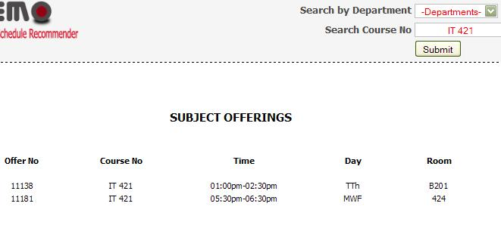

Searching both (by department and by course number), will display a filtered subjects.

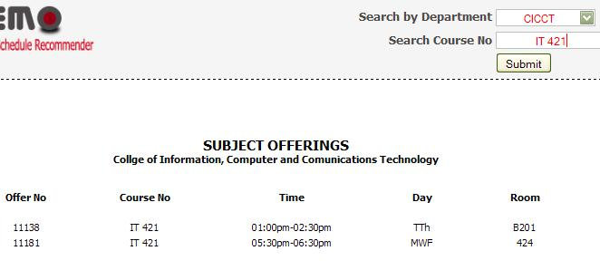

4.6 View Profile
By clicking the button for taken, the subjects that has been taken by a particular student will be displayed.
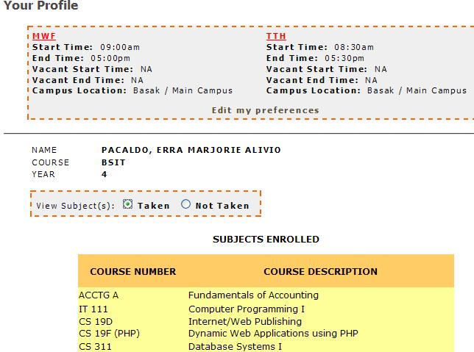

So with not taken…

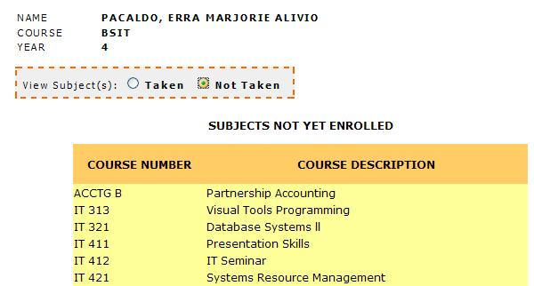

4.7 Skemo Utility
Attempting to close the utility will generate this warning,
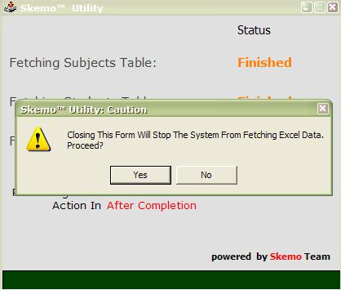
If you click NO, the utility program will continue running otherwise if you click YES, the system will prompt you to provide a password. This is for security reason.
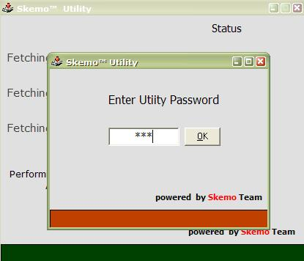
If you provided a valid password, the program will be terminated. If the password is invalid, an error message will be generated.
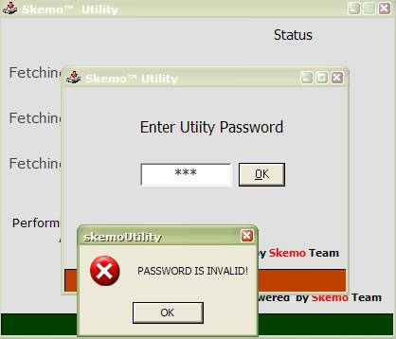
Clicking OK for invalid password will make the utility program continue running.
4.8 Prospectus Updater
Browse an excel file to be process.

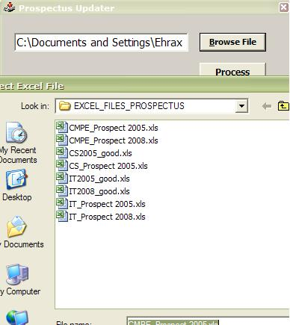

A message will be generated once the system has done processing the excel file.

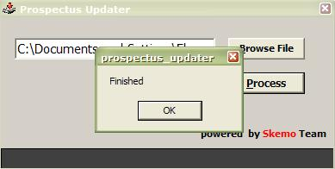
- ARCHITECTURAL DESIGN

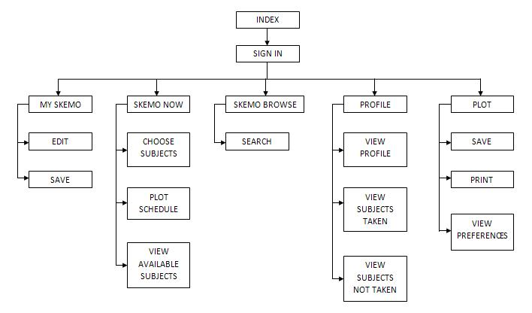

SKEMO: THE SUBJECT SCHEDULE RECOMMENDER SYSTEM

(USER’S MANUAL)

  - Introduction

Skemo: The Subject Schedule Recommender aims to provide the users (students) auto-generated class schedule to help him/her lessen his/her time and effort in plotting schedules manually. The system lets the user set his preferences that will be the bases in plotting. The system also provides some features that will help the students such as browsing of subject offerings and viewing of student’s profile (includes there personal data, subjects they have enrolled and not yet enrolled and the preferences they had set). The students will use there Student ID number to be able to have a privilege of the system.

  - System Requirements
In order for this system to work, you will need the following:
Operating System | Windows XP
DBMS | MySQL
Web Server | Apache with PHP installed
Web Browser | Mozilla Firefox Version 3.xxx

USER’S PAGE

    - SIGN IN

Users should sign-in first to avail privileges of the system.

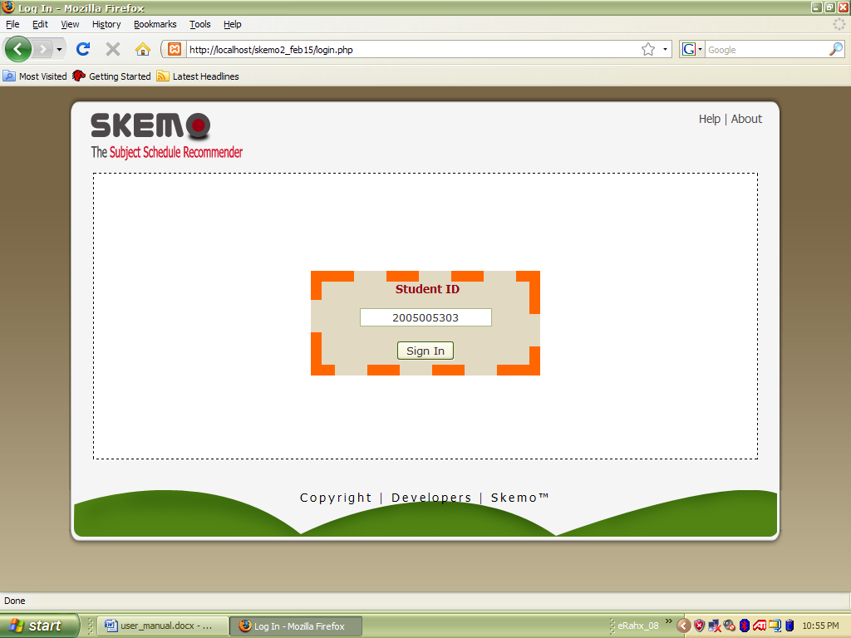

STEPS:
- Type your Student ID number in the sign in form.
- Click Sign-In button.

    - GETTING STARTED

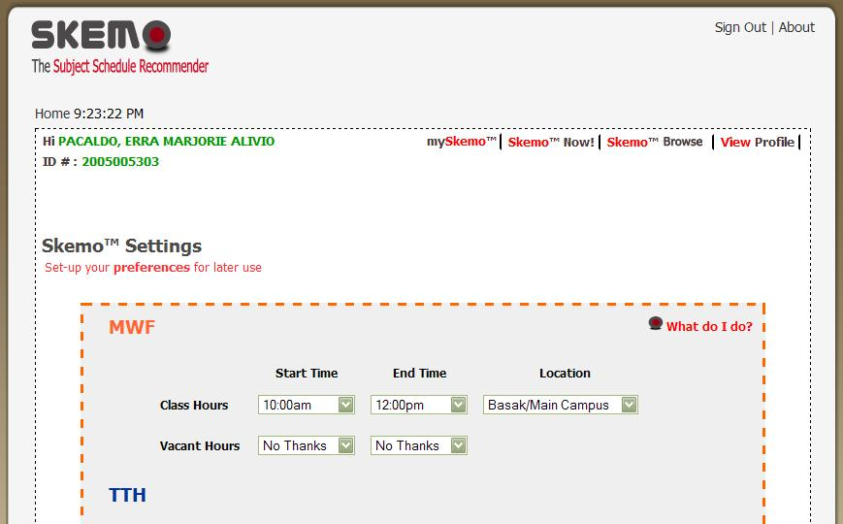

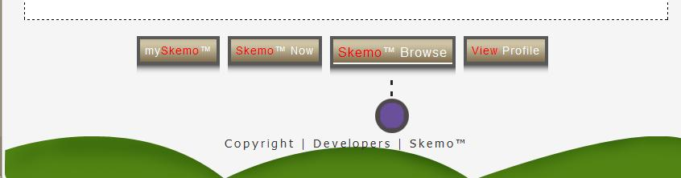

- To know about the system, click About.
- To edit your preferences, click mySkemoTM.
- Click SkemoTM Now to choose subjects you will enroll and view your plotted schedule.
- Click SkemoTM Browse to check subject offerings.
- To view your profile and the subjects you have taken and not yet taken, click View Profile.
- To view the system developers, click Developers.
- Click SkemoTM to know the uses of different functionalities.

6.3.3 mySkemoTM

This is where you can set your preferences. There are different settings for MWF and TTH schedules.

For Class Hours

- Start Time. Set the time when you would like your class to start.
- End Time. Set the time when you would like your class to end.
- Location. Choose the campus where you would like to spend your classes.

For Vacant Hours (optional)

- Start Time. Choose the time when you would like your vacant period to start.
- End Time. Choose the time when you would like your vacant period to end.

Click the check box No Class if you don’t like to have classes on those days.

After everything has been set, click Save Preferences to save your preferences for future use.

    - SkemoTM Now

Displays available subjects a student can take.

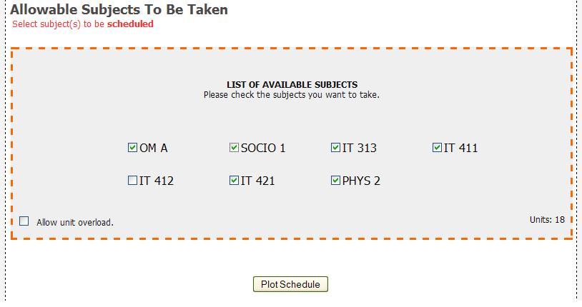

STEPS:

- Check the checkbox of the subjects you want to take.
- Check the checkbox ‘Allow unit overload’ to make subject overload.
- Press Plot Schedule button to view your plotted schedule.

    - SkemoTM Browse

This is use to search for subject offerings. There are three ways to search: by department, by course number, or both.

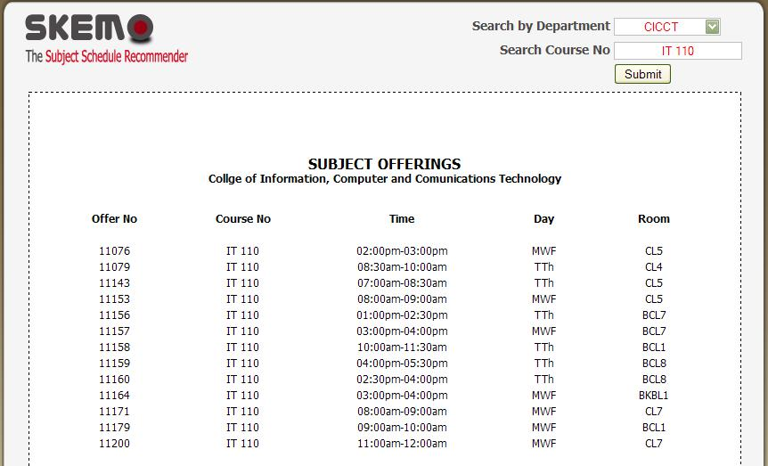

STEPS:

- Search by department – click the drop down button and choose a department. The departments are: CAS, CICCT, COE, COMMERCE, ENGINEERING, CRE and GUIDANCE. Click submit button.

- Search course number – fill up the textbox with the course number you want to search then click submit button.

- Search by department and by course number – click the drop down button and choose a department. Fill up the textbox with the course number you want to search then click submit button.

    - View Profile

This page displays your profile (name, course and year), schedule preferences and the subjects you have taken and not yet taken.

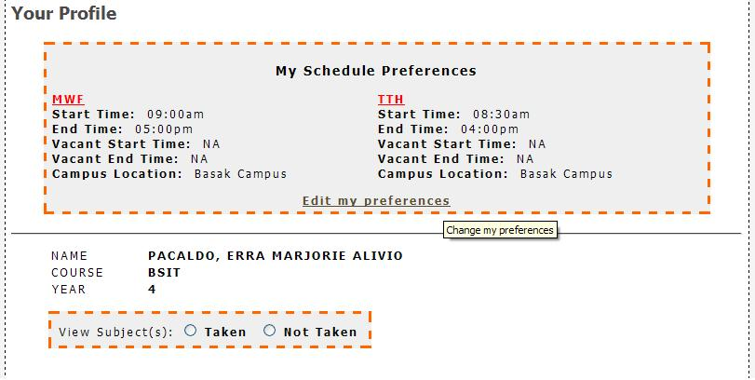

STEPS:

- To view the subjects you have taken, click the radio button for taken and results will be displayed.
- For viewing the subjects not yet taken, click the radio button for not taken and results will be displayed.
- To edit your preferences, click Edit my preferences.

    - RESULT

This is the generated class schedule.

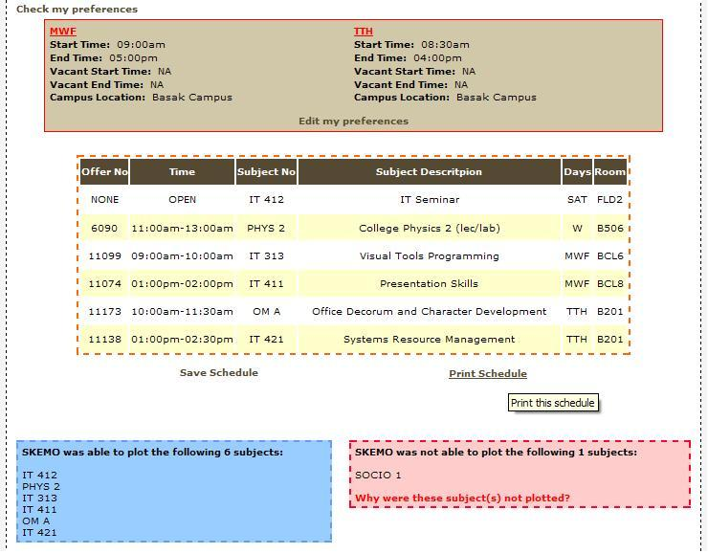

STEPS:

- To save your schedule, click Save Schedule.
- To print the plotted schedule, click Print Schedule.
- Click Edit my preferences, to make some changes to your saved preferences.

    - SAVE SCHEDULE

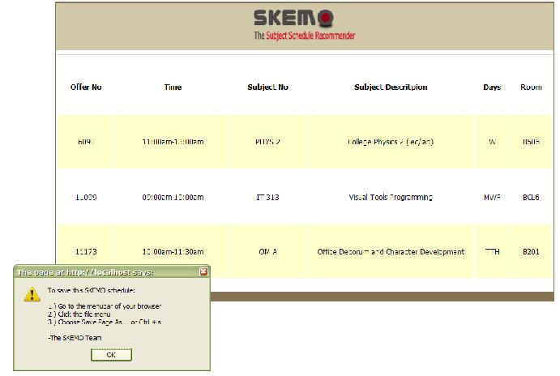

STEPS:
- Go to the menu bar of your browser.
- Click the file menu.
- Choose Save Page As or click Ctrl + S.

    - PRINT SCHEDULE

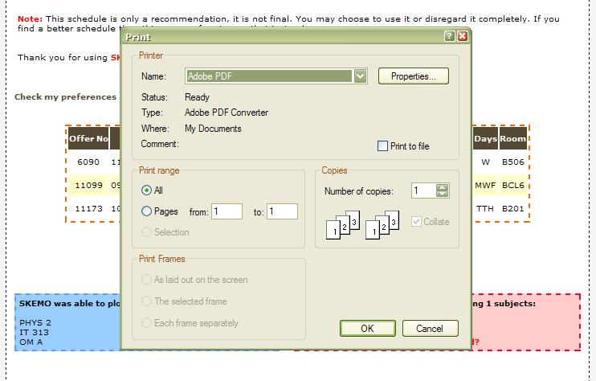

STEPS:
- When the standard print dialogue box appears, set your printing preferences.
- Click OK button to print your schedule.

MIDDLEWARES

6.4.1 Skemo Utility

This utility is use to fetch data from excel file to MySQL database.

Figure 4.1.1


Figure 4.1.2

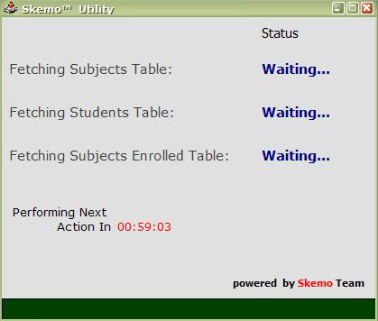

- Double click SkemoUtility.exe (Figure 4.1.1). When the utility already runs (Figure 4.1.2), you can minimize it and it will be shown in your system tray located at the bottom part of your desktop.

6.4.2 PROSPECTUS UPDATER

Figure 4.2.1

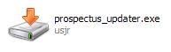

Figure 4.2.2

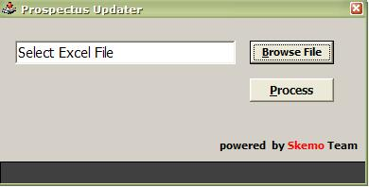

STEPS:
- Double click prospectus_updater.exe (Figure 4.2.1).
- Click Browse File button to select excel file to be process.
- Once you have selected an excel file, click Process button to process the excel file to the database.

VII. THE RECOMMENDATION PROCESS

To be able to come up with a reliable recommendation, the developers made the following process:

- The system gathers all the schedules that coincide with the preferences set by the student.

- The system temporarily stores all the schedule data into one database table.

- The system will look for subjects in the database table. Subjects with little offerings will be prioritized by the system.

- The system will then check if the schedule adheres to all its rules such as:

- Student doesn’t have three (3) successive subjects.
- The system needs to give the student time to travel from Basak Campus to Main Campus or vice versa.
- Check if the student wants to have a vacant time.

- If all the rules were followed then the system will plot the student’s schedule.

- The system then provides the student two (2) options to print or save his/her schedule.

GLOSARRY

- preference – first choice, the favoring of one person, a prior right

- subject - a branch of study

- schedule - a timetable or programme of planned events or work, etc.

- browse - to read or inspect items on display

- utility - a useful thing; a service or function

CURRICULUM VITAE

Name : BALILI, EDMUNDO JR. W.
Birthday : March 07, 1989
Address :
Mobile No. : 09272937801
Email Add. :
Batch : March 2009

Name : GANDIONGCO, RAFAEL G.
Birthday :
Address :
Mobile No. : 09278467536
Email Add. :
Batch : March 2009

Name : PACALDO, ERRA MARJORIE A.
Birthday : January 08, 1989
Address : Puso, Poblacion, Cordova, Cebu
Mobile No. : 09272961792 / 09227773527
Email Add. : erramcfaden@yahoo.com
Batch : March 2009

