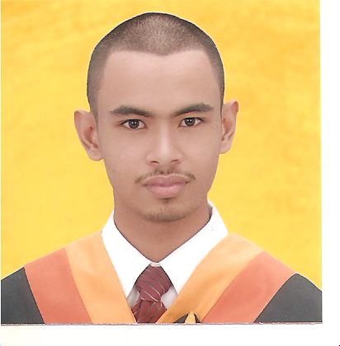

RAFAEL G. GANDIONCO
San Roque Talisay City, Cebu 6045 , Philippines
Telephone# (6332) 269-9640
Cell#639278467536
Website : http://rafaelgandi.tk
Email: rafaelgandi@gmail.com

PERSONAL BACKGROUND:

Age: 23 years old
Birth date: March 26, 1988
Birthplace: Cebu City, Philippines
Status: Single
Height: 5’ 7”
Language/s: English, Filipino

EDUCATIONAL BACKGROUND:

College
University of San Jose-Recoletos, Basak Campus
Degree: Bachelor of Science in Information Technology

Secondary
St. Scholasticas Academy, Tabunok 2001-2004
Tabunok Talosay City, Cebu Philippines

Elementary
Clarita B. Dacua Institite of Learning 1993-2000
Inayawan Cebu, City Philippines

TRAININGS AND SEMINARS:

REQUIREMENTS MANAGEMENT AND SOFTWARE TESTING
17th floor i3 building
Asia Town IT Park Lahug, Cebu City
Date: November 25-26, 2011

E-BUSINESS
St. Ezikiel Moreno Building, University of San Jose-Recoletos,
Basak, Cebu City
Date: March 2008

SKILLS:

Languages:
- JavaScript (AJAX)
- jQuery
- Mootools
- JSON
- HTML 5
- MySQL
- Adobe Business Catalyst CMS

Software:
- Notepad ++

ACADEMIC ACHIEVEMENTS

- SKEMO Subject Schedule Recommender for USJ-R awarded as the best IT project for the school year 08-09, I was one of the developers of this web application. (http://cicct.usjr.edu.ph/view.php?type=menu&view=con_static&id=20)

ACADEMIC PROJECTS:

- SKEMO Subject Schedule Recommender for USJ-R
Date of accomplishment: NOVEMBER 2008-MARCH 2009
University of San Jose-Recoletos, Basak Campus
Link: http://project.usjr.edu.ph/proj03/skemo_system

- USJ-R Computer Engineering Department Website
Date of accomplishment: APRIL 2008-MAY 2008
University of San Jose-Recoletos, Basak Campus
Link: http://cmpe.usjr.edu.ph

- USJ-R Supreme Student Council Website
Date of accomplishment: JULY 2008-AUGUST 2008
University of San Jose-Recoletos, Basak Campus
Link: http://ssc.usjr.edu.ph

EXTRA-CURRICULAR ACTIVITIES:

- Member- ICTO (Information and Computer Technology Organization)
- Student Volunteer USJ-R Basak Research and Development Labs

EMPLOYERS:

Nettrac Communications Inc. (http://nettrac.net)
Position: Web Developer

Webxpress Inc. (http://webxcebu.com)
Position: Web Developer (JavaScript / jQuery developer)

SITES AND PROJECTS I WAS ONE OF THE DEVELOPER:

- http://cmpe.usjr.edu.ph/
- http://ssc.usjr.edu.ph/
- http://www.altusdynamics.com/
- http://jacklondonstudios.ca/
- http://cp4.nettrac.net/
- http://www.engliftsystems.com/
- http://biochemicals.smartwebmarketing.com.au/
- http://themeat-tingplace.com.au/
- http://skelhire.smartwebmarketing.com.au/home
- http://choosingaschool.com.au/
- http://bargainshopper.com.au/
- http://roadrider.com.au/
- http://unimagslifeetc.businesscatalyst.com/
- http://completewedding.com.au/
- http://dirtaction.com.au/index.htm
- http://uksmartbag.smartwebmarketing.com.au/index.htm
- http://mcportal.com.au/
- http://www.mystrata.biz/home.php
- http://plugins.jquery.com/project/jadrotate
- http://www.skimax.com.au/
- http://thereefmovie.com/
- http://www.donnahay.com.au/
- http://velovita.net.au/
- http://www.apresvelo.com
- http://tumbleweed.com.au/
- http://www.davidsouthwick.com.au/
- http://scottish.eleadxpress.com/
- http://districtgrand.eleadxpress.com/

For more visit: http://rafaelgandi.tk

REFERENCES:

Mr. Mark Anthony S. Lumeran
Buyer Representative
Supply Chain Management
Purchasing / Materials Planning / Commodity Team Leader
Fairchild Semiconductor Tm
MEZ, Lapulapu City Cebu
Philippines 6015
Mobile # 639179553392

