1.1

MAIL FROM: abc@gmail.com

250 OK

RCPT TO: [adnan.tariq@ipvs.uni-stuttgart.de](mailto:adnan.tariq@ipvs.uni-stuttgart.de)

250 OK

DATA

354 Start mail input, end with <CRLF>.<CRLF>

From: [abc@gmail.com](mailto:abc@gmail.com)

Subject: Net-based Applications Exercise

To: [adnan.tariq@ipvs.uni-stuttgart.de](mailto:adnan.tariq@ipvs.uni-stuttgart.de)

Hello Mr. Adnan,

do you know how the Umlaut "=E4" and the letter "=DF" are encoded using quoted-printable encoding?

.

250 OK

Note: “ä” is represented as “=E4” and “ß” is represented as “=DF” in quoted printable

1.2

From: [abc@gmail.com](mailto:abc@gmail.com)

Subject: Net-based Applications Exercise

To: [adnan.tariq@ipvs.uni-stuttgart.de](mailto:adnan.tariq@ipvs.uni-stuttgart.de)

Message-ID: [20020520235147.A23513@studi.informatik.uni-stuttgart.de](mailto:20020520235147.A23513@studi.informatik.uni-stuttgart.de)

Mime-Version: 1.0  
Content-Type: multipart/mixed; boundary="17pEHd4RhPHOinZp”  
Content-Disposition: inline

--17pEHd4RhPHOinZp  
Content-Type: text/plain; charset=us-ascii  
Content-Transfer-Encoding: QUOTED-PRINTABLE  
Content-Disposition: inline

Hello Mr. Adnan,

do you know how the Umlaut "=E4" and the letter "=DF" are encoded using quoted-printable encoding?

--17pEHd4RhPHOinZp  
Content-Type: application/pdf  
Content-Disposition: attachment; filename=”message.pdf”  
Content-Transfer-Encoding: base64

SGVsbG8gTXIuIEFkbmFuLA0KZG8geW91IGtub3cgaG93IHRoZS (…)

1.3 Decoded: Übung macht den Meister

First 4 characters in Base64 represent 24 bits (6 \* 4), which can be converted to 3 bytes, which lead to 3 ISO-8859-1 characters. We have encoded:

3GJ1 -> 110111 000110 001001 110101

Converting this binary sequence to 3 bytes, we have:

DC 62 75

Which, in ISO-8859-1, are:

Übu

2.1

USER group07

331 Password required for group07.

PASS \*\*\*\*\*\*

230 User group07 logged in.

CWD /home/group07/A06T02

250 CWD command successful.

PWD

257 “/home/group07/A06T02” is current directory.

PORT 129,69,210,73,19,137

200 PORT command successful.

RETR download.txt

150 Opening ASCII mode data connection for download.txt (21 bytes).

226 Transfer complete.

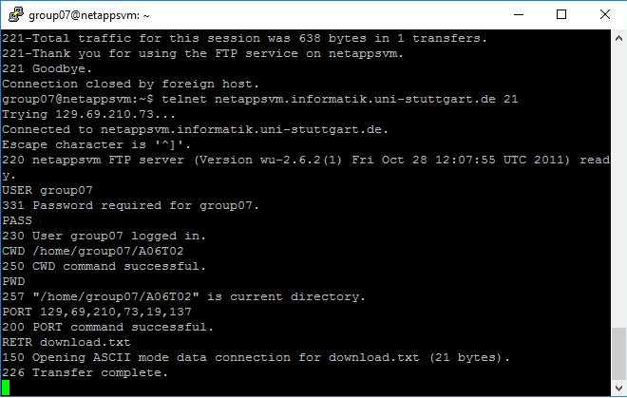

2.2 For the passive mode, instead of running the PORT command and informing where the server should connect to send/receive the data, we run PASV and receive an answer from the server with the information of where should we (as a client) connect to receive/send the data.