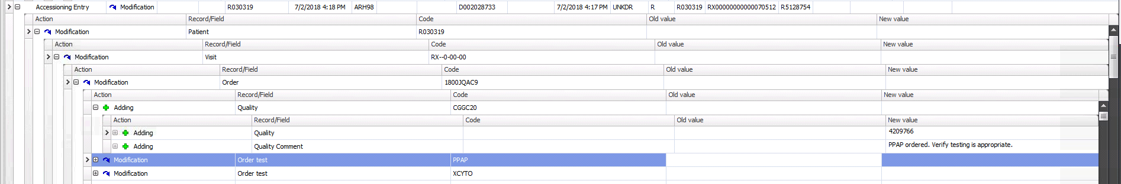
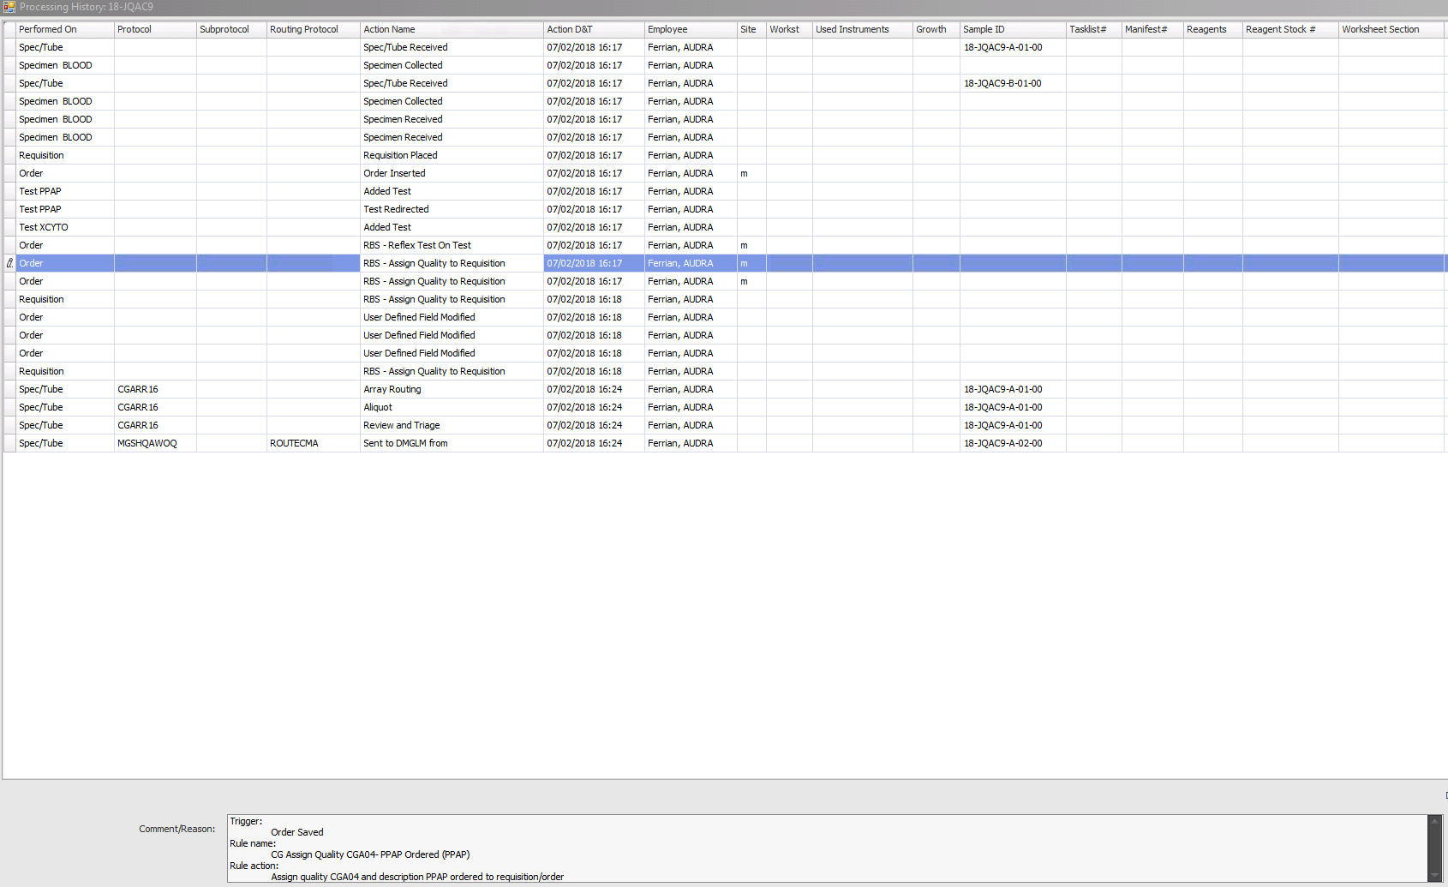

As you see in database there is only one problem assigned to #LMS user.
Base on processing history there should be at least 3.

On local environment

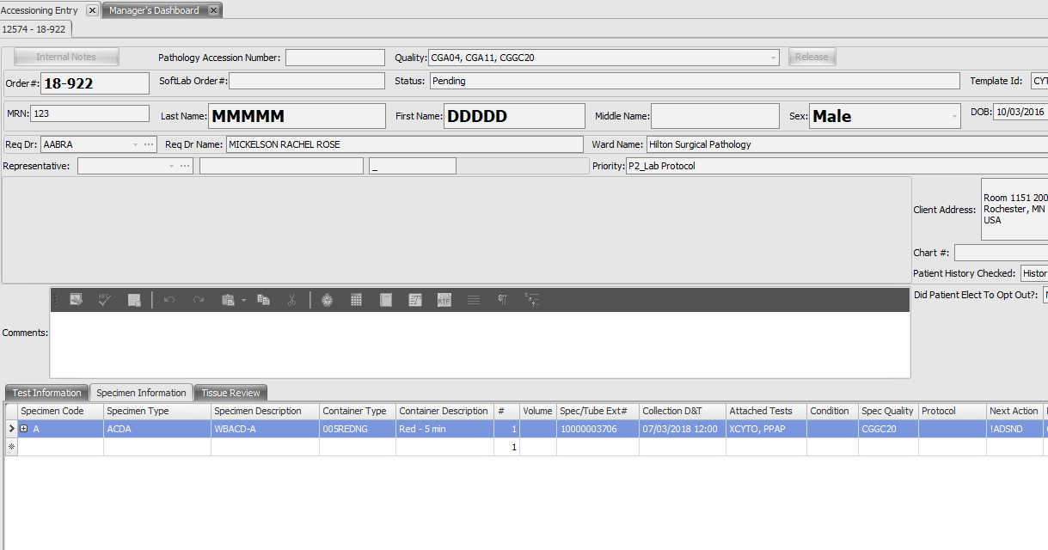

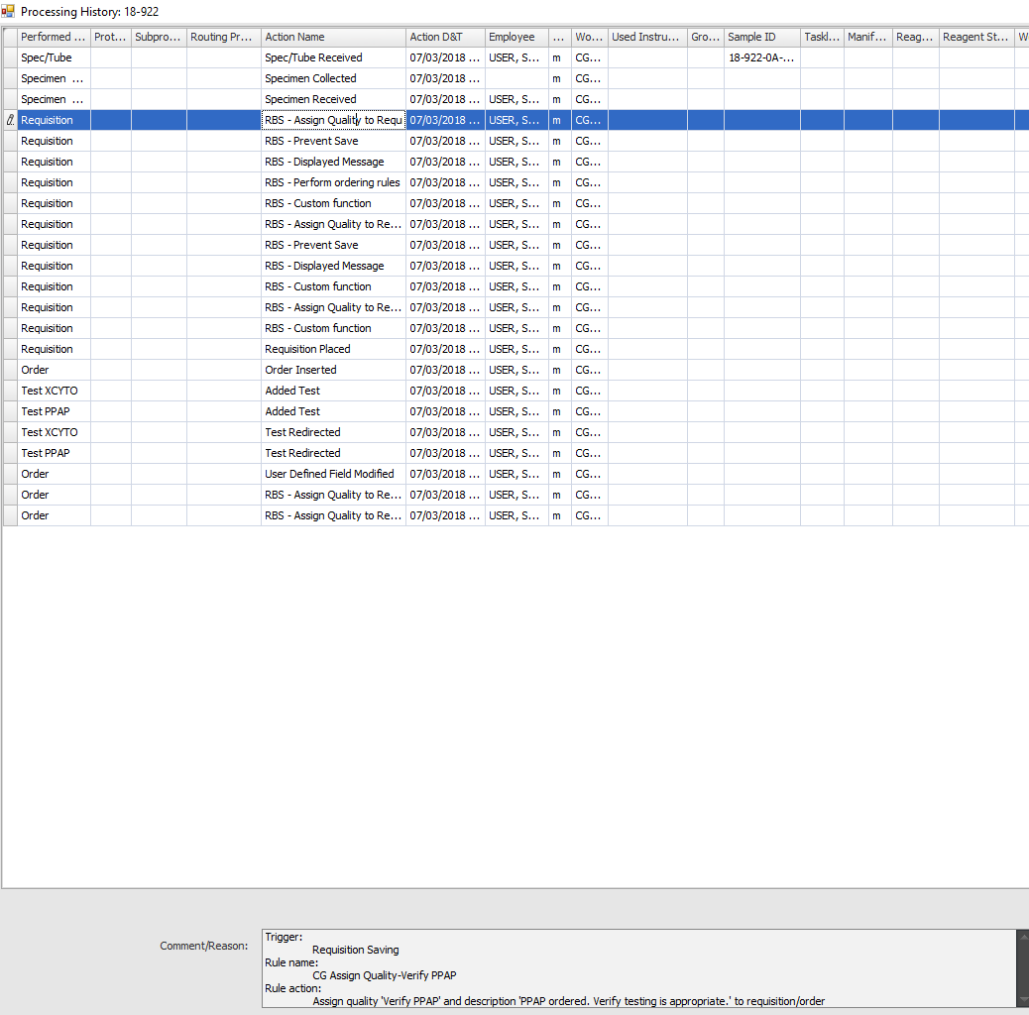

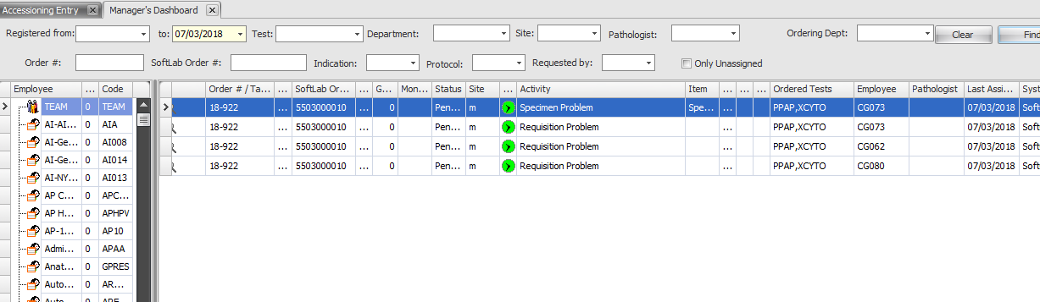
It looks like assignment are set based on

