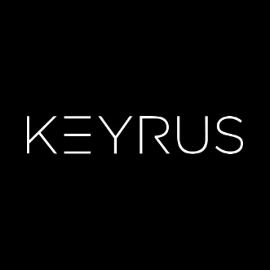

**ITS Brasil**

www.keyrus.com/br/

Test Evidence

**IT Quality Assurance**

KEYRUS Brasil

|  |  |  |  |
| --- | --- | --- | --- |
| Version | Name | Role | Creation Date |
| 1.0 | Matheus Garcia Dias | QA Analyst | 12/02/2020 |

**Version**