|  |  |
| --- | --- |
| **Title:** | **Window Lifter Controller** |

**1.- PURPOSE………………………………………………………………………….………………………..4**

**2.-DEFINITIONS AND ABREVIATIONS…………………………………………….……………………….4**

**3.-REALIZATION CONSTRAINTS AND TARGETS………………………………………………………..5**

**4.-SW CONCEPTUAL DESIGN……………………………………………………………………………….6**

**5.- SW Component internal breakdown……………………………………………………………………7**

**5.1.- Diagrams by component…………………………..…………………………………………..7**

**5.1.1.-Complet Diagram…………………………………………………………………………..….8**

## 5.2.- Functional Decomposition…………………………………………………………………………….10

**5.3.- Function Description and Dynamic Behavior……………………………………………………..12**

## 5.3.1- Function voidappUpDown_void_manualUp()……………………………….……………………12

## 5.3.2.- Function void appUpDown_void_manualDown()…………………..……..……………………12

## 5.3.3.- Function T_U32 appUpDown_u32_PushUpButton()…………………...………………………13

## 5.3.4.-FunctionT_U32appUpDown_u32_PushDownButton()……….…………………………………14

## 5.3.5.- Function T_U32 appUpDown_u32_PushAntipinch()……………………………………………14

## 5.3.6.- Function void appUpDown_void_default_Leds(T_U32 led)………………..………….………15

## 5.3.7.- Function void appUpDown_void_clearGPIO()………………………………...…………….……16

## 5.3.8.- Function void appUpDown_void_timer1()……………………………………..……………..…..16

**5.3.9.- Function void appUpDown_void_timer0()………………………………………….…..…………17**

## 5.3.10.- Function T_U32 appUpDown_u32_validation10ms()…………………………………..……….18

## 5.3.11.- Function T_U32 appUpDown_u32_validation500ms()…………………………………………18

## 5.3.12.- Function T_U32 halWinMov_u32_ValidateUpButton()………………………….………..……19

## 5.3.13.- Function T_U32 halWinMov_u32_ValidateUpButton()………………..………..………………20

## 5.3.14.- Function T_U32 halWinMov_u32_ValidateAntipinch()*……………*……………..……20

## 5.3.15.- Function void halWinMov_void_ToggleBlueLed(T_U32 u32_status)…………..……21

## 5.3.16.- Function void halWinMov_void_ToggleRedLed(T_U32 u32_status)…………………22

## 5.3.17.- Function void halWinMov_void_ToggleGreenLed(T_U32 u32_status)…………………22

## 5.3.18.- Function void halWinMov_void_ToggleLedBar#(T_U32 u32_status)……………...……23

## 5.3.19 .- Function void main_void_onetouchUp()*……………..………………*…………...……24

## 5.3.20.- Function void main_void_onetouchDown()…………………………………………...……25

## 5.3.21.- Function void main_void_behaviorUp()….…………………………………………………..26

## 5.3.22.- Function void main_void_behaviorDown()….…………………………………………………..26

## 5.3.23.- Function void main_void_Antipinch()….…………………………………………………..27

## 5.3.24.- Function void main_void_idleState()….…………………………………………………..27

|  |  |  |  |  |
| --- | --- | --- | --- | --- |
| **History** | | | | |
| **Issue status**  (Index) | **Maturity/Date**  (draft/invalid/valid)  (dd-mmm-yyyy) | **Author**  Department | **Check/Release**  Department | **Description** |
| 1.0 | Draft  04-0ct-09 | Miguel Garcia | Miguel Garcia | Creation of the document. |
| 2.0 | Draft  26-Oct-17 | Rodrigo Mortera | Rodrigo Mortera | Insert Diagrams. |
| 2.1 | Draft  27-Oct-17 | Rafael Sanchez | Rafael Sanchez | Add function descriptions.­­­­­­ |
| 2.2 | Draft  28-Oct-17 | Rodrigo Mortera | Rodrigo Mortera | Updates Diagrams |
| 2.3 | Draft  29-Oct-17 | Rafael Sanchez | Rafael Sanchez | Updates function descriptions and Add flow chart to each function. |

**Table of Contents**

# Purpose

This document explains how the window lifter works and also describe each function through the layer programming method.

# Definitions and abbreviations

**Definitions**

|  |  |
| --- | --- |
| *BlueLed* | *Define to identify the port for the Blue Led* |
| *RedLed* | *Define to identify the port for the Red Led* |
| *GreenLed* | *Define to identify the port for the Green Led* |
| *UpButton* | *Define to identify the port for the push button 12* |
| *DownButton* | *Define to identify the port for the push button 13* |
| *LedBar_1* | *Define to identify the port for the Bar’s first Led* |
| *LedBar_2* | *Define to identify the port for the Bar’s secondary Led* |
| *LedBar_3* | *Define to identify the port for the Bar’s third Led* |
| *LedBar_4* | *Define to identify the port for the Bar’s fourth Led* |
| *LedBar_5* | *Define to identify the port for the Bar’s fifth Led* |
| *LedBar_6* | *Define to identify the port for the Bar’s sixth Led* |
| *LedBar_7* | *Define to identify the port for the Bar’s seventh Led* |
| *LedBar_8* | *Define to identify the port for the Bar’s eighth Led* |
| *LedBar_9* | *Define to identify the port for the Bar’s ninth Led* |
| *LedBar_10* | *Define to identify the port for the Bar’s tenth Led* |
| *malGPIO_init_void_WDOG_disable* | *Disable watchdog* |
| *malGPIO_init_void_PORT_init()* | *Port init* |
| *SOSC_init_8MHz* | *Clock of 8Mhz* |
| *SPLL_init_160MHz* | *Clock of 160Mhz* |
| *NormalRUNmode_80MHz* | *Set the mode of the timer to normal with 8Mhz* |
| *malGPIO_init_void_LPIT0_init* | *Initialize timers* |
| *u32_lpit0_ch0_flag_counter* | *Variable to control timer 0* |
| *u32_lpit0_ch1_flag_counter* | *Variable to control timer 1* |
| *appUpDown_void_clearGPIO()* | *Function to turnoff/turnon BlueLed, GreenLed, RedLed and Ledbars* |
| *appUpDown_u32_PushDownButton()* | *Read if Down Button is pushed* |
| *appUpDown_u32_PushUpButton()* | *Read if Up Button is pushed* |
| *appUpDown_u32_validation10ms()* | *Validate if the button is pushed at least during 10 ms* |
| *appUpDown_u32_validation500ms()* | *Validate if the button is pushed at least during 500 ms* |
| *appUpDown_void_timer1()* | *Increase the variable u32_lpit0_ch1_flag_counter each 1 ms* |
| *appUpDown_void_default_Leds(T_U32 led)* | *Turn on/off Leds in a default phase* |
| *main_void_oneTouchUp()* | *Ascending turn on the LedBar leds with just one touch* |
| *main_void_oneTouchDown()* | *Descending turn on the LedBar leds with just one touch* |
| *main_void_behaviorUp()* | *Select the turn on leds behavior.* |
| *main_void_behaviorDown()* | *Select the turn off leds behavior.* |
| *main_void_antiPinch()* | *Do the antipinch action* |
| *main_void_idleState()* | *Put the program in an idle state* |

**Abbreviations**

|  |  |
| --- | --- |
| CH1 | Channel1 |
| CH2 | Channel2 |
| R&D | Research and Develop |

**References**

|  |  |  |
| --- | --- | --- |
| **N°** | **Document name** | **Reference** |
| *1* | *USER_GUIDE_S32K144* | [Link](https://www.nxp.com/products/microcontrollers-and-processors/arm-based-processors-and-mcus/s32-automotive-processors-and-microcontrollers/32-bit-automotive-general-purpose-microcontrollers:S32K?tab=Documentation_Tab) |
| 2 | [***S32K14x Series Reference Manual***](https://www.nxp.com/docs/en/reference-manual/S32K-RM.pdf) |
| 3 | [***S32K1xx Data Sheet***](https://www.nxp.com/docs/en/data-sheet/S32K-DS.pdf) |
| 4 | ***AN5413, s32k14x Series Cookbook*** |

# Realization constraints and targets

The objective of the task is to achieve to lift and down a window car simulated by 10 red LedBar regarding to the customer request. The development of the project must be on the Development Kit Platform S32K144EVB NXP microcontroller provided by Continental R&D.

# SW Conceptual design

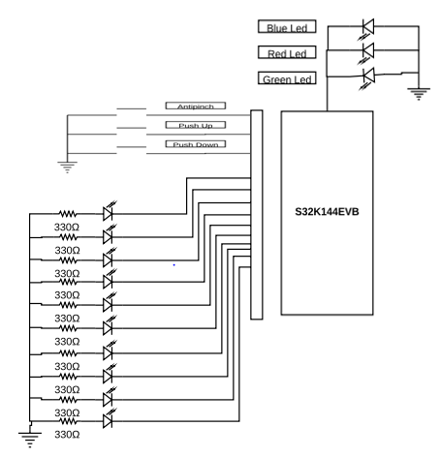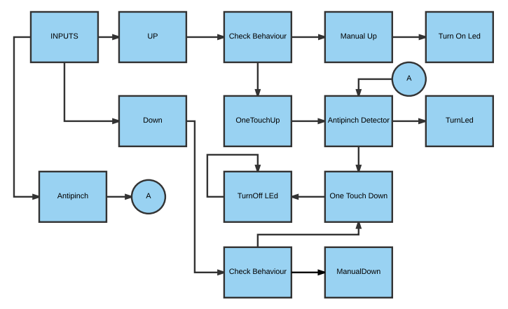

1. **SW Component internal breakdown**
   1. **Diagrams by component**

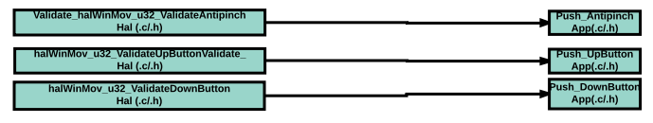

* **Validate_Antipinch function to validate the push in Push_Antipinch function in App.**
* **Validate_UpButton function to validate the push in Push_UpButton function in App.**
* **Validate_DownButton function works to validate the push in Push_DownButton function in App.**

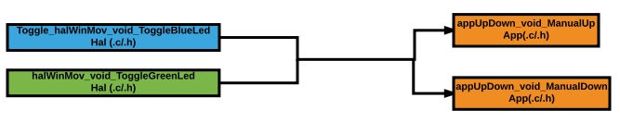

* **Toggle functions execute the functionality to turn on or turn off the led’s, called by either Manual_Up or Manual_Down functions in App.**

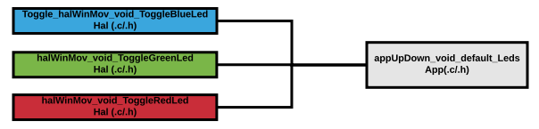

* **The Clear_Leds function Works to condition if the leds should to be on or off.**

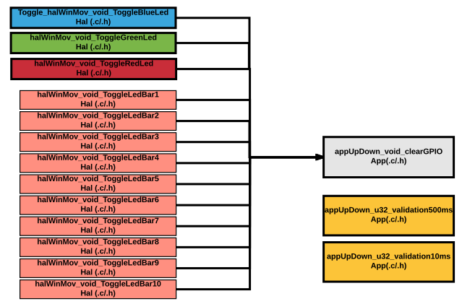

* **The Clear_GPIO only Works to clear all the inputs and outputs used in the program.**

## Complete Diagram

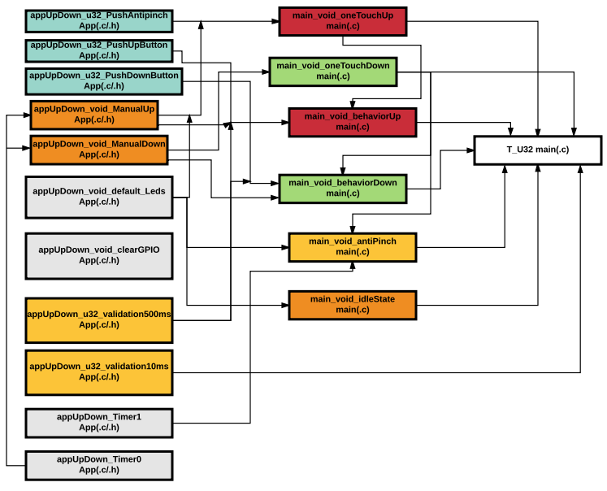

appUpDown_Timer0 enables the timer to count 400ms.

appUpDown_Timer1 enables the timer to count 1ms.

## Functional Decomposition

## 

## 

## 

* 1. **Function Description and Dynamic Behavior**

## Function void appUpDown_void_manualUp()

|  |  |
| --- | --- |
| **Description** | Ascending Turn on the Led Bar using a switch statement, the Led number is proportional with s32_switchFlag value. |
| **Return Value** | void |
| **Precondition** | The s32_switchFlag has to be set with a value [-1 to 9] |
| **Post condition** | The LedBar is turned on. |
| **Error Conditions** |  |

**Dynamic Behavior**

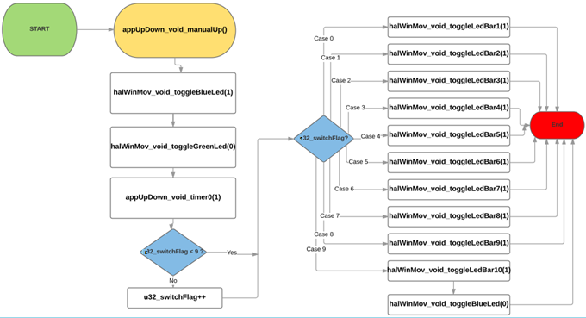

## Function void appUpDown_void_manualDown()

|  |  |
| --- | --- |
| **Description** | Descending Turn on the Led Bar using a switch statement, the Led number is proportional with s32_switchFlag value. |
| **Return Value** | void |
| **Precondition** | The s32_switchFlag has to be set with a value [-1 to 9] |
| **Post condition** | The ledbar is turned off. |
| **Error Conditions** |  |

**Dynamic Behavior**

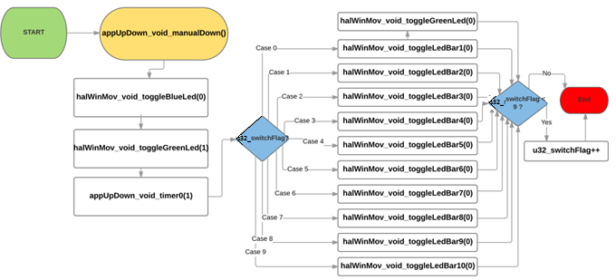

## Function T_U32 appUpDown_u32_PushUpButton()

|  |  |
| --- | --- |
| **Description** | Calls halWinMov_u32_ValidateUpButton function, to know if the halWinMov_u32_ValidateUpButton()is true or false |
| **Parameter 1** <input| output| inout> |  |
| **Parameter 2..n** |  |
| **Return Value** | T_U32 1 , 0 |
| **Precondition** |  |
| **Post condition** |  |
| **Error Conditions** |  |

**Dynamic Behavior**

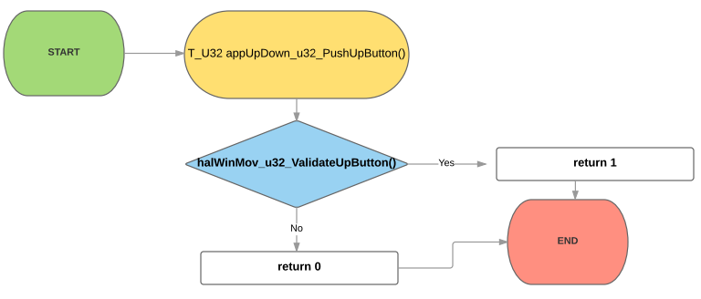

## Function T_U32 appUpDown_u32_PushDownButton()

|  |  |
| --- | --- |
| **Description** | Calls Calls halWinMov_u32_ValidateDownButton() function, to know if the Calls halWinMov_u32_ValidateDownButton()is true or false |
| **Parameter 1** <input| output| inout> |  |
| **Parameter 2..n** |  |
| **Return Value** | T_U32 1 , 0 |
| **Precondition** |  |
| **Post condition** |  |
| **Error Conditions** |  |

**Dynamic Behavior**

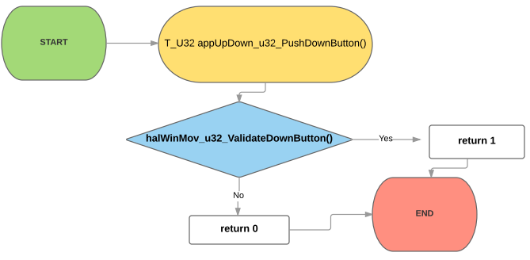

## Function T_U32 appUpDown_u32_PushAntipinch()

|  |  |
| --- | --- |
| **Description** | Calls halWinMov_u32_ValidateAntipinch() function, to know if the halWinMov_u32_ValidateUpButton()is true or false |
| **Parameter 1** <input| output| inout> |  |
| **Parameter 2..n** |  |
| **Return Value** | T_U32 1 , 0 |
| **Precondition** |  |
| **Post condition** |  |
| **Error Conditions** |  |

**Dynamic Behavior**

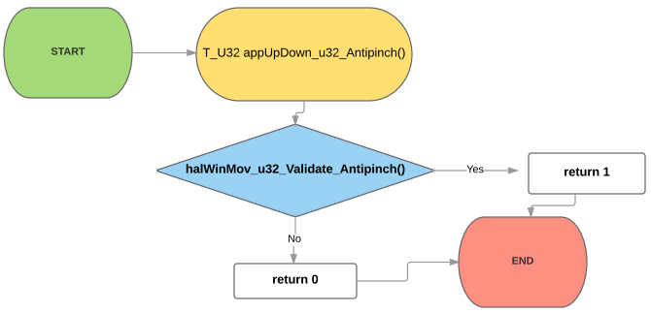

## Function void appUpDown_void_default_Leds(T_U32 led)

|  |  |
| --- | --- |
| **Description** | Using T_U32 led, with a switch statement, select case 0,1,2,3 and default.  case 0 → Turn off Blue, Green and Red Led.  case 1 → Turn off Blue.  case 2 → Turn off Green.  case 3 → Turn on Red.  default → Turn on Blue, Green and Red Led. |
| **Parameter 1** <input| output| inout> | input T_U32 |
| **Parameter 2..n** |  |
| **Return Value** | void |
| **Precondition** |  |
| **Post condition** |  |
| **Error Conditions** |  |

**Dynamic Behavior**

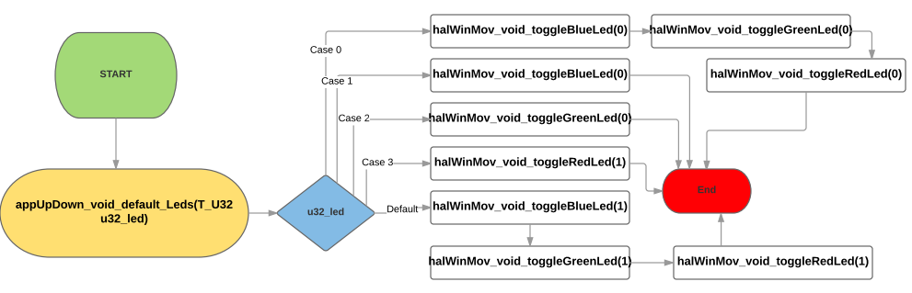

## Function void appUpDown_void_clearGPIO()

|  |  |
| --- | --- |
| **Description** | Turn off Blue Led, Green Led, Red Led and LedBar# |
| **Parameter 1** <input| output| inout> |  |
| **Parameter 2..n** |  |
| **Return Value** | void |
| **Precondition** |  |
| **Post condition** |  |
| **Error Conditions** |  |

**Dynamic Behavior**

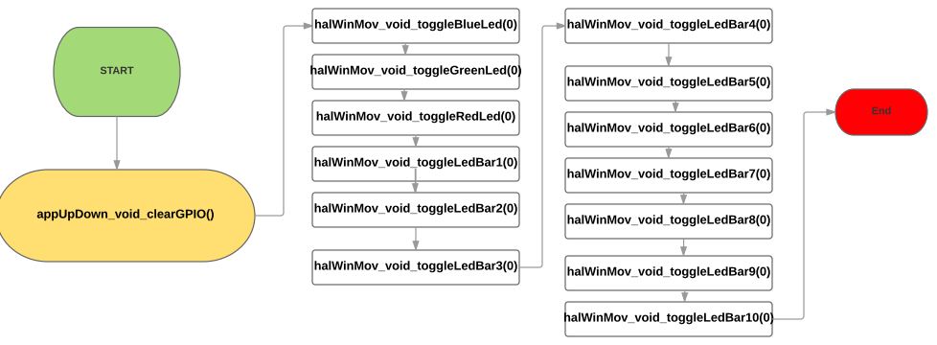

## Function void appUpDown_void_timer1()

|  |  |
| --- | --- |
| **Description** | After 40000 cycles has occurred increment u32_lpit0_ch1_flag_counter variable. (1 ms) |
| **Parameter 1** <input| output| inout> |  |
| **Parameter 2..n** |  |
| **Return Value** | void |
| **Precondition** | The LPIT_MSR_TIF1_MASK timer should be configured and initialized |
| **Post condition** | The LPIT_MSR_TIF1_MASK timer has been cleared |
| **Error Conditions** |  |

**Dynamic Behavior**

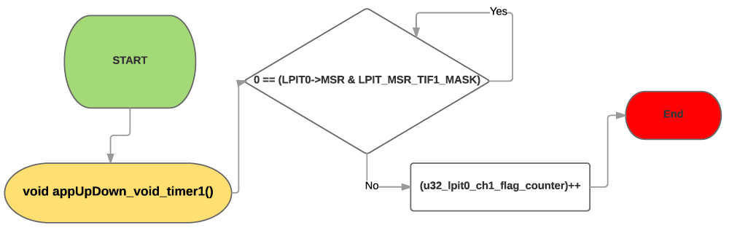

## Function void appUpDown_void_timer0()

|  |  |
| --- | --- |
| **Description** | After 16 000 000 cycles has occurred increment u32_lpit0_ch0_flag_counter variable. (400 ms) |
| **Parameter 1** <input| output| inout> |  |
| **Parameter 2..n** |  |
| **Return Value** | void |
| **Precondition** | The LPIT_MSR_TIF0_MASK timer should be configured and initialized |
| **Post condition** | The LPIT_MSR_TIF0_MASK timer has been cleared |
| **Error Conditions** |  |

**Dynamic Behavior**

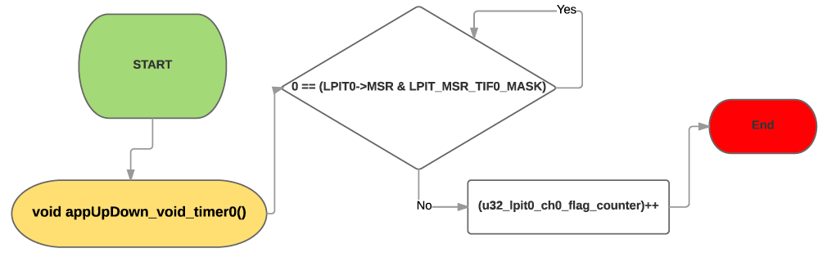

## Function T_U32 appUpDown_u32_validation10ms()

|  |  |
| --- | --- |
| **Description** | Check when u32_lpit0_ch1_flag_counter is equal or higher to 10. This mean that 10 ms are occurred. |
| **Parameter 1** <input| output| inout> |  |
| **Parameter 2..n** |  |
| **Return Value** | T_U32 1,0 |
| **Precondition** | The LPIT_MSR_TIF1_MASK timer should be configured and initialized, u32_lpit0_ch0_flag should be 0 at the beginning |
| **Post condition** |  |
| **Error Conditions** |  |

**Dynamic Behavior**

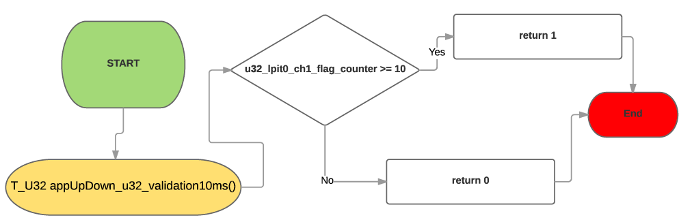

## Function T_U32 appUpDown_u32_validation500ms()

|  |  |
| --- | --- |
| **Description** | Check when u32_lpit0_ch1_flag_counter is equal or higher to 500. |
| **Parameter 1** <input| output| inout> |  |
| **Parameter 2..n** |  |
| **Return Value** | T_U32 1,0 |
| **Precondition** | The LPIT_MSR_TIF1_MASK timer should be configured and initialized, u32_lpit0_ch1_flag should be 0 at the beginning |
| **Post condition** |  |
| **Error Conditions** |  |

**Dynamic Behavior**

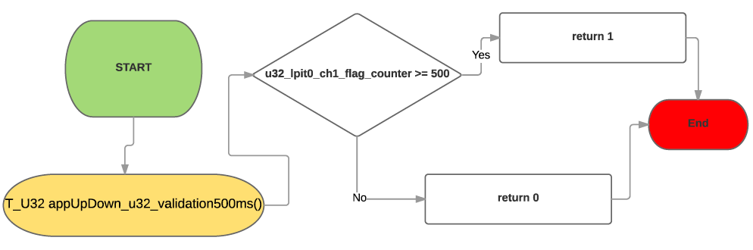

## Function T_U32 halWinMov_u32_ValidateUpButton()

|  |  |
| --- | --- |
| **Description** | Check if PORT C12 value is in High or Low and returns 1 if is High and 0 if is Low |
| **Parameter 1** <input| output| inout> |  |
| **Parameter 2..n** |  |
| **Return Value** | T_U32 1,0 |
| **Precondition** | The PORTD C12 should be configured as input |
| **Post condition** |  |
| **Error Conditions** |  |

**Dynamic Behavior**

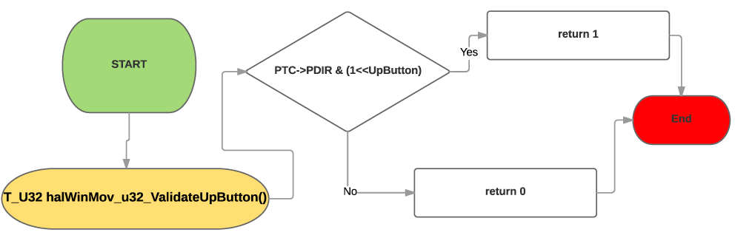

## Function T_U32 halWinMov_u32_ValidateUpButton()

|  |  |
| --- | --- |
| **Description** | Check if PORT C13 value is in High or Low and returns 1 if is High and 0 if is Low |
| **Parameter 1** <input| output| inout> |  |
| **Parameter 2..n** |  |
| **Return Value** | T_U32 1,0 |
| **Precondition** | The PORTD C13 should be configured as input. |
| **Post condition** |  |
| **Error Conditions** |  |

**Dynamic Behavior**

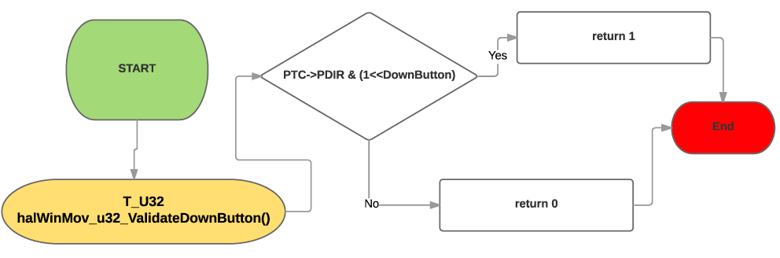

## Function T_U32 halWinMov_u32_ValidateAntipinch()

|  |  |
| --- | --- |
| **Description** | Check if PORT E13 value is in High or Low and returns 1 if is High and 0 if is Low |
| **Parameter 1** <input| output| inout> |  |
| **Parameter 2..n** |  |
| **Return Value** | T_U32 1,0 |
| **Precondition** | The PORTD E13 should be configured as input. |
| **Post condition** |  |
| **Error Conditions** |  |

**Dynamic Behavior**

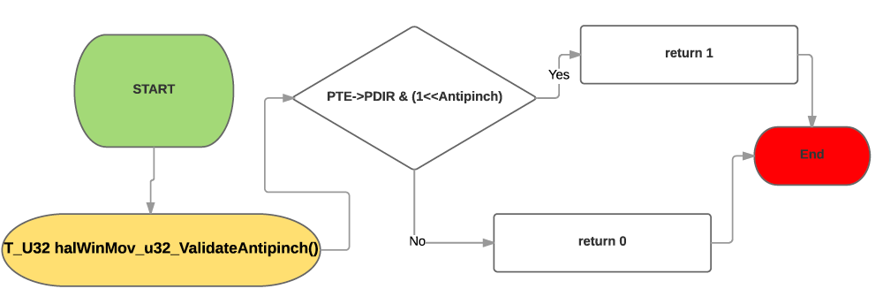

## Function void halWinMov_void_ToggleBlueLed(T_U32 u32_status)

|  |  |
| --- | --- |
| **Description** | Write in PORT D0:  - High if int status = 1.  - Low if int status = 0. |
| **Parameter 1** <input| output| inout> | Input T_U32 u32_status |
| **Parameter 2..n** |  |
| **Return Value** | void |
| **Precondition** | The PORTD D0 should be configured as output. |
| **Post condition** |  |
| **Error Conditions** |  |

**Dynamic Behavior**

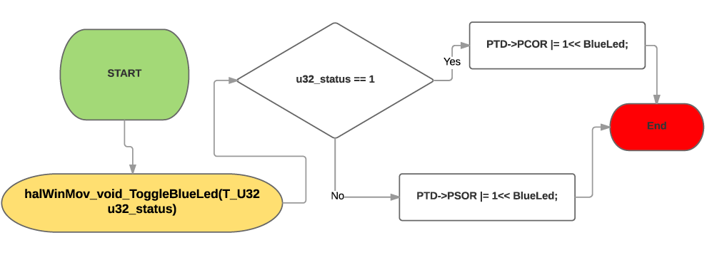

## Function void halWinMov_void_ToggleRedLed(T_U32 u32_status)

|  |  |
| --- | --- |
| **Description** | Write in PORT D15:  - High if int status = 1.  - Low if int status = 0. |
| **Parameter 1** <input| output| inout> | Input T_U32 u32_status |
| **Parameter 2..n** |  |
| **Return Value** | void |
| **Precondition** | The PORTD D15 should be configured as output. |
| **Post condition** |  |
| **Error Conditions** |  |

**Dynamic Behavior**

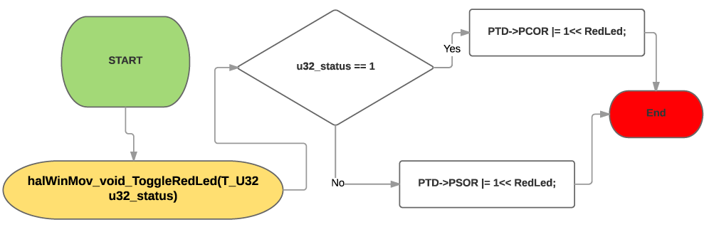

## Function void halWinMov_void_ToggleGreenLed(T_U32 u32_status)

|  |  |
| --- | --- |
| **Description** | Write in PORT D16:  - High if int status = 1.  - Low if int status = 0. |
| **Parameter 1** <input| output| inout> | Input T_U32 u32_status |
| **Parameter 2..n** |  |
| **Return Value** | void |
| **Precondition** | The PORTD D16 should be configured as output. |
| **Post condition** |  |
| **Error Conditions** |  |

**Dynamic Behavior**

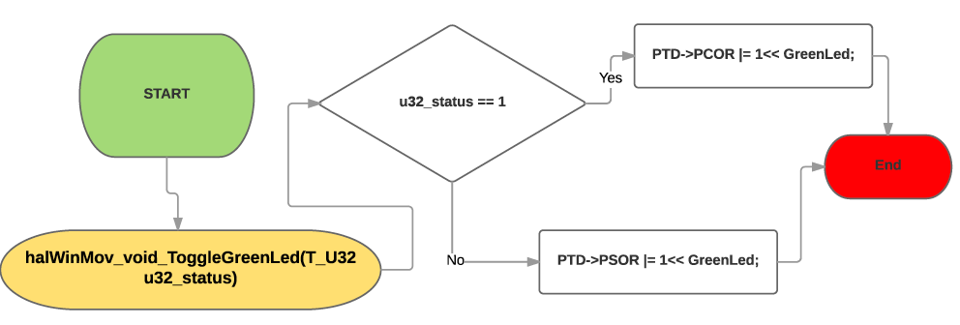

## Function void halWinMov_void_ToggleLedBar#(T_U32 u32_status)

|  |  |  |
| --- | --- | --- |
| **Description** | Write High or Low in Led number # | |
| LedBar_1  Write in PORT C7:  - High if int status = 1.  - Low if int status = 0.  LedBar_2  Write in PORT B17:  - High if int status = 1.  - Low if int status = 0.  LedBar_3  Write in PORT B14:  - High if int status = 1.  - Low if int status = 0.  LedBar_4  Write in PORT B15:  - High if int status = 1.  - Low if int status = 0.  LedBar_5  Write in PORT B16:  - High if int status = 1.  - Low if int status = 0. | LedBar_6  Write in PORT C14:  - High if int status = 1.  - Low if int status = 0.  LedBar_7  Write in PORT C3:  - High if int status = 1.  - Low if int status = 0.  LedBar_8  Write in PORT E16:  - High if int status = 1.  - Low if int status = 0.  LedBar_9  Write in PORT E15:  - High if int status = 1.  - Low if int status = 0.  LedBar_10  Write in PORT E14:  - High if int status = 1.  - Low if int status = 0. |
| **Parameter 1** <input| output| inout> | Input T_U32 u32_status | |
| **Parameter 2..n** |  | |
| **Return Value** | void | |
| **Precondition** | Should be configured as output: | |
| PORT C7  PORT B17  PORT B14  PORT B15  PORT B16 | PORT C14  PORT C3  PORT E16  PORT E15  PORT E14 |
| **Post condition** |  | |
| **Error Conditions** |  | |

**Dynamic Behavior**

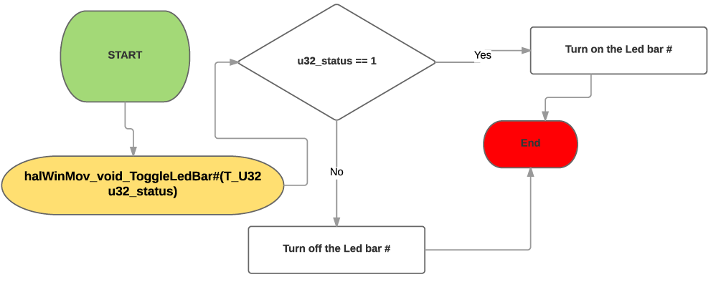

## Function void main_void_onetouchUp()

|  |  |
| --- | --- |
| **Description** | Calls appUpDown_void_ManualUp() inside a while to similuted the lift movement. And turn on all the led bar |
| **Parameter 1** <input| output| inout> |  |
| **Parameter 2..n** |  |
| **Return Value** | void |
| **Precondition** |  |
| **Post condition** |  |
| **Error Conditions** |  |

**Dynamic Behavior**

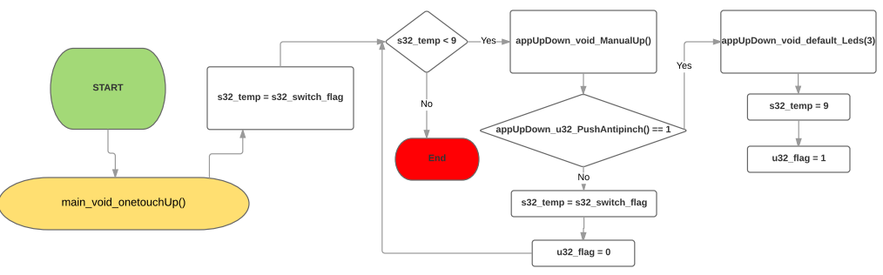

## Function void main_void_onetouchDown()

|  |  |
| --- | --- |
| **Description** | Calls appUpDown_void_ManualUp() inside a while to similuted the lift movement. And turn on all the led bar |
| **Parameter 1** <input| output| inout> |  |
| **Parameter 2..n** |  |
| **Return Value** | void |
| **Precondition** |  |
| **Post condition** |  |
| **Error Conditions** |  |

**Dynamic Behavior**

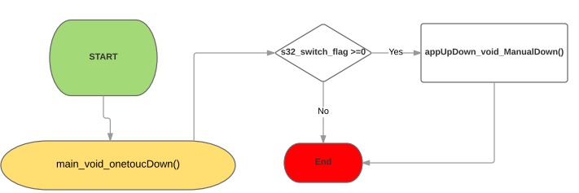

## Function void main_void_behaviorUp()

|  |  |
| --- | --- |
| **Description** | Select the behavior between Manual Up and OneTouchUp |
| **Parameter 1** <input| output| inout> |  |
| **Parameter 2..n** |  |
| **Return Value** | void |
| **Precondition** |  |
| **Post condition** |  |
| **Error Conditions** |  |

**Dynamic Behavior**

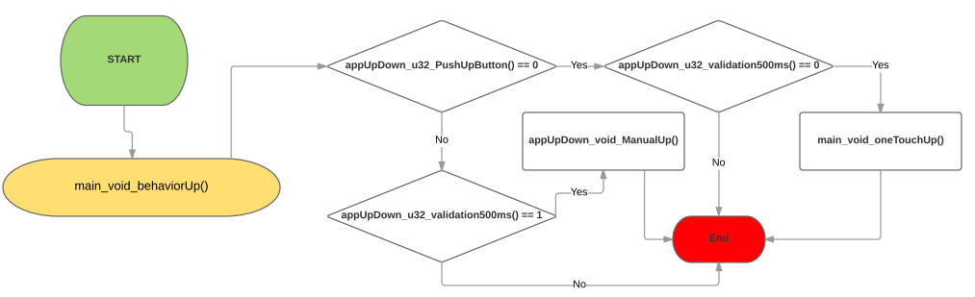

## Function void main_void_behaviorDown()

|  |  |
| --- | --- |
| **Description** | Select the behavior between Manual Down and OneTouchDown |
| **Parameter 1** <input| output| inout> |  |
| **Parameter 2..n** |  |
| **Return Value** | void |
| **Precondition** |  |
| **Post condition** |  |
| **Error Conditions** |  |

**Dynamic Behavior**

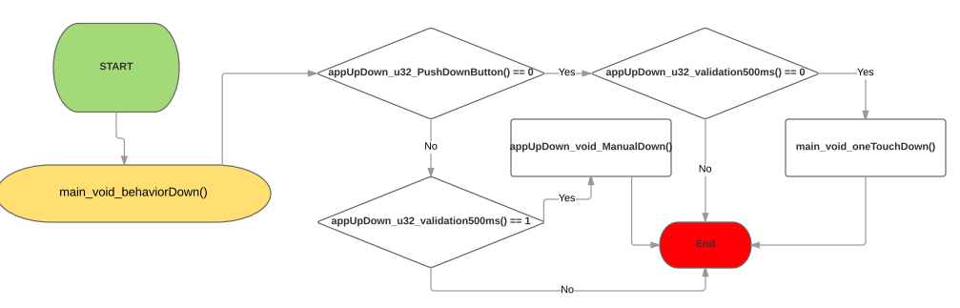

## Function void main_void_Antipinch()

|  |  |
| --- | --- |
| **Description** | If the flag antipinch is 1, the action antipinch is going to be activated. During 5 seconds it will not respond to any action. |
| **Parameter 1** <input| output| inout> |  |
| **Parameter 2..n** |  |
| **Return Value** | void |
| **Precondition** |  |
| **Post condition** |  |
| **Error Conditions** |  |

**Dynamic Behavior**

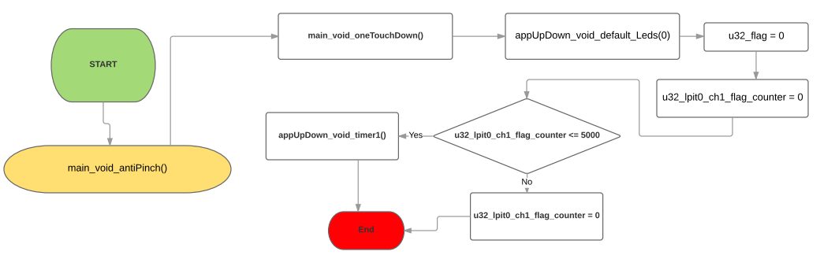

## Function void main_void_idleState()

|  |  |
| --- | --- |
| **Description** | Put the all the leds in Low. |
| **Parameter 1** <input| output| inout> |  |
| **Parameter 2..n** |  |
| **Return Value** | void |
| **Precondition** |  |
| **Post condition** |  |
| **Error Conditions** |  |

**Dynamic Behavior**

