GlemO RWA Product DFD and Requirements V4.7
Current data flows, product requirements and implementation boundaries for the GlemO RWA platform prototype. Updated 15 September 2026.

Purpose
This document declares the current data flow diagrams and product requirements for the GlemO RWA platform prototype. It replaces legacy DFD interpretations and aligns the documentation with the current V4.7 platform status.

Product Requirements
ID | Requirement | Scope | Primary Screens
R1 | Public asset discovery | MVP1 core | market, assetFactSheet, distributionSaas
R2 | Buyer account and eligibility | MVP1 core | retailPortal, investorGate, institutionalPortal
R3 | Seller onboarding | MVP1 core | sellerOrgAdmin, bankOps, assetFactory
R4 | Validator gate | MVP1 core | validatorDesk, documentReview, complianceCases
R5 | Admin transaction clearance | MVP1 core | transactionClearance, adminDashboard
R6 | Transaction declaration layer | MVP1 core | transactionLayer, ledger, reports
R7 | Revenue operations | MVP1 core | billingRevenue, sellerPlans
R8 | Distribution SaaS | MVP1 beta | distributionSaas, distributionPartner
R9 | AI concierge governance | MVP1 beta | aiOps, conciergeDesk
R10 | Rails and chain architecture | MVP1 beta | railPartner, riskEngine, ledger
R11 | Asset technical sheet | MVP1 core | assetFactSheet
R12 | Builder ecosystem | Phase two | ecosystemBuilder

Requirement Details
R1 Public asset discovery: Marketplace, official distribution channels, asset fact sheet and clear risk labels must be visible before account creation. Scope: MVP1 core. Screens: market, assetFactSheet, distributionSaas.
R2 Buyer account and eligibility: Retail and institutional buyers need private profile, wallets, KYC/KYB, suitability, jurisdiction and transaction history. Scope: MVP1 core. Screens: retailPortal, investorGate, institutionalPortal.
R3 Seller onboarding: Banks, originators and approved sellers need entity profile, KYB, signers, plan, asset factory and distribution controls. Scope: MVP1 core. Screens: sellerOrgAdmin, bankOps, assetFactory.
R4 Validator gate: Assets cannot go live without evidence review, validator status and admin publication control. Scope: MVP1 core. Screens: validatorDesk, documentReview, complianceCases.
R5 Admin transaction clearance: Sensitive transactions can enter standby; seller pre-check helps prepare evidence, but central admin controls platform release in MVP1. Scope: MVP1 core. Screens: transactionClearance, adminDashboard.
R6 Transaction declaration layer: The platform needs private actor ledgers and a public sanitized explorer for activity, proof hashes and chain route status. Scope: MVP1 core. Screens: transactionLayer, ledger, reports.
R7 Revenue operations: SaaS, setup, servicing, transaction fees, invoices, card/crypto payment and collection status must be visible to prove business model. Scope: MVP1 core. Screens: billingRevenue, sellerPlans.
R8 Distribution SaaS: Enterprise clients need channel map, conversion analytics, external transaction leakage, incentives and partner performance. Scope: MVP1 beta. Screens: distributionSaas, distributionPartner.
R9 AI concierge governance: AI requests must capture prompt chain, allowed data scope, human QA, delivery log and customer request history. Scope: MVP1 beta. Screens: aiOps, conciergeDesk.
R10 Rails and chain architecture: Ethereum plus Base should be documented as the initial EVM-aligned architecture, with partner rails for custody, payment and reconciliation. Scope: MVP1 beta. Screens: railPartner, riskEngine, ledger.
R11 Asset technical sheet: Each tokenized asset needs responsible entities, tokenization history, collateral, documents, performance and liquidity behavior. Scope: MVP1 core. Screens: assetFactSheet.
R12 Builder ecosystem: dApps, plugins and extensions should exist as a future expansion layer after marketplace and distribution rail proof. Scope: Phase two. Screens: ecosystemBuilder.

Data Flow Diagrams

DFD 00 - Requirements Traceability Map
How current product requirements connect to screens, data stores and operating controls.
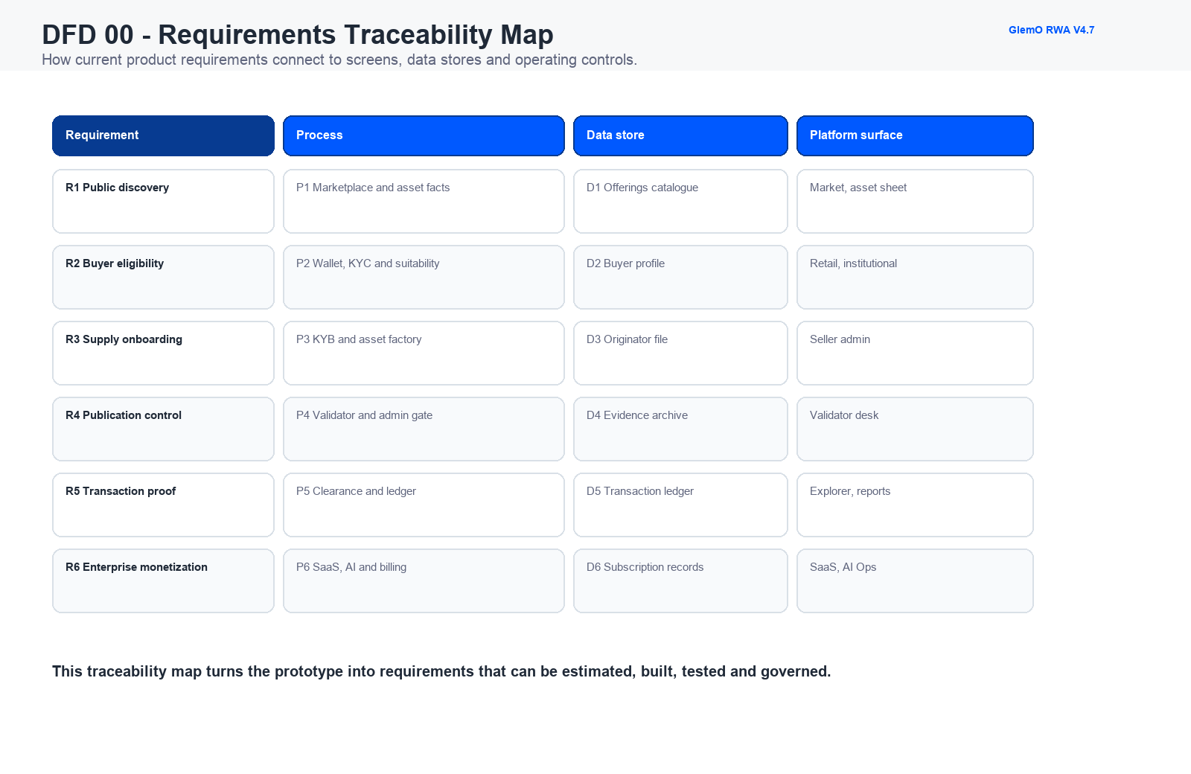

DFD 01 - Platform Context
GlemO as a neutral liquidity and distribution rail for tokenized real world assets.
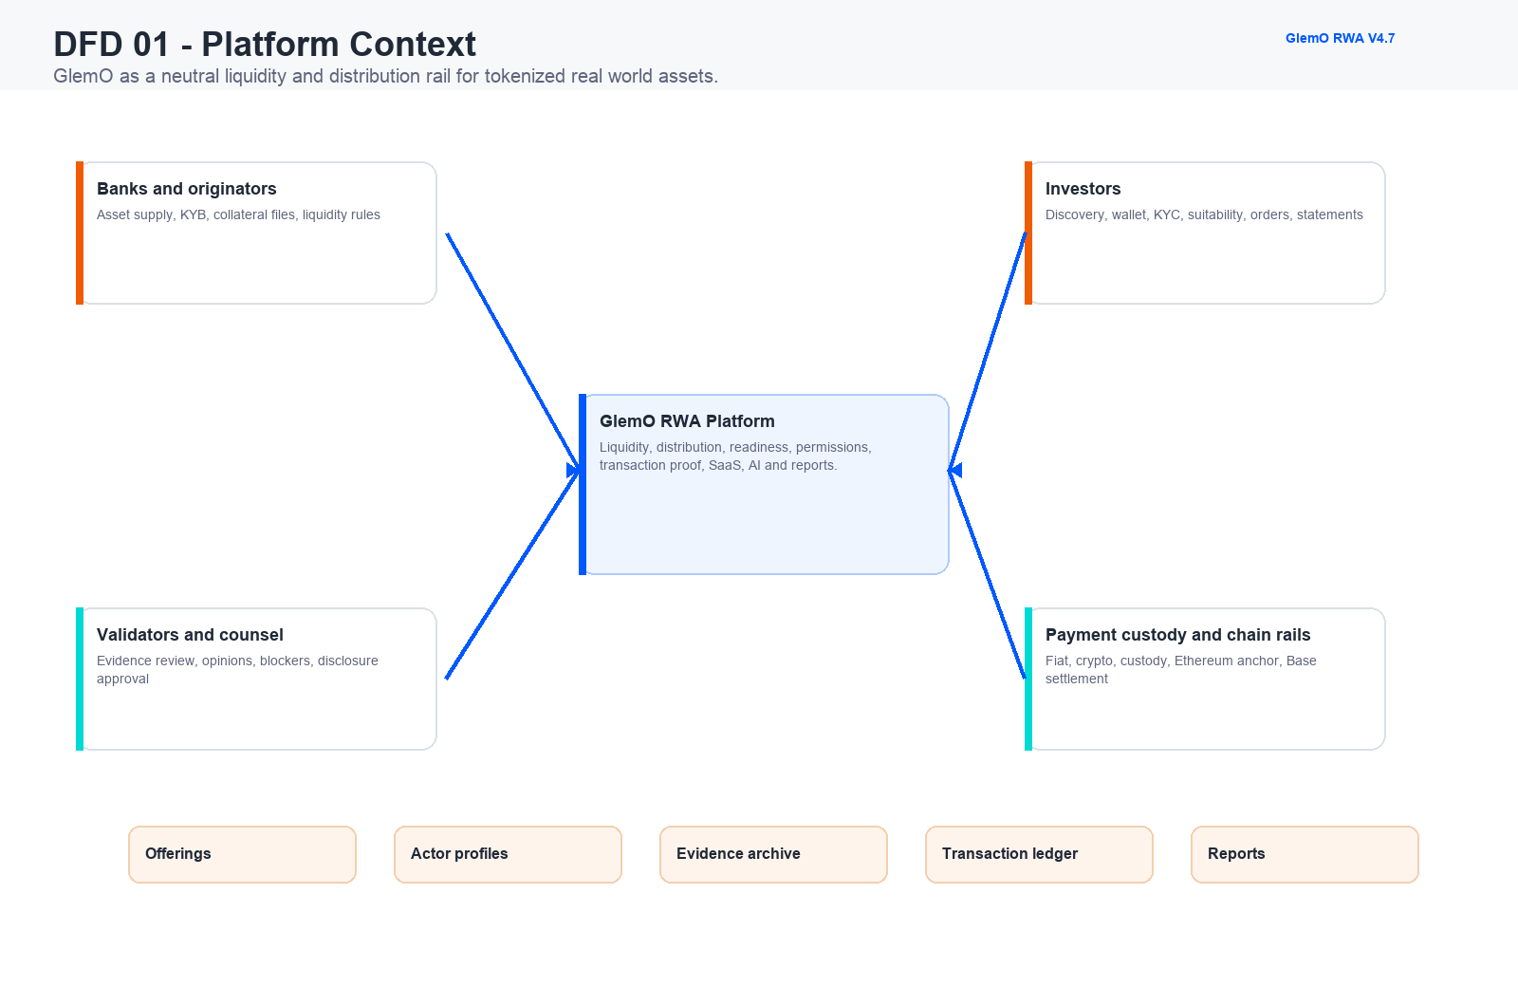

DFD 02 - Buyer Onboarding and Eligibility
Retail and institutional buyers move from public discovery to qualified allocation.
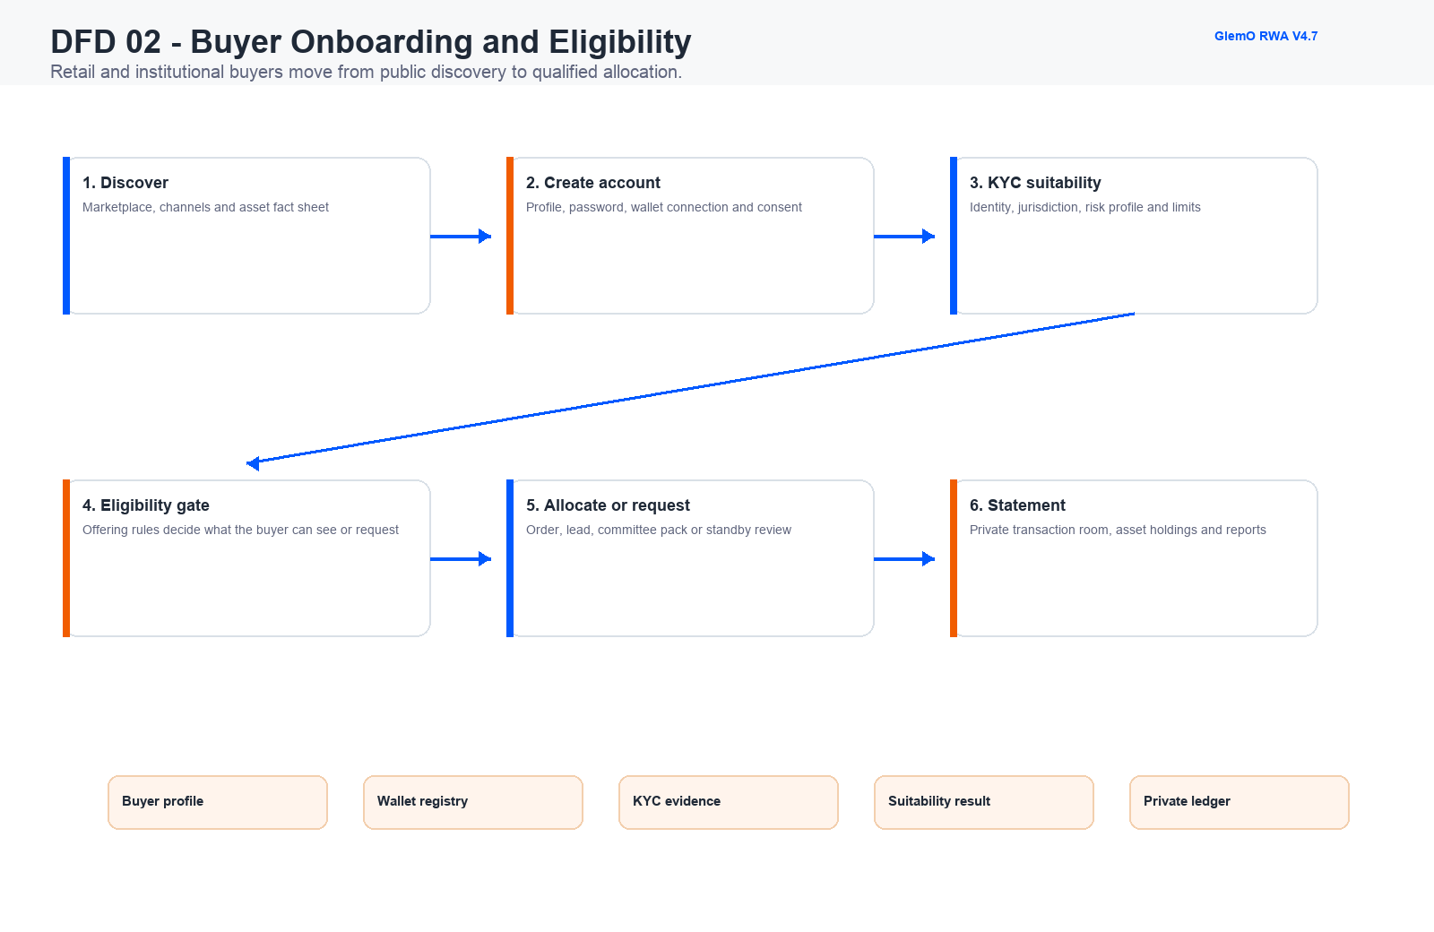

DFD 03 - Originator and Asset Factory
Approved sellers create tokenized pools or standalone assets with evidence and rules.
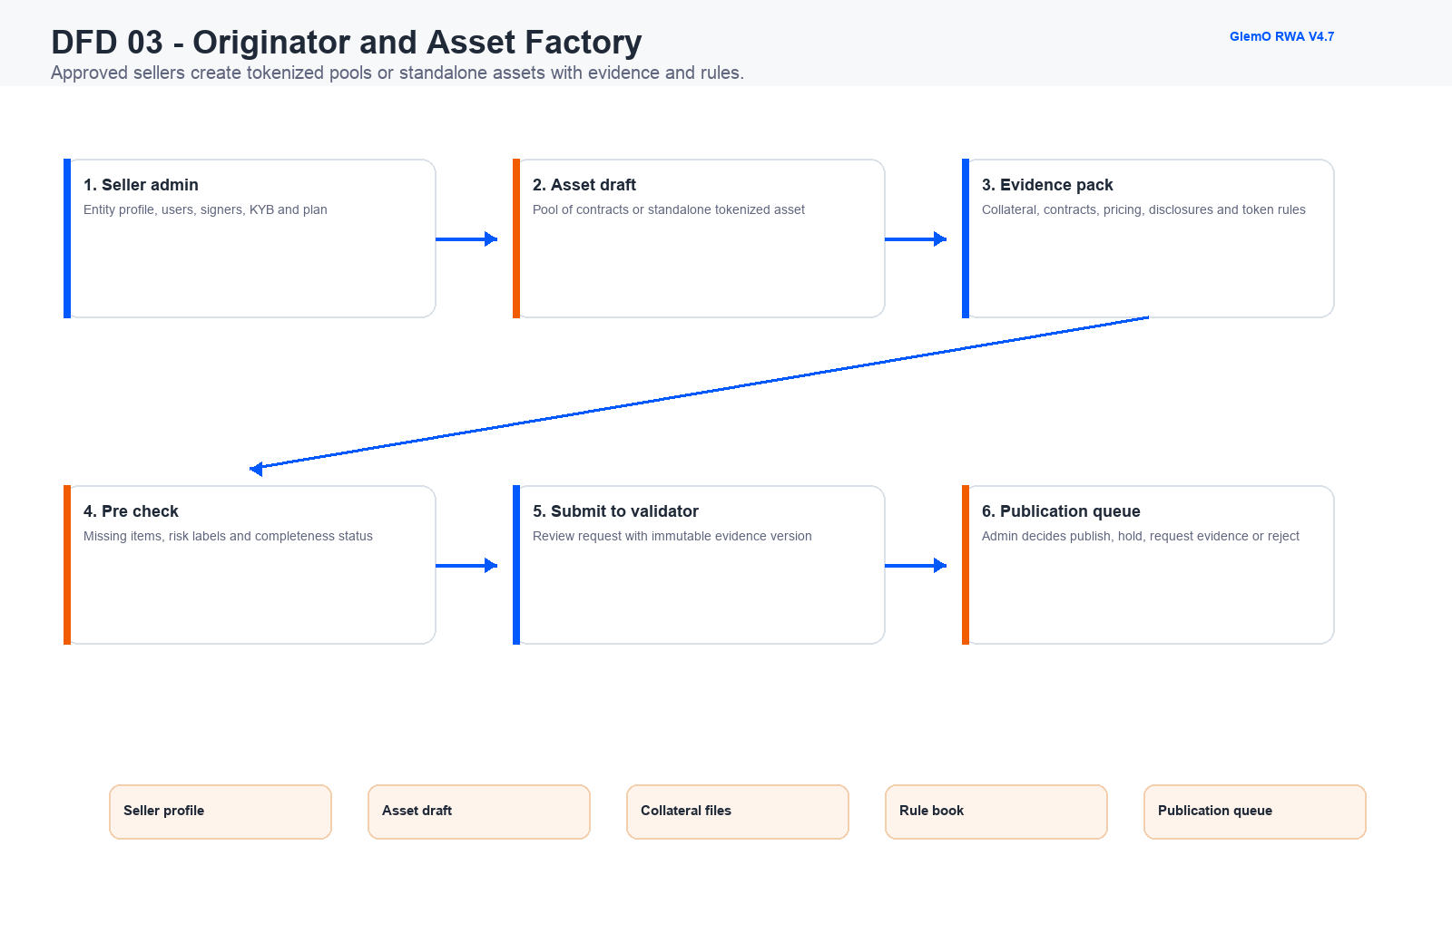

DFD 04 - Validator and Admin Control Gate
Publication and sensitive transactions remain controlled in MVP1.
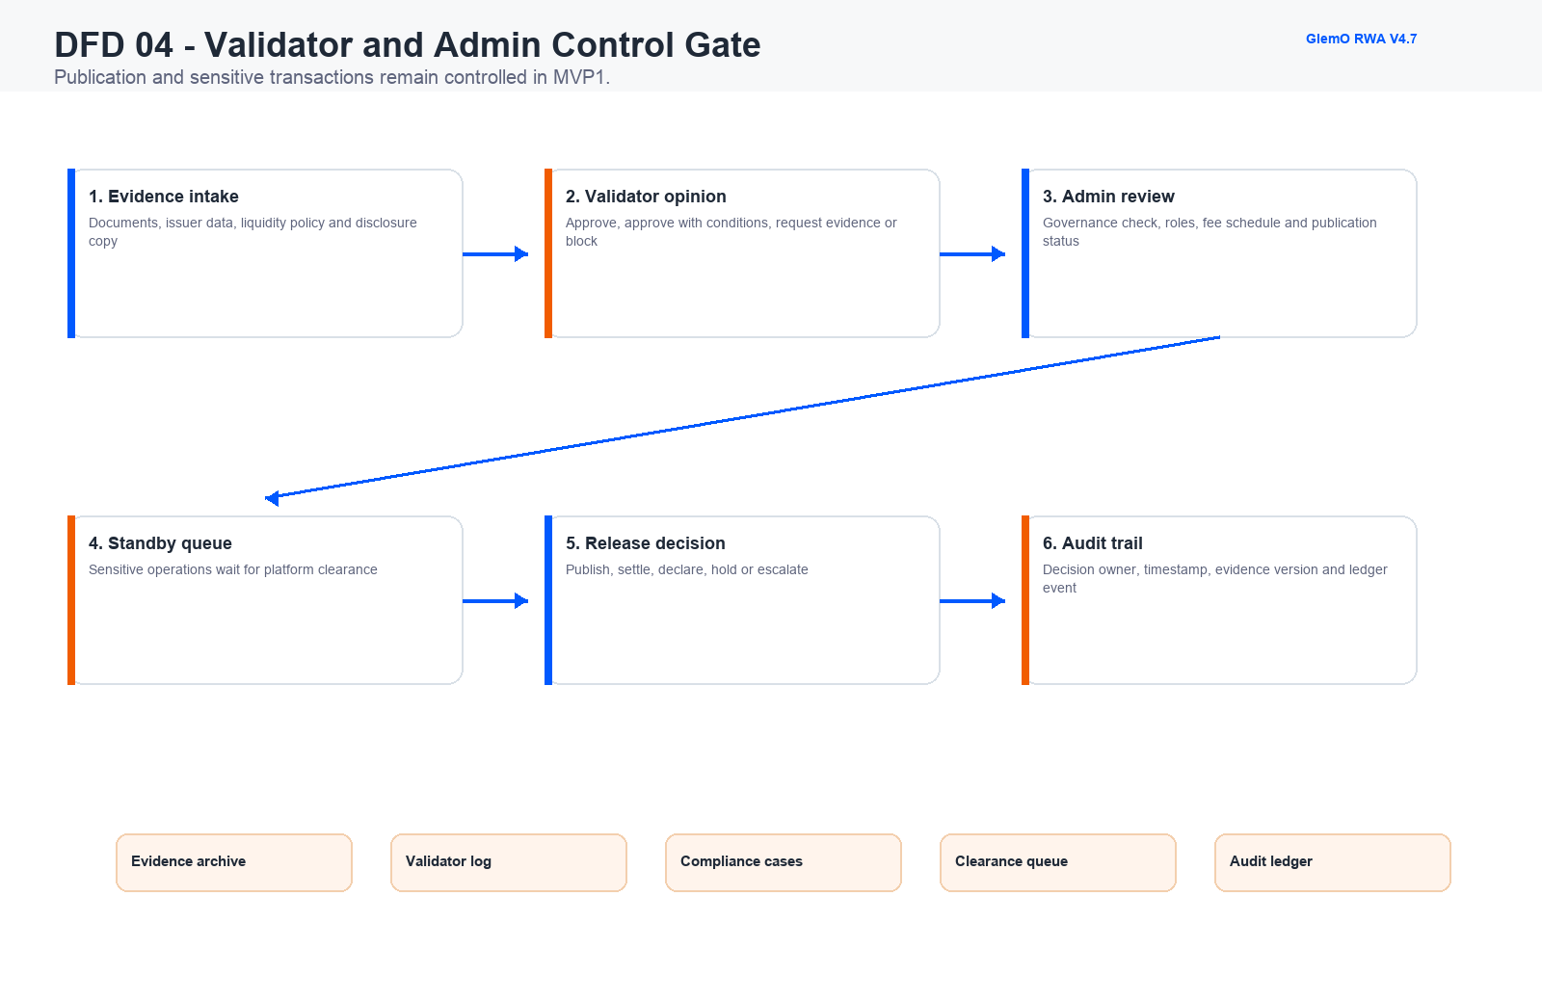

DFD 05 - Transaction Layer and Public Proof
Private ledgers hold full details while public explorer declares sanitized platform activity.
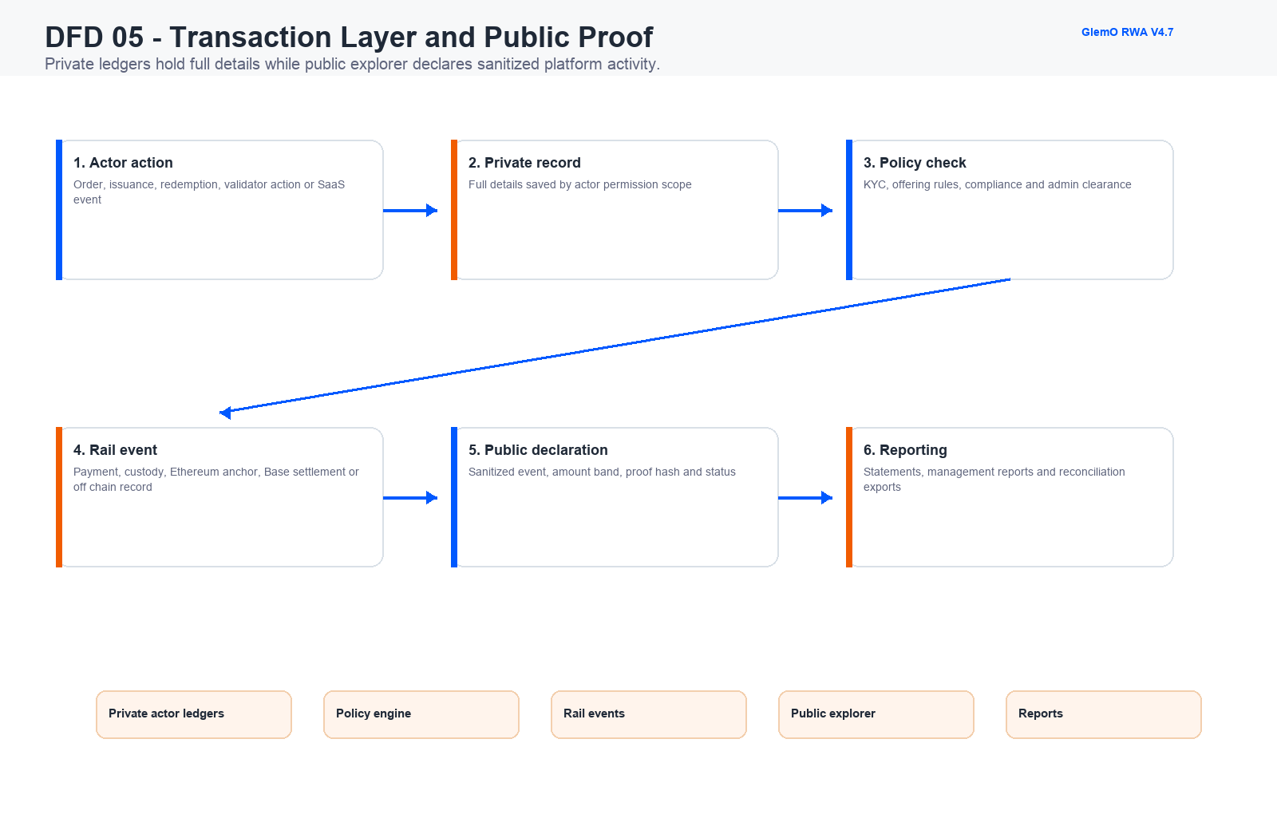

DFD 06 - Distribution SaaS and Revenue
Transparency for users becomes paid intelligence for banks and asset sponsors.
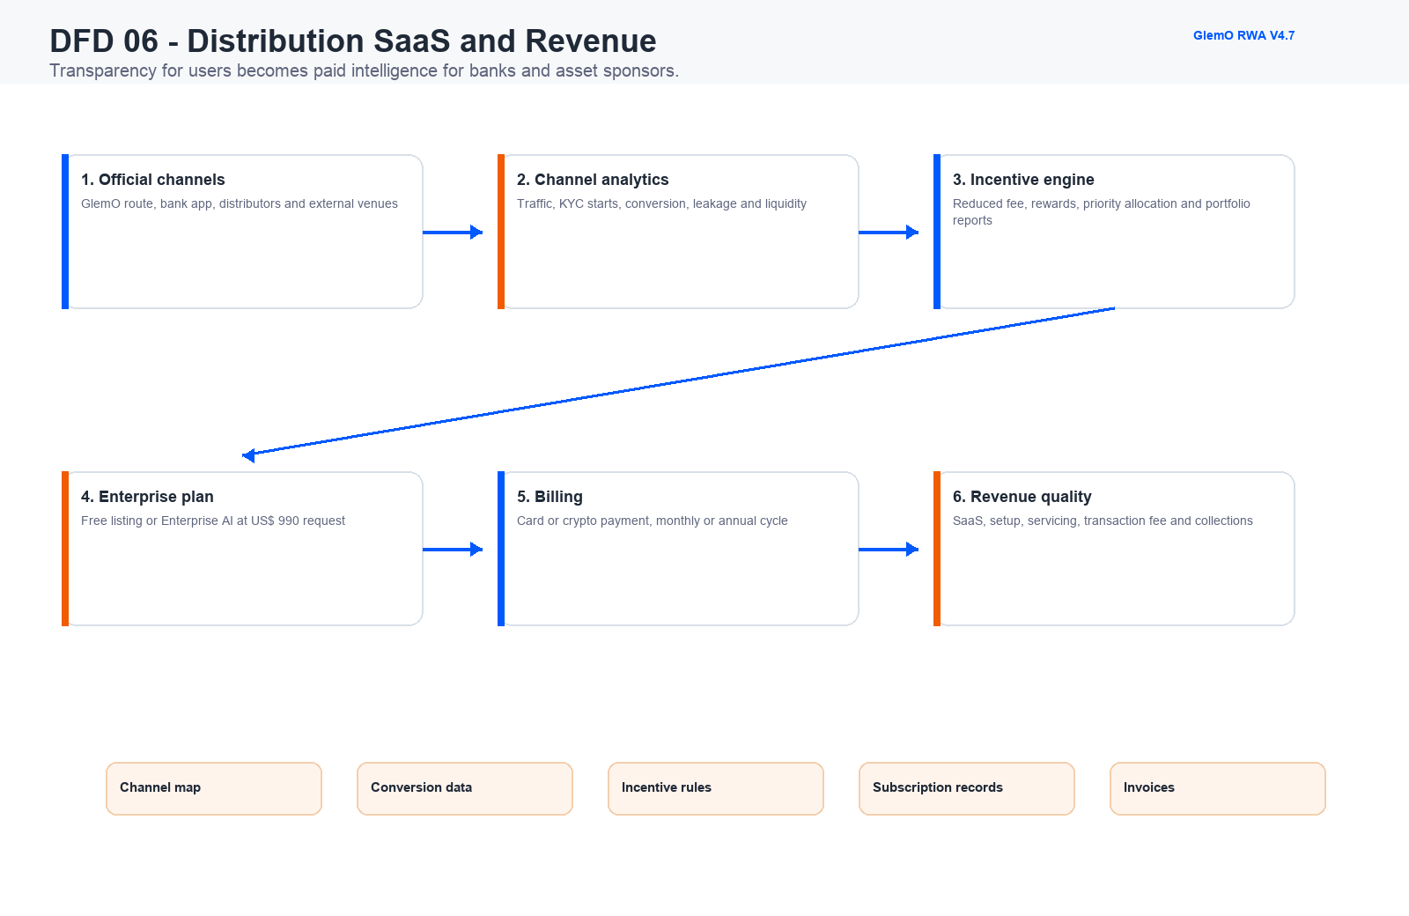

DFD 07 - AI Agents and Concierge
Enterprise requests become controlled prompts, reviewed reports and auditable outputs.
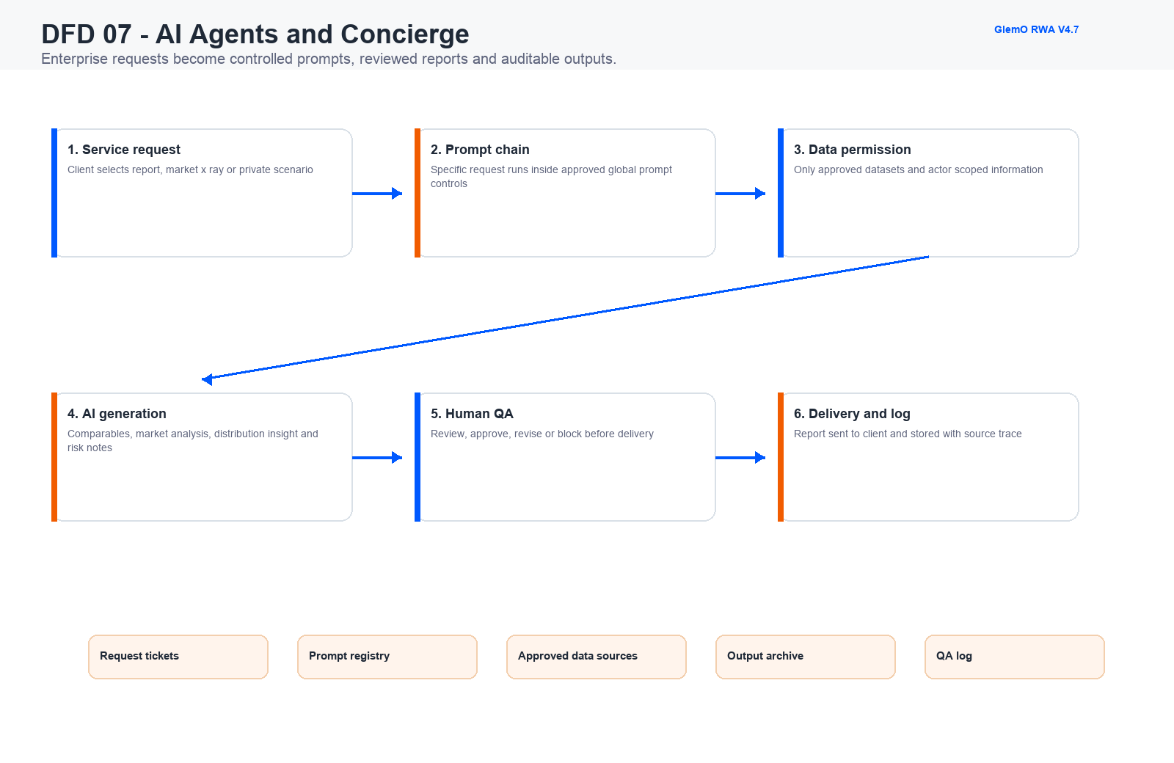

DFD 08 - Rails Settlement and Reconciliation
Ethereum and Base are the core EVM routes, while partner rails handle custody, payments and fallback.
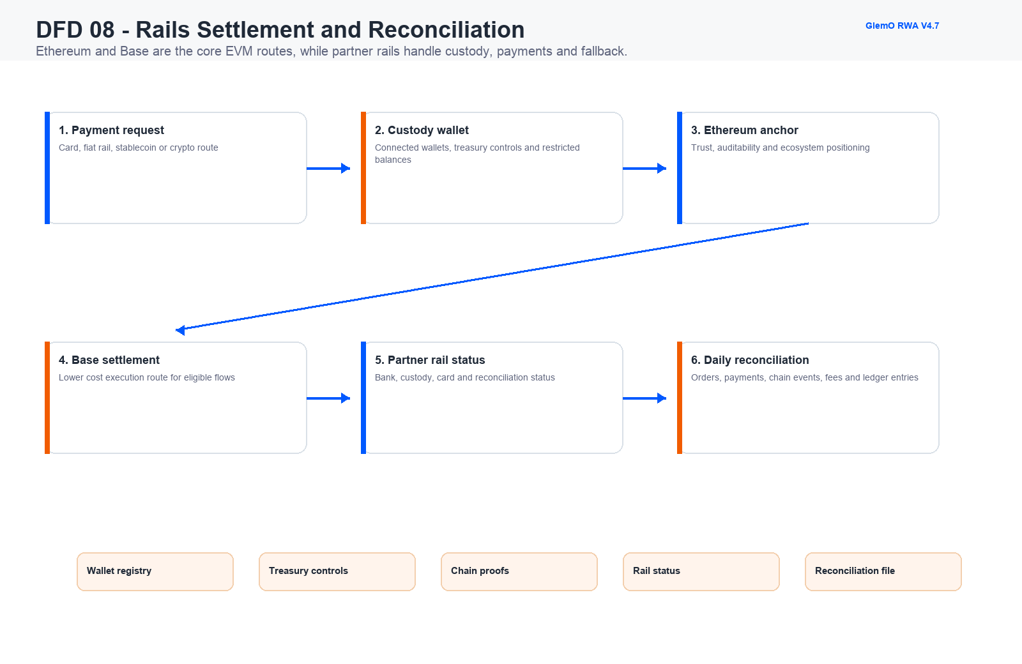

DFD 09 - Builder dApp and Plugin Ecosystem
dApps and plugins expand the platform after the core liquidity loop is proven.
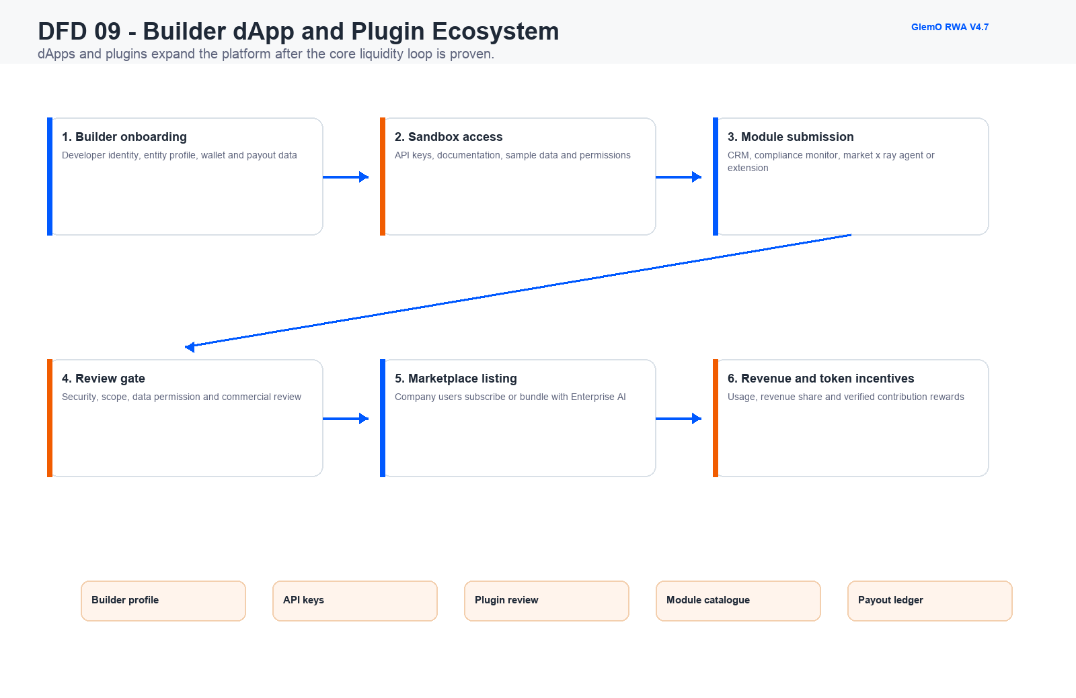

MVP1 Operating Interpretation
The current platform is intentionally broader than a simple token marketplace. The real product is the controlled operating system around the marketplace: buyer qualification, seller supply, evidence, validation, admin release, transaction declaration, reports, paid distribution intelligence and AI-driven enterprise service.
For MVP1, automation should be selective. Manual admin review, validator triage, concierge delivery and reconciliation are acceptable if the workflow has a clear owner, evidence trail, status and ledger event.

