- Create Tables
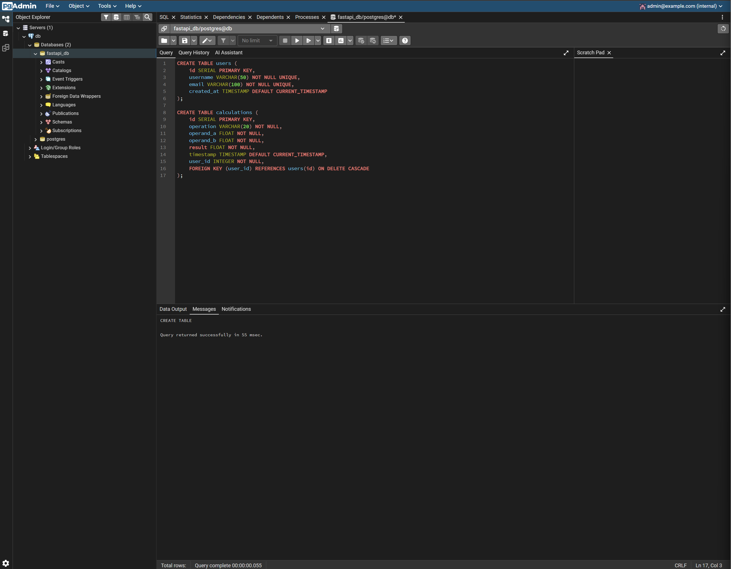
In this screenshot, we are executing a query that creates a users table with basic user information (user ID, username, email, and the user creation time). We also create a calculations table to store calculation history from the calculator with the calculation info (id, the operation, the result, the timestamp, and the user’s ID which references the users table).

- Insert Records
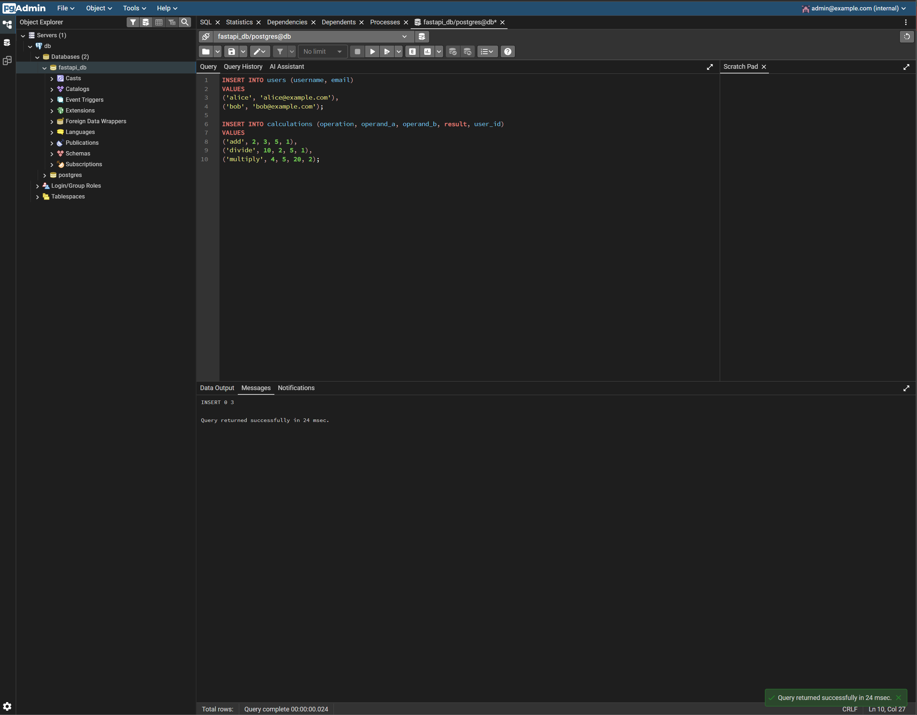
In this screenshot, we are manually inserting records into the users table to create new users. We then manually insert calculation records into the calculations table referencing these users so the users will have a calculation history.

- Query Data
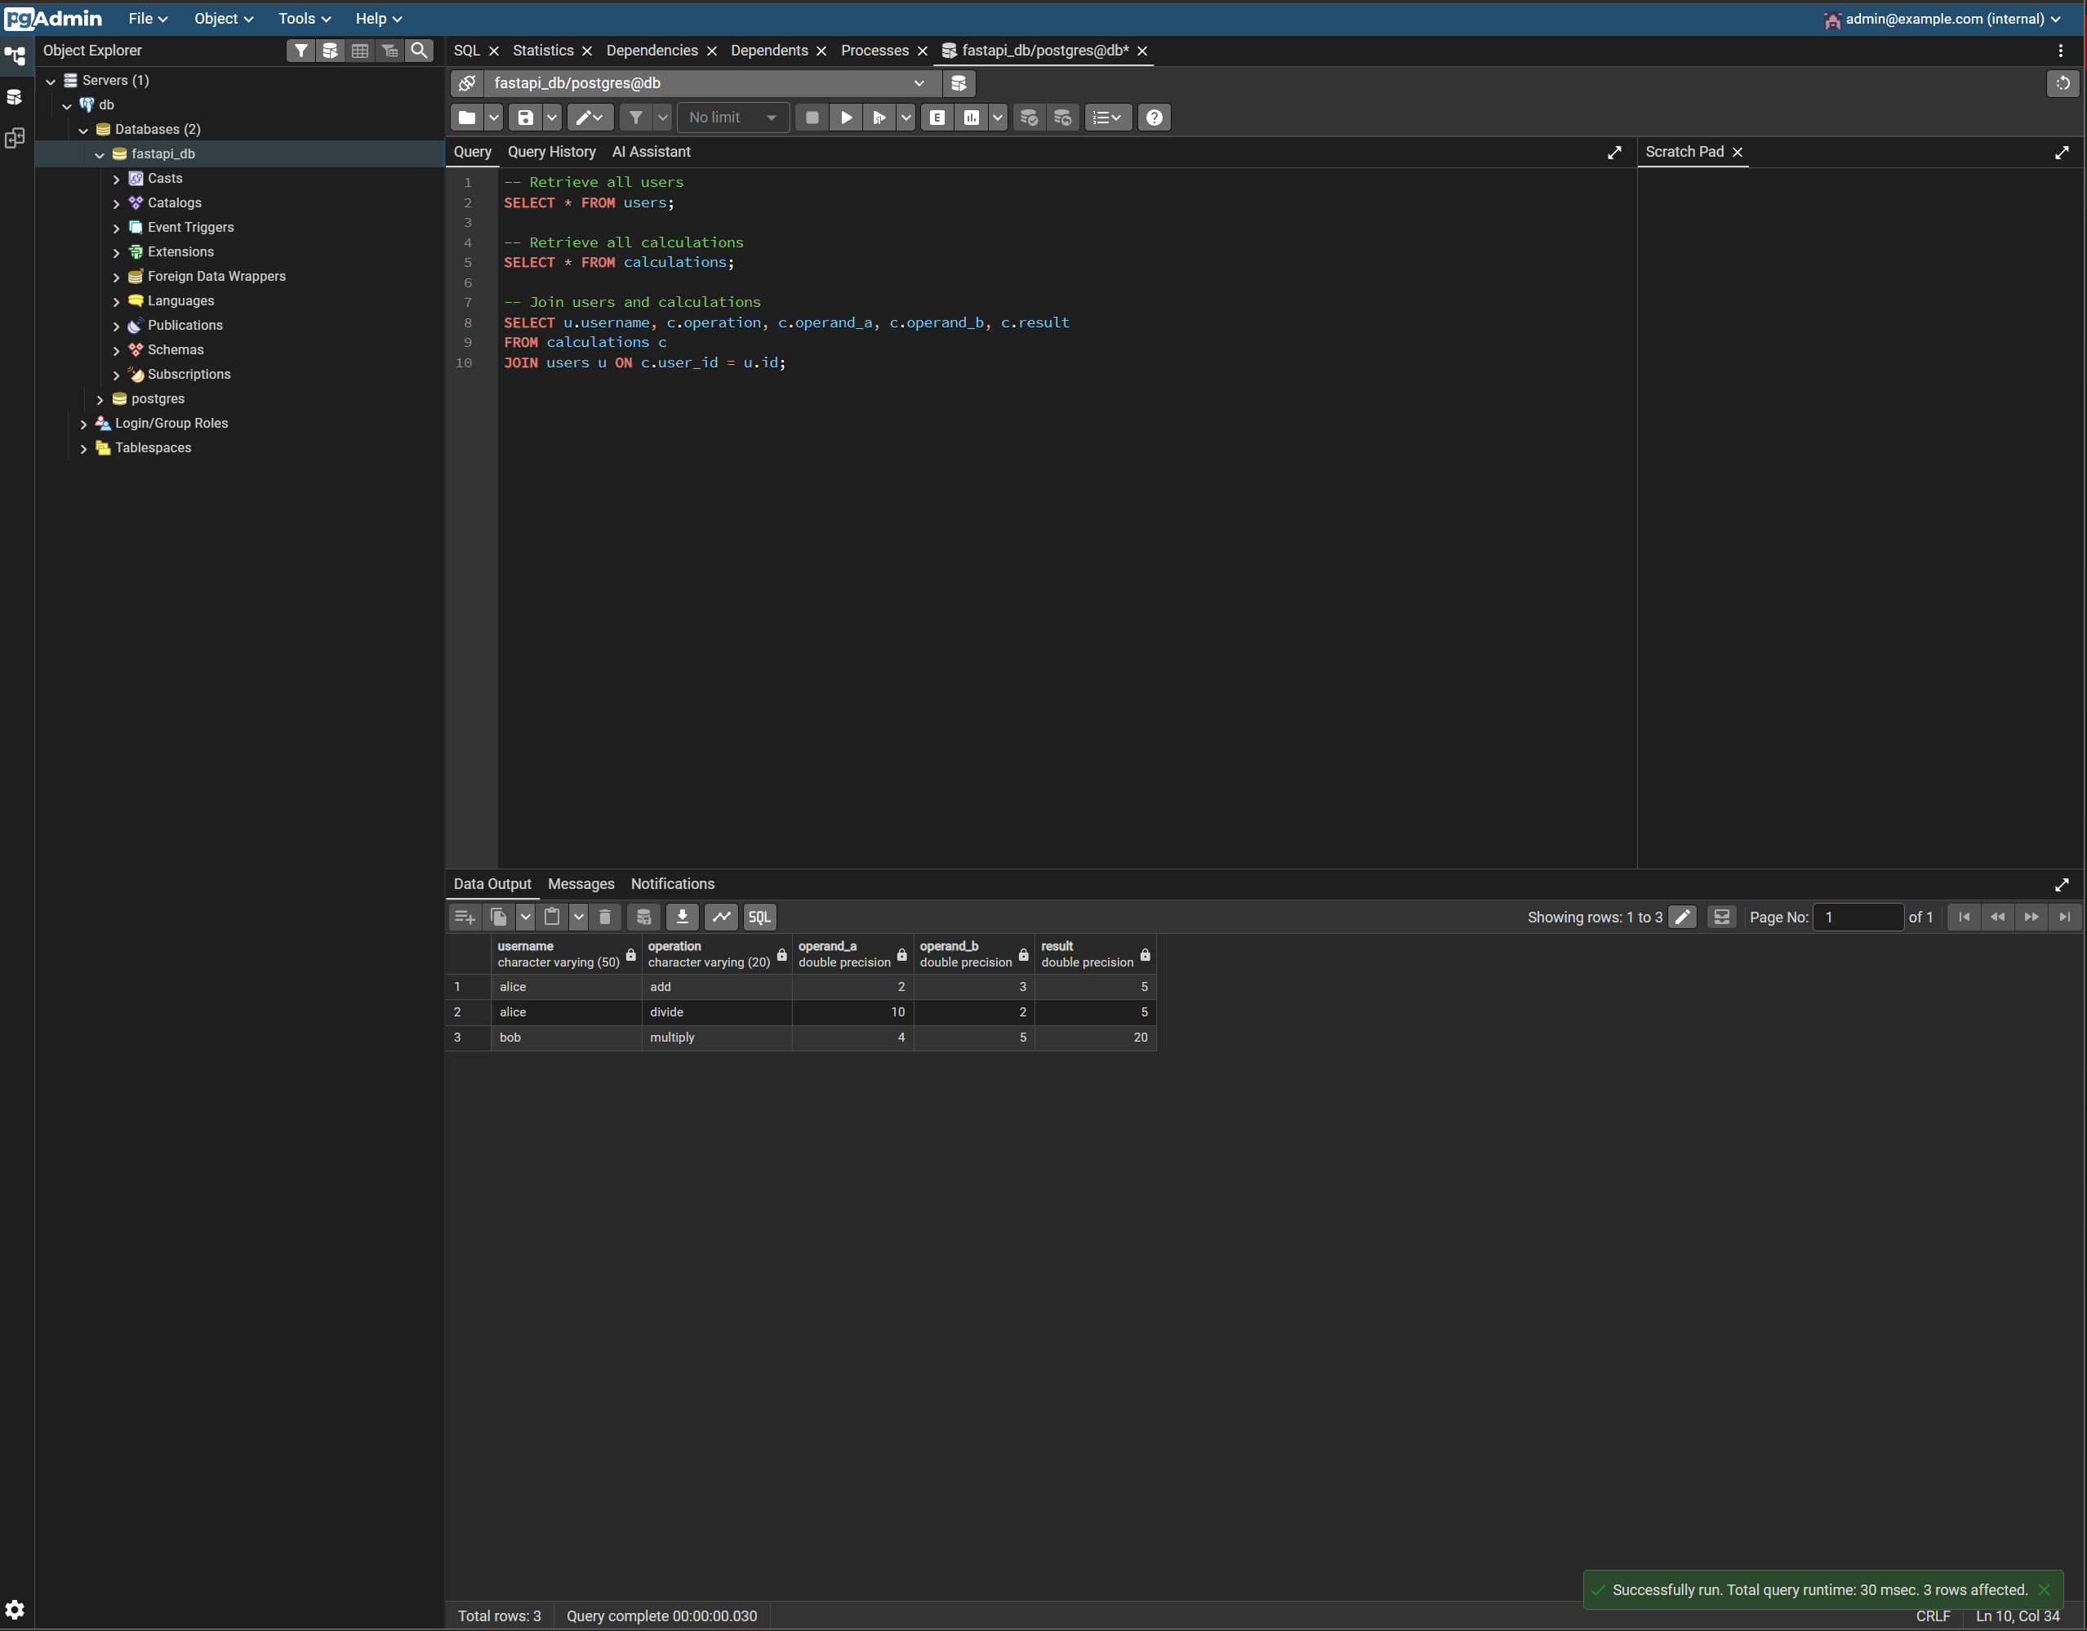
In this screenshot, we fetch all records from the users and calculations tables and then join the records from the 2 tables together using the user’s ID (calculations.user_id and users.id). It returns all of the calculation history with the responsible user’s username.

- Update a Record
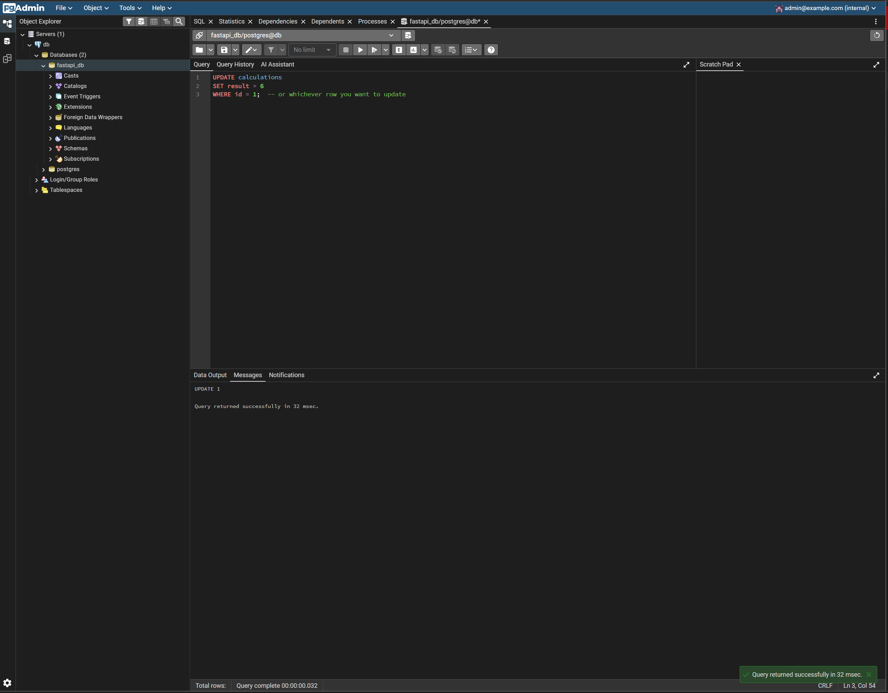
In this screenshot, we update the calculations table and set the calculation result to be 6 for any records where the user’s ID is 1, which in this case is alice.

- Delete a Record
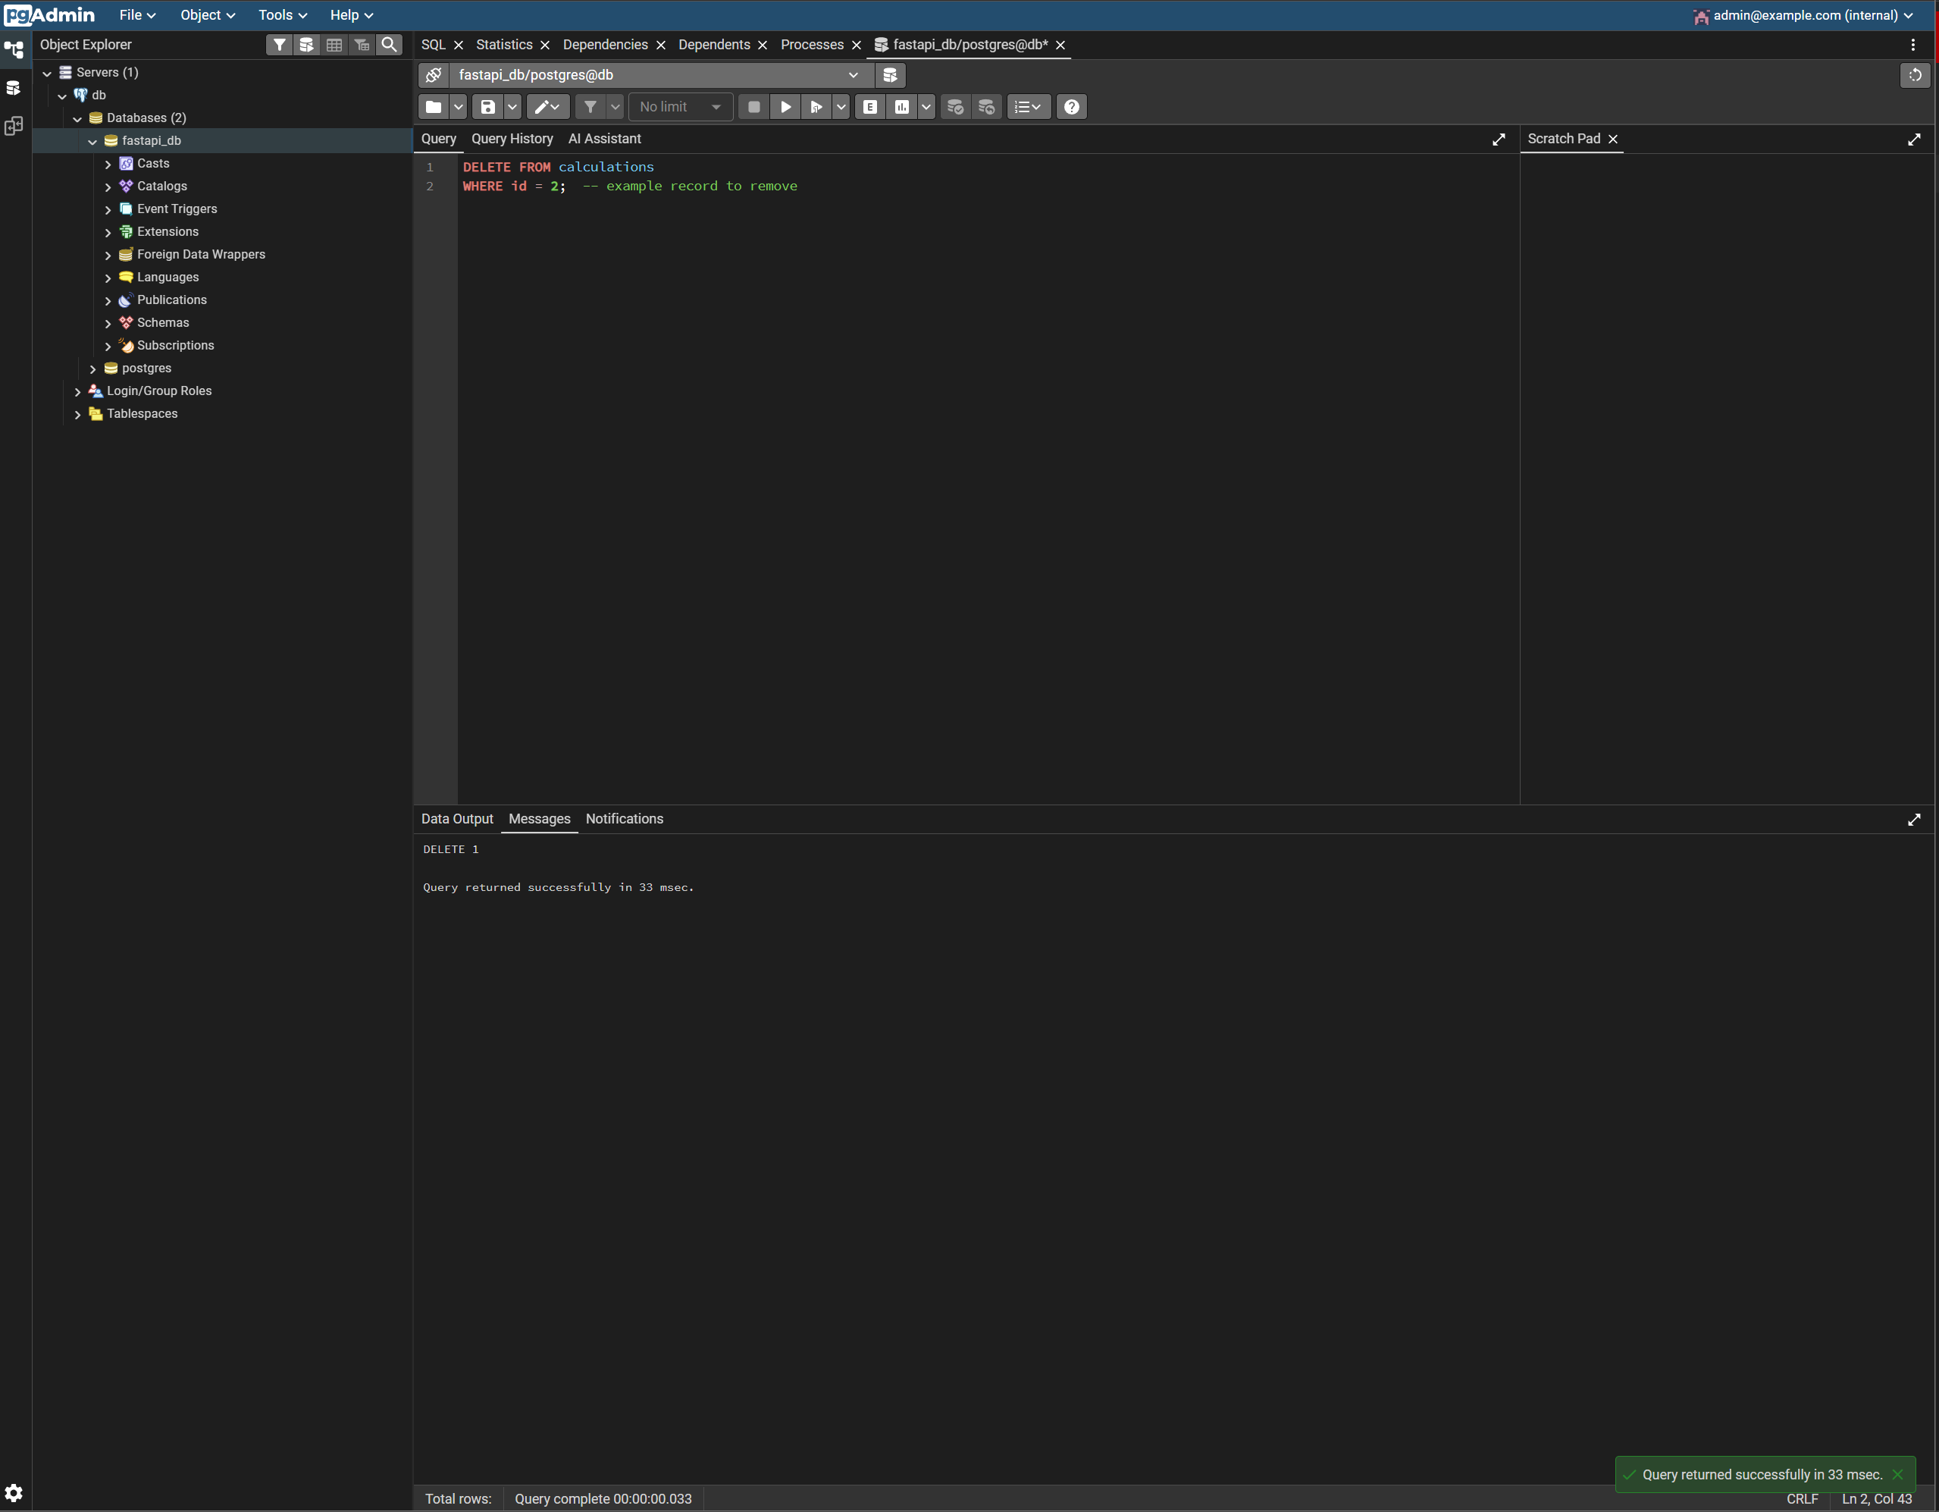
In this screenshot, we are deleting all records in the calculations table that are owned by the user with ID 2, which in this case is bob. So we are essentially just deleting bob’s calculation history.

