Northbrew Supply Chain Intelligence Dashboard
End to End Business Intelligence Final Report
Prepared by: Rafael Nalom Garcia Pasaribu
Role: Business and Data Analyst Consultant
Tool: Microsoft Power BI, DAX, Power Query and Data Modelling
Dataset: Simulated Supply Chain Dataset
This report documents the business problem, analytical process, dashboard design, key insights and recommendations developed for the Northbrew supply chain analytics project.

Executive Summary
This project developed a Power BI business intelligence solution for Northbrew, a simulated company that manages products, warehouses, suppliers and purchase orders. The dashboard was designed to support management decisions in supply chain performance, inventory control, supplier reliability and procurement cost management.
The main finding is that Northbrew shows strong overall operating performance, but risk is not evenly distributed. The company has high inventory value and a strong fill rate, yet stockout risk remains concentrated in Mobile and Accessories. This means the issue is not only about the total amount of inventory. The more important issue is whether the right products are available in the right categories and locations.
The report also shows that supplier performance should not be judged only through fill rate. Since supplier fill rate is relatively similar across suppliers, delivery delay, defect rate and landed cost exposure give a clearer view of supplier risk. The procurement page adds a financial view by showing how purchase value, freight cost and landed cost contribute to total cost exposure.
The final Power BI report contains four pages: Executive Overview, Inventory Intelligence, Supplier Performance, and Procurement Cost and Action Plan. Together, these pages provide a management ready view of what is happening, where the risk sits and what action should be considered next.

1. Introduction

1.1 Project Background
Supply chain performance is an important area for business decision making because it connects inventory, suppliers, warehouses and procurement cost. A company may have strong sales or high inventory value but still experience operational problems if stock is not allocated properly, suppliers deliver late or freight cost becomes too high.
Northbrew is used as a simulated business case to demonstrate how Power BI can be used to transform operational data into a structured business intelligence system. Although the dataset is not from a real company, the project was designed to reflect realistic business questions that are common in supply chain and procurement reporting.

1.2 Business Problem
The business problem is that management needs one clear view of supply chain health. Without an integrated dashboard, it is difficult to understand where inventory value is concentrated, which categories are creating stockout risk, which suppliers require review and where procurement cost is being driven.
The project therefore focuses on decision support. The dashboard does not only show numbers. It links the numbers to actions, such as reviewing safety stock, monitoring overstock risk, assessing supplier delay and controlling freight exposure.

1.3 Project Objective
The objective of this project is to design an end to end Power BI analytics solution that helps Northbrew monitor supply chain performance and identify practical improvement opportunities. The report supports management in understanding inventory exposure, supplier reliability, stockout risk and procurement cost.

2. Business Questions and Stakeholder Needs
The dashboard was built around four main business questions. The first question asks whether the supply chain is healthy overall. The second asks where inventory value and stockout risk are concentrated. The third asks which suppliers need procurement review. The final question asks where procurement cost is coming from and what cost drivers can be managed.
Different stakeholders need different levels of detail. Senior management needs a high level summary, while inventory and procurement users need more specific operational views. The dashboard structure reflects this difference by separating the report into four pages with different purposes.
Stakeholder | Main Need | Dashboard Response
Executive management | Overall supply chain health and key risks | Executive Overview page with KPI cards, summary and main risk visuals
Inventory or operations manager | Category stock exposure and stockout risk | Inventory Intelligence page with category value, demand, receipts and action matrix
Procurement manager | Supplier reliability and supplier cost exposure | Supplier Performance page with supplier risk matrix and landed cost view
Finance or commercial manager | Procurement spending and cost drivers | Procurement Cost and Action Plan page with landed cost, freight burden and cost exposure

3. Data Understanding and Preparation

3.1 Dataset Overview
The project uses a simulated supply chain dataset. The dataset contains dimension tables for date, product, supplier and warehouse. It also contains fact tables for daily inventory and purchase orders. This structure allows the dashboard to analyse both operational inventory movement and procurement performance.
Table | Purpose
dim_date | Provides calendar fields such as date, month and year for time based analysis
dim_product | Stores product details such as product category and reorder point
dim_supplier | Stores supplier details such as supplier name and country
dim_warehouse | Stores warehouse information for location based inventory analysis
fact_inventory_daily | Stores daily stock, demand, receipt and stockout records
fact_purchase_order | Stores purchase orders, delivery delay, defect quantity, freight cost and landed cost

3.2 Data Preparation
The preparation stage focused on making the data suitable for reporting. Data types were checked for dates, numeric values and percentage fields. Date fields were connected to the date dimension where appropriate. Measures were separated into a dedicated measure table so the model would be easier to maintain and explain.
The project also required several business assumptions. Inventory value was treated as a current snapshot when used in KPI cards. For trend charts, a separate trend measure was used because daily inventory values should not always be interpreted in the same way as point in time inventory. This distinction is important because inventory is often a snapshot metric, while purchase value and landed cost are cumulative metrics.

4. Data Model and KPI Design

4.1 Data Model
The Power BI model follows a star schema approach. Dimension tables filter the fact tables, while measures calculate the management KPIs used in the dashboard. This design is simple, scalable and suitable for a portfolio project because it shows that the report is not built only from flat tables.
Relationship | Business Meaning
dim_date to fact_inventory_daily | Allows inventory movement and stockout analysis by month and year
dim_date to fact_purchase_order | Allows purchase order and delivery analysis by time period
dim_product to inventory and purchase facts | Allows analysis by category and product
dim_warehouse to inventory and purchase facts | Allows analysis by warehouse
dim_supplier to fact_purchase_order | Allows supplier level procurement and reliability analysis

4.2 KPI Design
The KPI design focused on measures that management can use to evaluate performance and make decisions. Some KPIs are financial, such as total landed cost and freight cost percentage. Others are operational, such as stockout count, current on hand quantity, late delivery rate and average defect rate.
KPI | Purpose
Total Purchase Value | Shows the value of supplier purchase orders before freight and landed cost
Total Freight Cost | Shows freight exposure across suppliers and countries
Total Landed Cost | Shows the total procurement cost after freight and related cost components
Current Inventory Value | Shows the current value of stock held by the business
Current On Hand Quantity | Shows current stock quantity available
Stockout Count | Shows how often stockout events occur
Fill Rate | Shows whether ordered quantity is received from suppliers
Late Delivery Rate | Shows the percentage of completed purchase orders delivered late
Average Defect Rate | Shows quality risk based on defective received quantity
Freight Cost Percentage | Shows freight cost relative to purchase value

5. Dashboard Development
The dashboard was designed as a four page Power BI report. Each page answers a different management question. A consistent layout, colour palette, sidebar navigation, KPI cards and filter panel were used to make the report feel like one connected business intelligence system.
The design approach uses a clear hierarchy. KPI cards appear at the top, because they provide the fastest summary. The middle area contains the main visual story. The bottom section supports the page with more detailed analysis or action guidance. This layout helps users understand the page without needing to read every chart in detail.

5.1 Page 1: Executive Overview
The Executive Overview page is designed for senior users who need a quick view of supply chain health. It includes total landed cost, current inventory value, fill rate, stockout count and average defect rate. The page also includes an executive summary that translates the main results into action.
The main insight from this page is that Northbrew has a strong fill rate of 97.5 percent, but it still has stockout concentration and increasing inventory value. This creates a mixed signal. The business is performing well in some areas, but it still needs to review supplier reliability and safety stock for high risk categories.
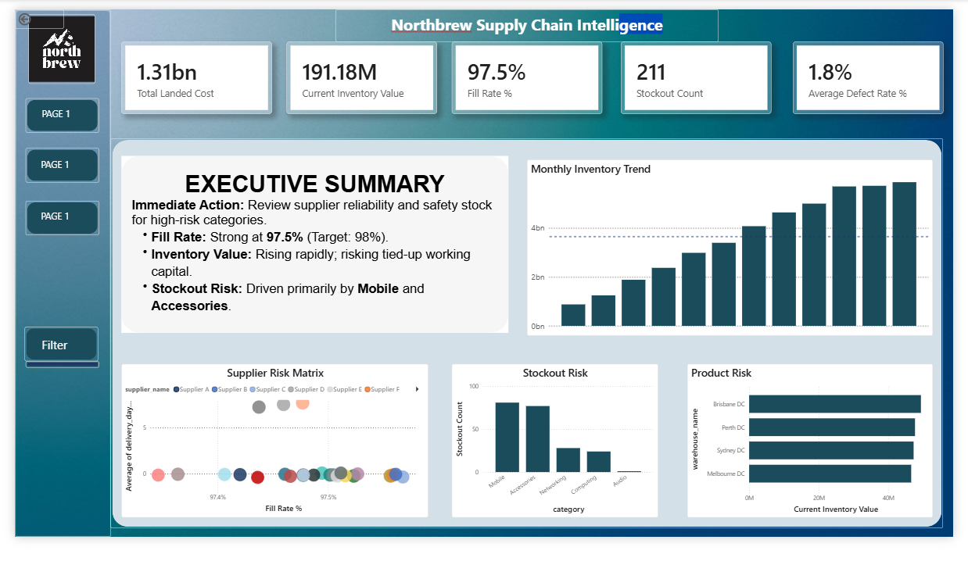
Figure 1. Executive Overview dashboard page

5.2 Page 2: Inventory Intelligence
The Inventory Intelligence page focuses on where inventory value and stockout risk are located. The page uses inventory value by category, demand versus receipts, stockout risk by category and an inventory action matrix. This page is more operational than the executive page because it helps identify where inventory action should be prioritised.
The action matrix is an important part of the report because it avoids showing only charts. It interprets the relationship between inventory value and stockout risk. For example, Mobile appears as a high value and high stockout category, which suggests that safety stock should be reviewed. Networking appears as high value but lower stockout pressure, which suggests possible overstock monitoring.
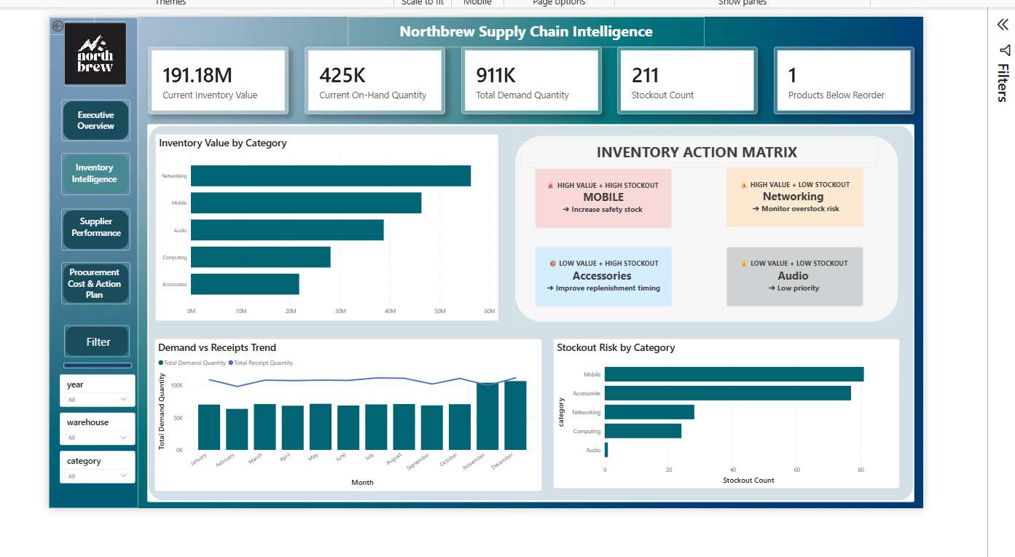
Figure 2. Inventory Intelligence dashboard page

5.3 Page 3: Supplier Performance
The Supplier Performance page evaluates supplier reliability and cost importance. The page includes total suppliers, total purchase orders, total landed cost, late delivery rate and average defect rate. The supplier risk matrix shows how suppliers compare through delivery delay, defect rate and landed cost exposure.
A useful finding from this page is that fill rate does not strongly separate suppliers because many suppliers have similar fill rate performance. This means supplier review should focus more on late delivery, defect rate and landed cost exposure. A supplier can have a high fill rate but still create problems if orders arrive late or contain defects.
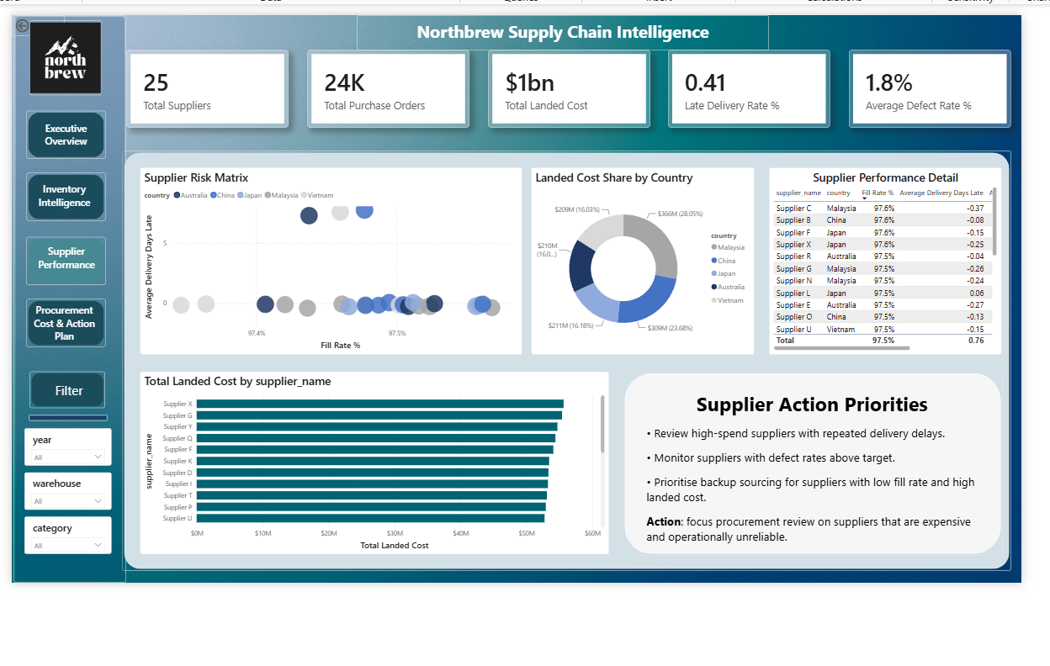
Figure 3. Supplier Performance dashboard page

5.4 Page 4: Procurement Cost and Action Plan
The Procurement Cost and Action Plan page connects supply chain activity to financial exposure. It uses total purchase value, total freight cost, total landed cost, freight cost percentage and average landed cost per unit. The page also analyses landed cost by category, freight burden by supplier, purchase value versus freight cost and freight cost share by country.
This final page gives the project a commercial ending. It shows that procurement performance should not be judged by purchase value only. Freight cost, landed cost and supplier location can change the true cost of supply. The page therefore supports decisions such as reviewing freight heavy routes and renegotiating supplier contracts.
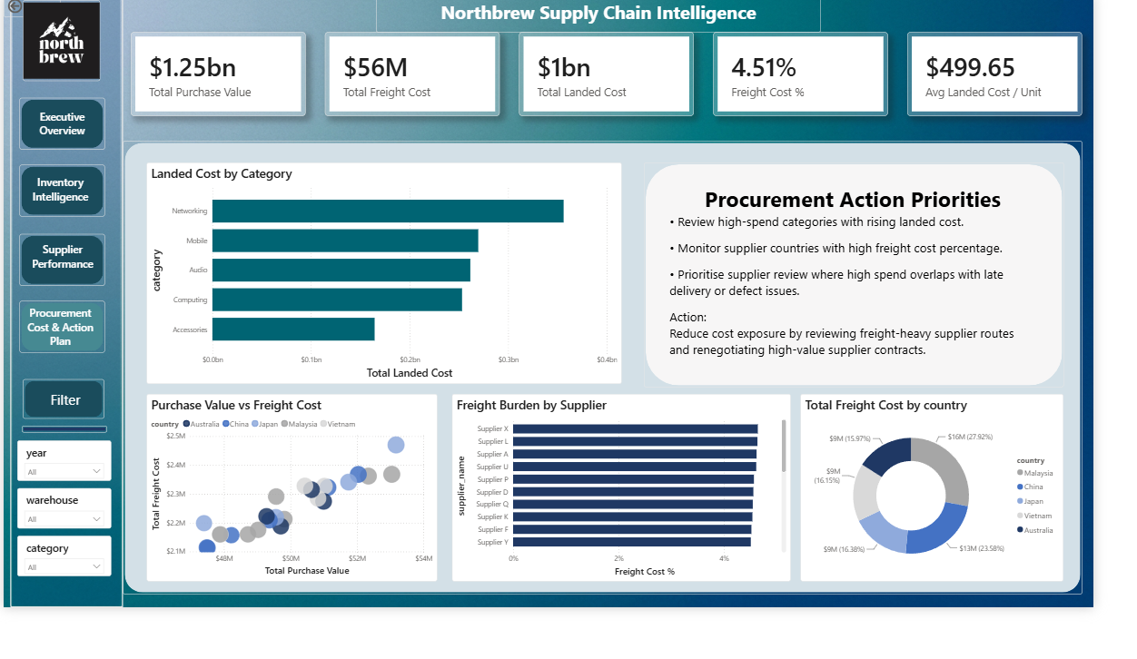
Figure 4. Procurement Cost and Action Plan dashboard page

6. Key Findings

6.1 Inventory Value and Stockout Risk Are Not the Same Problem
The dashboard shows that inventory value is high, but stockout risk still exists in specific categories. This is an important finding because it shows that the problem is not simply a lack of stock. The business may have enough total inventory, but it may not be allocated correctly across product categories.
Mobile and Accessories create the highest stockout risk. At the same time, Networking holds a large amount of inventory value. This creates a practical management issue. The business should not only buy more stock. It should review which categories need more protection and which categories may already have too much capital tied up.

6.2 Supplier Risk Is Better Seen Through Delay, Defects and Cost
Supplier fill rate is strong overall and does not vary much across suppliers. This makes fill rate useful as a general KPI, but weaker as the main tool for ranking supplier risk. The supplier page therefore gives more attention to average delivery days late, late delivery rate, average defect rate and landed cost.
This approach is more realistic because supplier performance is multi dimensional. A supplier can deliver most ordered quantity but still create operational pressure through late arrivals or quality problems. Procurement should therefore review suppliers that are expensive and operationally unreliable, not only suppliers with lower fill rates.

6.3 Procurement Cost Is More Than Purchase Value
The procurement page shows that total cost exposure includes purchase value, freight cost and landed cost. Freight cost percentage provides a clearer view of cost efficiency because it shows how much freight is added relative to purchase value. This is useful when comparing suppliers or countries.
The purchase value versus freight cost visual supports this analysis by showing whether suppliers with high purchase value also create high freight exposure. The donut chart adds a country level view, which helps management understand where freight cost is concentrated.

7. Recommendations
The first recommendation is to review safety stock settings for Mobile and Accessories. These categories have the highest stockout risk and should be prioritised before lower risk categories. This does not mean the business should increase stock everywhere. It means stock protection should be more targeted.
The second recommendation is to monitor Networking for possible overstock risk. Networking holds a high level of inventory value, but it does not appear to create the same level of stockout pressure as Mobile. This suggests that some working capital may be tied up in areas that are not currently the most urgent risk.
The third recommendation is to use a supplier review process that combines cost, delay and quality. Suppliers with high landed cost, late delivery and higher defect rates should be reviewed first. This creates a more practical review process than ranking suppliers only by fill rate.
The fourth recommendation is to investigate freight burden by supplier and country. Management should identify where freight cost percentage is high and consider whether alternative routes, supplier terms or sourcing locations could reduce total cost exposure.
The final recommendation is to use the dashboard as a regular management review tool. A monthly review would allow Northbrew to track whether inventory risk, supplier delay and procurement cost are improving over time.

8. Limitations and Future Improvement

8.1 Limitations
The main limitation is that the dataset is simulated. The dashboard demonstrates business intelligence capability, but the numerical findings should not be treated as real company performance. The purpose of the project is to show the ability to define a business problem, build a data model, create measures, design a dashboard and explain business recommendations.
Another limitation is that some important business outcomes are not directly measured. For example, stockout lost sales are not directly calculated. Customer satisfaction, supplier contract terms and margin data are also not included in the current model. These areas would improve the strength of the analysis if real operational data were available.

8.2 Future Improvement
Future improvement could include a forecasting page, a reorder simulation, and a supplier scoring model. The forecasting page could estimate future demand and expected stockout pressure. A reorder simulation could test how different safety stock settings affect inventory value and service level. A supplier scoring model could combine landed cost, defect rate, delay and fill rate into one weighted supplier risk score.
The project could also be improved by adding SQL and Python pipeline documentation. This would make the portfolio stronger because it would show the full workflow from raw data preparation to dashboard reporting.

9. Conclusion
The Northbrew Supply Chain Intelligence Dashboard demonstrates how Power BI can support supply chain decision making. The project connects operational performance, inventory risk, supplier reliability and procurement cost into one structured report. It shows that the business can have strong overall performance while still facing specific risks in category allocation, supplier reliability and freight exposure.
The final report is suitable as a portfolio case study because it shows end to end business analysis work. It includes problem definition, stakeholder thinking, data modelling, KPI design, dashboard development and management recommendations. The strongest value of the project is not only the dashboard design, but the ability to turn data into a clear business story.

Appendix A: Dashboard Page Summary
Page | Audience | Main Question
Executive Overview | Senior management | Is the supply chain healthy overall?
Inventory Intelligence | Inventory and operations users | Where are inventory risk and stockout risk concentrated?
Supplier Performance | Procurement manager | Which suppliers need review?
Procurement Cost and Action Plan | Finance and procurement users | Where is cost exposure and what can be controlled?

Appendix B: Selected DAX Measures
The measures below are examples of the business logic used in the Power BI model. They are included to show how the dashboard was supported by calculated KPIs rather than raw fields only.
Measure | Business Logic
Fill Rate % | Received quantity divided by ordered quantity
Freight Cost % | Total freight cost divided by total purchase value
Average Landed Cost per Unit | Total landed cost divided by total received quantity
Stockout Count | Count of inventory records where stockout flag is true
Late Delivery Rate % | Late completed purchase orders divided by all completed purchase orders
Average Defect Rate % | Defect quantity divided by received quantity

Appendix C: Portfolio Positioning Statement
This project can be presented as a simulated business intelligence case study. It demonstrates the ability to understand a business problem, structure requirements, model data, build Power BI pages, create DAX measures and communicate recommendations. The project is especially relevant for Business Analyst, Data Analyst, Supply Chain Analyst and Procurement Analyst roles.

