Active Management Consultancy · SRS v1.2

Software Requirements Specification — Active Management Consultancy System
The detailed requirements document for the accounting practice management system of Active Management Consultancy — referred to in this document as the "AMC System": a complete definition of functional and non-functional requirements, workflow diagrams and data model, and additional running costs. The binding reference for any development party, and the acceptance reference at delivery.
Prepared by: Rafah Alabdullah | Date: 2026-08-30 | Based on: System Blueprint v1.0 | Status: For review and approval

1. Introduction

1.1 Purpose of this document
This document defines the requirements of the AMC System with measurable precision, so that any developer can implement the system without assumptions, and management can accept or reject each part at delivery by referring to the requirement number.

1.2 Scope
The system covers: client management from the first WhatsApp contact through billing, task management using templates for the tax and accounting services, per-client time tracking and hourly billing, the tax deadline engine, AI invoice processing, follow-up automation, bank reconciliation, and QuickBooks integration. Out of scope: the system does not file returns with the Federal Tax Authority automatically — filing on the EmaraTax platform remains a manual step performed by the accountant.

1.3 Definitions and abbreviations
Term | Meaning
AMC | Short name of the system, after Active Management Consultancy
FR / NFR | Functional requirement / non-functional requirement
M / S / C | Priority: Must (mandatory) / Should (important) / Could (later enhancement) — MoSCoW method
Time Entry | One time record: staff member + task + start and end time
Unbilled | Approved hours not yet included in an invoice
Exception | An AI-extracted item that requires mandatory human review
FTA / TRN | Federal Tax Authority / Tax Registration Number

1.4 References
The "Work and Services Procedures — Accounting and Tax" document, the "Business Requirements and Accounting Workflow" document, and the AMC System Blueprint v1.0 approved in this session.

2. Overall Description

2.1 System perspective
The AMC System is a central web application used by four categories of internal and external users, connected to specific external systems. The following diagram defines the system boundary precisely — what goes in and what comes out:
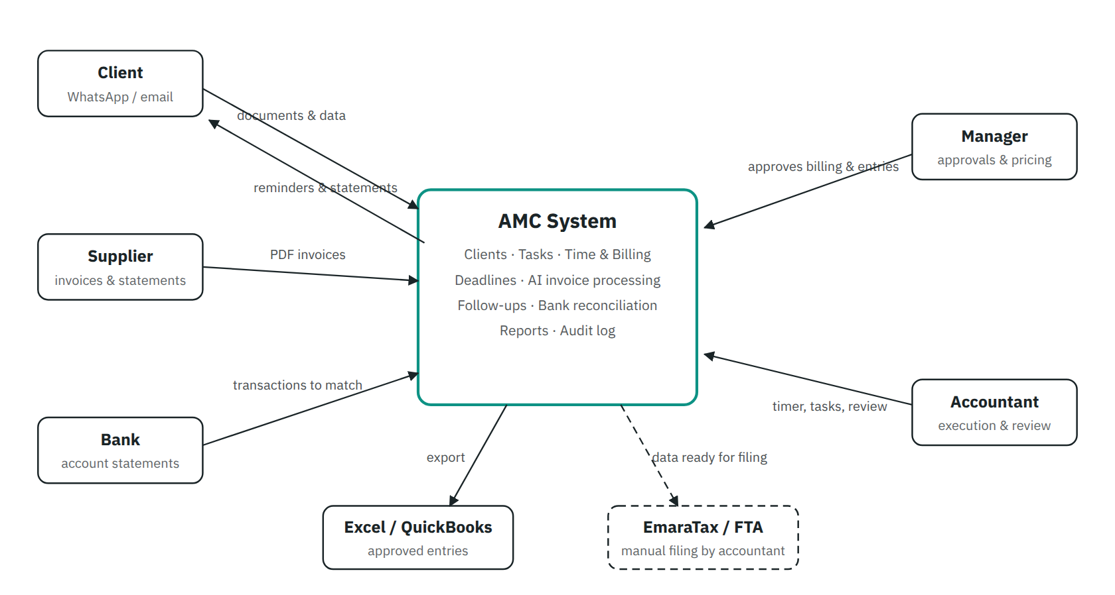
Figure 1 — Context diagram. The dashed line means the EmaraTax relationship is outside the system boundary: the AMC System prepares the data, and the accountant files it manually on the platform.

2.2 User categories and permissions
Role | View | Edit | Approve | Export | Manage rates & users
Manager (Wael Ajam) | Everything | Everything | Billing + entries + exceptions | Yes | Yes
Accountant | Assigned clients | Own tasks, time and reviews | AI items within own clients | Excel only | No
Data entry | Assigned invoice batches | Upload files and correct fields | No | No | No
Client (later phase, C) | Portal: own statements, invoices and requested documents | Upload own documents | No | No | No

2.3 Operating environment and constraints
- A responsive web application running in the browser (desktop + phone) — the timer must work from the phone, since staff may work outside the office.
- Bilingual interface: Arabic (RTL) primarily, with the English accounting terms used in the company's working documents.
- Sensitive financial data → secure hosting, encryption in transit and at rest, and daily backups.
- Any external AI service is assessed for privacy before adoption, and receives only the minimum data required.

3. Functional Requirements
Every requirement has a fixed number used in contracts, testing, and acceptance. Priority: M Must S Should C Could

3.1 Clients & Leads
ID | Requirement | Priority
FR-01 | Record every incoming enquiry as a Lead: name, phone, ad source, requested service, status (new / contacted / quoted / confirmed / declined). | M
FR-02 | A complete client file: legal details, TRN, tax registration status (CT / VAT), tax period, contacts, and subscribed services. | M
FR-03 | An hourly rate field per client, with a company-wide default applied when none is set, and a history of every rate change. | M
FR-04 | A document repository per client: type, file, expiry date, status (required / received / expired / being renewed). | M
FR-05 | An encrypted vault for EmaraTax credentials and the registered email, visible only to authorized users, with every access recorded in the audit log. | M
FR-06 | A chronological contact log per client (call / message / email) with the ability to attach conversation screenshots. | S

3.2 Services & Tasks
ID | Requirement | Priority
FR-10 | Predefined service templates for the eleven services (CT registration, VAT registration, VAT return, CT return, tax profile update, deregistration, VAT refund, penalty waiver, EmaraTax requests, monthly accounting, audit); each template includes the steps, the required-documents list, and the deadline rule. | M
FR-11 | When a client subscribes to a service, the system creates the task automatically from the template with the document checklist. | M
FR-12 | Task states: awaiting documents → ready → in progress → waiting for client → waiting for authority → completed. A task cannot move to "in progress" before the essential documents are complete. | M
FR-13 | Assign every task to a responsible staff member, with reassignment and a workload view per person. | M
FR-14 | Recurring tasks renew automatically: monthly accounting every month, VAT return every quarter, CT return annually per each company's tax period. | M
FR-15 | Company document templates (Letter, Declaration, VAT Report, penalty waiver form) generated from the system pre-filled with client data, ready for stamp and signature. | S

3.3 Time Tracking
ID | Requirement | Priority
FR-20 | A Start / Stop timer at task level; every time entry is mandatorily linked to (client + task + staff member). No unattributed time exists. | M
FR-21 | One active timer per staff member: starting a new task automatically stops and records the previous one. | M
FR-22 | Manual time entry is allowed, flagged as "manual" and recorded in the audit log with a reason. | M
FR-23 | Each entry is classified Billable / Non-billable; the default for client tasks is Billable. | M
FR-24 | A daily/weekly timesheet per staff member with total hours and billable percentage. | S
FR-25 | Idle detection: a timer running after working hours or beyond a set limit without activity → a confirmation prompt before the time is counted. | S
FR-26 | Entries are locked once included in an invoice — no edits unless an authorized user unlinks them from the invoice. | M

3.4 Billing
ID | Requirement | Priority
FR-30 | Create Quotations from the system (line items, estimated hours or amount) with states: draft / sent / accepted / declined. | M
FR-31 | A monthly billing statement per client: approved unbilled hours × the client's hourly rate, broken down by service, task, date, and staff member. | M
FR-32 | Statement review before issuing: exclude or adjust any line (the change is recorded), then convert to an Invoice in one click. | M
FR-33 | Invoice states: draft / sent / partially paid / paid / overdue — overdue invoices enter the follow-ups module automatically. | M
FR-34 | Support the existing-clients exception: work may start before payment while the invoice remains visible as "collection pending" on the dashboard. | M
FR-35 | Reports: hours by client / staff member / service, billed vs. unbilled, and client profitability (value of their time vs. what they paid). | M
FR-36 | Additional pricing models: fixed fee per service and monthly retainer, with hours still recorded to measure profitability. | C

3.5 Deadline Engine
ID | Requirement | Priority
FR-40 | Compute the VAT return deadline automatically (the 28th of the month following each quarterly period end) and the CT return deadline per each company's tax period. | M
FR-41 | Create the "prepare return" task and send the document request to the client on day one of the filing month — never waiting for the deadline. | M
FR-42 | Monitor document expiry dates (trade licence, Emirates ID, passport) with staged alerts at 90 / 60 / 30 days, and a "tax profile update" task upon renewal. | M
FR-43 | Escalation chain: a document not received within 7 days → client reminder; 14 days → accountant alert; 5 days before the deadline without completion → manager alert. (Durations configurable.) | M
FR-44 | A monthly calendar showing all firm deadlines: returns, expiries, and overdue tasks. | S

3.6 AI Invoice Processing
ID | Requirement | Priority
FR-50 | Bulk upload of up to 200 PDF files (or images) in one batch, linked to a specific client, with a processing progress bar. | M
FR-51 | Extract the 15 fields per invoice: date, number, supplier, supplier/client account, description, ledger account, amount before VAT, VAT rate, VAT amount, total, currency, expense type, reference, confidence score, and notes. | M
FR-52 | Suggest the ledger account from: defined rules (SEWA → Utilities, …) + a chart of accounts importable from QuickBooks + learning from previously approved transactions of the same supplier. | M
FR-53 | Automatic checks: (amount before tax + VAT = total), a sensible VAT rate, no duplicates (same supplier + number + amount), and mandatory fields present. | M
FR-54 | Every item carries a confidence score; items below the threshold (configurable, default 90%) or failing any check enter the exceptions queue mandatorily. | M
FR-55 | A review screen showing the item beside the original invoice image, with Approve / Edit / Reject actions and low-confidence fields highlighted. | M
FR-56 | Export approved items to Excel in the standard format immediately, and to QuickBooks via API in its phase. | M
FR-57 | An approval record per item: who approved, when, and what was edited before approval (before/after values). | M
FR-58 | A permanent link between every approved entry and its original document; open the PDF from the record in one click. | M
FR-59 | Unified search: by invoice number, supplier/client, date, amount, or ledger account. | M

3.7 Follow-ups (clients and suppliers)
ID | Requirement | Priority
FR-60 | Accounts receivable list: overdue clients ranked by debt age and amount, with each client's invoice details. | M
FR-61 | Generate professional follow-up messages from templates staged by debt age (gentle reminder → follow-up → final notice), reviewed before sending. | M
FR-62 | Record follow-up dates and replies; no reply within a set period → an automatic reminder to the responsible accountant. | M
FR-63 | Supplier follow-up: a list of missing invoices and statements, with automatic request messages. | S
FR-64 | Compare a supplier's statement with the records: show what is in their statement but not recorded by us, and what we recorded that is missing from their statement. | S
FR-65 | Send messages directly via the WhatsApp Business API / email from within the system. | C

3.8 Bank Reconciliation
ID | Requirement | Priority
FR-70 | Import the bank statement (CSV / Excel / PDF) and read the transactions: date, amount, reference, description. | S
FR-71 | Suggest matches automatically based on amount, date, reference, and description, with a confidence score per suggestion. | S
FR-72 | Lists of matched (for confirmation), unmatched, and possibly duplicated transactions — plus a report of pending items. | S

3.9 Dashboard, Reports & VAT Support
ID | Requirement | Priority
FR-80 | A role-based main dashboard showing: invoices received / processed / awaiting review / with exceptions, overdue clients, suppliers with missing documents, unmatched bank transactions, VAT items needing review, each accountant's tasks, and pending follow-ups. | M
FR-81 | A "hours this month" card: hours and value per client, billed vs. unbilled — for the manager. | M
FR-82 | A VAT report for the period: aggregate VAT amounts from processed items, separate taxable from non-taxable, list items with unusual tax treatment — with drill-down from any figure to its invoice. | M
FR-83 | Export any report to Excel / PDF. | S

4. Workflow Diagrams

4.1 The quarterly VAT return cycle
FR-40 and FR-41 laid out in time — proactive follow-up means the work starts on day 1, not day 28:
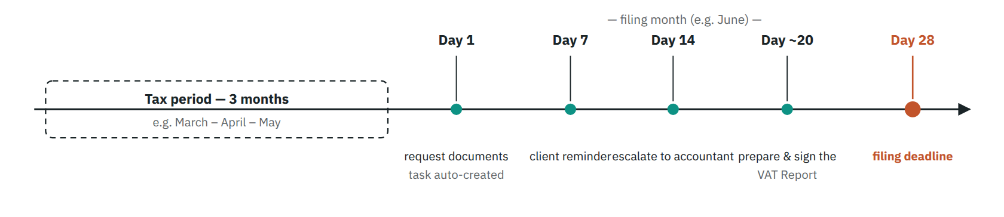
Figure 2 — The VAT return cycle. Green dots are actions the system triggers automatically; the orange dot is the statutory deadline every alert is measured against. The same logic applies to the annual CT return and to document expiries (90/60/30 days).

4.2 The AI invoice processing pipeline
Requirements FR-50 through FR-58 as a single production line, with the decision point that separates fast approval from mandatory review:
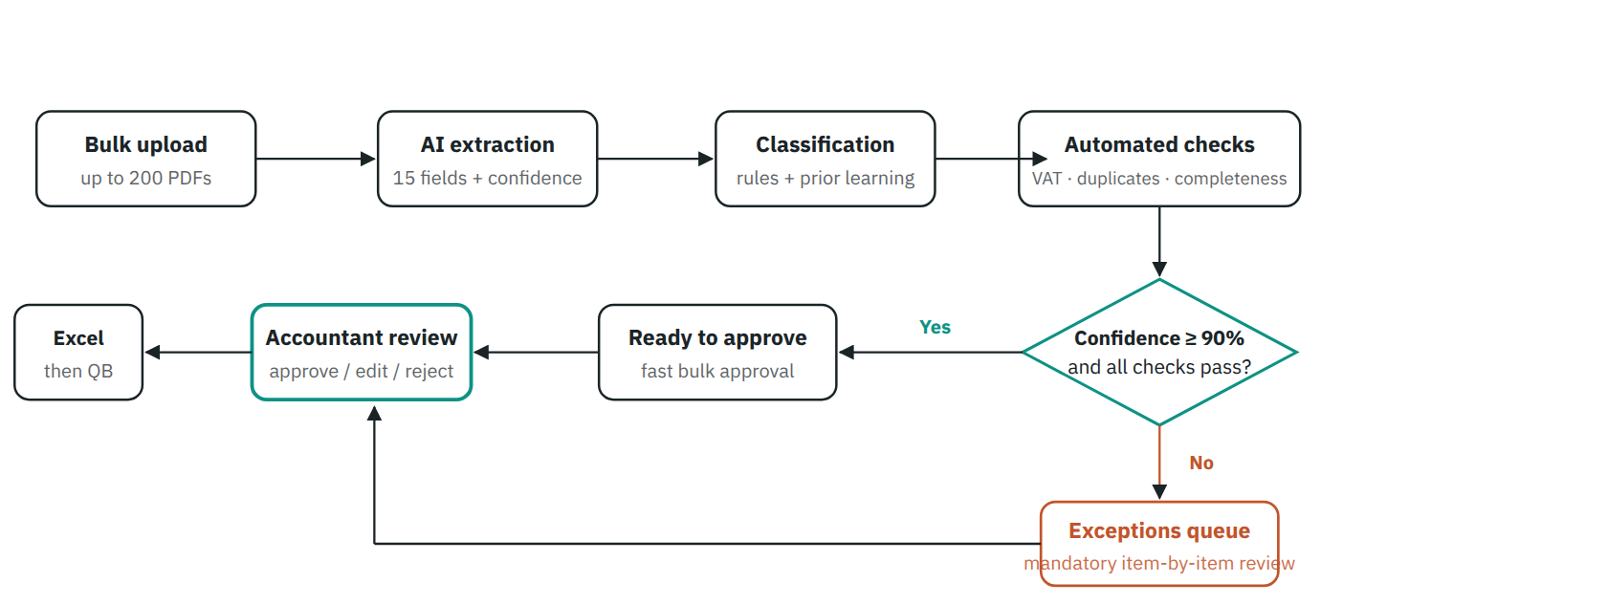
Figure 3 — The invoice pipeline. The decision point is the heart of the design: the accountant does not open 100 invoices — only what falls into the exceptions queue (orange) is reviewed in detail, and the rest is approved in bulk. Every approval is recorded with its owner and time (FR-57).

4.3 From the timer to the invoice
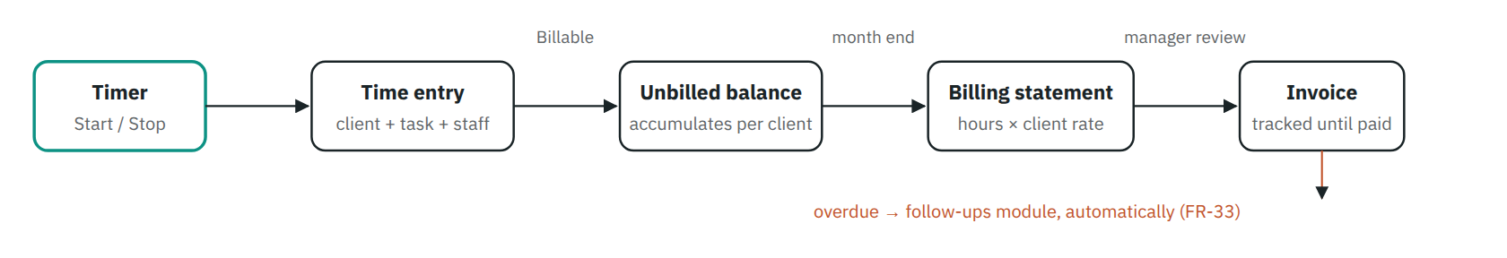
Figure 4 — From time to revenue. Once entries are included in an invoice they are locked and cannot be edited (FR-26) — this is what makes the client's statement defensible.

5. Data Model — ERD
The core entities and their relationships. Every entity writes its events to the AuditLog (who, what, when, before/after) — omitted from the drawing to avoid tangled arrows:
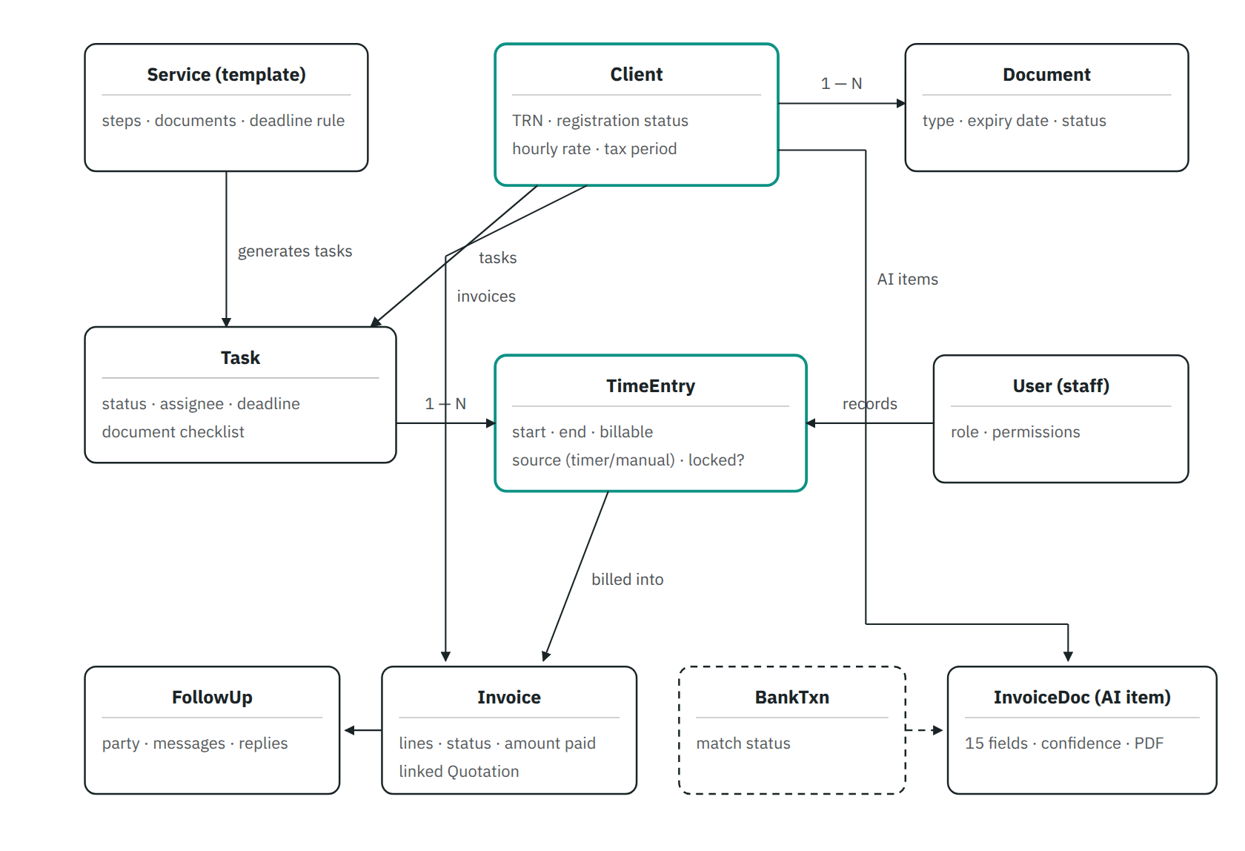
Figure 5 — Entity model. The two green-framed entities are the billing core: every TimeEntry connects client, staff member and task, and all hour reports derive from it. The dashed frame = the Phase 6 module; the arrow from Invoice to FollowUp means an overdue invoice creates a follow-up automatically.

6. Non-functional Requirements
ID | Category | Measurable requirement
NFR-01 | Performance | Any main screen opens in under 3 seconds; a batch of 100 PDF invoices completes processing in under 15 minutes with a progress bar.
NFR-02 | Reliability | Failure to read one invoice never stops the rest of the batch — the failed item goes to exceptions and the rest continues.
NFR-03 | Timer accuracy | An internet outage or a closed browser never loses recorded time: the timer resumes or proposes a correction on return.
NFR-04 | Security | TLS encryption in transit and AES-256 at rest; EmaraTax passwords in a separate encrypted vault; sessions expire automatically.
NFR-05 | Auditability | Every create/edit/approve/export/access to sensitive data is recorded and never deleted; the audit log is read-only.
NFR-06 | Privacy | External AI services receive only the minimum data, and our data is never used to train general models.
NFR-07 | Usability | An Arabic RTL interface with English accounting terminology; the timer and task list fully usable from a phone.
NFR-08 | Backup | An automatic daily copy of the database and documents, with periodic restore testing.
NFR-09 | Scalability | The design accommodates growth to 500 clients and 10 users without a rebuild.
NFR-10 | Target AI accuracy | After the tuning period: ≥ 95% of extracted fields correct on clean invoices, and zero items posted to the ledger without human approval.

7. Additional Running Costs
The system is built specifically for Active Management Consultancy, so there are no monthly per-user software licence fees as with off-the-shelf products. The only additional costs are the running costs of the services the system depends on — chiefly extracting data from files using AI . The figures below are planning estimates in UAE dirhams, to be confirmed against actual provider pricing at implementation:
Item | How it is charged | Approx. monthly estimate
Invoice data extraction (AI / OCR) | Charged per processed page — roughly AED 0.05 to 0.15 per page depending on the provider and file quality. Cost scales directly with invoice volume. | At ~1,000 invoices/month: AED 50–150 At ~3,000 invoices: AED 150–450
Hosting and database | A cloud server + managed database, sufficient for 10 users and 500 clients. | AED 40–150
Document storage and backup | Encrypted cloud storage for PDFs and documents, with a daily copy. | AED 20–75
WhatsApp Business API | A fee per business-initiated conversation (reminders and follow-ups) per Meta's UAE pricing — pay as you go. | AED 20–120 depending on volume
Transactional email | The service sending reminders and statements by email; free tiers usually suffice at first. | AED 0–40
QuickBooks API integration | No additional fees — covered by the company's existing QuickBooks subscription. | AED 0
Domain and SSL certificate | One annual fee (~AED 50–120 per year). | ~AED 5–10 (spread monthly)
Approximate total | — | ≈ AED 150–500 per month at current volumes, rising with the number of processed invoices

A pricing point worth noting: since extraction cost is charged per invoice, it can be treated as a direct cost on each client's file — the system knows how many invoices were processed per client, so the cost can be included in their billing statement or service price instead of being absorbed by the firm.
AI and WhatsApp service prices change constantly — these estimates are reviewed and fixed against the chosen providers' prices before each phase begins, and a monthly spending cap with an alert is enabled (added as requirement FR-90 : a usage dashboard showing monthly processing cost, overall and per client).

8. Acceptance Criteria per Phase
Phase | Accepted when…
P1 | A real client is registered with their services, their tasks are auto-created from templates, the timer works from phone and desktop, and the next VAT return deadline shows correctly for every registered client (FR-01…14, FR-20…26, FR-40…44).
P2 | The system produces a monthly billing statement for a real client — their hours × their rate — which converts to an invoice after your review, and the figures match a manual calculation (FR-30…35).
P3 | A batch of 50 real PDF invoices is processed and produces a correct Excel file with ≥ 90% of fields right on the first attempt, and every error lands in the exceptions queue rather than the approved file (FR-50…56, NFR-01/02).
P4 | No unapproved item can be exported, and every edit appears in the audit log with before/after values (FR-54…58, NFR-05).
P5 | The receivables list matches reality, and staged messages are generated from the templates with their follow-ups recorded (FR-60…64).
P6 | A real bank statement is imported and ≥ 80% of its transactions match automatically, with a clear list of pending items (FR-70…72).
P7 | An approved entry reaches QuickBooks correctly — right account, right tax — with no manual input (FR-56).

9. Risks & Assumptions
Risk | Impact | How we handle it
Poorly scanned invoices lower extraction accuracy | Longer review time | The confidence threshold + exceptions queue guarantee no error slips through; continuous tuning from approved transactions raises accuracy month after month.
Staff forgetting to start the timer at first | Missing hours = lost revenue | A daily alert flags gaps between working hours and recorded time, and reasoned manual entry is available — with a weekly review in the first month until it becomes habit.
Delayed WhatsApp Business API approval | Automated sending postponed | Email and copy-paste templates as the fallback from day one; the application is submitted early.
Requirements changing during the build | Schedule stretch | Normal and expected — any new requirement is added to this document under a new FR number and its impact assessed before implementation.
Sensitive EmaraTax credentials | Serious security risk if leaked | Encrypted vault, strict permissions, every access logged (FR-05, NFR-04/05).

Assumptions: filing with the authority remains manual via EmaraTax; QuickBooks is the adopted accounting system; internal users in year one ≤ 10; and the operating language of the interface is Arabic/English as in this document.

