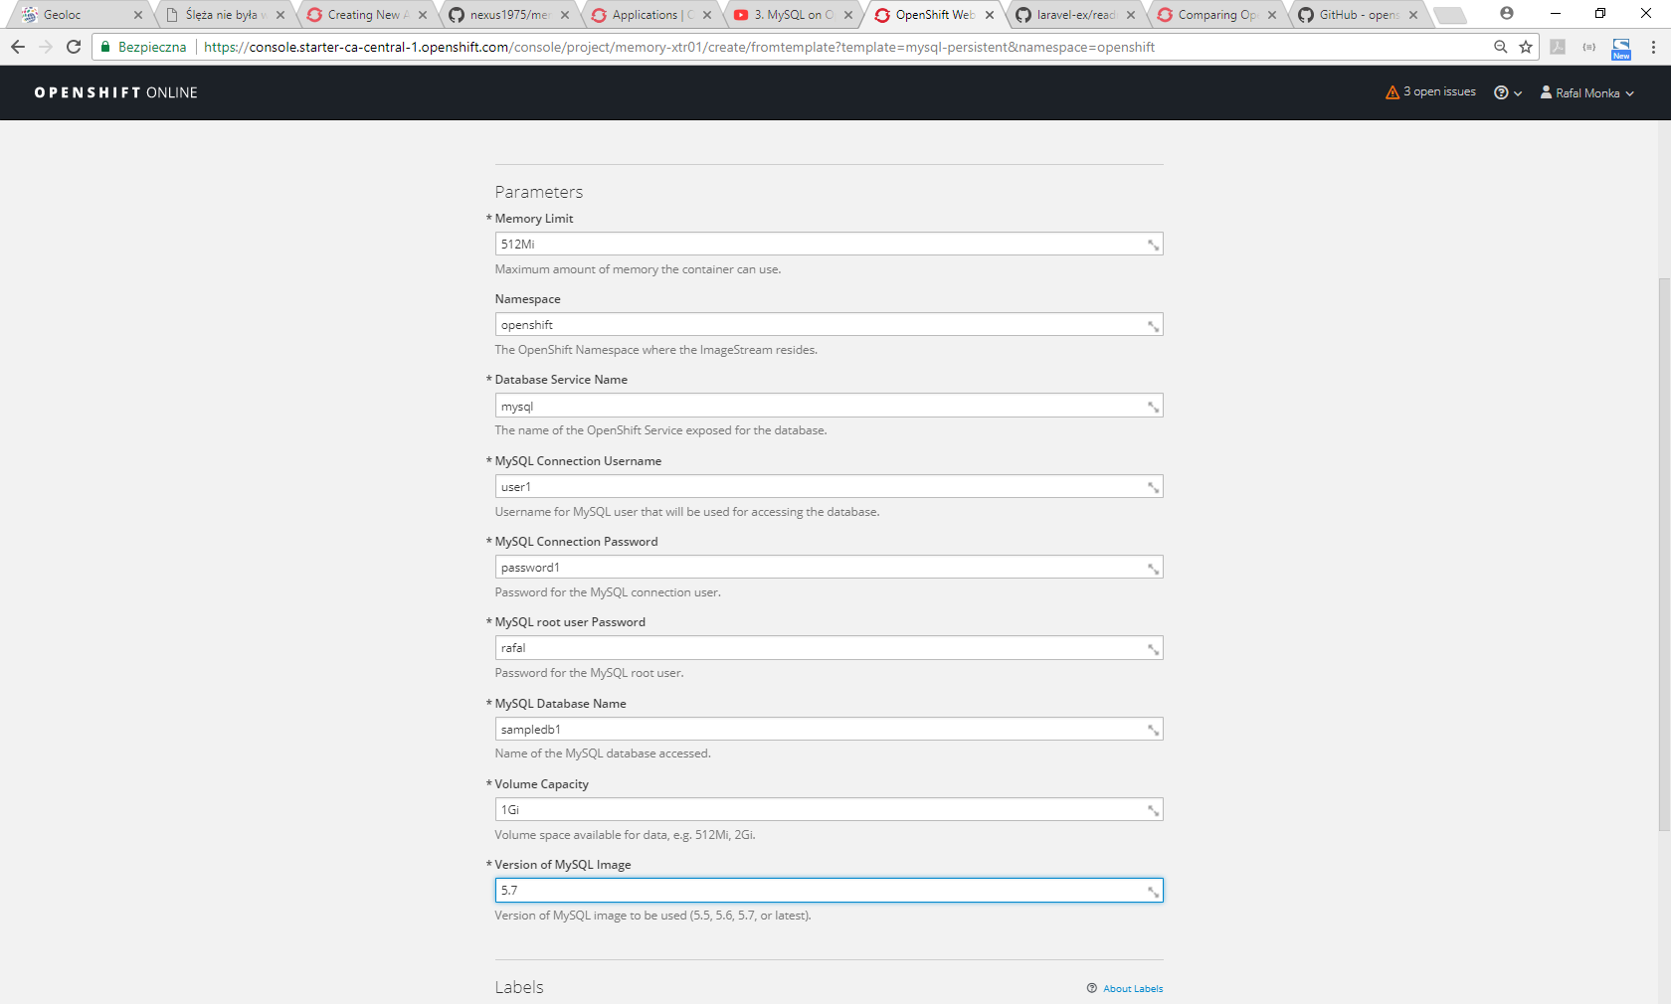

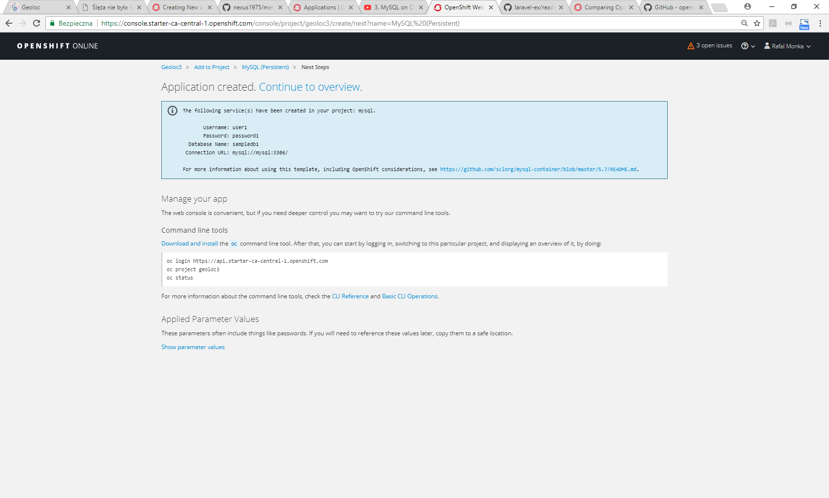

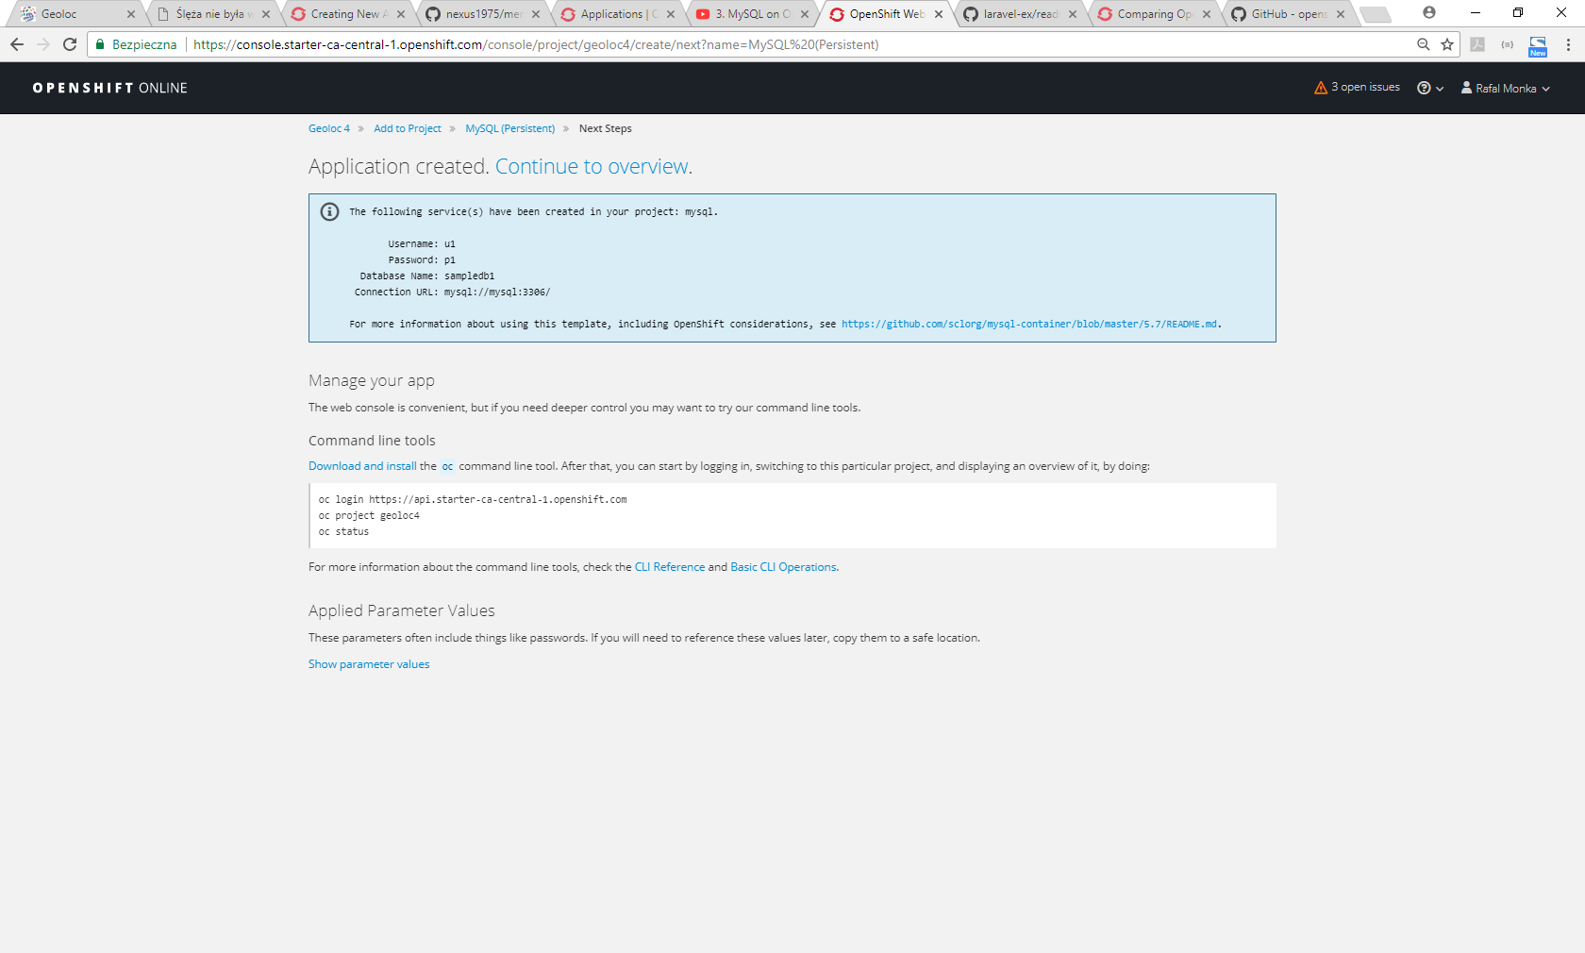

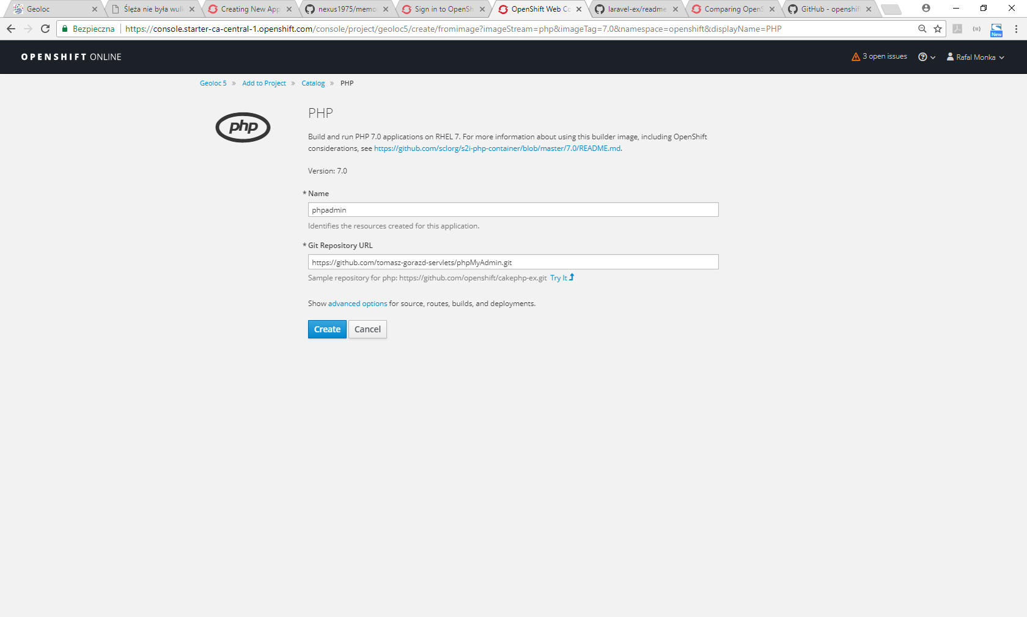

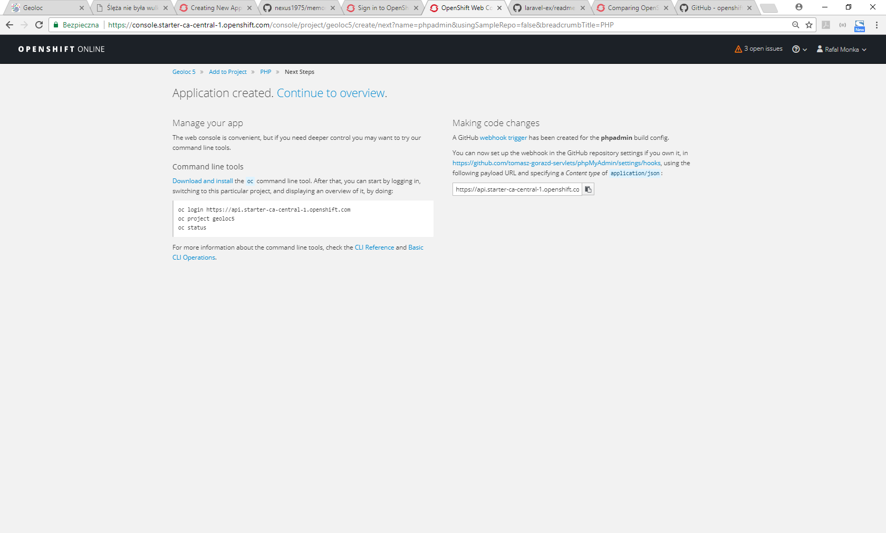

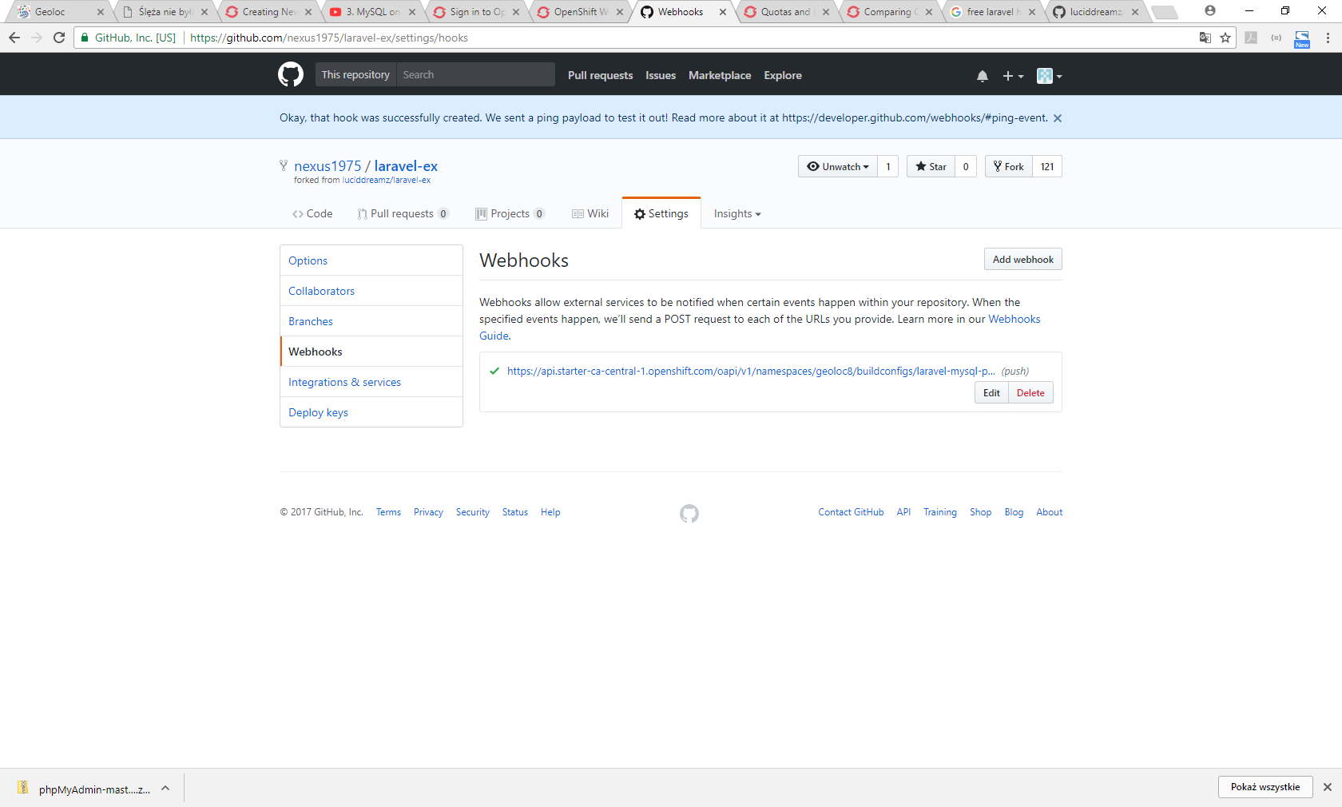

https://docs.openshift.com/enterprise/3.2/using_images/db_images/mysql.html

https://github.com/openshift/origin/tree/master/examples/image-streams

<https://stackoverflow.com/questions/1139762/ignore-files-that-have-already-been-committed-to-a-git-repository/1139797#1139797>