Uruchamianie Bonsai w Xephyr:

1.Install Xephyr:
sudo apt-get install xserver-xephyr

2.Run Xephyr:
Xephyr :1 -screen 1280x720 -ac &

3.Configure enviromet variable for QtCreator Run :

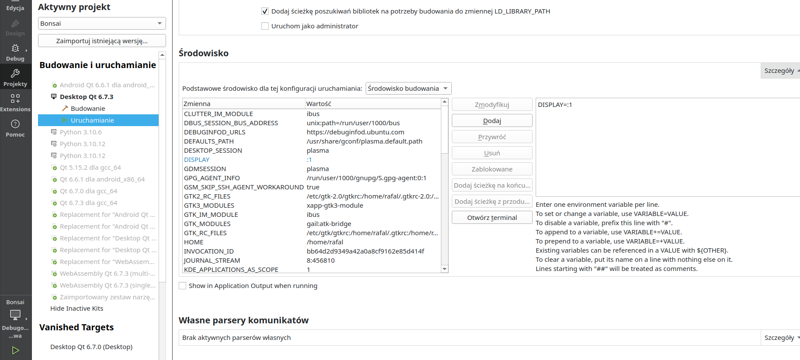

How to open gui applications like firefox in the Qt Wayland compositor which I created
Ask Question
Asked
Modified 2 years, 8 months ago
Viewed 866 times

0
I created an example Qt Wayland compositor and the QML code goes like this:
import QtQuick 2.15
import QtQuick.Window 2.15
import QtQuick.Controls 2.0
import QtWayland.Compositor 1.0

WaylandCompositor{
id:comp
WaylandOutput{
compositor:comp
sizeFollowsWindow:true
window:Window{
visible:true
width:700
height:700
Repeater{
model:shellSurfaces
ShellSurfaceItem{
shellSurface:modelData
onSurfaceDestroyed:shellSurfaces.remove(index)
}
}
}
}
ListModel{id:shellSurfaces}
WlShell{
onWlShellSurfaceCreated:{
shellSurfaces.append({shellSurface:shellSurface});
}
}
}
I know I can open a wiggly window using --platform wayland after the command. How can I open other software windows in the Wayland compositor(for example Firefox)?
(I don't know the basics of display servers and Wayland compositors. I think the compositor that I've created is just like a window manager and the apps that I open in it should just open in the compositor as it opens in a window manager).
- qt
- qml
- qt5
- qtwayland
Share
Improve this question
edited Nov 14, 2021 at 18:21

eyllanesc
243k1919 gold badges193193 silver badges271271 bronze badges
asked Nov 14, 2021 at 15:15

Newtron Malayalam
32744 silver badges1313 bronze badges
Add a comment

1 Answer
Highest score (default) Trending (recent votes count more) Date modified (newest first) Date created (oldest first)
1
When your compositor loads, it creates a socket on your computer. On my machine, it is located in /run/user/1000. It should be named something like 0-wayland.
In order to launch an app you need to pass the wayland display to it via a environment variable.
Example:
Launch firefox : WAYLAND_DISPLAY=wayland-0 XDG_RUNTIME_DIR=/run/user/1000 XDG_SESSION_TYPE="wayland" firefox
Launch kcalc(KDE's calculator): WAYLAND_DISPLAY=wayland-0 XDG_RUNTIME_DIR=/run/user/1000 XDG_SESSION_TYPE="wayland" kcalc
I think you get the idea.

