Supplementary Figure 1

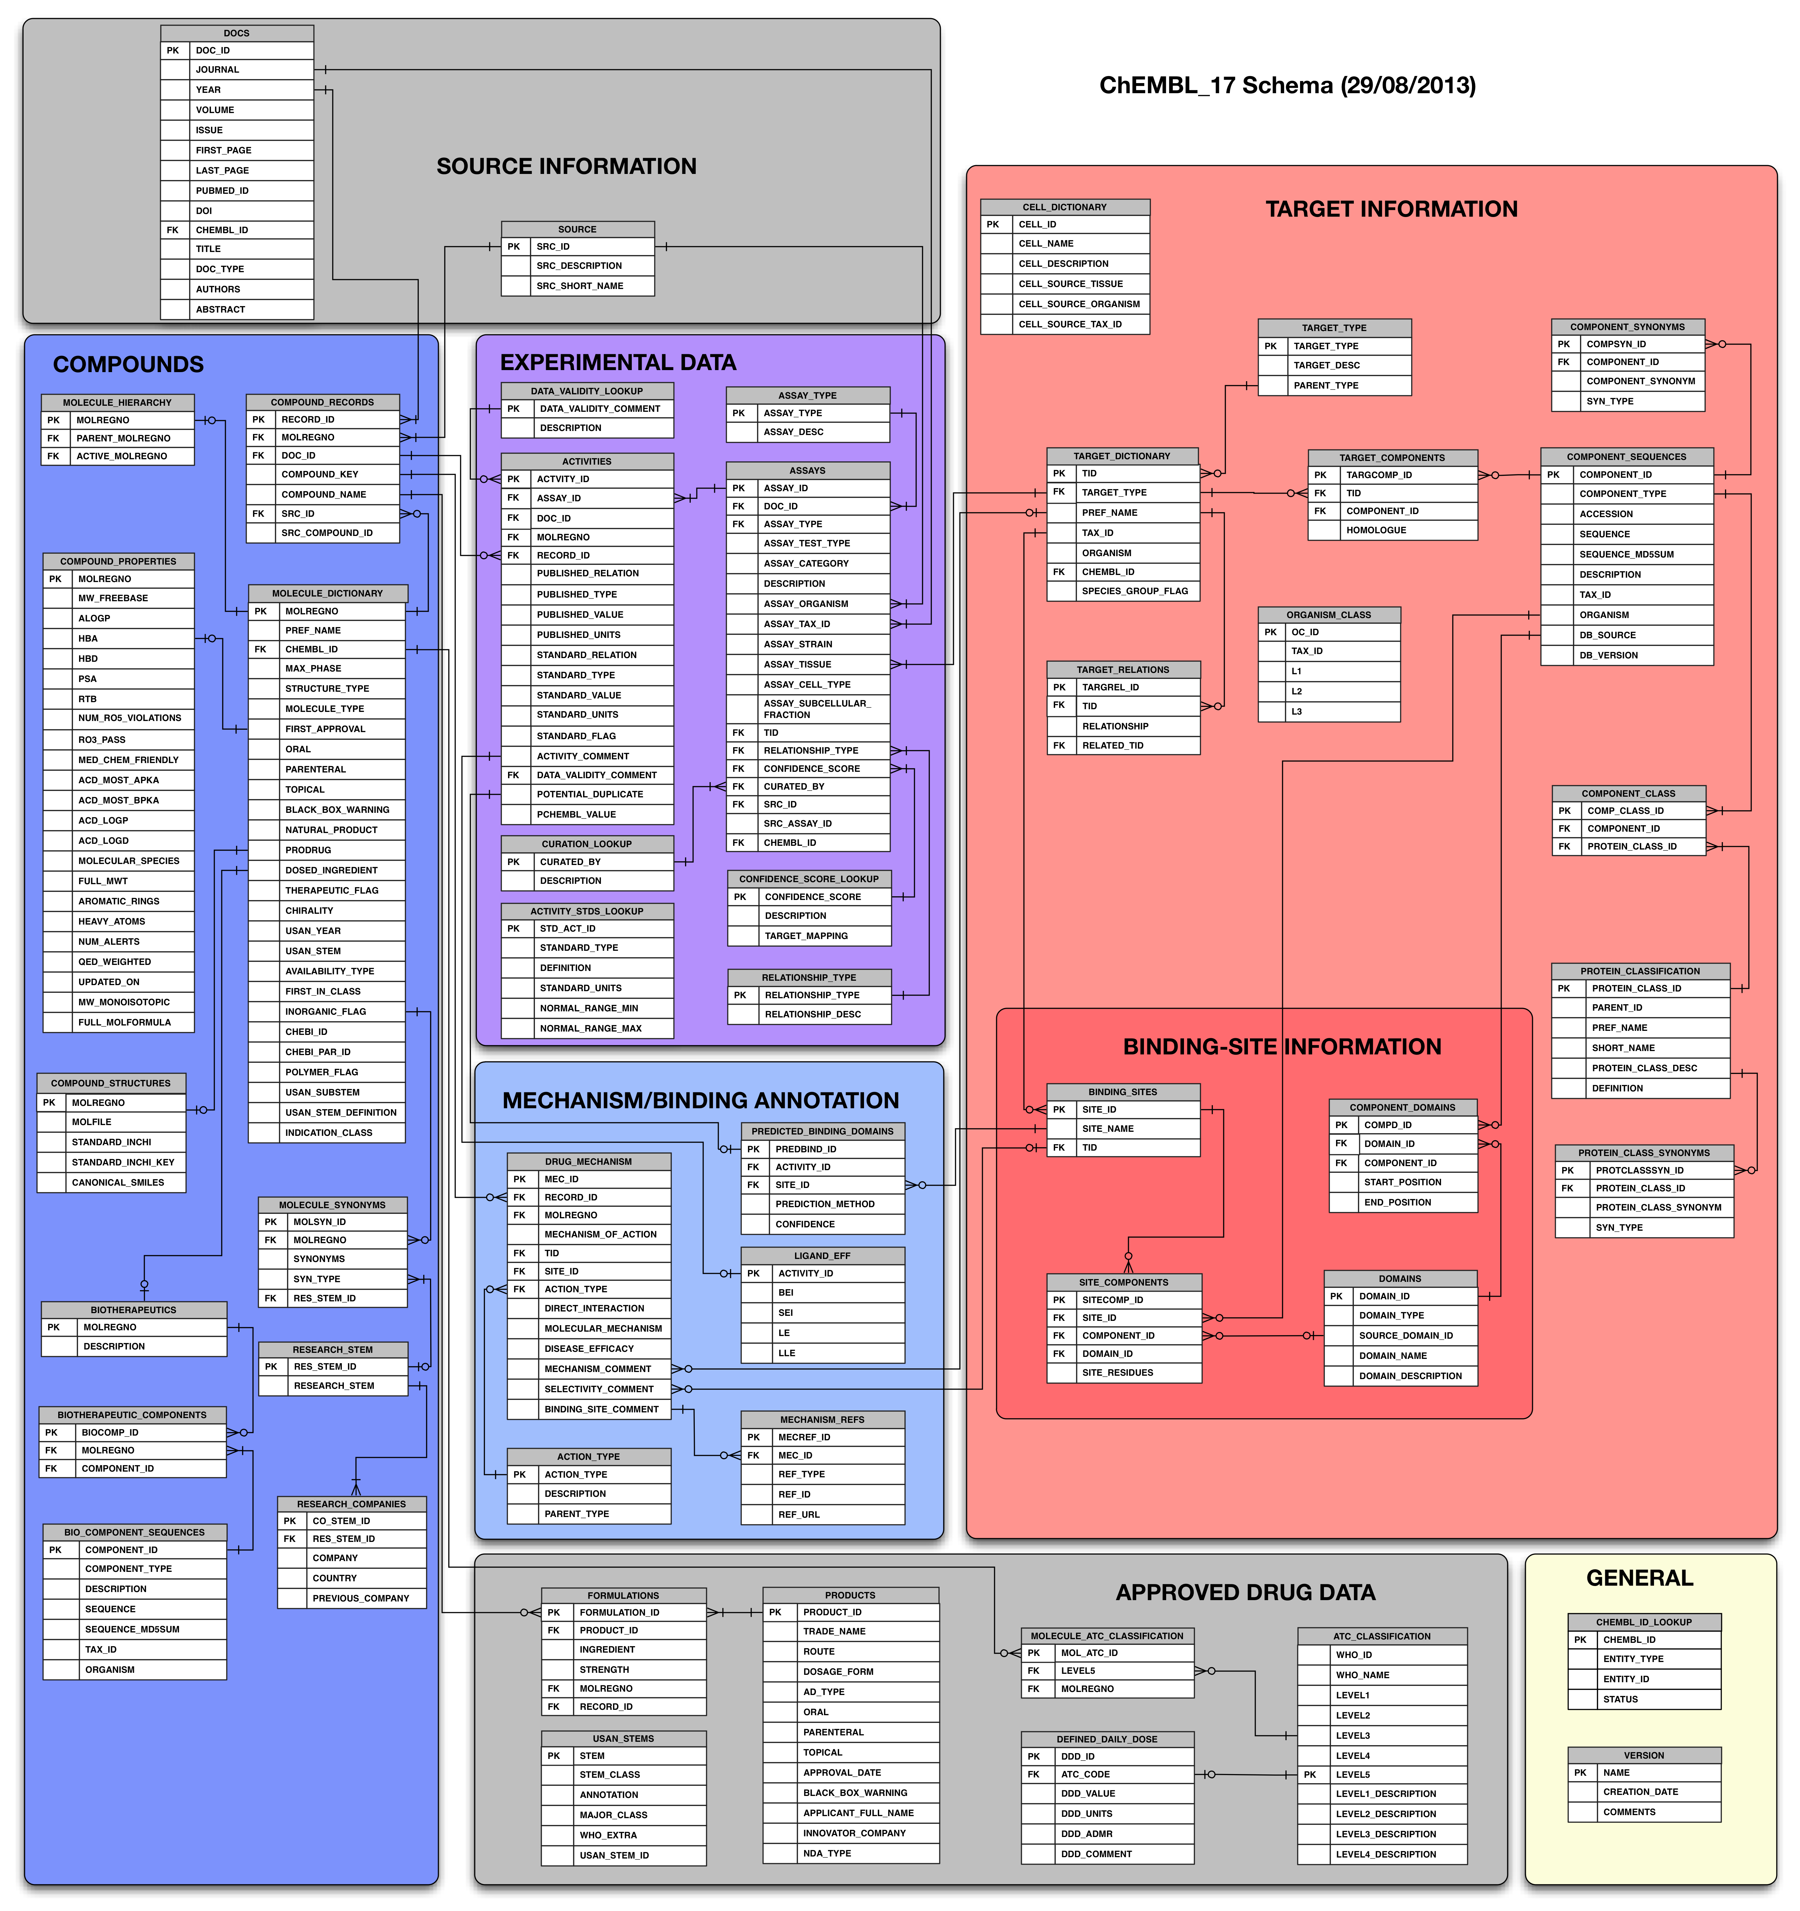

Supplementary Figure 2



Supplementary Figure Legends

Supplementary Figure 1: Diagram of the database schema for ChEMBL release 17. Coloured areas show tables storing related types of information (*e.g.*, compound related, target related). Detailed information about column types and constraints is omitted for clarity but is available in the full schema documentation.

Supplementary Figure 2: Screen-capture showing Related Documents feature of the Document Report Card. The five most related ChEMBL documents are returned, based on citations and compound or target overlap, allowing users to identify other potentially useful data sets.