**Specification:**

* Android emulator **480x800**, setting as follows (Nexus One, Nexus Note). For the demo tests having the resolution of **480x800 is crucial.**

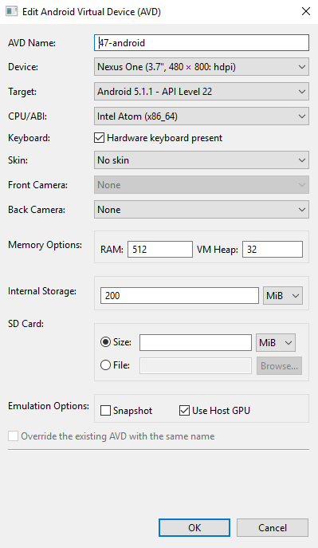

* **Appium server: 1.4.16** – downloaded from <http://appium.io/> .

if you come to install with via node (npm install ) , make sure you read:

<https://github.com/appium/appium/issues/7084#issuecomment-255724484>

<https://github.com/appium/appium/issues/7127#issuecomment-257204848>

One test will be failing with Appium 1.6 when asserting time (12:00)

* Java version: 1.7.0_79
* Python 2.7

**Proposal:**

* Implement OCR for toast messages.
* Migrate test cases to Page Object model framework with the following framework structure:

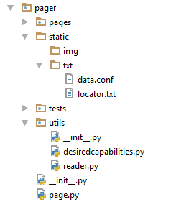

* Improve reporting ( investigate the *allure* reporting framework and integrate it )
* At the moment, swipe action as well as tap on coordinates are using fixed values for 480x800 so for larger screens this needs to be investigated and coordinates added.

**Issues:**

The following manifesting with Android 7.0 – API Level 24

CPU/ABI: Intel atom (x86_64)

**Run:**

* Run thetest to clean up all activities and leads created by admin and employee: *suite.addTest(TestsDemo(****"test_prep"****))* .

It would be a good routine to run this test before running the test suite.

* You need to delete all channel partners belongs to the employee before running tests ( this could be automated in future and added to test_prep)
* Tests are not independent, it means that one test creates data and another test verifies this data, so it’s crucial to have all tests working at all times.

