Table of Contents
name scoped 2
One-to-one association 2
One-to-many association 2
Db methods 2
html 3
text helpers 3
numbers helpers 3
date and time helpers 4
custom helpers 8
Form Helpers 8
Form Select Helpers 9
Date and time Select Helpers 10
Form Tag Helpers 12
Form Errors 13
Form Field Labels 14
Preventing Cross-Site Request Forgery (CSRF) 14

rails new <app_name>

rake -T → all tasks
rake -D → describe all tasks
rake -D db:migrate → describe all for db:migrate

rails generate model <model_name>

rails console

name scoped
scope :visible, where(:visible => true)

One-to-one association
Subject has_one :page
Page belongs_to :subject

methods
[subject_instance].page
[page_instance].subject

One-to-many association
Subject has_many :pages
Pages belongs_to :subject

Db methods
return array with all pages → [subject_instance].pages

add to that array → [subject_instance].pages << page

delete → [subject_instance].pages.delete(page_instance)

delete all →[subject_instance].pages.clear

is empty? → [subject_instance].empty?

Size → [subject_instance].pages.size

[page_instace].subject

html

<%= link_to("has link to",{:controller => "demo", :action => "index",:id => 20, :page => 5}) %>

<%= link_to('Roar','#', :onclick => "jsRoar(); return true;")%>

<%= image_tag('rails.png', :size => '50x64', :alt => 'Rails Logo')%>

<%= javascript_tag("jsRoar();")%>
<%= javascript_tag("alert('Hello');")%>
<%= javascript_tag("alert('#{escape_javascript(text)}');")%>

<%= image_tag('rails.png', :size => '50x64', :alt => 'Rails Logo')%>

text helpers

simples_cms/app/views/demo/text_helpers.html.erb

numbers helpers

Só podem ser usados na view

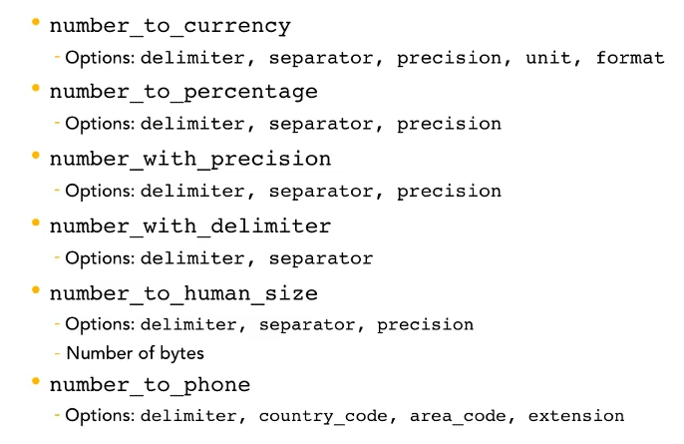
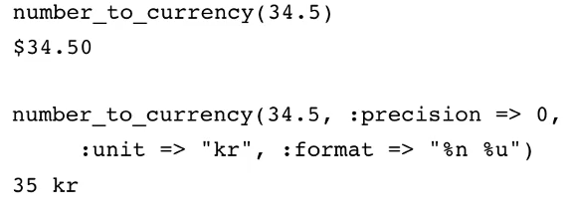

date and time helpers

disponível em todo local da app

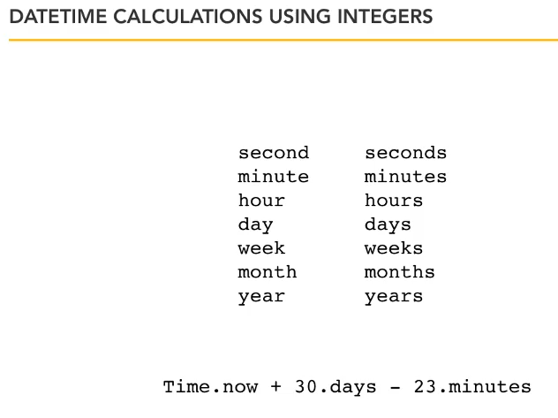

ago
30.days.ago = Time.now – 30.days

from_now
30.days.from_now = Time.now + 30.days

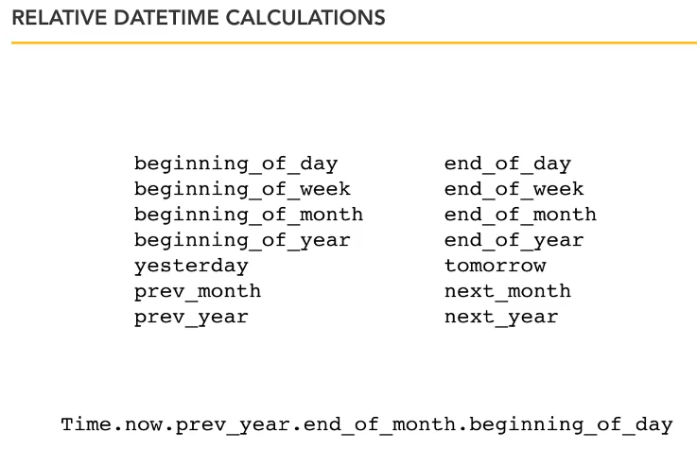

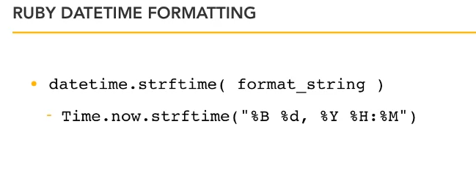

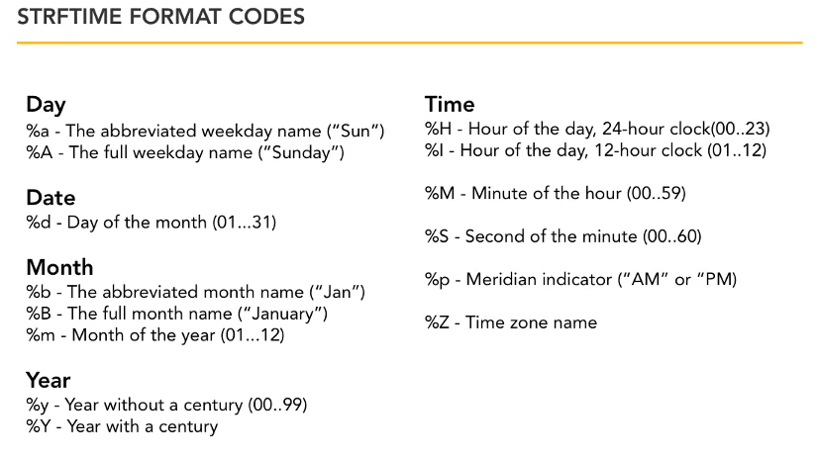

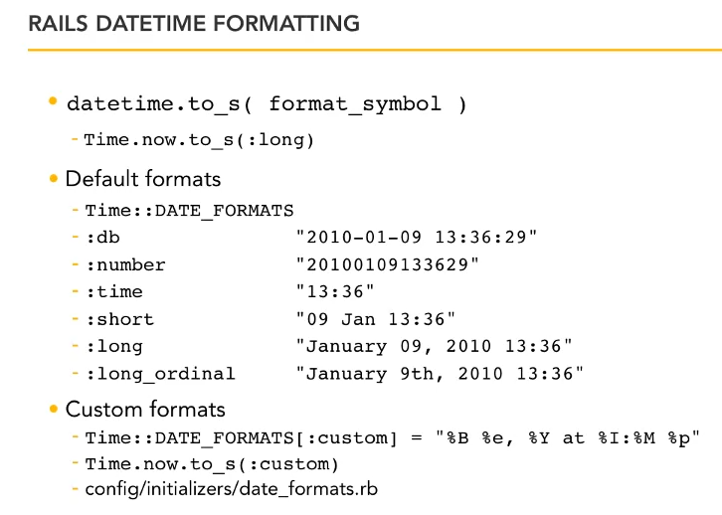

custom helpers

cada controller tem sua classe de helper methods que podem ser usados na view correspondente.

subjects_controller -> subjects_helper

Para compartilhar um helper com todos as views, colocar no application_helper

Form Helpers

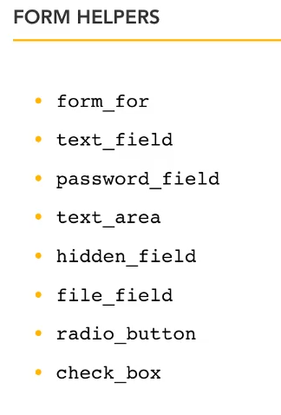

se for fazer upload de arquivo, é necessário o :html => { :multipart => true }

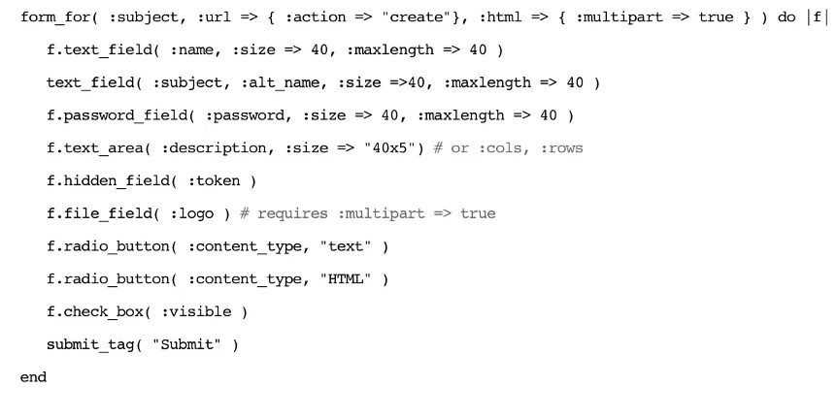

Form Select Helpers

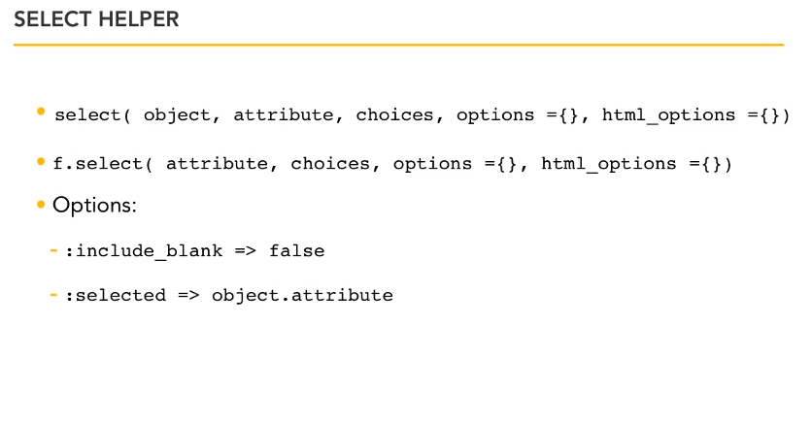
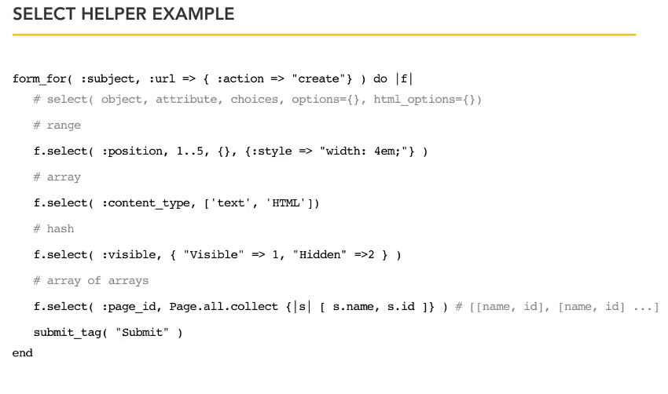

Date and time Select Helpers

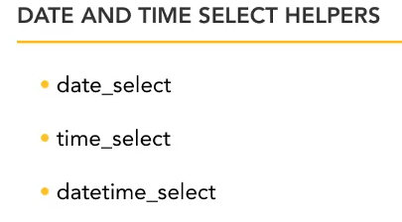

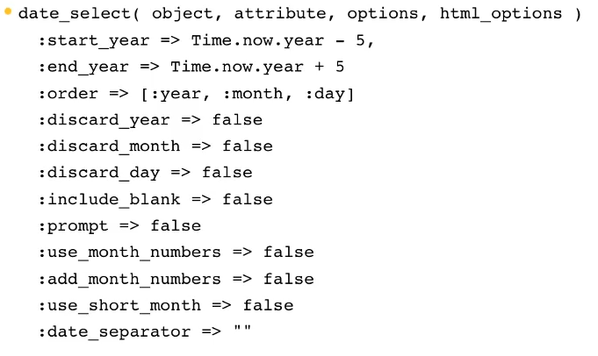

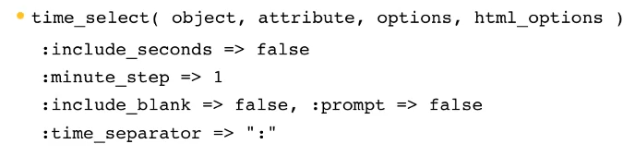

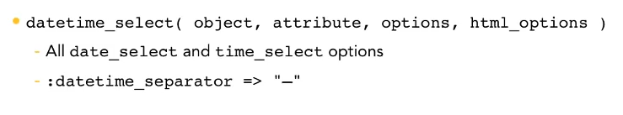

Form Tag Helpers

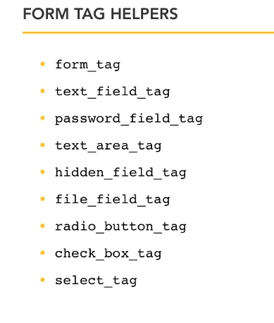

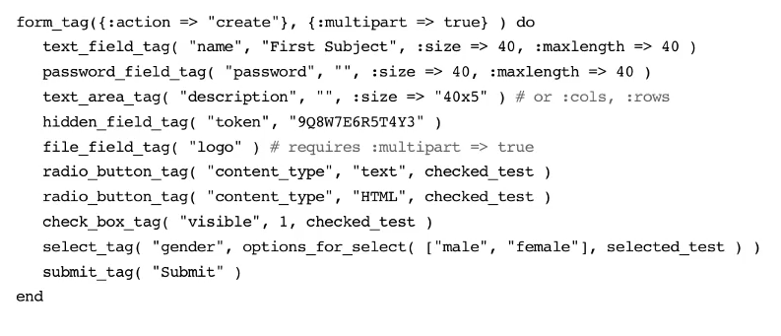

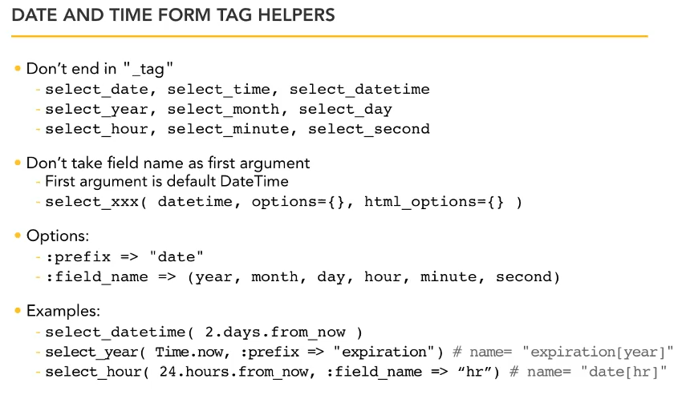

Form Errors

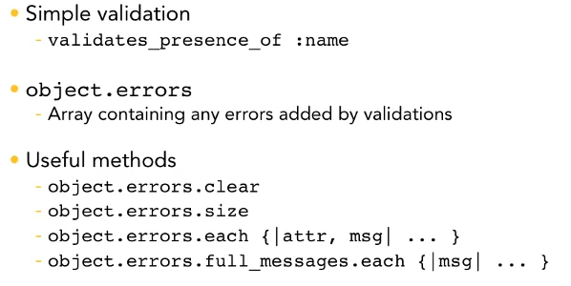
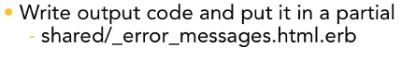

Form Field Labels

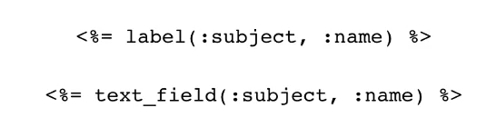

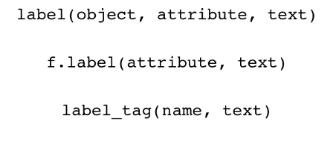

Preventing Cross-Site Request Forgery (CSRF)

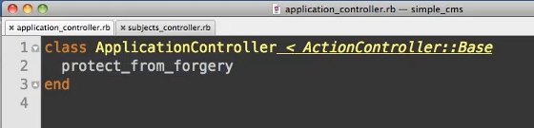

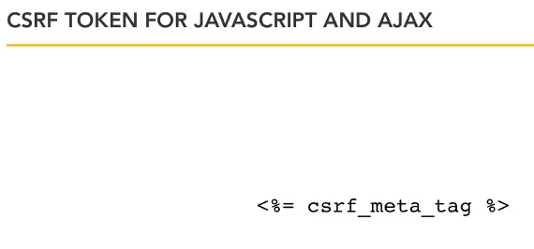

Escaping Input

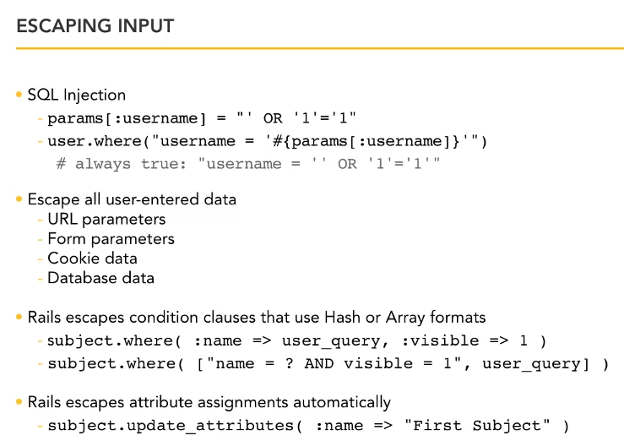

Escaping Output

Rails 3 faz o escape automático de todo output. O dev diz o que não quer que seja escaped.

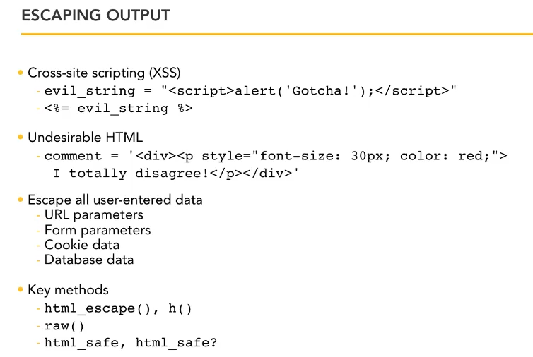

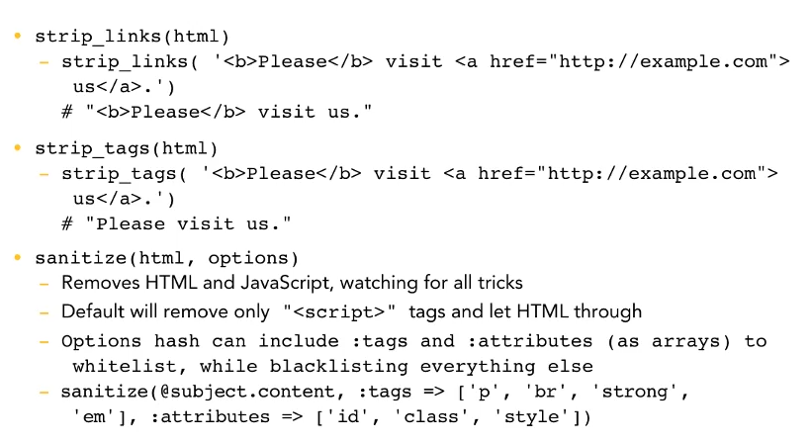

Validation Methods

